The Mann-Whitney U test (Treatment)

N | 80
The Mann-Whitney U test | 575.000
The Wilcoxon test | 1.395.000
Statistical tests | 575.000
The standard error (SE) | 98.951
Asymptotic Sig (bilateral) | 0.023
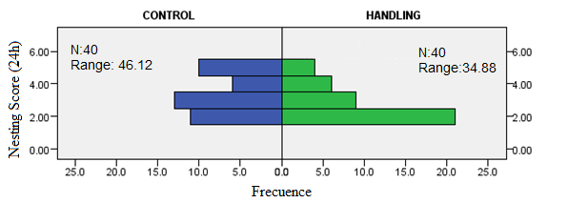
Nesting at 24h

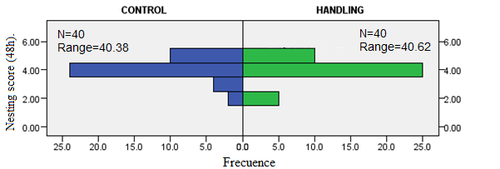
Nesting at 48h
N | 80
The Mann-Whitney U test | 805.000
The Wilcoxon test | 1.625.000
Statistical tests | 805.000
The standard error (SE) | 90.235
Asymptotic Sig (bilateral) | 0.956

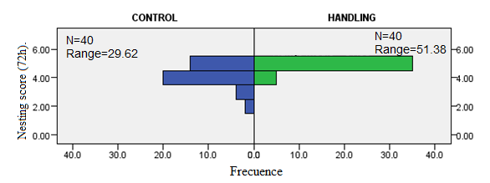
Nesting at 72h
N | 80
The Mann-Whitney U test | 1.235.000
The Wilcoxon test | 2.055.000
Statistical tests | 1.235.000
The standard error (SE) | 89.378
Asymptotic Sig (bilateral) | 0.000

