Supplemental information
Supplemental figure 1. LC/MS traces of peptoids
LC / MS trace of MXB1. t_{R} = 3.91 min. Gradient: 5–95% acetonitrile + 0.1% TFA over 6.80 min.
MS (ESI⁺, [M]⁺, C₁₀₄H₁₃₉N₁₇O₁₂): 1820.70.
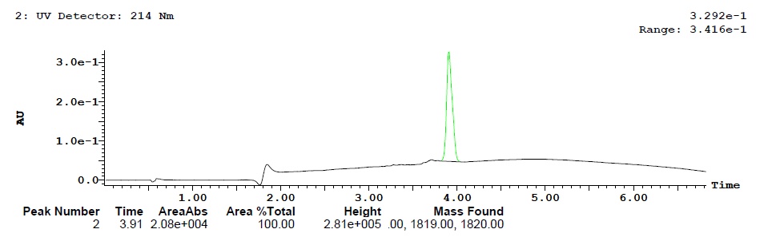

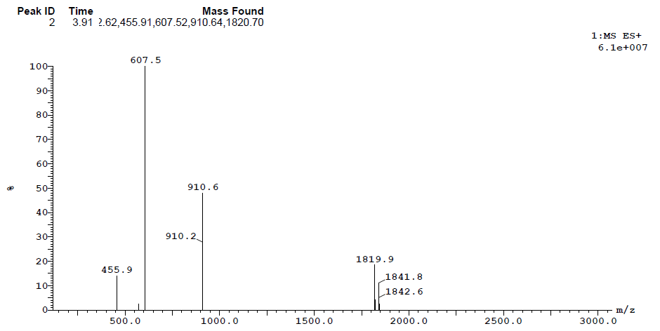

LC / MS trace of MXB2. t_{R} = 3.84 min. Gradient: 5–95% acetonitrile + 0.1% TFA over 6.80 min.
MS (ESI⁺, [M]⁺, C₅₂H₆₉Br₂N₉O₆): 1074.41.
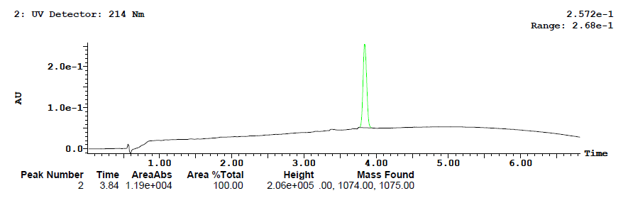

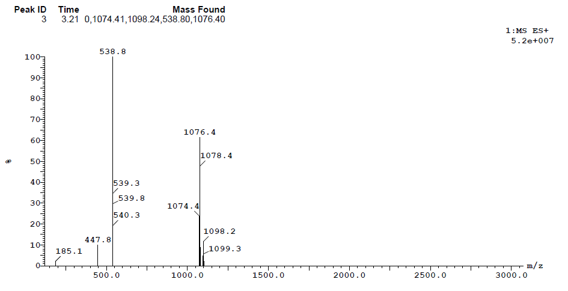
LC / MS trace of MXB3. t_{R} = 3.59 min. Gradient: 5–95% acetonitrile + 0.1% TFA over 6.80 min.
MS (ESI⁺, [M]⁺, C₅₂H₇₀BrN₉O₆): 996.50.
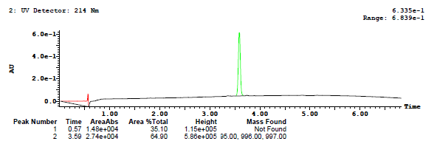

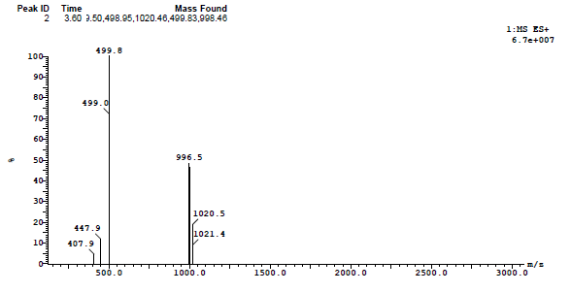

LC / MS trace of MXB4. t_{R} = 4.02 min. Gradient: 5–95% acetonitrile + 0.1% TFA over 6.80 min.
MS (ESI⁺, [M]⁺, C₅₂H₆₇Br₄N₉O₆): 1233.09.
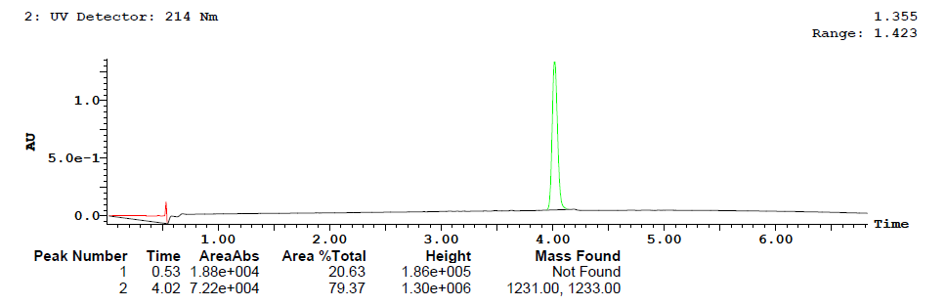

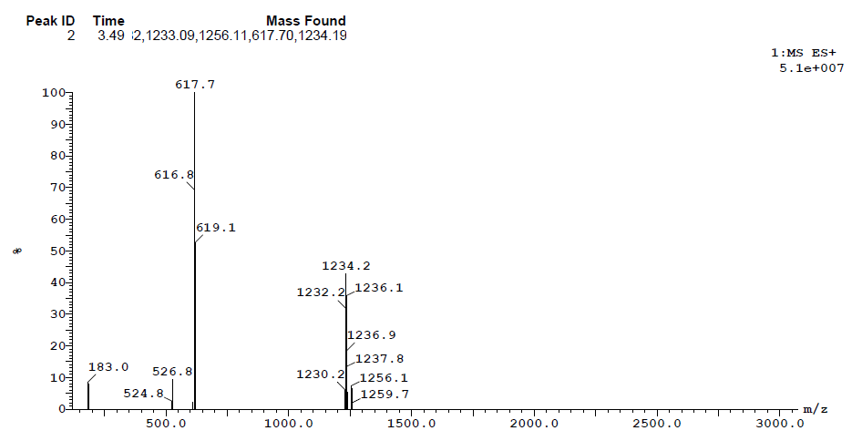

LC / MS trace of MXB5. t_{R} = 3.36 min. Gradient: 5–95% acetonitrile + 0.1% TFA over 6.80 min.
MS (ESI⁺, [M]⁺, C₄₇H₇₈N₈O₅): 835.65.
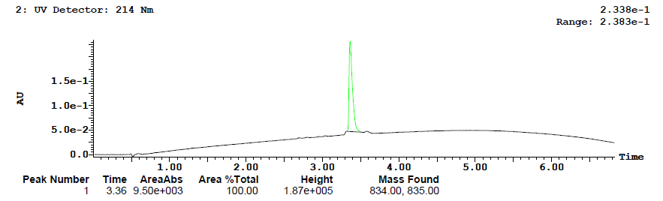

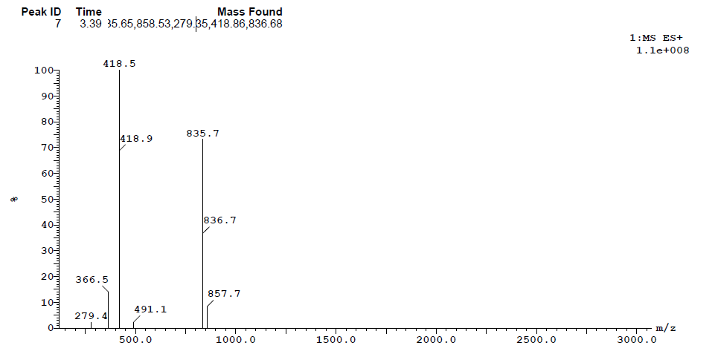
LC / MS trace of MXB6. t_{R} = 3.39 min. Gradient: 5–95% acetonitrile + 0.1% TFA over 6.80 min.
MS (ESI⁺, [M]⁺, C₉₄H₁₂₈N₁₆O₁₁): 1658.67.
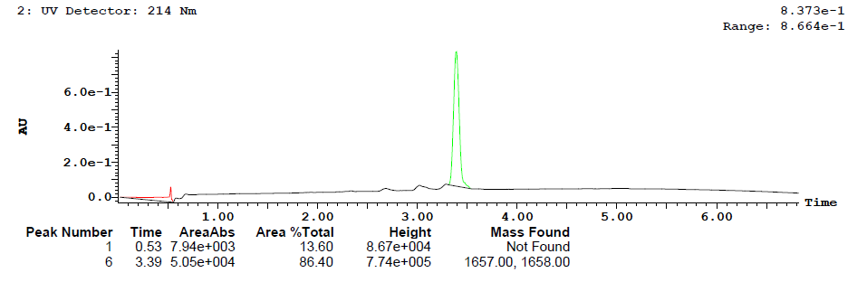

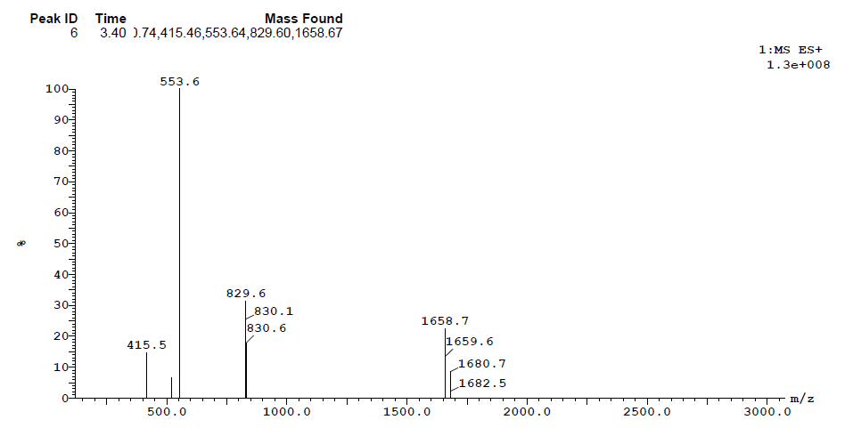

LC / MS trace of MXB7. t_{R} = 3.08 min. Gradient: 5–95% acetonitrile + 0.1% TFA over 6.80 min.
MS (ESI⁺, [M]⁺, C₅₂H₇₁N₉O₆): 918.61.
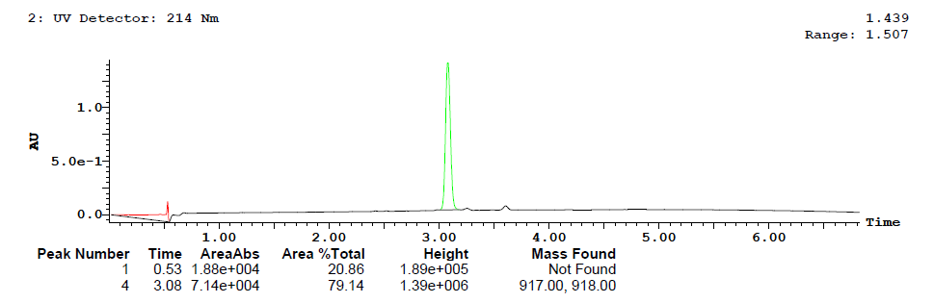

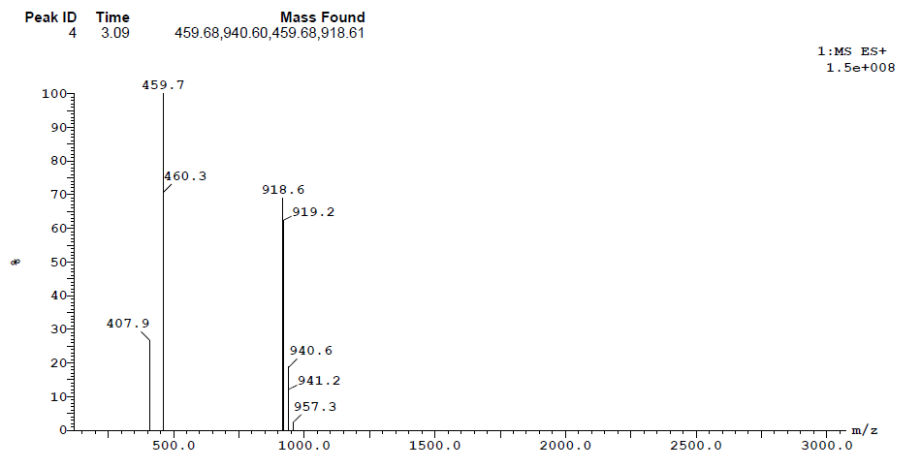

LC / MS trace of MXB8. t_{R} = 3.72 min. Gradient: 5–95% acetonitrile + 0.1% TFA over 6.80 min.
MS (ESI⁺, [M]⁺, C₆₄H₉₄N₁₀O₇): 1115.74.
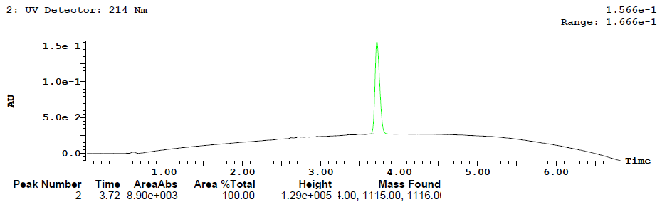

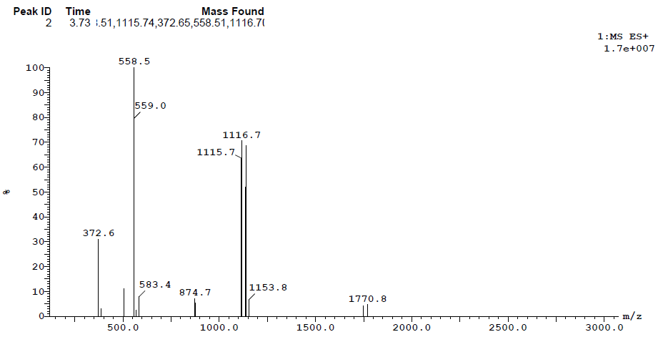

LC / MS trace of MXB9. t_{R} = 3.94 min. Gradient: 5–95% acetonitrile + 0.1% TFA over 6.80 min.
MS (ESI⁺, [M]⁺, C₆₄H₉₂Br₂N₁₀O₇): 1271.50.
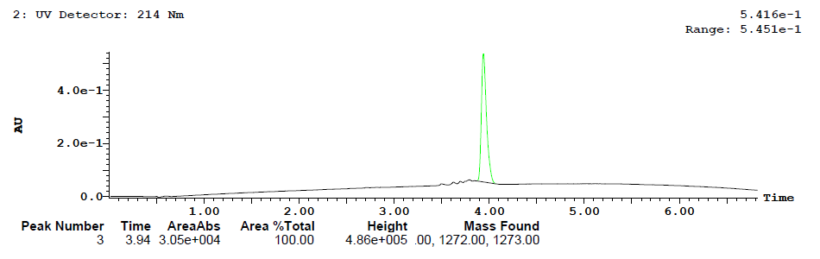

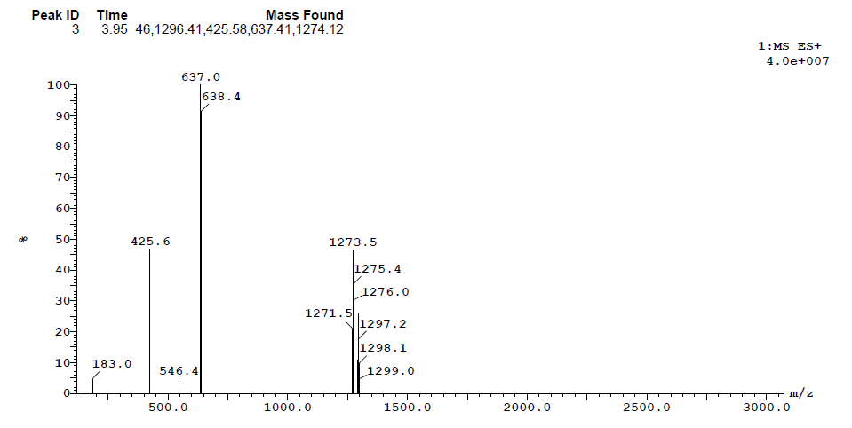

LC / MS trace of MXB10. t_{R} = 4.22 min. Gradient: 5–95% acetonitrile + 0.1% TFA over 6.80 min.
MS (ESI⁺, [M]⁺, C₆₇H₉₈Br₂N₁₀O₇): 1315.53.
