SUPPORTING INFORMATION

Association Behavior of Amphiphilic ABA Triblock Copolymer Composed of Poly(2-methoxyethyl acrylate) (A) and Poly(ethylene oxide) (B) in Aqueous Solution

Yoko Mizoue¹, Kazutoshi Haraguchi², Shin-ichi Yusa^{1,}*

¹Department of Applied Chemistry, Graduate School of Engineering, University of Hyogo, 2167 Shosha, Himeji, Hyogo 671-2280, Japan; ym85725@gmail.com
²College of Industrial Technology, Nihon University, 1-2-1 Izumicho, Narashino, Chiba, Japan; haraguchi.kazutoshi@nihon-u.ac.jp
*Correspondence: yusa@eng.u-hyogo.ac.jp

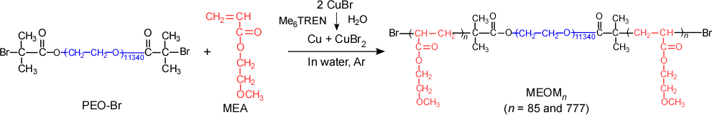
Scheme S1. Synthesis of MEOM_{n} (n = 85 and 777).

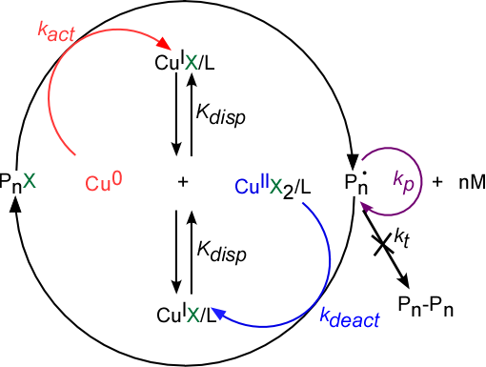
Figure S1. Mechanism of single-electron transfer-living radical polymerization (SET-LRP); M; monomer, P; polymer, Cu; copper, X; halogen, L; ligand, k_{act}; activation, k_{deact}; deactivation, k_{p}; propagation, k_{t}; termination.

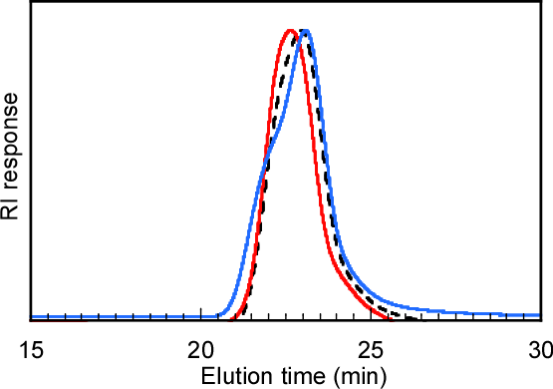
Figure S2. Gel-permeation chromatography (GPC) elution curves of PEO₁₁₃₄₀-Br (---), MEOM₈₅ (—), and MEOM₇₇₇ (—) using THF as an eluent with a flow rate of 1.0 mL/min at 40°C.

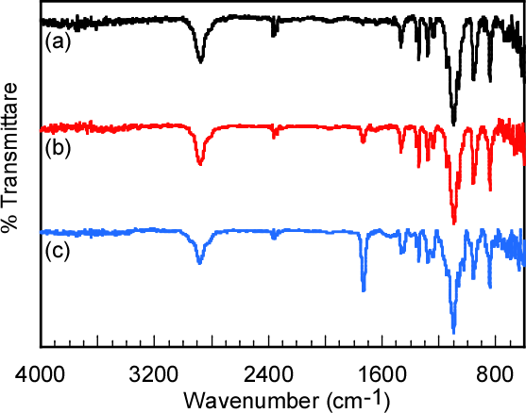
Figure S3. Attenuated total reflection (ATR) Fourier-transform infrared (FTIR) spectra of (a) PEO₁₁₃₄₀-Br, (b) MEOM₈₅, and (c) MEOM₇₇₇.

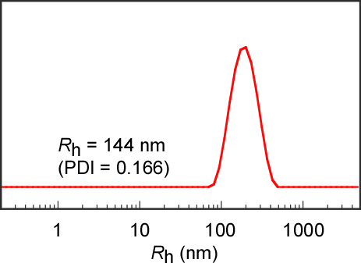
Figure S4. Hydrodynamic radius (R_{h}) distributions of MEOM₈₅ aqueous solution prepared by dialysis from THF solution against aqueous solution; the final polymer concentration (C_{p}) was adjusted to 0.1 g/L.

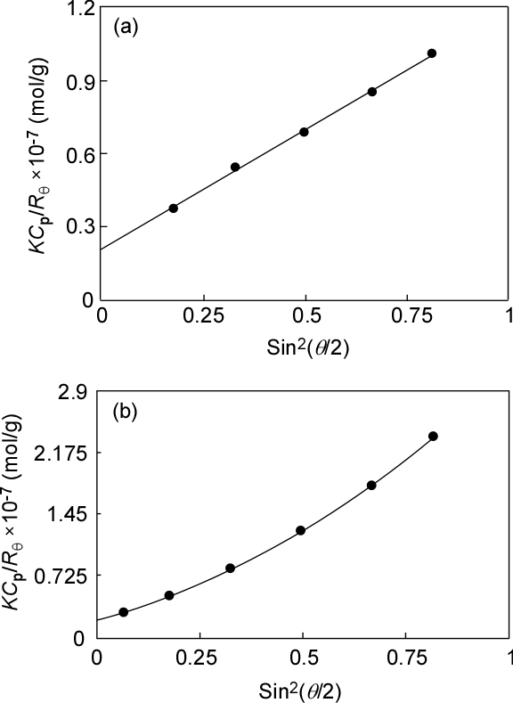
Figure S5. Debye plots for (a) MEOM₈₅ and (b) MEOM₇₇₇ in water.

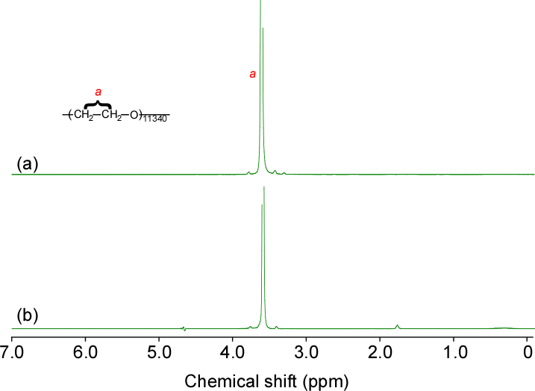
Figure S6. Water suppression by gradient-tailored excitation (WATERGATE) ¹H NMR spectroscopy in D₂O for (a) MEOM₈₅ and (b) MEOM₇₇₇ at 25°C.

