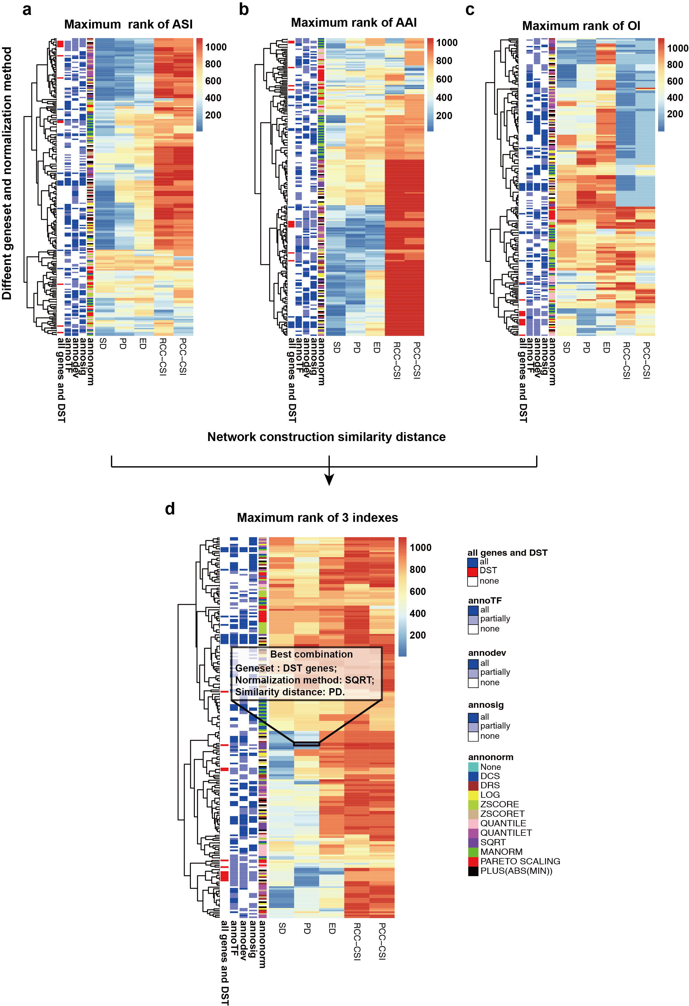
Supplementary Figure 1. Feature selection for spatial reconstruction. a, b and c, The maximum rank of ASI, AAI and OI in Geo-seq dataset with 19 gene sets and 12 normalization methods (‘annonorm’). Here, we compared 5 distance matrices, including Spearman distance (SD), Pearson distance (PD), Euclidean distance (ED) and CSI filtering on PCC and RCC (PCC-CSI and RCC-CSI). For the 19 gene sets, we annotated them with ‘annoTF’, ‘annodev’, and ‘annosig’ to show whether one gene set contain or partially contain genes from TFs (‘annoTF’), developmental related genes (‘annodev’) and signaling (‘annosig’) genes. All genes and DST genes were specifically annotated with ‘all gens and DST’. d, The maximum rank of the 3 indexes in Geo-seq dataset for spatial reconstruction.

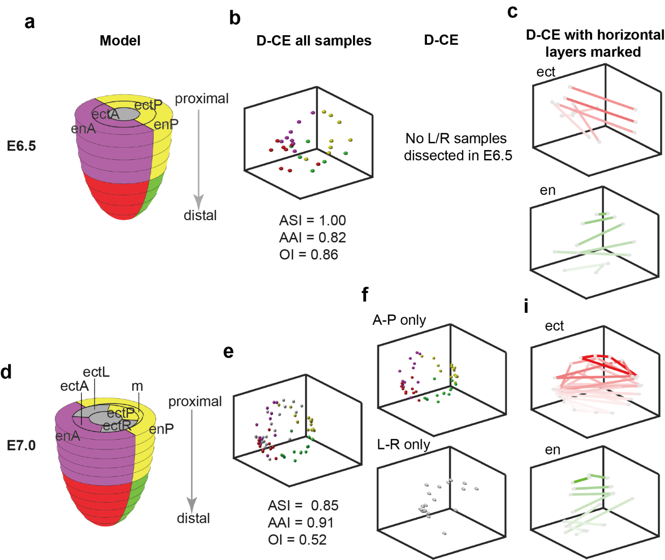
Supplementary Figure 2. Spatial reconstruction of 3D localizations of Geo-seq samples from E6.5 and E7.0 mouse embryos. a, b, c, d, e, f and i, Same analysis and visualization as in Fig. 3 for E6.5 (a, b and c) and E7.0 (d, e, f and i) samples.

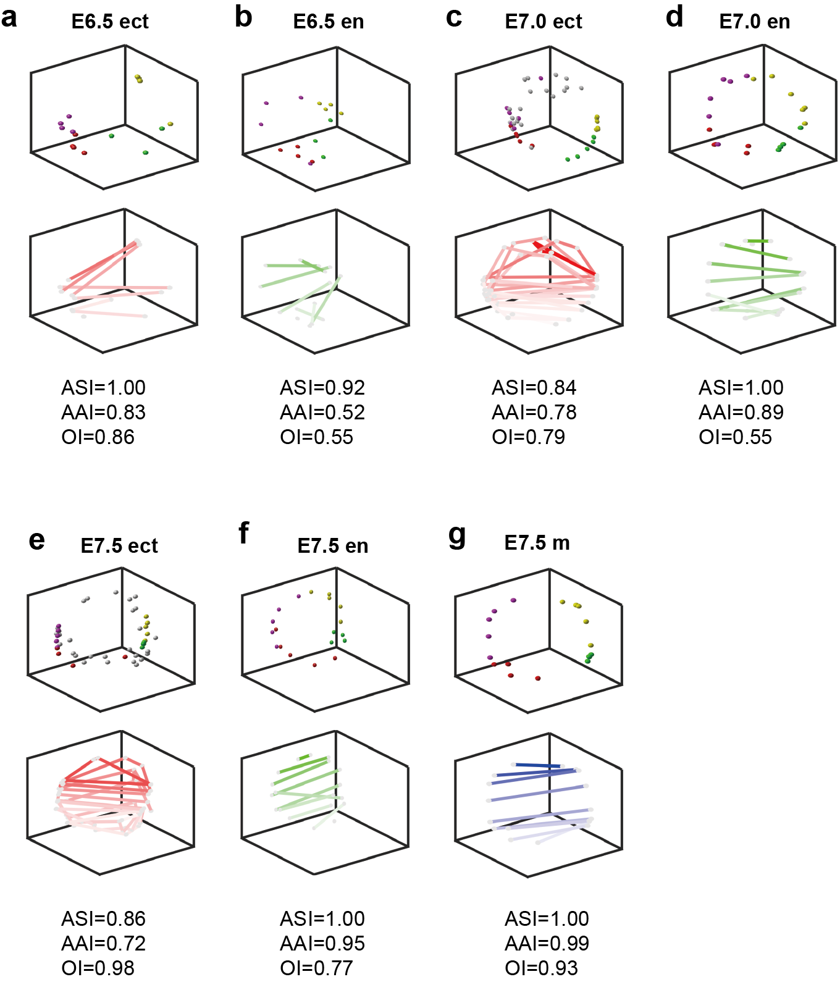
Supplementary Figure 3. Spatial reconstruction of 3D localizations of E6.5, E7.0 and E7.5 mouse embryo Geo-seq samples of each germ layer separately. a and b, D-CE spatial reconstruction from stage E6.5 ectoderm samples only (a) and endoderm samples only (b). The upper panels are reconstructed spatial locations of Geo-seq samples. E7.5, E6.5 and E7.0 mouse embryo samples’ original positions are color coded as in the models in Fig. 3a, Supplementary Fig. 2a and d, respectively. en, ect and m stand for endoderm, ectoderm and mesoderm. The lower panels show samples in the same horizontally micro-dissected layer connected by lines, which are color coded from dark to light in the proximal to distal order to visualize the recapitulation of the proximal to distal order in the samples, as in Fig. 3d. c and d, D-CE reconstruction from stage E7.0 ectoderm samples only (c) and endoderm samples only (d). Upper and lower panels are similarly displayed as panel a and b. e, f and g, D-CE reconstruction from stage E7.5 ectoderm samples only (e), endoderm samples only (f) and mesoderm samples only (g). Upper and lower panels are similarly displayed as panel a and b.

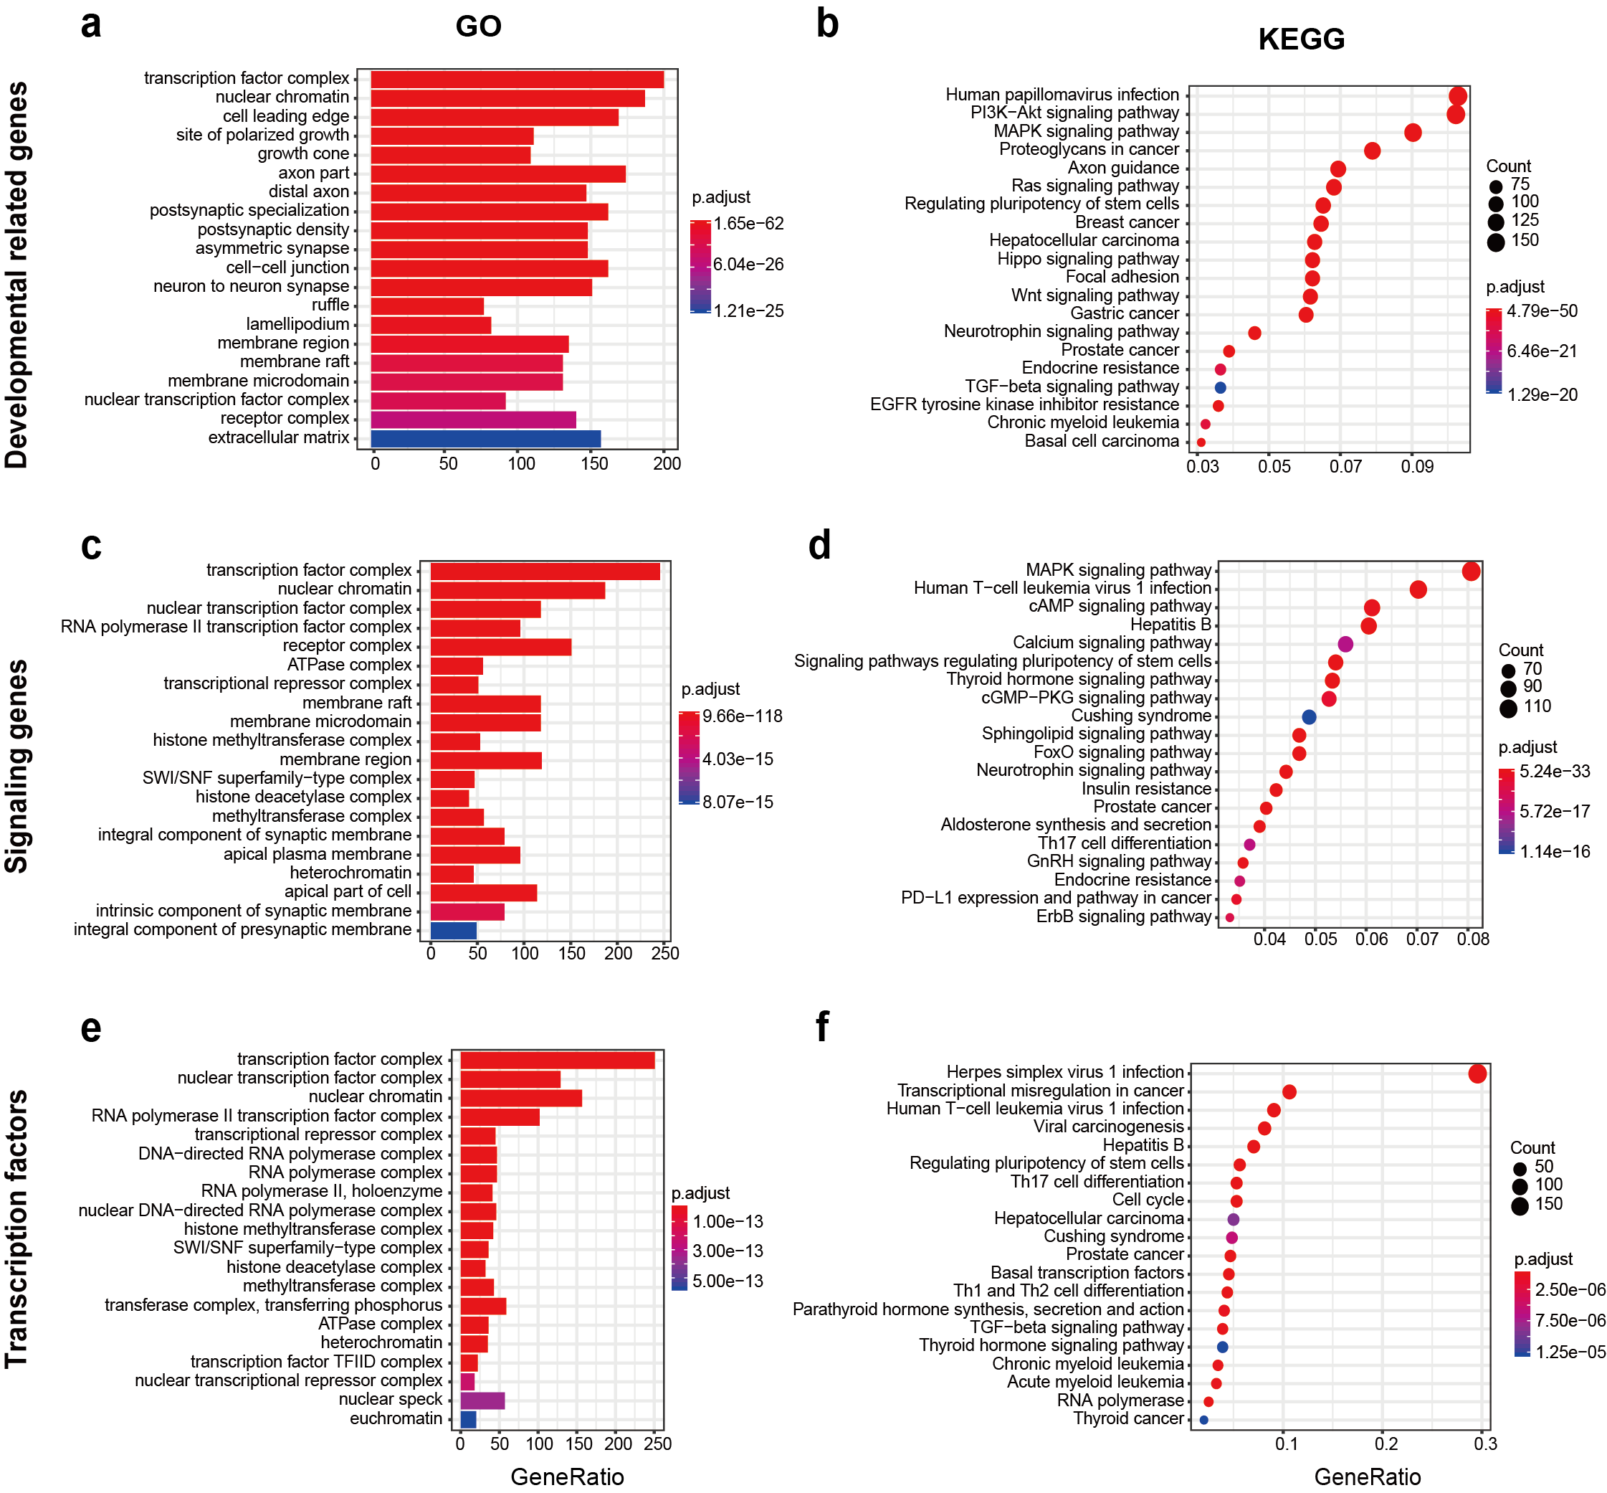

Supplementary Figure 4. Functional enrichment of input gene sets. GO (a, c and e) and KEGG (b, d and f) enrichment analysis of 3 gene sets, 3795 developmental related genes (a and b), 3470 signaling genes (c and d) and 1646 TFs (e and f), over the union of input genes in Fig. 1 that were used for spatial reconstruction.

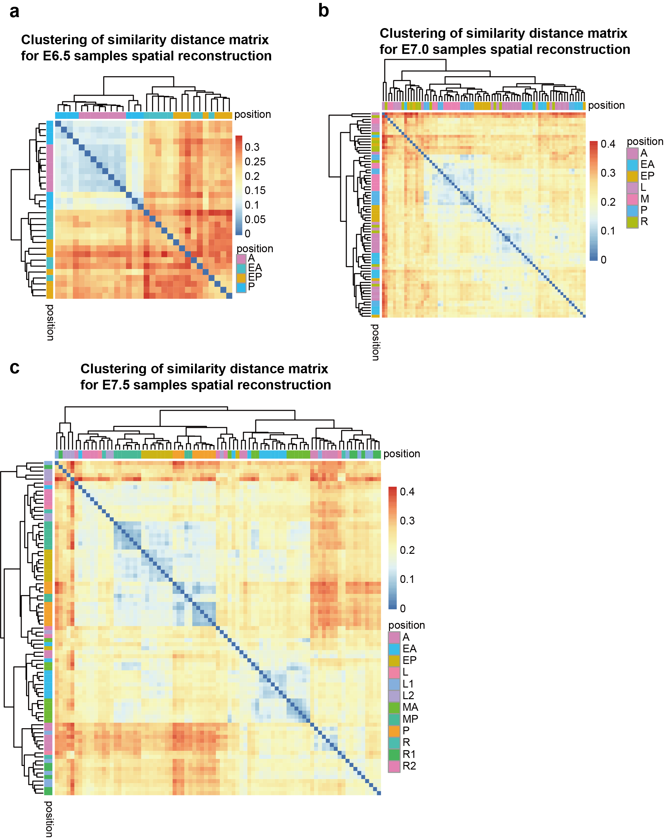

Supplementary Figure 5. Hierarchical clustering of distance matrix for Geo-seq samples spatial reconstruction. a, b and c, Hierarchical clustering of the distance matrix of E6.5, E7.0 and E7.5 samples based on the DST gene set, Pearson distance and normalized with SQRT.

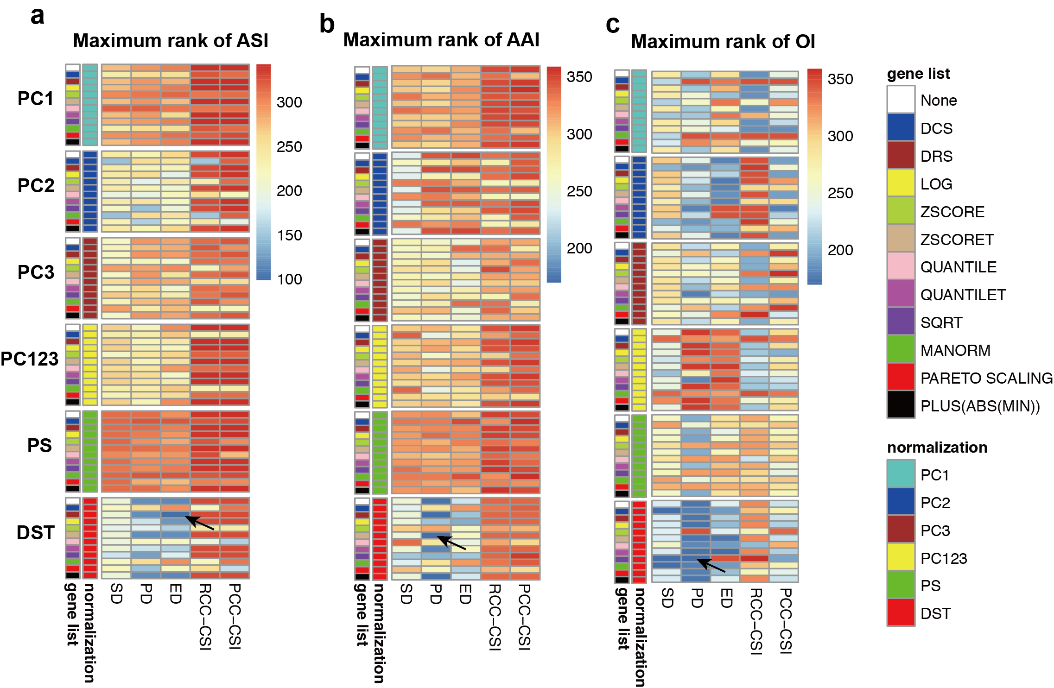
Supplementary Figure 6. Comparison of the principle component correlated genes (PC1, 2 or 3 or PC1, 2, 3 together) (Methods), Scialdone et al’s pseudospace gene list (PS) and DST genes. a, b and c, Maximum ranks of the ASI, AAI and OI of spatial reconstruction using the combinations of each of these gene lists with 12 different normalization methods and 3 distance metrics. The black arrow indicates the best combination in each panel.

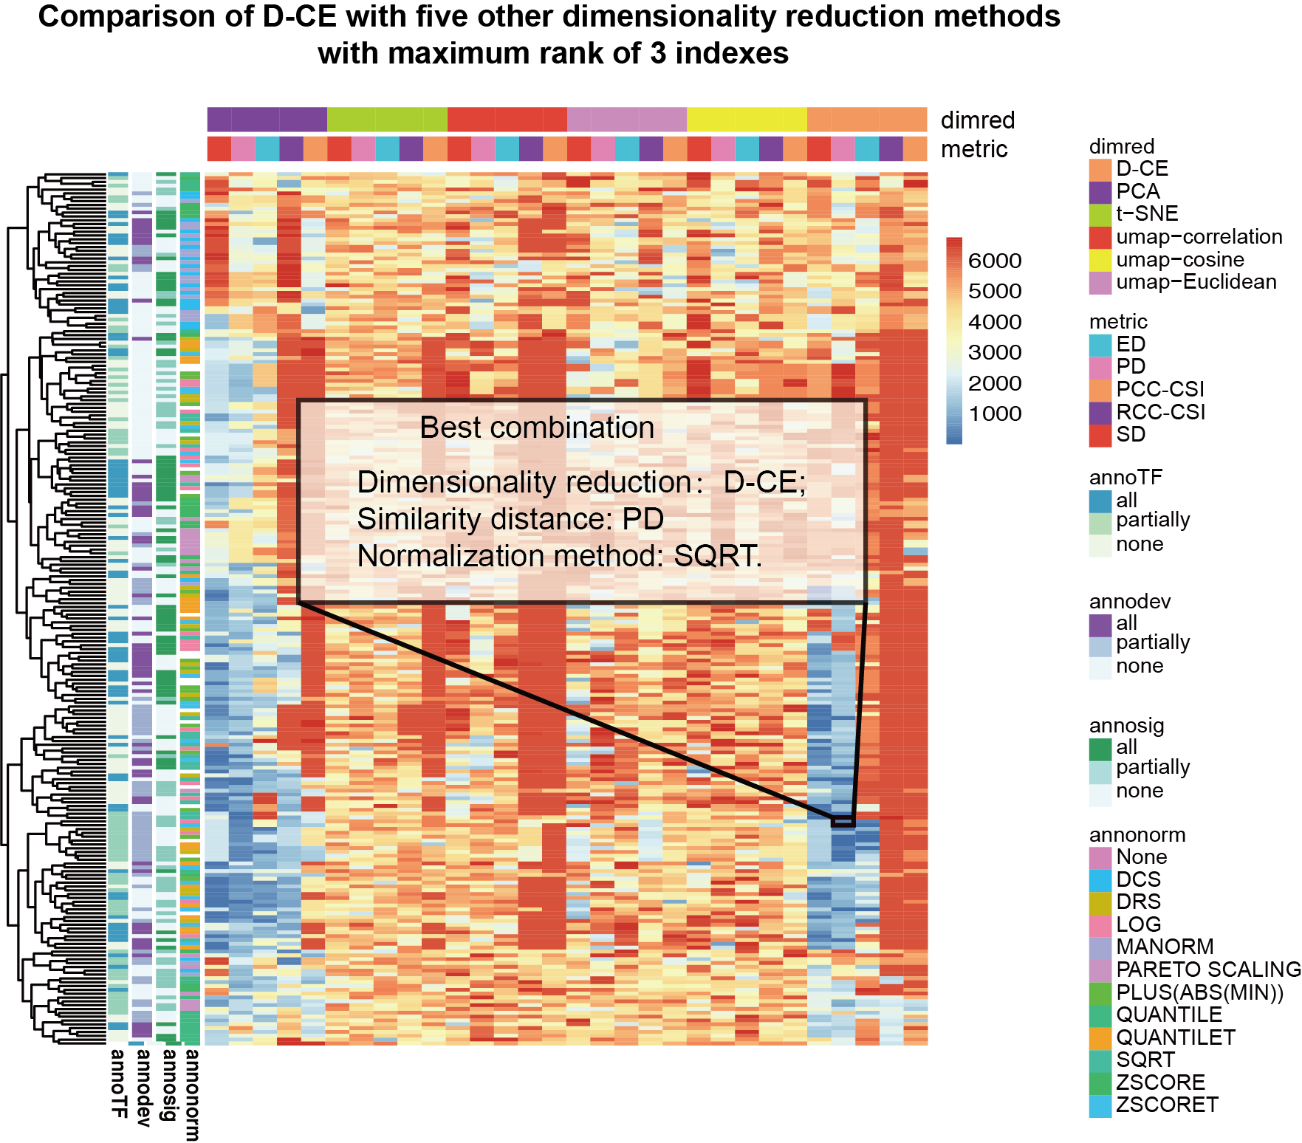
Supplementary Figure 7. Comparison of the reconstruction using PCA, t-SNE, UMAP with 3 distance metrics (umap-correlation (1 – PCC), umap-cosine (1-cosine similarity) and umap-Euclidean) and D-CE. Maximum rank of ASI, AAI and OI is used to measure performance (lower values indicate better performance) using different gene set, dimensionality reduction method, similarity distance and normalization method combinations. As highlighted in the rectangle, D-CE with Pearson distance performs the best.

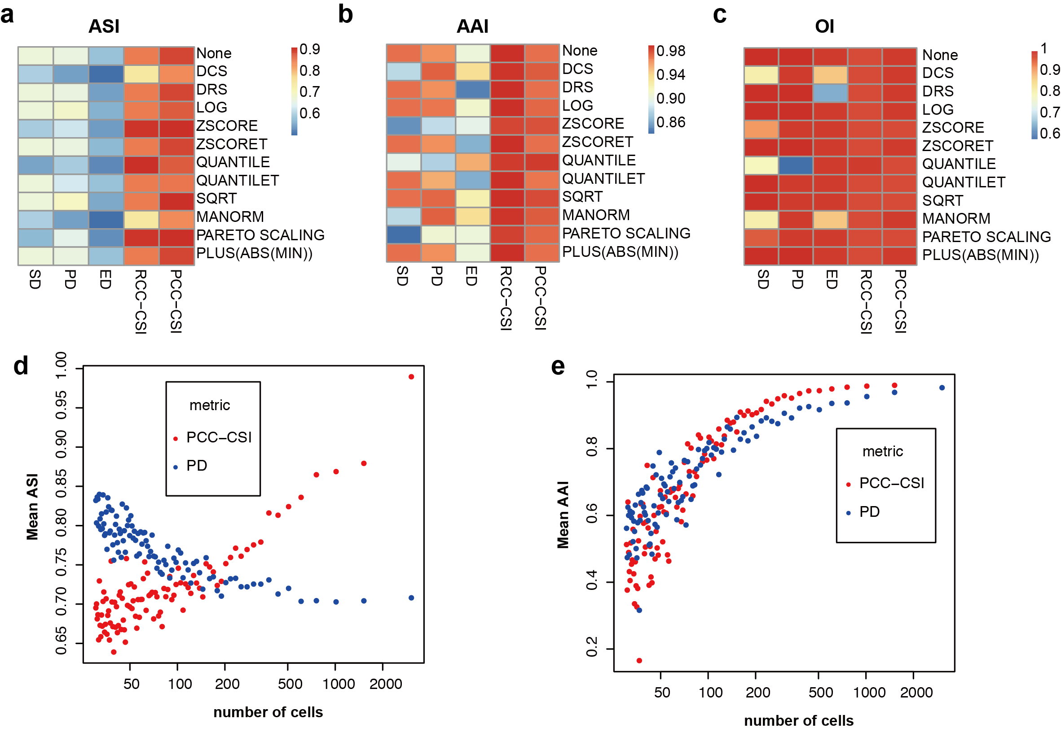

Supplementary Figure 8. PCC-CSI performs better than PD for D-CE reconstruction of the fly embryo BDTNP dataset. a, b and c, ASI, AAI and OI (the minimal OI of x, y, and z axis) of spatial reconstruction of the BDTNP dataset using different normalization method and distance/similarity metric. d and e, The mean ASI and AAI of spatial reconstruction of Drosophila embryo BDTNP dataset. Datasets of 1/n (n=2~100) of the BDTNP dataset were generated by randomly selecting samples at each indicated sampling rate, 20 repetitions were made at each sampling rate. The mean ASI and AAI of the reconstructed coordinates of 20 repeats by Pearson distance network and PCC-CSI network, respectively, are calculated and visualized.

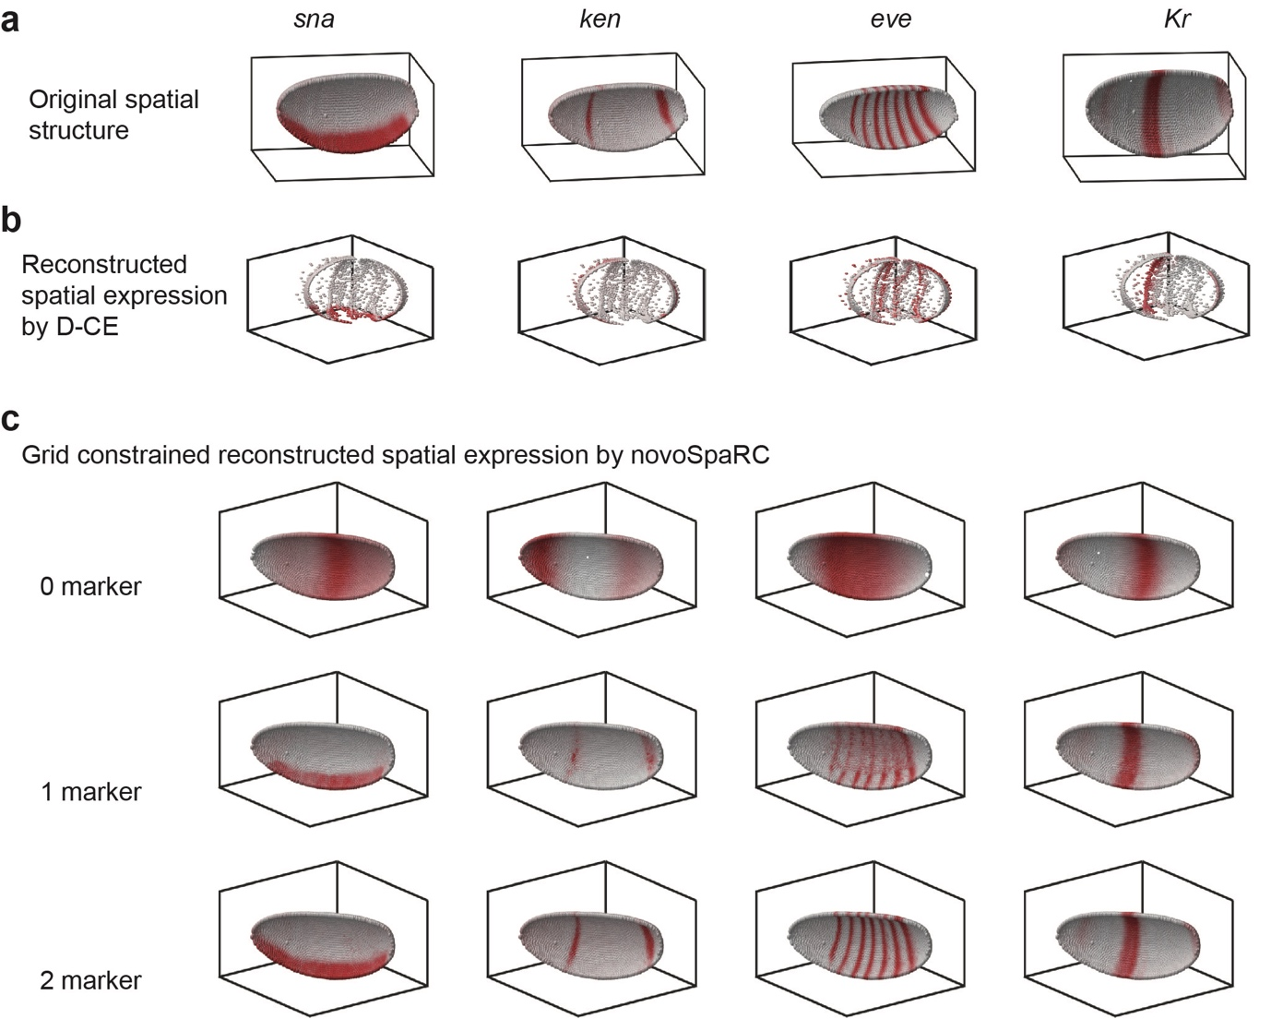

Supplementary Figure 9. Visualization of the expression patterns of 4 TFs (sna, ken, eve and Kr) in embryo structures reconstructed by D-CE or novoSpaRC. a, The expression of sna, ken, eve and kr in the gold standard gridded embryo structure. b, The reconstructed spatial gene expression pattern by D-CE. c, Template-based reconstructed spatial gene expression patterns by novoSpaRC with 0 marker, 1 marker and 2 markers, where the grid of the gold standard is used as a template predefined structure.

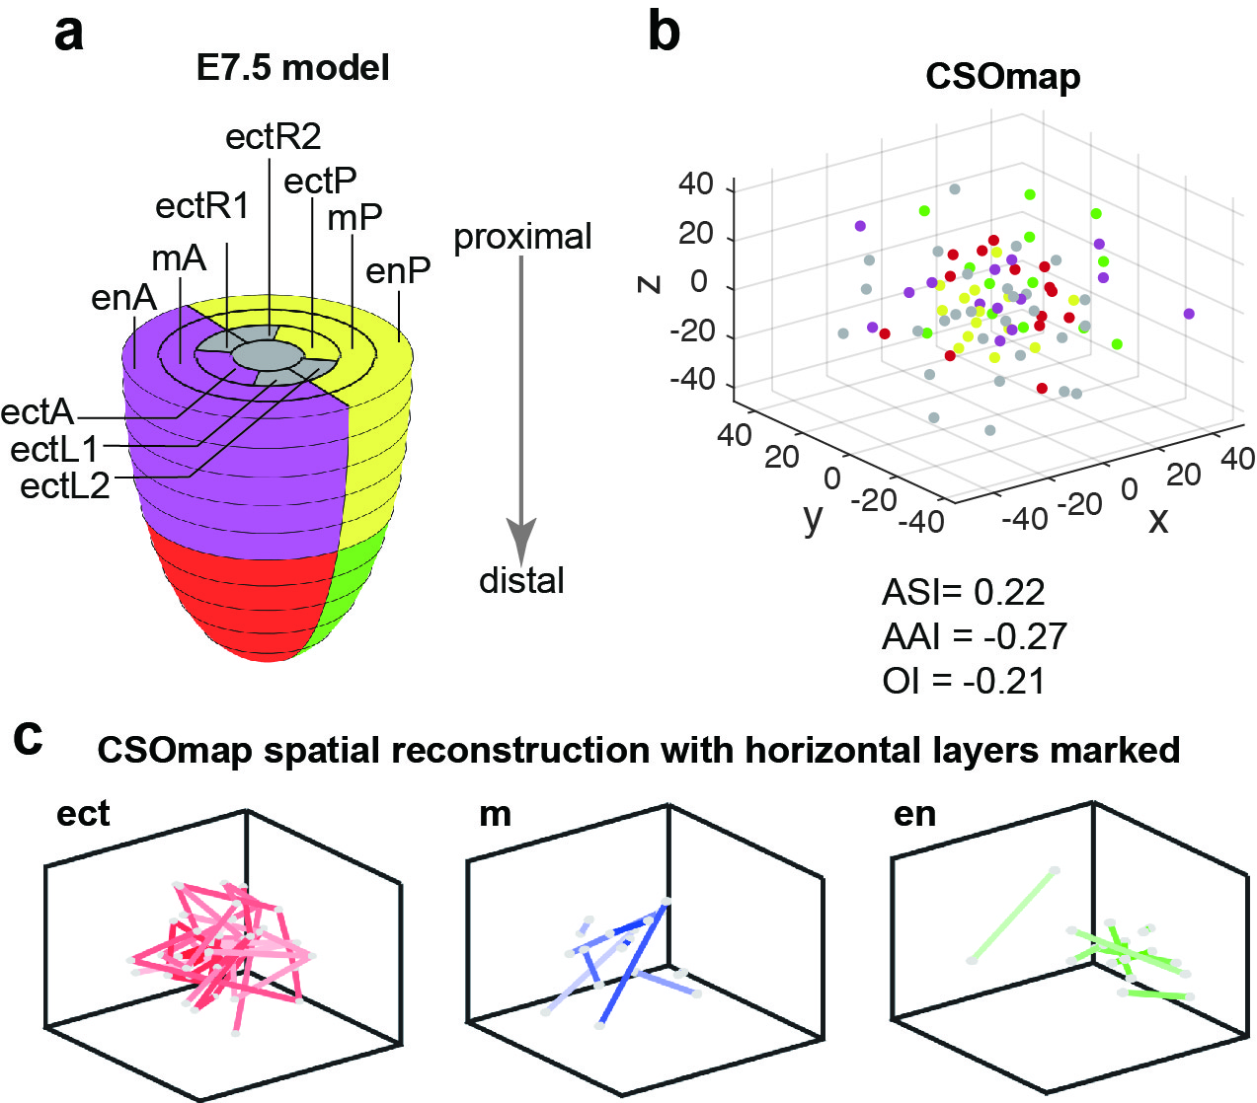
Supplementary Figure 10. Spatial reconstruction of 3D localizations of E7.5 Geo-seq samples with CSOmap. a, The same Illustration of the original locations of Geo-seq samples in E7.5 mouse embryo as in Fig. 3a. b, CSOmap reconstructed 3D localizations of mouse Geo-seq samples from stage E7.5 all samples of all three germ layers. It was reconstructed by following the instructions on the official website of CSOmap, https://codeocean.com/capsule/2860903/tree/v1. Samples’ original positions are color coded as in the model in panel a. AAI, ASI and OI all indicate an obvious failure in reconstruction by CSOmap. c, Same analysis and as in Fig. 3d for E7.5 to visualize order of the horizontal layers based on sample positions reconstructed by CSOmap, which shows that all layers are randomly and completely mixed.

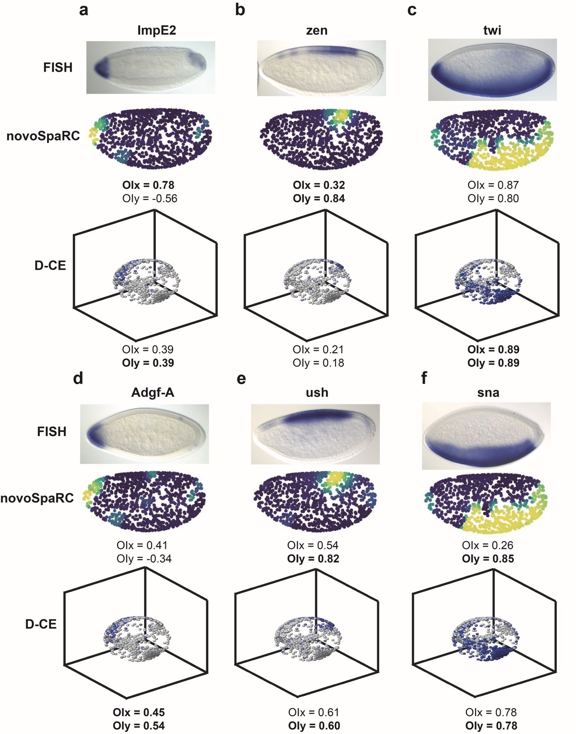

Supplementary Figure 11. Reconstruction of spatial gene expression patterns in Drosophila embryo from an scRNA-seq dataset. a to f, Reconstructed expression of 6 different marker genes, compared to FISH images reproduced from BDGP dataset¹⁸ (top row), second row is the novoSpaRC reconstructed pattern, and the bottom row is D-CE reconstructed pattern. For each index and gene, the best performing values among the 3 methods are highlighted by bold font.

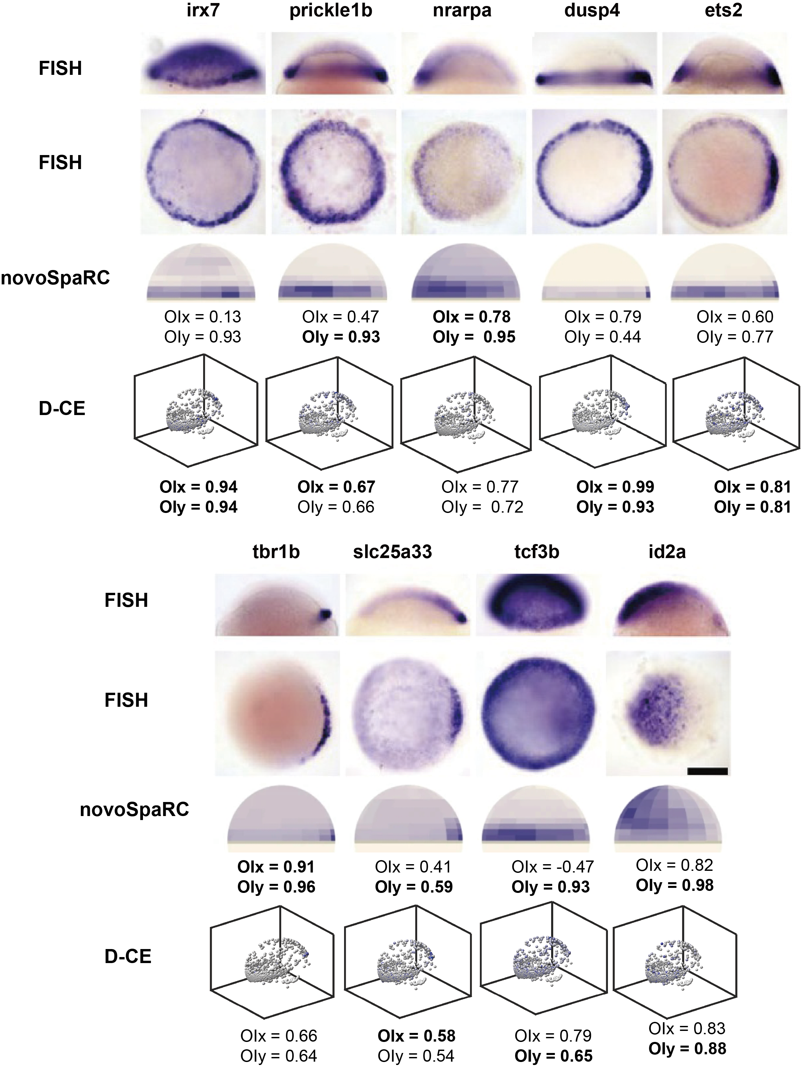

Supplementary Figure 12. Reconstruction of spatial gene expression patterns using zebrafish embryo from an scRNA-seq data. For each gene, the top 2 rows are the FISH images reproduced from ref. 9, the third row is the novoSpaRC reconstructed expression pattern using 15 marker genes reproduced from ref. 11, the bottom row is D-CE reconstructed pattern. For each index and gene, the best performing values among the 3 methods are highlighted by bold font.

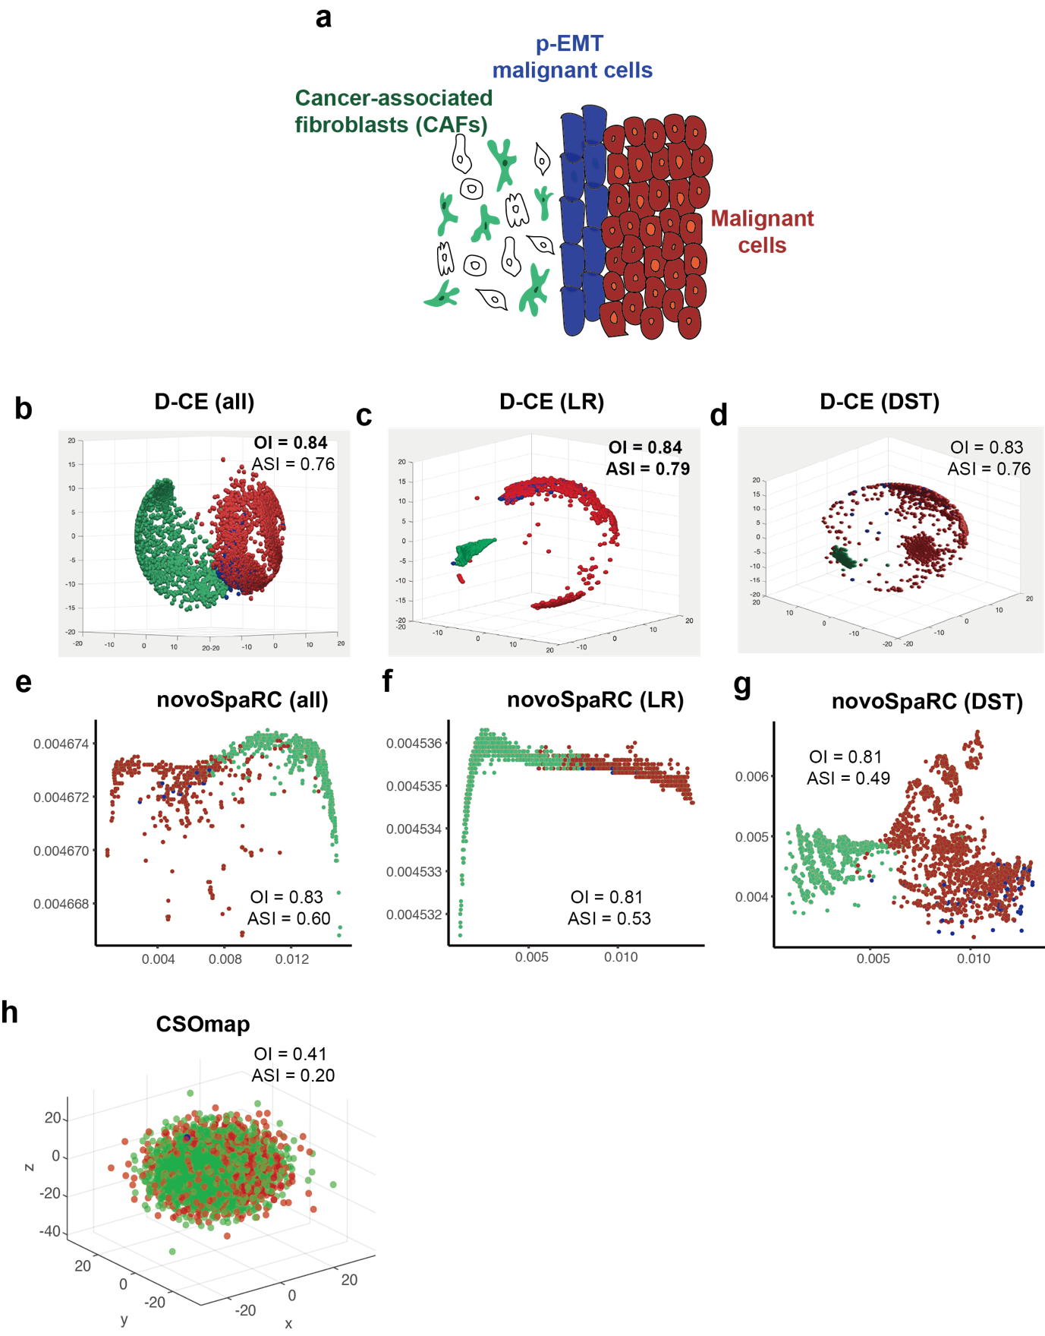
Supplementary Figure 13. Spatial reconstruction of head and neck cancer (HNC) cells by D-CE, novoSpaRC and CSOmap using scRNA-seq data. a. Illustration of spatial distributions observed in immunohistochemical (IHC) staining images of HNC patients with 3 types of cells, cancer-associated fibroblasts, partial epithelial to mesenchymal transition (p-EMT) malignant cells and epithelial malignant cells. b to d, 3D reconstruction of HNC cells by D-CE using all expressed genes (all) (b), ligand and receptor genes (LR) (c) and DST genes (d). For each index, the best performing values among all three methods and three gene lists are highlighted by bold font. e to g, Spatial reconstruction of HNC by novoSpaRC using all expressed genes (e), LR (f) and DST genes (g). novoSpaRC build-in function can only generate 2D grids, so all the novoSpaRC results shown here and below are 2D instead of 3D. h, 3D reconstruction of HNC with CSOmap.

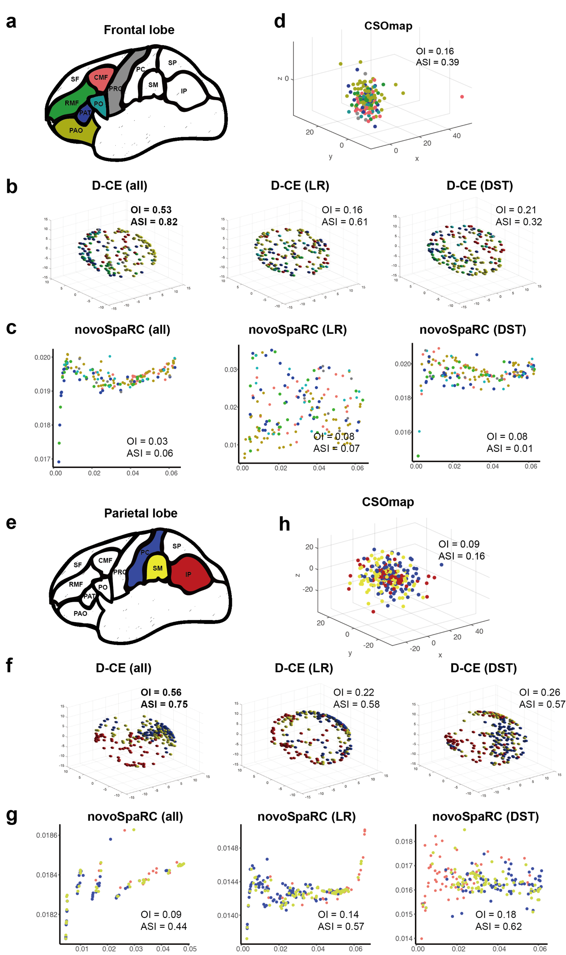
Supplementary Figure 14. Reconstruction of human embryonic cerebral cortex frontal and parietal lobe spatial domains scRNA-seq data by D-CE, novoSpaRC and CSOmap. a, Illustration of spatial domains in frontal lobe. 6 regions (CMF (caudal-middle-frontal), PRC (pre-central), PAO (pars orbitalis), PO (pars opercularis), RMF (rostral-middle-frontal) and PAT (pars triangulars)) were used in the following spatial reconstruction. b, 3D reconstruction of frontal lobe with D-CE use all expressed genes (left), ligand and receptor genes (middle) and DST genes (right). c, Spatial reconstruction of the same data with novoSpaRC use all expressed genes (left), ligand and receptor genes (middle) and DST genes (right). d, 3D reconstruction with CSOmap. e, Illustration of spatial domains in parietal lobe. 3 regions (PC (post-central), SM (supra-maginal) and IP (inferior parietal)) were used in the following spatial reconstruction. f, g and h, The same layout as b, c and d. For each index, the best performing values are highlighted by bold font.

Supplementary Figure 15. Reconstruction of mouse embryo brain ISH image derived gene expression spatial order with D-CE, novoSpaRC and CSOmap. a, illustration of spatial orders of ISH image derived samples (bins) along 3 radial lines across E14.5 mouse cerebral cortex layers. The 3 radial lines were manually placed across mouse cerebral cortex. Each line was than scaled into 20 bins.³¹ b and c, D-CE reconstructed structures using all genes (left), ligand-receptor genes (middle) and DST genes (right) colored by layers (b) and the order of bins (c). d and e, the reconstructed structure of by novoSpaRC with the same dataset b and c. f, CSOmap reconstructed structure colored by layers (up) and order (bottom). The best performing OI value is highlighted by bold font.

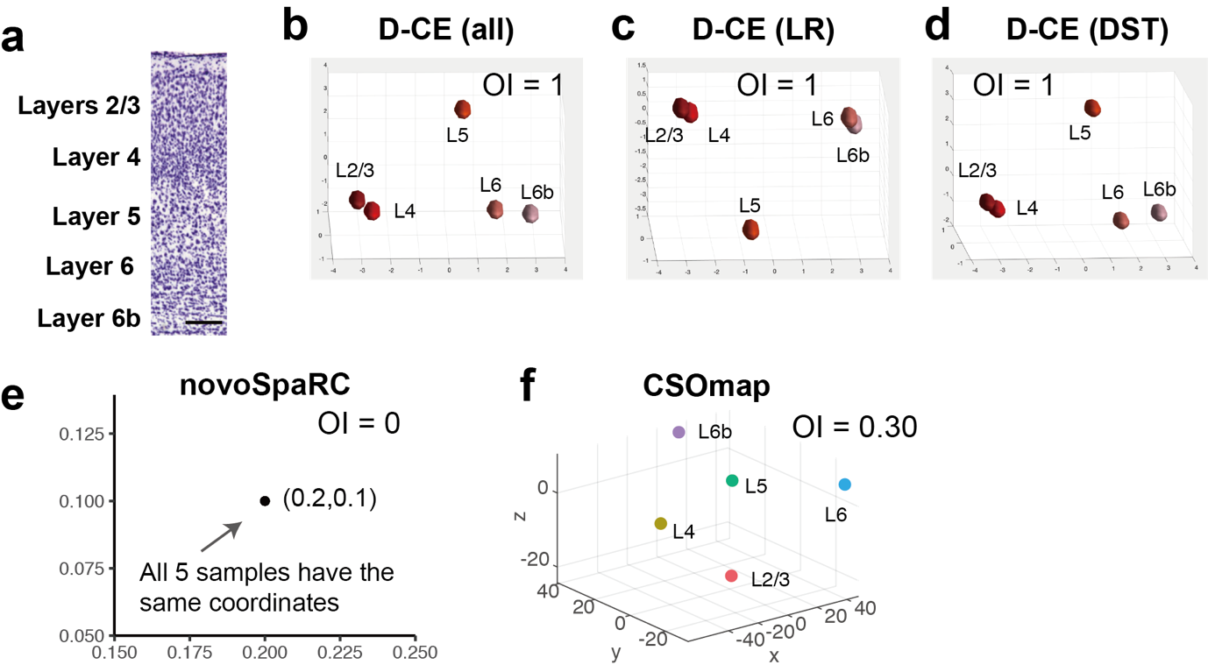
Supplementary Figure 16. Spatial reconstruction of 5 mouse neocortical layers RNA-seq data with D-CE, novoSpaRC and CSOmap. a, Cortex stained by Nissl shows the position of 5 mouse neocortical layers (reproduced from Ref. 32). b, c and d, D-CE reconstructed structure using all genes (left), LR genes (middle) and DST genes (right). e, novoSpaRC reconstructed structure of neocortical layers. f, CSOmap reconstructed structure of neocortical layers.

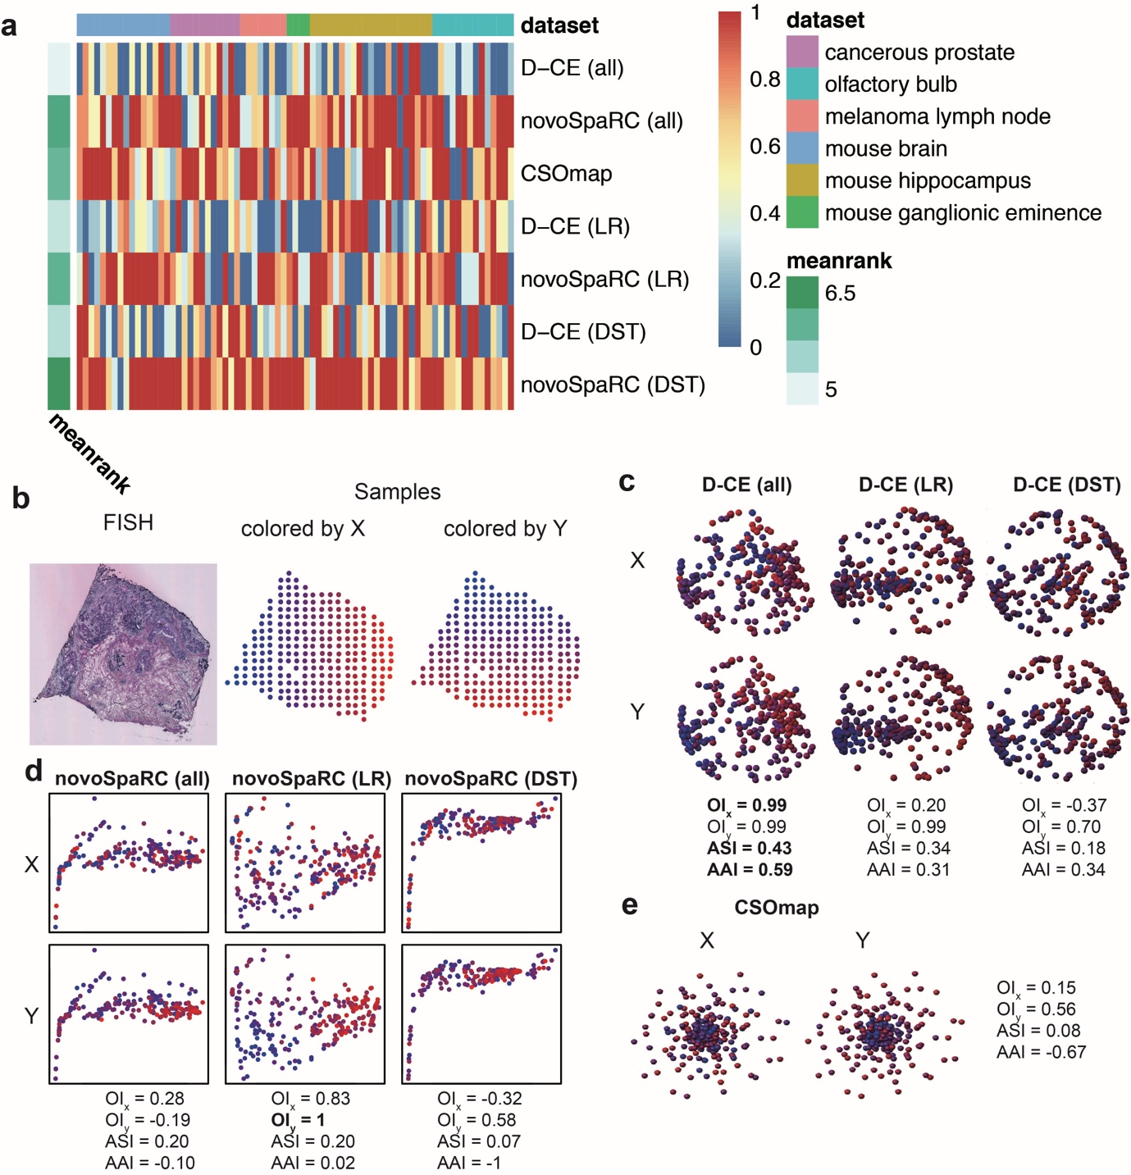
Supplementary Figure 17. Summary of spatial reconstruction of samples or cells using D-CE, novoSpaRC and CSOmap from 6 transcriptome datasets with spatial labels (the mouse olfactory bulb and human breast cancer, the cancerous prostate dataset and the melanoma lymph node barcoded microarray-based spatially resolved transcriptome datasets, a medial ganglionic eminence LCM-seq dataset, and the mouse hippocampus dataset and the mouse brain seqFISH datasets). a, Maximum rank heatmap of the 3 indexes (OI, ASI and AAI) of 75 arrays in different spatial transcriptome datasets (Methods, except the large spinal cord dataset containing 428 sections, which is shown in Supplementary Figure 18). Each column means one slice of spatial transcriptome sample and is scaled to [0-1]. b, Illustration of one example from the cancerous prostate dataset. Each point represents one sample, and the points are colored coded by the gradient along x axis (upper right) and y axis (lower right) from blue to red. c and d, D-CE (d) and novoSpaRC (e) reconstructed structures using all genes (left), LR (middle) and DST genes (right). e, CSOmap reconstructed structure with samples shown in panel b. For each index, the best performing values are highlighted by bold font.

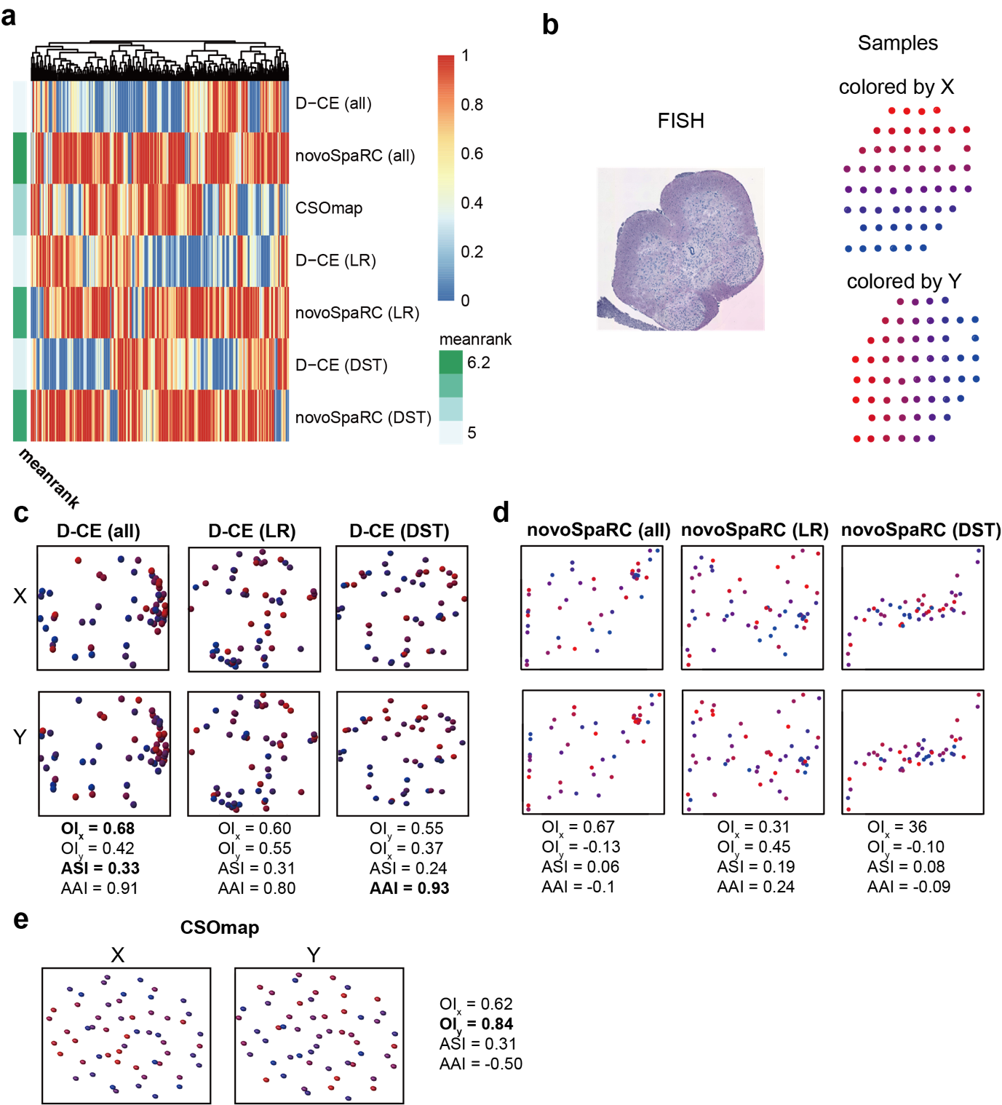
Supplementary Figure 18. Spatial reconstruction of mouse spinal cord samples by D-CE, novoSpaRC and CSOmap using barcoded microarray-based spatially resolved transcriptome data. a, Maximum rank heatmap of the 3 indexes (OI, ASI and AAI) of 428 slices. Each column means one slice of spatial transcriptome and is scaled to [0-1]. b, Illustration of one of the mouse spin cord, each point represents one sample and the points are colored coded by the gradient along x axis (middle) and y axis (right) from blue to red. c, D-CE reconstructed structure with samples shown in panel b. colored according to PC1 (left) and PC2 (right). d and e, novoSpaRC (d) and CSOmap (e) reconstructed structures using all genes (left), LR (middle) and DST genes (right).

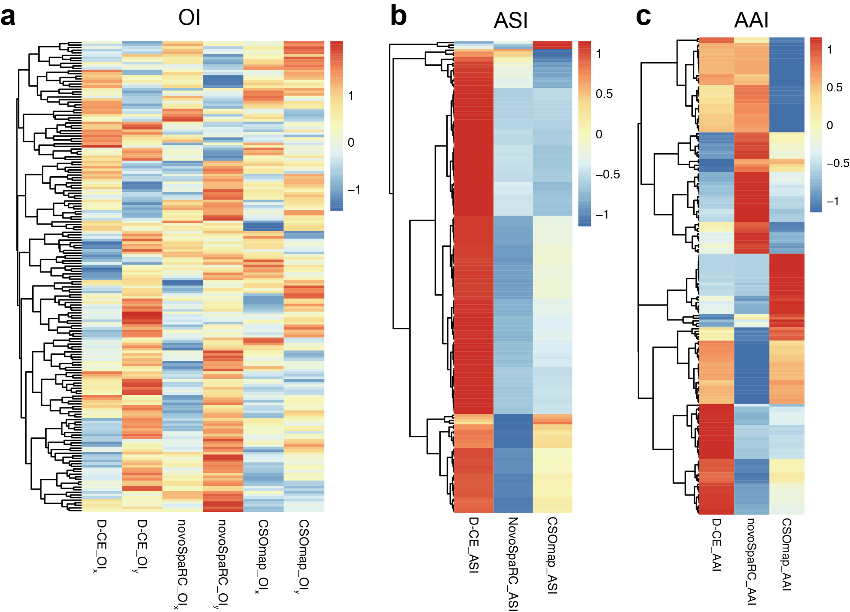
Supplementary Figure 19. Spatial reconstruction of mouse hypothalamic preoptic region with MERFISH (multiplexed error robust fluorescence in situ hybridization) data. a, OI heatmap with each row representing one FISH slices. All 161 genes were used here for D-CE, novoSpaRC and CSOmap. OI_{x} and OI_{y} were calculated same as Figure.4a. b and c, The same layout of ASI and AAI heatmap.

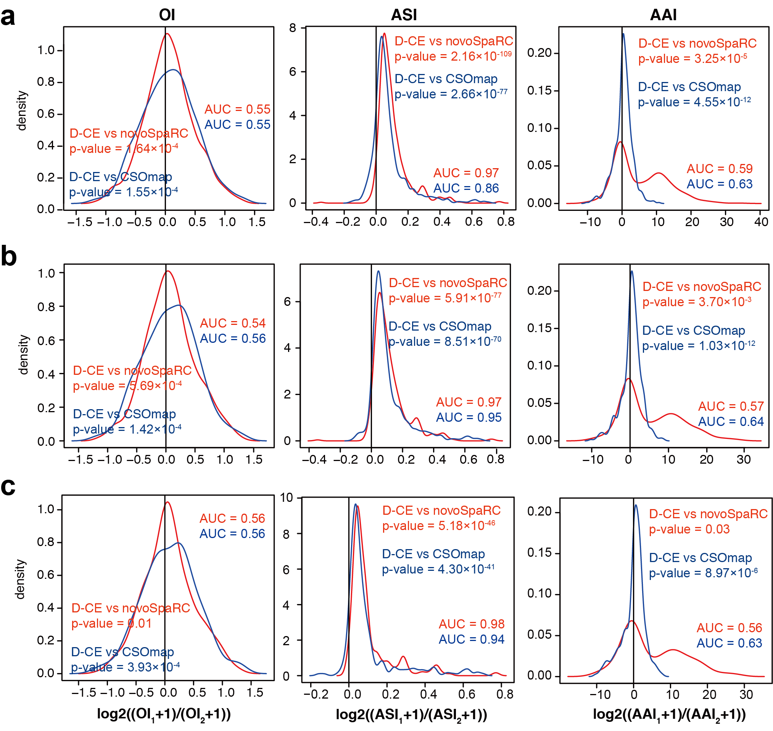
Supplementary Figure 20. Pairwise comparisons of all 681 reconstructions from 16 datasets with no filter (a) and filtered with ASI p-value < 0.05 (b). CSOmap is only applicable to 14 datasets and 679 reconstructions due to its limit to human and mouse data and LR genes only. c, Pairwise comparisons of 13 datasets (without mouse spinal cord datasets, because this datasets have 407 reconstructions). Layouts and annotations are the same as in Figure. 5.

Supplementary Table 1. 12 normalization methods evaluated for spatial reconstruction
Method | Description
None | without normalization
DRS | dividing by the sum within rows (cells)
DCS | dividing by the sum within columns (genes)
LOG | logarithm with base 10 of each matrix element plus 1
ZSCORE | ZSCORE within columns
ZSCORET | ZSCORE within rows
QUANTILE | quantile normalization within columns
QUANTILE T | quantile normalization within rows
SQRT | square root of each element of the matrix
MANORM | dividing by the column mean
PARETO SCALING | each column is centered to have mean of 0 by subtracting the column mean from each value in the column
PLUS(ABS(MIN)) | adding to each matrix’s element the minimum value in the matrix, in absolute value.

