Supplement to Zapata et al.: « Combining business model innovation and system dynamics under deep uncertainty of low-carbon transitions – a case study on industrial electrification and power grid management» - Extended methods

S1. Definition of use cases for flexible electrification technologies
For all use cases, the payback period [years] is calculated by dividing the investment cost [€] by the annual cash flow [€/year], i.e. the sum of costs and revenues from the flexibility technology. The investment costs for the three technologies are given in Table 2 of the main document. In addition, customers subscribing to the Power Alliance offer pay the installation costs of the smart control system $P_{inv,smart}$, set to a default value of €300.
In all cases, the annual costs are the sum of operational expenditures (assumed to be 2% of investment costs annually) and the per-capacity grid tariff $P_{grid,cap}$, which is defined as follows:
$P_{grid,cap}=C×P_{grid,ST}×f_{PAT}$, (S1)
where $C$ is the capacity of the flexibility installation (set to 500 kW for all three technologies, see Table 2 in the main document), $P_{grid,ST}$ the standard per-capacity grid tariff (set to a default value of 70 €/kW) and $f_{PAT}$ [-] the fraction of grid tariff paid by the users subscribing to the Power Alliance offer. For customers that are not subscribing to this offer, $f_{PAT}$ equals 1, whereas for the Power Alliance customers, $f_{PAT}$ is set to a default value of 0.1.
  - Power-to-Heat (PtH)
The PtH use case considers a system with a time-invariant investment cost of € 50’000, used to replace a gas boiler for the paper industry. The yearly revenues of this investment are given by $F_{saved}$, the amount of money saved in comparison to the reference case, i.e. if the customer covered 100% of their heat demand with the gas boiler:
$F_{saved, PtH}=F_{boiler}-F_{PtH}$, (S2)
where $F_{PtH}$ is the cost of producing heat with the PtH system, and $F_{boiler}$ is the cost to produce the same amount of heat as with the gas boiler. The amount of heat replaced by the PtH system ($E_{PtH}$ [kWh/year]) depends on its installed capacity $C$ [kW] (see Table 2 of the main document), running time $H_{running}$ (default value 6’000 hours/year) and efficiency $η_{PtH}$ (default value 97%):
$E_{PtH}=\frac{C×H_{running}}{η_{PtH}}$. (S3)
The cost for producing this energy with the PtH system further depends on the electricity price effectively paid by the customer, $P_{el, eff}$ [€/kWh]:
$F_{PtH}=E_{PtH}×P_{el,eff}$. (S4)
The effective electricity price corresponds to the wholesale electricity price (see Sect. S3 below), minus the fraction of electricity consumption coming from own renewable sources, which is assumed to come at no cost. The cost for producing the same amount of energy with the gas boiler is given by:
$F_{boiler}=\frac{E_{PtH}}{η_{boiler}}×P_{gas}$, (S5)
where $η_{boiler}$ is the boiler efficiency (set to 95%) and $P_{gas}$ is the price of gas [€/kWh] (see Sect. 3.2.1 of the main document).
  - Power-to-Hydrogen (PtH₂)
In the PtH₂ case, the yearly revenues are calculated in a similar way as for PtH. Here, the reference case is to buy hydrogen obtained via steam-methane reforming (SMR). The money sums $F_{saved, PtH2}$, $F_{SMR}$ and $F_{PtH2}$ are analogous to the terms in Eqs. S2, S4 and S5. The amount of hydrogen produced annually with the PtH2 system ($V_{P2H2}$ [kg/year]) is a function of its installed capacity $C$ [kW] (see Table 2 of the main document), running time $H_{running}$ (default value 6’000 hours/year) and efficiency $η_{PtH2}$ (default value 55 kWh/kg):
$V_{PtH2}=\frac{C×H_{running}}{η_{PtH2}}$. (S6)
The cost for producing this amount of hydrogen with the PtH2 system further depends on the electricity price $P_{el,eff}$ [€/kWh] (same definition as in the PtH case above):
$F_{PtH2}=V_{PtH2}×η_{PtH2}×P_{el,eff}$. (S7)
The cost for producing the same amount of hydrogen with SMR is given by:
$F_{boiler}=V_{PtH2}×P_{gas}×v_{gas,SMR}$, (S8)
where $P_{gas}$ is the price of gas [€/kWh] (see Sect. 3.2.1 of the main document) and $v_{gas,SMR}$ is the amount of gas needed to produce 1 kg of hydrogen with SMR (set to 40 kWh/kg).
  - Batteries
For batteries, the selected use case is arbitrage, i.e. taking advantage of price variability by buying and selling electricity at different times. Additionally, customers save money due to increased self-consumption. The daily revenues from arbitrage, $F_{arb,day}$, are defined as:
$F_{arb,day}=\left(P_{el,max}-\left(P_{el,min}×\left(1-f_{renew}\right)\right)\right)×η_{batt}×C×T_{dis}×n_{cycles}$, (S9)
where $P_{el,min}$ and $P_{el,max}$ are minimum and maximum energy prices [€/kWh], $f_{renew}$ the fraction of electricity consumption from own renewable generation [-], $η_{batt}$ battery efficiency (set to a default value of 70%), $C$ installed battery capacity (set to 500 kW), $T_{dis}$ discharge time (set to 1 hour), and $n_{cycles}$ the number of charge and discharge cycles per day (set to 1.5). Minimum and maximum electricity prices are obtained by subtracting and adding the parameters $d_{Pel,min}$ and $d_{Pel,max}$, respectively, from average electricity price $P_{el}$. The default value for $d_{Pel,min}$ and $d_{Pel,max}$ was set to 0.04 and 0.07 €/kWh, respectively. No intra-annual variations of daily minimum and maximum prices are considered, i.e. the annual revenues from arbitrage, $F_{arb}$, are obtained by multiplying $F_{arb,day}$ by 365.
The savings due to increased self-consumption, $F_{saved, batt}$, are calculated as follows:
$F_{saved, batt}=E_{saved,batt}×\left(P_{el}-P_{FIT}\right)$, (S10)
where $E_{saved,batt}$ is the amount of energy from own renewable generation saved due to the batteries (i.e. the amount that would otherwise be fed into the grid and purchased from the grid at a different time) [kWh/year], $P_{el}$ is total electricity price [€/kWh] and $P_{FIT}$ is the feed-in tariff for renewable electricity [€/kWh]. The amount of energy saved is calculated as follows:
$E_{saved,batt}=C×f_{PV,batt}×e_{PV}×f_{batt,SC}$, (S11)
where $C$ is installed battery capacity (set to 500 kW), $f_{PV,batt}$ the ratio of installed PV capacity to battery capacity (set to 1.2 kW per kWh of storage in battery, according to minimal requirements for subsidies in Germany; assuming a discharge time of 1h, the storage capacity of the battery is set to 500 kWh), $e_{PV}$ the annual electricity production (set to 1’000 kWh per kW of installed capacity), and $f_{batt,SC}$ the fraction of PV generation that is additionally used in self-consumption due to batteries, arbitrarily set to 0.3.

S2. Utility functions in the system dynamic model
Figure S1: a) Shape of the preference function for different values of β. The x-axis represents the utility of an option B relative to the utility of an option A, and the y-axis shows the fraction of people that choose option A. b) to d) Empirical functions representing the effects of perceived payback time (b), capital cost (c) and scarcity (d). The dots on b) and c) show the data points used to fit the functions.
The perceived utility $u_{x}$ of a decision option depends both on financial and social aspects. It is calculated as follows:
$u_{x}=f_{payback_time}×f_{capital}×f_{familiarity}×f_{scarcity}$, (S12)
where all variables are dimensionless. The empirical functions used to estimate $f_{payback_time}$, $f_{capital}$ and $f_{scarcity}$ are shown on Fig. S1 b, c and d, respectively. The functions for the effect of payback time and capital cost were parameterized based on data reported by Ebers & Wüstenhagen (2015) for homeowners and adjusted by Kubli (2018) to reflect the behavior of industrial customers. The effect of payback time is defined as:
$f_{payback_time}={0.9064}^{T_{p,p}}$, (S13)
where $T_{p,p}$ is the perceived payback period [years]. For the effect of capital cost, the function is defined as:
$f_{capital}= 1.16536-0.14579×ln\left(P_{capital}\right)$, (S14)
where $P_{capital}$ is the investment cost of a project. The scarcity function was adopted from Kubli and Ulli-Beer (2016). The capital costs are prescribed, static and technology-specific, whereas payback time, scarcity and familiarity are time-dependent. The calculation of perceived payback time is summarized in the next section.
The scarcity effect is relevant only for the Power Alliance tariff PAT. Indeed, as mentioned in Section 3.2.1 (main document), this business model presupposes that it is possible to use a higher fraction than 50% of the transmission capacity of power lines. The additional capacity sets an upper limit to the number of customers who can subscribe to the PAT, making it less likely for a customer to choose this option if there are already many customers with PAT. As shown on Fig. S1 d, the scarcity effect is small unless the potential for PAT customers is nearly fulfilled.

S3. Scenario definition
In the simulation model, the electricity price $P_{el}$ [€/kWh] paid by the customers is the sum of energy price, a surcharge to finance the development of renewable energy as per the German Renewable Energy Sources Act (EEG), a surcharge to subsidize the operation of combined heat and power (CHP) plants, an electricity tax, a concession levy, and the volumetric grid tariff (customers also pay a per-capacity grid tariff, which is not included in $P_{el}$ – see Sect. 3.1.2 of the main document for more information). Only the energy price and EEG surcharge vary temporally, whereas the other price components are assumed to remain constant, amounting to 4.18 €c/kWh in the BAU scenario and 3.74 €c/kWh under the climate policy scenario. This difference is due to the assumption that in a policy setting promoting electrification, all industrial customers are paying the preferential CHP surcharge tariff currently applicable to the energy intensive industry sectors. The breakdown is given in Table S1:
Table S1: Breakdown of the time-invariant components of electricity price in the BAU and CP scenarios.
Price component | Price under BAU scenario [€c/kWh] | Price under CP scenario [€c/kWh] | Reference
Electricity tax | 1.54 | 1.54 | (Fraunhofer ISI & Ecofys, 2015)
CHP surcharge | 0.438 | 0.03 | (Fraunhofer ISI & Ecofys, 2015)
Volumetric grid tariff | 2.06 | 2.06 | (DIHK, 2017)
Concession levy | 0.11 | 0.11 | (DIHK, 2017)
Total | 4.18 | 3.74

The renewable energy surcharge, hereafter referred to as $P_{EEG}$, differs between the two scenarios. The BAU scenario follows the path given by Prognos/EWI/GWS (2014), p. 227. In this forecast, $P_{EEG}$ gradually decreases to reach 0.8 €c/kWh by 2050. The CP scenario assumes that the EEG surcharge is substantially decreased and mostly replaced by a carbon tax to reduce the tax load of electricity compared to fossil fuels. Concretely, in this scenario, $P_{EEG}$ is reduced quickly at the beginning of the simulation, from the 2016 value of 6.35 €c/kWh to a minimum value of 0.05 €c/kWh by 2020. This value, corresponding to the EEG surcharge currently applied for electricity-intensive industry, is then kept throughout the simulation.
These assumptions lead to a difference in electricity price of more than 7 €c/kWh in 2020 (Fig. S2). Over the rest of the simulation period, this gap gradually diminishes as the EEG surcharge is phased out in the BAU scenario.
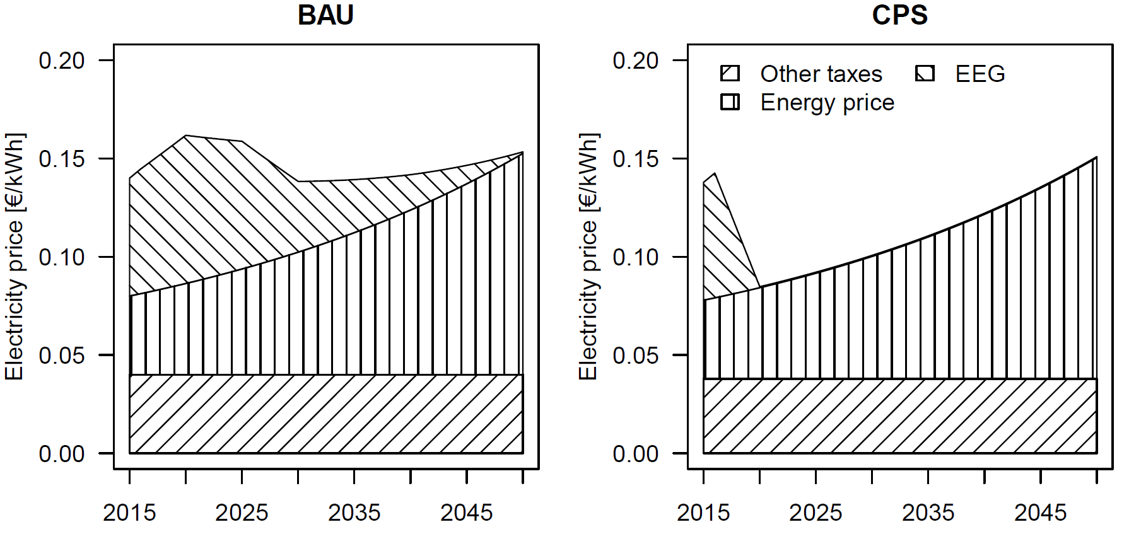
Figure S2: Development of the wholesale electricity price in the two scenarios. In both cases, an energy price increase of 3% per year is assumed. The CP scenario differs from the BAU scenario through an almost complete elimination of the EEG surcharge, as well as a slightly lower value for the time-invariant price components.
The wholesale cost of natural gas, $P_{gas}$, also depends on the scenario. Under the BAU scenario, $P_{gas}$ is simply the market price of natural gas, calculated as described in the main text (Section 3.2.1). Under the CP scenario, the carbon price $P_{CO2}$ is added to the market price (set to a default value of 0.01 €/kWh, i.e. 45 €/tCO₂).

