Supplement
Plants specifically modulate the microbiome of root-lesion nematodes in the rhizosphere, affecting their fitness
Ahmed Elhady^{1, 2 *}, Olivera Topalović¹, Holger Heuer¹
¹ Institute for Epidemiology and Pathogen Diagnostics, Julius Kühn Institute (JKI) – Federal Research Centre for Cultivated Plants, Braunschweig, Germany
² Department of Plant Protection, Faculty of Agriculture, Benha University, Benha, Egypt
* Correspondence:
Dr. Ahmed Elhady
ahmed.gomaa@julius-kuehn.de

Table S1. Percent dissimilarity of bacterial or fungal communities attached to the cuticle of Pratylenchus penetrans that were incubated in soil suspensions from different rhizospheres or bulk soil, or non-attached microbial communities in the respective soil suspension.
ª d-value: average of pairwise Pearson correlation coefficients among DGGE fingerprints within each group minus average of pairwise Pearson correlation coefficients among DGGE fingerprints of different groups.
Sources of soil suspensions of the pairwise comparisons of bacterial or fungal DGGE fingerprints |  | Dissimilarity [%]ª
 |  | Bacteria |  | Fungi
 |  | Soil | Attached to cuticle | Soil | Attached to cuticle
Experiment (1) | Bulk soil vs. maize rhizosphere | 37 | 23 | 58 | 62
 | Bulk soil vs. tomato rhizosphere | 64 | 35 | 35 | 88
 | Bulk soil vs. soybean rhizosphere | 30 | 40 | 49 | 65
 | Maize vs. tomato rhizosphere | 65 | 43 | 31 | 87
 | Maize vs. soybean rhizosphere | 14 | 51 | 61 | 43
 | Soybean vs. tomato rhizosphere | 51 | 68 | 30 | 57
Experiment (2) | Bulk soil vs. maize rhizosphere | 32 | 34 | 33 | 14
 | Bulk soil vs. oat rhizosphere | 29 | 31 | 44 | 28
 | Bulk soil vs. Ethiopian mustard rhizosphere | 31 | 12 | 18 | 10
 | Maize vs. oat rhizosphere | 12 | 29 | 28 | 29
 | Maize vs. Ethiopian mustard rhizosphere | 26 | 36 | 27 | 17
 | Oat vs. Ethiopian mustard rhizosphere | 25 | 22 | 35 | 3

Table S2. Identification and frequency of fungal and bacterial species associated with Pratylenchus penetrans after baiting in suspensions of bulk soil or different rhizosphere soils.
Band |  | Closest Genbank match | GenBank accession no. (% identity) | Specificity of band
 |  |  |  | Bulk soil | Maize rhizo-sphere | Soybean rhizo-sphere | Tomato rhizo-sphere | In-oculum
Fungal DGGE | 1 | Malassezia restricta | CP030254.1 (99%) |  | X | X | X
 | 2 | Penicillium corylophilum | MF475910.1 (99%) |  | X | X
 | 3 | Penicillium digitatum | MH864871.1 (99%) | X
 | 4 | Acremonium psychrophilum | MH862386.1 (96%) | X
 | 5 | Simplicillium sympodiophorum | KY434158.1 (99%) | X
 | 6 | Malassezia globosa | KM269155.1 (99%) | X | X
 | 7 | Myrothecium verrucaria | FJ235085.1 (99%) |  | X
 | 8 | Penicillium allii | AF218787.1 (99%) |  |  |  | X
 |  | Penicillium gladioli | MH856256.1 (99%)
 |  | Penicillium hordei | MH859204.1 (100%)
 | 9 | Scoliciosporum umbrinum | KX133008.1 (99%) | X
 | 10 | Aspergillus tonophilus | MH858639.1 (100%) |  | X
 | 11 | Cladosporium tenuissimum | MG569541.1 (99%) | X | X | X | X | X
 | 12 | Cladosporium cladosporioides | MH790419.1(100%) |  |  | X | X
 |  | Cladosporium allicinum | KY420929.1 (99%)
 | 13 | Sporidiobolus pararoseus | KY105483.1 (100%) |  |  |  | X
 | 14 | Cutaneotrichosporon curvatus | KY102995.1 (100%) |  |  |  | X
Bacterial DGGE | 1 | Paraburkholderia dipogonis | NR_145902.1 (100%) |  |  | X
 | 2 | Cutibacterium acnes | NR_040847.1 (99%) | X | X | X | X | X
 | 3 | Pseudomonas guariconensis | NR_135703.1 (99%) |  | X |  | X
 | 4 | Pseudomonas putida | NR_114794.1 (99%) |  |  | X | X
 | 5 | Pantoea stewartii | NR_104928.1 (95%) |  | X | X
 | 6 | Bradyrhizobium embrapense | NR_145861.1 (95%) | X | X | X | X
 | 7 | Streptococcus thermophilus | NR_042778.1 (99%) | X
 | 8 | Pseudomonas synxantha | NR_113583.1 (100%) | X | X | X | X
 | 9 | Streptococcus rubneri | NR_109720.1 (99%) |  |  |  | X
 | 10 | Enterobacter xiangfangensis | NR_126208.1 (99%) | X |  |  | X
 | 11 | Granulicatella adiacens Acinetobacter lwoffii | NR_025862.1 (99%) NR_113346.1 (99%) | X |  |  | X
 | 12 | Streptococcus himalayensis | NR_156072.1 (99%) | X | X | X | X
 | 13 | Moraxella nonliquefaciens | NR_104938.1 (99%) |  |  |  | X
 | 14 | Haemophilus sputorum  Veillonella tobetsuensis | NR_118143.1 (99%) NR_113570.1 (93%) | X | X | X
 | 15 | Streptococcus mitis  Streptococcus salivarius | NR_116207.1 (99%) NR_042776.1 (100%) | X | X | X

Figure S1. DGGE profiles of fungal ITS fragments amplified from DNA of bulk soil and rhizospheres of maize, soybean and tomato plants grown in the same soil. Letters A, B, C, and D represent biological replicates of each treatment.

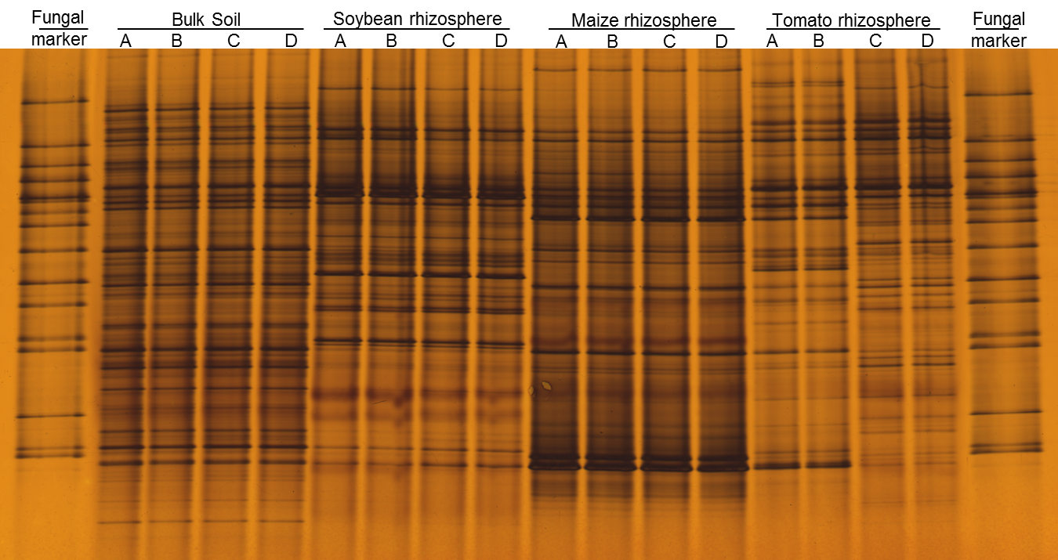

Figure S2. DGGE profiles of bacterial 16S rRNA fragment fragments amplified from DNA of bulk soil and rhizospheres of maize, soybean and tomato plants grown in the same soil. Letters A, B, C, and D represent biological replicates of each treatment.

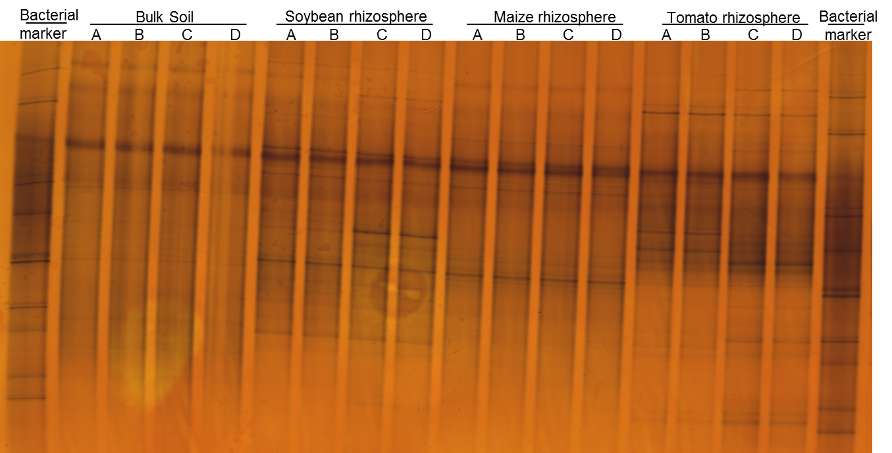
Figure S3. Box-PCR fingerprint of bacterial strains isolated from Pratylenchus penetrans cuticle after incubation in bulk soil or the rhizosphere soils of maize, tomato, or soybean.
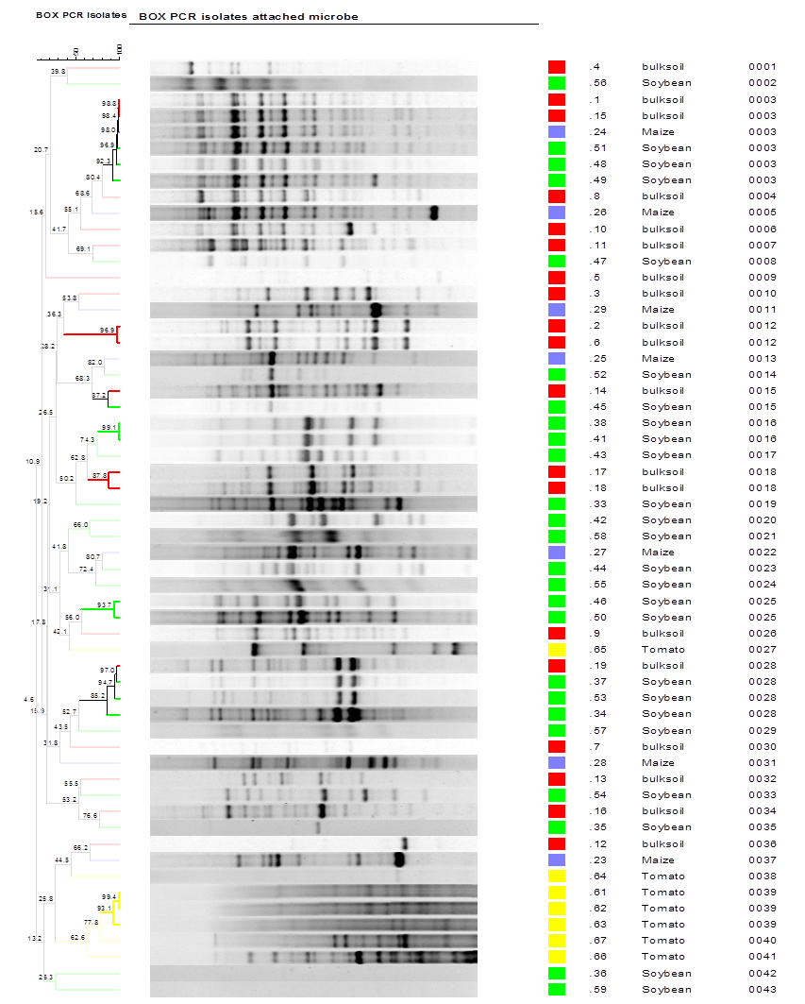

Figure S4. Effect of pre-incubation of Pratylenchus penetrans in root exudates of soybean, maize, or tomato on the bacterial community attached to the cuticle. Contr.: control DNA from surface disinfected nematodes that served as inoculum.

Figure S5. Effect of pre-incubation of Pratylenchus penetrans in root exudates of soybean, maize, or tomato on the fungal community attached to the cuticle. NAA: 1 µM α-naphthalene acetic acid (auxin). Contr.: control DNA from surface disinfected nematodes that served as inoculum.
