**Supplementary Information**

**How one pandemic led to another: was African swine fever virus (ASFV) the disruption contributing to severe acute respiratory syndrome coronavirus 2 (SARS‑CoV‑2) emergence?**

Wei Xia1, Joseph Hughes2, David L. Robertson2, Xiaowei Jiang3*

1National School of Agricultural Institution and Development, South China Agricultural University, Guangzhou, China.

2MRC-University of Glasgow Centre for Virus Research (CVR), Glasgow, UK.

3Department of Biological Sciences, Xi'an Jiaotong-Liverpool University (XJTLU), Suzhou, China.

*Corresponding author: Xiaowei.Jiang@xjtlu.edu.cn

### Supplementary Notes

**The importance of pork supply and pork price for China**

In economics, meat consumption tends to increase in response to rising per capita income for a country, especially in developing countries (Figure S1). This process is referred to as the ‘livestock revolution’1. China follows the same trend2,3. Demand for meat and meat products continues to increase especially over the last three decades (Figure S2). China has become the world largest pork consumer. Although the per capita meat consumption in China is still much lower than most developed countries, it continues to increase from year to year4. OECD predicts that annual per capita consumption will reach 51.5 kg per capita in 2025 (Figure S2). Assuming that the Chinese population size is still 1.3 billion in 2025, the meat demand will be ~70 million tons annually. China is unique in terms of scale and speed of change3. The ‘livestock revolution’ in China has profound global impacts far beyond its own borders, such as agricultural production, international trade, and zoonotic pathogen spillovers5,6, including coronavirus transmission from susceptible bat speceis7.

Pork is the most important meat in the Chinese diet with a three thousand year history, accounting for 50-70% meat intake2,8. An average Chinese consumer consumes ~30 kg per year, compared with American consumers at ~24 kg and UK consumers at 16 kg (Figure S3). Importantly, in the Chinese economy pork price is found to be strongly linked to the national Consumer Price Index (CPI)9. Maintaining a relatively stable pork price is critically important for macroeconomic stabilization and social harmonization. The pork market in China has been closely monitored and regulated10. Ensuring sustainable pork supply at affordable prices has been one of the top priorities for the Chinese government, especially in important holiday seasons11. Consequently, the Chinese government has made great efforts to contain ASFV spread and stabilize the pork market11,12.

**Pig industry prior to ASFV outbreak in August 2018**

Besides pig cycle effects, China’s pig market is much more complicated than the theoretical fluctuations, which has been influenced by various factors, including disease epidemics, production costs, policy interventions, seasonal consumption patterns, and macroeconomic policies13. Prior to 2019, China had experienced a lasting decline in pork production since 2014, with ~4 million Metric tons reduction from 2014 to 2018 (Figure S4).

Such reduction is thought to be highly correlated with China’s national development plan regarding environmental regulations and agricultural restructuring and upgrading14. The new ‘Environment Protection Law’ approved in 2014 came into force in 2015. Livestock production was fully banned in the protected regions, mostly in the southern provinces3. Moreover, ‘the 13th Five Year Plan for National Pig Production (2016-2020)’ by MARA designed a precise action plan with radical changes in the traditional geographic distribution of pig production15. Pig production will be shifted from provinces along the waterways in the south and dense population urban areas. Meanwhile, the southwest and northeast provinces are designed as new pig production centers to realize environmental protection and integration of farming and breeding for livestock production. Further in 2017, The ‘Action Plan for Recycling of Resources from Livestock Production’ was enacted by MARA to accelerate the progress. Numerous middle and small pig farms had been closed in the southern provinces. In 2017, 0.26 million farms had been closed3. Large-scaled agricultural enterprises in the south were compensated and subsidized to relocate their new standardized pig farms in the northeast and southwest provinces16.

In the past, the southern provinces used to be both producers and consumers. This dramatic shift of pig supply from the south to the north prior to 2019 may have exacerbate the uneven distribution of pork production between south and north16, and worsened the pork shortage in the south that was affected by large-scale ASFV outbreaks in 2019.

**Mitigating pork shortage**

China was facing significant pork shortage in late 2019. To tackle the pork crisis by ASFV, Chinese government took a multitude of measures to restore pig production in 201917. Minimum pig production scales for each province were assigned. Large-scale standardized pig production and cold chain transportation of pork meats are strongly state supported. On 10 September 2019, the central government released a notification that the overall share of large-scale pig farms should exceed 85% by 2022. Additionally, piglets and chilled pork were officially permitted to enjoy Green Channel policy, and breeding pigs and frozen pork had been waived from freeway toll fees prior to 30 June 2020 nationwide11. Most local governments responded to the administrative orders promptly. For instance, a notification on 16th October 2019 by the Wuhan government provided aggressive support of securing pig production and supply. Two million Yuan subsidy per every 10,000 increases in slaughtered heads at-one-go for upgrading pig farms to the ‘modern, close-end, recycling and pollution-free’ environmental, 0.6 million Yuan at-one-go for biosecurity requirements and 3 million Yuan awards per every 10,000 pig heads at-one-go for those slaughtered scale over 20,000 pig heads prior to 202118. Most other provinces adopted similar radical stimulation measures. Such high fiscal subsidies and support policies for expanding pig herds tend to inspire excessive reproductive movements of sow and piglets nationwide. During the ASFV epidemic, even with government support to farm more pigs, pig growth cycle played a role in limiting domestic supply by the end of 2019 and the pig inventory size dropped by 118 million pig herds from 2018 to 2019, prior to the COVID-19 outbreak in Wuhan, December 2019 (Figure S5).

China also imported notable meats and aquatic products from the global market throughout the year of 2019, particularly chilled and frozen meat, to mitigate the pork shortage, accounting for 5% of domestic pork demand (Figure S6). For the first three quarters, China imported 1.3 million Mt pork. In the past, China has been self-sufficient and imported pork only accounts for approximately 1% of its overall pork consumption.

### Supplementary Figures



**Figure S1**. Meat consumption and GDP per capita, 2019. It shows the dynamics of meat consumption per capita for most OECD countries. Generally, per capita meat consumption increases with GDP per capita increase. Four major emerging economies, Brazil, Russian Federation, China and South Africa consumed higher meat volume than the world average. Average Chinese consumes 46 kilograms of meat annually.

Data source: Annual meat consumption data in 2019 is from OECD database; GDP per capita values expressed in gross domestic product (GDP) at current international dollars adjusted by purchasing power parity (PPP) conversion factor is from World Bank Database19. Note: Meat consumption data only include beef, pork, poultry, and sheep meat in the OECD database, not including fish and seafoods.

**Figure S2**. Dynamics of China’s meat consumption per capita in 1990-2025. The latest year of available data were 2019 and the data afterwards 2020-2029 are predicted by the Organisation for Economic Co-operation and Development (OECD). Three solid red arrows indicate the trend of continual increases of annual meat and pork consumption per capita in China. The dotted lines are projected trends in the next five years. Both pork and meat consumption decreased in the year 2019.

Data source OECD database, <https://data.oecd.org/agroutput/meat-consumption.htm>.

**Figure S3**. Comparison of meat consumption per capita for four major meats, 2019. The meat in the OECD database refers to pork, poultry, beef and veal and sheep, which are measured in kilograms of retail weight per capita. Per capita pork consumption volume and relative share out of four meats in China are both much higher than the other countries shown.

Data source: OECD database, https://data.oecd.org/agroutput/meat-consumption.htm.

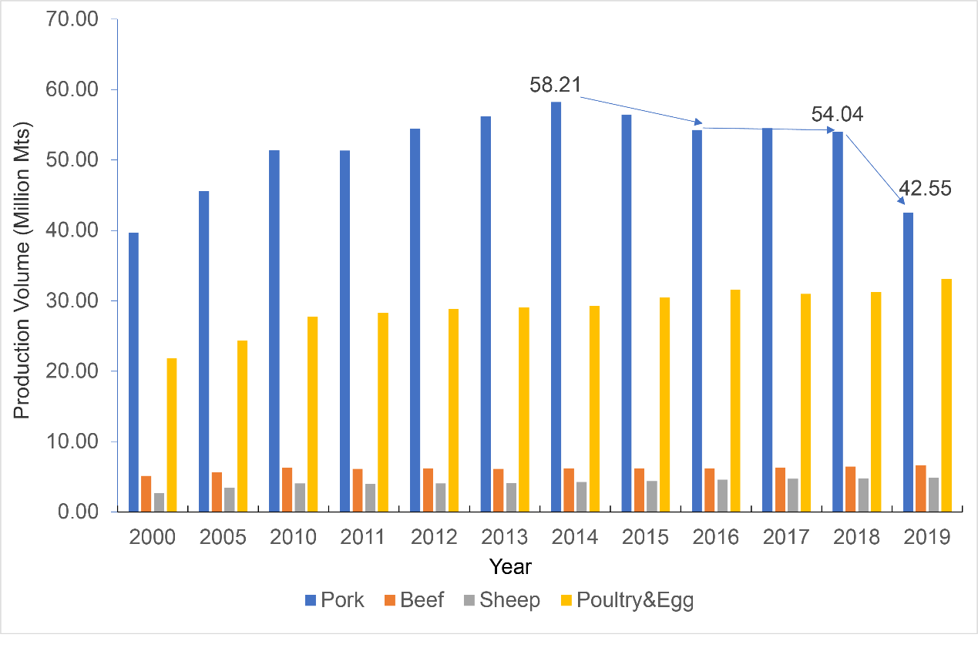

**Figure S4**. Trend of meat production in China from 2000 to 2019 in million tons. Pig and poultry and egg production increased rapidly during 2000 to 2014, while beef and sheep production stayed relatively stable. Pig production continued to decline since 2014 and experienced a sharp reduction by ~12 million Mts in 2019.

Data source: China Statistical Yearbook (2020), National Bureau of Statistics, China.

**Figure S5**. Live pig inventory and slaughtered pigs during 1999-2020.

Data source: China Rural Statistical Yearbook 2020.

**Figure S6**. China’s import values of meat and edible offal, Fish and Seafoods in USD during 2010-2019. China imported notable meats and fish and seafoods from world market. The meat includes beef, poultry, pork and mutton, and offal includes the edible offal from beef, poultry and pork. Traded data for mutton offal has not been reported separately in the database.

Data source: United Nations (UN), Comtrade database (<https://comtrade.un.org/data/>). Notes: Offal are edible offal. Meat and Offal, fish and seafood are either fresh, chilled, or frozen.

**Supplementary Tables**

Table S1. Major regulations on the Movements of Pigs and Related Products by Chinese Government from Aug 2018 to Nov 2019.

|  |  |  |
| --- | --- | --- |
| Date | Regulations | Contents |
| 2018-8-3 | launched the African Swine Fever Contingency Plan and Emergency Response Level-II * | Blockade hog and related products from the affected county. Suspend domestic hog outwards movements from Shenyang City temporarily. |
| 2018-8-10 | Announcement of ASFV surveillance and control of the transportation of live pigs by MARA (No.2018-38) | Blockade live pigs, wild boars, and related meat products outwards from affected districts. |
| 2018-8-30 | Announcement of prevention and control of zoonotic diseases including ASFV epidemic by China State Council | Clarify the primary responsibility of local governments for ASFV control.  Clarify the importance of transportation restriction. |
| 2018-8-31 | Announcement of reinforcing the surveillance of the transportation of pigs and pork products by MARA (No. 2018-29) | Suspend live pigs outwards of the ASF-affected county/city/province and close all live pig markets of the province; Suspend live pigs outwards beyond the county for all counties and pork products outwards beyond the city if the city with more than two affected counties; Suspend live pigs outwards beyond the city and pork products outwards beyond the province for all cities if the province with more than two affected cities.  Suspend pork products out of the city if the county with one case, products out of the province of other counties in the city. |
| 2018-9-11 | Announcement of further reinforcing the surveillance of inter-provincial transportation of pigs and pig products by MARA (No. 2018-33) | Blockade live pig movement outwards from the adjacent provinces of affected provinces; temporally close live pig markets in these adjacent provinces. |
| 2018-10-26 | Announcement of further enhancing the prevention and control of ASFV epidemic by China State Council | Blockade outwards movements from affected provinces and adjacent provinces; forbid movements of hogs passing through affected provinces.  Deactivate green channels for hogs, pork and pork products.  Promote cold chain and chilled meat supply system and transportation. |
| 2018-10-31 | Announcement No.79 by MARA | Set up requirements for hog transportation vehicles; Registration and GPS-tracking system for the vehicles; |
| 2018-11-15 | Joint announcement of efficiently reinforcing the surveillance of live pig transportation by MARA, Ministry of transport, Ministry of Public Security | Reinforce cooperation among ministries on efficient surveillance and control of pig transportation vehicles. All live pigs are blockaded from affected districts according to regulations. |
| 2018-11-20 | Announcement of further reinforcing the surveillance of quarantine and transportation of live pigs (MARA) | Stricter control on pig movement from high-risk districts to low-risk districts.  Deactivate the quarantine certification system for live pigs and pork products from affected districts. |
| 2018-12-28 | Announcement of regulating the transportation of live pigs and pig products | List exceptions for pig movements within affected provinces:  Piglets and breeding swine can be transported from affected counties within the province with laboratory ASF-free certificate. |
| 2019-1-24 | African Swine Fever Contingency Plan (2019) | Adjust the original three-level Emergency Response to four-level. New Level II refers to an epidemic in more than five adjacent provinces at one time with expanding trends within 30 days. |
| 2019-6-22 | China State Council Decision on the Reinforcement of Prevention and Control of African Swine Fever | Establish a special channel for live pig transportation.  Promote cold supply chain for transporting meat instead of live pigs.  Reinforce border inspection and quarantine and punish smuggling of live pigs and pig products. |

Data source: Documents from China State council from:

(1) <http://www.gov.cn/zhengce/2018-09/01/content_5318271.htm>;

(2) <http://www.xm.gov.cn/zwgk/flfg/sfbwj/201811/t20181108_2162333.htm>;

(3) <http://www.gov.cn/gongbao/content/2019/content_5411601.htm>.

Documents of Ministry of Agriculture and Rural Affairs PRC from:

<http://www.moa.gov.cn/ztzl/fzzwfk/zcfg/index.htm>.

Note: * Extraordinary (Class I) Epidemic refers to “Within 15 days, more than 2 (including) provincial administrative districts were affected by the epidemic”; Major (Level II) epidemic refers to “Within 15 days, an outbreak occurred in more than one (including) county-level administrative regions in one provincial administrative region”.

**Table S2**. Market structure for wild animal farming in 2016. The wildlife farming is a large industry in China with an annual output at 520 billion Yuan, acting an important role in national economy20. Most of farmed wild animals were utilized for skins and furs, and for consumption as well.

|  |  |  |  |
| --- | --- | --- | --- |
|  |  | Employment(millions) | Output (billion RMB) |
| 1 | Animals for skin and furs | 7.60 | 389.48 |
| 2 | Animals for medical uses | 0.21 | 5.03 |
| 3 | Animals for foods | 6.26 | 125.05 |
| 4 | Animals for pets | 0.01 | 0.65 |
| 5 | Primates for experiment | 0.002 | 0.40 |
|  | Total | 14.082 | 520.61 |

Data Source: Chinese Academy of Engineering, 2017, Report on Sustainable Development Strategy

**Table S3**. Annual pelt production of minks, foxes and raccoon dogs for leading production provinces between 2015-2019. Most fur animals are produced in the Northern China.

|  |  |  |  |  |  |
| --- | --- | --- | --- | --- | --- |
| **Province** | **2015** | **2016** | **2017** | **2018** | **2019** |
| **Shandong** |  |  |  |  |  |
| Mink | 35208400 | 18364320 | 14683680 | 16003560 | 6638751 |
| Fox | 6461200 | 4497075 | 5717550 | 7547260 | 5800860 |
| Raccoon dog | 3860780 | 3095183 | 3081400 | 3689136 | 2989800 |
| **Liaoning** |  |  |  |  |  |
| Mink | 6141000 | 3900456 | 3613240 | 3150960 | 3097850 |
| Fox | 2009700 | 1907620 | 2584530 | 2817180 | 3141411 |
| Raccoon dog | 355810 | / | / | / | / |
| **Heilongjiang** |  |  |  |  |  |
| Mink | 2189400 | 2759880 | 1275140 | 684090 | 1147958 |
| Fox | / | / | / | / | / |
| Raccoon dog | / | 1523353 | 654720 | 1257660 | 1350846 |
| **Hebei** |  |  |  |  |  |
| Mink | / | / | / | / | / |
| Fox | 4463100 | 4752605 | 4101690 | 3698853 | 3971136 |
| Raccoon dog | 11168570 | 9874618 | 8223680 | 6941790 | 8439390 |

Data source: Annual Industrial Report by China Leather Industry Association21-25.

Note: (1) The original reports only provide statistics for China’s top three production provinces for captive-bred minks, foxes, and raccoon dogs. (2) The original statistics for total pelt output were reported at the scale of 10,000, and output of the top three producers were reported as percentage. Therefore, the data above are a rough estimation.

**Supplementary Reference**

1 Delgado, C. L., Rosegrant, M. W., Steinfeld, H., Ehui, S. K. & Courbois, C. Livestock to 2020: the next food revolution. *Vision Discussion Papers* **30**, 27-29 (2001).

2 Zhou, G., Zhang, W. & Xu, X. China's meat industry revolution: Challenges and opportunities for the future. *Meat Science* **92**, 188-196 (2012).

3 Bai, Z. *et al.* China’s livestock transition: Driving forces, impacts, and consequences. *Science Advances* **4**, eaar8534 (2018).

4 Li, X. L., Yuan, Q. H., WanA, L. Q. & He, F. Perspectives on livestock production systems in China. *The Rangeland Journal* **30**, 211-220 (2008).

5 Plowright, R. K. *et al.* Pathways to zoonotic spillover. *Nature Reviews Microbiology* **15**, 502-510 (2017).

6 Morens, D. M. & Fauci, A. S. J. C. Emerging pandemic diseases: How we got to COVID-19. (2020).

7 Rulli, M. C., D’Odorico, P., Galli, N. & Hayman, D. T. S. Land-use change and the livestock revolution increase the risk of zoonotic coronavirus transmission from rhinolophid bats. *Nature Food* **2**, 409-416, doi:10.1038/s43016-021-00285-x (2021).

8 Yu, X. & Abler, D. Where have all the pigs gone? Inconsistencies in pork statistics in China. *China Economic Review* **30**, 469-484, doi:<https://doi.org/10.1016/j.chieco.2014.03.004> (2014).

9 He, P., Quan, L. & Ma, J. An Emprical Study on the 'Pork Price Cycle' of Chinese CPI. *Inquiry Into Economic Issues* **8**, 17-22 (2013).

10 Tan, Y. & Zeng, H. Price transmission, reserve regulation and price volatility. *China Agricultural Economic Review* **11** (2019).

11 China State Council. (ed China State Council) (Beijing, 2019).

12 Yun, C.-H. Unforeseen enemy: African swine fever. *Asian-Australasian Journal of Animal Sciences* **33**, 1-3, doi:<https://doi.org/10.5713/ajas.2020.0001ED> (2020).

13 Gale, F., Marti, D. & Hu, D. China’s Volatile Pork Industry. (United States Department of Agriculture, 2012).

14 Bai, Z. *et al.* China’s pig relocation in balance. *Nature Sustainability* **2**, 888, doi:<https://doi.org/10.1038/s41893-019-0391-2> (2020).

15 MARA. (ed Ministry of Agriculture and Rural Affairs) (Ministry of Agriculture and Rural Affairs, Beijing, 2016).

16 Bai, Z., Zhao, J., Wei, Z., Jin, X. & Ma, L. Socio-economic drivers of pig production and their effects on achieving sustainable development goals in China. *Journal of Integrative Environmental Sciences* **16**, 141-155, doi:10.1080/1943815X.2019.1671463 (2019).

17 Ding, Y. & Wang, Y. Big government: The fight against the African Swine Fever in China. *Journal of Biosafety Biosecurity* **2**, 44-49 (2020).

18 Luo, Z. & Tian, X. Can China’s meat imports be sustainable? A case study of mad cow disease. *Applied Economics* **50**, 1022-1042 (2018).

19 World Bank. (World Bank WorldBank Database, 2020).

20 Chinese Academy of Engineering. Report on Sustainable Development Strategy of China's Wildlife Farming Industry (in Chinese). (Beijing, 2017).

21 Wang, D. & Qing, Z. Statistics of pelt number for minks, foxes and raccoon dogs in China in 2019 and market analysis (in Chinese). *Beijing Leather* **5**, 64-66 (2020).

22 Wang, D. Statistical Analysis of pelt number for minks, foxes and raccoon dogs in China in 2018 (in Chinese). *Beijing Leather* **9**, 69-71 (2019).

23 Wang, D. Statistical Analysis of pelt number for minks, foxes and raccoon dogs in China in 2016 (in Chinese). *Leather and Chemicals* **34**, 43-44 (2017).

24 Wang, D. Statistical Analysis of pelt number for minks, foxes and raccoon dogs in China in 2017 (in Chinese). *Leather and Chemicals* **35**, 7-8 (2018).

25 Wang, D. Statistical Analysis of pelt number for minks, foxes and raccoon dogs in China in 2015 (in Chinese). *Leather and Chemicals* **33**, 40-41 (2016).