Brecha, et al. – Ocean Thermal Energy Conversion - Flexible Support Technology for 100% Renewable Energy Systems in the Caribbean
Supplementary Information

Part I – GIS mapping details and procedure outline
Maps with layers are available to view publicly at xxx
Data sources
For the bathymetry data:
Reference: https://www.gebco.net/data_and_products/gridded_bathymetry_data/#a1
https://www.gebco.net/data_and_products/gridded_bathymetry_data/gebco_2020/
GEBCO Compilation Group (2020) GEBCO 2020 Grid (doi:10.5285/a29c5465-b138-234d-e053-6c86abc040b9)
Cell resolution: 15 arc seconds (GRID cell size range in meters: 383.5m (N) -> 458.25m (S)
Coordinate System: WGS 1984
Extent (see below)
GEBCO operates under the International Hydrographic Organization (IHO) and the Intergovernmental Oceanographic Commission (IOC) (of UNESCO)
For the coastline data:
NOAA Coastlines Shapefile: https://www.ngdc.noaa.gov/mgg/shorelines/
Wessel, P., and W. H. F. Smith (1996), A global, self-consistent, hierarchical, high-resolution shoreline database, J. Geophys. Res., 101(B4), 8741–8743, doi:10.1029/96JB00104.
Coordinate System: WGS 1984
Projected Coordinate System: Equidistant Conic, NAD 1983 (see below for screen shot of modifications for Caribbean study area)
Extent: Matched GEBCO dataset

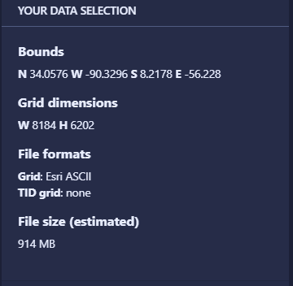
Procedure notes:
- Downloaded Caribbean region (see download screen capture) – clip can be to any exact extent wanted. Download format: Esri ASCII for use with ArcGIS Pro (Import as Esri GRID file)
- Display GEBCO GRID in ArcGIS Pro
- Extracted all values < -1000m
  - Convert to poly (will also use to extract all areas >5km from coastline)
  - Overlay on basemap with detailed coastline/land layer (extracted to same extent)
  - Bright blue areas all depths > -1000m
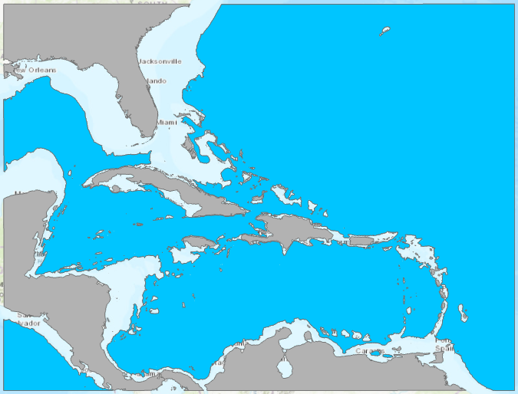

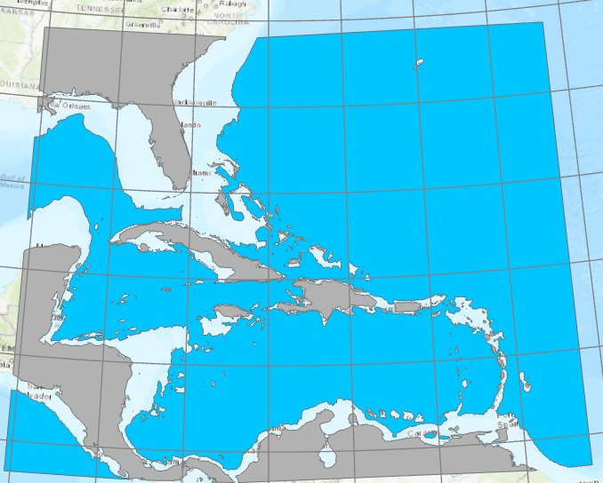
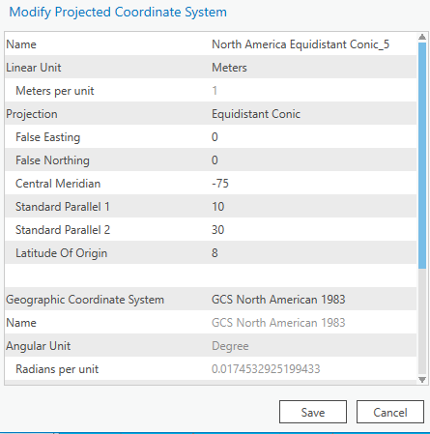
- Projected coastline/land feature class (horizontal datum in meters) for region.
Modified Equidistant Conic:
- Create four buffers from coastline/land layer
- < 2.5km
- 2.5km – 5.0km
- 5.0km – 7.5km
- 7.5km – 10km
- kept as separate feature classes for ease of display and future analysis
- extracted buffer areas with ocean depth areas greater than 1000m
Part II – Results of mapping and preliminary site selection

Table SI2 summarizes several of the locations with promising OTEC resources in the Caribbean. Static maps of these islands are shown below; the maps with layers as defined in the main text can be viewed interactively at https://arcg.is/11vrHe .
Jamaica | Western | Negril (hotels, airport)
 | Northwestern | Lucea
 | Northwestern | Montego Bay
 | Southeast | East of Kingston
Grand Cayman | All areas | George Town, Bodden Town, East End, West Bay
Cuba | Southeast | Santiago de Cuba
 | Northeast | Guardalavaca (tourist resorts)
 | Northeast | Playa Uvero, Playa La Playita (tourist resorts)
 | Northeast | Havana
Bahamas | Central | Nassau
Turks and Caicos Islands | East | Cockburn Town
Haiti | West | Canal de St.-Marc, Canal de la Gonâve
Dominican Republic | South | Barahona, Paraíso, Los Patos
Puerto Rico | Southeast | Guayama
Guadeloupe | Northeast | Le Moule
Dominica | West coast | Roseau, Portsmouth
Martinique | West coast | Fort-de-France, St Pierre
St Lucia | Southwest | Soufriére
St Vincent and the Grenadines | West coast | Kingstown

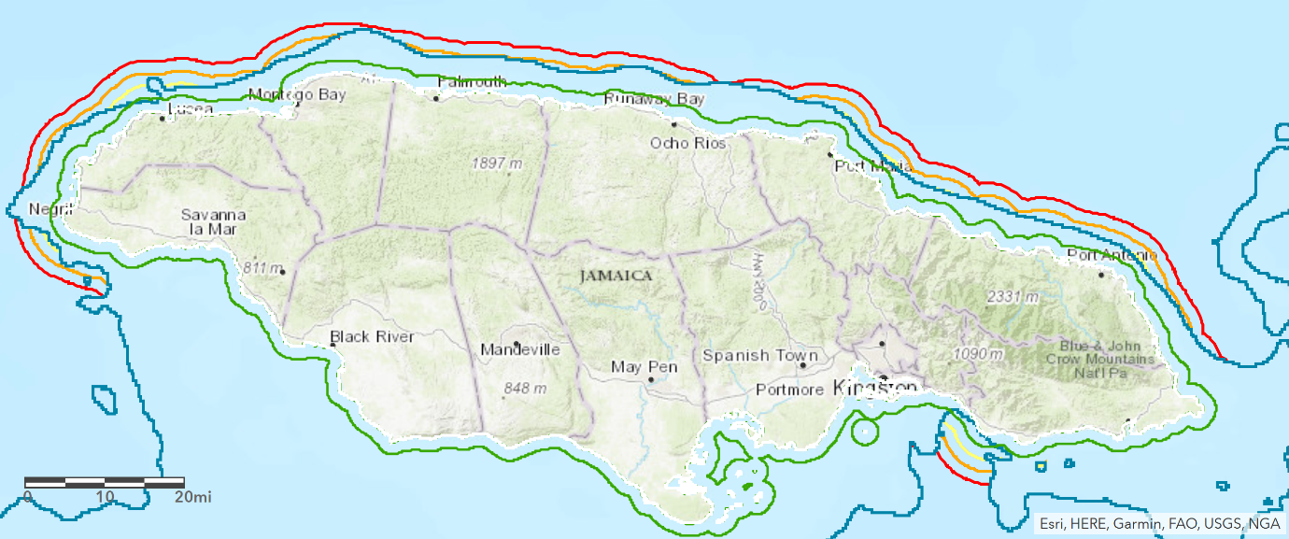
Figure S1 - Map of Jamaica with contour for 1000m depth (blue) and for distances to coast in 2.5km increments.

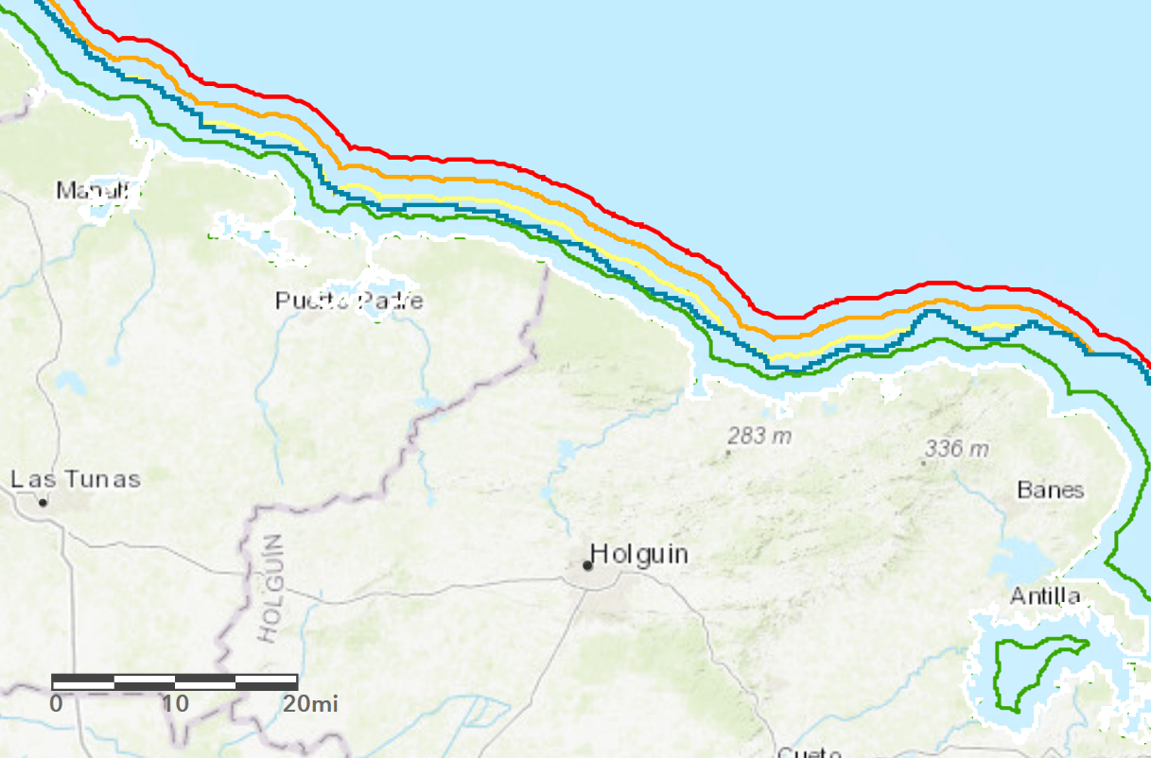
Figure S2 - Map of northeastern Cuba with contour for 1000m depth (blue) and for distances to coast in 2.5km increments.

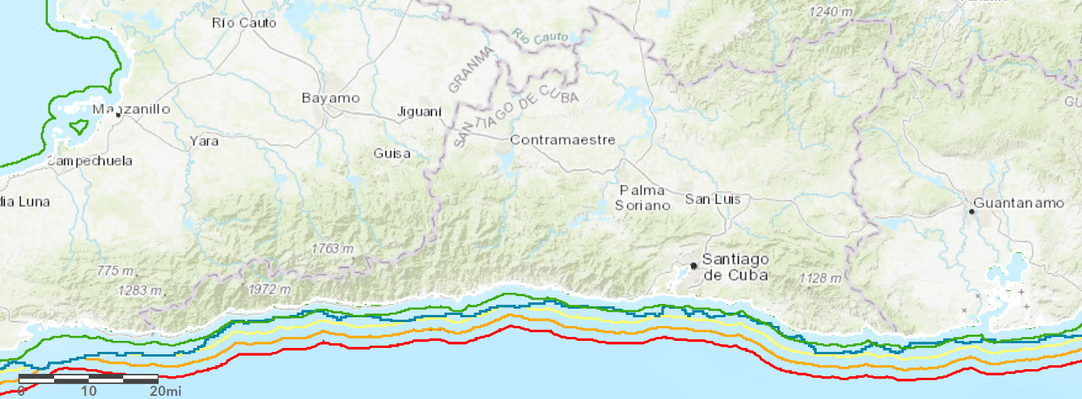
Figure S3 - Map of southern Cuba with contour for 1000m depth (blue) and for distances to coast in 2.5km increments.
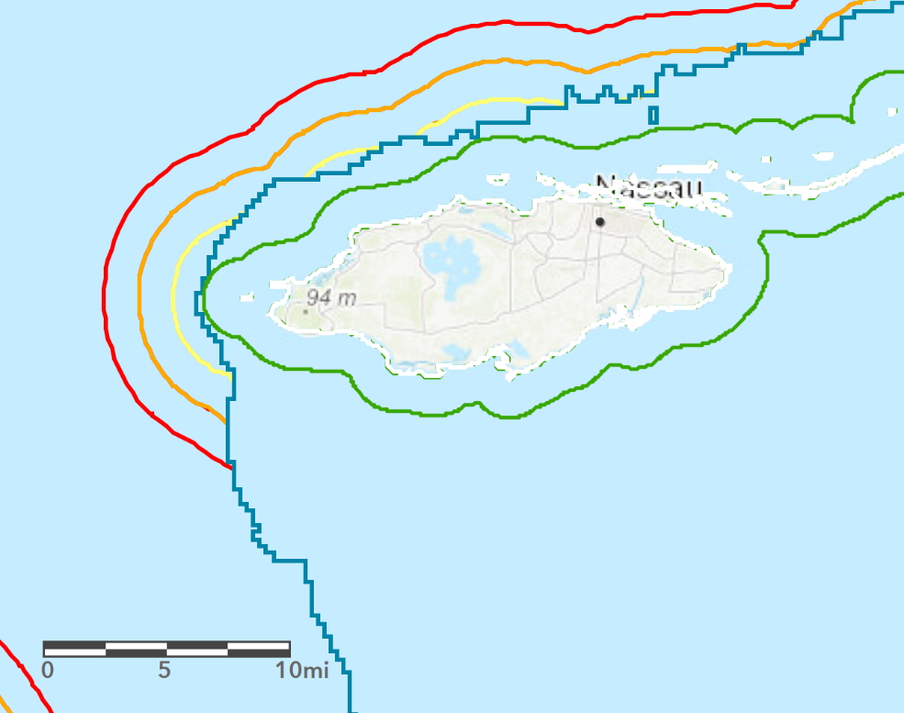
Figure S4 - Map of the Bahamas near Nassau with contour for 1000m depth (blue) and for distances to coast in 2.5km increments.
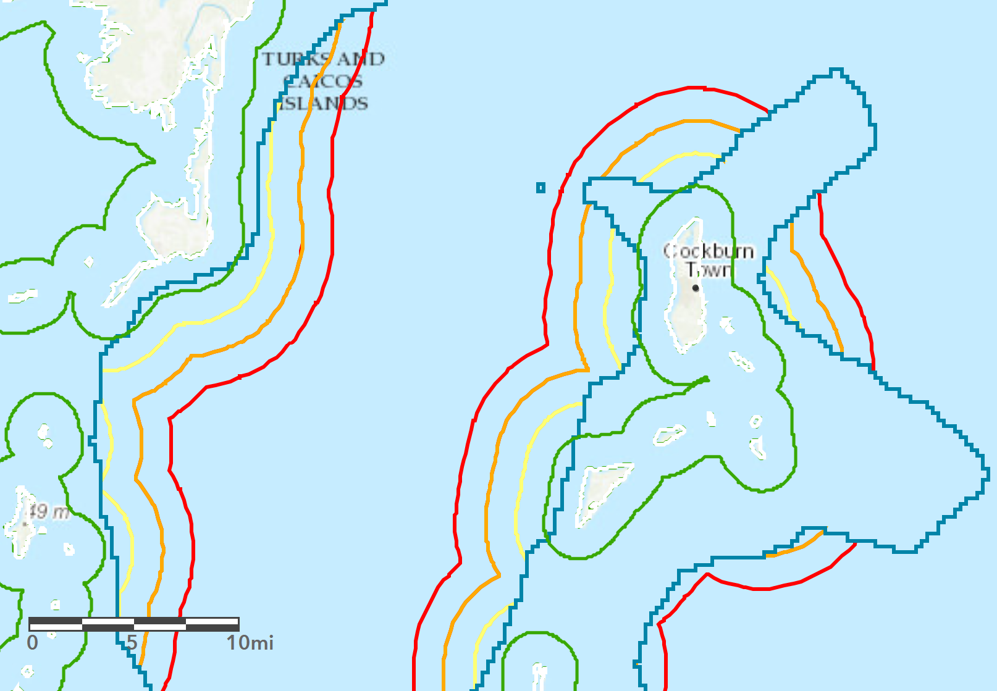
Figure S5 - Map of the Turks and Caicos Islands with contour for 1000m depth (blue) and for distances to coast in 2.5km increments.

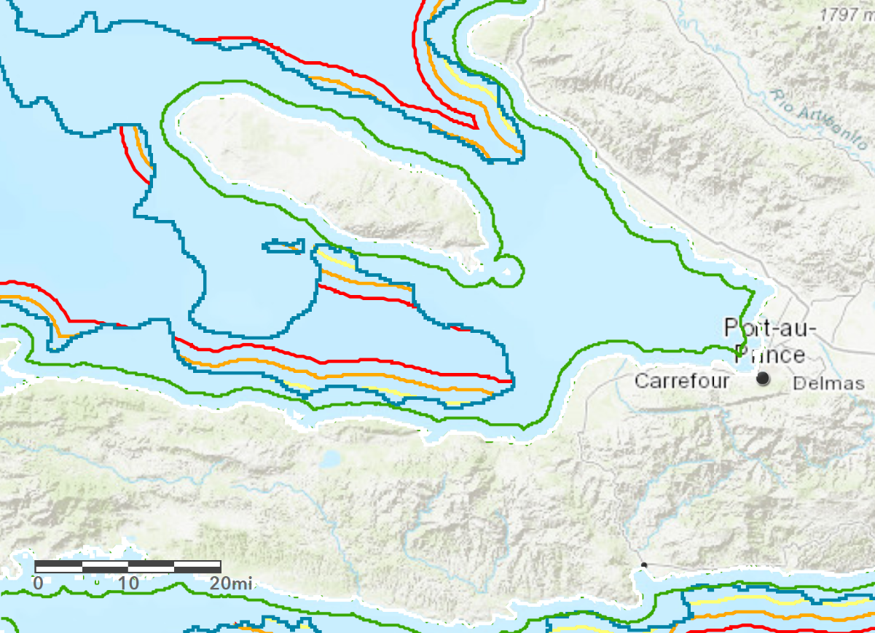
Figure S6 - Map of the western Haiti with contour for 1000m depth (blue) and for distances to coast in 2.5km increments.

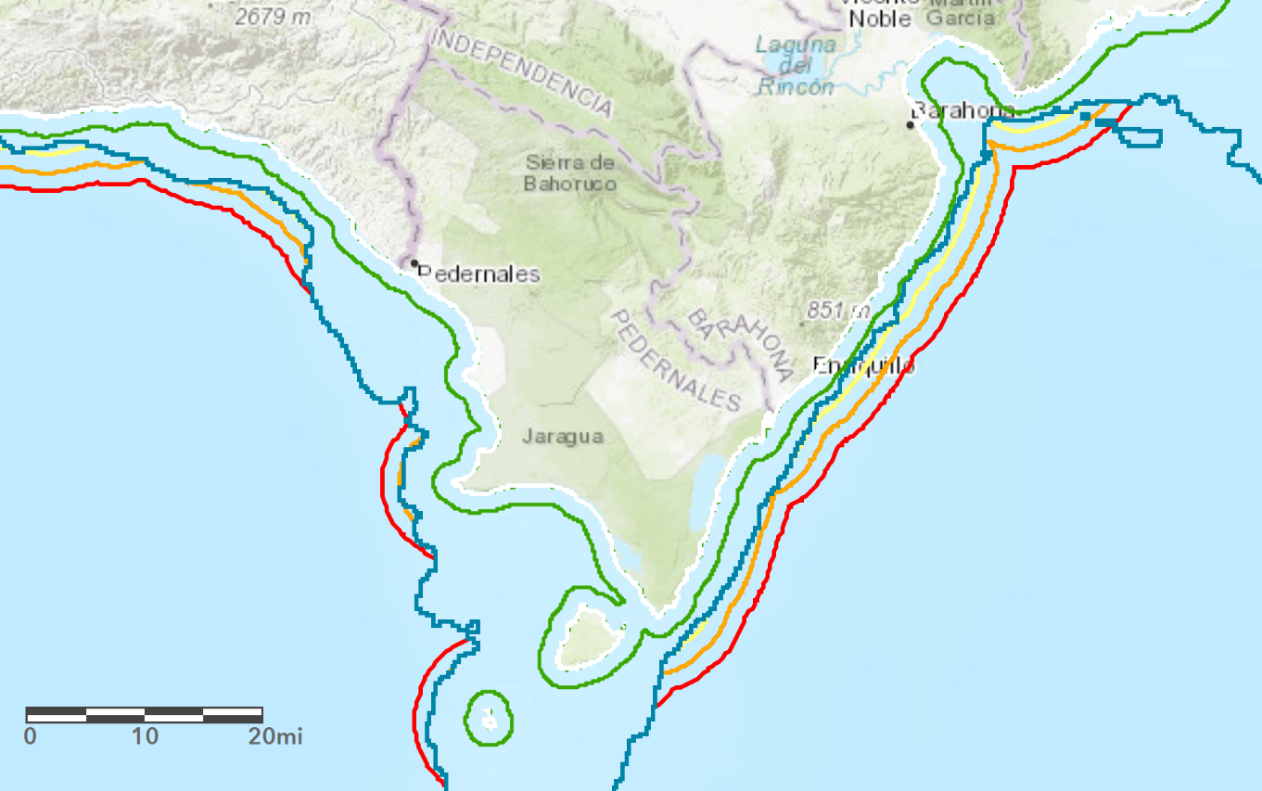
Figure S7 - Map of southern Dominican Republic with contour for 1000m depth (blue) and for distances to coast in 2.5km increments.

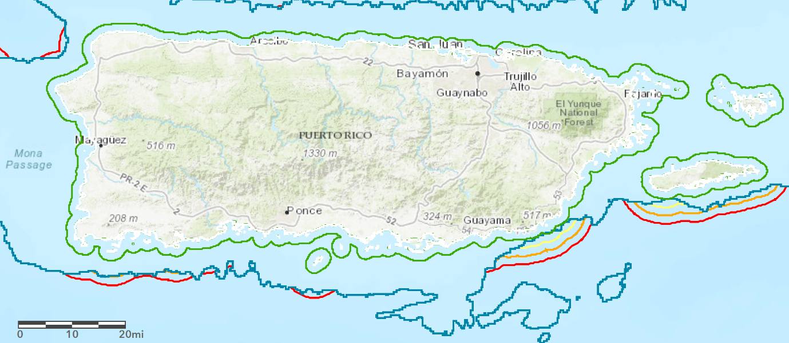
Figure S8 - Map of Puerto Rico with contour for 1000m depth (blue) and for distances to coast in 2.5km increments.

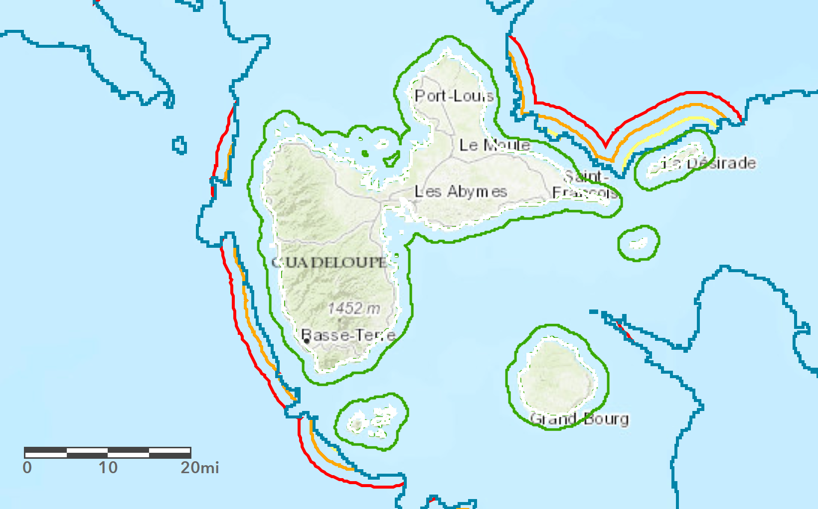
Figure S9 - Map of Guadeloupe with contour for 1000m depth (blue) and for distances to coast in 2.5km increments.

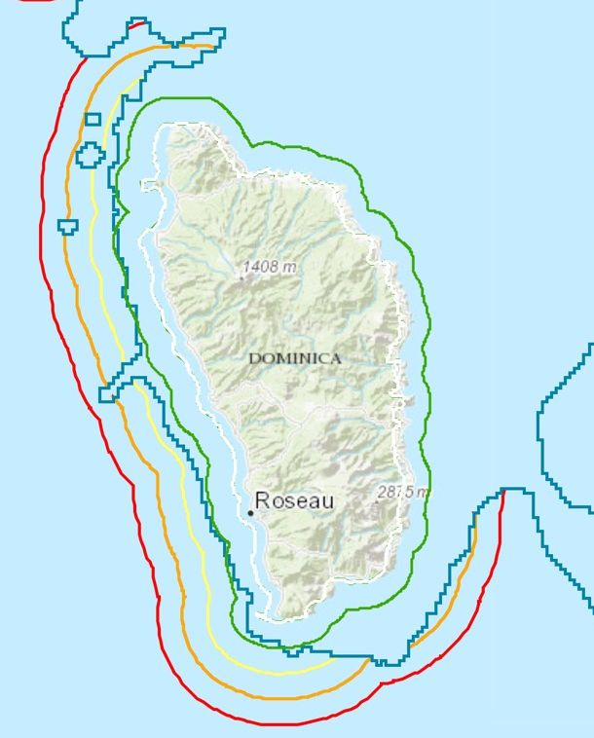
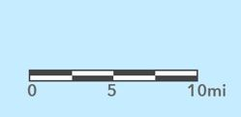
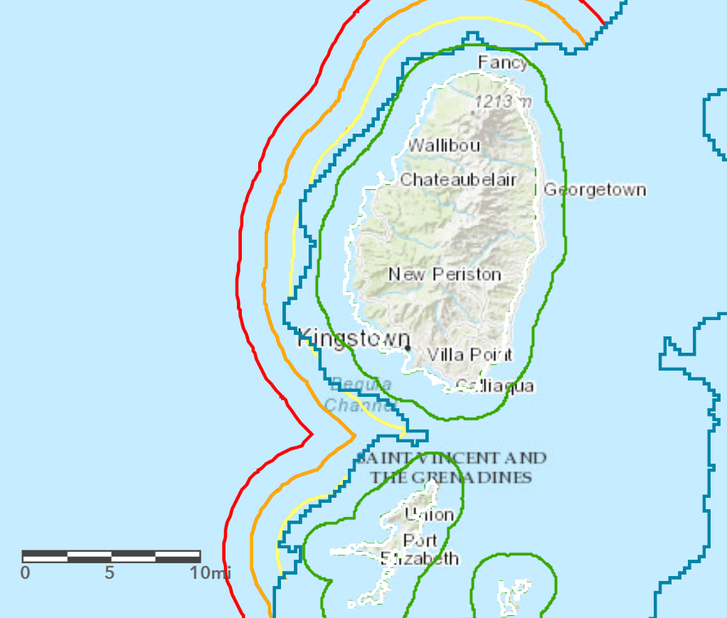
Figure S10 - Map of Dominica with contour for 1000m depth (blue) and for distances to coast in 2.5km increments.
Figure S11 - Map of St. Vincent and the Grenadines with contour for 1000m depth (blue) and for distances to coast in 2.5km increments.
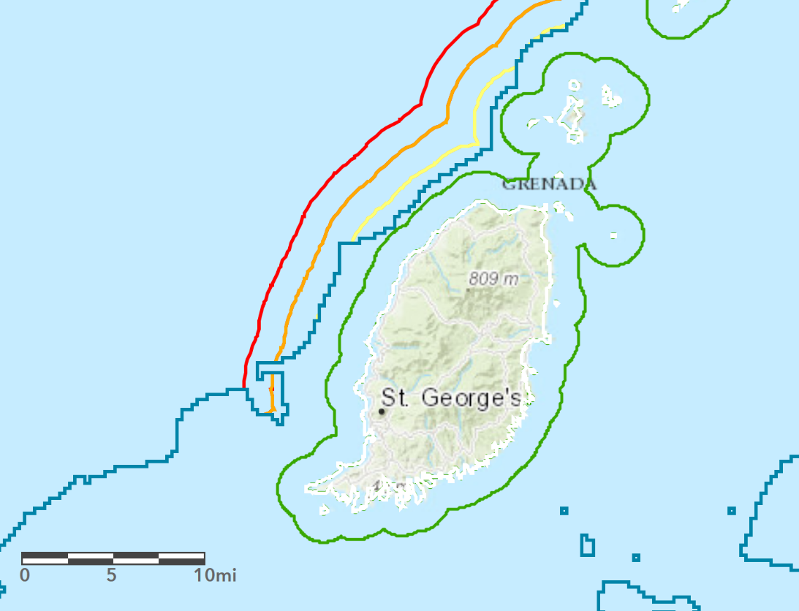
Figure S12 - Map of Grenada with contour for 1000m depth (blue) and for distances to coast in 2.5km increments.

Part III - Residual Load Duration Curves

In Fig. S13 the overall system residual demand is shown for a situation in which VRE + dispatchable power + storage is not able to meet demand during many hours of the year. Parameters are chosen as: Peak demand, 37.7 MW; solar pv capacity, 50 MW; wind capacity, 24 MW; dispatchable capacity, 15 MW; battery storage capacity, 100 MWh. It is useful to look at the results of the model in terms of load duration and residual load duration curves (LDC and RLDC) as these show at a glance the contributions of VRE, dispatchable power and storage to satisfying overall demand. In Fig. S14 the top curve (orange) represents the system load, but now sorted from its highest to its lowest value during the year. Therefore the x-axis does not represent a sequence in time, but rather a fraction of the year during which the load is larger than a given amount. Likewise, the second curve (blue) represents VRE subtracted from the load for each hour, then sorted from highest value to lowest value. The gray curve in Fig. yyy gives the sorted remainder of both dispatchable power and VRE subtracted from the load, and finally, the yellow curve includes storage, also sorted after being subtracted for each hour of the year.
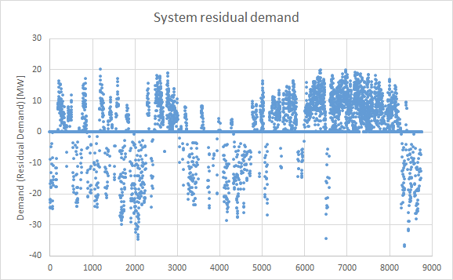
Figure S13 - Residual load throughout all hours of the representative year

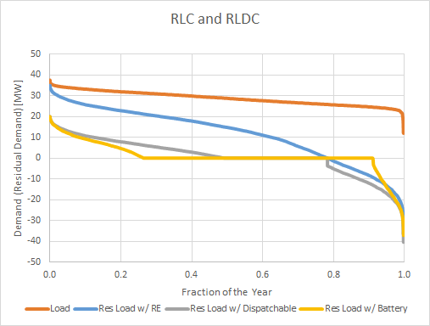
Figure S14 - Load duration curve (orange) and residual load duration curves (RLDCs) considering variable renewable energy (VRE) only (blue), VRE + dispatchable renewable (gray) and including battery storage (yellow)

Comparing Figs. S13 and S14 we see in the former that the maximum value is reached at 20MW for a very few hours of the year; this is represented in Fig. S14 by that same value at the left-hand edge of the traces in the yellow and gray curves. Negative values in both Fig. S13 and Fig. S14 represent overproduction of VRE during a fraction of hours, and that the yellow curve extends further to the right (fewer remaining hours) and to the left compared to the gray curve is a reflection of the fact that storage enables the system to take up a certain amount of overproduction (right-hand end of curve) and use it for some fraction of hours when demand exceeds total production of both VRE and dispatchable power, thus shifting the left-hand end of the yellow curve further to the left compared to the gray curve. The ideal outcome is to flatten the yellow curve to zero with a combination of VRE, dispatchable power and storage, while having a minimum of hours with excess generation (i.e. negative values of the RLDC).
In Fig. S15 another limiting case is shown, with 37 MW peak demand, 110 MW of solar pv capacity, 90 MW of wind capacity, 10 MW of dispatchable capacity, 1000 MWh of battery storage. The combination of technologies is chosen to (very nearly) eliminate unserved demand on an hourly basis throughout the year. However, with very little dispatchable power available, a large amount of battery storage is needed, which remains nearly fully-charged In this case, the demand is met at all hours (perhaps with the exception of a very small number within the limits of standard grid operating parameters) as shown in the upper panel. The battery state of charge is shown for this case in the lower panel; one sees that the battery is nearly always in a state of fully charged capacity. Only for a relatively short period of a few days, shown in the lower panel, and as a time series through the year, is the full capacity of the battery necessary (around hours 7200-7300, at the end of October). In this case, without sufficient dispatchable capacity, there is both significant curtailment of VRE (~45% of total generation) and the need for investment in large battery capacity.

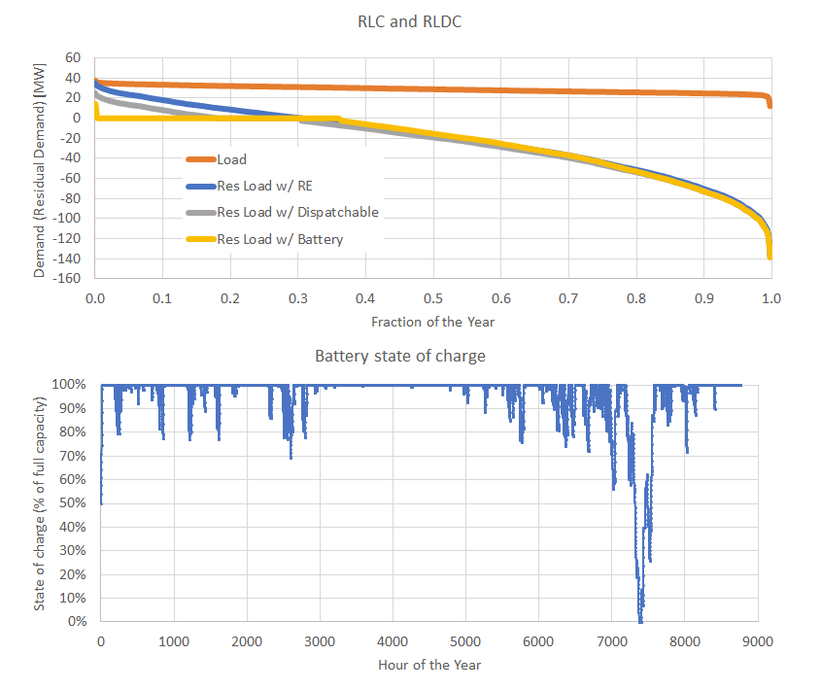
Figure S15 - (Top) RLDC as in the previous figure, but for a system with relatively low dispatchable renewable energy capacity; demand is satisfied for very nearly all hours. (Bottom) Battery state of charge throughout the year is such that the system is usually fully charged; a large battery capacity is necessary in the absence of dispatchable power capacity, although that full battery capacity is needed for only very few hours of the year.

