Table S1. Satellite images used for the analysis.
Satellite Instrument | Acquisition date | Product types
Sentinel-2 MSI | 2019_06_20 | Level-1C
Sentinel-2 MSI | 2019_07_25 | Level-1C
Sentinel-2 MSI | 2019_08_19 | Level-1C

Figure S2. Results of the ‘Area of Applicability’ (AOA) analisys. The Applicability Index (Dissimilarity Index – DI) are stretched between 0 and 1 for visualizzation purposes (a). The derived AOA is binarized. The area outside the AOA is shown in black. (b).
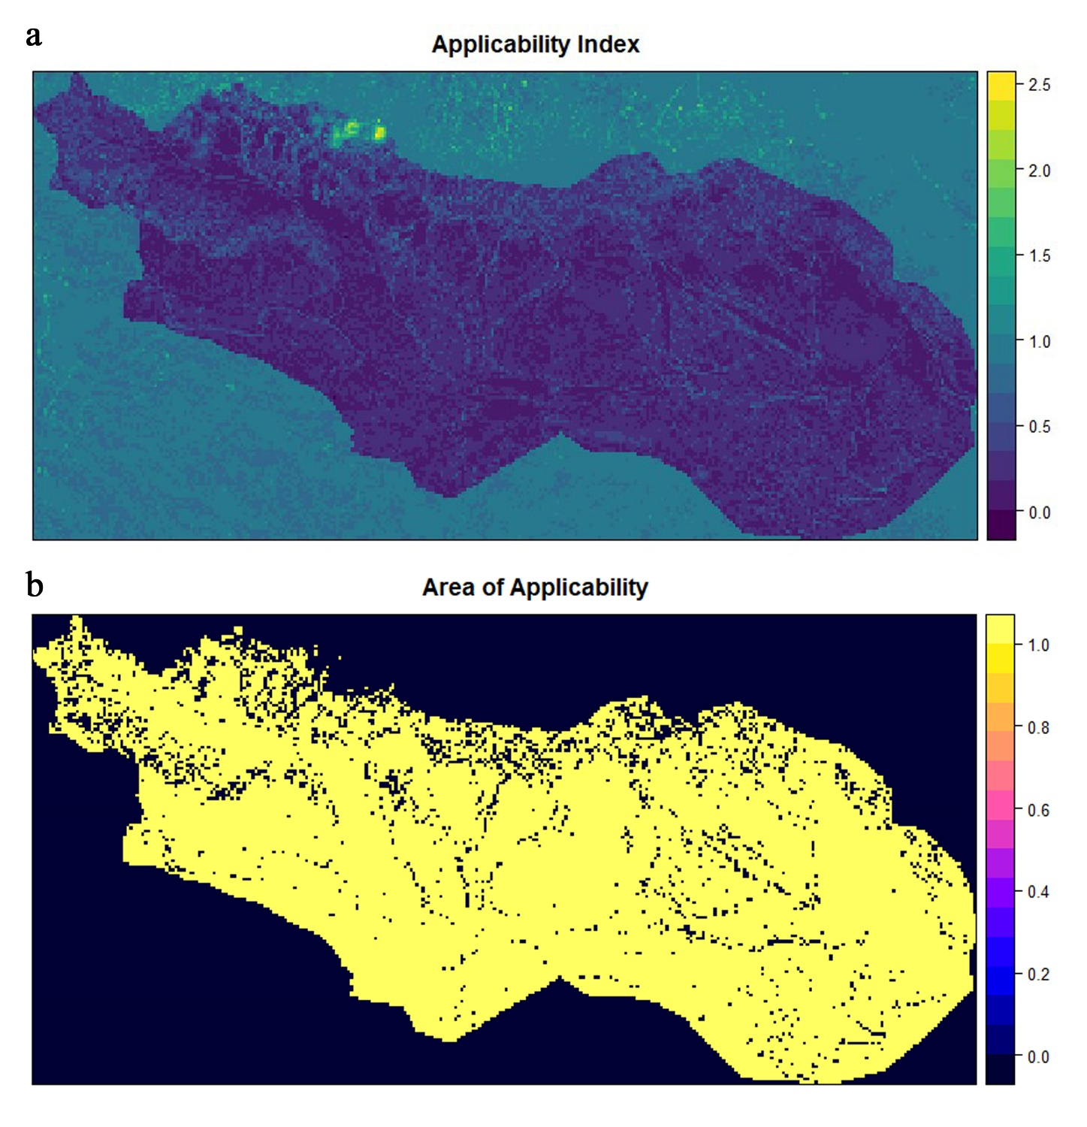
Table S3. Accuracy statistics. Classification accuracy (%) for the Brachypodium genuense cover when applied to the validation dataset. Training data consisted of a random sample (80%) of the full dataset and validation was conducted on the remaining data.
Confusion Matrix
Predicted |  | Reference
 |  | Class 1 (Presence) | Class 2 (Absence)
 | Class 1 (Presence) | 7 | 2
 | Class 2 (Absence) | 0 | 13

Overall statistics.
Accuracy: 0.9091 Kappa: 0.8053
95% CI: (0.7084, 0.9888) P-Value [Acc > NIR]: 0.6818

Sensitivity: 1.0000
Specificity: 0.8667
Pos Pred Value: 0.7778
Neg Pred Value: 1.0000
Prevalence: 0.3182
Detection Rate: 0.3182
Detection Prevalence: 0.4091
Balanced Accuracy: 0.9333

Figure S4. Maps derived from Local Indicators of Spatial Association (LISA) analysis of the classified B. genuense patches.
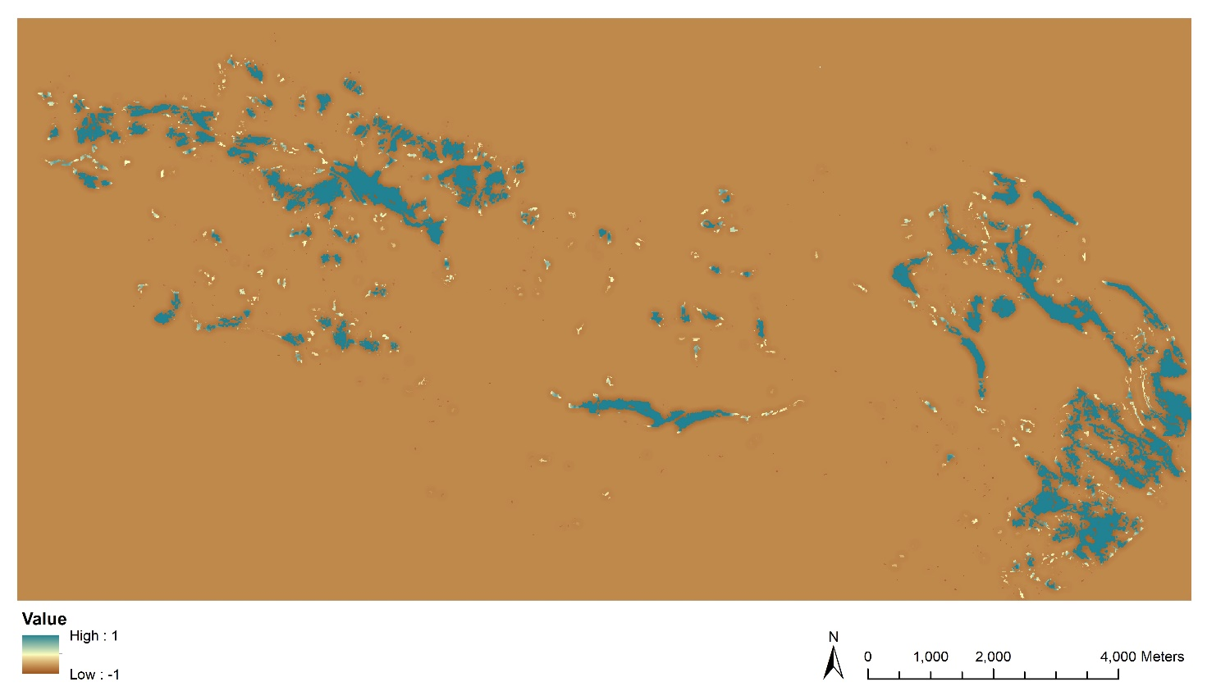

Table S5. Plant associations recognized in the study area. The 12 associations correspond with the syntaxa shown in the ‘La vegetazione di Campo Imperatore (Gran Sasso d’Italia)’ (Biondi et al. 1999). Based on the Habitat Natura 2000 nomenclature, the associations were divided into 5 habitats through an 'expert based' process.
n. | Plant association | Diagnostic taxa | Syntaxonomy | code | Habitat (Annex I, Directive 92/CEE)
1 | Daphno oleoidis-Juniperetum alpinae | Juniperus communis subsp. alpina, Arctostaphylous uva-ursi, Cotoneaster integerrimus, C. nebrodensis, Juniperus communis subsp. hemisphaerica | Daphno oleoidis-Juniperion alpinae | 4060 | Alpine and Boreal heaths
2 | Galio magellensis-Festucetum dimorphae | Festuca dimorpha, Galium magellense, Leontodon montanus subsp. melanotrichus |  | 8120 | Calcareous and calcschist screes of the montane to alpine levels (Thlaspietea rotundifolii)
3 | Seslerietum apenninae | Sesleria apennina, Androsace villosa, Helianthemum oelandicum ssp. alpestre, Pedicularis elegans | Seslerion apenninae | 6170 | Alpine and subalpine calcareous grasslands
4 | Carici humilis-Seslerietum apenninae | Sesleria apennina, Carex humilis, Carum heldreichii, Anthyllis montana ssp atropurpurea | Seslerion apenninae
5 | Luzulo italicae-Nardetum strictae | Nardus stricta, Luzula italica, Crocus albiflorus, Potentilla crantzii, Euphrasia salisburgensis | Ranunculo pollinensis-Nardion strcitae | *6230 | Species-rich Nardus grasslands, on siliceous substrates in mountain areas (and sub-mountain areas, in Continental Europe)
 | subass. caricetosum kitaibelianae | Carex kitaibeliana, Gentiana verna, Festuca violaceaa subsp. italica, Draba aizoides, Ohyteuma orbiculare, Erigeron epiroticus
6 | Taraxaco apennini-Trifolietum thalii | Trifolium thalii, Taraxacum apenninum, Bellis perennis, Barbarea bracyeosa, Sagina glabra | Ranunculo pollinensis-Nardion strcitae
7 | Poo violaceae-Nardetum strictae | Nardus stricta, Poa violacea, Crocus neapolitanus, Luzula campestris, Agrostis tenuis | Ranunculo pollinensis-Nardion strcitae
8 | Koelerio splendentis-Brometum erecti | Bromus erectus, Koeleria splendes, Globularia meridionalis, Trifolium montanum, Gentianella columnae, Helianthemum oelandicum ssp. alpestre, Valeriana tuberosa, Pedicularis comosa | Phleo ambigui-Bromion erecti | *6210 | Semi-natural dry grasslands and scrubland facies on calcareous substrates (Festuco-Brometalia) (*important orchid sites)
9 | Polygalo majoris-Seslerietum nitidae | Sesleria nitida, Polygala major, Anthyllis montana subsp. atropurpurea, Laserpitium siler, Biscutella laevigata | Phleo ambigui-Bromion erecti
10 | Cirsío acaulis-Sesleríetun nitidae | Sesleria nitida, Cirsium acaule, Trifolium pratense subsp. semipurpureum, Linum catharticum, Bellis perennis | Phleo ambigui-Bromion erecti
11 | Poo alpinae-Festucetun circummediterraneae | Festuca circummediterranea, Poa alpina, Trifolium repens, Koeleria splendens, Dianthus delthoides, Crocus neapolitanus | Phleo ambigui-Bromion erecti
 | subass. poetosum violaceae | Poa violcaea
12 | Plantago holostei-Helianthemetum cani | Helianthemum oelandicum subsp. canum, Plantago holesteum | Phleo ambigui-Bromion erecti

