﻿SUPPLEMENTAL MATERIALS
Endothelial Autocrine Signaling through CXCL12/CXCR4/FoxM1 Axis Contributes to Severe Pulmonary Arterial Hypertension
Dan Yi, Bin Liu, Ting Wang, Qi Liao, Maggie M. Zhu, You-Yang Zhao and Zhiyu Dai

Supplemental Table 1, Clinical and demographic characteristics of PAH patients and control
ID | PAH or Failed Donor | Gender | Race | Ethnicity | Age | WHO Functional Class | 6MWD (m) | mPAP  (mmHg) | CO  (mL/min) | PVR (WU) | Treatment
PHBI-ST-036 | IPAH | Female | White | Non-Hispanic | 11 | No data | 243.8 | 95 | No data | No data | No data
PHBI-ST-042 | IPAH | Male | White | Non-Hispanic | 53 | IV | 77.7 | 45 | 4.28 | 8.18 | No data
PHBI-UA-026 | IPAH | Female | White | Non-Hispanic | 55 | II | 381 | 52 | 5.59 | 7.33 | No data
PHBI-AH-022 | Failed donor | Female | White | Non-Hispanic | 57 | N/A | N/A | N/A | N/A | N/A | N/A
PHBI-BA-044 | Failed donor | Male | White | Non-Hispanic | 30 | N/A | N/A | N/A | N/A | N/A | N/A
PHBI-BA-059 | Failed donor | Female | Asian | Non-Hispanic | 34 | N/A | N/A | N/A | N/A | N/A | N/A

Supplemental Table 2, Primer sequences for QRT-PCR analysis
Gene name | Forward primer | Reverse primer
hFOXM1 | ﻿GGAGGAAATGCCACACTTAGCG | ﻿TAGGACTTCTTGGGTCTTGGGGTG
h18S rRNA | ﻿TTCCGACCATAAACGATGCCGA | ﻿GACTTTGGTTTCCCGGAAGCTG
mFoxm1 | ﻿CACTTGGATTGAGGACCACTT | GTCGTTTCTGCTGTGATTCC
mCyclophilin | ﻿GGCAAATGCTGGACCAAACAC | TTCCTGGACCCAAAACGCTC

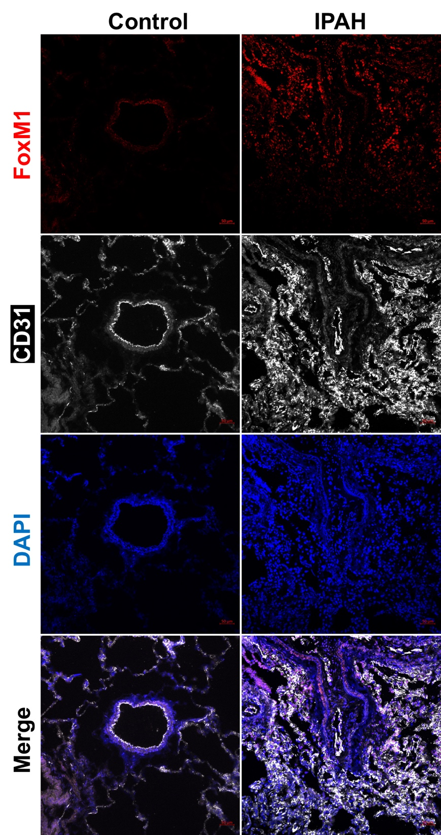
Supplemental Figure 1. Representative images of immunostaining against FoxM1 in lower magnification. Immunostaining against FoxM1 demonstrated that FoxM1 is highly expressed and induced in the lung of IPAH patients compared with failed donors (Control). Scale bar =50$μm$.

