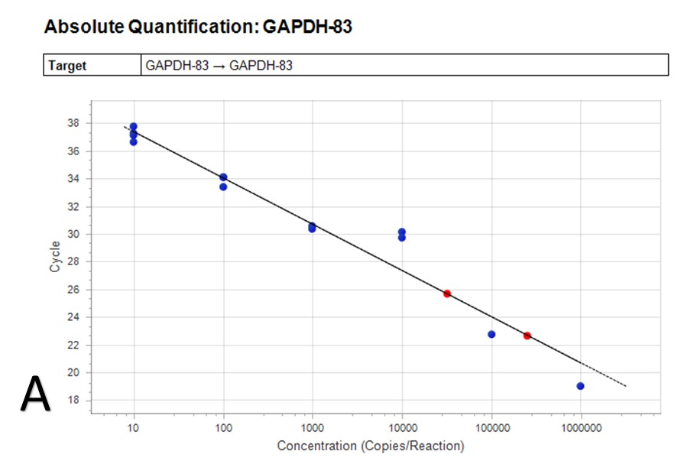
Supplementary Figures and Tables

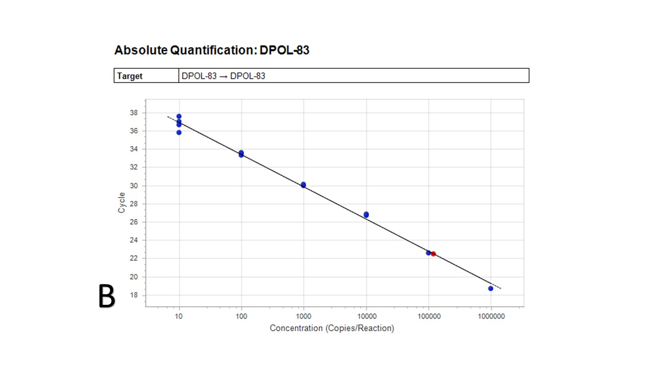
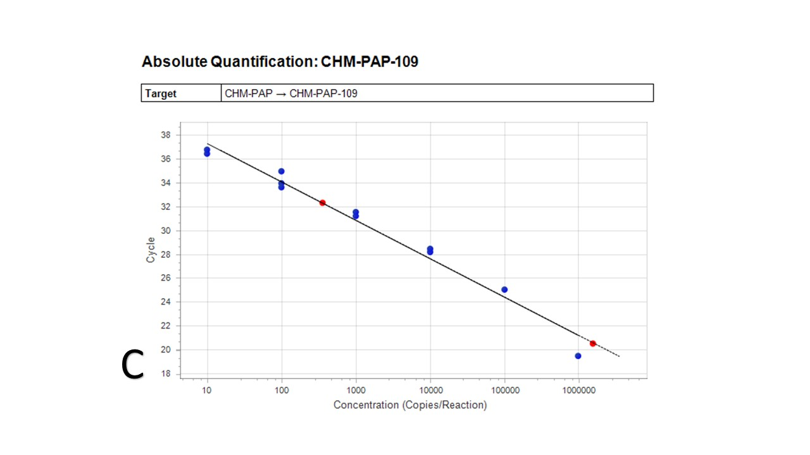
Figure S 1 Absolute quantification and the standard curves for three cloned plasmids: A) GAPDH, B) ChHV5 Dpol and C) CmPV1-E1 were plotted based on the cycles (cq values) and the log of concentration (10 to 10⁸ copies per reaction).
A
Table S 1 The origin of FP tumour samples (Group A) used in this study, including location, turtle tag number, curved carapace length (CCL) and weight. All samples were collected from green turtles, excluding three samples from a green/hawksbill hybrid (*) and one sample from a loggerhead (**). The calculated concentration of each target is provided for each sample (where applicable). The copy number per cell of Chelonia mydas papillomavirus 1 (CmPV1) and/or Chelonid alphaherpesvirus 5 (ChHV5) is per sample (shown as appropriate).
 |  |  | Demographic information (if available) |  |  | Calculated Concentration:  copy number per reaction (2 µL) |  |  | Copy number per cell
Sample region | Sample ID | Tag number |  | CCL (cm) | Weight (kg) | CmPV1 | ChHV5 | GAPDH | CmPV1 | ChHV5
Townsville | CB83FP | QA29610 |  | 45.0 | 8.0 |  | 1.40E+06 | 1.10E+05 |  | 2.55E+01
Townsville | CB93FP | QA36631 |  | 59.6 | 29.0 |  | 878573.1 | 132187.1 |  | 13.29287
Townsville | CB94FP | QA9554 |  | 53.7 | 13.1 |  | 736462.9 | 56987.51 |  | 25.84647
Townsville | CB95FP | QA29605 |  | 57.5 | 22.0 |  | 102.1898 | 34.12851 |  | 5.98853
Townsville | CB96FP | QA32170 |  | 61.1 | 26.0 |  |  | 11295.94
Townsville | CB97FP | K92985 |  | 46.2 | - |  | 296245.1 | 39526.74 |  | 14.98961
Townsville | CB98FP | QA15682 |  | 49.7 | 10.6 |  | 20.40152 | 23485.09 |  | 0.001737
Townsville | CB99FP1 | QA42017 |  | 48.6 | 13.1 |  | 540504.7 | 171407.8 |  | 6.306654
Townsville | CB99FP2 |  |  |  |  | 54.67283 | 417018.6 | 108785.5 | 0.001005 | 7.666805
Townsville | CB100FP? | QA38829 |  | 42.0 | 8.2 |  | 21.44204 | 677.4224 |  | 0.063305
Townsville | CB101FP1 | QA7433 |  | 44.9 | 8.8 | 384.6 | 6.52E+05 | 1.36E+05 | 5.66E-03 | 9.59E+00
Townsville | CB101FP2 |  |  |  |  | 871.7 | 3.19E+06 | 1.95E+05 | 0.008945 | 32.69369
Townsville | CB101FP3 |  |  |  |  | 37.96307 | 921489.6 | 220937.9 | 0.000344 | 8.341616
Townsville | CB102FP1 | QA47530 |  | 48.1 | 12.7 | 702.1854 | 5360.511 | 67088.33 | 0.020933 | 0.159805
Townsville | CB102FP2 |  |  |  |  | 133.3026 | 6554.884 | 63568.35 | 0.004194 | 0.206231
Townsville | CB102FP3 |  |  |  |  | 5045 | 1125 | 6.47E+04 | 0.155999 | 0.034787
Townsville | CB103FP1 | QA7392 |  | 50.2 | 12.9 | 88.65 | 2.50E+05 | 2.58E+05 | 0.000689 | 1.937864
Townsville | CB103FP2 |  |  |  |  | 214.8988 | 434833 | 118051.5 | 0.003641 | 7.366834
Townsville | CB103FP3 |  |  |  |  | 163.0798 | 234421.1 | 44396.28 | 0.007347 | 10.5604
Townsville | CB104FP1 | QA42248 |  | 44.2 | 8.8 |  | 808530.2 | 151929.6 |  | 10.64349
Townsville | CB104FP2 |  |  |  |  |  | 134093.7 | 10722.72 |  | 25.01113
Townsville | CB104FP3 |  |  |  |  | 52.90798 | 245960 | 53662.31 | 0.001972 | 9.166954
Townsville | CB105FP1 | QA38803 |  | 50.5 | 13.4 | 74.3866 | 489490.7 | 147616.6 | 0.001008 | 6.631921
Townsville | CB105FP2 |  |  |  |  | 19.25 | 4.70E+05 | 2.96E+05 | 0.00013 | 3.175397
Townsville | CB106FP1 | QA7381 |  | 53.0 | 14.9 | 80.9203 | 186848.6 | 36285.02 | 0.00446 | 10.29894
Townsville | CB106FP2 |  |  |  |  | 328.3374 | 298552.9 | 30872.87 | 0.02127 | 19.34079
Townsville | CB106FP3 |  |  |  |  | 35.47351 | 119518.3 | 55331.87 | 0.001282 | 4.320054
Townsville | CB107FP1 | QA7388 |  | 49.5 | 13.1 |  | 470056.9 | 104041.2 |  | 9.035978
Townsville | CB107FP2 |  |  |  |  |  | 780594 | 1140585 |  | 1.368761
Townsville | CB107FP3 |  |  |  |  | 20.8703 | 252964.3 | 682013.6 | 6.12E-05 | 0.741816
Townsville | CB108FP1 | QA42923 |  | 43.6 | 6.5 |  | 198.266 | 9170.036 |  | 0.043242
Townsville | CB108FP2 |  |  |  |  | 17.05147 | 214.5014 | 26865.94 | 0.001269 | 0.015968
Townsville | CB108FP3 |  |  |  |  |  | 23.1668 | 1384.618 |  | 0.033463
Townsville | CB109FP1 | QA38835 |  | 50.3 | 15.3 | 694.8 | 1.96E+05 | 1.55E+06 | 0.000897 | 0.252421
Townsville | CB109FP2 |  |  |  |  | 477.2608 | 95185.5 | 59923.15 | 0.015929 | 3.176919
Townsville | CB109FP3 |  |  |  |  | 367.427 | 81824.71 | 46010.18 | 0.015972 | 3.556809
Townsville | CB110FP1 | QA38827 |  | 44.0 | 9.8 |  | 491515.1 | 176833.8 |  | 5.559063
Townsville | CB110FP2 |  |  |  |  | 27.00222 | 116724.7 | 49669.29 | 0.001087 | 4.700076
Townsville | CB110FP3 |  |  |  |  | 205.3986 | 795979.2 | 72820.47 | 0.005641 | 21.86141
Townsville | CB111FP1 | QA36842 |  | 46.3 | 12.5 |  | 522285.4 | 97321.2 |  | 10.73323
Townsville | CB111FP2 |  |  |  |  |  | 526739 | 97293.38 |  | 10.82785
Townsville | CB111FP3 |  |  |  |  |  | 626337.6 | 136207.9 |  | 9.196785
Townsville | CB112FP1 | QA47488* |  | 60.3 | 21.8 |  | 3219.141 | 61.73183 |  | 104.2943
Townsville | CB112FP2 |  |  |  |  |  | 23636.45 | 1442.775 |  | 32.76527
Townsville | CB112FP3 |  |  |  |  |  | 63443.51 | 3841.37 |  | 33.03171
Townsville | CB113FP1 | No Tag |  |  |  |  | 239.0367 | 46.51105 |  | 10.2787
Townsville | CB113FP2 |  |  |  |  |  | 141.8268 | 85.7317 |  | 3.30862
Townsville | CB113FP3 |  |  |  |  |  | 1974.158 | 270.6072 |  | 14.59058
Townsville | CB114FP1 | QA62135 |  | 48.0 | 9.7 | 59.85474 | 1338103 | 152347 | 0.000786 | 17.56652
Townsville | CB114FP2 |  |  |  |  | 88.32 | 2.13E+06 | 2.63E+05 | 0.000672 | 16.23431
Townsville | CB114FP3 |  |  |  |  | 227.478 | 478559.2 | 132242.7 | 0.00344 | 7.237587
Townsville | CB115FP | QA9588 |  |  |  |  | 836.8713 | 27311.15 |  | 0.061284
Bowen | BW99FP | K59365 |  | 46.5 | 11.6 | 206.0745 | 141624.4 | 62956.17 | 0.006547 | 4.499141
Bowen | BW01FP | K52477 |  | 48.4 | 12.0 | 523.4 | 8.714 | 7.88E+04 | 0.013286 | 0.000221
Bowen | BW107FP | K97336 |  | 25.7 | 10.5 | 36.6676 | 2008167 | 332241.6 | 0.000221 | 12.08859
Bowen | BW108FP | QA15758 |  | 49.4 | 13.0 | 10.60037 | 3566.926 | 17655.55 | 0.001201 | 0.404057
Bowen | BW116FP | QA15730 |  | 71.6 | 34.2 | 29.57064 |  | 1517.905 | 0.038962
Bowen | BW117FP | QA15763 |  | 58.0 | 21.9 |  |  | 323.4765
Bowen | BW118FP | QA15774 |  | 48.7 | 11.0 | 535.6 | 393.3 | 1.55E+06 | 0.000691 | 0.000507
Bowen | BW119FP | QA15788 |  | 53.3 | 15.6 | 222 |  | 1.85E+04 | 0.024
Bowen | BW120FP | QA32132** |  | 85.5 | 72.4 |  | 32681.3 | 664.4833 |  | 98.36606
Bowen | BW121FP | QA36607 |  | 73.1 | 43.0 |  |  | 26796.37
Bowen | BW122FP | QA36634 |  | 57.4 | 22.5 | 177.6 | 15.31 | 8.49E+04 | 0.004186 | 0.000361
Bowen | BW123FP | QA7340 |  | 45.3 | 10.2 |  | 381673.2 | 38733.7 |  | 19.70755
Bowen | BW124FP1 | QA36626 |  | 44.8 | - | 47.64 | 5.57E+04 | 3.01E+05 | 0.000317 | 0.370259
Bowen | BW124FP2 |  |  |  |  | 124.4032 | 9514.502 | 38719.79 | 0.006426 | 0.491454
Bowen | BW125FP? | QA36635 |  | 55.9 | 18.0 | 91.28411 |  | 1160.759 | 0.157284
Bowen | BW126FP1 | QA36636 |  | 47.6 | 11.8 | 139 | 540 | 6.37E+04 | 0.004365 | 0.016957
Bowen | BW126FP2 |  |  |  |  |  | 504.0661 | 32806.78 |  | 0.030729
Bowen | BW127FP | K79524 |  | 95.1 | 93.3 |  | 144.0536 | 465.1105 |  | 0.619438
Bowen | BW128FP | K93052 |  | 42.5 | 8.5 | 282.977 | 13146.21 | 56709.25 | 0.00998 | 0.463635
Bowen | BW129FP | K94004 |  | 62.1 | 28.0 | 58.69069 |  | 1059.89 | 0.110749
Bowen | BW130FP | K97113 |  | 47.9 | - | 34.98911 | 1500457 | 441319.3 | 0.000159 | 6.799871
Bowen | BW131FP | K97114 |  | 50.5 | - |  | 1001654 | 134246.2 |  | 14.92265
Bowen | BW132FP | K97117 |  | 45.0 | - |  | 1266036 | 66100.51 |  | 38.30639
Bowen | BW134FP | K97287 |  | 57.0 | - |  | 1161.984 | 423.0933 |  | 5.492801
Bowen | BW135FP | K97288 |  | 46.2 | - |  | 19154.51 | 823.3694 |  | 46.52715
Bowen | BW136FP | K97289 |  | 51.8 | - | 31.38807 | 977766.9 | 114030.7 | 0.000551 | 17.14919
Bowen | BW137FP | QA15638 |  | 48.6 | 11.0 |  | 711360.8 | 53662.31 |  | 26.51249
Bowen | BW138FP | QA15672 |  | 45.3 | 10.6 | 92.18531 |  | 218.2944 | 0.844596
Bowen | BW139FP | QA15678 |  | 76.2 | 43.6 | 81.8215 | 526334.1 | 116521.1 | 0.001404 | 9.034143
Bowen | BW140FP | QA15761 |  | 77.1 | 54.6 | 18.1 |  | 1.73E+05 | 0.000209
Bowen | BW141FP | QA15787 |  | 43.1 | 9.2 |  |  | 735.9959
Bowen | BW142FP | QA15951 |  | 45.4 | - |  | 1015825 | 112528.1 |  | 18.0546
Bowen | BW143FP | QA24175 |  | 45.5 | 9.7 | 48.73993 | 10522.63 | 23596.39 | 0.004131 | 0.891885
Bowen | BW144FP | QA29702 |  | 44.4 | 10.0 |  | 1783868 | 37523.27 |  | 95.08061
Bowen | BW145FP | QA36630 |  | 47.8 | 13.0 |  | 959.5476 | 73.93351 |  | 25.95704
Bowen | BW146FP? | QA47548 |  | 42.1 | 9.4 |  | 5716.798 | 116980.2 |  | 0.09774
Bowen | BW147FP? | K52483 |  | 52.3 | 14.8 |  |  | 40.52847
Bowen | BW148FP? | K97048 |  | 46.6 | - |  |  | 118.6637
Bowen | BW149FP? | K97070 |  | 69.8 | 35.7 |  |  | 218.5727
Bowen | BW150FP? | QA15666 |  | 46.9 | 12.0 |  | 108.8702 | 265.1811 |  | 0.821101
Bowen | BW151FP | QA9536 |  | 44.6 | 8.4 |  |  | 38.6224
Bowen | BW151FP? |  |  |  |  |  |  | 466.9192
Bowen | BW152FP | K52464 |  | 54.0 | - | 989.7 | 6731 | 4.58E+05 | 0.004327 | 0.029425
Bowen | BW153FP | K92663 |  | 44.7 | - | 56.70054 | 994366.6 | 649735.5 | 0.000175 | 3.060835
Bowen | BW154FP | K93074 |  | 45.0 | 11.0 |  | 1050644 | 2893897 |  | 0.72611
Bowen | BW155FP | K93640 |  | 47.9 | 11.8 |  | 3464088 | 1747469 |  | 3.964693
Bowen | BW156FP | K97025 |  | 48.1 | - | 2.74E+05 | 229.2 | 5.20E+05 | 1.052915 | 0.000882
Bowen | BW158FP | K97483 |  | 48.5 | - |  | 4198527 | 357145.9 |  | 23.51155
Bowen | BW159FP | QA15979 |  | 47.2 | - | 691.5 | 6.75E+07 | 1.07E+06 | 0.001289 | 125.8155
Bowen | BW160FP | QA15980 |  | 44.0 | - | 700.6 | 5.46E+06 | 6.30E+05 | 0.002224 | 17.33333
Bowen | BW162FP | K93038 |  |  |  | 289.6609 | 10591.46 | 396380.4 | 0.001462 | 0.053441
Bowen | 9231 | 09-231 |  | 57.1 | - |  | 7890963 | 1897729 |  | 8.316219
Bowen | QA4962 |  |  | 44.5 | - |  | 3593647 | 440901.9 |  | 16.30135
Brisbane | MB01FP1 | No tag 1 |  | 46.3 | - |  | 3357202 | 1426079 |  | 4.708297
Brisbane | MB01FP2 |  |  |  | - | 138.2 | 2.96E+06 | 2.63E+05 | 0.001052 | 22.53521
Brisbane | MB01FP3 |  |  |  | - | 76.03 | 3.60E+06 | 2.39E+05 | 0.000636 | 30.07525
Brisbane | MB03FP1 | No tag 3 |  | 44.4 |  |  | 1341747 | 380937 |  | 7.044456
Brisbane | MB03FP2 |  |  |  |  |  | 1085463 | 428380.2 |  | 5.067754
Brisbane | MB03FP3 |  |  |  |  |  | 1793180 | 168068.6 |  | 21.33866
Brisbane | MB04FP1 | No tag 4 |  | 43.1 | - |  | 1473331 | 644726.9 |  | 4.570403
Brisbane | MB04FP2 |  |  |  |  |  | 1671718 | 366606.7 |  | 9.119955
Brisbane | MB05FP | QA45711 |  | 52.1 | - |  | 526739 | 130350.6 |  | 8.081882
Brisbane | MB06FP1 | K87178 |  | 62.3 | - |  |  | 1102.324
Brisbane | MB07FP1 | Kerry |  |  |  | 30.86612 | 2760.825 | 24.33378 | 2.536895 | 226.913
Brisbane | SW01FP1 | Alice |  | 45.0 | - |  | 1464828 | 1452514 |  | 2.016956
Brisbane | SW01FP2 |  |  |  |  |  | 1200042 | 555127.4 |  | 4.323483
Brisbane | SW02FP1 | Tay |  | 52.4 | - |  | 421877 | 68090.06 |  | 12.39174
Brisbane | SW02FP2 |  |  |  |  | 69.20469 | 3409431 | 133954 | 0.001033 | 50.90448
Gladstone | GS52FP1 | QA34793 |  | 101.1 | 126.0 | 465.8 | 873.4 | 1.73E+05 | 0.005388 | 0.010103
Gladstone | GS72FP | QA58207 |  | 60.2 | 24.0 | 30.16769 | 124822.2 | 60702.27 | 0.000994 | 4.112603
Gladstone | GS73FP | QA58252 |  | 60.3 | 23.3 |  |  | 63999.65
Gladstone | GS74FP | QA58271 |  | 70.1 | 36.5 |  |  | 87067.35
Cairns | CN01FP1 | Roxy |  | 47.6 | - | 280.9117 | 15494467 | 295511.4 | 0.001901 | 104.8654
Cairns | CN01FP2 |  |  |  |  | 52.11943 | 4125650 | 1471992 | 7.08E-05 | 5.605533
Cairns | CN02FP1 | Destiny |  |  |  | 150.3 | 1.99E+05 | 5.35E+04 | 0.005621 | 7.430815
Airlie Beach | AB01FP1 | No tag |  | 49.0 | - |  | 615406.1 | 360485 |  | 3.414323
Airlie Beach | AB01FP2 |  |  |  |  | 163.9059 | 419042.9 | 345041.6 | 0.00095 | 2.428942
Airlie Beach | AB01FP3 |  |  |  |  | 57.86459 | 822700.7 | 397632.6 | 0.000291 | 4.137994
Airlie Beach | AB01FP4 |  |  |  |  |  | 868046.4 | 409597.7 |  | 4.238531

Table S 2 The origin of samples of non-tumoured skin from turtles with FP tumours (Group B samples) used in this study, including location, turtle tag number, curved carapace length (CCL) and weight. All samples were collected from green turtles, excluding one sample from a loggerhead (Caretta caretta) (**). The calculated concentration of each target is provided for each sample (where applicable). The copy number per cell of Chelonia mydas papillomavirus 1 (CmPV1) and/or Chelonid alphaherpesvirus 5 (ChHV5) is per sample (shown as appropriate).
 |  | Demographic information (if available) |  |  | Calculated Concentration:  copy number per reaction (2 µL) |  |  | Copy number per cell
Sample region | Sample ID | Tag number | CCL (cm) | Weight (kg) | CmPV1 | ChHV5 | GAPDH | CmPV1 | ChHV5
Townsville | CB83N | QA29610 | 45.0 | 8.0 |  |  | 152.7935
Townsville | CB99N | QA42017 | 48.6 | 13.1 |  |  | 4984.502
Townsville | CB101N | QA7433 | 44.9 | 8.8 |  |  | 251.6029
Townsville | CB102N | QA47530 | 48.1 | 12.7 |  |  | 9585.92
Townsville | CB103N | QA7392 | 50.2 | 12.9 |  |  | 2382.61
Townsville | CB104N | QA42248 | 44.2 | 8.8 |  |  | 6637
Townsville | CB105N | QA38803 | 50.5 | 13.4 |  |  | 381.9397
Townsville | CB106N | QA7381 | 53.0 | 14.9 |  | 14.03 | 2.06E+04 |  | 0.001361
Townsville | CB107N | QA7388 | 49.5 | 13.1 |  |  | 152.7935
Townsville | CB108N | QA42923 | 43.6 | 6.5 | 247 |  | 1.03E+04 | 0.047776
Townsville | CB109N | QA38835 | 50.3 | 15.3 |  |  | 689.5522
Townsville | CB110N | QA38827 | 44.0 | 9.8 |  |  | 168.9975
Townsville | CB111N | QA36842 | 46.3 | 12.5 | 11.29 | 7756 | 2.01E+05 | 1.13E-04 | 0.077289
Bowen | BW01N | K52477 | 48.4 | 12.0 |  |  | 1.59E+04
Bowen | BW99N | K59365 | 46.5 | 11.6 | 5545 |  | 4.36E+04 | 0.254241
Bowen | BW107N | K97336 | 25.7 | 10.5 |  |  | 1894.727
Bowen | BW108N | QA15758 | 49.4 | 13.0 |  | 113 | 5107.794 | 0.000163 | 0.002029
Bowen | BW116N | QA15730 | 71.6 | 34.2 |  |  | 4025.03
Bowen | BW117N | QA15763 | 58.0 | 21.9 |  |  | 5270.715
Bowen | BW118N | QA15774 | 48.7 | 11.0 |  |  | 2045.76
Bowen | BW119N | QA15788 | 53.3 | 15.6 | 9.80E+04 |  | 2.60E+04 | 7.535563
Bowen | BW120N | QA32132** | 85.5 | 72.4 | 29.30379 |  | 575.9478 | 0.101758
Bowen | BW121N | QA36607 | 73.1 | 43.0 |  |  | 8326.585
Bowen | BW122N | QA36634 | 57.4 | 22.5 | 6140 |  | 2.73E+04 | 0.450312
Bowen | BW124N | QA36626 | 44.8 | - |  |  | 5151.827
Bowen | BW125N | QA36635 | 55.9 | 18.0 | 46.79859 |  | 4460.513 | 0.020983
Bowen | BW126N | QA36636 | 47.6 | 11.8 | 143.9676 |  | 4905.244 | 0.058699
Bowen | BW145N | QA36630 | 47.8 | 13.0 |  |  | 559.6557
Gladstone | GS52N | QA34793 | 101.1 | 126.0 | 5089 |  | 1.15E+05 | 0.088427
Gladstone | GS72N | QA58207 | 60.2 | 24.0 |  |  | 3375.547
Gladstone | GS73N | QA58252 | 60.3 | 23.3 |  |  | 2107.846
Gladstone | GS74N | QA58271 | 70.1 | 36.5 |  |  | 2542.889
Brisbane | MB01N | No tag 1 | 46.3 | - |  | 25.52748 | 47467.26 |  | 0.001076
Brisbane | MB03N | No tag 3 | 44.4 | - |  |  | 1.04E+04
Brisbane | MB05N | QA45711 | 52.1 | - |  |  | 2341.659
Brisbane | MB06N | K87178 | 62.3 | - |  |  | 638.0339

Table S 3 The origin of samples of non-tumoured skin from turtles without FP tumours (Group C samples) used in this study, including location, turtle tag number, curved carapace length (CCL) and weight. All samples were collected from green turtles. The calculated concentration of each target is provided for each sample (where applicable). The copy number per cell of Chelonia mydas papillomavirus 1 (CmPV1) and/or Chelonid alphaherpesvirus 5 (ChHV5) is per sample (shown as appropriate).
 |  | Demographic information (if available) |  |  | Calculated Concentration:  copy number per reaction (2 µL) |  |  | Copy number per cell
Sample region | Sample ID | Tag number | CCL (cm) | Weight (kg) | CmPV1 | ChHV5 | GAPDH | CmPV1 | ChHV5
Townsville | CB01 | QA32220 | 44.7 | 9.6 |  |  | 7.47E+10
Townsville | CB02 | K92947/QA29615 | 47.4 | 10.0 |  |  | 1054004
Townsville | CB03 | QA32265 | 48.3 | 48.0 | 472.9 |  | 1.75E+11 | 5.42E-09
Townsville | CB04 | QA29616 | 66.4 | 30.0 |  |  | 4.71E+10
Townsville | CB05 | K56931 | 46.6 | 12.0 |  |  | 2.03E+11
Townsville | CB06 | K18987 | 46.3 | 11.0 |  |  | 9.76E+09
Townsville | CB07 | QA29706 | 42.7 | 8.2 |  |  | 115230.7
Townsville | CB09 | QA32222 | 54.3 | 17.1 | 135.2 |  | 415974.6 | 0.00065
Townsville | CB10 | QA29603 | 48.4 | 13.0 |  |  | 1750133
Townsville | CB11 | QA29709 | 62.5 | - |  |  | 1038195
Townsville | CB12 | QA9469 | 45.2 | 9.5 |  |  | 210205
Townsville | CB13 | QA29712 | 75.7 | - |  |  | 147270.7
Townsville | CB14 | QA29711 | 45.4 | 10.8 |  |  | 187592.2
Townsville | CB16 | QA29604 | 52.2 | 16.5 |  |  | 261816.5
Townsville | CB18 | QA29707 | 48.0 | 13.6 |  |  | 599831.6
Townsville | CB20 | QA32206 | 46.9 | 10.5 | 135.8 |  | 782863.6 | 0.000347
Townsville | CB21 | QA29601 | 48.6 | 13.0 |  |  | 271393.4
Townsville | CB22 | K90948 | 43.2 | 9.0 | 7452 |  | 182648.2 | 0.0816
Townsville | CB23 | QA32212 | 42.2 | 8.8 | 546.1 |  | 202033.1 | 0.005406
Townsville | CB24 | QA32215 | 69.4 | - |  |  | 291322.8
Townsville | CB25 | QA32213 | 46.5 | 10.8 |  |  | 1.75E+11
Townsville | CB26 | QA9595 | 50.9 | 15.0 |  |  | 4.71E+10
Townsville | CB27 | QA29605 | 57.4 | 22.0 |  |  | 2.03E+11
Townsville | CB28 | K92803 | 83.2 | - |  |  | 9.76E+09
Townsville | CB29 | K92644 | 60.0 | - |  |  | 1.09E+10
Townsville | CB30 | K92999 | 47.2 | - | 240.7 |  | 484542.3 | 0.000994
Townsville | CB31 | QA32211/K40368 | 44.2 | 8.5 | 107 |  | 759056.1 | 0.000282
Townsville | CB32 | K59356 | 45.2 | 10.2 | 653.4 |  | 1581766 | 0.000826
Townsville | CB33 | QA29620 | 48.7 | 14.5 |  |  | 87366.36
Townsville | CB34 | K92670 | 70.8 | - |  |  | 317240.5
Townsville | CB35 | QA32242 | 85.8 | - |  | 88.7 | 1046292 |  | 0.00017
Townsville | CB36 | QA32275 | 73.6 | - |  | 2.22E+05 | 116871.9 |  | 3.792186
Townsville | CB37 | QA32250 | 86.6 | - |  | 55.47 | 125619.5 |  | 0.000883
Townsville | CB38 | QA32234 | 71.8 | - |  |  | 698437.2
Townsville | CB39 | K92985 | 46.2 | - |  |  | 144322.9
Townsville | CB40 | QA15846 | 103.9 | - |  |  | 115230.7
Townsville | CB41 | K90921 | 40.8 | 7.1 |  |  | 69273.49
Townsville | CB42 | QA15682 | 49.7 | 10.6 |  |  | 274325.9
Townsville | CB43 | K92980 | 46.4 | 9.6 |  |  | 176742.8
Townsville | CB44 | QA32300 | 48.5 | 11.8 |  |  | 162074.6
Townsville | CB45 | K92981 | 50.7 | 11.9 | 87.23 |  | 254332.9 | 0.000686
Townsville | CB46 | K92982 | 45.2 | 9.1 |  |  | 374370.4
Townsville | CB47 | K92990 | 74.6 | - | 1189 |  | 283515.5 | 0.008388
Townsville | CB48 | QA9280 | 100.9 | - |  |  | 1.52E+05
Townsville | CB49 | QA36779 | 46.6 | - |  |  | 1.1E+09
Townsville | CB50 | QA9279 | 48.8 | - |  |  | 1.09E+10
Townsville | CB51 | QA9528 | 43.9 | - |  |  | 4.39E+05
Townsville | CB52 | QA9283 | 46.3 | - |  |  | 3.93E+05
Townsville | CB53 | K88974 | 68.5 | - |  |  | 6.11E+05
Townsville | CB54 | K92949 | 48.9 | 12.1 |  |  | 115230.7
Townsville | CB55 | QA9277 | 47.8 | - |  |  | 5.97E+10
Townsville | CB56 | K74948 | 55.7 | - |  | 131.6 | 9.95E+05 |  | 0.000264
Townsville | CB57 | QA36799 | 50.4 | - |  | 1.42E+05 | 1.44E+11 |  | 1.97E-06
Townsville | CB58 | QA36776 | 93.2 | - |  |  | 3.81E+10
Townsville | CB59 | QA36778 | 108.1 | - |  |  | 1.46E+11
Townsville | CB60 | K92989 | 68.7 | - | 106.6 |  | 6.84E+09 | 3.12E-08
Bowen | BW02 | QA15707 | 46.8 | 10.8 |  |  | 3.23E+05
Bowen | BW03 | QA29729 | 45.9 | 11.4 |  |  | 1.18E+06
Bowen | BW04 | QA36605 | 113.9 | 130+ |  |  | 7.21E+05
Bowen | BW05 | QA15776 | 45.0 | 8.7 | 1424 |  | 1.69E+05 | 0.016902
Bowen | BW06 | QA15785 | 49.1 | 10.5 |  |  | 1.07E+05
Bowen | BW07 | K59353 | 60.6 | 21.9 | 12.63 |  | 1.45E+05 | 0.000175
Bowen | BW08 | K59391 | 45.5 | 9.5 | 93.03 |  | 1.58E+05 | 0.001181
Bowen | BW09 | K92959 | 42.5 | 7.7 |  |  | 1.90E+05
Bowen | BW10 | QA15796 | 54.0 | 17.5 | 25.13 |  | 3.04E+05 | 0.000165
Bowen | BW11 | QA36603 | 80.5 | 48.0 |  |  | 4.39E+05
Bowen | BW12 | QA36606 | 85.7 | 61.0 |  | 164.4 | 3.93E+05 |  | 0.000838
Bowen | BW13 | QA15777 | 44.4 | 7.9 |  |  | 6.11E+05
Bowen | BW14 | QA32125 | 42.3 | 9.1 |  |  | 2.13E+05
Bowen | BW15 | QA32123 | 48.1 | 12.6 |  |  | 1.58E+05
Bowen | BW16 | QA15968 | 47.0 | 11.6 |  |  | 1.64E+05
Bowen | BW17 | K52467 | 58.5 | 22.2 | 1.36E+04 |  | 2.38E+05 | 0.114262
Bowen | BW18 | K94004 | 63.0 | 25.1 | 6286 |  | 8.93E+04 | 0.140863
Bowen | BW19 | K92945 | 46.0 | 10.2 | 67.85 |  | 4.44E+04 | 0.003056
Bowen | BW20 | QA15794 | 49.0 | 12.1 | 11.21 |  | 5.08E+04 | 0.000442
Bowen | BW21 | QA15782 | 58.0 | 19.3 | 105.2 |  | 1.82E+05 | 0.001154
Bowen | BW22 | QA15799 | 64.0 | 23.6 | 100.2 |  | 2.54E+05 | 0.00079
Bowen | BW23 | K97074 | 97.0 | 97.1 |  | 4129 | 3.86E+05 |  | 0.021394
Bowen | BW24 | QA15769 | 97.0 | 100.2 | 12.95 |  | 5.81E+05 | 4.46E-05
Bowen | BW25 | K97161 | 89.0 | 74.8 |  | 29.07 | 1.29E+06 |  | 4.50E-05
Bowen | BW26 | QA15732 | 82.3 | 60.8 |  | 46.72 | 7.40E+04 |  | 0.001263
Bowen | BW27 | QA10912 | 103.3 | 126.5 | 21.16 |  | 3.20E+05 | 0.000132
Bowen | BW28 | QA15748 | 97.5 | 94.0 | 504.9 |  | 1.00E+06 | 0.001006
Bowen | BW29 | QA15746 | 106.5 | 134.3 |  |  | 1.21E+05
Bowen | BW30 | K97284 | 53.8 | 13.3 | 13.29 | 8401 | 1.43E+05 | 0.000185 | 0.117251
Bowen | BW31 | QA15733 | 64.5 | 30.9 |  |  | 6.00E+05
Bowen | BW32 | QA15766 | 43.7 | 8.5 |  |  | 1.37E+05
Bowen | BW33 | QA15740 | 65.9 | 29.5 |  |  | 1.19E+05
Bowen | BW34 | K59377 | 44.5 | 10.1 |  | 17.18 | 7.21E+04 |  | 0.000476
Bowen | BW35 | QA15717 | 47.6 | 10.3 |  |  | 2.60E+05
Bowen | BW36 | QA15709 | 44.4 | 8.3 | 38.34 | 11.1 | 1.51E+05 | 0.000506 | 0.000147
Bowen | BW37 | K59378 | 47.5 | 12.2 | 208.2 |  | 1.55E+05 | 0.00268
Bowen | BW38 | QA15718 | 49.2 | 13.7 | 276.1 |  | 2.47E+05 | 0.00224
Bowen | BW39 | QA15770 | 44.5 | 8.2 | 54.92 |  | 3.59E+05 | 0.000306
Bowen | BW40 | QA15775 | 43.5 | 10.0 |  |  | 2.92E+05
Bowen | BW41 | QA15747 | 45.1 | 10.0 | 18.55 |  | 1.52E+05 | 0.000244
Bowen | BW42 | QA15710 | 56.5 | 16.9 |  |  | 1.02E+09
Bowen | BW43 | QA15764 | 47.5 | 12.5 | 27.08 |  | 7.30E+08 | 7.42E-08
Bowen | BW44 | QA15767 | 49.3 | 13.9 |  |  | 6.14E+08
Bowen | BW45 | K97135 | 46.8 | 12.5 | 129.3 | 1143 | 1.11E+08 | 2.34E-06 | 2.07E-05
Bowen | BW46 | QA15731 | 55.0 | 19.9 | 3.66E+04 |  | 2.26E+08 | 0.000324
Bowen | BW47 | QA15736 | 41.2 | 7.4 | 46.8 |  | 1.15E+07 | 8.13E-06
Bowen | BW48 | K59376 | 57.5 | 18.9 | 696.7 |  | 9.07E+08 | 1.54E-06
Bowen | BW49 | QA15771 | 47.4 | 11.2 | 108.4 |  | 1.85E+09 | 1.18E-07
Bowen | BW50 | K59383 | 45.8 | 9.9 | 75.02 |  | 1.04E+08 | 1.44E-06
Bowen | BW51 | K59381 | 48.4 | 13.0 | 111.8 |  | 3.82E+07 | 5.85E-06
Bowen | BW52 | QA32101 | 44.7 | 10.5 | 275.4 |  | 8.65E+07 | 6.37E-06
Bowen | BW53 | QA29752 | 42.7 | 9.8 | 1043 |  | 1.74E+08 | 1.20E-05
Bowen | BW54 | K52467 | 57.4 | 21.8 | 194.3 |  | 3.27E+08 | 1.19E-06
Bowen | BW55 | QA15783 | 44.8 | 11.8 | 186.7 |  | 5.59E+08 | 6.69E-07
Bowen | BW56 | K52461 | 61.5 | 28.0 |  |  | 1.64E+09
Bowen | BW57 | K59382 | 58.0 | 22.0 | 973.7 |  | 4.89E+08 | 3.98E-06
Bowen | BW58 | QA36658 | 44.1 | 10.0 | 112.1 |  | 2.58E+09 | 8.70E-08
Bowen | BW59 | QA36604 | 46.8 | 11.0 |  |  | 1.66E+08
Bowen | BW60 | QA36612 | 93.5 | 86.0 | 35.99 |  | 4.64E+07 | 1.55E-06
Bowen | BW61 | QA36655 | 45.5 | 12.0 |  |  | 3.55E+08
Bowen | BW62 | QA36820 | 46.7 | 13.0 | 61.73 |  | 1.27E+09 | 9.75E-08
Bowen | BW63 | QA32124 | 57.0 | 22.5 | 539.8 | 952.4 | 7.63E+07 | 1.42E-05 | 2.50E-05
Bowen | BW64 | QA24108 | 48.6 | 12.6 | 1.02E+04 |  | 4.74E+08 | 4.31E-05
Bowen | BW65 | QA29731 | 65.6 | 34.5 | 220.7 | 11.16 | 4.91E+08 | 9.00E-07 | 4.55E-08
Bowen | BW66 | QA15716 | 67.8 | 34.0 | 29.72 |  | 2.00E+08 | 2.97E-07
Bowen | BW67 | QA36625 | 55.1 | 23.0 | 1318 |  | 5.57E+08 | 4.73E-06
Bowen | BW68 | QA32120 | 56.5 | 20.4 | 1848 |  | 6.34E+08 | 5.83E-06
Bowen | BW69 | QA29745 | 50.6 | 14.5 | 3.36E+05 |  | 6.83E+08 | 0.000983
Bowen | BW70 | QA36611 | 51.6 | 14.5 |  |  | 4.33E+08
Bowen | BW71 | QA32122 | 37.2 | 13.1 | 91.59 |  | 1.86E+07 | 9.83E-06
Bowen | BW72 | QA36608 | 43.7 | 12.5 | 467.6 |  | 4.80E+08 | 1.95E-06
Bowen | BW73 | QA36656 | 43.5 | 10.2 | 86.26 |  | 3.95E+08 | 4.37E-07
Bowen | BW74 | QA29730 | 44.2 | 10.7 | 933.8 |  | 6.39E+08 | 2.92E-06
Bowen | BW75 | QA36676 | 44.3 | 9.5 | 52.07 |  | 1.28E+08 | 8.16E-07
Bowen | BW76 | QA36679 | 45.8 | 9.0 | 96.83 |  | 3.15E+08 | 6.15E-07
Bowen | BW77 | QA36677 | 43.0 | 10.0 | 33.6 | 484.6 | 4.24E+07 | 1.59E-06 | 2.29E-05
Bowen | BW78 | QA36684 | 51.4 | 16.0 | 253.5 |  | 7.92E+07 | 6.40E-06
Bowen | BW79 | QA15641 | 53.6 | 17.6 | 2009 |  | 6.74E+08 | 5.96E-06
Bowen | BW80 | QA32109 | 43.7 | 20.6 |  | 1.97E+04 | 1.10E+09 |  | 3.60E-05
Bowen | BW81 | QA32104 | 47.5 | 21.6 | 28.97 |  | 3.33E+08 | 1.74E-07
Gladstone | GS01 | QA33350 | 42.1 | 7.5 |  |  | 2.51E+10
Gladstone | GS02 | QA33349 | 42.5 | 8.9 |  | 3.64E+04 | 4.13E+12 |  | 1.76E-08
Gladstone | GS03 | QA33342 | 111.0 | 153.0 |  | 2217 | 7.47E+11 |  | 5.93E-09
Gladstone | GS04 | QA33363 | 107.4 | 141.0 |  | 1579 | 7.07E+12 |  | 4.47E-10
Gladstone | GS05 | QA33340 | 96.3 | 97.0 |  | 36.32 | 1.56E+12 |  | 4.66E-11
Gladstone | GS06 | QA33373 | 99.4 | 117.0 |  |  | 2.13E+12
Gladstone | GS07 | QA33352 | 88.3 | 94.0 |  | 601.9 | 6.42E+10 |  | 1.88E-08
Gladstone | GS08 | QA33341 | 95.1 | 88.0 |  | 1186 | 4.72E+11 |  | 5.03E-09
Gladstone | GS09 | QA33332 | 79.6 | 55.0 |  | 327.7 | 2.47E+12 |  | 2.66E-10
Gladstone | GS10 | QA33330 | 98.0 | 108.0 |  | 666.4 | 2.52E+12 |  | 5.29E-10
Gladstone | GS11 | QA33357 | 106.0 | 128.0 |  | 6170 | 1.28E+12 |  | 9.66E-09
Gladstone | GS12 | QA33343 | 95.4 | 97.0 |  | 2.19E+05 | 1.82E+12 |  | 2.40E-07
Gladstone | GS13 | QA39981 | 100.3 | 103.0 |  | 5.44E+04 | 2.12E+12 |  | 5.12E-08
Gladstone | GS14 | QA33354 | 87.1 | 66.0 |  | 183.2 | 3.24E+12 |  | 1.13E-10
Gladstone | GS15 | QA33333 | 79.7 | 53.5 |  | 1845 | 4.44E+12 |  | 8.31E-10
Gladstone | GS16 | QA33329 | 63.9 | 30.0 |  |  | 5.01E+12
Gladstone | GS17 | QA34529 | 47.9 | 11.8 |  |  | 3.38E+14
Gladstone | GS18 | QA33337 | 48.5 | 14.1 |  |  | 2.70E+10
Gladstone | GS19 | QA33370 | 47.5 | 11.4 |  | 536.4 | 1.21E+07 |  | 8.87E-05
Gladstone | GS20 | QA33365 | 60.0 | 22.9 |  |  | 2.38E+11
Gladstone | GS21 | QA33368 | 46.0 | 11.8 |  |  | 9.38E+07
Gladstone | GS22 | QA33367 | 52.1 | 17.0 |  |  | 5.77E+12
Gladstone | GS23 | QA33375 | 49.1 | 14.7 |  | 216.3 | 3.52E+08 |  | 1.23E-06
Gladstone | GS24 | K70229 | 105.7 | 142.0 |  | 110.9 | 4.51E+12 |  | 4.92E-11
Gladstone | GS25 | QA43067 | 105.7 | 140.0 |  |  | 176742.8
Gladstone | GS26 | QA43063 | 93.5 | 93.0 |  |  | 162074.6
Gladstone | GS27 | QA43068 | 96.1 | 106.0 |  |  | 254332.9
Gladstone | GS28 | QA43065 | 97.7 | 96.0 |  |  | 2.52E+12
Gladstone | GS29 | QA43056 | 52.7 | 17.8 |  |  | 1.28E+12
Gladstone | GS30 | QA43061 | 84.3 | 75.0 |  |  | 1.82E+12
Gladstone | GS31 | QA43060 | 74.8 | 45.0 |  |  | 5.56E+13
Gladstone | GS32 | QA43055 | 85.1 | 75.0 |  |  | 1.54E+12
Gladstone | GS33 | QA43058 | 88.7 | 72.0 |  | 14.38 | 1.15E+12 |  | 2.49E-11
Gladstone | GS34 | QA43059 | 99.5 | 120.0 |  |  | 7.55E+11
Gladstone | GS35 | QA27998 | 41.6 | 7.6 | 385.5 |  | 1.31E+10 | 5.89E-08
Gladstone | GS36 | QA43053 | 44.5 | 8.6 | 6688 |  | 1.90E+11 | 7.05E-08
Gladstone | GS37 | QA27997 | 60.0 | 19.0 | 141.9 |  | 4.15E+10 | 6.84E-09
Gladstone | GS38 | QA43044 | 43.1 | 6.5 |  |  | 5.37E+09
Gladstone | GS39 | QA43043 | 42.6 | 6.2 |  |  | 4.01E+10
Gladstone | GS40 | QA43023 | 102.7 | 131.0 |  |  | 1.04E+12
Gladstone | GS41 | QA43031 | 59.8 | 26.0 |  |  | 7.64E+09
Gladstone | GS42 | QA43022 | 90.6 | 82.0 |  | 18.86 | 1.09E+10 |  | 3.45E-09
Gladstone | GS43 | QA43033 | 56.0 | 21.0 |  | 169.2 | 2.59E+09 |  | 1.31E-07
Gladstone | GS44 | QA43036 | 80.6 | 64.0 | 66.39 | 8356 | 2.12E+09 | 6.27E-08 | 7.89E-06
Gladstone | GS45 | QA43041 | 94.3 | 92.0 |  | 850.8 | 3.37E+09 |  | 5.05E-07
Gladstone | GS46 | QA43003 | 43.3 | 8.8 |  | 86.45 | 5.58E+07 |  | 3.10E-06
Gladstone | GS47 | QA43004 | 93.8 | 104.0 |  |  | 7.38E+09
Gladstone | GS48 | QA43035 | 64.6 | 32.0 |  |  | 9.29E+09
Gladstone | GS49 | QA34580 | 46.2 | 10.8 | 62.42 |  | 6.22E+06 | 2.01E-05
Gladstone | GS50 | QA34576 | 43.4 | 9.9 | 593.1 |  | 1.09E+10 | 2.09E-03

Table S 4 The average copy number of ChHV5 in various units calculated in different studies in comparison to the current study
The copy number per reaction of GAPDH is consistent in samples from green turtles with and without FP tumours. In other words, there is no significant difference between the quantities of tissues used for the qPCR reactions and subsequently viral load comparison (P value: 0.282). As the starting tissue mass appeared to be similar in samples, after calculating the DNA extraction elute volume (50µL of extracted DNA in DNase free water to 20µL of PCR reaction) the estimated mean of ChHV5 viral loads appears to be approximately 3.707×105 copies/µL of DNA extract from tumour tissues. This unit calculation enabled us to compare our results of ChHV5 viral loads with previous studies that used different protocols and calculated copies/cell, copies/µL of samples in PCR reaction or copies/µgr of DNA (Table S7). Overall, the results in this study are consistent with studies in other regions.
 |  |  | Quackenbush et al., 2001 | Greenblatt, et al., 2005 | Page-Karjian et al., 2015 | Alfaro-Núñez et al., 2016 | Current study
FP-afflicted turtles | FP Tumour Samples (Group A in the present study) | Copies/cell | 15.21 | 13.9 | - | 15.61 ± 12.5 | 15.635± 30.152
 |  | copies/µL of samples in PCR reaction | - | - | - | 4.9×10⁴ | 4.297×10⁵
 |  | copies/µg of DNA | 3.3× 10⁴ to 4.9× 10⁶ | - | 3.24 × 10⁸  (1.6 × 10³ -2.0 × 10⁹) | - | 5.367×10⁵
 | Non-tumoured skin from turtles with FP tumours  (Group B in the present study) | Copies/cell | - | 0.03$ | - | 0.02 ± 0.00 | 0.020± 0.0379
 |  | copies/µL of samples in PCR reaction | - | - | - | 1.8×10¹ | 1.818×10²
 |  | copies/µg of DNA | 122 ± 82.67 | - | 22722  (2.5 × 10² - 7.1 × 10⁴) | - | 2.272×10³
Non-tumoured turtles  (Group C in the present study) |  | Copies/cell | - | - | - | 6.03 | 0.100± 0.606
 |  | copies/µL of samples in PCR reaction | - | - | - | 5.8×10⁴ | 2.614×10³
 |  | copies/µg of DNA | - | - | 5463  (6.0 × 10² - 1.7 × 10⁴) | - | 3.269×10³

