Article
Title: Potential Hazards at the New York City Bridges, 1982 – 2006
Bojidar Yanev ¹
Citation: Lastname, F.; Lastname, F.; Lastname, F. Title. Sustainability 2021, 13, x. https://doi.org/10.3390/xxxxx
Academic Editor: Firstname Lastname
Received: date
Accepted: date
Published: date
Publisher’s Note: MDPI stays neutral with regard to jurisdictional claims in published maps and institutional affiliations.
Copyright: © 2021 by the authors. Submitted for possible open access publication under the terms and conditions of the Creative Commons Attribution (CC BY) license (http://creativecommons.org/licenses/by/4.0/).
¹ Adjunct Professor, Department of Civil Engineering & Engineering Mchanics,Columbia University, New York; bojidaryanev1@gmail.com
Abstract: New York State Department of Transportation designates potentially hazardous conditions on bridges as flags. From 1982 until 2006 the flags issued for the bridges owned by New York City underwent all phases typical of crises, including a gradual increase, an exponential expansion, an extended peak, a gradual decline, and a convergence to a higher but manageable level. The attempts to forecast the flag pattern as it was developing are reviewed for possible relevance to management of the transportation infrastructure and in general.

Keywords: bridge, condition, flag, forecast, management, sustainability

1. Introduction
The Federal-Aid Highway Act of 1968 initiated modern vehicular bridge management in the United States, and by extension, worldwide. The National Bridge Inventory (NBI), established by the Federal Highway Administration (FHWA) quickly built a database of 230,000 bridges and is currently approaching 650,000. A vehicular tunnel database was initiated in 2015. Integration of the railroad bridge database is expected.
In its present form, NBI is equipped to support strategic lifecycle decisions on local and
national levels. Originally however, its overwhelming priority was to identify and avert disasters, such as the collapse of the Silver Bridge at Point Pleasant in 1967. Tactically, potential hazards had to be promptly identified and mitigated. Strategically, realistic life-cycle bridge performance had to be modeled and optimized. To these ends, the Act mandated biennial inspections of vehicular bridges, and hence, the assessment of their conditions [1]. To serve both objectives, the visual biennial inspections had to supply actionable qualitative and quantitative assessments of bridge conditions.

2. Bridge Conditions
In order to support decisions allocating considerable public funds to transportation networks, bridge management systems must integrate information from all pertinent and reliable sources in concise actionable form. The NBI compensates for the vagueness of the term ‘condition’ with a database of complementary qualitative and quantitative, descriptive and prescriptive bridge assessments. Local owners supplemented NBI according to their specific needs. Table 1 illustrates the essential evaluations and appraisals. The resulting condition database, illustrated in Fig. 1, supports bridge management decisions on both project and network levels. Milestones in that process were the introduction, by the American Association of State Highway Transportation Officials (AASHTO), of the LRFD Bridge Design Specifications [2] and the AASHTO Bridge Element Bridge Condition States, adopted by the Federal Highway Administration [3].

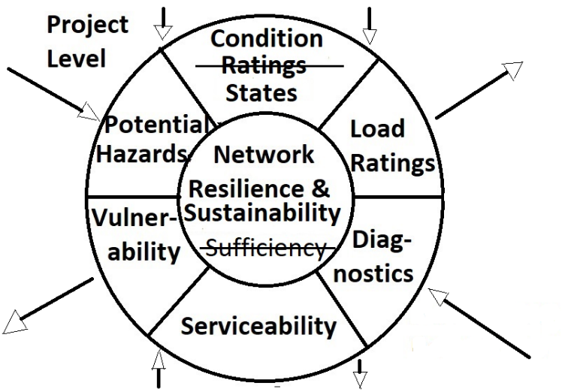
Fig. 1. Bridge assessments
The biennial inspections update the NBI with two types of assessments: descriptive and prescriptive. The original condition ratings were essentially descriptive. The element level condition states which superseded them combine descriptive opinions of qualified engineers with quantitative measurements and, at the lowest level 4, imply prescriptive recommendations. Prescriptive assessments recommend action. Such are the ‘flag’ reports of potential hazards according to New York State Department of Transportation defined in [4] and earlier versions.
Table 1. Bridge assessments
Evaluation Type Source Description
______________________________________________________________________________________________
Element condition rating Descriptive FHWA 1995 9 – new / 0 – imminent failure
Bridge serviceability appraisal Descriptive FHWA 1995 9 – superior to design criteria / 0 – closed
Maintenance rating Prescriptive FHWA 2002 9 – no repairs needed / 1 - closed
Sufficiency rating Computed FHWA 1995 S1 + S2 + S3 + S4 < 100%, where:
by weighted S1 – Structural adequacy & safety;
formula S2 – Serviceability & obsolescence;
S3 – Essentiality for public use;
S4 – Special reductions
Load rating Computed FHWA 1995 Inventory & Operating load ratings
by analysis AASHTO 2017 According to AASHTO
Condition states Descriptive / FHWA 2014 4 – Good; 3 – Fair; 2 – Poor; 1 - Severe
Prescriptive
Element condition rating Descriptive NYS DOT 2014 7 – new / 1 – totally deteriorated or failed
Flags Prescriptive NYS DOT 2014 Potential hazards: structural & safety

Based on its bridge inventory, New York State DOT also recognizes a number of vulnerabilities, such as steel details, concrete details, seismic, hydraulic, collision, overload, and acts of destruction. Overload has been since superseded.
In another significant development, advanced technologies are offering a variety of non-destructive testing and evaluation (NDT & E) techniques [5], allowing for a quantification of previously purely qualitative assessments.
The qualitative condition ratings and quantitative diagnostics describe ‘as is’ conditions on the project or ground-up level. Also ground-up, the prescriptive flag reports identify potential hazards, requiring a timely resolution. Load ratings, flag resolutions, and vulnerabilities are determined top-down at the network level. Serviceability combines ground-up findings and top-down determinations. Each capability complements the others. In the database illustrated in Fig. 1 information flows ground-up and top-down from and to the project and network levels through such a redundant system of complementary evaluations.
The terms robustness, resilience and sustainability are relatively recent enhancements to the assessment vocabulary. Bruneau and Reinhorn [6] define resilience as the ability to prepare and plan for, absorb, recover from, and more successfully adapt to adverse events. Robustness is defined as the ability of a structure or network with an impaired resistance to redistribute its supply to meet the load demand in constrained time, for example during ‘extreme events’. Thus, robustness, redundancy and ductility characterize a capability to meet rapidly changing demands on the project level. Resilience and sustainability describe the network level capacity to deliver services effectively and efficiently over an essentially perpetual lifecycle. Neither of these terms is rated according to any qualifying or quantifying scale so far. FHWA advances bridge management towards standardizing these assessments in [7].
Up to 2015 bridge inspections according to [4] and its earlier versions included the following significant features:
- Inspection team leaders are professional engineers licensed in N.Y. All inspectors pass a state course;
- Fracture-critical elements are inspected hands-on and certified by the team leader;
- All bridge elements were rated in all spans on a scale from 7 (new) to 1 (failed), 3 signifies “not functioning as designed”;
- Potential hazards are designated as flags and processed separately.
In [8] the seven condition rating levels were superseded by the four element condition states recommended by [3]. The other features pertain.
In their incongruous dimensions, the various assessments supply a multi-faceted view of the infrastructure and of each other. In the example of Fig. 2 ‘bridge condition’ and ‘sufficiency’ ratings circa 2008 are compared for the roughly 700 vehicular bridges of New York City, enumerated in Table 2. The two sets of ratings are obtained by weighted average formulae. The former is based on qualitative condition ratings from 7 to 1 according to [4]. The latter is based on qualitative condition and importance assessments from 9 to 0 according to [1]. It includes qualitative assessments of importance, serviceability and obsolescence. Consistently with the basic management commitment to safety, structural conditions rated ≤ 3 (not functioning as designed) are few. In contrast, sufficiency ratings < 50% are numerous. If the two sets of data points were reduced to average patterns, the ‘structural condition’ one would be concave, tending asymptotically towards the condition rating of 4, and the sufficiency one would be concave, declining to 0 at about 85 years (essentially consistent with the 75 yeas useful life recommended by [2] and earlier editions). The conspicuous outliers in both graphs reflect rehabilitations. This suggests that the network is structurally safe but wanting in serviceability. The demand for quality of service can (and should) exceed the supply. A reverse set of patterns would have been unsafe and unacceptable. The physical states described by the structural condition ratings must supply more resistance than the ambient conditions are likely to demand by a safe margin.
Table 2. NYC Bridges & Tunnels
Type Quantity
____________________________________
East River Crossings 4
Moveable 25
Waterway 51
Arterial 208
Off – System (Local) 389
Pedestrian 107
Tunnels 6
Total 790

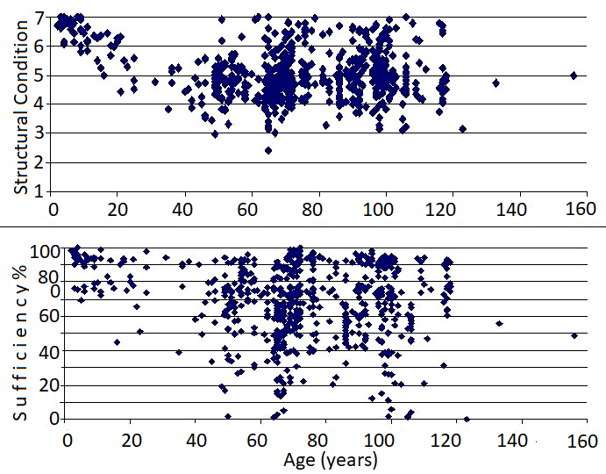
Fig. 2. Condition and sufficiency ratings for the New York City bridges (circa 2008)
Comparing condition and load ratings reveals a similar relationship, again contributing to safer standards of operation. Still qualitative to a large degree, structural condition ratings sound alarms that load ratings must verify analytically. In the commonly adopted procedure, qualitative visual inspections may rate bridges unsafe, and require AASHTO load ratings. The latter may be level I, II, or III, include proof loading, and determine that the structure has quantifiably acceptable load-bearing capacity.
In contrast, flag reports, designating potential hazards, prescribe corrective action. The NYS DOT flag protocol was the first line of defense against the proliferating potentially hazardous bridge-related conditions. Over time it evolved to an essential risk-based indicator of the state of the network. Flags are defined in [4] as follows:
Red Flag - A structural flag that is used to report the failure or potential failure of a primary structural component that is likely to occur before the next scheduled biennial inspection.
Yellow Flag - A structural flag that is used to report a potentially hazardous structural condition which, if left unattended could become a clear and present danger before the next scheduled biennial inspection. This flag would also be used to report the actual or imminent failure of a non-critical structural component, where such failure may reduce the reserve capacity or redundancy of the bridge but would not result in a structural collapse.
Safety Flag - A flag that is used to report a condition presenting a clear and present danger to vehicular or pedestrian traffic but poses no danger of structural failure or collapse. Safety Flags can be issued on closed bridges whose condition presents a threat to vehicular or pedestrian traffic underneath or in their immediate vicinity.
Prompt Interim Action (PIA) – A flag demanding resolution by the responsible owner within 24 hours.
As defined, flags may or may not signify element or service failures. Their veracity and gravity can vary widely. The evolution and significance of the flag incidence in New York City from their inception in 1982 to their reaching a stable ‘steady state’ circa 2006 is described herein.
Correctly interpreted, descriptive ratings, such as the ones of Fig. 2, reflect the network condition realistically when combined with the prescriptive flag reports. The average bridge life of 80 to 100 years that they may suggest is meaningless. The worst cases of 40 to 45 years generate the flags and govern the needs. So long as deterioration is not delayed by other means, new bridges fill this category as soon as the current ones are rehabilitated.

3. The NYC bridge network and management
During the last several decades, the vehicular bridges managed by NYC DOT have fluctuated around the numbers in Table 2. Without adjusting original dates of completion for rehabilitations, their average age circa 1990 was approximately 75 years. Approximately 600 bridges on the arterial network in the five city boroughs are managed by NYS DOT. Their average age was approximately 40 years.
Figure 3 illustrates the flags issued for the approximately 700 New York City vehicular bridges from1982, when the records began, to 2006. The following five periods are discernible:
1982 – 1987 Steady state following initial adjustments.
1987 – 1992 Increase by an annual factor reaching 2.
1992 – 1996 Steady state peaking approximately 24 times above the initial one.
1996 – 1999 Decrease by an annual factor of approximately 1.24.
1999 – 2006 Steady state at a level approximately 10 times above the initial one.
Beyond 2006 the flag numbers have fluctuated about the number of 1200, suggesting a ‘steady state’ corresponding to similarly steady bridge conditions.
The direct costs of flag mitigation (not necessarily including permanent repair) for the City bridges were averaging at approximately 15K $US during the years under consideration. Estimates of the notoriously intractable user costs due to traffic interruptions would be higher. The costs of the potential hazards escalating to actual accidents can be vaguely estimated, based on annual court case settlements in New York City. As a result, all levels of city management recognized the urgent need to address the looming crisis in bridge conditions. Two events captured the attention of general public as well.
In 1988 bridge inspectors found the deterioration of the Williamsburg Bridge across East River so advanced that the structure was closed temporarily to all vehicular and subway traffic. The ensuing in-depth inspection, analysis and reviews [9] concluded that a rehabilitation, at a cost exceeding 1 billion $US was possible and urgent. A less visible, but no less significant consequence was the re-establishment of the Bureau of Bridges (later Division) at the New York City Department of Transportation (NYC DOT). During the various financial crunches over the 20th century, the powerful Bridge Commission of the early 1900s had been gradually absorbed by various more general departments.
On June 1, 1989 a piece of concrete spalled from the underside of the Franklin Delano Roosevelt (FDR) Drive on the Manhattan East Side at 19th St. and killed a motorist [10]. A review of the current bridge inspection reports by the Bridge Inspection & Management Unit, NYC DOT indicated that nearly half of the City bridges had decks in similar condition.
Under these constraining circumstances, the new City Bureau of Bridges had to obtain emergency funding, and retain qualified in-house and contracted expertise, based on a credible projection of short-time needs. The Bridge Inspection & Management Unit was charged to model flag expectations. Some of the steps in that process for 1991 were reported in [11]. The projection for 1992 is described herein.
4. The forecasting model
In 1991 the Inspection & Management Unit at the Bridge Division undertook to forecast the flags expected in the following biennial inspection. The projection for 1991 had proven realistic and the process was adjusted with the new information. That information consisted of the inspection reports generated by consultants for NYS, and the hands-on knowledge of the Unit teams (qualified by the NYS standards). The escalation beginning in 1988 compounded to an indeterminable degree several factors, including the following:
- accelerating structural deterioration;
- increased frequency of inspections;
- engineering judgment reflecting events, such as those at the Williamsburg and the FDR;
- interim modifications of the flagging procedures by [4].
As in all engineering solutions, the forecast had to balance the determinism and uncertainty of the phenomenological and probabilistic approaches. Reference [12] attributes uncertainty to ignorance, vagueness and randomness. Each requires its specific treatment. Condition ratings suffer from ignorance and vagueness, whereas structural behavior and ambient conditions can be random. Phenomenological models describe and explain material behavior observed under controlled conditions. They are modified according to the frequency of obtained test results (as is the ‘nominal’ resistance prescribed by design specifications). Within statistically and probabilistically established bounds, randomness can be modeled according to ‘degree of belief’ and ‘frequency’. Frequentist or statistical models are mathematically tractable and can be calibrated to fit continuous processes, but miss the discontinuities of instabilities and failures.
Flag incidence could be correlated phenomenologically with element condition ratings if the latter, in turn, were also correlated with actual conditions. Expecting that a) structures deteriorate, and b) flags increase with deterioration, the rates of these two phenomena had to be established and, to the extent possible, correlated, according to the available information. The recent and immediately subsequent flags and condition ratings were likely to contain a similar level of subjectivity. The sharp increases between 1987 and 1989 in Fig. 3 suggest that the closure of the Williamsburg Bridge in 1988 and the fatal accident at the FDR in 1989 might have influenced flagging practices to some degree. Condition ratings may have been affected similarly. Thus, a projection based on past inspection reports would forecast future flags and not future conditions. To remedy that discrepancy, direct knowledge of the structures had to be incorporated as much as possible.
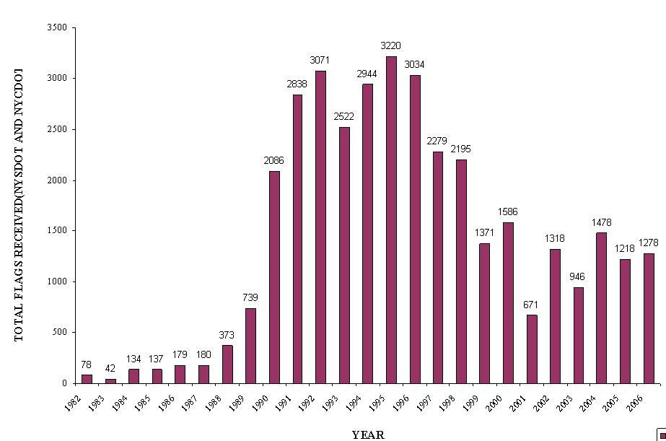
Fig. 3. Flag history for the NYC bridges 1982 – 2006 (Bridge Inspection & Management, NYC DOT)
The first step was to present the relevant information as coherently as possible and allow it guide the forecasting. The following steps were taken:
- All flags were attributed to the bridge elements whose conditions had caused them. Eighteen structural elements were contributing approximately 85% of all the annual flags. The study focused on these elements. A sub-set of 10 elements contributed 70% of the flags. That information was useful for the subsequent flag prioritization and mitigation.
- A correlation was sought between the number of flags issued and the condition rating of the responsible element(s) at that time. The flagged elements were represented as a fraction of all elements with the same rating. These fractions were regarded as estimates of the likelihood for the elements at each rating level to be flagged. The results for 1991 are shown in Table 3. The 4932 wearing surface ratings correspond to the number of spans in the inventory. Bridge railings and approach guide rails were combined for brevity herein, accounting for their high number.
Similar tables were compiled manually for all years since 1982, leading to the following observations:
- The expected tendency of lower rated elements to attract more flags was generally confirmed. However, the ratio of flagged / total elements with same rating had increased steadily.
- Potentially hazardous conditions are re-flagged absent evidence of long-term mitigating measures. Consequently, the flags for any year include new and pre-existing ones.
- Flags on railings, curbs, utilities, and medians include consequences of traffic accidents and are less dependent (but not entirely independent) of bridge element ratings.
- Due to their poor condition, size and complexity, East River and moveable bridges attracted significantly more flags. Therefore, they were excluded from the projection model and their contribution reflected site-specific information.
The following assumptions were made:
- A flag expectation level was defined as the number of flags that each element was likely to receive at each condition rating level during the following biennial inspection. For each element it was obtained based on the results in Table 3 and the observed trends in condition ratings.
- The distribution of the element ratings across the scale from 7 to 1 was assumed based on observed condition rating changes, and, in some cases, bridge-specific information. If the bridge network were in a ‘steady state’ from one year to the next, the element rating distribution across the rating scale ought to be close to constant. In the modeled case however, bridges were ‘sliding down’ at annual rates ≥ 0.2 points and rehabilitations were pending. The shortest useful lives of primary members and RC decks were between 30 and 40 years, and those of joints, scuppers and bearings were under 10 years. The lower rated populations were gaining and the higher rated ones were shrinking. Concurrently, lower rated populations were becoming ‘saturated’ with flags. Thus, the flag forecast had to be a product of the increases in low-rated elements and in flags at low ratings.
- Due to their poor condition at the time, approximately half the City bridges were receiving annual interim inspections, focusing on low rated elements and flagged conditions. Thus flag estimates for 1992 used numbers from both the interim inspection in 1991 and the biennial one of 1990.
The results for decks and primary members, which are the heaviest contributors of the most structurally consequential flags are shown in Table 4. Low-rated primary members were being flagged more than once in a span, whereas a failed deck would be flagged summarily for the span. Based on the record and phenomenological reasoning, the flag expectations for decks and primary members rated 1were assumed to be 100% and 250%, respectively.
The expected flags for the 18 critical elements in 1992 are enumerated in Table 5. Whereas in Table 3 the actual flagged / total element ratio is the computed outcome, in Table 5 the assumed flag / total element ratios produce the computed outcome of 2380 expected flags.
Since the 18 elements were assumed to account for 85% of the flags in that bridge population, the forecast was corrected to a total of 2380 / 0.85 = 2800. Special considerations in determining the flagged / total element ratios and adjusting the final result included the following:
- Columns deteriorate relatively slowly, whereas their flags are promptly mitigated with temporary supports. Hence, the flag expectation was (uniquely) lowered.
- Wearing surfaces, curbs, railings, utilities, and expansion joints generate flags at higher rates due to a combination of poor condition, performance, and accidents.
- The size and condition of the 4 East River and 25 moveable bridges required special provisions. They were awaiting the rehabilitations which later upgraded their conditions at costs summarily exceeding 7 billion $US. Moreover, the inventory under-represented their size. According to the NBI, Queensboro has 53 + 37 = 90 spans, and the Brooklyn has 75 spans. The span numbers at the Williamsburg and Manhattan are comparable. These high numbers however, reflect only the approaches. Between anchorages, each of the three suspension bridges is counted as three spans.
The two levels of Queensboro Bridge have 2 x 5 spans. Given respective lengths of 284/487/284 m (Brooklyn), 182/488/182 m (Williamsburg), 222/449/222 m (Manhattan), and 143/361/384/300/140 m (Queensboro), the number of stiffening truss panels quantifies these mega-structures more realistically. Consistently with that view, they were receiving approximately 10 times more flags than the assumptions of Table 5 imply. Hence, as sources of flags they required special provisions. Even after substantial rehabilitation projects, but with many still pending, the biennial inspection of the Brooklyn Bridge in 2010 [13] issued 408 flags.
Figure 3 indicates 2838 in 1991, whereas Table 3 indicates 1819 flags for the critical 18 elements. Correcting that number and subtracting it from the total obtains the contribution of the 4 East River and 25 moveable bridges to the total flag number in 1991 as 2838 – 1819 / 0.85 = 698.
Based on the existing records of flags, known conditions and emergency repairs, only 430 flags were added to the forecast. Thus, the flags projected for 1992 were 2800 + 430 = 3230. The actual number in Fig. 3 is 3071. In 1995 flags peaked at 3220.
The following blocks of the NYC Bridge Management database made forecasting the demand as described feasible:
- a detailed span – specific inventory;
- descriptive span – and element – specific condition ratings;
- descriptive and prescriptive flag reports of potential hazards.
The qualitatively different descriptive condition ratings and prescriptive flags were viewed as symptoms of the same state of the bridge network. Hence, although diverse in nature, they were assumed to be subject to similar general influences. Their apparent correlation for the current year could therefore be extrapolated with certain qualification to the next one. Particularly useful was the directive (since rescinded) to issue flags for all affected structural elements. In a significant drawback, flag reports did not specify the condition ratings of the affected elements. For the study presented herein, the flags from 1982 to 1990 were correlated to condition ratings manually. Table 3 herein is one of hundreds of tables compiled manually under a severe time constraint. NYC DOT later developed software correlating the NYS DOT flag and condition rating databases.
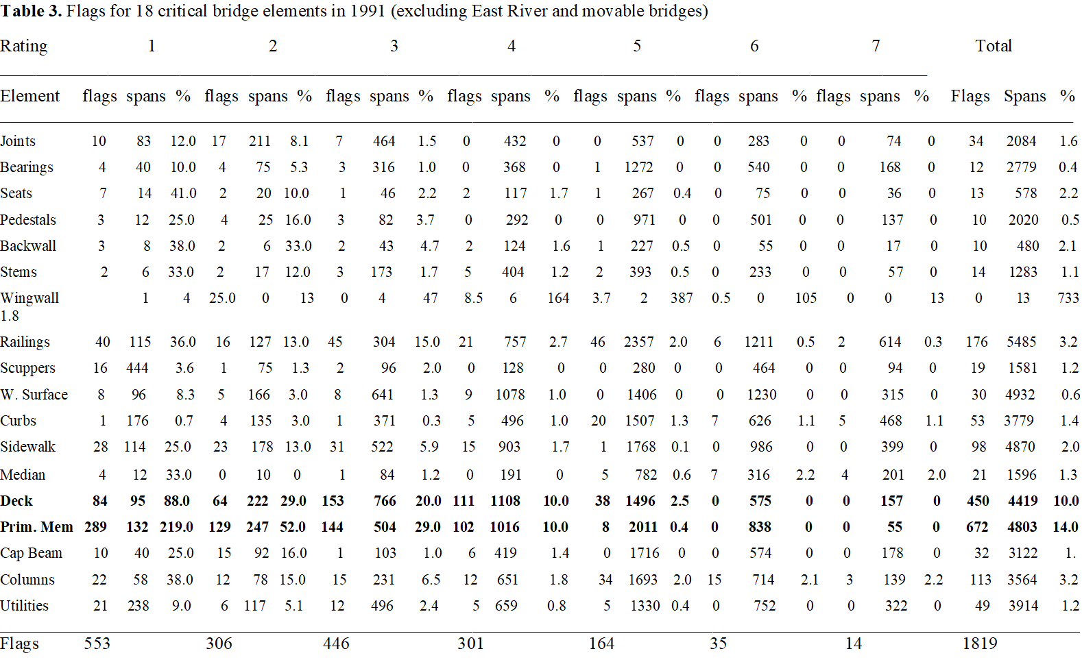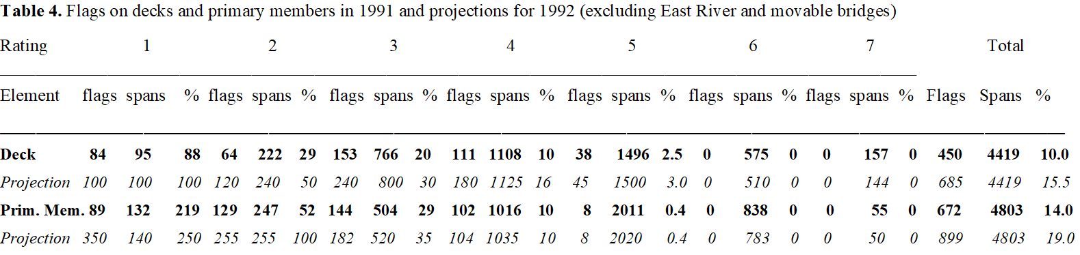

Table 5. Flag projections for 18 critical elements in 1992 (excluding East River and movable bridges)
Element ∑Spans % ∑Flags
_________________________________________________
Joints 2084 2.0 42
Bearings 2779 0.8 34
Seats 578 2.3 14
Pedestals 2020 0.8 16
Backwall 480 2.2 11
Stems 1283 1.2 15
Wingwall 733 1.9 14
Railings 5485 3.2 176
Scuppers 1581 1.8 29
W. Surface 4932 1.5 74
Curbs 3779 1.4 53
Sidewalk 4870 2.2 107
Median 1596 1.3 21
Deck 4419 15.5 685
Prim. Mem 4803 19.0 913
Cap Beam 3122 1.1 35
Columns 3564 2.5 90
Utilities 3914 1.3 51
∑Flags 2380

5. Conclusions
‘Extreme events’ of varying duration periodically afflict the social infrastructure. The causes of some of them are viewed as random, others are more phenomenologically predictable. During the early 1990s the vehicular bridges of New York City were in a state of advanced deterioration analogous to an event of extended duration. The specifics were highly site – and moment – dependent. Nevertheless, the example of forecasting extreme infrastructure demands under sever constraints allows for some generally valid observations.
Given the heterogeneous information and the inherent discontinuities, a rigorous, universally applicable algorithm could not have been developed then and is not available at present. The words of Von Neumann and Morgenstern in [14] (p. 2) still apply: “Even in sciences which are far more advanced than economics, like physics, there is no universal system available at present.” The authors highly recommend quantification, but recognize its limitations. Engineering management must maximize reliance on science, but, particularly under severe constraints, has to produce art. As extensively quantifiable as decision support might be, managers are needed, if at all, for converting qualitative decisions into actions.
In retrospect, the Weibull distribution is easily scaled to fit the flag pattern from 1989 to 2006, as it is in most non-performance phenomena. Used a posteriori, it can be an argument for prevention, rather than a tool of response. A priori, neither the scaling of the parameters nor the form of the function could have been selected. No quantified algorithm can compensate for qualitative managerial expertise and understanding.
Since a single perfect condition assessment system does not exist, engineering management, as all other engineering specialties, becomes robust by relying, as much as possible, on redundant and complementary strengths. Duplication and re-distribution of effort have ensured most engineering successes, whereas their elimination has caused many failures.
The quantified element level condition states introduced by [3] and adopted by NYS DOT (2016) can be a valuable enhancement, but not a replacement of the qualitative ratings. The transition from the 10- and 7- levels of the FHWA and NYS DOT qualitative condition ratings to the 4 quantified element condition states, all of which can coexist in the same element (in a span or in the bridge), introduces a critical discontinuity in the existing NBI database. Changes in the NYS DOT flagging procedure have had a similar effect. According to [8] non-structural conditions are no longer ‘flagged’ according to [8] and utilities are treated separately. Under these changing conditions, bridge managers more than ever need hands-on knowledge of both the database ‘top-down’ and the bridge conditions ‘ground-up’.
The pattern of Fig. 3 has implications that managers from most fields would recognize. The flag ‘avalanche’ of 1987 – 1995 was rooted in the infrastructure neglect of the 1970s and early 1980s. In a policy, since rescinded, bridge maintenance was not eligible for federal funding at the time. Eighty City bridges had been fully or partially closed, many were load-posted and flags were proliferating. Funding eventually responded to the demand of the dramatic ‘extreme events’ at the Williamsburg Bridge and the FDR. For example, after the fatal accident at the FDR on June 1, 1990, fifty million $US were dedicated to inspection and mitigation of similarly rated condition.
Emergency prioritization reduces management to primitive triage, typical of conflicts. Under the ever-present funding constraints, potential hazard mitigation at the worst cases may not leave adequate resources for maintaining the good ones. The direct and user costs absorbed in reversing such a state are much higher than the optimal.
Between 1993 and 2003 flag numbers declined due to capital reconstruction projects at an average annual cost of 600 million $US. Subsequent management strategies must prevent relapsing to the conditions of 1987. Since, once accelerated, structural deterioration is irreversible, cost-effective network planning requires at least a 20-year horizon.
The random events of traffic, climate and other factors will always cause a certain number of potentially (and genuinely) hazardous conditions, unrelated to structural deterioration. The management of any particular network must budget for their identification and mitigation. In the case of Fig. 3 that number appears to be around 1200. Any increase would signal declining structural conditions or increased demand.
Strategic infrastructure management maintains the assets in a sustainable condition or state. A tactical one should respond robustly to emergency demands. Identifying and eliminating the sources of potential hazards advances both objectives. As [15] suggests, condition assessments remain a work in progress. Resilience, robustness and sustainability are relatively recent network and project level qualifiers. They are still to be integrated in bridge condition assessments in forms sufficiently qualified & quantified for optimal design choices and management decisions.

Funding: This research received no external funding.
Data Availability Statement: Data supporting reported results can be found in the annual reports of NYC DOT, Bridge Division.
Acknowledgments: The Bridge Inspection & Management Unit at NYC DOT performed the
reported work in 1990 under the author’s direction. The expressed views are solely his own.
Conflicts of Interest: The authors declare no conflict of interest
- FHWA 1971, 1988, 1995, Recording and Coding Guide for the Structure Inventory and Appraisal of the Nation’s Bridges, Federal Highway Administration, FHWA-PD-96-001, U.S. Department of Transportation, Washington, D.C.
- AASHTO (American Association of State Highway Transportation Officials) LRFD (Load and Resistance Factor Design) Bridge Specifications 2017, 8th Edition.
- FHWA 2014, Specifications for the National Bridge Inventory Bridge Elements, Federal Highway Administration, FHWA-01-21-2014, U.S. Department of Transportation, Washington, D.C.
- NYS DOT (New York State Department of Transportation) 1984, 2014, Bridge Inspection Manual, Albany, N.Y.
- FHWA 2013, Identification of Nondestructive Evaluation Needs for the United States Highway Infrastructure, Federal Highway Administration, FHWAA-HRT-13-056, U.S. Department of Transportation, Washington, D.C.
- Bruneau, M. and A. Reinhorn, April 18-22, 2006, Overview of the Resilience Concept, Proceedings of the 8th U.S. National Conference on Earthquake Engineering, San Francisco, CA.
- FHWA 2008, Bridge Preservation Guide, Office of the Infrastructure, Federal Highway Administration, U.S. Department of Transportation, Washington, D.C.
- NYS DOT (New York State Department of Transportation) 2016, Bridge Inspection Manual, Albany, N.Y.
- Williamsburg Bridge Technical Advisory Committee 1988, Technical Report to the Commissioners of Transportation of the City and State of New York, Howard Needles Tammen & Bergendorf, June 30.
- Lubasch, A. H. 1989, FDR Is Called Safe as Structural Tests Continue, NY Times, June 3, 1989, New York, N.Y.
- Yanev, B. 2007, Bridge Management, John Wiley & Sons, Inc., Hoboken, N.J.
- ISO, 1995, Guide to the Expression of Uncertainty in Measurement, 2nd Ed., International Organization of Standardization, Geneva.
- Weidlinger Assoc., Inc. 2010, Brooklyn Bridge Biennial Inspection Report, prepared for New York State Department of Transportation, Contract No. D030695, PIN X760.82.121, New York, N.Y.
- Von Neumann, J., and O. Morgenstern 1944, Theory of Games and Economic Behavior, Science Editions, John Wiley & Sons, Inc., New York.
- FHWA 2020, NPRM (Notice of Proposed Rulemaking), National Bridge Inspection Standards, Federal Highway Administration, U.S. Department of Transportation, Washington, D.C.

