“Supplementary Material”

Real-world contribution of electrification and renovation scenarios to the fleet emissions in West Midland boroughs, UK
Louisa K. Osei, Omid Ghaffarpasand, and Francis D. Pope
School of Geography, Earth, and Environmental Sciences, University of Birmingham, Birmingham, UK
Motorway Roads
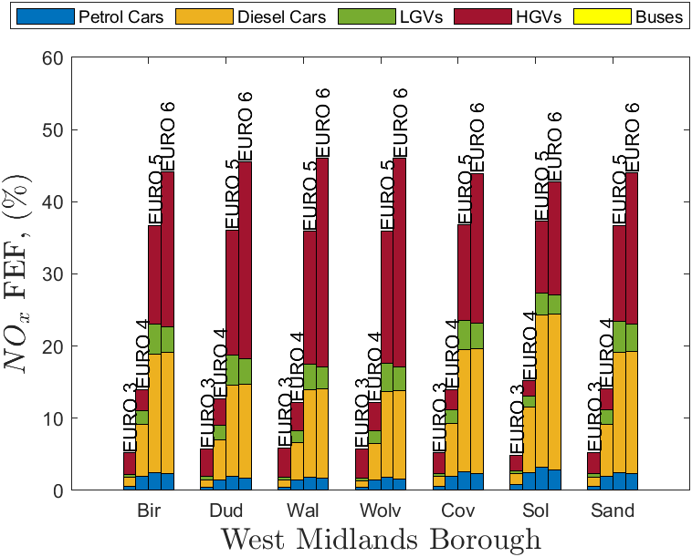
- NO_{x}
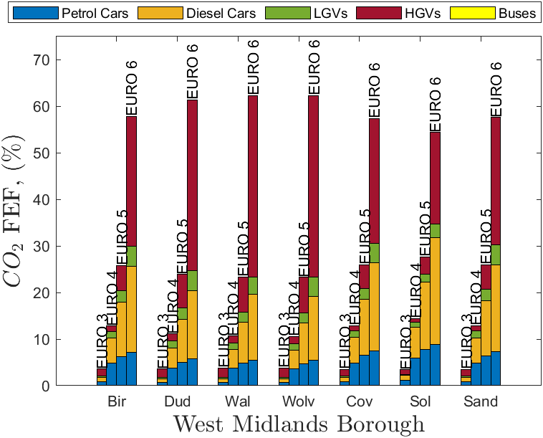
- CO₂
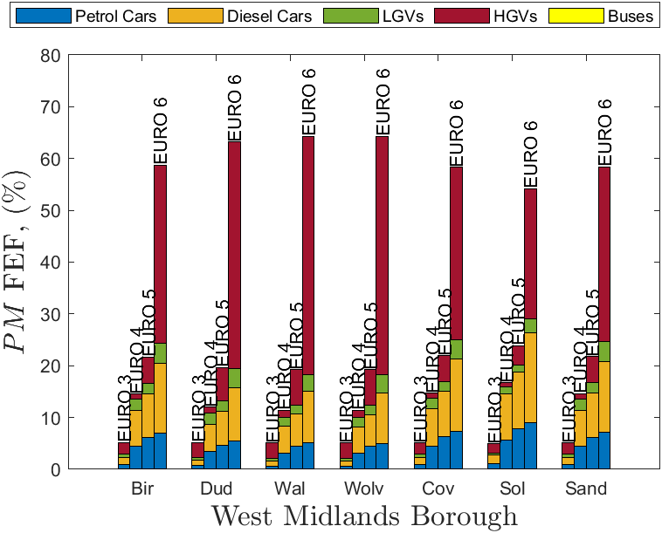
- PM
Figure S1. The effect of fleet electrification on motorway emissions of (a) NOx, (b) CO2, and (c) PM in West Midlands boroughs. In the y-axis, (%) is based on the total fleet emission.

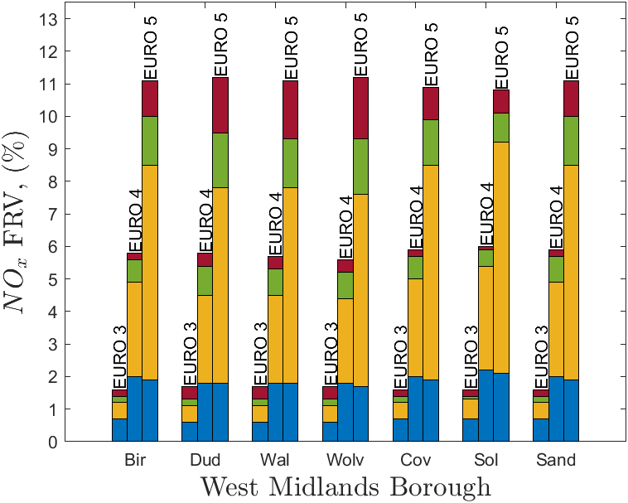
- NO_{x}
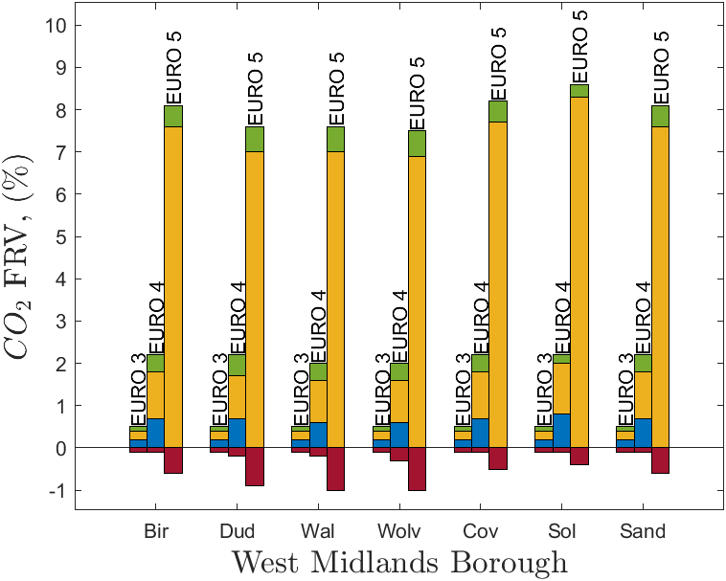
- CO₂
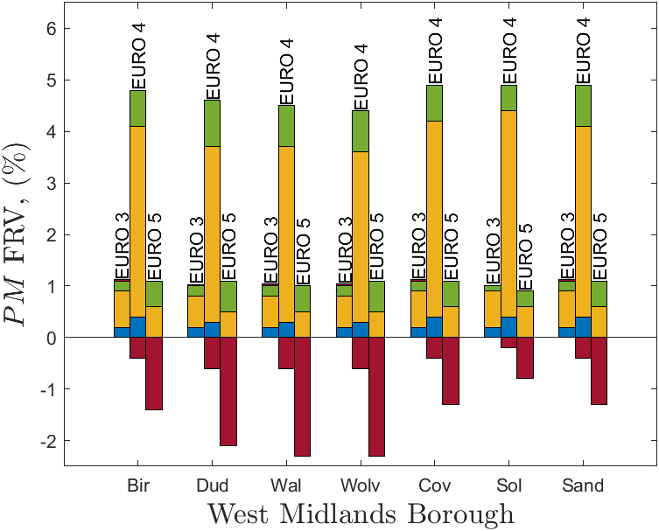
- PM
Figure S2. The effect of fleet renovation on motorway emissions of (a) NOx, (b) CO2, and (c) PM in West Midlands boroughs. In the y-axis, (%) is based on the total fleet emission.

Rural Roads
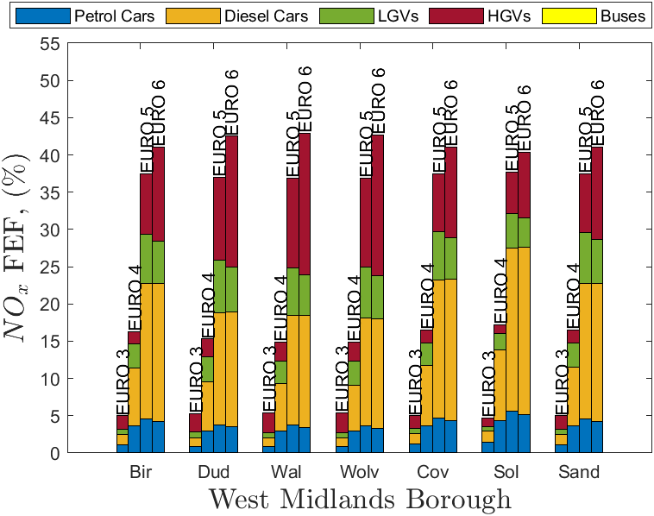
- NO_{x}
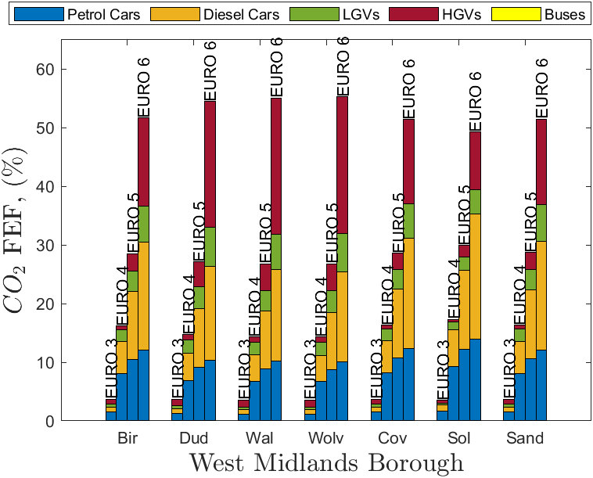
- CO₂
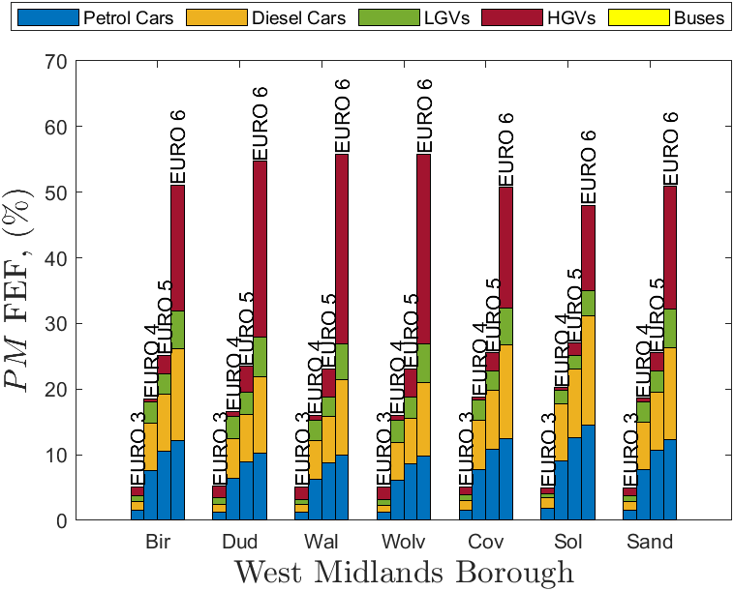
- PM
Figure S3. The effect of fleet electrification on rural road emissions of (a) NOx, (b) CO2, and (c) PM in West Midlands boroughs. In the y-axis, (%) is based on the total fleet emission.

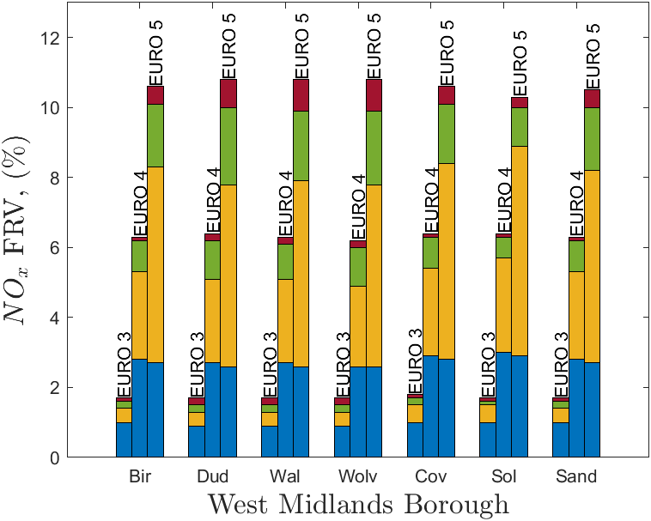
- NO_{x}
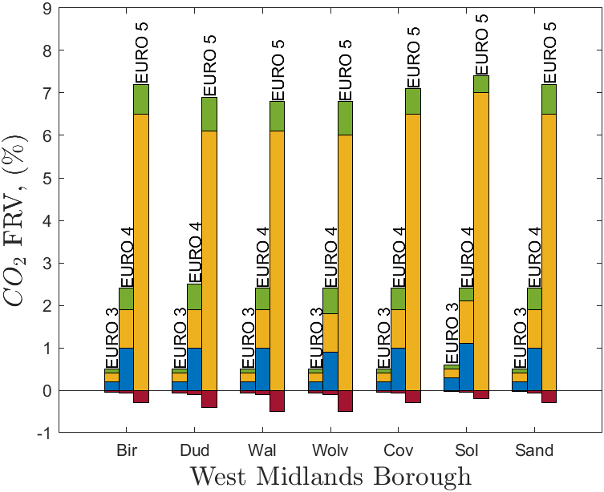
- CO₂
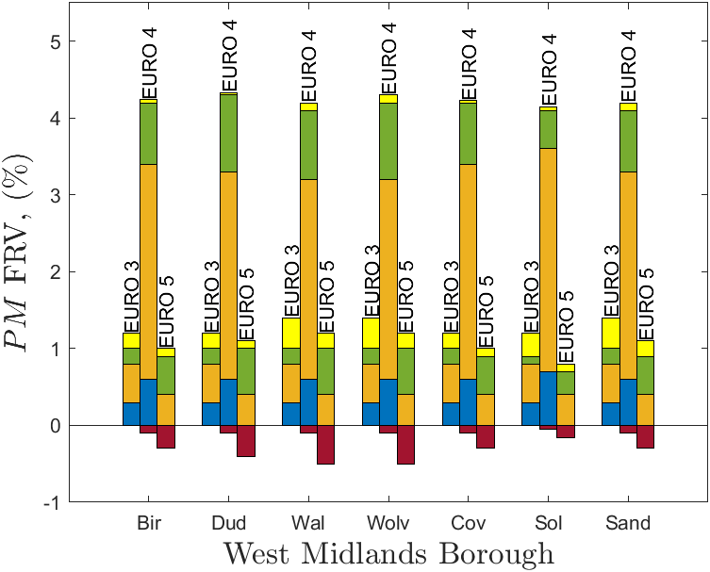
- PM
Figure S4. The effect of fleet renovation on rural road emissions of (a) NOx, (b) CO2, and (c) PM in West Midlands boroughs. In the y-axis, (%) is based on the total fleet emission.

Corresponding author, Email. f.pope@bham.ac.uk

