Tissue-specific knockdown of genes of the Argonaute family modulates lifespan and radioresistance in Drosophila melanogaster
Ekaterina Proshkina, Elena Yushkova, Lyubov Koval, Nadezhda Zemskaya, Evgeniya Shchegoleva, Ilya Solovev, Daria Yakovleva, Natalya Minnikhanova, Natalya Ulyasheva, Mikhail Shaposhnikov, Alexey Moskalev
Supplementary Materials
Table S1. Drosophila melanogaster strains.
Strain | Genotype | Description | Source
Canton-S | Wild-type strain | Wild-type strain | Bloomington Drosophila Stock Center, USA (#64349)
RNAi-AGO1 | y[1] v[1]; P{y[+t7.7] v[+t1.8]=TRiP.HM04006}attP2 | Expresses dsRNA for RNAi of AGO1 under UAS control in the VALIUM1 vector | Bloomington Drosophila Stock Center, USA (#31700)
RNAi-AGO2 | y[1] sc[*] v[1] sev[21]; P{y[+t7.7] v[+t1.8]=TRiP.HMS00108}attP2 | Expresses dsRNA for RNAi of AGO2 under UAS control in the VALIUM20 vector | Bloomington Drosophila Stock Center, USA (#34799)
RNAi-AGO3 | y[1] v[1]; P{y[+t7.7] v[+t1.8]=TRiP.HMC02938}attP40 | Expresses dsRNA for RNAi of AGO3 under UAS control in the VALIUM20 vector | Bloomington Drosophila Stock Center, USA (#44543)
RNAi-piwi | y[1] v[1]; P{y[+t7.7] v[+t1.8]=TRiP.HMJ21827}attP40/CyO | Expresses dsRNA for RNAi of piwi under UAS control in the VALIUM20 vector | Bloomington Drosophila Stock Center, USA (#57819)
GS-elav | y[1] w[*]; P{w[+mC]=elav-Switch.O}GSG301 | Expresses steroid-activated GAL4 in the nervous system | Bloomington Drosophila Stock Center, USA (#43642)
GS-S106 | w[1118]; P{w[+mW.hs]=Switch1}106 | Expresses GAL4 fused to steroid receptor ligand binding domain in the adult fat body | Bloomington Drosophila Stock Center, USA (#8151)
GS-TIGS-2 | P{Switch-unk}TIGS-2 | Expresses GAL4 in the digestive system | Courtesy of Dr. Seroude (Queen’s University, Canada) from Scott Pletcher (University of Michigan, USA)
GS-Mhc | w; Sp/CyO; P{MHC-GeneSwitch} | Expresses GAL4 in muscles
All strains are maintained in the Collection of Laboratory Strains of Fruit Flies Drosophila (IB FRC Komi SC UB RAS, Syktyvkar, Russia).
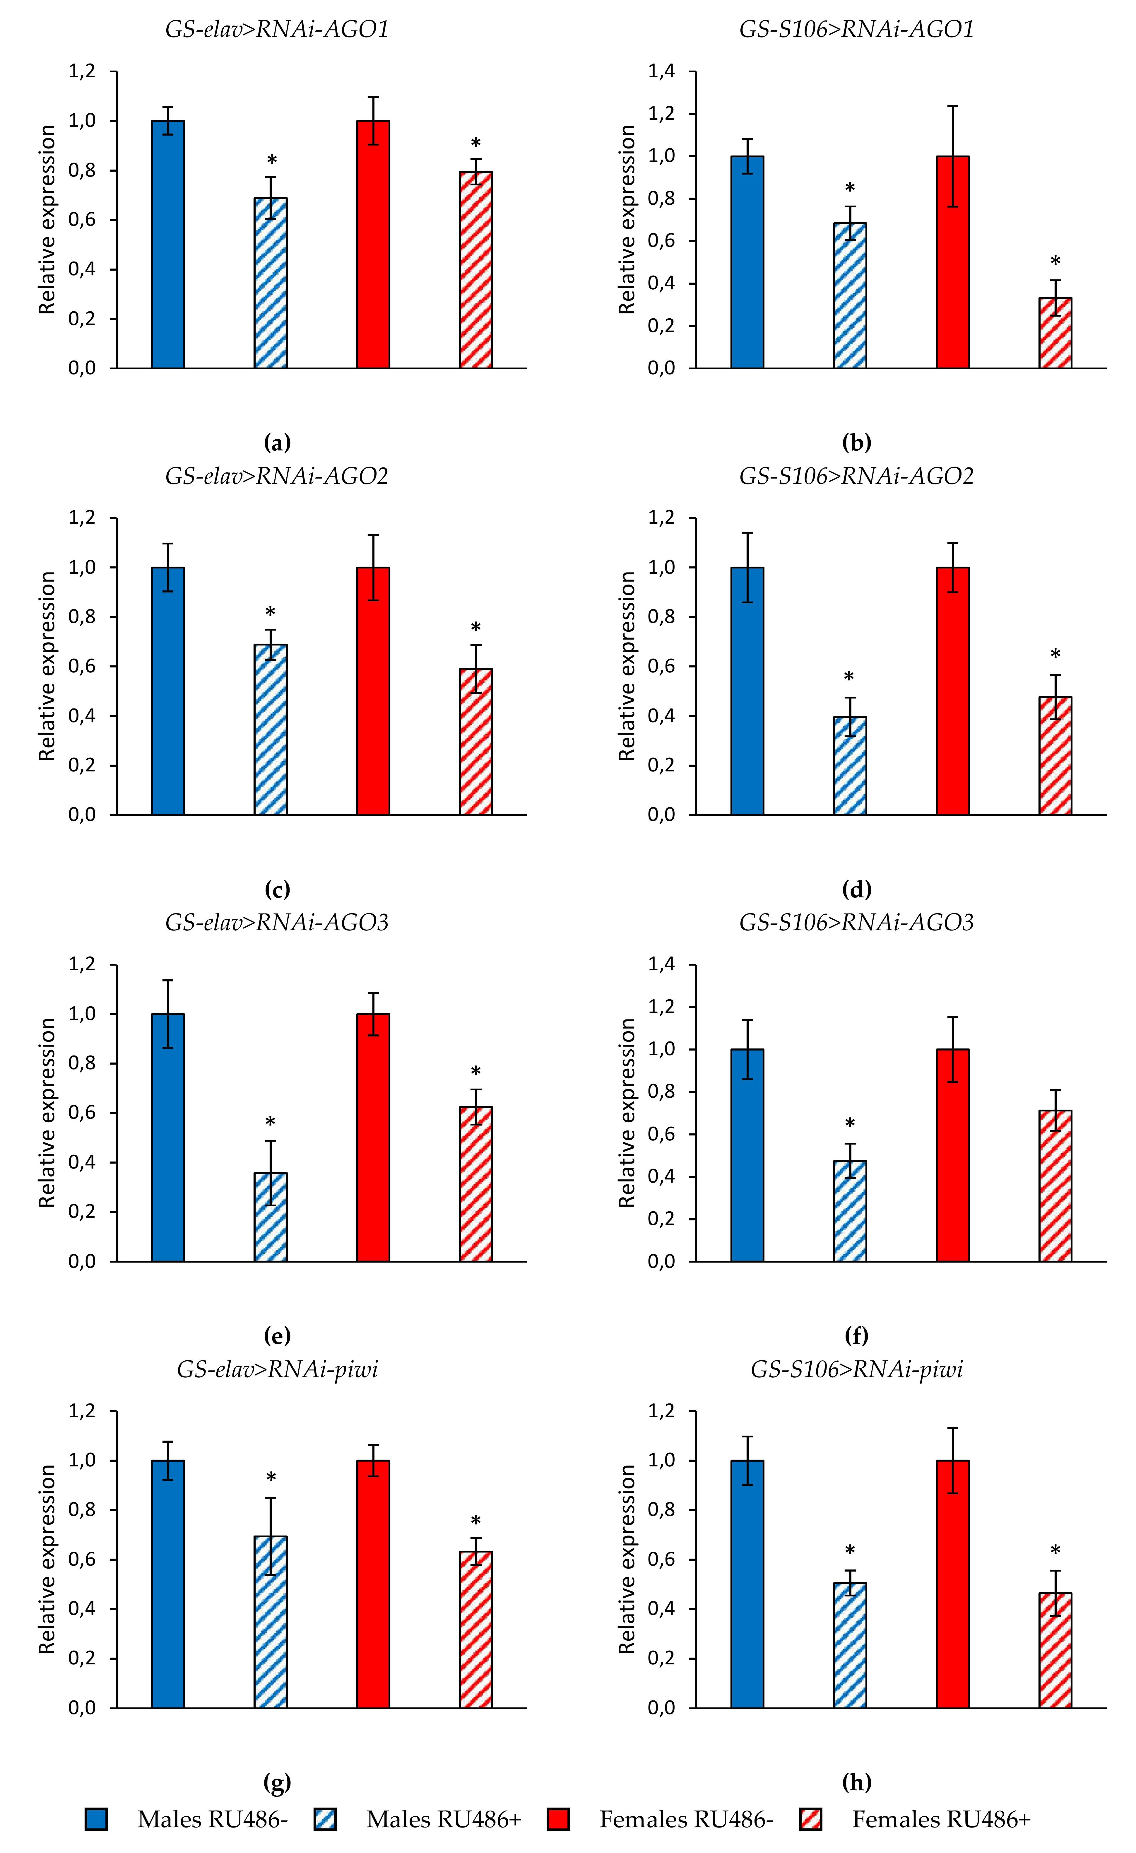
Figure S1. Knockdown of AGO1 (a, b), AGO2 (c, d), AGO3 (e, f), and piwi (g, h) in investigated flies. * - p < 0.05 (Mann-Whitney U-test).
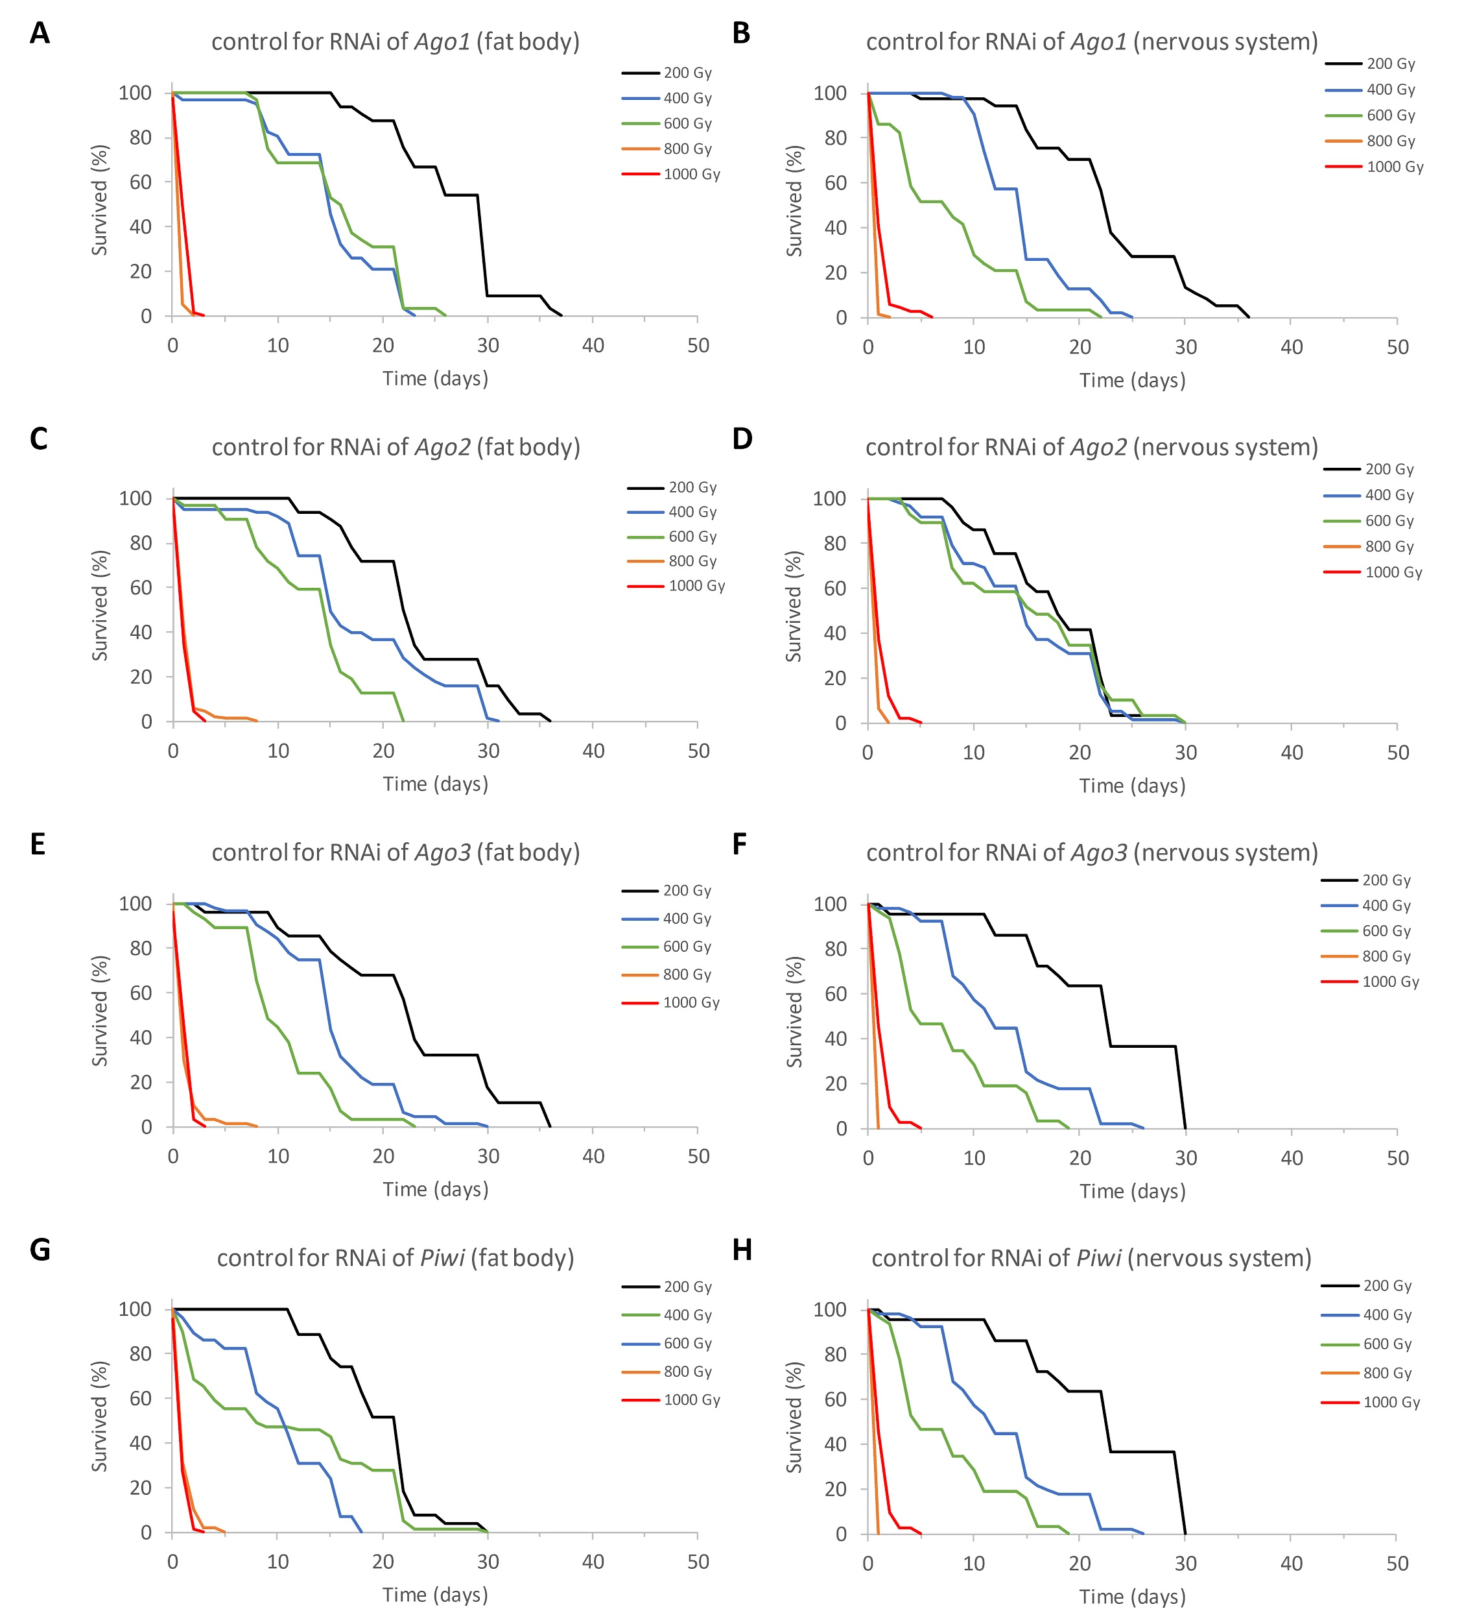
Figure S2. Effects of acute gamma irradiation on the survival of Drosophila male imago from the controls for RNAi of AGO1 (a, b), AGO2 (c, d), AGO3 (e, f), piwi (g, h) in the fat body (a, c, e, g) and nervous system (b ,d, f, h).

Table S2. Primers for real-time PCR.
Gene | Forward primer | Reverse primer
β-Tubulin | GCAACTCCACTGCCATCC | CCTGCTCCTCCTCGAACT
RpL32 | GAAGCGCACCAAGCACTTCATC | CGCCATTTGTGCGACAGCTTAG
EF1α | AGGGCAAGAAGTAGCTGGTTTGC | GCTGCTACTACTGCGTGTTGTTG
AGO1 | TGCGTCGCAAGTATCGTGTGTG | TCCAGCTGCAGTGGGAATGATTG
AGO2 | ATCTACTACCGAGATGGCGTGAGC | TCTTGGGTTTACAGCCCACCTTG
AGO3 | AACACTCGCATCTTCTCGGGTAGC | TCTACGACAGTTCCTGGCAATGGG
piwi | AATTCCTGAGCTCTGCCGAGTG | TCATGGCACGCATAAGCTGAAAG
HeT-A1 | CGCGCGGAACCCATCTTCAGA | CGCCGCAGTCGTTTGGTGAGT
R1-element | CGTTGTTTCCACTGCCGTTA | CCTAGGCTGCGGAAACTGAT
Rt1a | CCACACAGACTGAGGCAGAA | ACGCATAACTTTCCGGTTTG
1731 | AGCAAACGTCTGTTGGAAGG | CGACAGCAAAACAACACTGC
412 | CACCGGTTTGGTCGAAAG | GGACATGCCTGGTATTTTGG
blood | TGCCACAGTACCTGATTTCG | GATTCGCCTTTTACGTTTGC
opus | CGAGGAGTGGGGAGAGATTG | TGCGAAAATCTGCCTGAACC
roo | CGTCTGCAATGTACTGGCTCT | CGGCACTCCACTAACTTCTCC
microsatellite/LINE-1 | GGCCATGTCCGTCTGTCC | AGCTAGTGTGAATGCGAACG
Sod1 | TGCACGAGTTCGGTGACAACAC | TCCTTGCCATACGGATTGAAGTGC
Prx5 | CCGATGAGCTGAAGTCCAAG | TTGCCGTTCTCCACCACCAG
Gadd45 | AAGTCGCGCACAGATACTCACG | TTTGTTGGTTCGGCAGCTGGTC
Xpc | AGAAGACGGTGCATTTGAGATTGC | ATGGGATGACAAGCGCCTTGATG
Ku80 | AGCTTCAGAATGTCGCAACTACC | TCGTTGAAATCGAAGAGCAGGAG
spn-B | ATCACGCAATCCCATCGAGGAC | TCCGGTGCGAGAACATTAACCTG
Hsp27 | ACTGGGTCGTCGTCGTTATTCG | CGCGCGACGTGACATTTGATTG
Hsp68 | TGGGCACATTCGATCTCACTGG | TAACGTCGATCTTGGGCACTCC
Atg1 | AGACTCTTCCTCGTGCAACTAGC | GCTTGAGATCACGATGCACAATTC
Atg5 | CTCGTCAAGCTCAACTCCAAGG | GTTGACCAATCCCAGCCAAAGC
Ire1 | GACAGTGAGGACAGCCGAATTATC | GCGATTGCGGATCCTTGTGTATC

Table S3. Lifespan parameters of flies with tissue-specific knockdown of the Argonaute genes.
Genotype | Sex | Replicate | RU486 | $\overline{X}$±SE | M | 90% | MRDT | N
GS-elav>RNAi-AGO1 | Males | 1 | - | 62.0±1.0 | 61 | 76 | 8.41 | 146
 |  |  | + | 67.6±1.0 ** | 68 *** | 79 | 6.60 | 149
 |  | 2 | - | 52.6±0.6 | 54.5 | 63 | 5.16 | 190
 |  |  | + | 50.4±0.7 * | 52 * | 62 | 5.46 | 171
 | Females | 1 | - | 73.0±1.4 | 74 | 88 | 7.38 | 111
 |  |  | + | 71.0±2.3 | 78 | 91 | 9.56 | 98
 |  | 2 | - | 62.5±1.6 | 66 | 74 | 5.83 | 83
 |  |  | + | 59.2±1.2 *** | 63 *** | 69 *** | 5.06 | 119
GS-S106>RNAi-AGO1 | Males | 1 | - | 57.6±1.0 | 56 | 72 | 8.17 | 144
 |  |  | + | 59.5±1.0 | 61 | 72 | 6.66 | 131
 | Females | 1 | - | 57.3±2.8 | 71 | 89 | 20.4 | 129
 |  |  | + | 72.0±1.9 | 76 ** | 91 | 8.94 | 121
 |  | 2 | - | 65.1±0.8 | 67 | 74 | 4.57 | 197
 |  |  | + | 63.7±0.9 | 65 ** | 77 * | 5.78 | 177
GS-TIGS-2>RNAi-AGO1 | Males | 1 | - | 52.3±1.0 | 51 | 65 | 7.25 | 141
 |  |  | + | 51.2±0.9 | 49.5 | 68 | 7.20 | 150
 | Females | 1 | - | 66.3±2.3 | 76 | 91 | 12.29 | 122
 |  |  | + | 64.2±2.3 | 74 | 92 | 13.34 | 140
GS-Mhc>RNAi-AGO1 | Males | 1 | - | 47.9±1.0 | 49 | 60 | 7.04 | 134
 |  |  | + | 29.5±1.4 *** | 32 *** | 49 *** | 12.56 | 138
 | Females | 1 | - | 55.7±1.4 | 59 | 72 | 7.55 | 115
 |  |  | + | 24.9±1.9 *** | 11 *** | 53 *** | 36.91 | 107
GS-elav>RNAi-AGO2 | Males | 1 | - | 45.1±1.1 | 44 | 61 | 9.02 | 153
 |  |  | + | 42.7±0.9 ** | 42 * | 56 * | 6.99 | 146
 |  | 2 | - | 52.9±0.9 | 55 | 65 | 6.80 | 180
 |  |  | + | 53.3±0.7 | 55 | 63 *** | 5.00 | 172
 | Females | 1 | - | 69.5±1.1 | 73 | 84 | 6.28 | 138
 |  |  | + | 61.2±1.6 *** | 63 *** | 80 | 9.13 | 139
 |  | 2 | - | 64.4±1.1 | 68 | 77 | 5.97 | 187
 |  |  | + | 60.9±0.9 *** | 64 *** | 75 | 6.60 | 174
GS-S106>RNAi-AGO2 | Males | 1 | - | 40.0±1.2 | 42 | 57 | 9.55 | 158
 |  |  | + | 40.0±1.5 | 41 | 60 | 10.83 | 115
 |  | 2 | - | 58.1±0.8 | 58 | 70 | 6.31 | 173
 |  |  | + | 57.2±0.6 | 57 | 64 *** | 5.21 | 171
 | Females | 1 | - | 63.9±1.7 | 69 | 83 | 10.26 | 164
 |  |  | + | 66.5±1.3 | 66 | 84 | 7.66 | 151
 |  | 2 | - | 64.1±0.8 | 65 | 78 | 6.41 | 192
 |  |  | + | 63.8±0.9 | 65 | 77 | 5.57 | 170
GS-TIGS-2>RNAi-AGO2 | Males | 1 | - | 46.5±0.9 | 45 | 60 | 9.61 | 159
 |  |  | + | 46.5±1.1 | 45 | 64 | 8.66 | 122
 | Females | 1 | - | 80.1±1.1 | 83 | 92 | 5.53 | 147
 |  |  | + | 76.2±1.2 *** | 78 *** | 88 * | 5.86 | 136
GS-Mhc>RNAi-AGO2 | Males | 1 | - | 41.7±1.1 | 39 | 57 | 9.17 | 136
 |  |  | + | 27.0±0.9 *** | 29 *** | 37 *** | 8.40 | 123
 | Females | 1 | - | 74.7±1.5 | 75 | 84 | 4.63 | 66
 |  |  | + | 14.9±1.7 *** | 8 *** | 43 *** | 6931.47 | 83
GS-elav>RNAi-AGO3 | Males | 1 | - | 59.9±0.9 | 62 | 70 | 5.98 | 136
 |  |  | + | 52.5±1.3 *** | 56 *** | 64 *** | 6.26 | 125
 |  | 2 | - | 51.3±1.6 | 54 | 64 | 7.23 | 66
 |  |  | + | 54.1±1.0 | 53 | 64 | 5.92 | 79
 | Females | 1 | - | 66.5±2.1 | 77 | 84 | 9.32 | 125
 |  |  | + | 69.3±1.1 * | 74 * | 83 | 6.86 | 148
 |  | 2 | - | 61.8±2.2 | 70 | 83 | 10.22 | 98
 |  |  | + | 69.5±1.5 | 74 | 82 | 6.34 | 87
GS-S106>RNAi-AGO3 | Males | 1 | - | 57.0±0.8 | 57 | 68 | 5.67 | 128
 |  |  | + | 56.9±0.9 | 57 | 67 | 5.96 | 152
 |  | 2 | - | 54.5±0.9 | 56 | 68 | 6.68 | 169
 |  |  | + | 54.3±1.0 | 56 | 66 | 7.10 | 159
 | Females | 1 | - | 77.6±1.2 | 77.5 | 93 | 7.84 | 102
 |  |  | + | 71.0±1.9 *** | 77 | 86 *** | 7.59 | 109
 |  | 2 | - | 67.8±1.2 | 71 | 84 | 7.54 | 220
 |  |  | + | 68.5±1.0 | 71 | 81 *** | 6.39 | 220
GS-TIGS-2>RNAi-AGO3 | Males | 1 | - | 51.8±0.9 | 53 | 59 | 5.45 | 129
 |  |  | + | 46.5±0.9 *** | 50 *** | 54 | 6.50 | 132
 | Females | 1 | - | 57.1±2.7 | 70.5 | 86 | 16.10 | 112
 |  |  | + | 62.1±2.3 | 73 | 87 | 12.80 | 126
GS-Mhc>RNAi-AGO3 | Males | 1 | - | 57.5±0.6 | 59 | 64 | 3.93 | 139
 |  |  | + | 26.2±0.5 *** | 25 *** | 36 *** | 4.24 | 142
 | Females | 1 | - | 74.0±1.7 | 80.5 | 89 | 7.75 | 112
 |  |  | + | 16.4±1.1 *** | 12 *** | 33 *** | 13.73 | 86
GS-elav>RNAi-piwi | Males | 1 | - | 62.5±1.1 | 64 | 78 | 7.42 | 154
 |  |  | + | 69.5±0.9 *** | 72 *** | 82 *** | 6.16 | 137
 | Females | 1 | - | 72.8±2.0 | 75 | 85 | 6.27 | 73
 |  |  | + | 76.9±2.1 *** | 82 *** | 88 | 5.46 | 64
 |  | 2 | - | 68.6±1.8 | 69.5 | 79 | 5.84 | 36
 |  |  | + | 72.1±1.3 | 71 | 81 | 4.24 | 41
GS-S106>RNAi-piwi | Males | 1 | - | 61.7±1.0 | 61 | 75 | 7.50 | 119
 |  |  | + | 62.6±1.3 * | 64 | 77 | 7.82 | 119
 |  | 2 | - | 53.2±0.7 | 53 | 64 | 5.42 | 159
 |  |  | + | 55.1±1.0 * | 57 ** | 64 | 5.01 | 128
 | Females | 1 | - | 62.9±2.1 | 71 | 84 | 11.00 | 114
 |  |  | + | 65.1±1.9 | 69 | 84 | 9.12 | 118
 |  | 2 | - | 63.6±1.1 | 66 | 78 | 6.93 | 168
 |  |  | + | 64.2±1.5 | 66 | 80 | 7.68 | 147
GS-TIGS-2>RNAi-piwi | Males | 1 | - | 60.7±0.9 | 64 | 71 | 5.94 | 162
 |  |  | + | 59.4±0.8 | 59 | 73 | 6.79 | 170
 | Females | 1 | - | 77.8±0.9 | 80.5 | 86 | 5.24 | 138
 |  |  | + | 76.6±1.0 | 77 | 85 | 5.07 | 131
GS-Mhc>RNAi-piwi | Males | 1 | - | 53.4±1.0 | 55.5 | 62 | 4.36 | 86
 |  |  | + | 26.9±1.6 *** | 26 *** | 51 *** | 15.56 | 93
 | Females | 1 | - | 69.1±4.6 | 82 | 85 | 8.76 | 115
 |  |  | + | 16.5±2.3 *** | 10 *** | 37 *** | 21.94 | 126
$\overline{X}$±SE - mean lifespan (days)
M - median lifespan (days)
90% - the age of 90 % mortality (days)
MRDT - the mortality rate doubling time (days)
N - the number of flies in a sample
* - differences between variants with Argonautes’ knockdown induction with RU486 and without knockdown are statistically significant with p < 0.05 (fifth column - Mantel-Cox test, sixth column - Gehan-Breslow-Wilcoxon test, seventh column - Wang-Allison test)
** - p < 0.01
*** - p < 0.001

Table S4 Survival of flies with tissue-specific knockdown of the Argonaute genes in the condition of γ-irradiation.
Genotype | Sex | RU486 | IR | $\overline{X}$±SE | M | 90% | MRDT | N
GS-elav>RNAi-AGO1 | Males | - | 0 | 47.5±1.4 | 49.5 | 64 | 8.42 | 118
 |  | + | 0 | 47.4±1.4 | 51 | 66 | 8.60 | 124
 |  | - | 700 | 21.4±0.5 | 20 | 27 | 3.15 | 122
 |  | + | 700 | 20.0±0.5 | 21 | 27 | 3.53 | 113
 | Females | - | 0 | 58.4±1.6 | 66 | 80 | 9.29 | 163
 |  | + | 0 | 54.1±1.3 *** | 59 *** | 68 *** | 7.10 | 116
 |  | - | 700 | 18.1±0.6 | 17 | 21 | 8.74 | 109
 |  | + | 700 | 29.4±1.2 *** | 21 *** | 47 *** | 9.81 | 106
GS-S106>RNAi-AGO1 | Males | - | 0 | 42.2±1.2 | 44 | 59 | 8.20 | 118
 |  | + | 0 | 43.4±1.2 | 41 | 60 | 8.42 | 115
 |  | - | 700 | 19.5±0.6 | 18 | 28 | 4.29 | 116
 |  | + | 700 | 26.6±0.7 *** | 28 *** | 34 *** | 4.28 | 117
 | Females | - | 0 | 60.5±1.3 | 66 | 75 | 7.57 | 188
 |  | + | 0 | 57.9±1.4 *** | 66 ** | 70 *** | 6.11 | 114
 |  | - | 700 | 19.4±0.9 | 18 | 31 | 10.60 | 118
 |  | + | 700 | 31.4±1.5 *** | 28 *** | 56 *** | 13.79 | 111
GS-elav>RNAi-AGO2 | Males | - | 0 | 50.1±1.1 | 52 | 60 | 6.17 | 115
 |  | + | 0 | 54.6±0.8 | 56 ** | 65 | 4.76 | 116
 |  | - | 700 | 30.1±0.9 | 31 | 42 | 6.15 | 119
 |  | + | 700 | 22.0±1.0 *** | 17 *** | 38 | 11.77 | 118
 | Females | - | 0 | 60.3±1.3 | 63 | 73 | 5.86 | 114
 |  | + | 0 | 60.7±1.4 * | 67 ** | 73 | 5.87 | 118
 |  | - | 700 | 29.4±1.4 | 21 | 51 | 13.09 | 101
 |  | + | 700 | 26.3±1.5 | 17 *** | 56 | 22.70 | 110
GS-S106>RNAi-AGO2 | Males | - | 0 | 43.1±1.7 | 46 | 63 | 11.01 | 122
 |  | + | 0 | 44.9±1.1 * | 46 | 58 ** | 6.46 | 107
 |  | - | 700 | 35.5±0.8 | 38 | 44 | 4.54 | 121
 |  | + | 700 | 32.8±0.8 ** | 34 ** | 41 | 4.94 | 118
 | Females | - | 0 | 63.9±1.1 | 66 | 76 | 6.12 | 140
 |  | + | 0 | 65.1±1.3 | 69 | 75 | 5.46 | 98
 |  | - | 700 | 25.6±1.3 | 20 | 46 | 14.58 | 115
 |  | + | 700 | 27.9±1.6 * | 17 | 59 *** | 23.86 | 128
GS-elav>RNAi-AGO3 | Males | - | 0 | 50.4±1.2 | 52 | 67 | 7.27 | 116
 |  | + | 0 | 48.4±1.4 | 51 | 63 * | 7.02 | 99
 |  | - | 700 | 27.9±0.8 | 28 | 38 | 5.78 | 118
 |  | + | 700 | 19.1±0.7 *** | 17 *** | 30 ** | 6.58 | 117
 | Females | - | 0 | 67.2±1.6 | 73 | 83 | 7.45 | 132
 |  | + | 0 | 67.2±1.6 | 70 | 81 | 6.90 | 110
 |  | - | 700 | 20.8±1.0 | 17 | 41 | 15.15 | 114
 |  | + | 700 | 23.3±1.1 | 17 | 45 | 15.38 | 114
GS-S106>RNAi-AGO3 | Males | - | 0 | 49.3±1.4 | 51 | 63 | 8.15 | 115
 |  | + | 0 | 50.7±1.4 | 51.5 | 66 | 8.03 | 112
 |  | - | 700 | 28.1±0.9 | 30 | 38 | 6.30 | 121
 |  | + | 700 | 25.7±0.9 | 25 | 38 | 7.92 | 116
 | Females | - | 0 | 67.3±1.7 | 74 | 83 | 7.26 | 125
 |  | + | 0 | 67.6±1.5 | 70 | 83 | 7.52 | 121
 |  | - | 700 | 28.9±1.5 | 27 | 51 | 15.23 | 109
 |  | + | 700 | 38.4±1.6 *** | 41 *** | 60 *** | 11.88 | 114
GS-elav>RNAi-piwi | Males | - | 0 | 45.7±1.2 | 46 | 60 | 6.98 | 113
 |  | + | 0 | 46.0±1.2 | 48 | 60 | 6.70 | 95
 |  | - | 700 | 24.0±0.7 | 25 | 34 | 5.80 | 124
 |  | + | 700 | 17.2±0.5 *** | 14 *** | 26 *** | 5.55 | 118
 | Females | - | 0 | 63.3±1 .0 | 66 | 74 | 5.80 | 129
 |  | + | 0 | 66.3±1.4 *** | 68 *** | 80 ** | 7.22 | 127
 |  | - | 700 | 35.2±1.0 | 38 | 51 | 6.56 | 114
 |  | + | 700 | 22.1±1.0 *** | 17 *** | 40 | 12.82 | 115
GS-S106>RNAi-piwi | Males | - | 0 | 48.9±1.3 | 51 | 63 | 6.98 | 97
 |  | + | 0 | 53.9±1.1 *** | 59 ** | 66 ** | 5.86 | 113
 |  | - | 700 | 22.1±0.8 | 25 | 31 | 5.31 | 103
 |  | + | 700 | 25.0±0.8 *** | 25 ** | 38 *** | 6.34 | 120
 | Females | - | 0 | 64.3±1.4 | 68 | 80 | 7.24 | 129
 |  | + | 0 | 60.2±1.8 | 68 | 77 | 9.49 | 147
 |  | - | 700 | 23.9±1.4 | 17 | 51 | 24.45 | 116
 |  | + | 700 | 46.6±1.5 *** | 51 *** | 63 *** | 8.34 | 114
$\overline{X}$±SE - mean lifespan (days)
M - median lifespan (days)
90% - the age of 90 % mortality (days)
MRDT - the mortality rate doubling time (days)
N - the number of flies in a sample
* - differences between variants with Argonautes’ knockdown induction with RU486 and without knockdown are statistically significant with p < 0.05 (fifth column - Mantel-Cox test, sixth column - Gehan-Breslow-Wilcoxon test, seventh column - Wang-Allison test)
** - p < 0.01
*** - p < 0.001

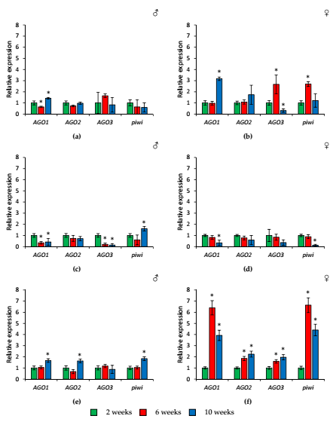
Figure S3. Age-related changes in the expression of Argonaute genes in heads (a, b), toraxes (c, d), abdomens (e, f) of wild-type Canton-S males (a, c, e) and females (b, d, f). * - p < 0.05 (Mann-Whitney U-test).
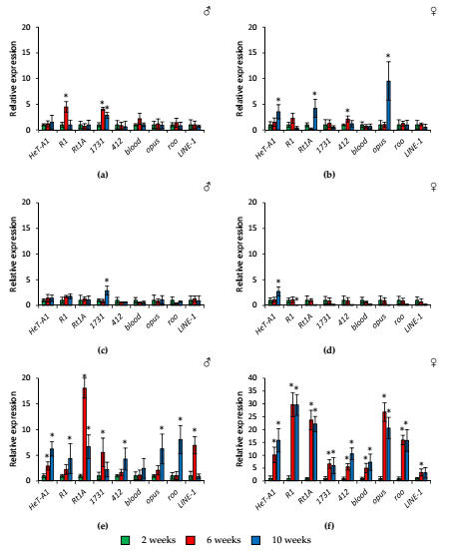
Figure S4. Age-related changes in the expression of transposable elements in heads (a, b), toraxes (c, d), abdomens (e, f) of wild-type Canton-S males (a, c, e) and females (b, d, f). * - p < 0.05 (Mann-Whitney U-test).
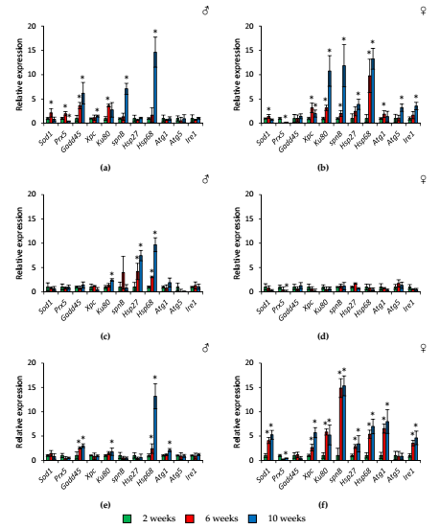
Figure S5. Age-related changes in the expression of stress response genes in heads (a, b), toraxes (c, d), abdomens (e, f) of wild-type Canton-S males (a, c, e) and females (b, d, f). * - p < 0.05 (Mann-Whitney U-test).

