Supplemental Information

Changes in Concentrations and Sources of Atmospheric PM, Polycyclic Aromatic Hydrocarbons and Nitropolycyclic Aromatic Hydrocarbons in Kanazawa, Japan

Kazuichi Hayakawa^{a*}, Ning Tang^{b,c}, Wanli Xing^{c}, Pham Kim Oanh^{d}, Akinori Hara^{d} and Hiroyuki Nakamura^{d}

^{a*}Low Level Radioactivity Laboratory, Institute of Nature and Environmental Technology, Kanazawa University, O-24 Wake-machi, Nomi, Ishikawa, 923-1224 Japan (*Corresponding author)
^{b}Institute of Nature and Environmental Technology, Kanazawa University, Kakuma-machi, Kanazawa, Ishikawa, 920-1192 Japan
^{c} Pharmaceutical and Health Sciences, Graduate School of Medical Sciences, Kanazawa University, Kakuma-machi, Kanazawa, 920-1192 Japan
^{d} Medical Sciences, Graduate School of Medical Sciences, Kanazawa University, 13-1, Takara-machi, Kanazawa, 920-8640 Japan

List of Contents
Number of total pages: 9 pages
Number of Text: 2 (5 pages)
Number of Figure: 1 (1 page)
Number of Table: 1 (1 page)
References (1 page)
Text S1. Sample treatments and analytical procedures

An area (2 × 5 cm) of each quartz filter containing atmospheric TSP or PM from typical sources was cut into small pieces in a glass flask and an internal standard solution including Pyr-d₁₀ and 1-NP-d₉ was added. PAHs, NPAHs and internal standards were extracted twice through ultrasonication with benzene/ethanol (3:1, v/v). The solution was then washed successively with diluted solutions of sodium hydroxide and sulfuric acid, and twice with ultrapure water. After 100 μL of dimethyl sulfoxide (DMSO) was added to the organic solution, the mixture was concentrated using a rotary evaporator, and the residual solution was dissolved in ethanol. After filtering the solution with a membrane disk (HLC-DISK3, pore size 0.45 μm, Kanto Chemical Co., Tokyo, Japan), an aliquot of the solution was injected into the two high-performance liquid chromatographic (HPLC) systems (LC-10A series, Shimadzu Inc., Kyoto, Japan) for the separate detection of PAHs and NPAHs.
Nine PAHs, fluoranthene (FR), Pyr, benz[a]anthracene (BaA), chrysene (Chr), benzo[b]fluoranthene (BbF), benzo[k]fluoranthene (BkF), banzo[a]pyrene (BaP), benzo[ghi]perylene (BghiPe), indeno[1,2,3-cd]pyrene (IDP), were identified using HPLC equipped with a fluorescence detector according to the USEPA methods (Wise et al., 2016). The analytical column was a reversed-phase column (Inertsil ODS-P, 4.6 i.d. × 250 mm, GL Sciences Inc., Tokyo, Japan). The mobile phase was a mixture of acetonitrile/water with a flow rate of 1 mL/min and was operated under a gradient concentration. The excitation (Ex) and emission (Em) wavelengths of the fluorescence detector were set at Ex 286 nm and Em 433 nm which are optimum for Pyr and Pyr-d₁₀ (Hayakawa et al., 2006).
Six NPAHs, 9-nitroanthracene (9-NA), 1-nitropyrene (1-NP), 6-nitrocrysene (6-NC), 7-nitrobenz[a]anthracene (7-NBaA), 3-nitroperylene (3-NPer) and 6-nitrobenzo[a]pyrene (6-NBaP), were determined using an HPLC equipped with a chemiluminescence detector. The analytical columns were reversed-phase columns (Cosmosil 5C18-MS-II, 4.6 i.d. × (250 + 150) mm, Nacalai Tesque, Kyoto, Japan). The mobile phase was a mixture of an imidazole buffer and acetonitrile. The chemiluminescence reagent solution was an acetonitrile solution containing bis(2,4,6-trichlorophenyl)oxalate and hydrogen peroxide. The flow rate of the chemiluminescence reagent solution was 1 mL/min. Pyr and 1-NP were quantified by using Pyr-d₁₀ and 1-NP-d₉ with other PAHs and NPAHs. The validity of this method has already been confirmed through our previous published reports showing recoveries that varied between 87 and 104%, with limits of detection (S/N = 3) that varied between 0.25 and 1.5 fmol, and limits of quantification (S/N = 10) that varied between 10⁻¹⁵ and 10⁻¹² (over two orders) and showed good linearity (r² > 0.899) (Hayakawa et al., 1991 and 1995; Tang et al., 2005).

Text S2 Calculation of source contribution to combustion-derived particulate

Atmospheric particulate (P) consists of combustion-derived particulate (P_{c}) and non-combustion derived particulate (P_{o}). P_{o} consists of particulate from natural sources such as soils, plants and road surface scraps. P_{c} can be divided further into particulate from sources with high combustion temperatures (P_{h}) and particulate from sources with low-combustion temperatures (P_{l}) and is described as follows:

P = P_{c} + P_{o} -------------------------------------------------------------------------------------- (i)
P_{c} = P_{h} + P_{l} ------------------------------------------------------------------------------------- (ii)

Letting the proportion of P_{h} in P_{c} be x (0 < x < 1) and the proportion of P_{c} in P be y (0 < y < 1) in equations (i) and (ii), the following equations are obtained for atmospheric concentrations of P_{h} ([P_{h}]), P_{l} ([P_{l}]), P_{c} ([P_{c}]), P_{o} ([P_{o}]) and P ([P]):

[P_{h}] ＝ [P_{c}]x and [P_{l}] ＝ [P_{c}] (1 － x) ------------------------------------------- (iii)
[P_{c}] ＝ [P]y and [P_{o}] ＝ [P] (1 － y) -------------------------------------------- (iv)

Therefore, x is able to provide an estimation on the extent to which high temperature combustion products (P_{h}) are contributing to combustion-derived particulate (P_{c}), and y is able to provide an estimate on the extent to which P_{c} contributes to the total particulate (P). From equations (iii) and (iv), the concentration ratio of P_{h} and P_{l} ([P_{h}] : [P_{l}]) in the atmosphere at the monitoring sites is given by x : (1 － x) and the concentration ratio of P_{c} and P_{o} ([P_{c}] : [P_{o}]) is given by y : (1 － y).
Hear [1-NP_{h}], [1-NP_{l}] and [1-NP_{c}] are 1-NP concentrations in P_{h}, P_{l} and P_{c}, respectively, and [Pyr_{h}], [Pyr_{l}] and [Pyr_{c}] are Pyr concentrations in P_{h}, P_{l} and P_{c}, respectively, assuming that both 1-NP and Pyr are not chemically changed in the urban atmosphere during the period between emission to sampling (Fig. 1). Atmospheric concentrations of 1-NP bound to P_{h} and P_{l} at the monitoring sites are respectively given by [1-NP_{h}][P_{h}]x and [1-NP_{l}][P_{l}](1 － x). The atmospheric concentrations of Pyr bound to P_{h} and P_{l} at the monitoring sites are also respectively given by [Pyr_{h}][P_{h}]x and [Pyr_{l}][P_{l}](1 － x), and the following equations are obtained for atmospheric concentrations of 1-NP ([1-NP]) and Pyr ([Pyr]):

[1-NP] ＝ [1-NP_{h}][P_{c}]x + [1-NP_{l}][P_{c}](1 － x) ------------------------------------------- (v)
[Pyr] ＝ [Pyr_{h}][P_{c}]x + [Pyr_{l}][P_{c}](1 － x) ------------------------------------------------- (vi)

The atmospheric [1-NP]/[Pyr] ratio at the monitoring site can therefore be expressed by the following equation:

[1-NP]/[Pyr] ＝ {[1-NP_{h}]x ＋ [1-NP_{l}](1 － x)}/{[Pyr_{h}]x ＋ [Pyr_{l}](1 － x)} -- (vii)

Replacing [P_{c}] in the right side of equation (v) with [P]y according to equation (iv), the atmospheric [1-NP] at the monitoring site can be expressed by the following equation.

[1-NP] ＝ {[1-NP_{h}]x ＋ [1-NP_{l}](1 － x)}[P]y ------------------------------------- (viii)

Equation (vii) means that the contribution ratio of P_{h} to Pc (= x) is a function of [1-NP]/[Pyr].
Here, automobiles and coal combustion are used as standard sources for P_{h} and P_{l}. By introducing values of [1-NP_{h}] (= 65.5 pmol mg⁻³), [1-NP_{l}] (= 4.6 pmol mg⁻³), [Pyr_{h}] (= 180 pmol mg⁻³) and [Pyr_{l}] (= 3,400 pmol mg⁻³) derived from Table 1 into equations (vii) and (viii), the following equations are obtained.

[1-NP]/[Pyr] ＝ {65.5x ＋ 4.6(1 － x)}/{180x ＋ 3,400(1 － x)} ------------- (vii’)
[1-NP] ＝ {65.5x ＋ 4.6(1 － x)}[P]y ---------------------------------------------- (viii’)

where [1-NP] and [Pyr] are atmospheric concentrations of 1-NP and Pyr at the various monitoring sites. [1-NP_{h}], [Pyr_{h}], [1-NP_{l}] and [Pyr_{l}] can be obtained by analyzing 1-NP and Pyr in P_{h} and P_{l} (Hayakawa et al., 2020).

Figure S1
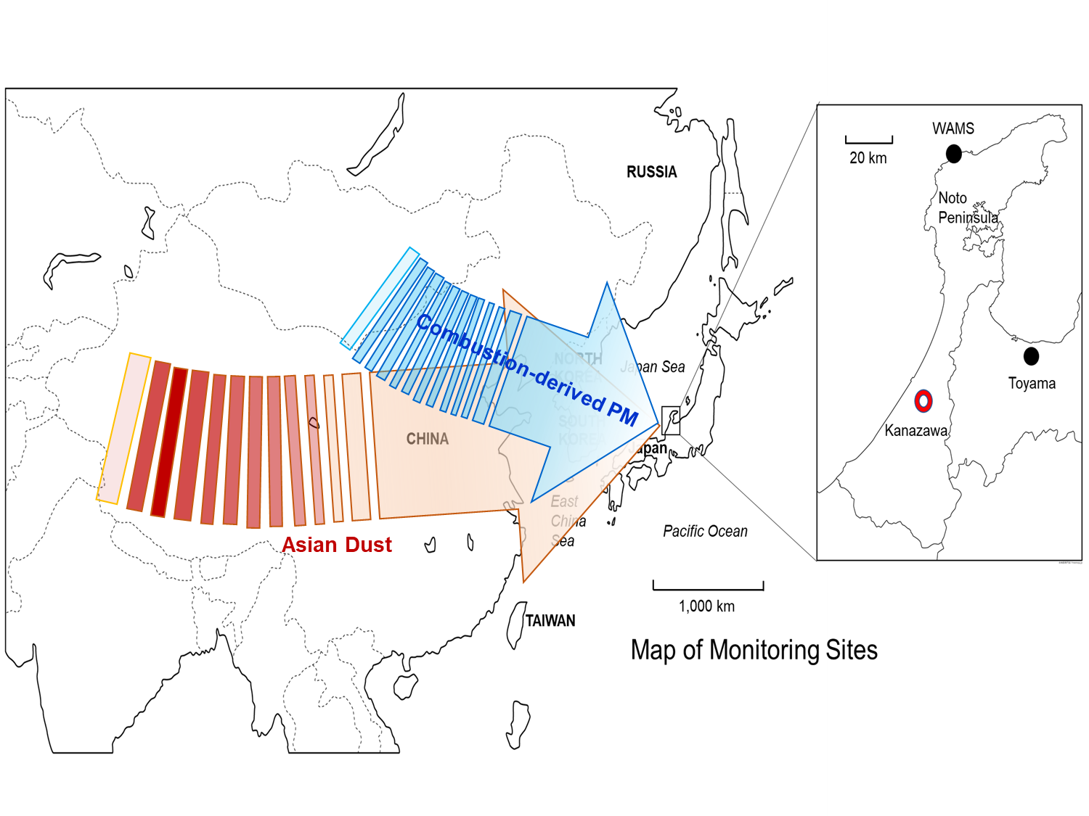

Table S1. Correlation coefficients between atmospheric compounds
 | PM_{2.5} | PM_{>2.5} | P₀ | P_{c} | P_{h} | P_{l} | ΣPAH | ΣNPAH
PM_{2.5}
PM_{>2.5} | 0.6921
P₀ | 0.9999 | 0.6934
P_{c} | 0.5585 | 0.4390 | 0.5456
P_{h} | 0.1186 | 0.0150 | 0.6518 | 0.7038
P_{l} | 0.6626 | 0.5732 | 0.1075 | 0.9223 | 0.3800
ΣPAH | 0.6811 | 0.5954 | 0.6716 | 0.8661 | 0.3116 | 0.9737
ΣNPAH | 0.3850 | 0.3268 | 0.3582 | 0.8211 | 0.6689 | 0.7152 | 0.7520
TSP samples were collected in Kanazawa for 7 days in every season from spring, summer, autumn, 2017 to winter, 2018. P_{o}, particulate from non-combustion source; P_{c}, particulate from combustion source; P_{h}, particulate from combustion source with higher temperature (automobiles); P_{l}, particulate from combustion source with lower temperature (heating facilities/industries). Bold means correlation coefficient ≥ 0.9; Underline means 0.9 > correlation coefficient ≥ 0.7.

References

Hayakawa, K., Kitamura, R., Butoh, M., Imaizumi, N., Miyazaki, M., Determination of diamino- and aminopyrenes by high-performance liquid chromatography with chemiluminescence detection. Anal. Sci., 7, 573-577 (1991). https://doi.org/10.2116/analsci.7.573
Hayakawa, K., Murahashi, T., Butoh, M., Miyazaki, M., Determination of 1,3-, 1,6-, and 1,8-dinitropyrenes and 1-nitropyrene in urban air by high-performance liquid chromatography using chemiluminescence detection. Environ. Sci. Technol., 29, 928-932 (1995). https://doi.org/10.1021/es00004a012
Hayakawa, K., Tang, N., Toriba, A., Nagato, E. G., Calculating sources of combustion-derived particulates using 1-nitropyrene and pyrene as markers. Environ. Pollut., 265, Part B, 114730 (2020). https://doi.org/10.1016/j.envpol.2020.114730
Tang, N., Taga, R., Hattori, T., Toriba, A., Kizu, R., Hayakawa, K., Simultaneous determination of twenty-one mutagenic nitropolycyclic aromatic hydrocarbons by high-performance liquid chromatography with chemiluminescence detection. Proceedings of the 13th International Symposium, Bioluminescence and Chemiluminescence Progress and Perspective, ed. by A. Tsuji et al., World Science, London, pp. 441-444, 2005.

