Supplementary
Utilizing the food-pathogen metabolome to putatively identify biomarkers for the detection of Shiga toxin-producing E. coli (STEC) from spinach.
Snehal R. Jadhav¹, Rohan M. Shah^{2,3}, Avinash V. Karpe³, Robert S. Barlow⁴, Kate E. McMillan⁴, Michelle L. Colgrave⁵, David J. Beale^{3*}
¹ Consumer-Analytical-Safety-Sensory (CASS) Food Research Centre, School of Exercise and Nutrition Sciences, Deakin University, Burwood, VIC, 3220, Australia. Snehal.Jadhav@deakin.edu.au (SRJ).
² Department of Chemistry and Biotechnology, Faculty of Science, Engineering and Technology, Swinburne University of Technology, Hawthorn, VIC 3122, Australia. rshah@swin.edu.au (RMS).
³ Land and Water, Commonwealth Scientific and Industrial Research Organization, Ecoscience Precinct, Dutton Park, QLD, 4102, Australia. R.Shah@csiro.au (RMS); Avinash.Karpe@csiro.au (AVK); David.Beale@csiro.au (DJB).
⁴ Agriculture and Food, Commonwealth Scientific and Industrial Research Organization, Coopers Plains, QLD, 4108, Australia. Robert.Barlow@csiro.au (RSB); Kate.McMillan@csiro.au (KEM).
⁵ Agriculture and Food, Commonwealth Scientific and Industrial Research Organization, St Lucia, QLD, 4067, Australia. Michelle.Colgrave@csiro.au (MLC).

* Correspondence: Dr David J Beale, Senior Research Scientist, Environmental Systems Biology. David.Beale@csiro.au; Tel.: +61 7 3833 5774.
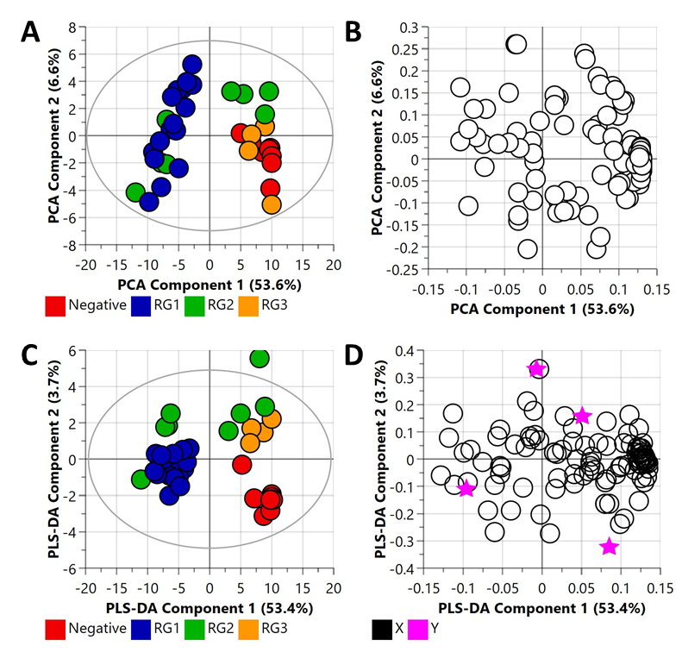
Figure S1. Principal component analysis (PCA) (R2X (cum) = 0.653, Q2 = 0.521) and partial least square-discriminant analysis (PLS-DA) (R2X (cum) = 0.571, R2Y (cum) = 0.494, Q2 = 0.312) of bacterial pellet samples collected from buffered peptone water (BPW) cultures. Note, the eclipse presented in Figure S1A and S1C represents the Hotelling's confidence limit (95%). Note: The colored circles in panel “A” and “C” represent each analysed samples, while the purple-colored stars in panel “B” and “D” indicate the average group position for each sample cluster, with the white circles representing the distribution of metabolite features between these groups.
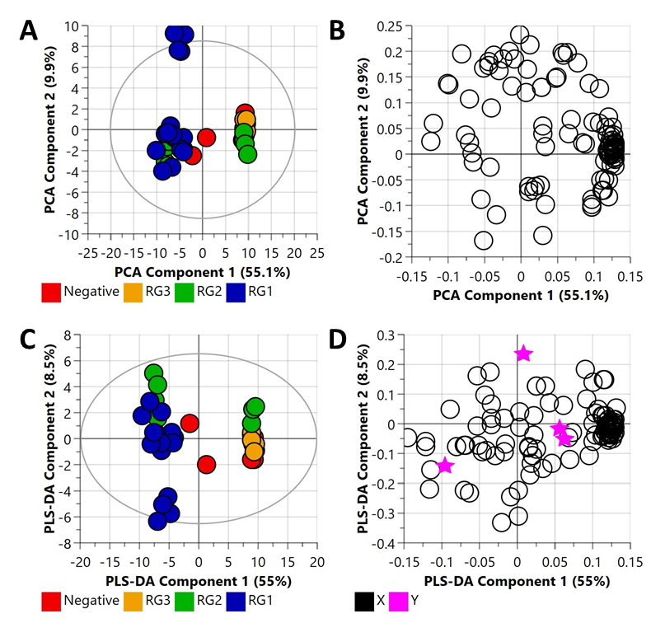
Figure S2. Principal component analysis (PCA) (R2X (cum) = 0.649, Q2 = 0.581) and partial least square-discriminant analysis (PLS-DA) (R2X (cum) = 0.696, R2Y (cum) = 0.697, Q2 = 0.347) of bacterial supernatant samples collected from buffered peptone water (BPW) cultures. Note, the eclipse presented in Figure S2A and S2C represents the Hotelling's confidence limit (95%). The colored circles in panel “A” and “C” represent each analysed samples, while the purple-colored stars in panel “B” and “D” indicate the average group position for each sample cluster, with the white circles representing the distribution of metabolite features between these groups.
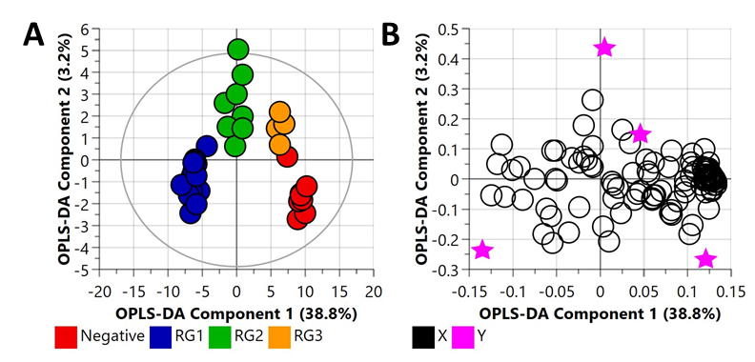Figure S3. Orthogonal Partial Least Square-Discriminant Analysis (A) scatter plot and (B) loading plot of bacterial pellet samples collected from BPW cultures (n=38; note, the negative group includes Salmonella). R²X (cum) = 0.697, R²Y (cum) = 0.637, Q² = 0.345. Note, the eclipse presented in Figure 2A represents the Hotelling's confidence limit (95%). Note: The colored circles in panel “A” represent each analysed samples, while the purple-colored stars in panel “B” indicate the average group position for each sample cluster, with the white circles representing the distribution of metabolite features between these groups.
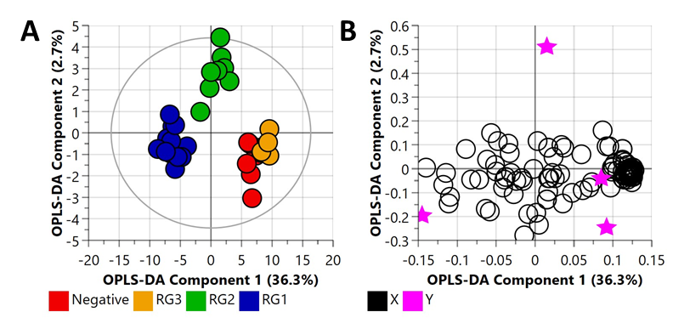Figure S4. Orthogonal Partial Least Square-Discriminant Analysis (A) scatter plot and (B) loading plot of bacterial supernatant samples collected from BPW cultures (n=38; note, the negative group includes Salmonella). R²X (cum) = 0.765, R²Y (cum) = 0.845, Q² = 0.421. Note, the eclipse presented in Figure 3A represents the Hotelling's confidence limit (95%). Note: The colored circles in panel “A” represent each analysed samples, while the purple-colored stars in panel “B” indicate the average group position for each sample cluster, with the white circles representing the distribution of metabolite features between these groups.
Table S1: Cross validation (CV)-ANOVA of the OPLS-DA bacterial pellet model (Figure S3).
OPLS-DA (Figure S3) | SS | DF | MS | F-test | P value | SD
Total corr. | 105 | 105 | 1 |  |  | 1
Regression | 46.6142 | 30 | 1.55381 | 1.99595 | 0.00844 | 1.24652
Residual | 58.3858 | 75 | 0.778478 |  |  | 0.882314
In this table, SS: sum-of-squares, DF: degrees of freedom, MS: mean squares, SD: standard deviation
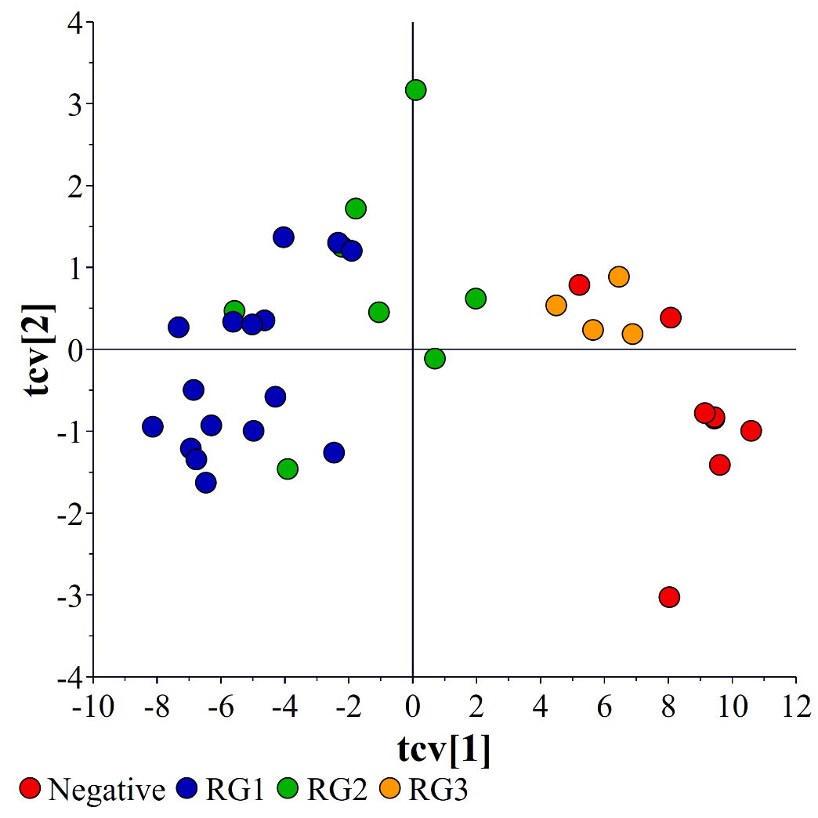
Figure S5: Cross Validation (CV) Scores plots of the OPLS-DA bacterial pellet model. Note, the scatter plot of the cross-validated score vectors is analogous to the scatter plot of regular score vectors (Figure 1) but illustrates the sample stability of each point in relation to the other groups.
Table S2: Cross validation (CV)-ANOVA of the OPLS-DA bacterial supernatant model (Figure S4).
OPLS-DA (Figure S4) | SS | DF | MS | F-test | P value | SD
Total corr. | 105 | 105 | 1 |  |  | 1
Regression | 36.9623 | 39 | 0.947751 | 0.919366 | 0.605361 | 0.973525
Residual | 68.0377 | 66 | 1.03087 |  |  | 1.01532
In this table, SS: sum-of-squares, DF: degrees of freedom, MS: mean squares, SD: standard deviation
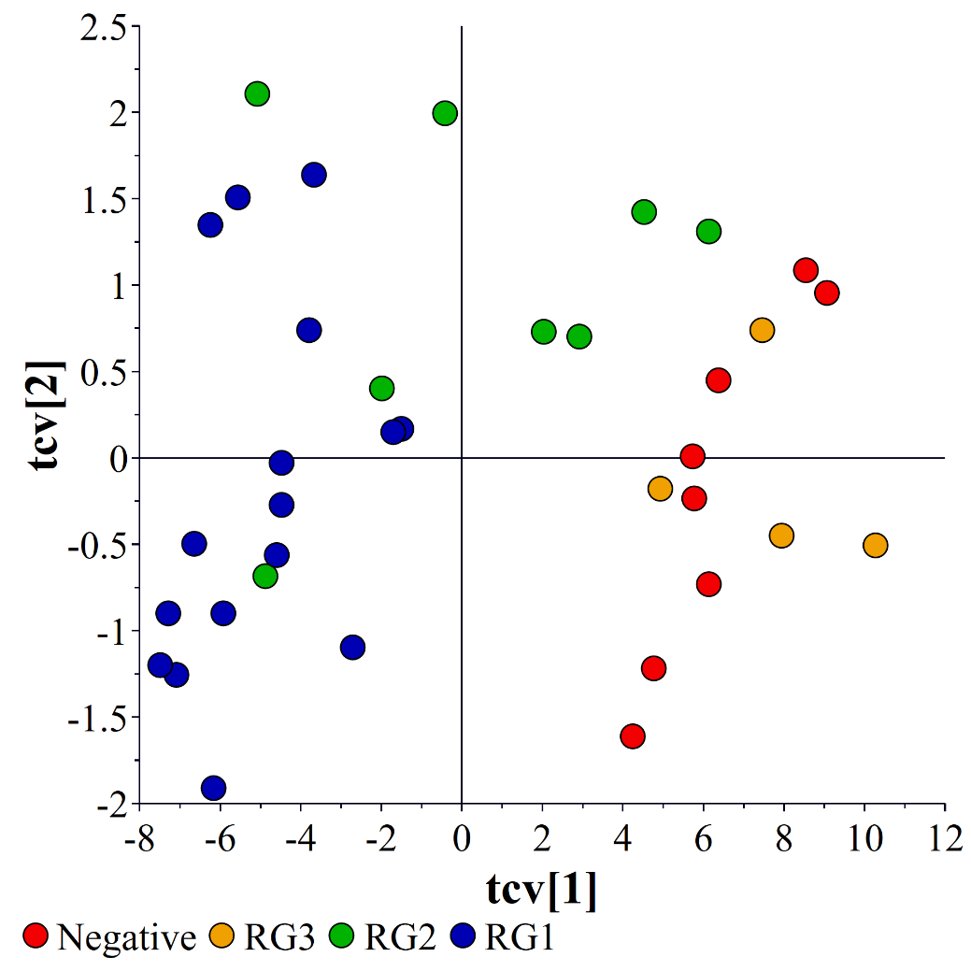
Figure S6: Cross Validation (CV) Scores plots of the OPLS-DA bacterial supernatant model. Note, the scatter plot of the cross-validated score vectors is analogous to the scatter plot of regular score vectors (Figure 1) but illustrates the sample stability of each point in relation to the other groups.
Table S3: Significant metabolites in bacterial pellet samples collected from BPW cultures (n=38; note, the negative group includes Salmonella).
Metabolites | Fold change | Adjusted P value | Regulation
Compound_18 | 36.416 | 0.000146 | up
Compound_14 | 35.204 | 8.28E-06 | up
Compound_12 | 33.318 | 0.001508 | up
2-amino-2-methyl-1,3-propanediol | 31.664 | 9.19E-05 | up
D-sphingosine | 25.018 | 1.85E-13 | up
Compound_73 | 24.241 | 7.12E-10 | up
Compound_107 | 16.051 | 0.001213 | up
Compound_87 | 15.753 | 0.000257 | up
Compound_21 | 12.48 | 5.78E-07 | up
Compound_104 | 10.114 | 7.33E-10 | up
Behenic acid | 9.6772 | 4.92E-05 | up
2,3-dihydroxybiphenyl | 9.5005 | 0.000127 | up
Compound_2 | 8.2141 | 0.004631 | up
Compound_96 | 8.2125 | 0.001037 | up
Compound_44 | 8.1728 | 3.47E-05 | up
Compound_50 | 8.1701 | 7.38E-05 | up
Compound_61 | 8.0776 | 0.000731 | up
Compound_11 | 7.9889 | 4.92E-05 | up
Compound_24 | 6.6523 | 0.000146 | up
Compound_38 | 6.5173 | 0.000712 | up
Acetohydroxamic acid | 6.2431 | 0.000146 | up
Compound_27 | 6.2068 | 0.004362 | up
3-hydroxyanthranilic acid | 5.8699 | 0.000731 | up
Compound_51 | 5.8517 | 0.002949 | up
Compound_103 | 5.5829 | 1.30E-05 | up
Pelargonic acid | 5.4489 | 4.92E-05 | up
Compound_97 | 5.2038 | 0.007991 | up
Compound_9 | 5.1091 | 0.000808 | up
Compound_5 | 4.5896 | 0.004927 | up
Compound_99 | 4.5847 | 0.000158 | up
4-aminophenol | 4.5141 | 0.000143 | up
Compound_48 | 4.4353 | 0.006312 | up
Compound_106 | 4.3723 | 0.000245 | up
Compound_49 | 4.2725 | 0.013932 | up
DL-2-amino-3-phosphonopropionic acid | 4.1294 | 0.000466 | up
Compound_16 | 3.9466 | 0.000811 | up
Glycolic acid | 3.9064 | 0.000182 | up
Compound_19 | 3.8993 | 0.001678 | up
Halostachine | 3.8843 | 0.002475 | up
Compound_26 | 3.8763 | 0.000781 | up
Compound_82 | 3.7364 | 0.003348 | up
Compound_68 | 3.5628 | 0.00204 | up
Lauric acid | 2.2008 | 0.026559 | up
2,6-Dihydroxy-4-Methoxytoluene | 2.0793 | 0.002067 | up
1-hexadecanol | 2.0793 | 0.002067 | up
Compound_105 | 2.0371 | 0.017356 | up
Pipecolic acid | 0.48959 | 2.58E-06 | down
Trimethyllysine | 0.41389 | 1.40E-05 | down
Compound_70 | 0.37818 | 3.95E-07 | down
L-methionine | 0.37376 | 3.95E-07 | down
Compound_79 | 0.34472 | 4.07E-07 | down
Cytidine | 0.29306 | 3.72E-06 | down
Compound_111 | 0.25147 | 8.28E-06 | down
Compound_76 | 0.24706 | 1.61E-05 | down
Compound_77 | 0.23977 | 7.69E-05 | down
N-acetyl-ornithine | 0.23468 | 2.48E-05 | down
Compound_83 | 0.21965 | 1.56E-06 | down
Compound_109 | 0.21267 | 1.61E-05 | down

Table S4: Significant metabolites in bacterial supernatant samples collected from BPW cultures (n=38; note, the negative group includes Salmonella).
Metabolites | Fold change | Adjusted P value | Regulation
Compound_103 | 38.929 | 6.63E-05 | up
Compound_21 | 34.426 | 3.12E-07 | up
Compound_104 | 22.265 | 6.98E-07 | up
Compound_107 | 19.281 | 6.74E-07 | up
2-amino-2-methyl-1,3-propanediol | 18.976 | 0.002331 | up
Compound_87 | 17.041 | 0.000872 | up
2,3-dihydroxybiphenyl | 10.598 | 0.000988 | up
Compound_105 | 6.9911 | 0.000729 | up
Compound_38 | 6.8391 | 0.013821 | up
Compound_44 | 6.6591 | 0.004764 | up
Compound_102 | 6.6434 | 0.020342 | up
Compound_96 | 6.4177 | 0.00816 | up
Compound_48 | 6.2733 | 0.002057 | up
behenic acid | 5.4042 | 0.001537 | up
Compound_18 | 5.3986 | 0.000729 | up
2,3-butanediol | 5.0483 | 0.001857 | up
Compound_4 | 5.0482 | 0.001857 | up
Compound_14 | 4.9289 | 0.002907 | up
Compound_51 | 4.6055 | 0.002113 | up
Compound_49 | 4.5877 | 0.025265 | up
pelargonic acid | 3.8394 | 0.018413 | up
Compound_11 | 3.7539 | 0.002784 | up
Compound_61 | 3.6594 | 0.012926 | up
Compound_24 | 3.4676 | 0.003368 | up
Compound_12 | 3.4617 | 0.034869 | up
4-aminophenol | 3.3531 | 0.000729 | up
acetohydroxamic acid | 3.3156 | 0.003907 | up
Compound_5 | 3.1738 | 0.012242 | up
Compound_9 | 3.073 | 0.005124 | up
Compound_99 | 2.865 | 0.001857 | up
Compound_106 | 2.813 | 0.00348 | up
Compound_26 | 2.7512 | 0.013821 | up
glycolic acid | 2.6654 | 0.002113 | up
3-hydroxyanthranilic acid | 2.5867 | 0.031998 | up
Compound_27 | 2.5864 | 0.031998 | up
halostachine | 2.5024 | 0.025265 | up
Compound_19 | 2.5024 | 0.025265 | up
Compound_22 | 2.4491 | 0.00816 | up
Compound_16 | 2.4334 | 0.031998 | up
DL-2-amino-3-phosphonopropionic acid | 2.4136 | 0.019143 | up
D-sphingosine | 2.3341 | 0.001613 | up
Compound_68 | 2.2822 | 0.049952 | up
Compound_73 | 2.2638 | 0.003307 | up
Compound_76 | 0.48847 | 0.007747 | down
Compound_77 | 0.48806 | 0.018413 | down
Compound_111 | 0.46467 | 0.004764 | down
epsilon-caprolactam | 0.31819 | 0.003841 | down
Compound_109 | 0.30493 | 0.001613 | down
N-acetyl-ornithine | 0.25191 | 0.000804 | down

Table S5: ANOVA analysis of bacterial pellet samples collected from BPW cultures.
Metabolites | Pubchem ID | KEGG ID | F-statistic | P value | FDR | Fisher's LSD
D-sphingosine | 5280335 | C00319 | 55.978 | 1.05E-15 | 1.12E-13 | RG1 > Negative; RG2 > Negative; RG1 > RG2; RG1 > RG3; RG2 > RG3
L-methionine | 6137 | C00073 | 15.094 | 4.74E-07 | 8.38E-06 | Negative > RG1; Negative > RG2; RG3 > RG1; RG3 > RG2
Pipecolic acid | 439227 | C00408 | 12.302 | 4.31E-06 | 4.24E-05 | Negative > RG1; Negative > RG2; RG3 > RG1; RG3 > RG2
Cytidine | 596 | NA | 12.163 | 4.84E-06 | 4.27E-05 | Negative > RG1; Negative > RG2; RG3 > RG1; RG3 > RG2
N-acetyl-ornithine | 439232 | C00437 | 10.016 | 3.08E-05 | 2.17E-04 | Negative > RG1; Negative > RG2; RG3 > RG1; RG3 > RG2
Trimethyllysine | 159660 | NA | 9.5429 | 4.72E-05 | 2.94E-04 | Negative > RG1; Negative > RG2; RG3 > RG1; RG3 > RG2
Behenic acid | 8215 | C08281 | 8.806 | 9.31E-05 | 4.93E-04 | RG1 > Negative; RG2 > Negative; RG1 > RG3; RG2 > RG3
Conduritol epoxide | 119054 | NA | 8.3638 | 1.41E-04 | 6.80E-04 | Negative > RG1; Negative > RG2; RG3 > RG1
Pelargonic acid | 8158 | C01601 | 8.0606 | 1.89E-04 | 8.42E-04 | RG1 > Negative; RG2 > Negative; RG1 > RG3
2-amino-2-methyl-1,3-propanediol | 1531 | C11260 | 7.4813 | 3.31E-04 | 1.35E-03 | RG1 > Negative; RG2 > Negative; RG1 > RG3
2,6-Dihydroxy-4-Methoxytoluene | 238769 | NA | 7.2436 | 4.19E-04 | 1.48E-03 | RG1 > Negative; Negative > RG3; RG1 > RG3; RG2 > RG3
1-hexadecanol | 2682 | C00823 | 7.2436 | 4.19E-04 | 1.48E-03 | RG1 > Negative; Negative > RG3; RG1 > RG3; RG2 > RG3
2,3-dihydroxybiphenyl | 254 | C02526 | 6.817 | 6.41E-04 | 2.12E-03 | RG1 > Negative; RG2 > Negative; RG1 > RG3; RG2 > RG3
4-aminophenol | 403 | C02372 | 6.5666 | 8.25E-04 | 2.65E-03 | RG1 > Negative; RG2 > Negative; RG1 > RG3; RG2 > RG3
Acetohydroxamic acid | 1990 | C06808 | 6.4834 | 8.98E-04 | 2.72E-03 | RG1 > Negative; RG2 > Negative; RG1 > RG3; RG2 > RG3
Glycolic acid | 757 | C00160 | 6.2912 | 1.09E-03 | 3.13E-03 | RG1 > Negative; RG2 > Negative; RG1 > RG3; RG2 > RG3
DL-2-amino-3-phosphonopropionic acid | 3857 | C05672 | 5.3854 | 2.82E-03 | 7.11E-03 | RG1 > Negative; RG2 > Negative; RG1 > RG3; RG2 > RG3
Glycine | 750 | C00037 | 5.2306 | 3.32E-03 | 8.19E-03 | Negative > RG1; Negative > RG2; RG3 > RG1
3-hydroxyanthranilic acid | 86 | C00632 | 5.0685 | 3.95E-03 | 9.31E-03 | RG1 > Negative; RG2 > Negative; RG1 > RG3
Acetol | 8299 | C05235 | 5.0174 | 4.18E-03 | 9.62E-03 | Negative > RG1; RG3 > RG1
DL-3-aminoisobutyric acid | 64956 | C05145 | 3.9524 | 1.34E-02 | 2.59E-02 | RG1 > Negative; RG1 > RG3
Lauric acid | 3893 | C02679 | 3.7978 | 1.60E-02 | 2.95E-02 | RG1 > RG2; RG1 > RG3
Halostachine | 913 | C03711 | 3.7885 | 1.62E-02 | 2.95E-02 | RG1 > Negative; RG2 > Negative; RG1 > RG3; RG2 > RG3
L-proline | 145742 | C00148 | 3.4894 | 2.26E-02 | 3.69E-02 | Negative > RG1
Acetoacetate | 96 | C00164 | 3.2799 | 2.87E-02 | 4.51E-02 | RG1 > RG2; RG1 > RG3

Table S6: ANOVA analysis of bacterial supernatant samples collected from BPW cultures.
Metabolites | Pubchem ID | KEGG ID | F statistic | P value | FDR | Fisher's LSD
D-sphingosine | 5280335 | C00319 | 26.235 | 3.42E-10 | 1.81E-08 | RG1 > Negative; Negative > RG3; RG1 > RG2; RG1 > RG3; RG2 > RG3
pelargonic acid | 8158 | C01601 | 9.2378 | 6.24E-05 | 8.26E-04 | RG1 > Negative; RG1 > RG2; RG1 > RG3
2,3-dihydroxybiphenyl | 254 | C02526 | 8.6094 | 1.12E-04 | 1.32E-03 | RG1 > Negative; RG1 > RG2; RG1 > RG3
DL-3-aminoisobutyric acid | 64956 | C05145 | 8.2684 | 1.55E-04 | 1.64E-03 | RG1 > Negative; RG1 > RG2; RG1 > RG3
4-aminophenol | 403 | C02372 | 7.4483 | 3.42E-04 | 3.02E-03 | RG1 > Negative; RG1 > RG2; RG1 > RG3
behenic acid | 8215 | C08281 | 6.8098 | 6.45E-04 | 4.56E-03 | RG1 > Negative; RG1 > RG2; RG1 > RG3
N-acetyl-ornithine | 439232 | C00437 | 6.0757 | 1.37E-03 | 8.85E-03 | Negative > RG1; Negative > RG2; RG3 > RG1; RG3 > RG2
acetoacetate | 96 | C00164 | 6.0289 | 1.43E-03 | 8.85E-03 | RG3 > Negative; RG3 > RG1; RG3 > RG2
2,3-butanediol | 262 | NA | 5.5697 | 2.32E-03 | 1.12E-02 | RG1 > Negative; RG2 > Negative; RG1 > RG3; RG2 > RG3
L-alanine | 5950 | C00041 | 5.5275 | 2.42E-03 | 1.12E-02 | RG1 > Negative; RG1 > RG3
glycolic acid | 757 | C00160 | 5.1918 | 3.46E-03 | 1.47E-02 | RG1 > Negative; RG1 > RG3; RG2 > RG3
2-amino-2-methyl-1,3-propanediol | 1531 | C11260 | 4.9224 | 4.63E-03 | 1.75E-02 | RG1 > Negative; RG1 > RG3
acetohydroxamic acid | 1990 | C06808 | 4.377 | 8.39E-03 | 2.74E-02 | RG1 > Negative; RG1 > RG3; RG2 > RG3
epsilon-caprolactam | 7768 | C06593 | 4.2255 | 9.92E-03 | 3.09E-02 | Negative > RG1; RG3 > RG1; RG3 > RG2

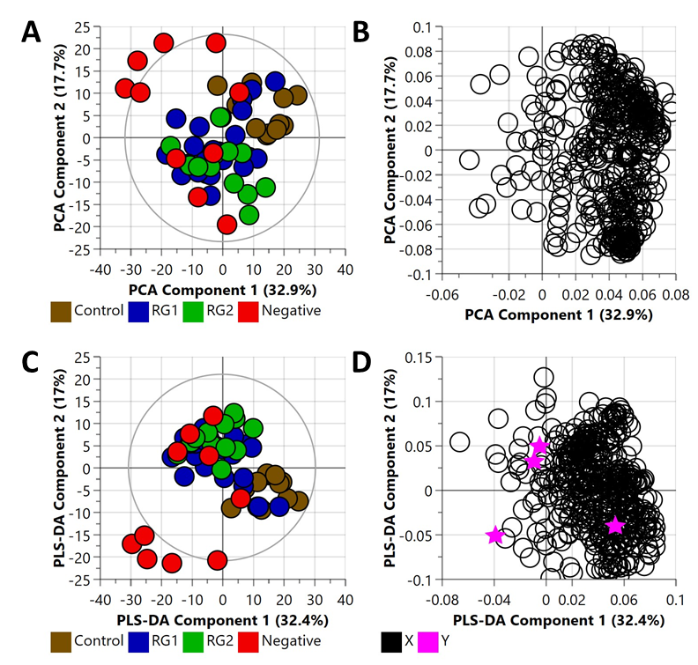
Figure S7. Principal component analysis (PCA) (R2X (cum) = 0.714, Q2 = 0.572) and partial least square-discriminant analysis (PLS-DA) (R2X (cum) = 0.671, R2Y (cum) = 0.757, Q2 = 0.431) of bacterial pellet samples collected from inoculated spinach samples. Note: the eclipse presented in Figure S4A and S4C represents the Hotelling's confidence limit (95%). The colored circles in panel “A” and “C” represent each analyzed samples, while the purple-colored stars in panel “B” and “D” indicate the average group position for each sample cluster, with the white circles representing the distribution of metabolite features between these groups.
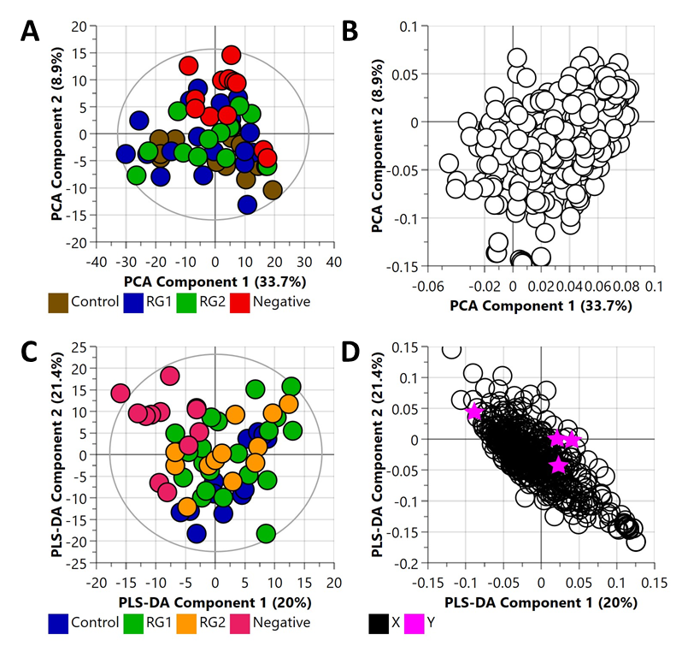
Figure S8. Principal component analysis (PCA) (R2X (cum) = 0.712, Q2 = 0.464) and partial least square-discriminant analysis (PLS-DA) (R2X (cum) = 0.52, R2Y (cum) = 0.746, Q2 = 0.329) of bacterial supernatant samples collected from inoculated spinach samples. Note: the eclipse presented in Figure S5A and S5C represents the Hotelling's confidence limit (95%). The colored circles in panel “A” and “C” represent each analysed samples, while the purple-colored stars in panel “B” and “D” indicate the average group position for each sample cluster, with the white circles representing the distribution of metabolite features between these groups.
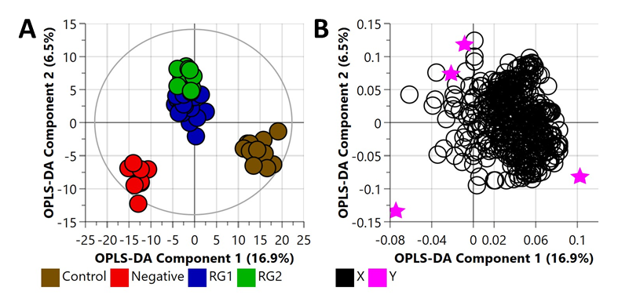Figure S9. Orthogonal Partial Least Square-Discriminant Analysis (A) scatter plot and (B) loading plot of bacterial pellet samples collected from inoculated spinach samples (n=58). R²X (cum) = 0.763, R²Y (cum) = 0.920, Q² = 0.314. Note, the eclipse presented in Figure 4A represents the Hotelling's confidence limit (95%). Note: The colored circles in panel “A” represent each analysed samples, while the purple-colored stars in panel “B” indicate the average group position for each sample cluster, with the white circles representing the distribution of metabolite features between these groups.
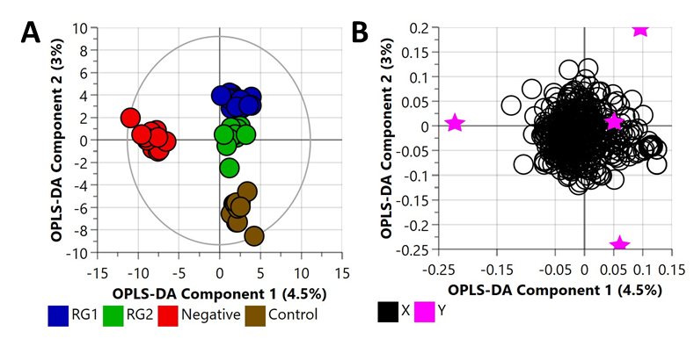
Figure S10. Orthogonal Partial Least Square-Discriminant Analysis (A) scatter plot and (B) loading plot of bacterial supernatant samples collected from inoculated spinach samples (n=58). R²X (cum) = 0.635, R²Y (cum) = 0.945, Q² = 0.429. Note, the eclipse presented in Figure 5A represents the Hotelling's confidence limit (95%). Note: The colored circles in panel “A” represent each analysed samples, while the purple-colored stars in panel “B” indicate the average group position for each sample cluster, with the white circles representing the distribution of metabolite features between these groups.
Table S7: Cross validation (CV)-ANOVA of the OPLS-DA inoculated spinach pellet model.
OPLS-DA (Inoculated spinach pellet model) | SS | DF | MS | F-test | P value | SD
Total corr. | 171 | 171 | 1 |  |  | 1
Regression | 79.5159 | 54 | 1.47252 | 1.88322 | 0.00234138 | 1.21347
Residual | 91.4841 | 117 | 0.781916 |  |  | 0.88426
In this table, SS: sum-of-squares, DF: degrees of freedom, MS: mean squares, SD: standard deviation
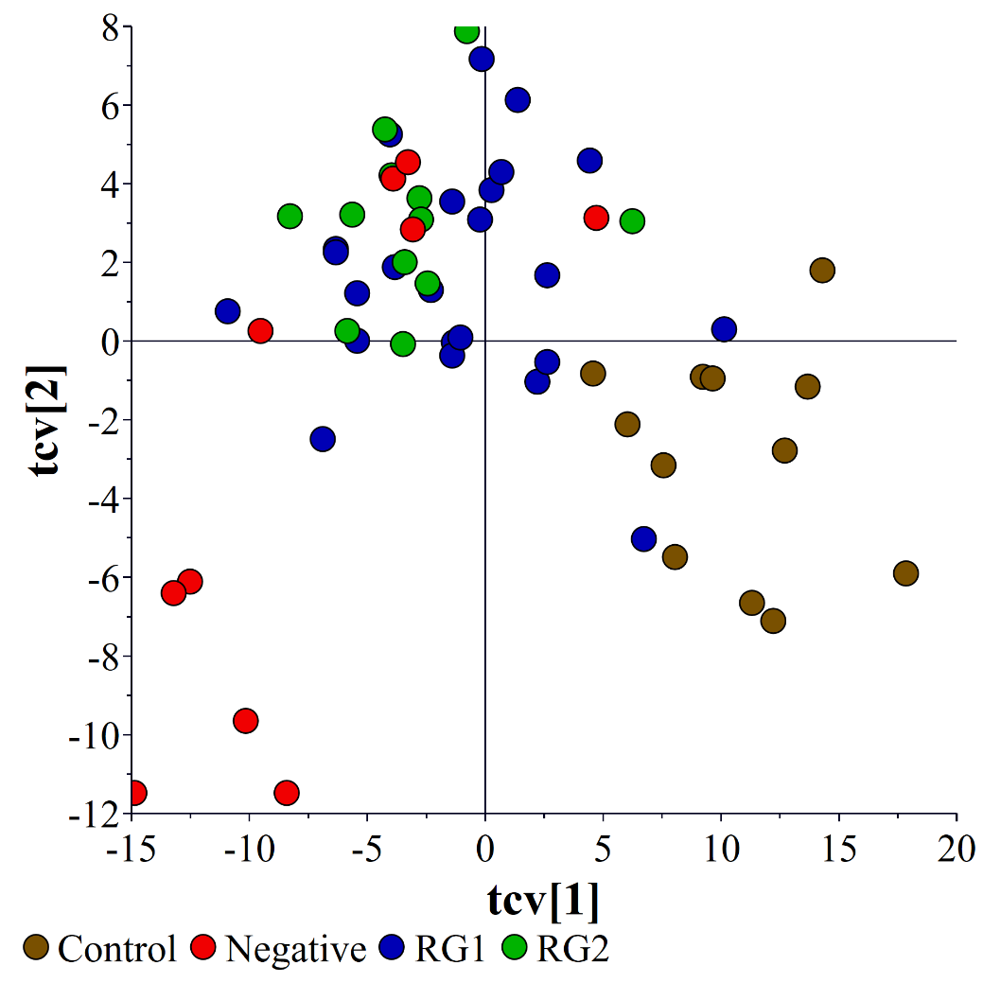
Figure S11: Cross Validation (CV) Scores plots of the OPLS-DA bacterial supernatant model. Note, the scatter plot of the cross-validated score vectors is analogous to the scatter plot of regular score vectors (Figure 1) but illustrates the sample stability of each point in relation to the other groups.
Table S8: Cross validation (CV)-ANOVA of the OPLS-DA inoculated spinach supernatant model.
OPLS-DA (Inoculated spinach supernatant model) | SS | DF | MS | F-test | P value | SD
Total corr. | 165 | 165 | 1 |  |  | 1
Regression | 71.263 | 54 | 1.31969 | 1.56272 | 0.0246481 | 1.14878
Residual | 93.737 | 111 | 0.844478 |  |  | 0.918955
In this table, SS: sum-of-squares, DF: degrees of freedom, MS: mean squares, SD: standard deviation
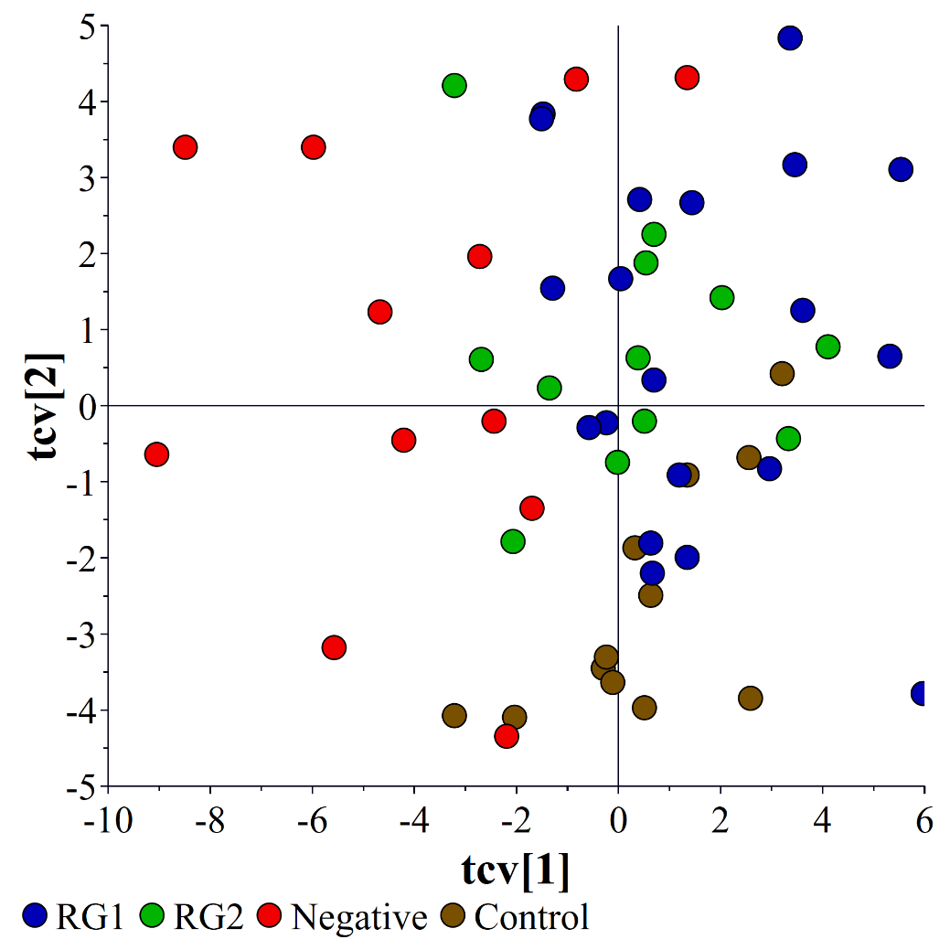
Figure S12: Cross Validation (CV) Scores plots of the OPLS-DA inoculated spinach supernatant model. Note, the scatter plot of the cross-validated score vectors is analogous to the scatter plot of regular score vectors (Figure 1) but illustrates the sample stability of each point in relation to the other groups.

Table S9: Significant metabolites identified in bacterial pellet from RG1-inoculated spinach samples.
Metabolites | Human Metabolome Database | KEGG | P value | Fold change | Regulation
L-methionine | HMDB0000696 | C00073 | 0.0045 | 2.36097 | Up
4-hydroxycinnamic acid | HMDB0002035 | C00811 | 0.01295 | 2.09518 | Up
Putrescine | HMDB0001414 | C00134 | 0.005317 | 0.490402 | Down
Citric acid | HMDB0000094 | C00158 | 0.012117 | 0.487528 | Down
L-threonine | HMDB0000167 | C00188 | 0.001047 | 0.483517 | Down
Inosine | HMDB0000195 | C00294 | 0.024845 | 0.46021 | Down
O-phosphocolamine | HMDB0000224 | C00346 | 0.049315 | 0.452313 | Down
Phosphoric acid | HMDB0002142 | C00009 | 0.011027 | 0.451882 | Down
Stearic acid | HMDB0000827 | C01530 | 0.000723 | 0.451536 | Down
L-glutamic acid | HMDB0000148 | C00025 | 0.000483 | 0.447883 | Down
Methyl Caprate | HMDB0033848 | No result | 0.002917 | 0.446061 | Down
Myristic acid | HMDB0000806 | C06424 | 0.000247 | 0.4452 | Down
Linoleic acid | HMDB0000673 | C01595 | 0.001348 | 0.439841 | Down
Methyl-beta-D-galactopyranoside | No result | C03619 | 0.000918 | 0.432168 | Down
Behenic acid | HMDB0000944 | C08281 | 0.004614 | 0.409336 | Down
Spermidine | HMDB0001257 | C00315 | 0.001029 | 0.409256 | Down
Acetol | HMDB0006961 | C05235 | 0.037705 | 0.402971 | Down
Glycerol 1-phosphate | No result | C03189 | 0.000989 | 0.390908 | Down
Methyl linolenate | No result | No result | 0.000984 | 0.388655 | Down
3-phosphoglyceric acid | HMDB0060180 | C00197 | 0.049638 | 0.386142 | Down
L-proline | HMDB0000162 | C00148 | 0.001112 | 0.339837 | Down
Guanosine | HMDB0000133 | C00387 | 0.018204 | 0.307033 | Down
Hypoxanthine | HMDB0000157 | C00262 | 0.000188 | 0.303996 | Down
Adenosine | HMDB0000050 | C00212 | 0.004923 | 0.29823 | Down
Eicosane | HMDB0059909 | No result | 0.005486 | 0.280899 | Down
Methyl Palmitate | HMDB0061859 | C16995 | 0.000534 | 0.271417 | Down
3,7-Dihydroxyflavone | HMDB0134547 | No result | 0.000689 | 0.266666 | Down
Aspartic acid | HMDB0000191 | C00049 | 0.000139 | 0.262345 | Down
Nitrazepam | HMDB0015534 | C07487 | 0.000594 | 0.254608 | Down
Phytol | No result | No result | 0.000145 | 0.254329 | Down
Adenine | HMDB0000034 | C00147 | 4.50E-05 | 0.252255 | Down
Cytosine | HMDB0000630 | C00380 | 0.009951 | 0.247596 | Down
Citraconic acid | HMDB0000749 | C01732 | 9.96E-06 | 0.243214 | Down
5,6-dihydro-5-methyluracil | HMDB0000079 | C00906 | 0.000315 | 0.24311 | Down
N-methylalanine | HMDB0094692 | C02721 | 8.90E-06 | 0.237281 | Down
Epsilon-caprolactam | HMDB0062769 | C06593 | 1.54E-06 | 0.231002 | Down
1-hexadecanol | HMDB0003424 | C00823 | 0.000528 | 0.230051 | Down
L-ornithine | HMDB0000214 | C00077 | 0.000239 | 0.230008 | Down
Lauric acid | HMDB0000638 | C02679 | 0.000154 | 0.226546 | Down
L-valine | HMDB0000883 | C00183 | 8.20E-08 | 0.226404 | Down
Cellotetraose | No result | C02013 | 1.23E-06 | 0.213537 | Down
L-lysine | HMDB0000182 | C00047 | 6.19E-06 | 0.213351 | Down
Methyl palmitoleate | No result | No result | 0.024343 | 0.20616 | Down
L-norleucine | HMDB0001645 | C01933 | 6.13E-08 | 0.171248 | Down
Tyrosine | HMDB0000158 | C00082 | 6.40E-08 | 0.161078 | Down
Xanthine | HMDB0000292 | C00385 | 4.85E-07 | 0.152953 | Down
L-tryptophan | HMDB0000929 | C00078 | 4.51E-07 | 0.090689 | Down

Table S10: Significant metabolites identified in bacterial pellet from RG2-inoculated spinach samples.
Metabolites | Human Metabolome Database | KEGG | P value | Fold change | Regulation
4-hydroxyphenylacetic acid | HMDB0000020 | C00642 | 0.00289 | 0.250798 | Down
5-aminovaleric acid | HMDB0003355 | C00431 | 5.33E-05 | 0.326284 | Down
Adenine | HMDB0000034 | C00147 | 1.49E-06 | 0.141199 | Down
Citric acid | HMDB0000094 | C00158 | 0.000386 | 0.269741 | Down
1,3-diaminopropane | HMDB0000002 | C00986 | 0.000867 | 0.352664 | Down
Cytosine | HMDB0000630 | C00380 | 0.01771 | 0.122146 | Down
D-Ala-D-Ala2 | No result | No result | 2.89E-05 | 0.396973 | Down
Glycerol 1-phosphate | No result | C03189 | 3.64E-05 | 0.279513 | Down
Hypoxanthine | HMDB0000157 | C00262 | 0.007248 | 0.340268 | Down
Phenethylamine | HMDB0012275 | C05332 | 0.018288 | 0.483771 | Down
Phosphoric acid | HMDB0002142 | C00009 | 0.009625 | 0.411665 | Down
Putrescine | HMDB0001414 | C00134 | 1.24E-05 | 0.347272 | Down
Spermidine | HMDB0001257 | C00315 | 0.004649 | 0.418087 | Down
Xanthine | HMDB0000292 | C00385 | 1.43E-06 | 0.093152 | Down
1-hexadecanol | HMDB0003424 | C00823 | 0.002572 | 0.157649 | Down
Lauric acid | HMDB0000638 | C02679 | 0.000927 | 0.122289 | Down
Thymidine | HMDB0000273 | C00214 | 0.033617 | 0.168474 | Down
Trans-4-hydroxy-L-proline | HMDB0000725 | C01157 | 0.041933 | 0.231242 | Down
L-serine | HMDB0000187 | C00065 | 0.003752 | 0.423077 | Down
Aspartic acid | HMDB0000191 | C00049 | 2.58E-05 | 0.140077 | Down
L-lysine | HMDB0000182 | C00047 | 3.27E-06 | 0.139814 | Down
Inosine | HMDB0000195 | C00294 | 0.001703 | 0.155599 | Down
Tyrosine | HMDB0000158 | C00082 | 2.29E-07 | 0.127933 | Down
L-methionine | HMDB0000696 | C00073 | 0.000106 | 3.08852 | Up
L-ornithine | HMDB0000214 | C00077 | 0.001884 | 0.117089 | Down
L-valine | HMDB0000883 | C00183 | 0.00029 | 0.34979 | Down
L-threonine | HMDB0000167 | C00188 | 3.12E-03 | 0.372341 | Down
L-tryptophan | HMDB0000929 | C00078 | 4.92E-05 | 0.062864 | Down
Guanosine | HMDB0000133 | C00387 | 0.000264 | 0.061949 | Down
2-hydroxybiphenyl | HMDB0032582 | C02499 | 0.001607 | 0.193868 | Down
Epsilon-caprolactam | HMDB0062769 | C06593 | 2.43E-06 | 0.176559 | Down
Methyl Palmitate | HMDB0061859 | C16995 | 0.000227 | 0.130236 | Down
Behenic acid | HMDB0000944 | C08281 | 0.000872 | 0.258145 | Down
Eicosane | HMDB0059909 | No result | 0.0025 | 0.046264 | Down
Acetol | HMDB0006961 | C05235 | 0.02656 | 0.194565 | Down
Dioctyl phthalate | No result | C03690 | 3.28E-05 | 0.434437 | Down
Hexanoic acid | HMDB0000535 | C01585 | 0.002573 | 0.288155 | Down
Methyl linolenate | No result | No result | 0.000702 | 0.289092 | Down
4-(2-hydroxyethyl)phenol | HMDB0004284 | C06044 | 6.63E-14 | 0.13254 | Down
Myristic acid | HMDB0000806 | C06424 | 0.000162 | 0.313572 | Down
Phendimetrazine | HMDB0015519 | No result | 0.000406 | 0.238234 | Down
L-norleucine | HMDB0001645 | C01933 | 2.32E-07 | 0.124477 | Down
L-glutamic acid | HMDB0000148 | C00025 | 4.98E-06 | 0.331559 | Down
Adenosine | HMDB0000050 | C00212 | 0.003319 | 0.14406 | Down
5,6-dihydro-5-methyluracil | HMDB0000079 | C00906 | 0.000585 | 0.206062 | Down
Methyl-beta-D-galactopyranoside | No result | C03619 | 0.003075 | 0.342085 | Down
3-Hydroxy-3',4'-Dimethoxyflavone | No result | No result | 0.028674 | 7.18358 | Up
L-proline | HMDB0000162 | C00148 | 4.40E-05 | 0.17678 | Down
3-phosphoglyceric acid | HMDB0060180 | C00197 | 0.016312 | 0.262672 | Down
Cellotetraose | No result | C02013 | 3.89E-05 | 0.130264 | Down
4-hydroxycinnamic acid | HMDB0002035 | C00811 | 0.000889 | 2.54912 | Up
Citraconic acid | HMDB0000749 | C01732 | 4.81E-06 | 0.212431 | Down
D-sphingosine | No result | C00319 | 0.002491 | 0.340146 | Down
Squalene | No result | No result | 0.016476 | 0.413256 | Down
Linoleic acid | HMDB0000673 | C01595 | 0.002483 | 0.36246 | Down
N-methylalanine | HMDB0094692 | C02721 | 0.000153 | 0.190999 | Down
3,7-Dihydroxyflavone | HMDB0134547 | No result | 5.52E-05 | 0.032102 | Down
Phytol | No result | No result | 0.000137 | 0.111386 | Down

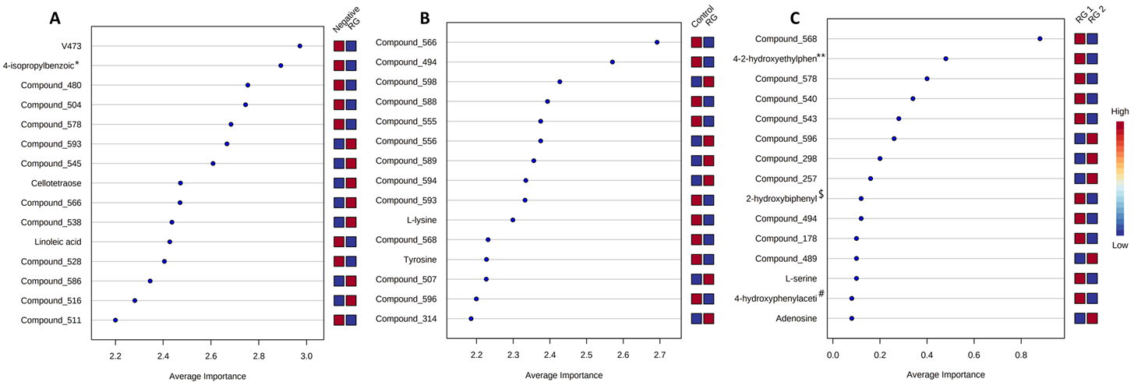
Figure S13. The plots indicate the top 15 validated biomarkers, as analysed by PLS-DA classification and feature ranking through a Monte-Carlo cross-validation (MCVV) method. The comparisons consisted of (A) Negative vs RG and (B) Control vs RG and, (C) RG 1 vs RG 2. Note: The symbols denote *4-isopropyl benzoic acid, **4-(2-hydroxyethyl)phenol, $2-hydroxybiphenyl and #4-hydroxyphenylacetic acid (A). Note: metabolites annotated “Compound_###” are indicative of unknown compounds.

