Article

Supplementary data

**Figure 1.** Dimensions of Field trial 1.

**Figure 2.** Dimension of Field trial 2.

**Figure 3.** *S. frugiperda* larvae distribution in field trial experiment 1 and pictures of different larvae instars found.

**Figure 4.** *B. bassiana* treated plants shown more than two corn cobs per plant.

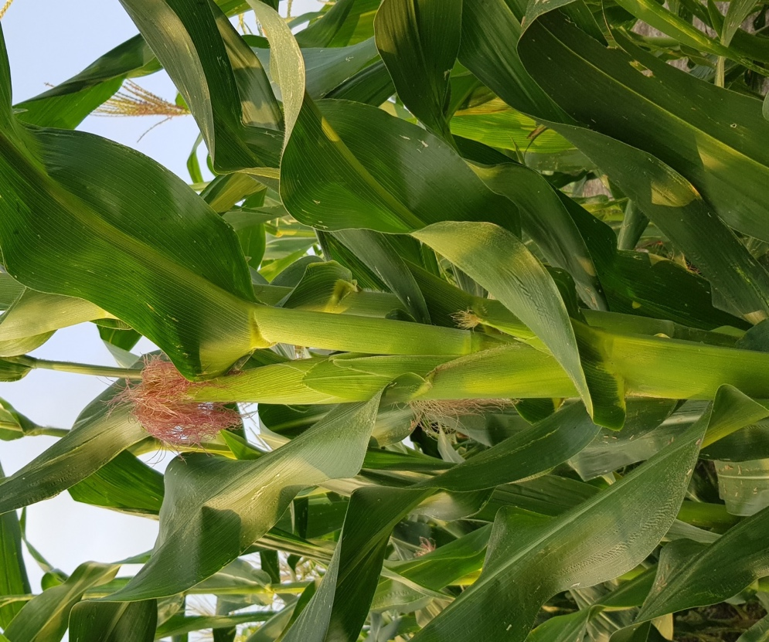

**Figure 5.** Insects observed during the field experiments.

|  |  |
| --- | --- |
|  |  |
|  |  |
|  |  |
|  |  |
|  |  |

**Figure 6.** 3rd instar *S. frugiperda* larva onto artificial diet.

**Figure 7.** *S. frugiperda* larva in *Z. mays* plant covered with a mesh cage.

