**Supporting Material for:**

**NMR Characterization of Angiogenin Variants and tRNAAla Products Impacting Aberrant Protein Oligomerization**

by Andrea Fagagnini, Miguel Garavís, Irene Gómez-Pinto, Sabrina Fasoli,

Giovanni Gotte and Douglas V. Laurents

**Supplementary Figure 1**: 1H-15N HSQC Spectrum of h-ANG (pH 6.5, 35 ºC)



The 1H-15N-type spectrum of WT h-ANG with representative assignments.

**Supplementary Figure 2**: 1H-15N HSQC Spectra of H13A h-ANG (pH 6.5, 35 ºC)

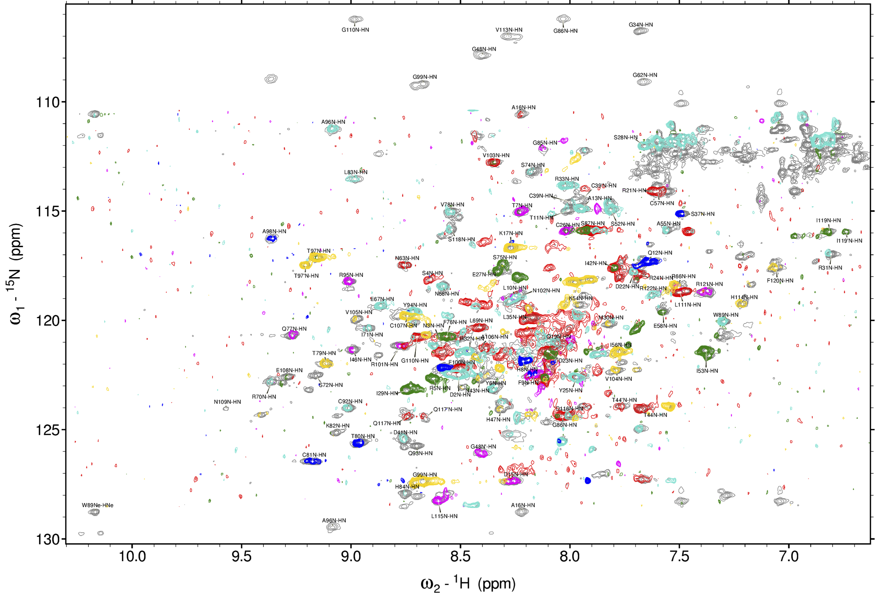

The 1H-15N-type spectrum of H13A h-ANG with representative assignments. For the central band of 15N, additional 1H-15N-type spectra filtered in 13C according to the 13C and 13C are shown in color. In these spectra, colors correspond to residues whose preceeding (*i-1*) residue are: A,V, I = **gold**, C,S= **green**, H,Y,F,W = **magenta**, G,N,D = **red**; T = **blue** and P,K,R,E,M,L,Q= **cyan**. Some doubled peaks are visible*, e.g.* T44, T97, Q117, I119. This behavior also appears in other variants and was previously reported by Lequin *et al.* under conditions of lower pH and temperature 25.

**Supplementary Figure 3**: 2D 1H-15N HSQC Spectrum of R121C h-ANG

(pH 6.5, 35 ºC)

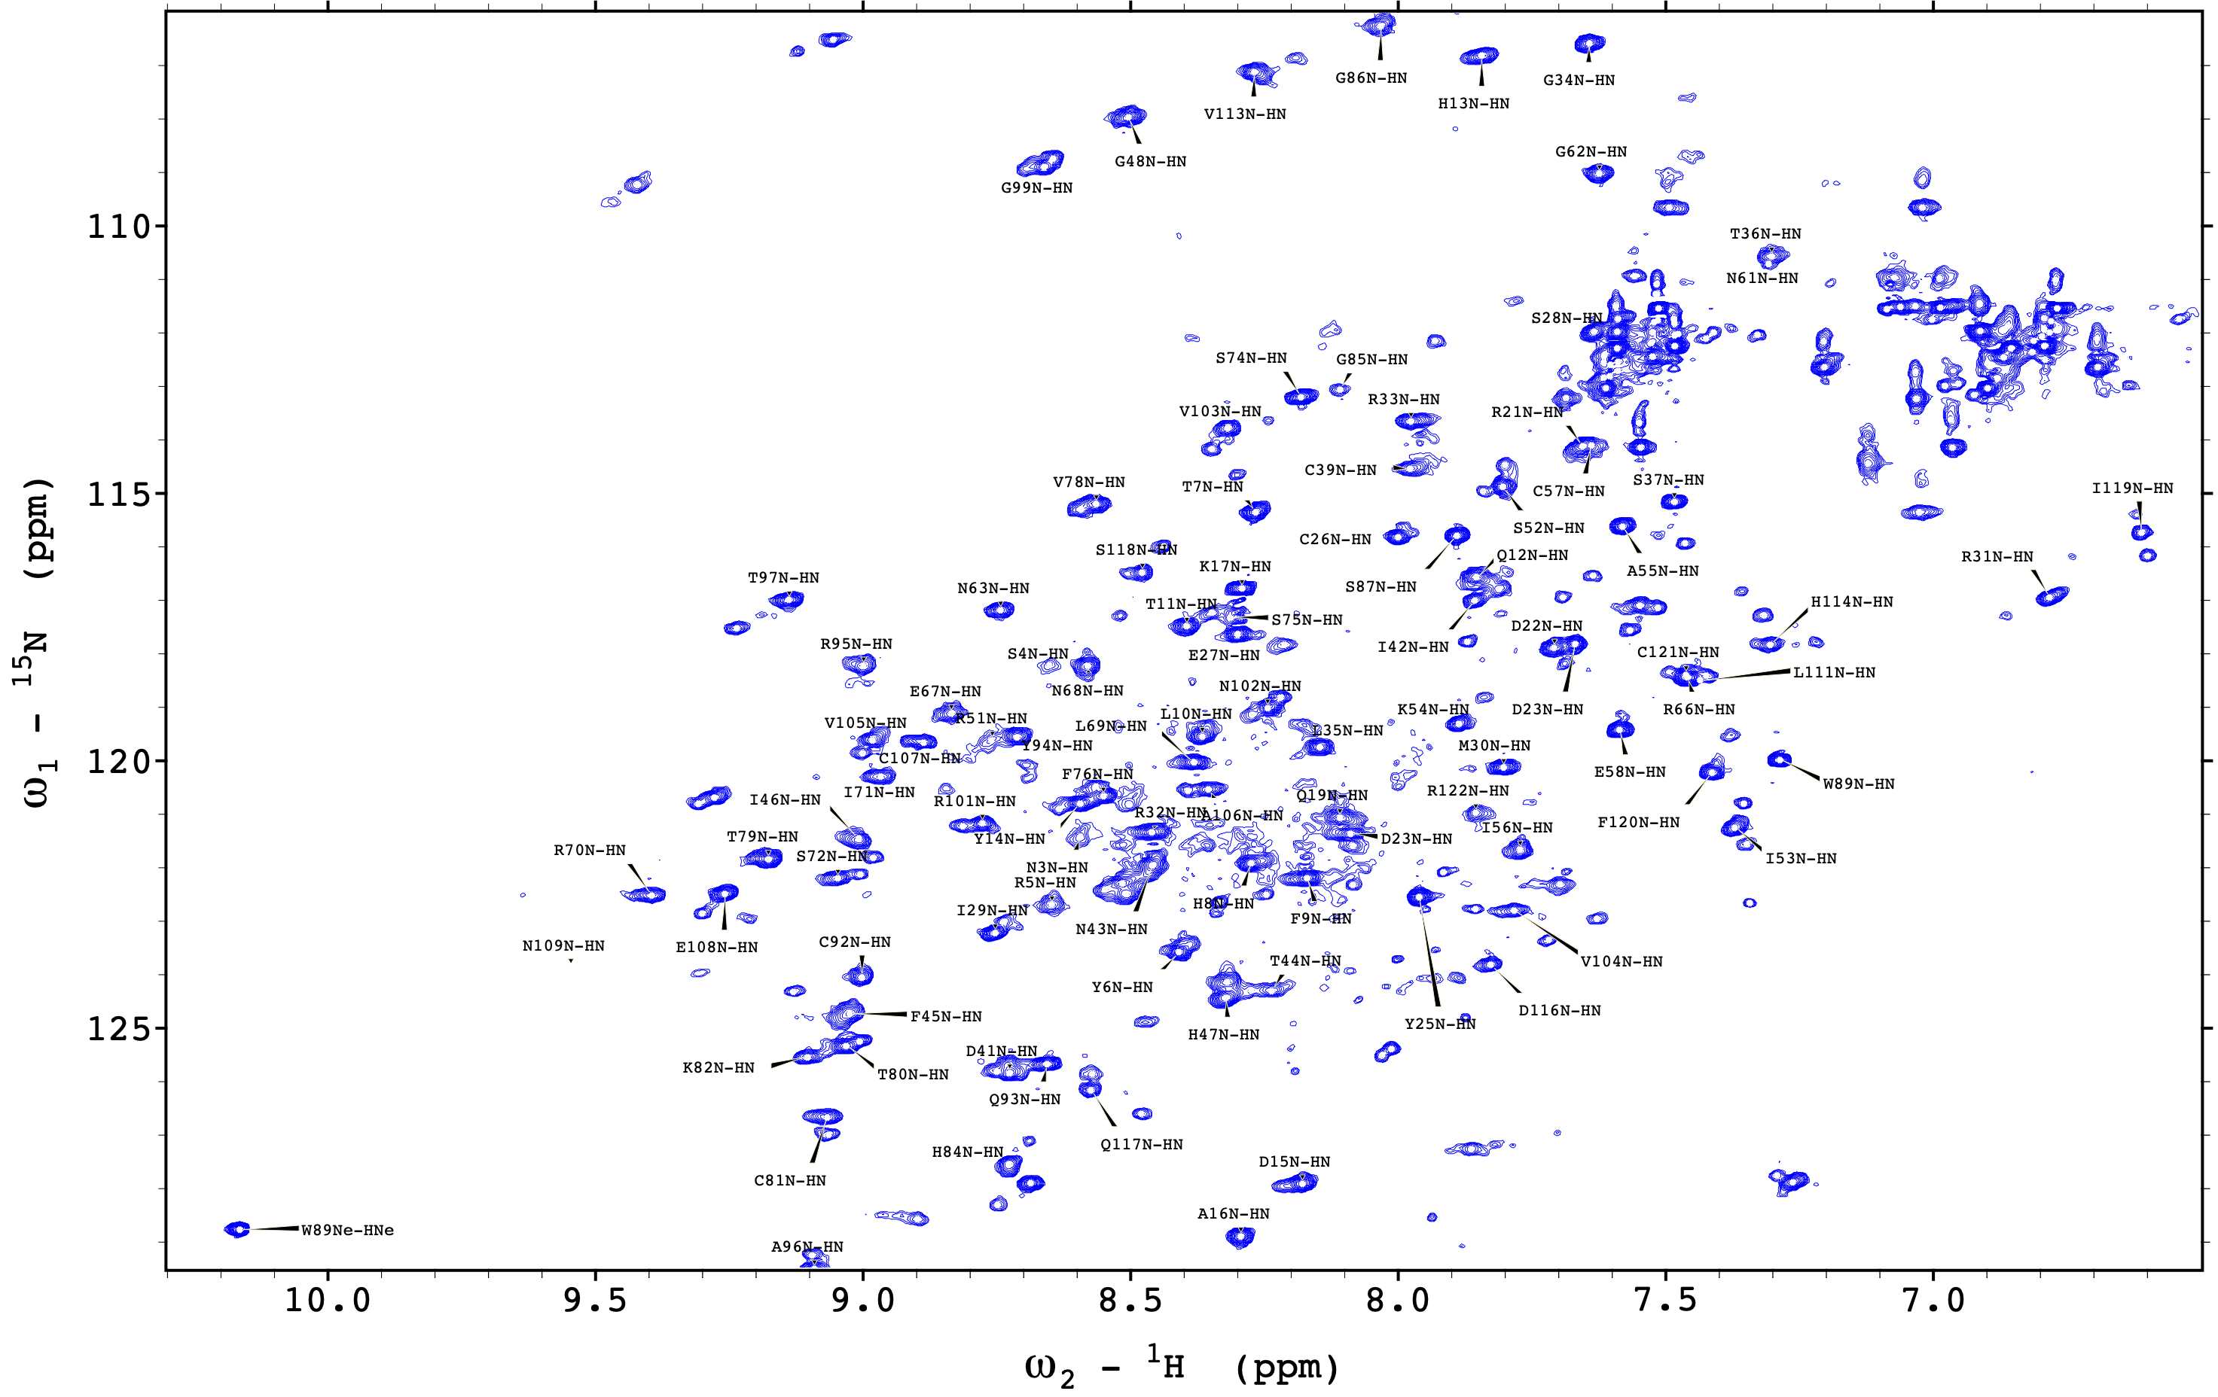

The 1H-15N-type spectrum of R121C h-ANG with representative assignments.

**Supplementary Figure 4**. 2D 1H-15N spectrum of C39W

h-ANG recorded at pH 6.5, 35 ºC

