Supplementary Materials
The effect of Ni-Modified LSFCO Promoting Layer on the Gas Produced Through Co-electrolysis of CO₂ and H₂O at Intermediate Temperatures
M. Lo Faro¹*, S. C. Zignani¹, V. Antonucci¹, and A. S. Aricò¹
¹ Institute of Advanced Energy Technologies (ITAE) of the Italian National Research Council (CNR), Via Salita S. Lucia sopra Contesse 5, 98126 Messina, Italy;
* Correspondence: Correspondence: lofaro@itae.cnr.it; Tel.: +39-090624243

The polarization curves conducted in the temperature range 525–800°C revealed an increase in ohmic constrain compared to the bare cell investigated under similar conditions [1]. This increase is due to the additional layer coated to the cathode.
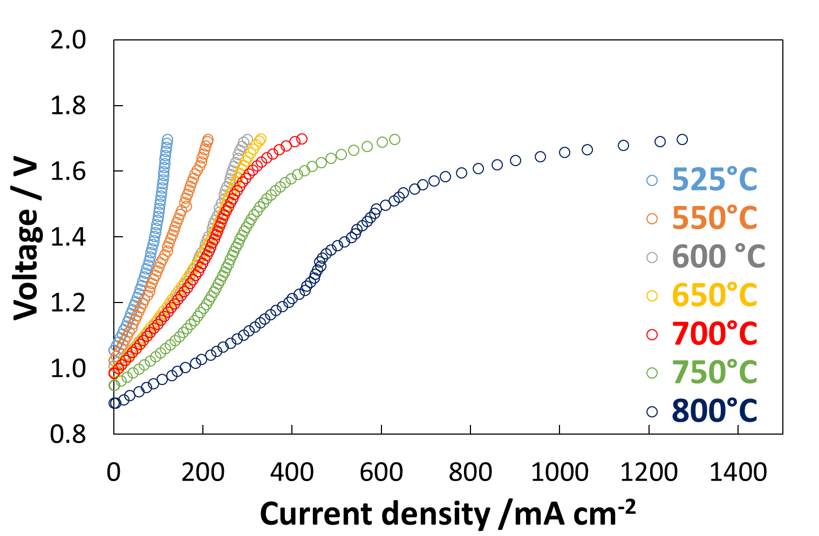
Figure S1. Polarization curves of the coated cell investigated in the temperature range 525–800 °C for the co-electrolysis of H₂O and CO₂.

The figure 2S shows the impedance spectra of cell at open circuit voltage (OCV). In OCV conditions, a limited current density was circulated in the cell as that derived from the variation of 10 mV around the OCV value. The increased temperature affected positively both the series resistance (Rs, intercept with X-axis at high frequencies) and the total resistance (Rt, intercept with the x-axis at low frequencies). In particular, it is observed a strong effect of the temperature on the semicircle appearing at low frequencies. Low frequency semicircle is related to the reaction characterised by slow kinetics. Although further tests are necessary to uniquely assign each semicircle to each reaction, our previous papers have ascribed to the anodic reaction (oxygen evolution) the low frequency semicircle [2, 3].
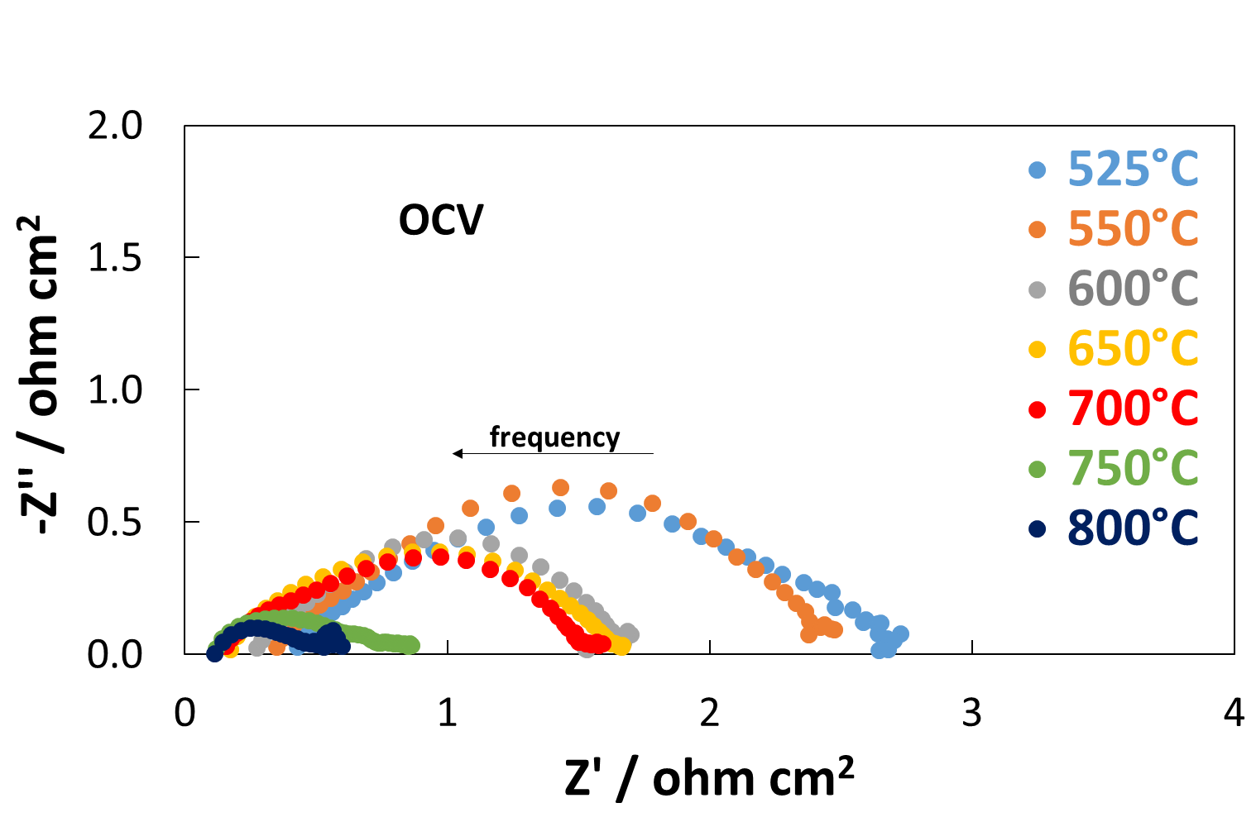
Figure 2. Impedance spectra of the coated cell investigated at OCV in the temperature range 525–800 °C for the co-electrolysis of H₂O and CO₂.
A similar trend with the temperature was observed for the EIS analysis conducted at 1.3 V. Nevertheless, at below temperatures, just a barely third semicircle was observed at high frequencies as a consequence of the different kinetics for reducing H₂O and CO₂.
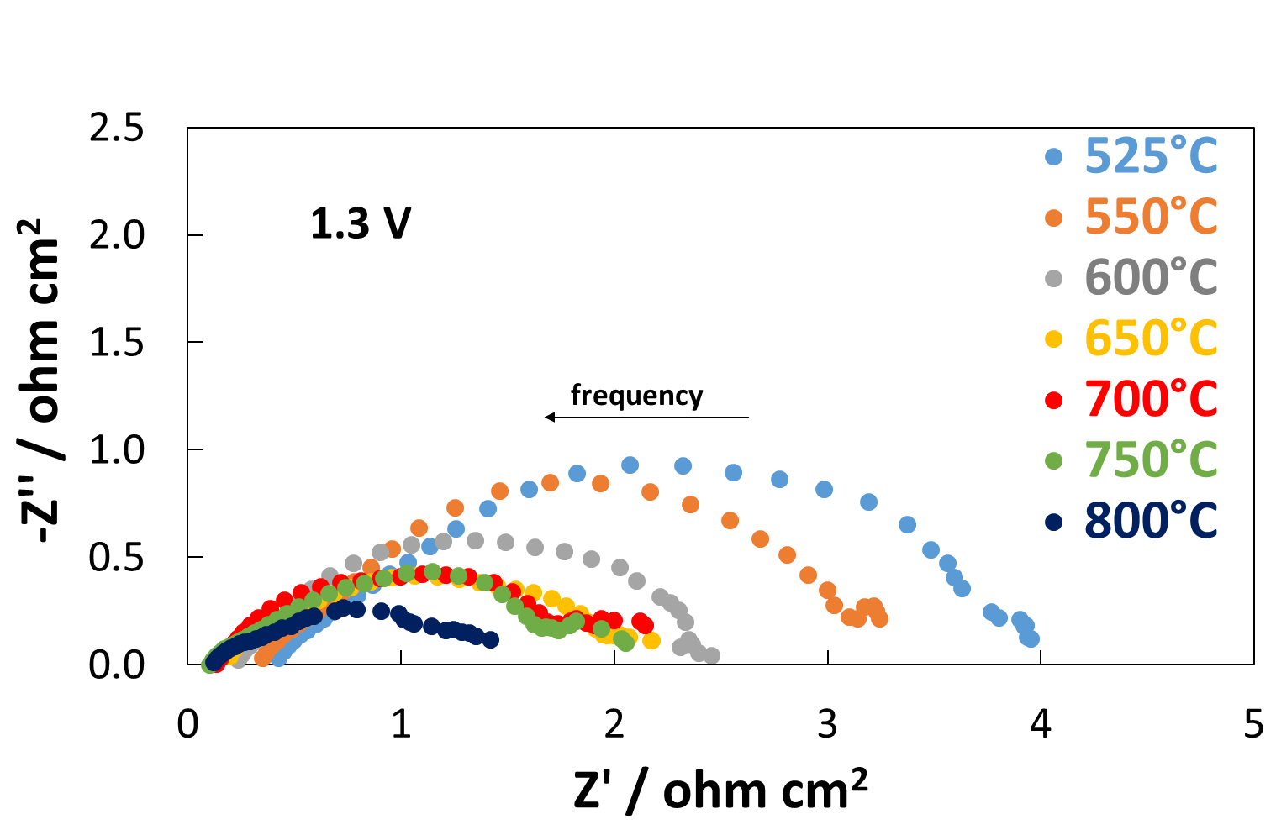
Figure 3. Impedance spectra of the coated cell investigated at 1.3 V in the temperature range 525–800 °C for the co-electrolysis of H₂O and CO₂.
In Figure S4 and S5 are reported the gas-chromatograms of cell operating at 150 mA cm⁻² and under OCV. These chromatograms were achieved using a Molsieve column (S4) and a Pore-Plot Q (S5) which are suitable for the separation of permanent gases and low weighted hydrocarbons, respectively.

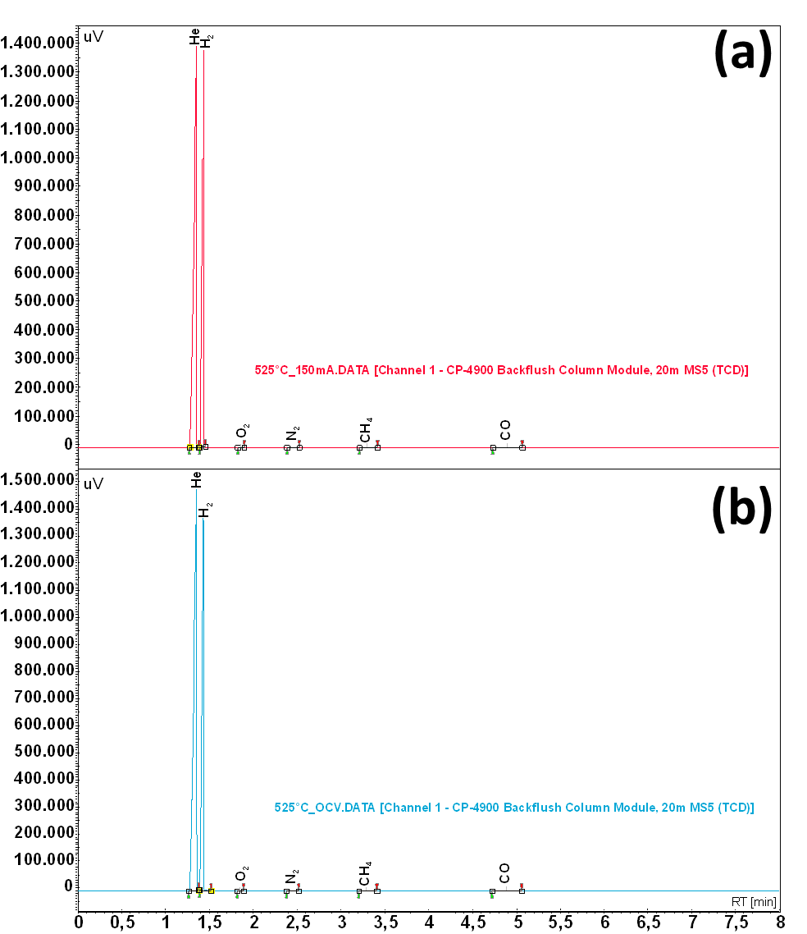
Figure S4. Analytes separated with a Molsieve Column and revealed with TCD. Gas-Chromatograms of outlet from cathode chamber of cell operating at 525 °C operating at 150 mA cm⁻² (a) and under OCV (b).

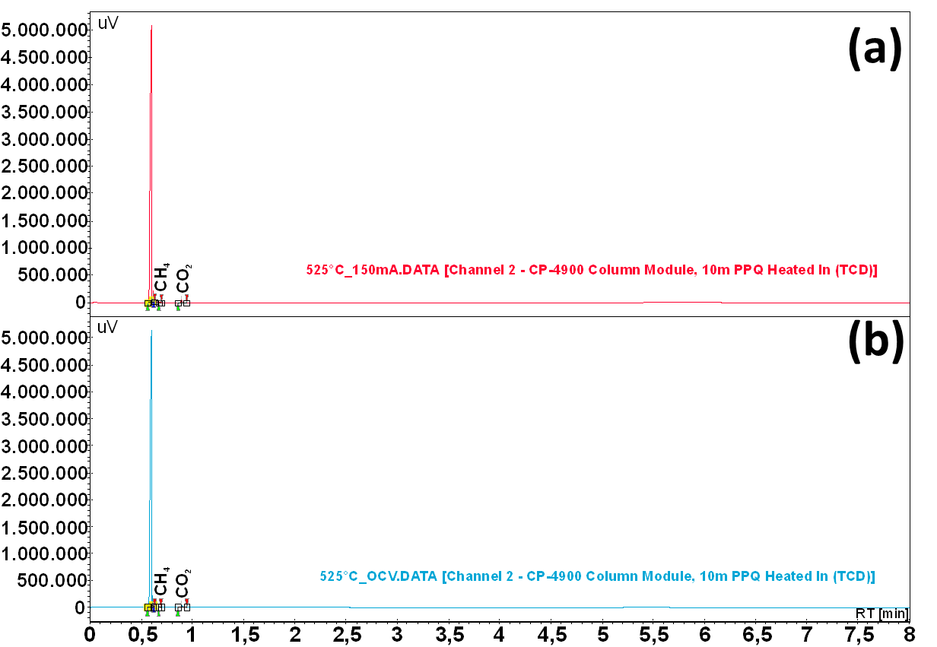
Figure 5. Analytes separated with a Pore-Plot Q Column and revealed with TCD. Gas-Chromatograms of outlet from cathode chamber of cell operating at 525 °C operating at 150 mA cm⁻² (a) and under OCV (b).
The gas-chromatographic data concerning C-based molecules where treated according to the following equation:
$$Carbon balance=\frac{{CO}_{out}+{CO}_{2_{out}}+{CH}_{4_{out}}}{{CO}_{2_{in}}}*100$$ | (1)
As observed in the figure S6, the carbon balance represented by the bar chart was close to 100%. This result was an indication of goodness for the gas sealing of cell.
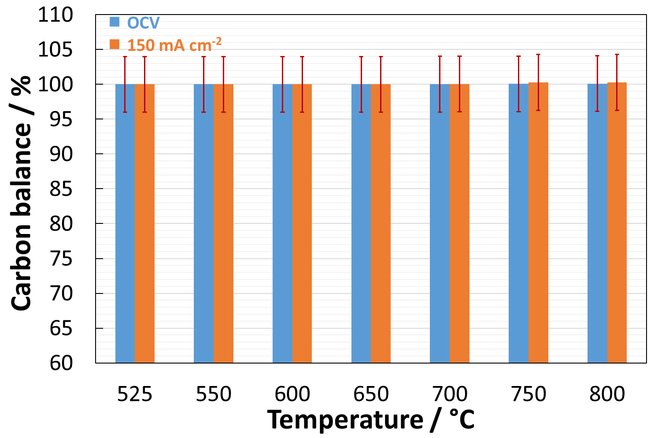
Figure 6. Carbon balance of gas achieved under practical conditions. The gas-chromatographic data were treated accordingly to equation 1 .
The figure S7 shows the SEM image of spent cell. The two magnifications demonstrated that the microstructure was not damaged from the temperature treatment and SOEC operation. It is worthy to note that no delamination occurred, especially at the anode-electrolyte interface, as it is one of the most known drawbacks of these cells (Fig. S4a). Another significant information was the absence of carbon deposits on the microporosity of cathode layer.
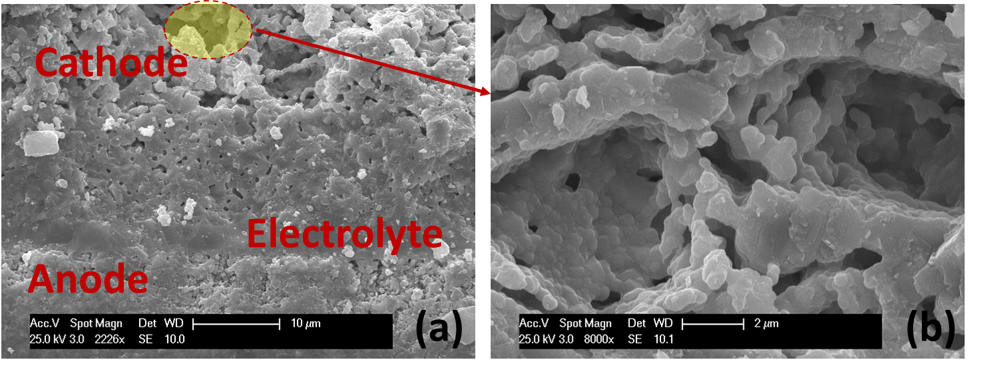
Figure 7. SEM analysis of spent cell highlighting the interface regions (a) and the magnification of cathode microstructure (b).

References
- [1] M. Lo Faro: S.C. Zignani, S. Trocino, V. Antonucci, A.S. Aricò, New insights on the co-electrolysis of CO₂ and H₂O through a solid oxide electrolyser operating at intermediate temperatures, Electrochimica Acta, 296 (2019) 458-464.
- [2] M. Lo Faro, S. Trocino, S.C. Zignani, V. Antonucci, A.S. Aricò, Production of syngas by solid oxide electrolysis: A case study, International Journal of Hydrogen Energy, 42 (2017) 27859-27865.
- [3] M. Lo Faro, W. Oliveira da Silva, W. Valenzuela Barrientos, G.G.A. Saglietti, S.C. Zignani, E.A. Ticianelli, V. Antonucci, A.S. Aricò, The role of CuSn alloy in the co-electrolysis of CO₂ and H₂O through an intermediate temperature solid oxide electrolyser, Journal of Energy Storage, 27 (2020).
Publisher’s Note: MDPI stays neutral with regard to jurisdictional claims in published maps and institutional affiliations.
© 2020 by the authors. Submitted for possible open access publication under the terms and conditions of the Creative Commons Attribution (CC BY) license (http://creativecommons.org/licenses/by/4.0/).

