Resource Interaction in Smallholder Farms is Linked to Farm Sustainability: Evidence from Indian Sundarbans
Rupak Goswami^{1,2,5}, Sonja Brodt³, Sangita Patra¹, Purnabha Dasgupta¹, Biswanath Mukherjee^{4,5}, Somen Nandi^{2,5,*}

Supplementary Information

Resource Interaction in Smallholder Farms is Linked to Farm Sustainability: Evidence from Indian Sundarbans

Rupak Goswami, Sonja Brodt, Sangita Patra, Purnabha Dasgupta, Biswanath Mukherjee, Somen Nandi

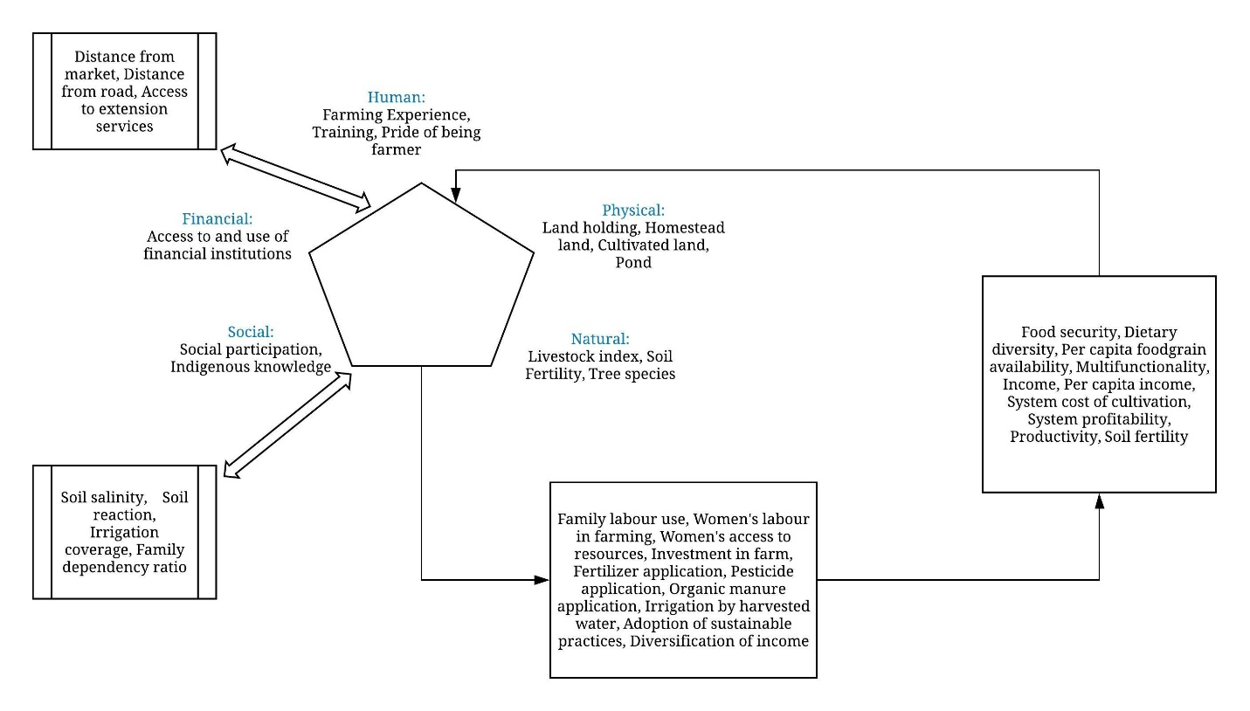
Fig. S1: Indicator framework adapted from the Livelihoods Framework (Scoones, 1998) and used for identifying sustainability indicators

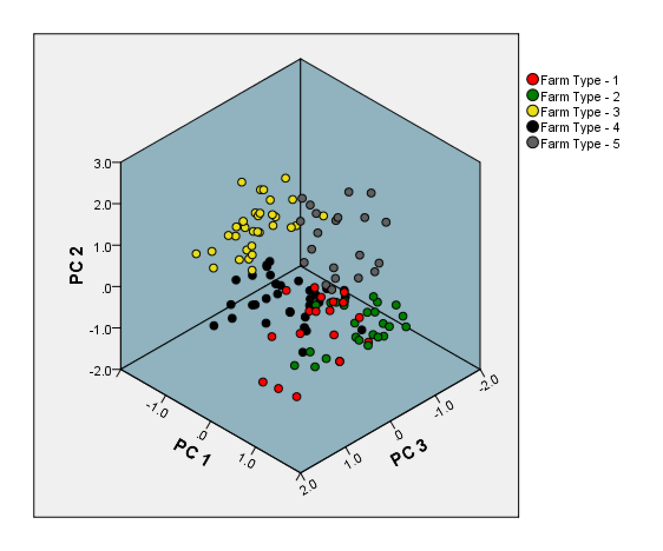
Fig. S2: Five farm types in the study areas identified by cluster analysis on 140 farms with six principal components (PC). The PCs were extracted from 12 variables. The farms are plotted against the first three PCs that account for the highest variance in the dataset.

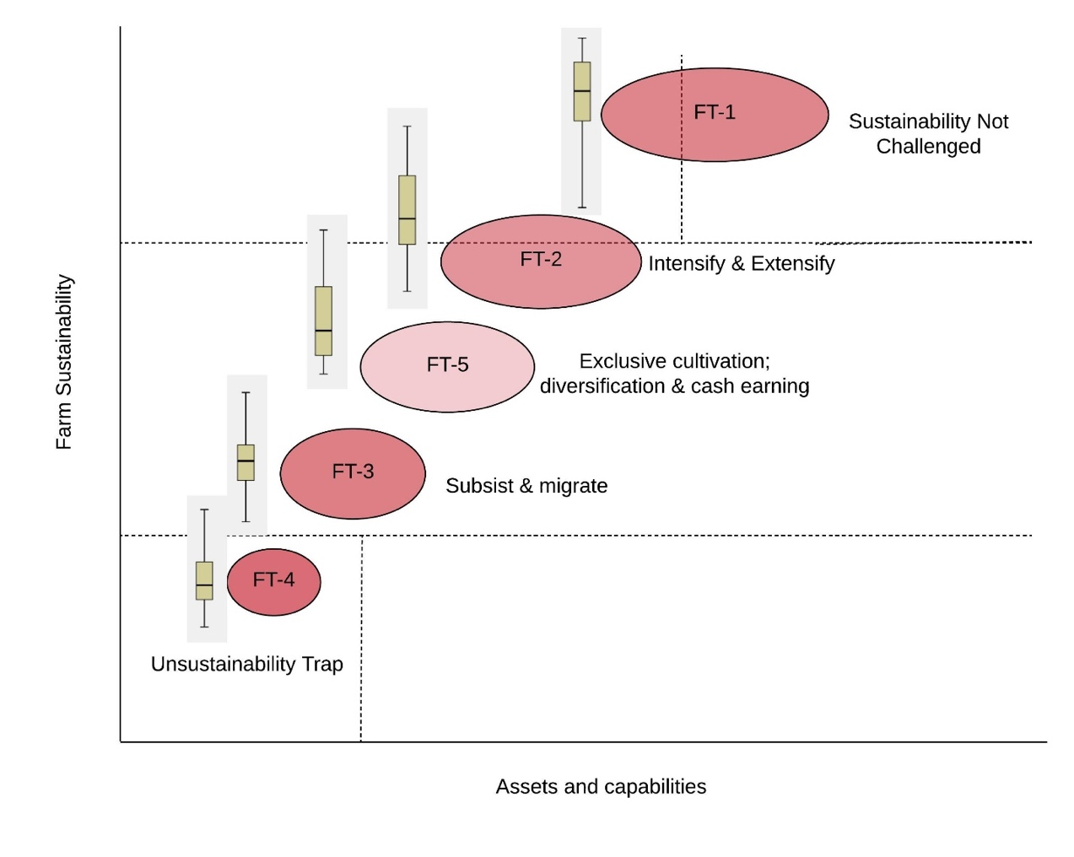
Fig. S3: Conceptual diagram showing sustainability regimes of different farm types concerning their assets and capabilities. Areas of the ovals represent mean sustainability score of the farm types. Whiskers are developed in another analysis and placed in this diagram to indicate the variability and overlapping in the range of sustainability. These are not exactly true to the x-axis. Horizontal lines indicate the tipping point for different sustainability regimes.

Farms under FT-1 earned from both farm and off-farm sources and remained sustainable even without enhancing management intensity on the farm. Among the farms having lesser assets and capabilities (resources and access to institutional services), one group resorted to intensification and extensification of agricultural enterprises to sustain livelihoods (FT-2), and another group of households with younger male family heads decided to send their male members out to earn cash and left the farming with women to subsist through diversification with livestock (FT-3). Another group of farms diversified with cattle, poultry, and vegetables; and depended largely or solely on farm income (FT-5). Both FT-3 and FT-5 accessed financial institutions to pursue their livelihood strategies. FT-4 remained in the unsustainability trap, mainly outside the social support system, and failed to diversify or intensify or extensify their farming, presumably due to the tiny landholding and asset base; they barely sustained on non-skilled labor work.

Table S1: Variables used in principal component analysis
Variables | Variable Code | Description | Measurement
Experience of farming* | EXP | The period for which the farm family is engaged in farming as a means of livelihoods | Years
Family Size* | FAMSZ | Total number of members in a family for whom cooking is done together | Frequency
Total income | INC | Total cash income earned by all members of the family in the last year (2017) | Indian Rupees
Off-farm income* | OFINC | Total cash income earned from non-farming sources by all members of the family in the last year (2017) | Indian Rupees
Landholding* | LAND | Legal ownership of Land either in own name or as a registered cultivator | Hectare
Homestead land | HMSTD | Legal ownership of homestead land | Hectare
Proportion of irrigated Land | IRR | The proportion of cultivated Land irrigated from all sources in non-rainy months (November-May) | The ratio of irrigated Land to gross cultivated Land
Cultivated Land* | CLTLN | The total amount of Land actually cultivated by the farm family last year; including own Land and leased-in Land | Hectare
NPK per ha* | NPK | The total physical weight of fertilizers used last year to provide primary nutrients to the crops | Kg ha⁻¹
Pesticide per ha* | PSTCD | The total physical weight of pesticides used per hectare last year to protect crops from pests | G ha⁻¹ OR ml ha⁻¹
Organic manure per ha | ORG | Total physical weight of bulky manure used per hectare in the crops last year. | t ha⁻¹
Cattle ownership* | CTL | Total number of productive cattle owned by the household during the data collection | Frequency
Bird ownership* | BRD | Total number of poultry birds (hen, duck raised by both caged and open yard system) owned by the household during the data collection | Frequency
Livestock Index* | LVSTK | A composite index based on the presence and number of cow, goat, sheep and poultry/birds | Summated weighted score for all the owned animals; weight depended on its species, sex and age.
Distance from market | DSTMR | The physical distance of the farm from the nearest agricultural market | Km
Distance from road | DSTRD | The physical distance of the farm from the nearest metal road | Km
Per capita food grain* | FDGRN | Food grain produced in own farm per capita in the last year | Total cereals produced last year divided by the number of family members (non-adult family members are adjusted for)
Use of family labor in farming | FMLBR | The proportion of family labor to total labor used in the farm last year (2017) | The ratio of family labor (manhour) and total labor (manhour)
Investment in farm | INVST | An investment made in the farm in the last year (2017) in monetary terms | Indian Rupees
Extension Contact* | EXTN | Frequency and degree of contact with different extension agencies/agents namely – Krishi Prajukti Sahayak (grassroots-level agricultural extension agent), agricultural extension officer, Gram Panchayat and NGO representatives | Summated score of all extension agent/agencies; for individual extension agent/agency response is scored as: 3 – at least once in a week, 2 – once in a month; 1 – once in a season; 0 – never
Note: PCA started with these twenty variables and iteration was stopped with twelve variables (asterisk) with which the final analysis was carried out.

Table S2: Variables used for the characterization of farm types
Variables | Variable code | Description | Measurement
Age of the household head | AGE | Chronological age of the household head | Years
Family Size | FAMSZ | Number of members in a family sharing the same kitchen | Absolute number
Family type | FAMTP | Type of family as per the composition and member relationship | Nuclear-1, Extended-2
Ethnic group | ETHN | The ethnic identity of a family as scheduled in the government record | Forward-1, Scheduled Caste-2, Scheduled Tribe – 3, Other Backward Caste - 4
Crop diversity | CRDIV | Number of crops grown last year in all land parcels | Frequency
Income from paddy | INCPD | Income received from paddy last year | INR
Income from fish | INCFS | Income received from fish last year | INR
Income from wages | INCWG | Income received from wages last year | INR
Income from livestock | INCLV | Income received from livestock last year | INR
Income from vegetables | INCVG | Income received from vegetables last year | INR
Off-farm income | OFINC | Total income received from all non-farm sources last year | INR
Landholding | LAND | Legal ownership of Land either in own name or as a registered cultivator | Hectare
Homestead land | HMSTD | Area of the legally owned homestead | Hectare
Pond ownership | POND | Legal ownership of water body | Yes-1, No-0
Proportion of irrigated Land | IRR | The proportion of cultivated Land irrigated from all sources in non-rainy months (November-May) | The ratio of irrigated Land to gross cultivated Land
NPK application | NPK | The total physical weight of fertilizers used last year to provide primary nutrients to the crops | Kg ha⁻¹
Pesticide | PSTCD | The total physical weight of pesticides used last year to protect the crops from pests | g ha⁻¹ OR ml ha⁻¹
Organic manure | ORG | The total physical weight of bulky manure used per hectare last year | t ha⁻¹
Cattle ownership | CTL | Total number of productive cattle owned by the household during the data collection | Frequency
Trees on farm | TREE | Number of trees on farmland and homestead | Frequency
Distance from market | DSTMR | The physical distance of the farm from the nearest agricultural market | Km
Distance from road | DSTRD | The physical distance of the farm from the nearest metal road | Km
Use of family labor in farming | FMLBR | The proportion of family labor to total labor used in the farm last year (2017) | The ratio of family labor (manhour) and total labor (manhour)
Gendered use of family labor | GNLBR | The proportion of female labor to male labor used in farming last year | The ratio of female labor (manhour) and male labor (manhour)
System cost of cultivation | SCOC | System cost of cultivation was determined by cost incurred for performing field operations (from sowing to harvesting, threshing, and storage of seeds) and input used for all crops in farm last year. For this, the concept ‘Cost A1’ as proposed by the Commission for Agricultural Costs and Prices (CACP) of India was followed. | INR ha⁻¹
Rice Equivalent Yield (REY) | REY | The yield of all non-rice crops of a farm across seasons converted into rice equivalent on a price basis | REY_{d} (t/ha) = $Y_{x}.\frac{P_{x}}{P_{r}}$, where Y_{x} is the yield of non-rice crops (t/ha), P_{x} is the price of the crop (INR t⁻¹), and P_{r} is the price of rice (INR t⁻¹).  Then REY for all non-rice crops of a farm across seasons were summated
System profitability | SPROF | Net profit from all farm enterprises last year | System gross return (INR ha⁻¹) – System cost of cultivation (INR ha⁻¹)
Investment in farm | INVST | An investment made in the farm last year (2017), in monetary terms | Indian Rupees
Soil testing | STEST | Whether soil testing is done in the last one year | Yes-1, No-0
Savings in the bank | SAVG | Functional savings account with a formal financial institution | Yes=1, No=0
Health insurance | HINS | Covered under a functional health insurance scheme | Yes=1, No=0
Crop insurance | CINS | Covered under a functional crop insurance scheme | Yes=1, No=0
Farmers’ Credit Card | FCC | Owns a functional farmers’ credit card | Yes=1, No=0
Membership to grassroots organization | MEMB | Formal affiliation to grassroots organization | Yes=1, No=0
Political affiliation | POL | Self-reported affiliation to political groups | Yes=1, No=0
SHG membership | SHG | Formal membership to a self-help group | Yes=1, No=0
Training | TRNG | Exposure of household head or de facto/de jure women household head to at least a day-long institutional training provided by extension agencies namely, Department of Agriculture/ registered non-profit organization/ local panchayat | Yes=1, No=0

Table S3: Indicators used in the assessment of farm sustainability
Indicators | Indicator code | Description | Measurement
Experience of farming | EXP | Period for which the farm family is engaged in farming as a means of livelihoods | Years
Family dependency ratio | FDR | Dependence of adult members (above the age of 18 years) on earning members in a family | Ratio of the number of dependent adult/s to earning adult/s in a family
Landholding | LAND | Legal ownership of Land either in own name or as a registered cultivator | Hectare
Homestead land | HMSTD | Legal ownership of homestead land | Hectare
Livestock index | LVSTI | Composite index based on presence and number of cow, goat, sheep, and poultry/birds | Summated weighted score for all owned animals; weight  dependent on its species, sex, and age
Social participation | SPART | Perceived participation of family members in locally functional institutions, namely farmers’ organization, community-based organization, panchayats, cooperatives, political parties, and self-help groups | Total number of participations in organizations, ranging 0-6; for an organization, Participation=1, else=0
Training | TRNG | Exposure of household head or de facto/de jure women household head to at least a day-long institutional training provided by extension agencies namely, Department of Agriculture/ registered non-profit organization/ local panchayat | Yes=1, No=0
Availability of cereals | CRL | Self-sufficiency of cereals produced in own farm to meet the need of all members of the household | Number of months during the past year* that the household survived on its cereal production
Dietary diversity | DIETD | Groups of self-produced food consumed by members of the household; types of food – rice, root crops, vegetables, fruits, meat, eggs, fish, pulses, milk/milk product, oil, sugar/honey, condiments/coffee/tea | Total number of food groups consumed by members of the household, ranging 0-12; for individual food group, Yes=1, else=0 [intra-household disparity not taken into account]
Per-capita food grain | FDPC | Per-capita food grain produced in own farm last year* | Total cereals produced during the past year divided by the number of family members (non-adult family members are adjusted for)
Women’s access to farm resource | WACC | Number of farm resources women have permanent access to; resources are – Land, water, trees, livestock, equipment, and inputs | Total number of resources that women have access to, ranging 0-6; for individual resources, Yes=1, else=0
Use of indigenous knowledge | ITK | The perceived extent of the use of indigenous knowledge in farming | Measured by a 5-point scale; 5=Very high and 0=not at all
Pride of being a farmer | PRIDE | The perceived sense of pride for being a farmer | Measured by a 5-point scale; 5=Very high and 0=not at all
Use of family labor in farming | FMLBR | The proportion of family labor to total human labor used in farming last year* | The ratio of family labor (manhour) and total labor (manhour)
Gendered use of family labor | GNLBR | The proportion of female labor to male labor used in farming last year* | The ratio of female labor (manhour) and male labor (manhour)
Multifunctionality of farming | MLFNC | Diversity of benefits accrued from farming; listed benefits are – food grain, vegetables, pulse, oils, fish, egg, milk, spices, fuel, fodder, irrigation, building material, plant protection, seeds, medicinal value, manure | Total number of usages made from existing farm resources, ranging 0-15; for individual use, 1=when made a use, else=0
Total income | INC | Total cash income earned by all members of a household from farming and non-farm sources including social supports last year* | Indian Rupees (INR)
Per capita income | INCPC | Per-capita cash income earned last year* | Total cash income earned by all family members divided by family size (INR head⁻¹)
Income diversity | INCD | Diversity of all income sources received last year* | Normalized Harfindahl Index based on income sources
Proportion of irrigated Land | IRR | The proportion of cultivated Land irrigated from all sources in non-rainy months (November-May) | The ratio of irrigated Land to gross cultivated Land
Cultivated Land | LANDC | The total amount of Land actually cultivated by farm family last year including own Land and leased-in Land | Hectare
Access to financial institutions | FNACC | Physical and legal access and use of financial institutions and/or their services; institutions/services are – bank account, savings with bank, fixed deposit with bank, health insurance, crop insurance, Farmers’ Credit Card | Total access and/or use of financial institutions ranging 0-6; 1=when a financial institution is used, otherwise=0
Distance to market | DSTMR | The physical distance of farm from nearest agricultural market | Km
Distance to road | DSTRD | The physical distance of the farm from the nearest metal road | Km
Extension contact | EXTN | Frequency and degree of contact with different extension agencies/agents namely – Krishi Prajukti Sahayak (grassroots-level agricultural extension agent), agricultural extension officer, Gram Panchayat, and NGO representatives | Summated score of all extension agent/agencies; for individual extension agent/agency, a response is scored as:3 – at least once a week; 2 – once a month; 1 – once in a season; 0 - never
System cost of cultivation | SCOC | System cost of cultivation was determined by cost incurred for performing field operations (from sowing to harvesting, threshing, and storage of seeds) and input used for all crops in farm last year. For this, the concept ‘Cost A1’ as proposed by the Commission for Agricultural Costs and Prices (CACP) of India was followed. | INR ha⁻¹
System profitability | SPROF | Net profit from all farm enterprises last year* | System gross return (INR ha⁻¹) – System cost of cultivation (INR ha⁻¹)
Investment in farm | INVST | The investment made in farm last year in monetary terms | INR
Soil fertility | SFERT | Soil fertility as perceived by a farm family | Measured on a 4-point scale; 4=high, 3=moderately high, 2= low, 1=barren
Soil reaction | SPH | Soil acidity and alkalinity as perceived by a farm family | Measured on a 4-point scale; 4=neutral, 3=slightly acidic/alkaline; 2=acidic/alkaline; 1=highly acidic/alkaline
Soil salinity | SSAL | Soil salinity as perceived by a farm family | Measured on a 4-point scale; 4=not saline at all, 3=slightly saline; 2=saline; 1=extremely saline
NPK use | NPK | The total physical weight of fertilizers used last year to provide primary nutrients to the crops* | Kg ha⁻¹
Pesticide use | PSTCD | The total physical weight of pesticides used last year to protect the crops from pests* | g ha⁻¹ OR ml ha⁻¹
Organic manure use | ORG | The total physical weight of bulky manure used per hectare last year* | t ha⁻¹
Ownership of pond | POND | Legal ownership of waterbody | Yes=1; No=0
Irrigation by preserved water | WTHRV | The proportion of cultivated Land irrigated by preserved water in the farm pond | Ratio of the irrigated area by pond water and total cultivated Land
Tree species diversity | TREED | Species diversity of tree on farmland and homestead | Number of tree species
Rice Equivalent Yield (REY) | REY | The yield of all non-rice crops of a farm across seasons converted into rice equivalent on a price basis | REY_{d} (t/ha) = $Y_{x}.\frac{P_{x}}{P_{r}}$, where Y_{x} is the yield of non-rice crops (t/ha), P_{x} is the price of the crop (INR t⁻¹), and P_{r} is the price of rice (INR t⁻¹).  Then REY for all non-rice crops of a farm across seasons were summated
Adoption of good agricultural practices | ADGAP | The extent of adoption from a set of sustainable agricultural practices recommended by the Department of Agriculture (of West Bengal State, India). Practices were – intercropping, soil testing, liquid manuring, biopesticide application, lime for soil amendment, water conservation, preservation of seed, agroforestry, renewable energy | The number of practices adopted divided by the total number of recommended practices multiplied by 100
* Last year refers to the 2017-2018 crop season

Table S4: Model outcomes for the field two Principal Components (independent variables) extracted from network properties and Ln10 Sustainability Index (dependent variable)
 | Minimum Error | Maximum Error | Mean Error | Mean Absolute Error | Standard Deviation | Linear Correlation | Occurrences
All farms | -.08 | .112 | .011 | .032 | .037 | 0.87 | 140
Farm type - 1 | -.073 | .076 | .032 | .041 | .035 | .809 | 22
Farm type - 2 | -.049 | .112 | .007 | .031 | .038 | .715 | 28
Farm type - 3 | -.066 | .1 | .017 | .031 | .034 | 63.8 | 33
Farm type - 4 | -.08 | .063 | -.008 | .03 | .036 | .727 | 35
Farm type - 5 | -.048 | .066 | .014 | .027 | .03 | .86 | 22
Three best models considered: XGBoost Tree 1, Random Trees, CHAID

Table S5: Summarizing farm types in terms of their background variables, drivers of sustainability, and occurrence and co-occurrence of farm resource interactions.
 | Farm Type - 1 |  | Farm Type - 2 | Farm Type - 3 | Farm Type - 4 | Farm Type – 5
Qualitative description | Extended families; have farm pond; operate in larger land and homestead plots with low to moderate input intensity and moderate to high system performance |  | Family farms with joint families; have farm pond; operate in marginal Land and homestead with high management intensity resulting in high system performance | Nuclear families having subsistence farms; operate on marginal Land and homestead plot; diversify with livestock and non-farm incomes; engage women labor and low inputs to secure low to medium system performance | Tribal and scheduled caste; nuclear families; operate in tiny farmland and homestead plot; survive on off-farm income; low management intensity lead to poor system performance; largely excluded from the socio-political entitlements | Nuclear, profit-oriented family farms located near the market; operate in marginal holding; diversify with livestock and other on-farm resources; low non-farm income; engage moderate input intensity to secure moderate system performance
Drivers of sustainability (stable indicators) | Positive: Experience of farming, Landholding, Social participation, Food security, Dietary diversity, Women’s access to resources, the pride of being a farmer, Multifunctionality, Total income, Extension contact, Soil reaction, Salinity, Tree diversity, Adoption of GAP  Negative: System Cost of cultivation |  | Positive: Experience of farming, Women’s access to resources, Pride of being a farmer, Proportion of family labor, Multifunctionality, Per capita income, Extension contact, System profitability, Soil reaction, Salinity, Tree diversity, Adoption of GAP  Negative: Landholding, Family dependency, System cost of cultivation, NPK application, Pesticide application | Positive: Livestock index, Food security, access to the financial institution, System cost of cultivation, NPK application, Pesticide application  Negative: Experience of farming, Landholding, Homestead, Pride, Extension contact, Soil reaction, Salinity, Organic manuring, Tree diversity, Adoption of GAP | Positive: Income diversity, System cost of cultivation, NPK application, Pesticide application  Negative: Experience of farming, Landholding, Homestead, Livestock index, Social participation, Dietary diversity, Women’s access to resources, Pride, Multifunctionality, Total income, Extension contact, System profitability, Salinity, Organic manuring, Tree diversity, Adoption of GAP | Positive: Livestock index, access to the financial institution, distance to market, distance to road  Negative: Landholding, Food security, Pride, Income diversity, Pesticide application
The abundance of farm resource interaction
Linkages |  | H->V, R->PL, H->R, R->C, V->PL, H->T, H->C, T->H, C->R, PL->R, H->PN, PL->PN, PN->V, K->R, K->C, PN->R, R->K, V->K, PN->PL, R->PN, V->R, C->K, PN->K, R->V, T->R, T->C, R->T, F->C, R->F, F->K, V->F, H->CP, PL->T, F->V | H->V, R->PL, H->R, R->C, V->PL, H->T, H->C, T->H, C->R, PL->R, H->PN, PL->PN, PN->V, K->R, K->C, PN->R, R->K, V->K, PN->PL, V->R, C->K, PN->K, R->V, T->R, T->C, R->T, F->C, R->F, F->K, V->F, H->CP, PL->T, F->V, C->CP | H->V, R->PL, H->R, R->C, V->PL, H->T, H->C, T->H, C->R, PL->R, H->PN, PL->PN, PN->V, K->R, PN->PL, R->H, C->V, V->H, R->PN, H->PL, K->H, PL->H, V->C, PL->V, H->K, K->V, C->H, PN->H, C->PN, T->PN, PN->C, V->PN, K->PL | H->V, R->PL, H->R, H->T, T->H, PL->R, R->H, V->H, K->H | H->V, R->PL, H->R, R->C, V->PL, H->T, H->C, T->H, C->R, PL->R, H->PN, PN->V, K->C, V->R, V->C, T->C,
Reciprocal linkage |  | R<->C, R<->PL, T<->H, PL<->PN, C<->K, R<->PN, R<->V, R<->T, R<->K, | R<->C, R<->PL, T<->H, PL<->PN, R R<->C, R<->PL, T<->H, PL<->PN, R->V, R->T, V->F | R<->C, R<->PL, T<->H, PL<->PN, V->H, R->H, V->PL, V->C, K->H, C->H, PL->H, PN->H, C->PN, V->PN | R->PL, R->H | R<->C, T->H
Triad |  | ∆R-C-H, ∆R-C-K, ∆R-PL-PN, ∆V-PN-H, ∆R-PN-H, ∆V-PL-PN, ∆R-PN-K, ∆V-PN-K, ∆R-V-PL, ∆R-V-K, ∆R-H-V, ∆R-V-PN, ∆R-T-H, ∆R-C-T, ∆R-V-F, ∆R-K-F, ∆V-K-F, ∆C-T-H, ∆R-C-F, ∆R-PL-T, ∆C-K-F | ∆R-C-H, ∆R-C-K, ∆R-PL-PN, ∆R-PN-H, ∆V-PL-PN, ∆R-PN-K, ∆V-PN-K, ∆R-V-PL, ∆R-V-K, ∆R-H-V, ∆R-V-PN, ∆R-T-H, ∆R-C-T, ∆R-V-F, ∆R-K-F, ∆V-K-F, ∆C-T-H, ∆R-C-F, ∆R-PL-T, ∆C-K-F, ∆C-H-CP | ∆R-C-H, ∆R-C-K, ∆R-PL-PN, ∆V-PN-H, ∆R-PN-H, ∆V-PL-PN, ∆R-PL-H, ∆V-PL-H, ∆V-C-H, ∆R-K-H, ∆R-PL-K, ∆R-CP-PN, ∆C-PN-H, ∆PL-PN-H, ∆PN-T-H, ∆V-K-H, ∆C-K-H, ∆V-CP-PN, ∆PL-K-H, | ∆R-PL-H, | ∆R-C-H, ∆R-C-K
Core |  | R, V, C, K | R, H, V, C, K | R, H, V, C, PL, PN | R, H, PL | R, H, V, C
Farm resource interactions associated with higher farm sustainability
Linkages |  | R->PN, R->F, R->PL, R->V, R->K, R->T, R->C, V->K, V->PL, V->F, V->R, C->R, C->K, C->CP, PN->K, PN->V, PN->PL, PN->R, PL->T, PL->R, PL->PN, H->V, H->PN, H->T, H->C, H->R, H->CP, K->R, K->C, T->C, T->R, T->H, F->K, F->C | R->PN, R->PL, R->C, R->K, R->V, R->T, R->F, V->R, V->PL, V->K, V->F, C->R, C->K, C->CP, PL->R, PL->PN, PL->T, PN->K, PN->R, PN->PL, PN->V, H->PN, H->T, H->CP, H->C, H->V, K->C, K->R, H->R, T->R, T->C, F->K, F->V, F->C | R->PN, R->F, R->T, R->V, R->C, V->K, V->PL, C->K, C->R, PL->T, PL->R, PL->PN, PN->K, PN->R, H->CP, H->V, H->PN, H->C, H->R, T->C, T->H, T->R, K->C, K->R, F->V, F->K, F->C | R->PN, R->V, R->PL, R->C, R->K, V->R, V->K, V->PL, C->R, C->K, PL->R, PL->PN, PN->K, PN->PL, PN->V, PN->R, H->C, H->CP, H->T, H->V, H->PN, T->H, T->R, K->C, K->R | R->PN, R->C, R->V, R->K, R->PL, R->F, R->T, V->R, V->PL, V->K, V->F, C->K, C->R, PL->R, PL->T, PL->PN, PN->R, PN->K, PN->PL, PN->V, T->H, H->CP, H->R, H->PN, H->T, H->V, H->C, K->R, K->C, F->C, F->K
Reciprocal linkage |  | R<->K, R<->V, R<->PL, R<->C, R<->PN, R<->T, V<->F, C<->K, PL<->PN, PN<->H, T<->H | R<->C, R<->K, R<->T, R<->V, R<->PN, R<->PL, V<->F, C<->K, PL<->PN, PN<->H, T<->H | R<->PN, R<->H, R<->C, R<->PL, R<->K, R<->H, C<->K, PL<->PN, PN<->H, T<->H | R<->PN, R<->PL, R<->T, R<->V, R<->K, V<->F, C<->K, PL<->PN, PN<->H, T<->H | R<->T, R<->C, R<->K, R<->V, R<->PN, V<->F, C<->K, PL<->PN, PN<->H, T<->H, V<->H, PL<->H
Triad |  | ∆R-PN-K, ∆R-PL-T, ∆R-K-F, ∆R-C-F, ∆R-V-PN, ∆R-V-F, ∆R-V-PL, ∆R-V-K, ∆R-T-H, ∆R-PN-H, ∆R-H-V, ∆R-C-T, ∆R-C-K, ∆R-PL-PN, ∆R-C-H, ∆V-K-F, ∆V-PN-K, ∆V-PN-H, ∆V-PL-PN, ∆C-K-F, ∆C-T-H | ∆R-C-H, ∆R-H-V, ∆R-T-H, ∆R-PN-H, ∆R-V-PL, ∆R-C-K, ∆R-K-F, ∆R-C-F, ∆R-PL-T, ∆R-VP-N, ∆R-V-K, ∆R-PL-PN, ∆R-C-T, ∆R-V-F, ∆R-PN-K, ∆V-PL-PN, ∆V-PN-K, ∆V-PN-H, ∆V-K-F, ∆C-T-H, ∆C-K-F | ∆R-C-H, ∆R-PN-H, ∆R-T-H, ∆R-H-V, ∆R-PL-PN, ∆R-V-K, ∆R-C-K, ∆R-V-PL, ∆R-V-PN, ∆R-PN-K, ∆V-PN-K, ∆V-PN-H, ∆V-PL-PN | ∆R-PL-T, ∆R-C-F, ∆R-C-T, ∆R-K-F, ∆R-V-F, ∆R-C-K, ∆R-V-K, ∆R-PN-K, ∆R-V-PN, ∆R-V-PL, ∆R-PL-PN, ∆R-H-V, ∆R-T-H, ∆R-PN-H, ∆R-C-H, ∆C-K-F, ∆C-T-H, ∆V-K-F, ∆V-PN-K, ∆V-PL-PN, ∆V-PN-H | ∆R-PL-T, ∆R-PN-K, ∆R-K-F, ∆R-C-F, ∆R-V-F, ∆R-V-PN, ∆R-H-V, ∆R-T-H, ∆R-PN-H, ∆R-C-H, ∆R-V-PL, ∆R-C-K, ∆R-C-T, ∆R-PL-PN, ∆R-V-K, ∆V-K-F, ∆V-PN-K, ∆V-PN-H, ∆V-PL-PN, ∆C-T-H, ∆C-K-F
Core |  | R, V; PN/C/H | R, V; PN/T | R, V; PL | R, V; PL/PN | R, V; PN/C

