Supplementary material

These supplementary materials include all the non-parametric analyses mentioned in the main manuscript, descriptive texts describing (bio-based) plastic as seen by the participants, information about the subject pool and potential skewness of the data, additional analyses that did not make it into the final version of the paper.

Participants
All studies were made available to participants residing in the following Western countries: UK, USA, Ireland, Germany, France, Spain, Australia, Austria, Belgium, Canada, Denmark, Finland, Iceland, Italy, Lichtenstein, Luxembourg, Netherlands, New Zealand, Norway, Portugal, Sweden, Switzerland. Within these countries, only people who had a Prolific Academic approval rate of > 99% were allowed to participate.

Study 1
Table S1
Descriptive statistics and skewness information of participants’ attitudes toward conventional and bio-based plastic (Study 1, N = 97).
 |  | Conventional plastic  positive |  | Conventional  plastic negative |  | Bio-based plastic positive |  | Bio-based plastic negative |  | Conventional  plastic overall |  | Bio-based plastic overall
Mean |  | 3.1 |  | 3.4 |  | 3.8 |  | 2.3 |  | -0.2 |  | 1.6
SE mean |  | 0.12 |  | 0.14 |  | 0.10 |  | 0.09 |  | 0.22 |  | 0.14
Median |  | 3 |  | 3 |  | 4 |  | 2 |  | 0 |  | 2
Std. Dev. |  | 1.2 |  | 1.4 |  | 1.0 |  | 0.9 |  | 2.2 |  | 1.4
Skewness |  | -0.25 |  | -0.25 |  | -0.51 |  | 0.69 |  | 0.27 |  | -0.64
SE skew |  | 0.25 |  | 0.25 |  | 0.25 |  | 0.25 |  | 0.25 |  | 0.25

Table S2
Wilcoxon rank-sum test results comparing participants’ attitudes towards conventional plastic with their attitudes towards bio-based plastics (Study 1, N = 97)

Relationship tested |  | T | SE | p- value | effect size (r)
P_Attitudes | BB_Attitudes | 2895.5 | 211.27 | < .001 | 0.59
P_positive | BB_positive | 2021 | 162.68 | < .001 | 0.51
P_negative | BB_negative | 412.5 | 201.32 | < .001 | -0.59
P_positive | P_negative | 1899 | 205.71 | < .001 | 0.14
BB_positive | BB_negative | 203.5 | 221.31 | < .001 | -0.73
Note. ‘P_’ stands for conventional plastic and ‘BB_’ indicates bio-based plastic.
Attitudes
We also computed the overall holistic attitude scores by subtracting participants’ negative attitudes from their positive ones. Conducting the same paired-samples t-test as before, we found that, overall, participants were more positive towards bio-based (M = 1.55, SD = 1.42) than conventional plastic (M = -0.19, SD = 2.15), t(96) = -7.24, p < .001, d = -0.74.
We did not find a significant difference in feelings of ambivalence towards the two types of plastic (M = 1.55, SD = 1.40 and M = 1.30, SD = 1.26 for conventional and bio-based plastic respectively), t(96) = 1.36, p = .18, d = 0.14.

Study 2
Table S3
Descriptive statistics and skewness information of participants’ attitudes, and importance to recycle with regards to conventional and bio-based plastic (Study 2, N = 52).
 |  |  | Conventional plastic positive |  |  | Conventional plastic negative |  |  |  | Bio-based plastic positive |  |  |  | Bio-based plastic negative |  |  | Conventional plastic overall |  |  |  |  |  | Bio-based plastic overall |  |  |  |  | Conventional plastic Recycle |  |  |  | Bio-based Conventional plastic Recycle
Mean |  | 4.35 |  |  |  |  | 5.38 |  | 5.71 |  |  |  |  |  | 4.50 |  |  |  |  | -1.04 |  |  |  |  | 1.21 |  |  |  |  | 6.79 |  |  | 6.40
Median |  | 4.00 |  |  |  |  | 6.00 |  | 6.00 |  |  |  |  |  | 4.00 |  |  |  |  | -1.00 |  |  |  |  | 1.00 |  |  |  |  | 7.00 |  |  | 7.00
Std. Dev |  | 1.75 |  |  |  |  | 1.56 |  | 1.26 |  |  |  |  |  | 1.34 |  |  |  |  | 2.47 |  |  |  |  | 1.54 |  |  |  |  | 0.67 |  |  | 1.07
Skew |  | -0.31 |  |  |  |  | -0.68 |  | -0.72 |  |  |  |  |  | 0.078 |  |  |  |  | -0.093 |  |  |  |  | -0.27 |  |  |  |  | -3.45 |  |  | -2.18
SE skew |  | 0.33 |  |  |  |  | 0.33 |  | 0.33 |  |  |  |  |  | 0.33 |  |  |  |  | 0.33 |  |  |  |  | 0.33 |  |  |  |  | 0.33 |  |  | 0.33
Kurtosis |  | -0.79 |  |  |  |  | -0.25 |  | -0.44 |  |  |  |  |  | 0.018 |  |  |  |  | -0.033 |  |  |  |  | 0.31 |  |  |  |  | 11.60 |  |  | 5.13
SE skew |  | 0.65 |  |  |  |  | 0.65 |  | 0.65 |  |  |  |  |  | 0.65 |  |  |  |  | 0.65 |  |  |  |  | 0.65 |  |  |  |  | 0.65 |  |  | 0.65

Table S4
Wilcoxon rank-sum test results comparing participants’ attitudes towards conventional plastic with their attitudes towards bio-based plastics (Study 2, N = 52)
Relationship tested |  | T | SE | p- value | effect size (r)
P_Attitudes | BB_Attitudes | 966 | 91.14 | < .001 | 0.65
P_positive | BB_positive | 600 | 60.42 | < .001 | 0.65
P_negative | BB_negative | 248.5 | 81.89 | .006 | -0.38
P_positive | P_negative | 591 | 71.11 | .005 | 0.39
BB_positive | BB_negative | 82.5 | 70.80 | < .001 | -0.60
Note. ‘P_’ stands for conventional plastic and ‘BB_’ indicates bio-based plastic.

Attitudes
When comparing overall holistic attitudes we found participants to be more positive towards bio-based (M = 1.21, SD = 1.54) than conventional plastic (M = -1.04, SD = 2.47) plastic, t(51) = -5.84, p < .001, d = -0.81. As in first Study, we did not find a significant difference in feelings of ambivalence towards the two types of plastic (M = 1.55, SD = 1.40 and M = 1.30, SD = 1.26 for conventional and bio-based plastic respectively), t(51) = -1.50, p = .139, d = -0.21.

Study 3
Informational texts about the difference between conventional and bio-based plastics
“In this study, we are interested in your opinions about plastic.
We are going to ask you questions about two different types of plastic: ‘normal’ plastic and ‘bio-based’ plastic.

The ‘normal’ plastic that you know from your everyday life is made from fossil feedstocks such as petroleum and natural gas.
The defining feature of ‘bio-based’ plastic is that it is made (entirely or partially) from ‘biomass’. Biomass is material made from animals and plants, such as wood or crops. An example of a bio-based product is paper. Nowadays, plastic can also be made from biomass.
Bio-based plastic is often very similar in appearance to conventional ‘normal’ plastic. Both of these two types of plastic can be shaped and used for a great variety of products, including bottles, utensils, toys, shopping bags, packaging materials, clothes, and many other everyday items.”

Attitudes
That participants were more positive towards bio-based (M = 2.60, SD = 2.21) than conventional plastic (M = -0.38, SD = 2.47), was also shown when comparing overall attitudes, t(507) = -21.33, p < .001, d = -0.95. Contrary to the first two studies, we found a significant difference in feelings of ambivalence towards the two types of plastic (M = 3.02, SD = 2.23 and M = 1.77, SD = 2.24 for conventional and bio-based plastic respectively), t(507) = 9.39, p < .001, d = 0.42. This suggests that participants seem to have more mixed feelings towards conventional plastic, compared to its more sustainable alternative.

Study 4
Manipulation texts
Control Condition.
Bio-based plastic
In recent years, more and more technologies have been developed to help protect the environment and combat climate change. One of these new technologies is bio-based plastic. Bio-based plastic is identical to conventional plastic, but rather than being made from fossil feedstocks like oil, coal, or natural gas, bio-based plastic is made (entirely or partially) from biomass. Examples of biomass material are wood or crops that are not eligible for food or feed production.

Negative Condition.
Bio-based plastic
In recent years, more and more technologies have been developed to help protect the environment and combat climate change. One of these new technologies is bio-based plastic. Bio-based plastic is identical to conventional plastic, but rather than being made from fossil feedstocks like oil, coal, or natural gas, bio-based plastic is made (entirely or partially) from biomass. Examples of biomass material are wood or crops that are not eligible for food or feed production.

Despite what many people believe, most bio-based plastic is not biodegradable. In other words, it is not easily broken down by microorganisms (e.g., bacteria). In that sense it is identical to conventional plastic in attributes and qualities. It therefore also does not help with alleviating problems like the ‘plastic soup’, and it does not prevent the harm to marine animals caused by plastic waste in the ocean.

Balanced Condition.
Bio-based plastic
In recent years, more and more technologies have been developed to help protect the environment and combat climate change. One of these new technologies is bio-based plastic. Bio-based plastic is identical to conventional plastic, but rather than being made from fossil feedstocks like oil, coal, or natural gas, bio-based plastic is made (entirely or partially) from biomass. Examples of biomass material are wood or crops that are not eligible for food or feed production.

Despite what many people believe, most bio-based plastic is not biodegradable. In other words, it is not easily broken down by microorganisms (e.g., bacteria). In that sense it is identical to conventional plastic in attributes and qualities. It therefore also does not help with alleviating problems like the ‘plastic soup’, and it does not prevent the harm to marine animals caused by plastic waste in the ocean.

What makes bio-based plastic more sustainable is that, unlike conventional plastic, it does not contribute to global warming. Throughout its life-cycle, conventional plastic contributes significantly to global warming by emitting large amounts of CO₂ that was previously stored underground in the form of fossil fuels. Bio-based plastic does not add any additional CO₂ to the atmosphere than was already present above ground.

Manipulation check
Participants were given a manipulation check to test their knowledge about bio-based plastic after having read the different manipulation texts. On a 7-point Likert scale (1 = completely untrue to 7 = completely true) they indicated how much they believed the following statements to be true: 1) “Bio-based plastic is biodegradable.”, 2) “Unlike regular plastic, bio-based plastic does not add any additional CO₂ to the atmosphere.” (reverse coded), 3) “Bio-based plastic does not contribute to the ‘plastic soup’ or marine pollution.”, and 4) “Bio-based plastic still contributes to global warming.” These statements were presented in a random order. Statements 1 and 3 concerned participants’ knowledge about the bio-degradability of bio-based plastic, were strongly correlated r(302) = 0.69 p < .001 and were combined into one biodegradability score. Statements 2 and 4 assessed participants’ knowledge about bio-based plastic’s CO₂ footprint and were combined into a CO₂ score, r(302) = -0.66, p < .001. Higher values indicate less knowledge (misconception). Depending on condition, participants were expected to have different amounts of knowledge about bio-based plastic: see Table 4.

Attitudes
Table S5
Wilcoxon rank-sum test results comparing participants’ attitudes towards conventional plastic with their attitudes towards bio-based plastics (Study 2, N = 52)
Relationship tested |  | T | SE | p- value | effect size (r)
P_Attitudes | BB_Attitudes | 34130.5 | 1294.92 | < .001 | 0.69
P_positive | BB_positive | 28484 | 1124.7 | < .001 | 0.66
P_negative | BB_negative | 4737.5 | 1129.1 | < .001 | -0.55
P_positive | P_negative | 27314.5 | 1213.5 | < .001 | 0.48
BB_positive | BB_negative | 6124 | 1192.1 | < .001 | -0.51
Note. ‘P_’ stands for conventional plastic and ‘BB_’ indicates bio-based plastic.
Overall, participants were more positive towards bio-based (M = 1.39, SD = 2.4) than conventional plastic (M = -1.42, SD = 2.5), t(303) = -16.02, p < .001. As in Study 1 and 2, we found no significant difference in feelings of ambivalence towards the two types of plastic (M = 2.04, SD = 2.0 and M = 2.25, SD = 2.3 for conventional and bio-based plastic respectively), t(303) = -1.36, p = .0174.

The Effect of Attitude on the Condition-Willingness to Pay Relationship
We expected more positive attitudes to lead to a higher willingness to pay than negative attitudes. We therefore predicted that attitudes would moderate the relationship between condition and willingness to pay, with participants with positive attitudes being willing to pay more, while participants with negative attitudes towards bio-based plastic would not. Alternatively, overall attitudes could also function as a mediator. Both the moderation and mediation hypotheses were pre-registered.

We hypothesised that attitude could potentially work as either a mediator or a moderator of the relationship between condition and willingness to pay. We therefore performed both analyses (5000 bootstraps) using PROCESS version 3 for SPSS [39].
As condition only affected the willingness to pay for the bottle measure, the moderation analysis was only conducted for that measure. The analysis revealed that neither attitudes towards conventional, nor towards bio-based plastic moderated the relationship between the manipulated condition and willingness to pay (b = -0.001, 95% CI [-0.014, 0.012], t = -0.13, p = .90 and b = 0.009, 95% CI [-0.006, 0.024], t = 1.35, p = 0.18, respectively).
While we found a parametric null effect, the non-parametric results suggested a statistically significant relationship between condition and self-reported willingness to pay. We therefore ran a mediation analysis to determine whether attitude mediated this relationship. The results revealed that there was no indirect effect of condition on willingness to pay for bio-based plastic attitudes (b = -0.01, 95% CI [-0.02, 0.00]).
Attitude strength
Besides overall (holistic) attitudes, we also measured attitude strength. In particular, we assessed two components of attitude strength: attitude certainty and attitude importance. Attitude certainty is an aspect of attitude strength and has been defined as the sense of conviction with which one holds one’s attitude (Gross, Holtz, & Miller, 1995). In general, attitudes held with greater certainty have greater attitude-behaviour correspondence, and tend to be more persistent and resistant to persuasion attempts (for overview see Petrocelli, Tormala, & Rucker, 2007). It has been argued that attitude certainty has two distinct aspects: attitude clarity and attitude correctness. Attitude clarity refers to a person’s subjective sense that they know what their own attitude is and attitude correctness to the subjective sense that their attitude is correct or valid (Petrocelli et al., 2007). In this research we measured both attitude clarity and correctness and then combined the responses into one attitude clarity score. We expected that the manipulation would affect attitude certainty. Specifically, we predicted attitude certainty to be stronger the more information the participants received (i.e., most certain in the positive condition). We also pre-registered an exploratory analysis to test whether attitude certainty moderates the relationship between holistic attitude and willingness to pay.
Another aspect of attitude strength that we assessed is attitude importance, or the degree of priority or significance a person attaches to an attitude (Howe & Krosnick, 2017). We included attitude importance because more important attitudes tend to be more stable over time and tend to influence what kind of information people seek out, and how they react to messages aimed at persuading them (for a review see Howe & Krosnick, 2017). We expected importance to moderate the relationship between condition and willingness to pay, with those with greater attitude importance being willing to pay more.
Results
Attitude Strength. We tested whether the manipulation affected participants’ attitude certainty. For that, we ran several one-way ANOVA’s with condition as the independent and attitude as the dependent variable. We found that neither attitude certainty as a whole [F(2, 301) = 0.61, p = .55), nor the clarity [F(2, 301) = 0.71, p = .50) or correctness [F(2, 301) = 0.41, p = .66] subscales showed a significant effect of manipulation on attitude certainty.
To test whether attitude certainty moderates the relationship between holistic attitude towards bio-based plastic and willingness to pay, we ran a bootstrapped (5000 bootstraps) moderation analysis using model 1 of Hayes (2017)’ PROCESS version 3. No significant interaction effect was found (b = -0.007, 95% CI [-0.017, 0.029], t = -1.39, p = .166), suggesting that attitude certainty does not moderate the relationship between condition and self-reported willingness to pay. When it comes to actual donation behaviour, attitude certainty appears to moderate the relationship between participants attitude towards bio-based plastic and their willingness to pay (b = -0.013, 95% CI [-0.023, -0.031], t = -2.56, p = .011). Specifically, those with low attitude certainty donate more the more positive their attitudes, while the opposite pattern is observed in those individuals with high attitude certainty (see Figure S1).

Figure S1
Simple slopes graph for the moderating effect of attitude certainty on the relationship between holistic attitude towards bio-based plastic and participants’ willingness to donate to a sustainable cause.

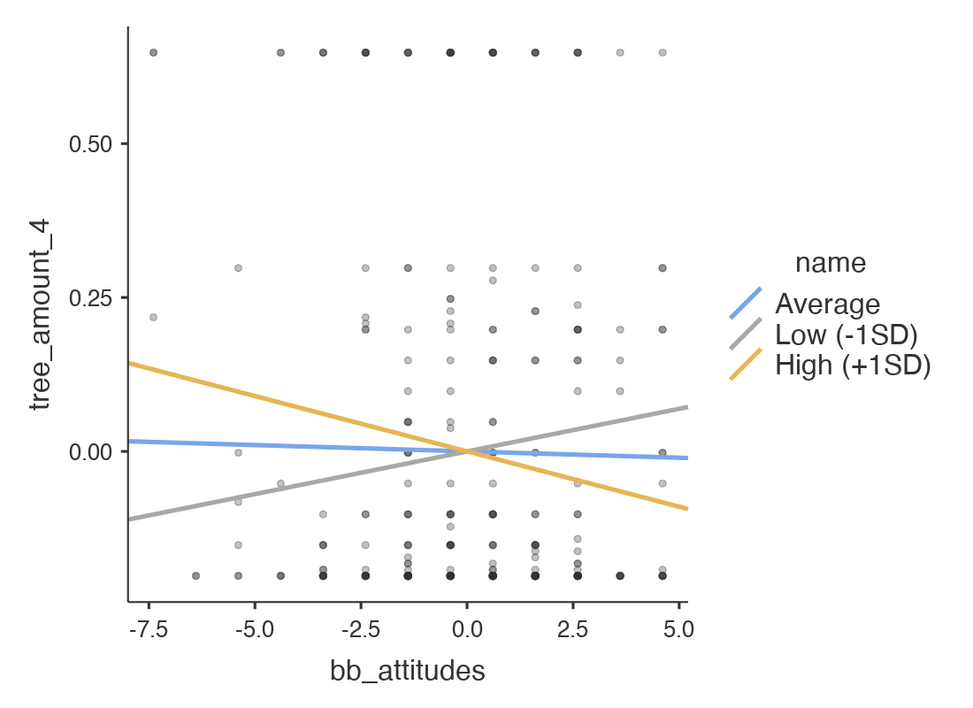

With regards to attitude importance, the results of the bootstrapped (5000 bootstraps) moderation analysis suggested that how important an attitude is to an individual did not seem to moderate the relationship between which condition they were in and their self-reported willingness to pay for a bio-based plastic product (b = 0.007, 95% CI [-0.015, 0.029], t = 0.64, p = .522). However, it did moderate the relationship between condition and donation behaviour (b = -.024, 95% CI [-0.046, -0.002], t = -2.15, p = .032). In particular, for those participants who do not attach a lot of significance to their plastic-related attitude, receiving more knowledge/information about bio-based plastic increases their willingness to donate (see Figure 7).

Figure S2
Simple slopes graph for the moderating effect of attitude importance on the relationship between condition and participants’ willingness to donate to a sustainable cause.

