A review of published and unpublished findings from 20 long-term monitoring studies of eastern monarch butterflies: the population was never in danger, despite recent winter colony declines

Supplemental Material - Descriptions of data sources

The following document explains the procedures and background of each source of data used in this review. In most cases, links are also given for even further information. They are loosely arranged according to the season in which the data is, or has been, collected (winter, spring, summer and fall), though in some cases there is seasonal overlap.

Winter colony size in Mexico
Perhaps the best-known data source that tracks the eastern monarch population size is the long-term surveys of the winter colonies in central Mexico. The colonies have been measured and reported by staff of WWF-Mexico beginning since 1994, and these data are publically-available from a variety of sources. Ironically, despite the fact that these data are so well-known, few people know that there had been previous measurements of the colonies by other researchers (see below). In general, the colonies are measured by assessing the perimeter of the trees that support monarch clusters (reported in total hectares). The colonies have traditionally been assessed in December, once all butterflies have arrived and settled (more recently, colonies have been assessed multiple times throughout the winter). The annual index of colony size (using WWF data only) has been used to track temporal trends in a large number of scientific studies, including the one study that first reported long-term declines at this stage (Brower et al. 2012).
Before the WWF took over management of these measurements in 1994, there were a series of researchers who had independently assessed the size of some or most of the colonies each winter. These measurements actually began the year following the discovery of the colonies, in the winter of 1976-1977! At that time, Lincoln Brower and Bill Calvert began assessing all colonies they could find each winter. As time went on, additional colonies continued to be found, and they still are even now. These early researchers measured colonies for 7 years, and they documented these measurements in an early publication (Calvert and Brower 1986). For the next two winters (1982-83 and 1983-84), Lincoln Brower himself apparently measured the colonies. From the winter of 1984-85 to 1990-91, the colony measurements were made by a student at Universidad Michoacana (Mejía 1996). Unfortunately, there were no measurements in the next two winters prior to the WWF management in 1994.
This dataset now spans 44 years (but with two missing years), although there is some inherent variation in the number of colonies measured each year, because not all colonies were discovered in the early years. Thus in the early years, only 2-6 colonies were measured per year, while in later years there are typically 9-12 colonies measured. However, this variation can be accounted for statistically, by including the number of colonies measured as a covariate. Importantly, prior to his passing in 2018, Lincoln Brower had shared his early notes on the colony measurements on to a colleague, and these include the information on which, and how many, colonies were measured ear year prior to 1994, and the WWF colony measurements thereafter up to 2016.
The complete dataset over the 44 years is graphed below. In this graph I have included the latest estimates of colony size from WWF up to last winter.
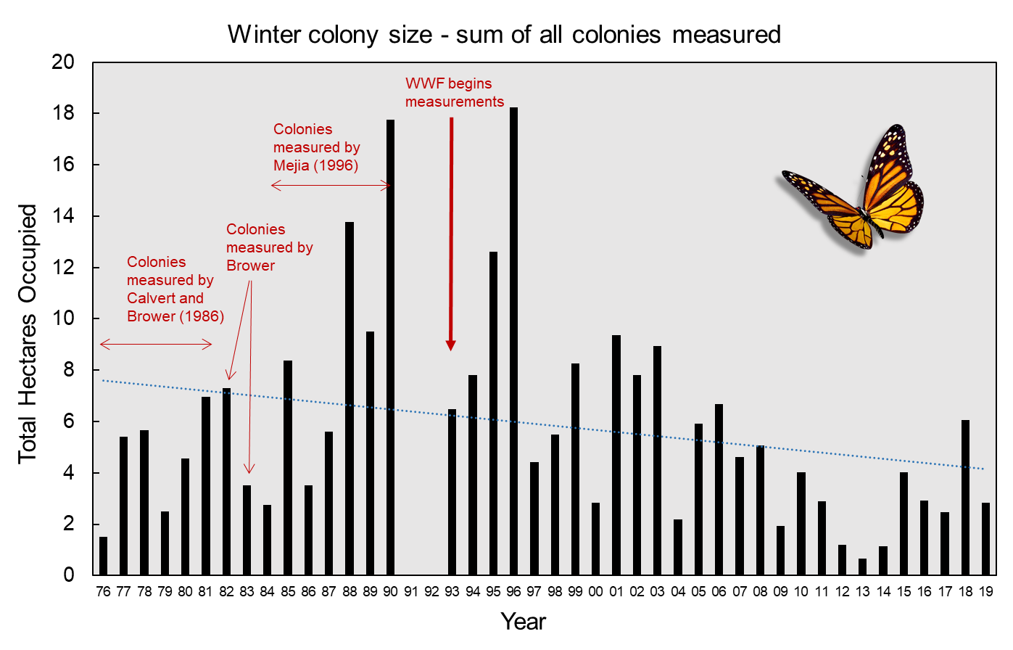
For the purposes of this project, I attempted to determine if there has been any statistical trend in colony size in two ways. First, I used a linear regression with colony size as the dependent variable, and using year and colony number as continuous predictors. Note that in my dataset, I only had information on colony number for 38 of the 42 years with data (so that n=38 for this analysis).
The number of colonies measured was nearly significant in this model, below, indicating that total colony area tended to be larger when more colonies were measured. Importantly, when colony number is accounted for, there is a statistically-significant negative effect of year, indicating a trend of smaller colonies over time. This trendline is plotted in the graph above.

Predictor | Beta | Beta Std.Err. | t value | p-value
Year | -0.19 | 0.0837 | -2.25 | 0.0311
Colonies measured | 0.60 | 0.3413 | 1.74 | 0.0898

This statistical approach may or may not be appropriate, give that it is trying to fit a linear pattern to a data series that is clearly not linear (i.e. in the graph there is a noticeable increase in the early years, followed by a decline later). Therefore I also examined these data by comparing mean colony size per decade, across time. I used an ANCOVA, where colony size was the response, decade was a categorical predictor, and the number of colonies measured was a continuous covariate. Again, the effective sample size here was n=38. The advantage to this approach is that it will detect changes over time regardless of the direction.
In this analysis the number of colonies measured was not a significant predictor of colony size (below). The average colony size did significantly differ across decades (graphed below).

Predictor | df | MS | F | P
Colonies measured | 1 | 7.52 | 0.65 | 0.4246
Decade | 4 | 71.38 | 6.21 | 0.0008
Error | 32 | 11.50

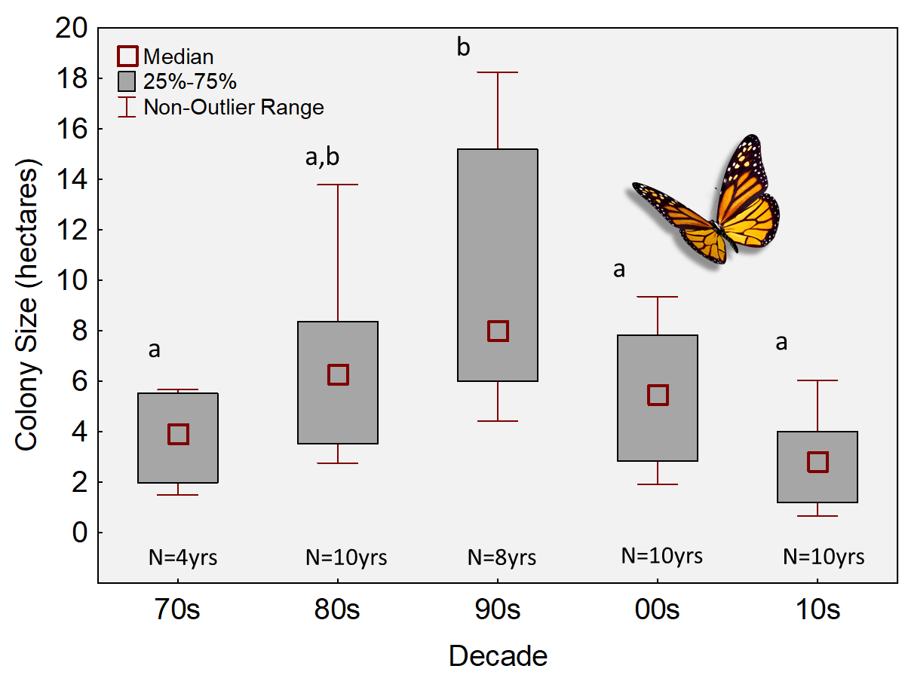
The graph above shows the median and range of colony size (hectares) for each decade. Letters above boxes indicate homogeneous subsets.
To understand how the average colony size compared across decades, I followed up the ANCOVA with Tukey’s post-hoc comparisons. This revealed that the colonies were significantly larger in the 1990s than all other decades (p<0.05). Importantly, this also showed how colony sizes in the last 10 years are not significantly different than those from the 1970s and 80s (p>0.05).
Both approaches above involve accounting for the variation in colony measurements over time. An alternative approach that does not require doing so is to consider the year-to-year variation in a single colony, such as the large colony at El Rosario. This colony had been measured each year dating back to 1984 (but not earlier). It has also traditionally been the largest colony. In fact, based on colony data provided in Saunders et al (2019), it has been estimated that the year-to-year size of this one colony is positively correlated (r=0.8, p<0.05) with the total colony size (A. Agrawal, pers. corresp.). Given this relationship, it is reasonable to assume that the total colony size for the years prior to the WWF measurements could be reflected by the size of El Rosario. Therefore one can estimate the total colony size of those years by extrapolating the El Rosario estimates by Mejia (1996). Below is a graph showing these early extrapolated estimates from 1984 to 1990, combined with the WWF colony data from 1993 onward (values provided by Anurag Agrawal).
r = -0.51
p = 0.002

The three different approaches used here to examine trends in the winter colony data all point to the same conclusion – there has been a modest decline in the size of the colonies, though the decline is not as dramatic as once thought (i.e. not 90%).
Spring surveys at Cross Creek Florida
Beginning in 1981 and onward, the late Lincoln Brower and colleagues have been monitoring the number of eggs and larvae found on milkweeds during the spring in a cattle pasture and surrounding areas in Florida. The 9 ha pasture is at “Cross Creek” in Alachua Co., FL (N 29°31.75′, W 82° 11.86′), and it contains more than 1000 Ascepias humistrata (sandhill milkweed) plants. Surveys are conducted every 3-4 days throughout the spring recolonization (mid-March to mid-May). The data from this project were recently compiled and presented (Brower et al. 2018). In that paper, Figure 10 reports the annual average number of eggs/stem in the surveys. I extracted these annual numbers from the figure and used these data here.

Journey North
This is a citizen science program originally started by Elizabeth Howard in the early 1990s, in which volunteers report observations of the first adult monarch they see each spring and summer. The sightings are compiled and presented online (https://journeynorth.org/monarchs), and by animating the maps, users can see how the spring migration from Mexico progresses northward, as the new sightings come in. With improvements in web technology, now users can add photos of each sighting is available, as well as detailed notes of the observation. Moreover, users now report other sightings, such as eggs, larvae, migration roosts, etc. However, the longest-running records are those of the first adult sightings.
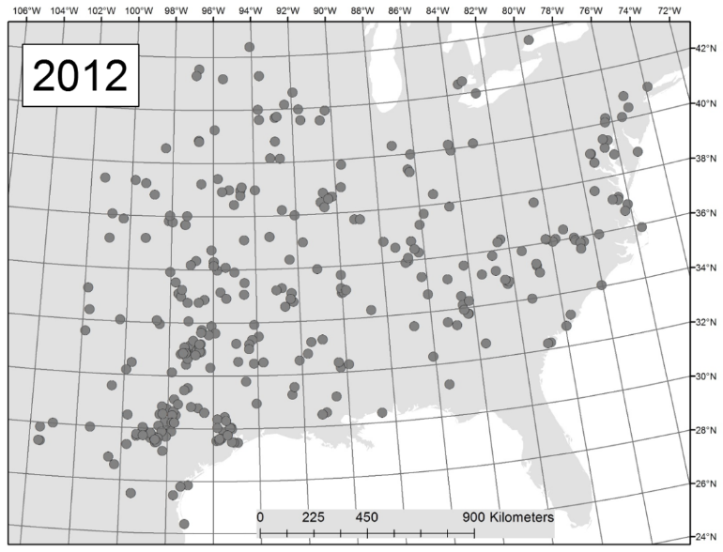
This long-term dataset of sightings is a valuable scientific resource, and has been used many times to investigate various aspects of monarch biology (Davis and Howard 2005, Howard and Davis 2011, Howard and Davis 2015, Lemoine 2015). Of importance here is the fact that these data can also be used to generate an index of overall geographic coverage of 1) the spring migration wave front, and 2) the final summer breeding range. Thus the size (i.e. geographic coverage) of the spring migration, or the summer range can be compared from year to year. This is done by tallying the number of latitude-longitude grid squares that contain sightings (Howard and Davis 2011, Howard and Davis 2015). Pictured is a figure (from Howard and Davis 2015) showing monarch sightings in 2012 (a low year) by the end of July. The map is drawn with 2x2 lat-long grid squares (each equivalent to approximately 50,000 km²).
Here, I used the Journey North database to compile indices of 1) spring migration size, and 2) summer breeding range size. For the spring migration, I characterized the migration size on April 30; by this date each year, the monarch recolonization phase has entered the lower part of the United States and has expanded eastward to fill in the southeastern states (Howard and Davis 2004). To characterize the summer breeding range, I determined the geographic coverage by the end of July. In each case, the annual indices represent the number of grid squares occupied by the date in question.

Monarch Larva Monitoring Project
This citizen science program has been operational since 1997 and has volunteers throughout the eastern monarch breeding range. It recruits volunteers to monitor patches of milkweed, or natural landscapes, for the presence of monarch eggs and larvae. Volunteers survey the sites throughout the summer months and results are collated and presented on the MLMP webpage.

A number of scientific investigations have examined these data to find temporal or regional patterns (Prysby and Oberhauser 1997, 2004, Stenoien et al. 2015). While all of the surveys throughout the summer are valuable, the peak number of eggs and larvae at the end of the summer are typically used as an overall index of larval abundance per year. These indices for the upper Midwest (the core breeding range) and over 22 years were provided in a 2019 newsletter to MLMP volunteers - https://monarchjointventure.org/images/uploads/mlmp/MLMP_Spring_2019_MLMP_Newsletter.pdf. I extracted these indices for use here.

More information about the MLMP program is given here - https://monarchjointventure.org/mlmp

North American Butterfly Association

This is a continent-wide citizen science organization that has been operational since 1993, and it is composed of butterfly enthusiasts and naturalists. It asks its volunteers to conduct annual surveys of butterflies in the middle of the summer breeding season. Surveyors are meant to keep track of the time spent searching, and the number of observers are taken into consideration. The observers count all butterflies seen within a circle with a 15 mile diameter (176 square miles), during one day, typically on the 4th of July (although now observers can record more than one survey day). There are over 450 sites monitored in this program.

More information on this program is available here - https://www.naba.org/

The number of monarchs seen each year is of relevance here, and these data have been compiled and analyzed elsewhere (Inamine et al. 2016, Agrawal and Inamine 2018). Here, I used the annual index of monarch abundance (average number monarchs/hr) from 1993 to 2017; these data were presented in supplemental material in those studies.

Massachusetts Butterfly Club

This is a group of experienced naturalists that conduct semi-regular field surveys of all butterflies at specific sites in the state of Massachusetts. It was formed in early 1990s “to promote the continued appreciation and documentation of the state’s butterflies.” It has a records compiler, and publishes a semi-annual journal Massachusetts Butterflies. The journal publishes sightings and season summaries. From the end of the 1990’s through 2010, the club consisted of a core of about 150 members, most of whom are seasoned butterfly observers.

Since surveys were not regular, and with varying personnel, the number of monarchs seen per year is derived from calculating the total number of monarchs seen each year, per the number of field reports each year. All data was provided to the author directly from the records compiler, Mark Fairbrother.

More information about this group is provided here - https://www.naba.org/chapters/nabambc/

Ohio Butterfly Monitoring Program
The Ohio Lepidopterists’ Society has been conducting weekly walking censuses of butterflies throughout the state since 1996. Volunteers walk the same transects each week and record all butterflies. For more information on this program, see http://www.ohiolepidopterists.org/index.html
These data have been recently examined for trends in abundance of a wide variety of butterfly species (Wepprich et al. 2019), including monarchs. Wepprich et al (2019) reported that the average number of monarchs seen in this program (from 1996 to 2016) shows a shallow but significant decline. Below is a graph reproduced from that study (Fig. 3).
Of note in this graph is the fact that there were two years at the beginning of the program in which monarchs were highly abundant, and these two years may be driving the significant decline detected by Wepprich et al. (2019). Since the dataset for the above graph ended at 2016, I attempted to acquire more recent census totals for the years since. At the time of this writing, these data had not been entered from the field datasheets. However, the program coordinator, Jerry Weidman, indicated in personal correspondence (August 21 2020) that since 2016 there has been a noticeable rebound in monarch abundance to the point where he does not believe there is a decline.
Given the tenuous nature of the decline in the above study, and observations of rebounding numbers since then, and moreover since the latest data is not available for analysis, I elected not to statistically examine the monarch data from this program, and to simply verbally characterize the pattern from this region as “unclear”. Tyson Wepprich is in agreement with this characterization (personal correspondence, 8/21/20).

Illinois Butterfly Monitoring Program
This citizen science program has been operational since the early 1990s. It has volunteers survey specific transects (walking) throughout the state of Illinois, reporting all butterflies seen. The sites are monitored on a weekly basis each summer (at least 6 visits per season). The standardized nature of the surveys, and the wide variety of habitats covered, make these data invaluable for tracking changes in abundance of butterflies. Moreover, given the location of the state within the core breeding range of the eastern population, and within the agricultural Midwest, the counts of monarchs seen are especially important.
I was kindly supplied data on the annual tally of monarchs across the entire state by the program coordinator, Doug Taron. These data span 26 years (1993-2019). For each year, the average number of monarchs seen per census is given.
For more information about this program, see https://bfly.org/

Iowa MSIM Program
The Iowa Department of Natural Resources has been conducting standardized wildlife surveys (including monarchs and other butterflies) each summer throughout the state since 2006, which they call the Multiple Species Inventory Monitoring (MSIM) Program. These are conducted on wildlife management areas as well as in private lands, and they entail personnel visiting the sites on a weekly basis and recording all butterflies seen along a transect while walking at a uniform pace (Kinkead et al. 2019). In a recent analysis of these data, Kinkead et al (2019) stated there were 420 sites throughout the state. However, not all of the sites were randomly-chosen and one of the take-aways from that paper was that this can affect the interpretation of results from a long-term study.
The lead author of the study (Kinkead) kindly provided me with a updated dataset from this program (2007-2019), which includes only data from sites that were randomly-chosen (n=333 sites). The units of measurement in these data are the number of monarchs seen per transect.

Ontario Butterfly Atlas

Run by the Toronto Entomologists’ Association, the Ontario Butterfly Atlas (https://www.ontarioinsects.org/atlas/) compiles sightings and records of butterflies in grid squares across the province, to map out their individual breeding distributions. The sightings come from a variety of sources, including museum collections, eButterfly, Butterflies and Moths of North America (BAMONA), and iNaturalist (Crewe et al. 2019). The data for monarchs (from 2003-2017) was examined in a recent study (Crewe et al. 2019) that used these records to compile an index of annual abundance. This index took into account the varying level of search effort and inherent latitudinal variation. The annual index of abundance was presented in a figure in the paper (Fig. 2); I extracted these indices for use here.

Annual Estimates of Breeding Range size in Canada
A recent study (Flockhart et al. 2019) compiled citizen science sightings of monarchs in eastern and western Canada to map out the distribution of the breeding range in that country. They used sightings from both Journey North, and E-Butterfly, and across 16 years (2000-2015). They estimated the breeding range size per year using spatial modelling, while taking into account bias from human density. They presented results on the variation in breeding size across years, populations, and in relation to weather variables.

I extracted the relevant information on the annual size of the eastern population breeding range from Figure 1B, which showed the change in breeding range size over time.

The study is open access and available here - https://www.facetsjournal.com/doi/pdf/10.1139/facets-2018-0011

Cape May Migration Monitoring Project
Starting in the early 1990s, a census of migrating monarchs has been conducted by volunteers each day during the fall at Cape May, New Jersey. The census is made from a vehicle, driving at low speed, and traversing a variety of habitats and back roads in the town. The census route is the same in each case. Only one observer counts, recording all monarchs seen (and without stopping). These census data have been examined previously (Walton and Brower 1996, Walton et al. 2005, Gibbs et al. 2006, Davis 2012) and serve as a useful index of the annual size of the migratory cohort on the Atlantic coast.
The annual census totals (average number of monarchs seen/hr) are given on the program website - http://www.monarchmonitoringproject.com/mmptwo.html. Here, I used the average census count per year for analysis, and using the most recent data available (1992-2018).

Long Point Migration Census

The Long Point Bird Observatory in Ontario Canada employs seasonal workers to track migrating bird abundance at their peninsula site on the north shore of Lake Erie, and starting in 1995 they also began tracking daily numbers of monarchs each fall. The standardized counts consist of a 1-h afternoon walking census conducted between 1300–1700 hours along a delineated path, during which a single surveyor counts the number of monarchs seen foraging or passing through the count area (Crewe and McCracken 2015). Two sites along the peninsula are monitored each year, called “Breakwater” and the “Tip” (pictured below).

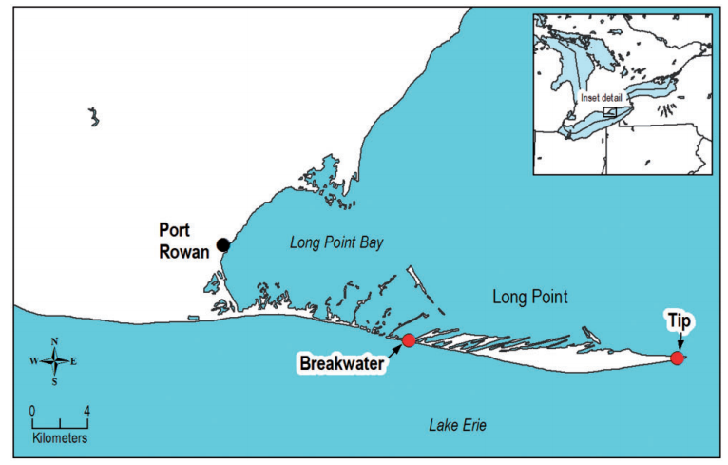
Image above (taken from Figure 1 in Crewe and McCracken 2015) shows the Long Point peninsula, Ontario.

These monarch census data are available for download (with permission) from the NatureCounts web portal (https://www.birdscanada.org/birdmon/default/main.jsp), run by Bird Studies Canada. I downloaded the most up-to-date census data (1995-2019). For each year I compiled the average census count for both sites, and then derived the overall average of these to create a time series consisting of a single abundance index per year (since using data from both sites is redundant). As with the other datasets considered in this review, I looked for a temporal change in abundance using Pearson correlation (monarch index vs. year).

Note that the approach used here to determine temporal changes in abundance differs from two prior analyses of these data (Crewe and McCracken 2015, Ethier 2020). Those investigations used a much more comprehensive Basian statistics approach to examine the day-by-day changes in monarch abundance, how they varied with weather (wind speed, direction, temperature and cloud cover), and how they varied between years. In those studies, researchers concluded that monarch abundance in this region had initially increased in the first decade of surveys, but has since declined (Crewe and McCracken 2015) or become stable (Ethier 2020). Moreover, both studies concluded there was an overall negative relationship with year across the entire dataset (Crewe and McCracken 2015, Ethier 2020).

This conclusion is different than what was determined in the current review. A Pearson correlation between the mean census count and year showed a minor decline that was not significant (see Results section of main paper).

Point Pelee Migration Roost Counts

Point Pelee National Park is the most southern point of mainland Canada situated on the northern shore of Lake Erie (41° 55' N, 82° 30' W) and is known as an important fall roosting location for monarchs. Since 1984, staff and volunteers at Point Pelee National Park have been conducting daily counts of roosting monarchs from September till the end of October. Prior to 2017 an evening walk was conducted by park staff just prior to sunset around a designated area at the tip of the peninsula. During this walk, all roosting monarch were counted by a single observer. The length of the survey route and duration of the walk was not standardized, nor was this information recorded. Thus, the survey is considered consistent, yet unstandardized. However, given that roosting monarchs remain in place, standardization is less important.

Information on the park is given here - https://www.pc.gc.ca/en/pn-np/on/pelee

The data from the roost counts have recently been analyzed and reported on in a forthcoming study (Ethier 2020), obtained here with permission. I extracted the annual index of monarch abundance (average roost size) from a figure (Fig. 2C) in that paper.

Peninsula Point Migration Project
This monitoring project began in 1996 and ended in 2014 (18yrs). It was a daily census of migrating and roosting monarchs at the Stonington, Michigan lighthouse. It was conducted nearly entirely by one person – CJ Meitner and later by Gina Badgett. The survey was a walking census along a trail that traversed a variety of habitats. The location of the peninsula on the north shore of Lake Michigan made it an ideal site for assessing the relative size of the migratory cohort in this region; its northern location meant that the census was counting the beginning of the migratory phase.
The data collected from this program had been examined in three prior studies (Meitner et al. 2004, Davis 2012, Badgett and Davis 2015). From these data I used the average census count per year for analyses in the current paper.

Journey North roost sightings
Each fall since 2003 the Journey North citizen science program asks its participants to report sightings of migratory roosts. These sightings can be from anywhere in the flyway - typically they are in a tree on a homeowner’s property, and they can range from a few to many thousands of monarchs. If possible, the volunteer is asked to estimate the number of monarchs in the roost(s). These roost estimates have been systematically reported since 2005 on the program web portal (https://journeynorth.org/sightings/). Not all roost sightings have counts.
I downloaded these sightings and compiled them for this review. There were 3557 sightings across the 17 years (2003-2019). I removed all sightings from western states, and also from Florida, and I removed any records of clusters forming at or near the overwintering sites (which are sometimes reported as migratory roosts). Next, I determined the average roost size for each year, for use in analyses.

Estimates of Midwestern monarch production
In 2017, a study was published that examined archived collections of monarch specimens from the Mexican overwintering colonies (Flockhart et al. 2017) to estimate where in North America they originated from. The authors used isotopic analysis of wing tissues to determine natal origins of specimens dating back to the mid-1970s, when the winter colonies were first discovered. The authors delineated the population’s entire breeding range into 6 distinct “breeding regions”, of which one was the central Midwest (Fig. 1 in the paper). This region is of particular importance because of its known history as being the core of the breeding range, and the area that is most affected by agricultural practices.
By compiling the total number of specimens that originated from the Midwest each year (out of the total examined that year), this approach allowed for annual estimates of “monarch production” from the Midwest vs other regions. In other words, how many monarchs at the overwintering colonies came from the Midwest. Specifically, the researchers presented a graph showing the temporal changes in regional production (Fig. 1). From this graph I extracted the information on the proportion of monarchs that came from the Midwest each year, over the 38-year period (1976-2014). While these numbers represent percentages, not counts, the long-term time series, plus the relevance of the Midwest to the monarch story, means they are useful nonetheless.

Museum records of monarchs
A recent study collated records of monarch specimens in museums in North America, in an attempt to track changes in their abundance over the last century (Boyle et al. 2019). The study was highly-criticized (Ries et al. 2019, Wepprich 2019) for the approach used to account for temporal variation in collection effort, which was to present the annual number of monarch specimens out of the total number of Lepidopteran specimens. The reason is that collection of night-flying moths is vastly different than collecting butterflies (UV lights versus hand nets), so the two should not be lumped together to control for effort. A more logical approach would be to calculate the annual proportion of butterfly specimens that are monarchs (Ries et al. 2019). Ries et al. (2019) did so in their rebuttal of the original paper, and presented a graph showing the corrected estimates of monarch abundance over time. These authors also demonstrated that this approach is also biased by outlier years, and so removal of these years is prudent. I extracted these data from this graph for use here. Thus, the dataset here represents the annual proportion of specimens that are monarchs. This dataset extends from 1906 to 2016.

Literature Cited

Agrawal, A. A., and H. Inamine. 2018. Mechanisms behind the monarch's decline. Science 360: 1294-1296.
Badgett, G., and A. K. Davis. 2015. Population trends of monarchs at a northern monitoring site: analyses of 19 years of fall migration counts at Peninsula Point, MI. Annals of the Entomological Society of America 108: 700-706.
Boyle, J. H., H. J. Dalgleish, and J. R. Puzey. 2019. Monarch butterfly and milkweed declines substantially predate the use of genetically modified crops. Proceedings of the National Academy of Sciences of the United States of America 116: 3006-3011.
Brower, L. P., O. R. Taylor, E. H. Williams, D. A. Slayback, R. R. Zubieta, and M. I. Ramirez. 2012. Decline of monarch butterflies overwintering in Mexico: is the migratory phenomenon at risk? Insect Conservation and Diversity 5: 95-100.
Brower, L. P., E. H. Williams, K. S. Dunford, J. C. Dunford, A. L. Knight, J. Daniels, J. A. Cohen, T. Van Hook, E. Saarinen, M. J. Standridge, S. W. Epstein, M. P. Zalucki, and S. B. Malcolm. 2018. A long-term survey of spring monarch butterflies in north-central Florida. Journal of Natural History 52: 2025-2046.
Calvert, W. H., and L. P. Brower. 1986. The location of monarch butterfly (Danaus plexippus L.) overwintering colonies in Mexico in relation to topography and climate. Journal of the Lepidopterists' Society 40: 164-187.
Crewe, T. L., and J. D. McCracken. 2015. Long-term trends in the number of monarch butterflies counted on fall migration at Long Point, Ontario, Canada (1995-2014). Annals of the Entomological Society of America 108: 707-717.
Crewe, T. L., G. W. Mitchell, and M. Larrivee. 2019. Size of the Canadian breeding population of monarch butterflies is driven by factors acting during spring migration and recolonization. Frontiers in Ecology and Evolution 7: 12.
Davis, A. K. 2012. Are migratory monarchs really declining in eastern North America? Examining evidence from two fall census programs. Insect Conservation and Diversity 5: 101-105.
Davis, A. K., and E. Howard. 2005. Spring recolonization rate of monarch butterflies in eastern North America: new estimates from citizen science data. Journal of the Lepidopterists' Society 59: 1-5.
Ethier, D. 2020. Population trends of Monarch butterflies (Danaus plexippus) migrating from the core of Canada’s eastern breeding population. Annals of the Entomological Society of America.
Flockhart, D. T. T., L. P. Brower, M. I. Ramirez, K. A. Hobson, L. I. Wassenaar, S. Altizer, and D. R. Norris. 2017. Regional climate on the breeding grounds predicts variation in the natal origin of monarch butterflies overwintering in Mexico over 38 years. Global Change Biology 23: 2565-2576.
Gibbs, D., R. Walton, L. Brower, and A. K. Davis. 2006. Monarch butterfly (Lepidoptera, Nymphalidae) migration monitoring at Chincoteague, VA and Cape May, NJ: a comparison of long-term trends. Journal of the Kansas Entomological Society 79: 156-164.
Howard, E., and A. K. Davis. 2004. Documenting the spring movements of monarch butterflies with Journey North, a citizen science program, pp. 105-114. In K. Oberhauser and M. Solensky (eds.), The monarch butterfly. Biology and Conservation. Cornell University Press, Ithaca, NY.
Howard, E., and A. K. Davis. 2011. A simple numerical index for assessing the spring migration of monarch butterflies using data from Journey North, a citizen-science program. Journal of the Lepidopterists' Society 65: 267-270.
Howard, E., and A. K. Davis. 2015. Investigating long-term changes in the spring migration of monarch butterflies (Lepidoptera: Nymphalidae) using 18 years of data from Journey North, a citizen science program. Annals of the Entomological Society of America 108: 664-669.
Inamine, H., S. P. Ellner, J. P. Springer, and A. A. Agrawal. 2016. Linking the continental migratory cycle of the monarch butterfly to understand its population decline. Oikos 125: 1081-1091.
Kinkead, K. E., T. M. Harms, S. J. Dinsmore, P. W. Frese, and K. T. Murphy. 2019. Design implications for surveys to monitor monarch butterfly population trends. Frontiers in Ecology and Evolution 7: 11.
Lemoine, N. P. 2015. Climate change may alter breeding ground distributions of eastern migratory monarchs (Danaus plexippus) via range expansion of Asclepias host plants. Plos One 10: e0118614. doi:10.1371/journal.pone.0118614.
Meitner, C. J., L. P. Brower, and A. K. Davis. 2004. Migration patterns and environmental effects on stopover of monarch butterflies (Lepidoptera, Nymphalidae) at Peninsula Point, Michigan. Environmental Entomology 33: 249-256.
Mejía, M. M. M. 1996. Caracterización de las colonias de la mariposa monarcha (Danaus plexippus L.) en la reserva esecial de la biosfera en la estado de Michoacán, Mexico. Tesis licenciatura, Universidad Michoacana de San Nicolás de Hidalgo.
Prysby, M. D., and K. Oberhauser. Large-scale monitoring of larval monarch populations and milkweed habitat in North America, pp. 379-383. In J. Hoth, L. Merino, K. Oberhauser, I. Pisanty, S. Price and T. Wilkinson (eds.), 1997 North American Conference on the Monarch Butterfly. Commission for Environmental Cooperation, Montreal, Quebec.
Prysby, M. D., and K. Oberhauser. 2004. Temporal and geographical variation in monarch densities: Citizen scientists document monarch population patterns, pp. 9-20. In K. S. Oberhauser and M. J. Solensky (eds.), The monarch butterfly. Biology and conservation. Cornell University Press, Ithaca, NY.
Ries, L., E. F. Zipkin, and R. P. Guralnick. 2019. Tracking trends in monarch abundance over the 20th century is currently impossible using museum records. Proceedings of the National Academy of Sciences of the United States of America 116: 13745-13748.
Saunders, S. P., L. Ries, N. Neupane, M. I. Ramirez, E. Garcia-Serrano, E. Rendon-Salinas, and E. F. Zipkin. 2019. Multiscale seasonal factors drive the size of winter monarch colonies. Proceedings of the National Academy of Sciences of the United States of America 116: 8609-8614.
Stenoien, C., K. R. Nail, and K. S. Oberhauser. 2015. Habitat productivity and temporal patterns of monarch butterfly egg densities in the eastern United States. Annals of the Entomological Society of America 108: 670-679.
Walton, R. K., and L. P. Brower. 1996. Monitoring the fall migration of the monarch butterfly Danaus plexippus L. (Nymphalidae: Danainae) in eastern North America: 1991-1994. Journal of the Lepidopterists' Society 50: 1-20.
Walton, R. K., L. P. Brower, and A. K. Davis. 2005. Long-term monitoring and fall migration patterns of the monarch butterfly (Nymphalidae: Danainae) in Cape May, NJ. Annals of the Entomological Society of America 98: 682-689.
Wepprich, T. 2019. Monarch butterfly trends are sensitive to unexamined changes in museum collections over time. Proceedings of the National Academy of Sciences of the United States of America 116: 13742-13744.
Wepprich, T., J. R. Adrion, L. Ries, J. Wiedmann, and N. M. Haddad. 2019. Butterfly abundance declines over 20 years of systematic monitoring in Ohio, USA. Plos One 14: 21.

