Spectroscopic analysis
Characterization of compound 017 as Phaseolin (4)
Compound 017 was purified from the column elution of the n-Hexane soluble fraction by preparative TLC over Silica gel F₂₅₄ using ethyl acetate-tolune (15:85) as the mobile phase. The compound appeared as a red spot on TLC after spraying the developed plate with 1% vanillin in sulfuric acid followed by heating at 110ºC for 4 minutes. From the developed plates, the band was scrapped off and eluted with 100% double-distilled chloroform to provide a colorless mass. It was found to be soluble in chloroform and ethyl acetate.
The ¹H, ¹³C, HMBC, HSQC, COSY NMR spectrum (400 MHz, CDCl₃, Figures: 3.1.1-3.1.8 and Table-3.1) of compound 017 displayed the presence of two methyl group at δ_{H} 1.45 with δ_{C} 27.84 ppm with a HMBC correlation to δ_{C} 76.09 and 129.64 ppm. The δ_{H} 6.58 double doublet (J = 8.4 Hz & 2.4 Hz) was assigned to the H-2 with δ_{C} of 109.67ppm. It has a HMBC correlation to δ_{C} 112.70 ppm which was assigned to C-19. δ_{H} 7.44 doublet (J = 8.4 Hz) was assigned to H-1 of the Phenol ring in the structure with a HMBC correlation to δ_{C} 156.74 ppm. The other hydrogen H-4 with a coupling constant (J= 2.4 Hz) had been assigned with δ_{H} 6.45 ppm doublet. The H-6a and H-6b have shown double doublet in the spectrum due to two non-equivalent proton in the same and adjacent carbon molecule with δ_{H} 3.63 and 4.25 ppm. The higher ppm is due to methoxy group and the HSQC correlation confirmed the same carbon with a chemical shift δ_{C} 66.69 ppm. The multiplet of 3.52 ppm would be assigned to H-7 in the dihydropyran ring fused with a dihydrofuran ring structure. The H-9 and H-10 were confirmed with ortho-coupling constant (J_{ortho} = 8 Hz) with a chemical shift of 6.98 doublet and 6.37 doublet respectively. Another ortho-coupling (J = 9.6Hz) of the pyran ring with chemical shift of 5.59 doublet and 6.53 doublet were confirmed to H-14 and H-15 position respectively with HSQC data correlating to δ_{C} 129.64 and 116.52 respectively. The HMBC correlation of H-14 and H-15 were 106.25 and 76.09 ppm that were assigned to C-16 and C-12 respectively. Finally, the H-18 of the fused dihydropyran and dihydrofuran ring was assigned a chemical shift of 5.5 doublet with δ_{C} of 78.7 ppm. All these sub structures impose a chemical structure that has a resemblance only with Phaseolin.
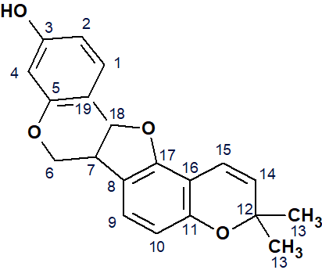

Figure 3.1: Structure of Phaseolin (4)

Table-3.1: ¹H, ¹³C, HMBC, HSQC, COSY NMR spectral data of compound 017 in CDCl₃
Protons and Carbons | δ_{H} and δ_{C} in ppm in CDCl₃
 | compound 017 in 2d NMR
 | δ_{H} in ppm, mult, J in Hz | HSQC data correlation (δ_{C} in ppm) | HMBC data correlation (δ_{C} in ppm) | δ_{C} in ppm
H-1 & C-1 | 7.44, d (J = 8.4 Hz) | 132.35 | 156.74 | 132.35
H-2 & C-2 | 6.58, dd (J = 8.4 Hz & 2.4 Hz) | 109.67 | 112.70 | 109.67
H-4 | 6.44, d (J = 2.4 Hz) | 103.67 | 109.67 | 103.67
C-5 |  |  |  | 156.74
H-6a | 3.63, Dd (J = 11.2 Hz & 10.8 Hz) | 66.59 |  | 66.59
H-6b | 4.25, Dd (J = 5.2 Hz & 10.8 Hz) | 66.59 |  | 66.59
H-7 & C-7 | 3.52m | 39.68 |  | 39.68
C-8 |  |  |  | 119.03
H-9 & C-9 | 6.98, d (J = 8.0 Hz) | 123.83 | 155.41 | 123.83
H-10 & C-10 | 6.37, d (J = 8.0 Hz) | 108.65 | 119.03 | 108.65
C11 |  |  |  | 153.77
C-12 |  |  |  | 76.09
Me-13 | 1.45s | 27.84 | 76.09 & 129.64 | 27.84
H-14 & C-14 | 5.59, d (J = 9.6 Hz) | 129.64 | 106.25 | 129..64
H-15 & C-15 | 6.53, d (J = 9.6 Hz) | 116.52 | 76.09 | 116.52
C-16 |  |  |  | 106.25
C-17 |  |  |  | 155.41
H-18 & C-18 | 5.50, d (J = 6.8 Hz) | 78.71 | 106.25 | 78.71
C19 |  |  |  | 112.7

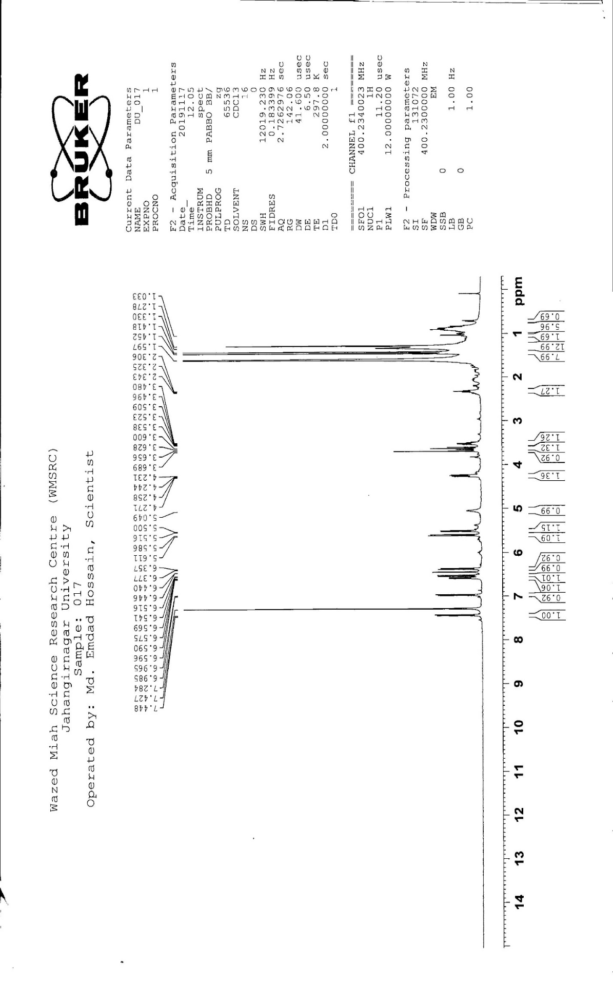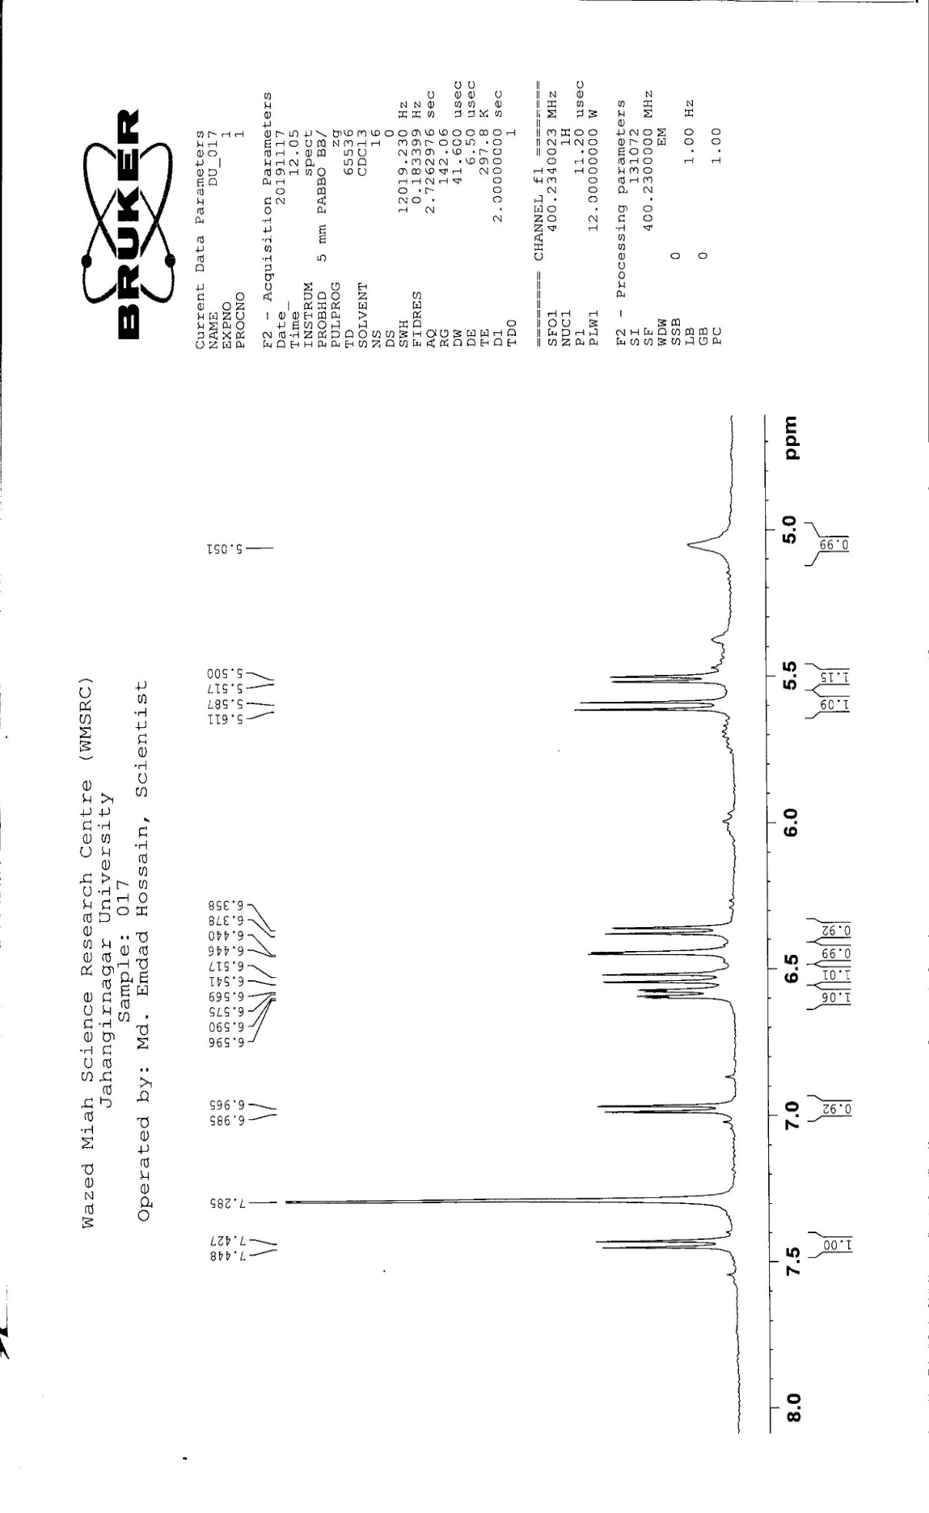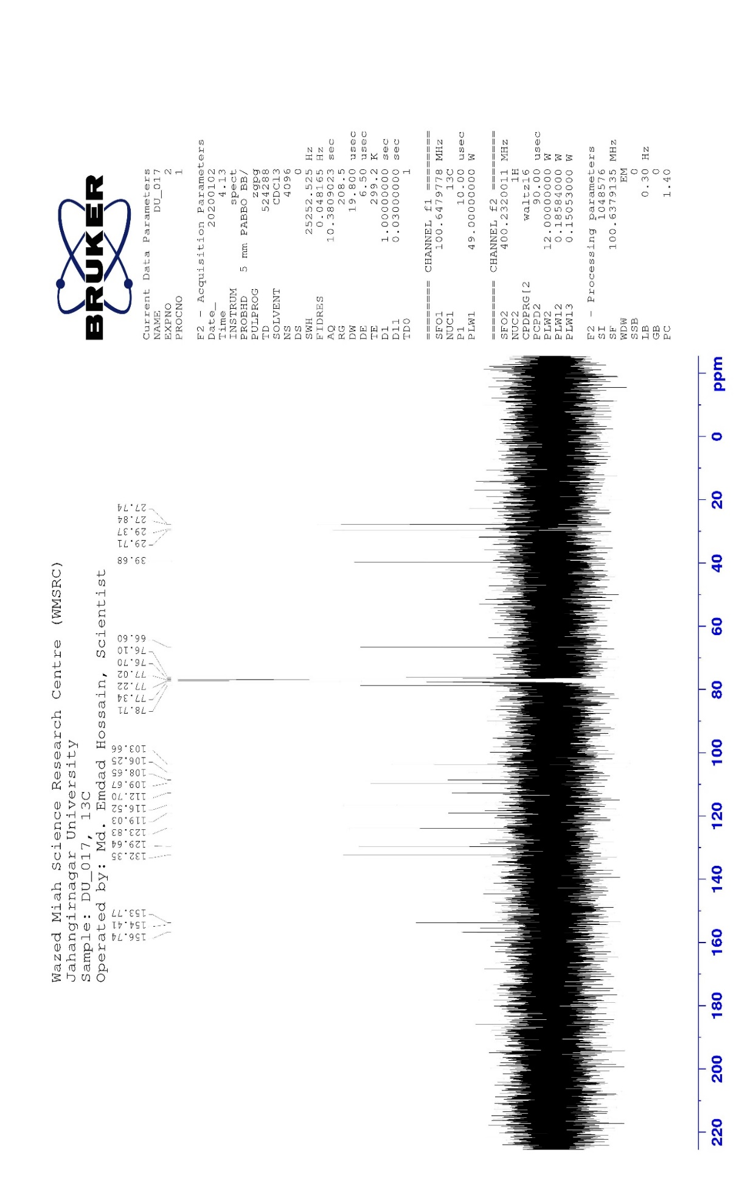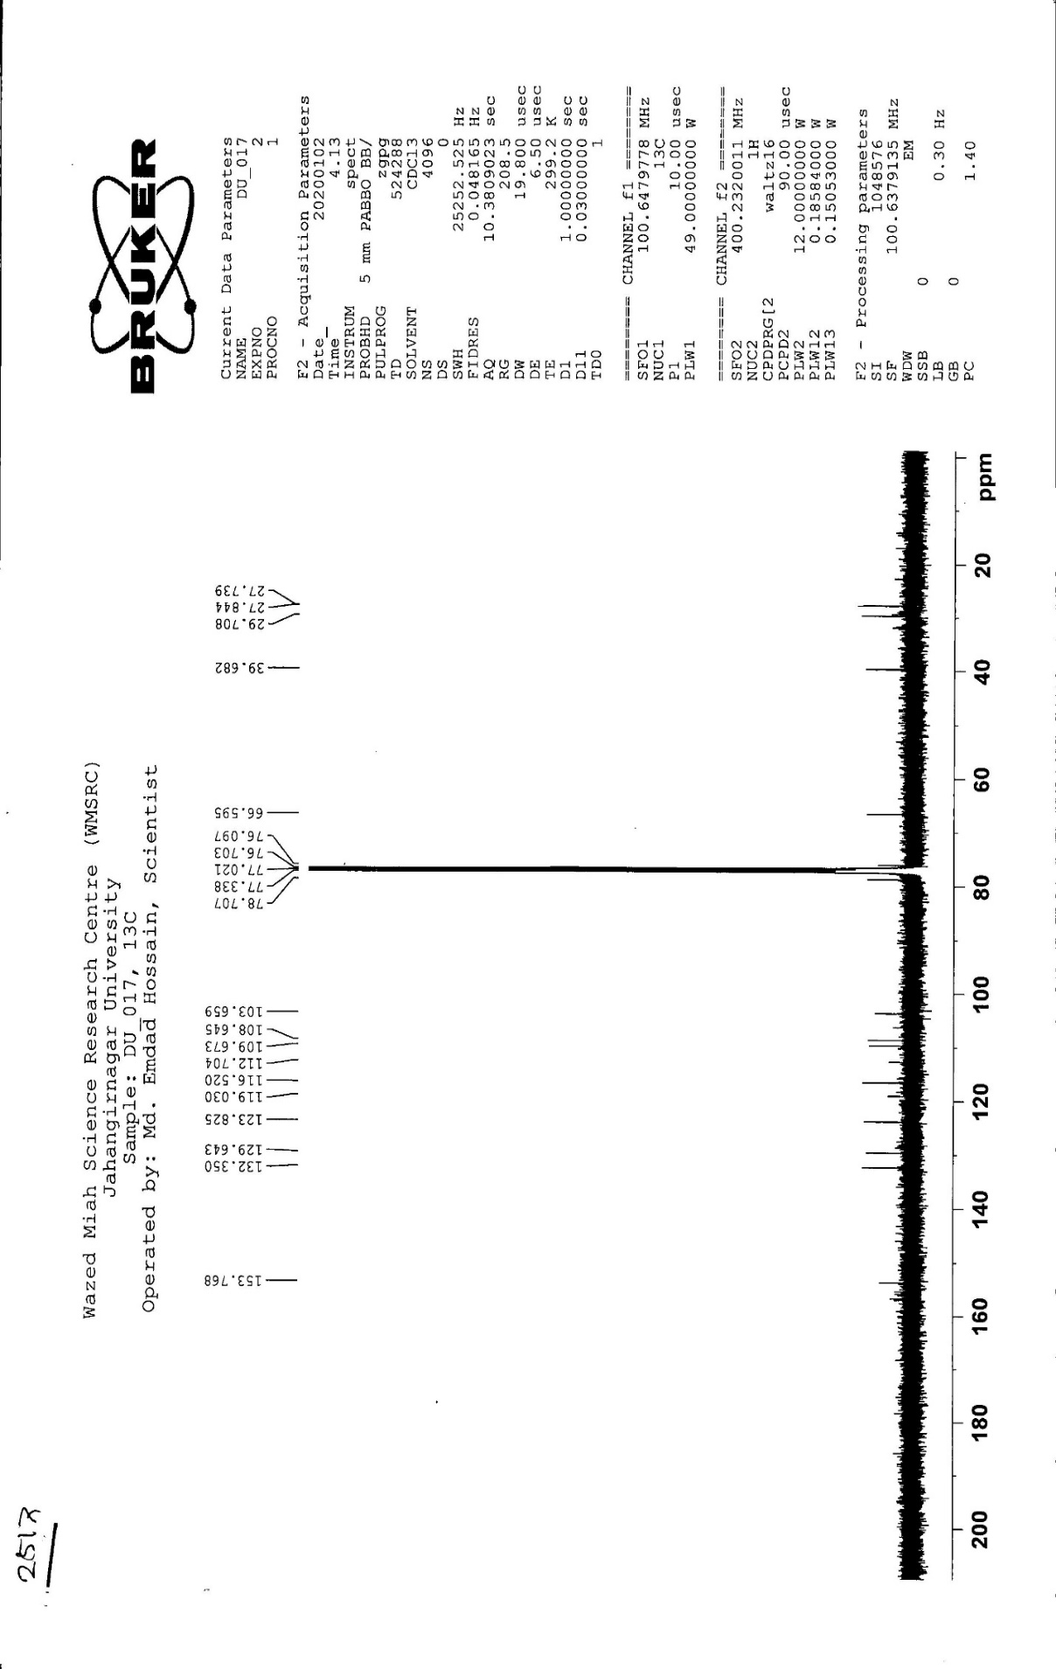

  - Figure 3.1.1: ¹H NMR spectrum (400 MHz) of compound 017 in CDCl₃

  - Figure 3.1.2: Partially expanded ¹H NMR spectrum (400 MHz) of compound 017 in CDCl₃

  - Figure 3.1.3: ¹³C NMR spectrum of compound 017 in CDCl₃

  - Figure 3.1.4: ¹³C NMR spectrum of compound 017 in CDCl₃

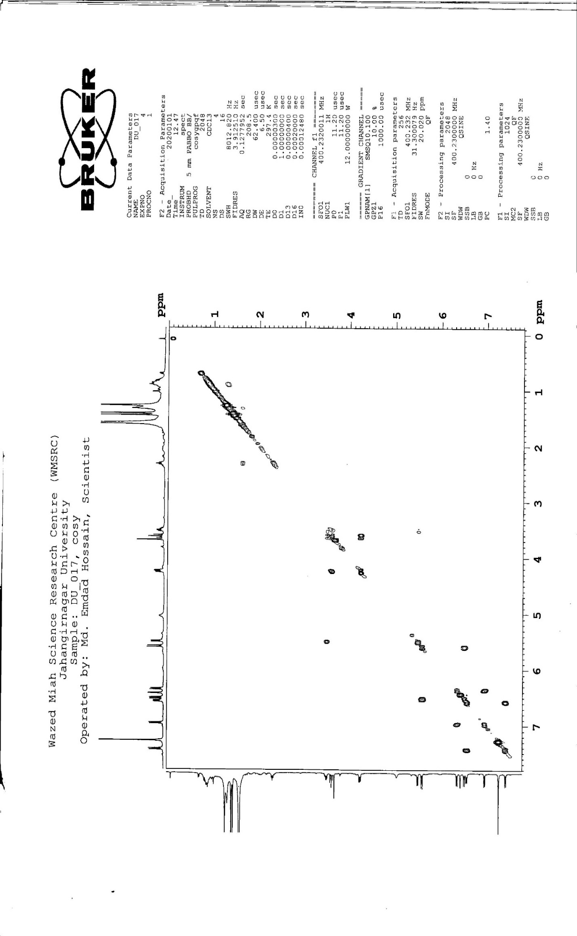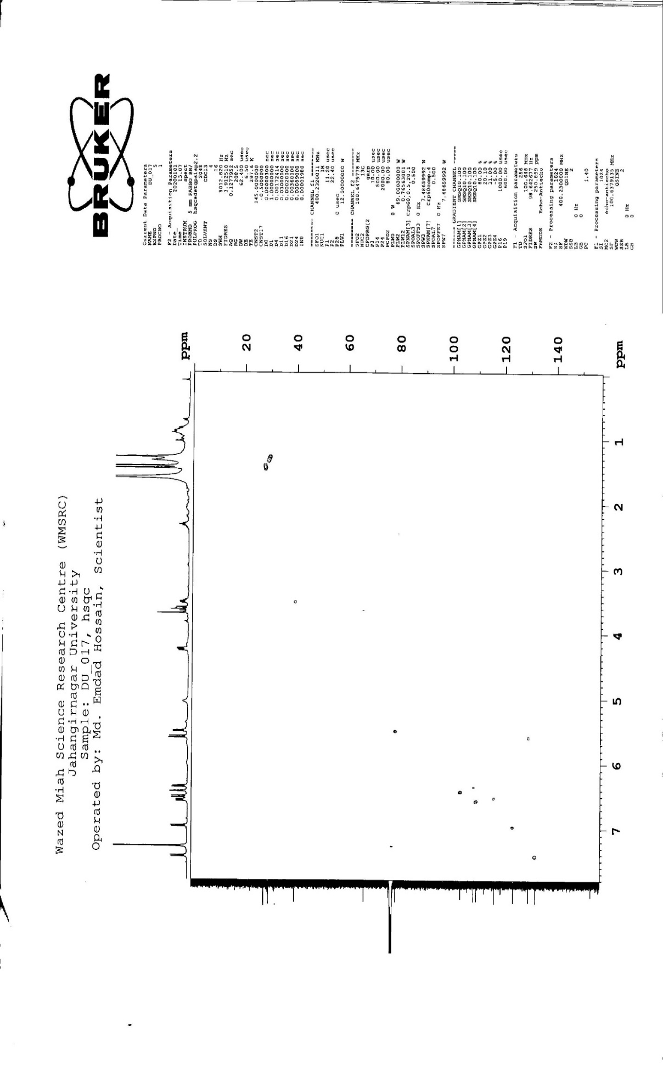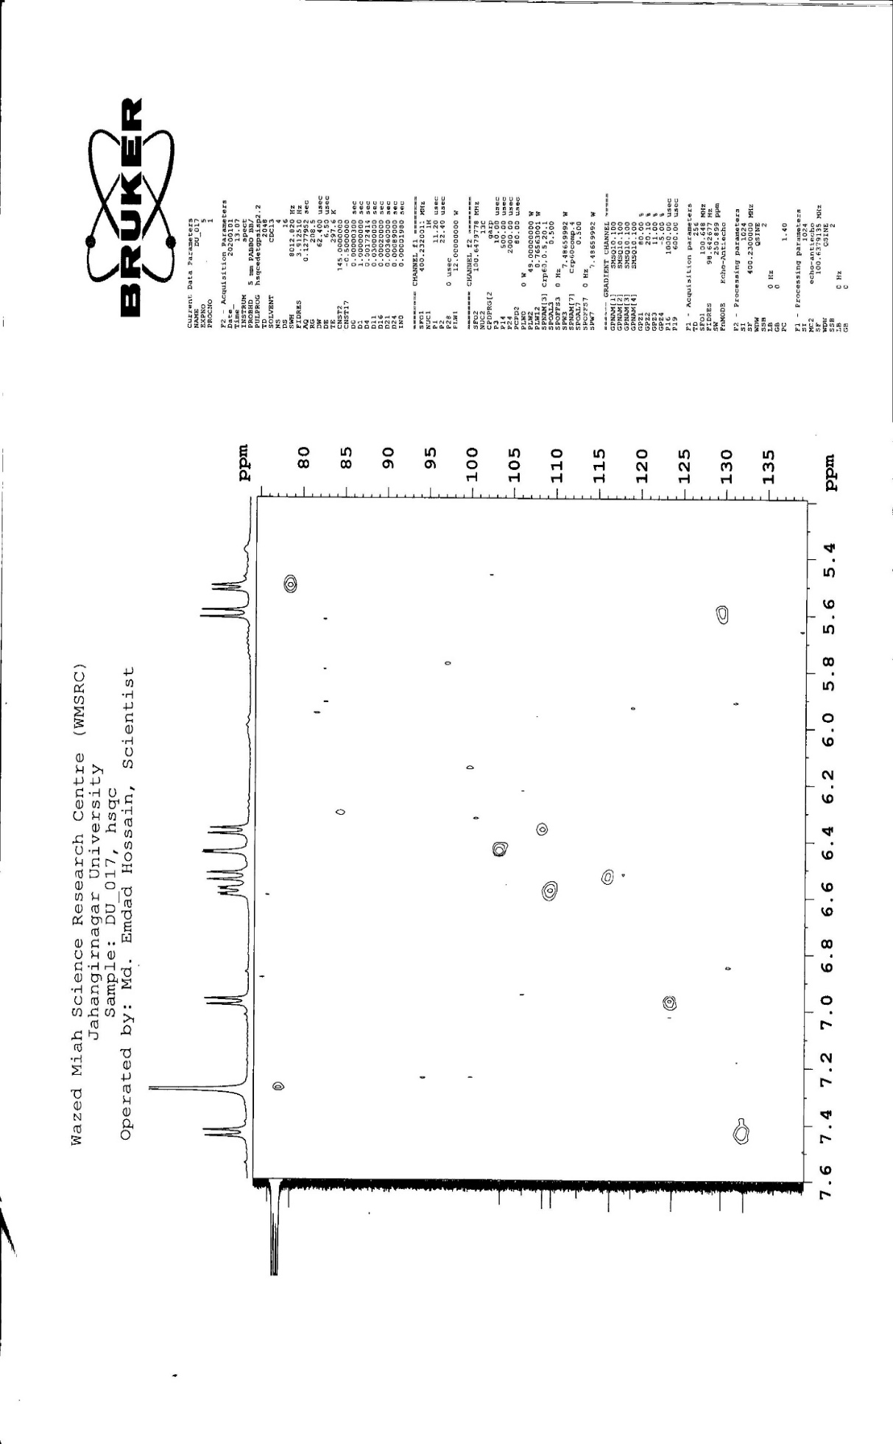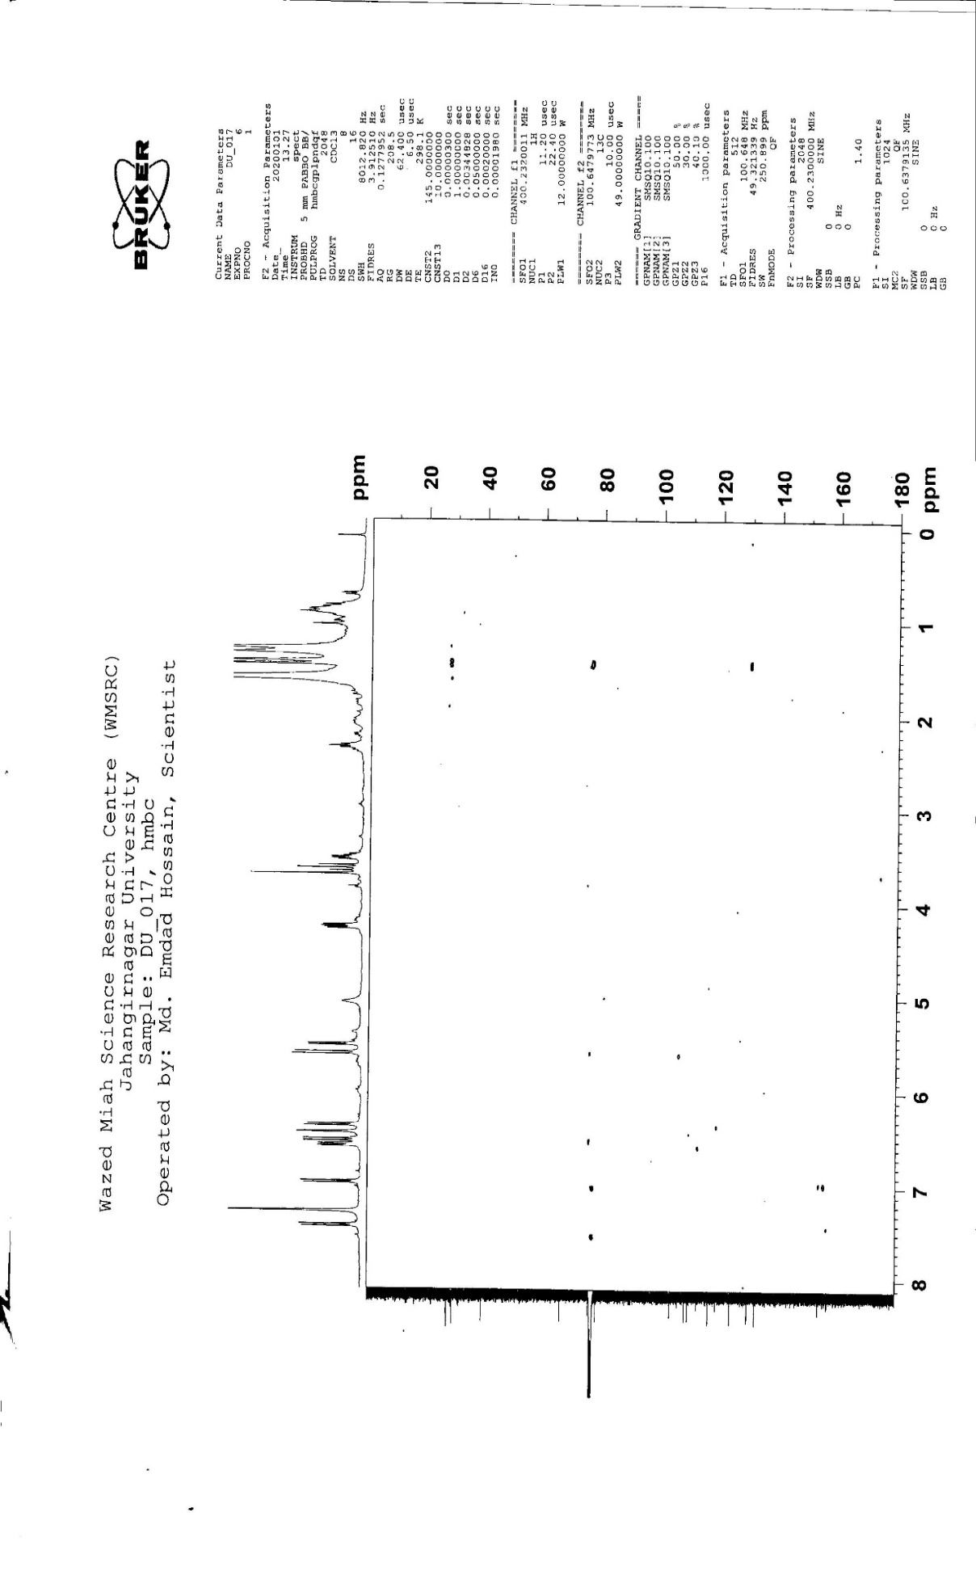

  - Figure 3.1.5: COSY NMR spectrum (400 MHz) of compound 017 in CDCl₃

  - Figure 3.1.6: HSQC NMR spectrum of compound 017 in CDCl₃

  - Figure 3.1.7: HSQC NMR spectrum of compound 017 in CDCl₃

  - Figure 3.1.8: HMBC NMR spectrum of compound 017 in CDCl₃

Characterization of compound 001 as β-amyrin (5) (mixture)
Compound 001 was purified from the column elution of the n-Hexane soluble fraction by preparative TLC over Silica gel F₂₅₄ using toluene-ethyl acetate (90:10) as the mobile phase. The compound appeared as a pink spot on TLC after spraying the developed plate with 1% vanillin in sulfuric acid followed by heating at 110ºC for 2-3 minutes. From the developed plates, the band was scrapped off and eluted with 100% double-distilled chloroform to provide a colorless mass. It was found to be soluble in chloroform and ethyl acetate.
The ¹H NMR spectrum (400 MHz, CDCl₃, Figures: 3.2.1-3.2.3 and Table-3.2) of compound 001 displayed the presence of eight methyl singlets at δ 0.92, 0.78, 0.97, 0.97, 1.02, 0.81, 0.85 and 0.85 which could be assigned to Me-23, Me-24, Me-25, Me-26, Me-27, Me-28, Me-29 and Me-30, of an oleanane-type triterpenoid carbon skeleton. A characteristic triplet (J = 3.6 Hz) at δ 5.21 was attributed to H-12 and suggested an olean-12-ene-type skeleton. On the other hand, a double doublet (J = 11.2, 4.8 Hz) of one proton intensity at δ 3.22 was typical for the oxymethine proton (H-3) of the pentacyclic triterpene.
On this basis, compound 001 was characterized as β-amyrin, the identity of which was confirmed by comparing its spectral data with published values (Kushiro et al., 1998) as well as co-TLC with authentic sample.

Figure 3.2: Structure of β-amyrin (5)
Table-3.2: ¹H NMR spectral data of compound 001 and β-amyrin (Kushiro et al., 1998) in CDCl₃.
Protons | δ_{H} in ppm in CDCl₃
 | compound 001 | β-amyrin (Kushiro et al., 1998)
 | δ in ppm, mult, J in Hz | δ in ppm, mult, J in Hz
H-3 | 3.22, dd (J = 11.2, 4.8 Hz) | 3.52 dd, (J = 11.5 and 4.8 Hz)
H-12 | 5.21, t (J = 3.6 Hz) | 5.18, t (J = 3.5 Hz)
Me-23 | 0.92, s | 0.94, s
Me-24 | 0.78, s | 0.78, s
Me-25 | 0.97, s | 0.97, s
Me-26 | 0.97, s | 0.97, s
Me-27 | 1.02, s | 1.00, s
Me-28 | 0.81, s | 0.83, s
Me-29 | 0.85, s | 0.86, s
Me-30 | 0.85, s | 0.86, s

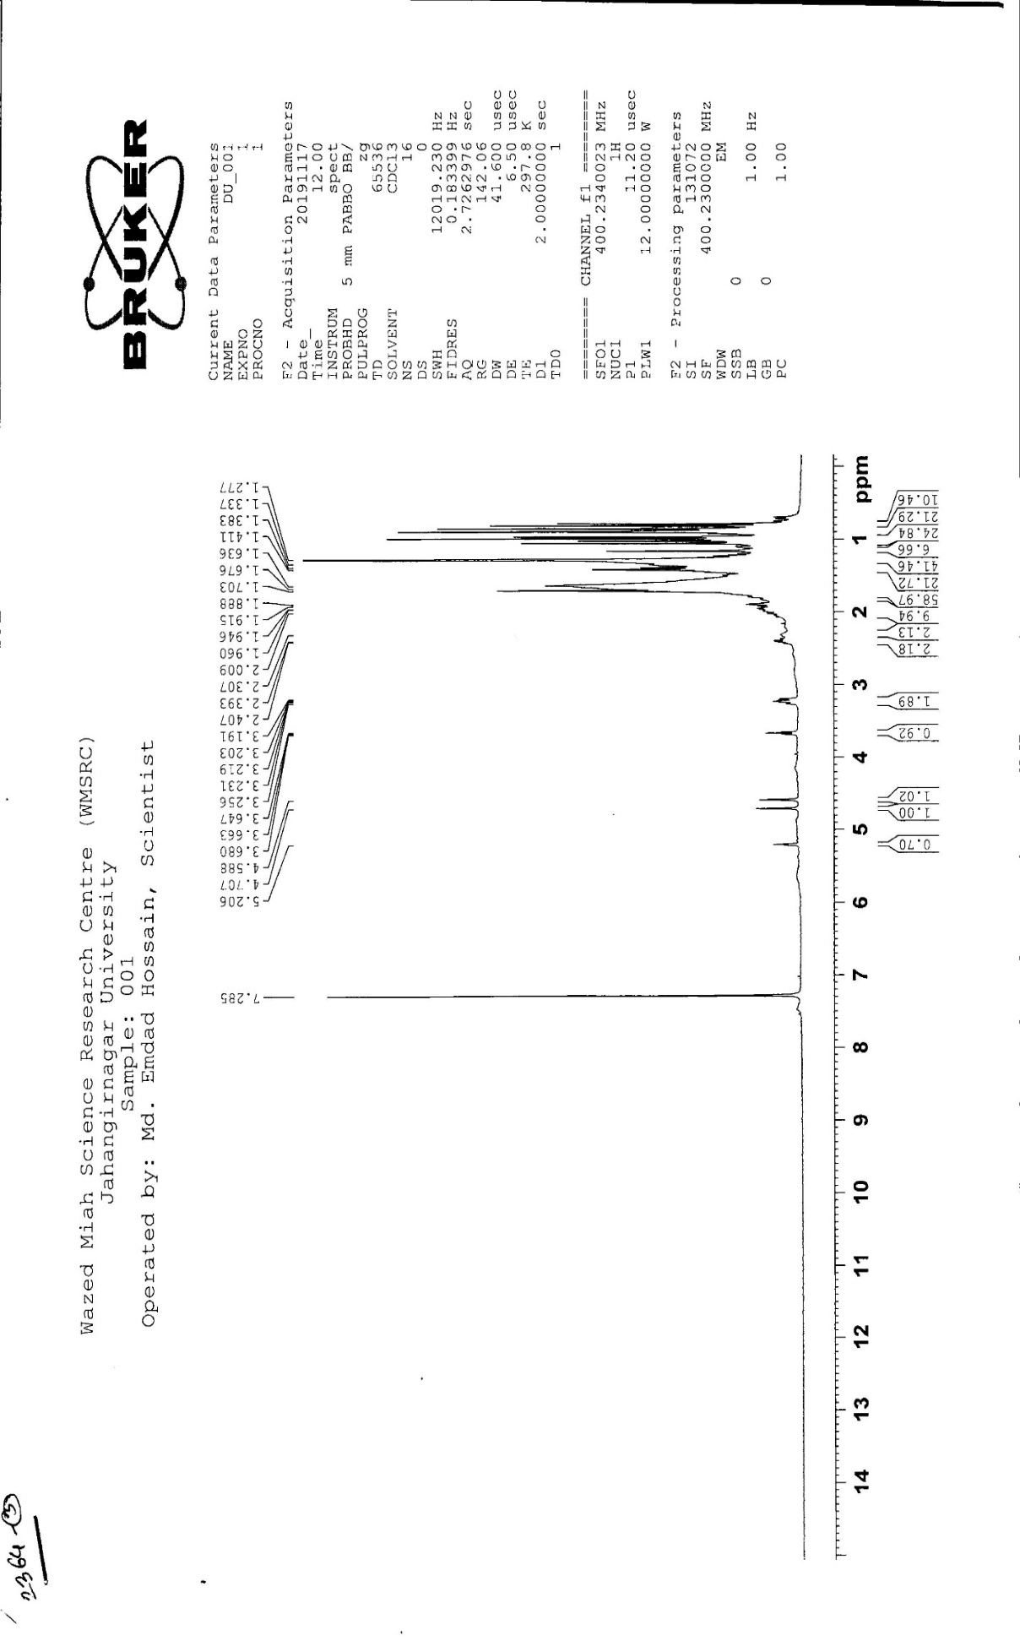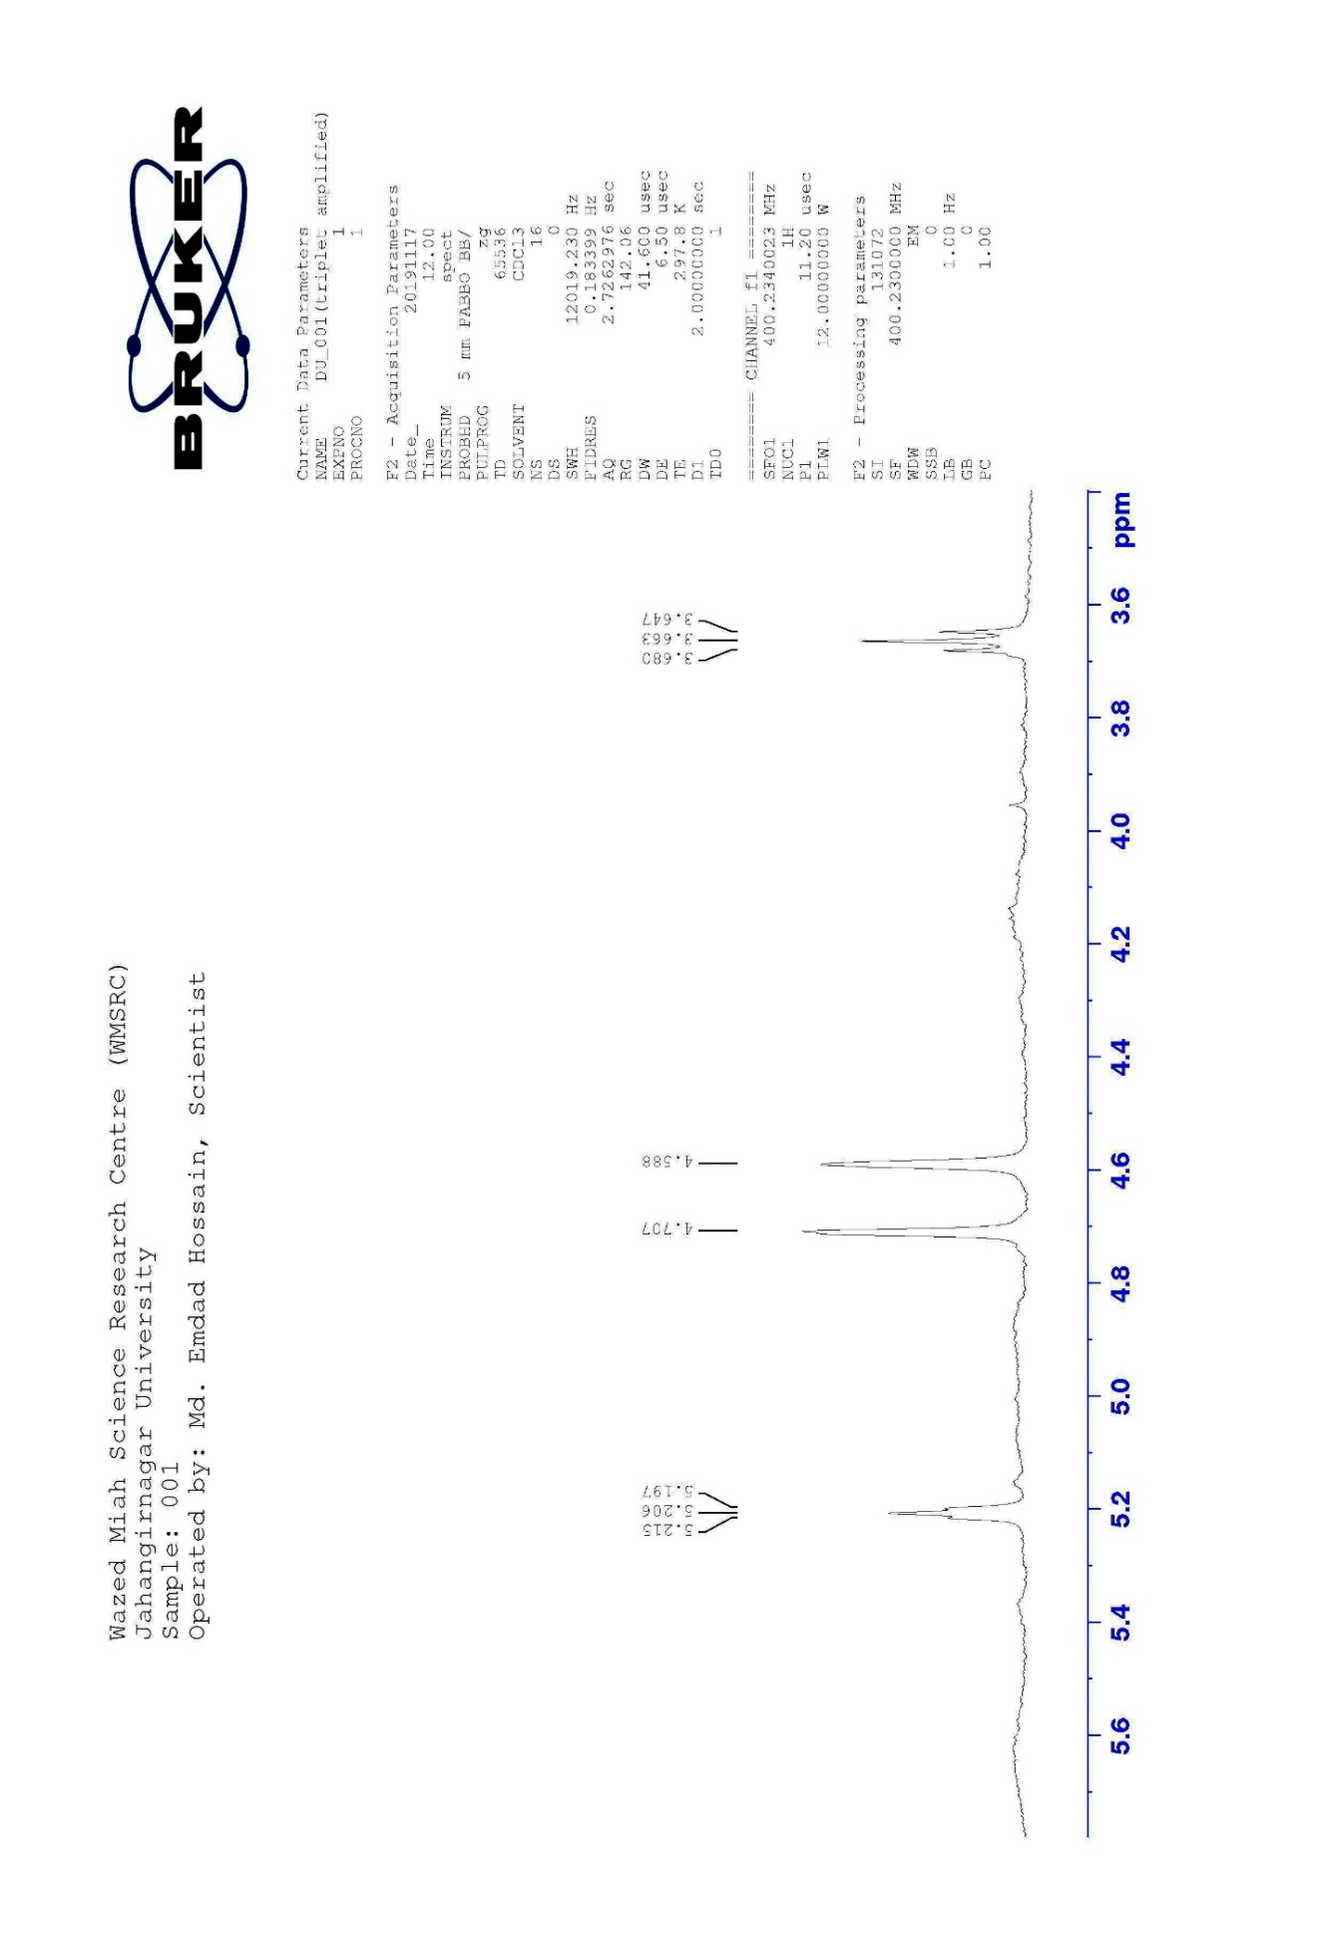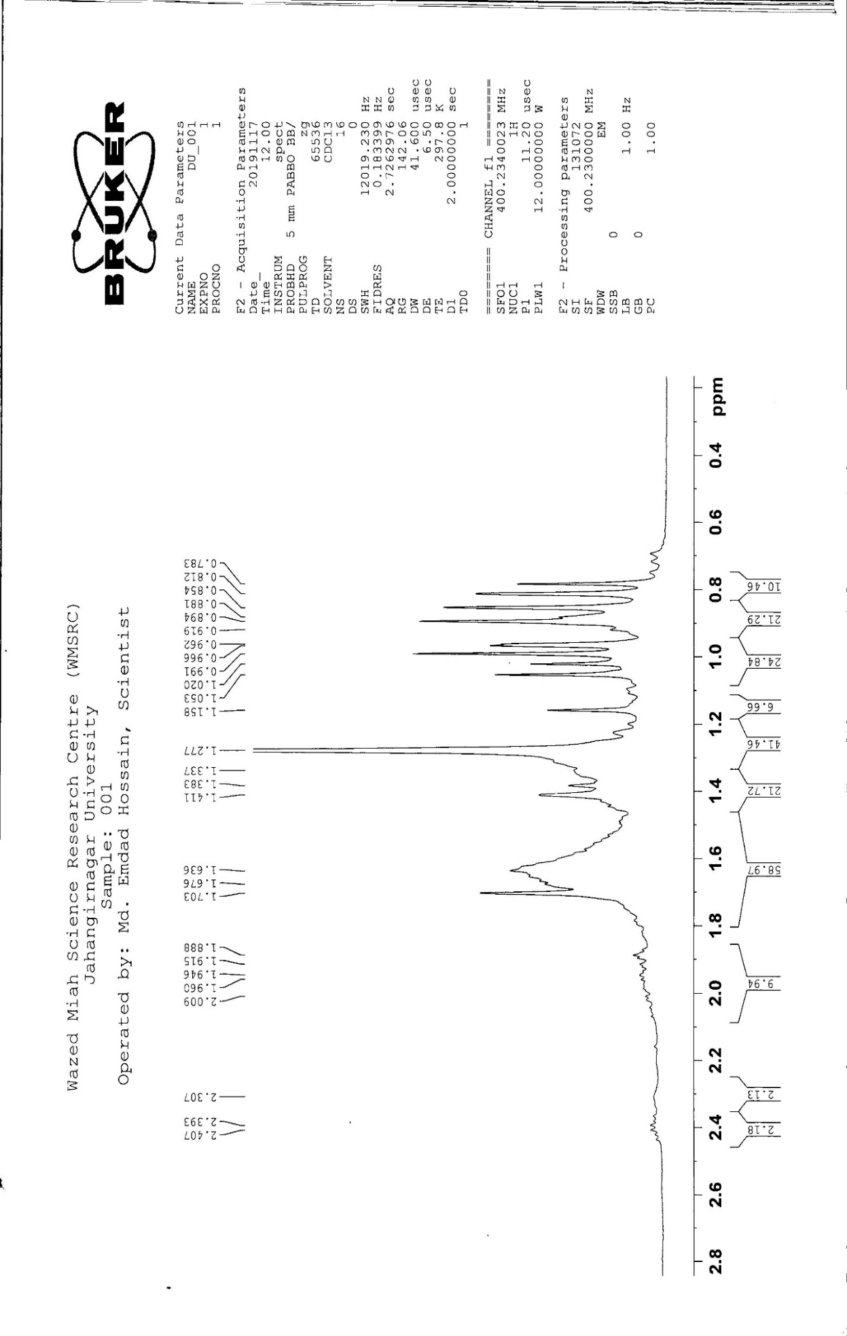

  - Figure 3.2.1: ¹H NMR spectrum (400 MHz) of compound 001 in CDCl₃ (β-amyrin)

  - Figure 3.2.2: Partially Expanded ¹H NMR spectrum (400 MHz) of compound 001 in CDCl₃ (β-amyrin)

  - Figure 3.2.3: Partially Expanded ¹H NMR spectrum (400 MHz) of compound 001 in CDCl₃ (β-amyrin)

Characterization of Compound 001 as lupeol (6) (mixture)
Compound 001 was obtained from the carbon tetrachloride soluble fraction of methanolic extract of leaves of E. fusca as white amorphous powder. It was evident as a violet spot on TLC (silica gel F₂₅₄) when the developed plate was sprayed with vanillin-sulfuric acid followed by heating at 110 °C for 5 minutes. The compound compound 001 was found to be soluble in hexane, ethyl acetate, and chloroform.
The Rf value of compound 001 was 0.5 on TLC plate over silica gel F₂₅₄ plate in ethyl acetate tolune (20:80). The ¹H NMR spectrum (400 MHz, CDCl₃, Figures: 3.3.1-3.3.3 and Table-3.3) of compound 001 exhibited a double doublet (J= 11.2 Hz and 4.8 Hz) of one proton intensity at δ 3.22, typical for an oxymethine proton at C-3 in a triterpene type carbon skeleton. The splitting pattern and coupling constant values (as double doublet) of this proton confirmed the β orientation of the C-3 oxygenated substituent. The spectrum also displayed two broad singlets at δ 4.71 and 4.58 (1H each) assignable to the vinylic protons at C-29. The 1H NMR spectrum showed a characteristic multiplet of one proton intensity at δ 2.01 which could be ascribed to the proton at C-19 and six singlets at δ 0.96, 0.78, 0.85, 1.02, 0.92 and 0.81 (3H each) assignable to methyl group protons at C-4 (H3-23, H3-24), C-10 (H3-25), C-8 (H3-26), C-14 (H3-27), C-17 (H3-28) and C-20, respectively. The downfield methyl group resonance at δ 1.67 could be ascribed to the vinylic methyl at C-20 (H3-30). Thus, MNC-3 was characterized as lupeol. This was further confirmed by comparing its 1H NMR spectral data with the published values (Jahan et al., 2010) as well as by co-TLC.
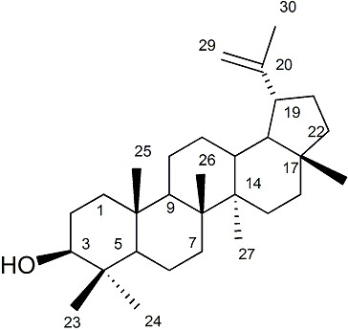
Figure 3.3: Structure of Lupeol (6)
Table 3.3: ¹H NMR spectral data of compound 001 and Lupeol (Jahan et al., 2010) in CDCl₃
Protons | δ_{H} in ppm in CDCl₃
 | compound 001 | Lupeol
 | δ in ppm, mult, J in Hz | δ in ppm, mult, J in Hz
H-3 | 3.22, dd (J = 11.2 Hz and 4.8 Hz) | 3.20, dd, (J=11.5 Hz and 5.0 Hz)
H-19 | 2.01, m | 2.28, m
H₃-23 | 0.96, s | 0.95 s
H₃-24 | 0.78, s | 0.78, s
H₃-25 | 0.85, s | 0.84, s
H₃-26 | 1.02, s | 1.02, s
H₃-27 | 0.92, s | 0.93, s
H₃-28 | 0.81, s | 0.82, s
H_{b}-29 | 4.71, br.s | 4.67, s
H_{a}-29 | 4.58, br.s | 4.55, s
H₃-30 | 1.67, s | 1.68, s

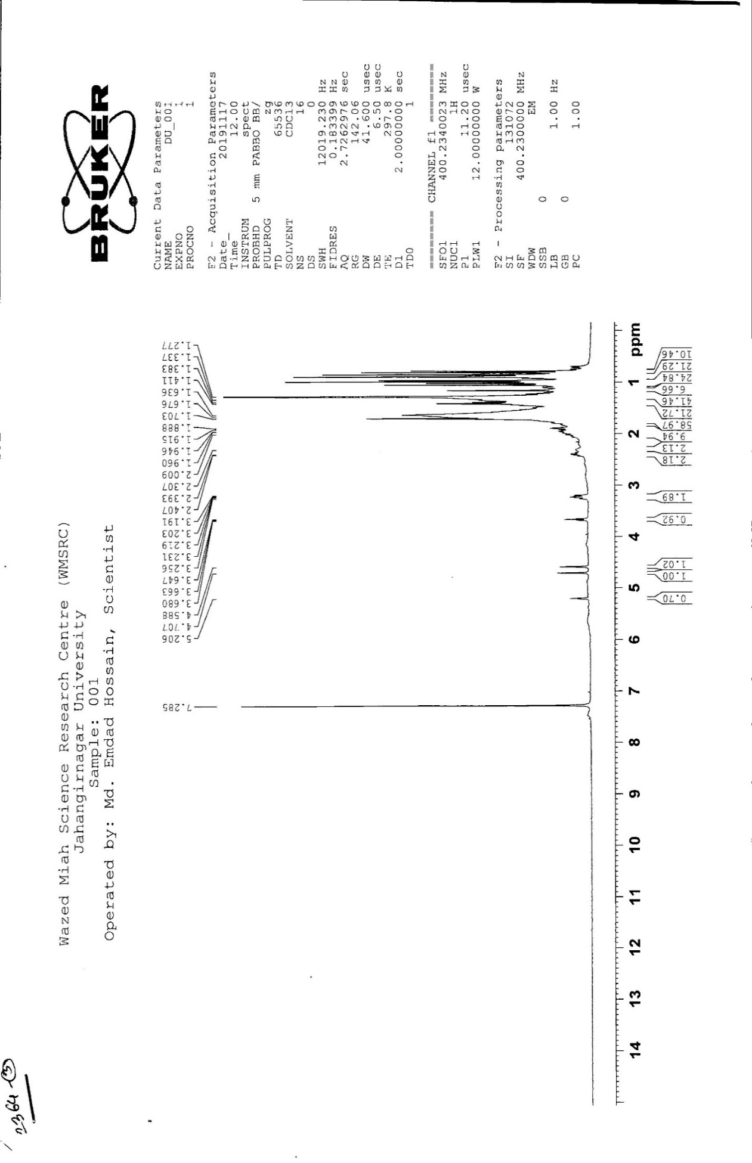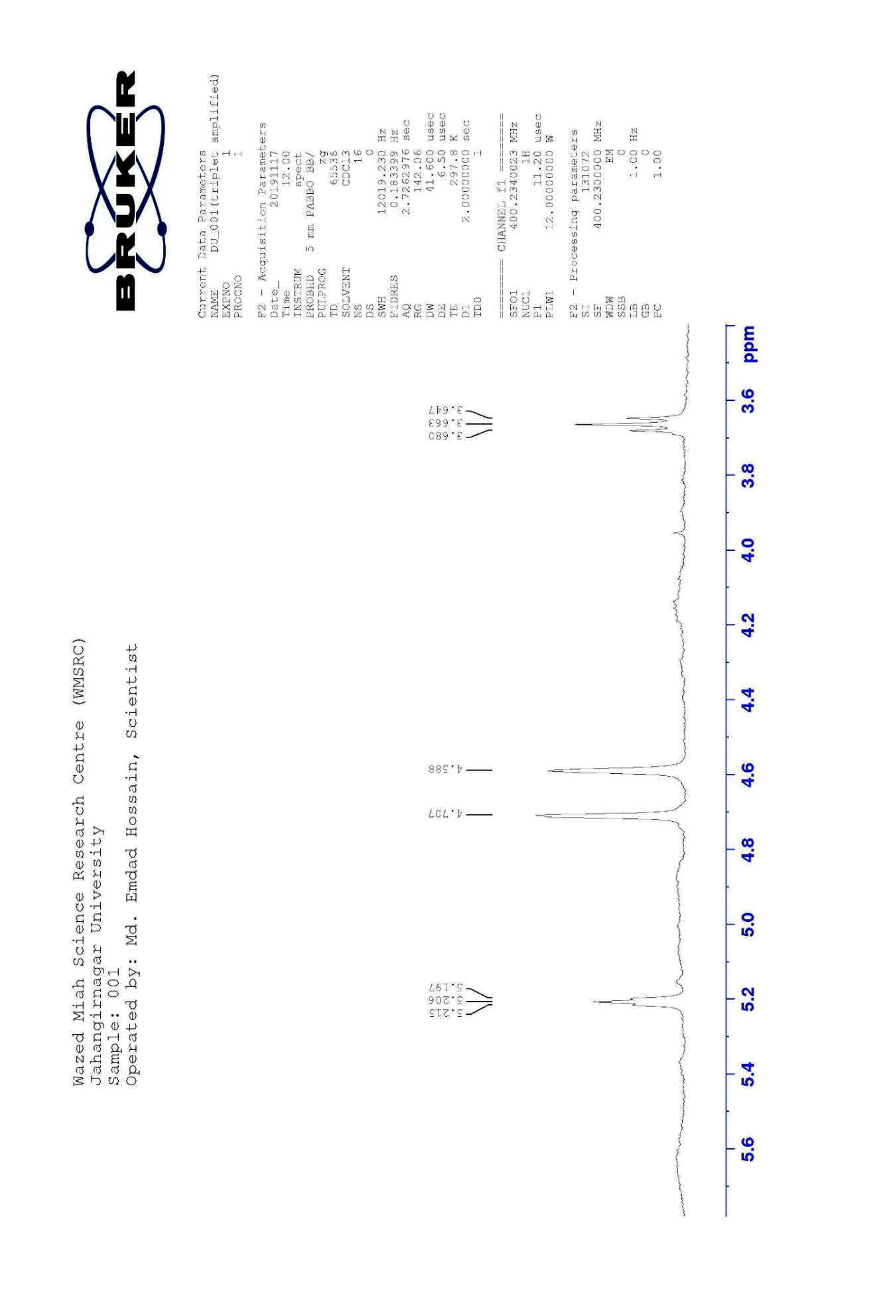

  - Figure 3.3.1: ¹H NMR spectrum (400 MHz) of compound 001 in CDCl₃ (lupeol)

  - Figure 3.3.2: Partially Expanded ¹H NMR spectrum (400 MHz) of compound 001 in CDCl₃ (lupeol)

  - Figure 3.3.3: Partially Expanded ¹H NMR spectrum (400 MHz) of compound 001 in CDCl₃ (lupeol)

Characterization of compound 31 as stigmasterol (7)
Slightly impure compound 31 was obtained from the column fractions of n-Hexane soluble partitionate. It was then purified by preparative TLC over silica gel F₂₅₄ using toluene and ethyl acetate (95:5). From the developed plates, the band was scrapped off and eluted with 100% double-distilled chloroform to afford colorless crystals. Spraying the developed plate with 1% vanillin-sulfuric acid gave a pink colored spot when the plate was heated at 110°C for several minutes. It was found to be soluble in chloroform and ethyl acetate.
The ¹H, ¹³C NMR (400 MHz, CDCl₃, Figures: 3.4.1-3.4.4 and Table-3.4) of compound 31 exhibited signals indicative of a steroidal compound. It displayed a one proton multiplet at δ 3.51, the position and multiplicity of which was indicative to H-3 of a steroidal nucleus. The typical olefinic H-6 of the steroidal skeleton was evident as a doublet (J = 4.4 Hz) at δ 5.34 that integrated for one proton. It also showed olefinic protons at δ 5.14 and 5.01 (H-22 and H-23). The spectrum also revealed signals at δ 0.69 and δ 0.99 (3H each) assignable to two tertiary methyl groups at C-13 (H₃-18) and C-10 (H₃-19), respectively.
Two doublets (J = 6.8 Hz) centered at δ 0.79 (H₃-26) and 0.86 (H₃-27) which could be ascribed to the methyl groups at C-25. The doublets (J = 8.0 Hz) at δ 1.01 (H₃-21) was assignable to the methyl group at C-20. On the other hand, the doublet (J = 6.4 Hz) of three proton intensity at δ 0.91 (H₃-29) could be ascribed to the primary methyl attached to C-28. Two singlets of three proton intensity each at δ 0.69 and 0.99 could be assigned to the primary methyl group attached to C-18 and C-19, respectively.
The above spectral features are in close agreement to those observed for stigmasterol (Chaturvedula et al., 2012). Co-TLC of compound 31 with previously isolated authentic stigmasterol, confirmed the identity of compound 31.

stigmasterol (7)

Table 3.4: ¹H, NMR spectral data of compound 31 and stigmasterol (Chaturvedula et al., 2012) in CDCl_{3.}
Position | compound 31 | stigmasterol (Chaturvedula et al., 2012)
 | δ_{H}, multi, J in Hz | δ_{H}, multi, J in Hz
H-3 | 3.51, m | 3.52, m
H-6 | 5.34, d (J = 4.4 Hz) | 5.35, d (J = 7.0 Hz)
H₃-18 | 0.69, s | 0.69, s
H₃-19 | 0.99, s | 1.01, s
H₃-21 | 1.01, d (J = 8 Hz) | 1.02, d (J = 6.6 Hz)
H-22 | 5.14, dd (J = 15.2 and 8.4 Hz) | 5.15, dd (J = 12 and 8 Hz)
H-23 | 5.01, dd (J = 15.2 and 8.4 Hz) | 5.03, dd (J = 12 and 8 Hz)
H₃-26 | 0.79, d (J = 6.8 Hz) | 0.79, d (J = 7.0 Hz)
H₃-27 | 0.86, d (J = 6.8 Hz) | 0.84, d (J = 7.0 Hz)
H₃-29 | 0.91, d (J = 6.4 Hz) | 0.80, d (J = 7.0 Hz)

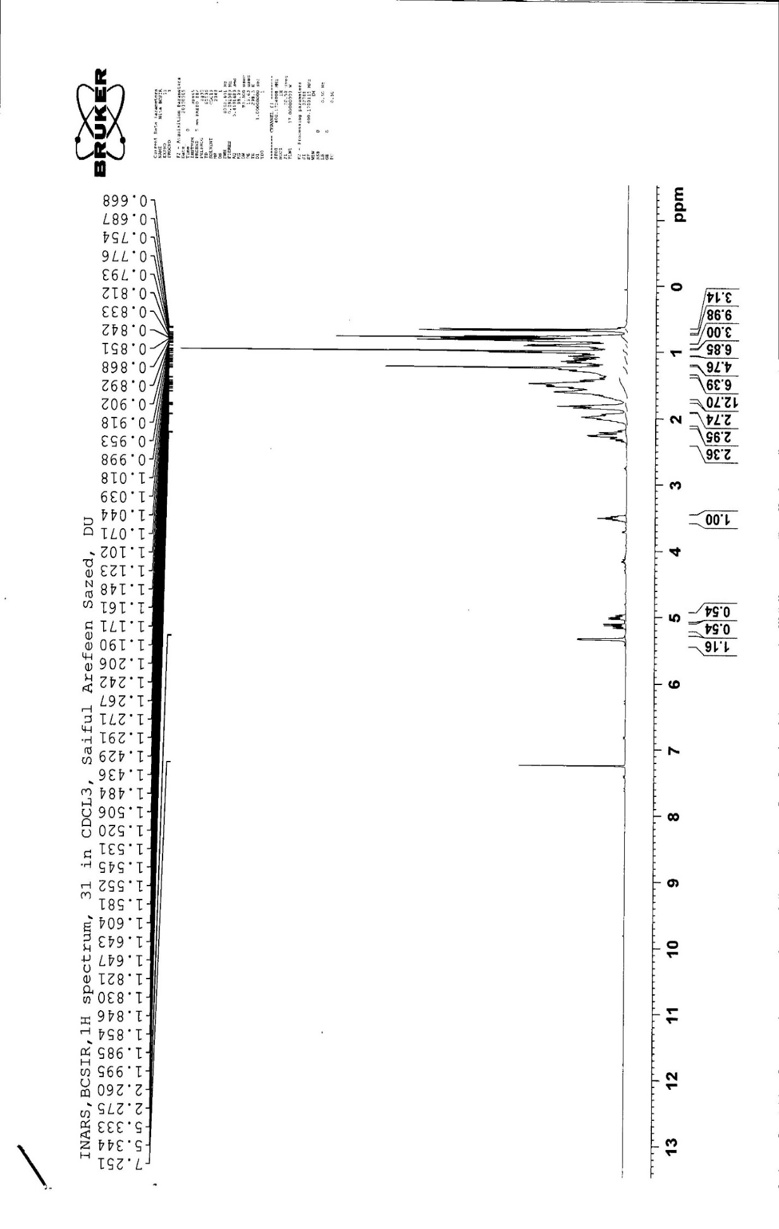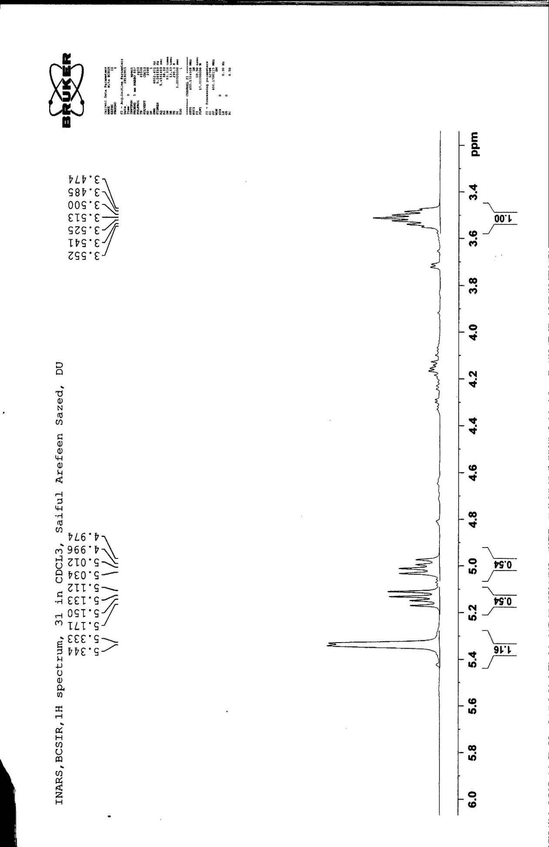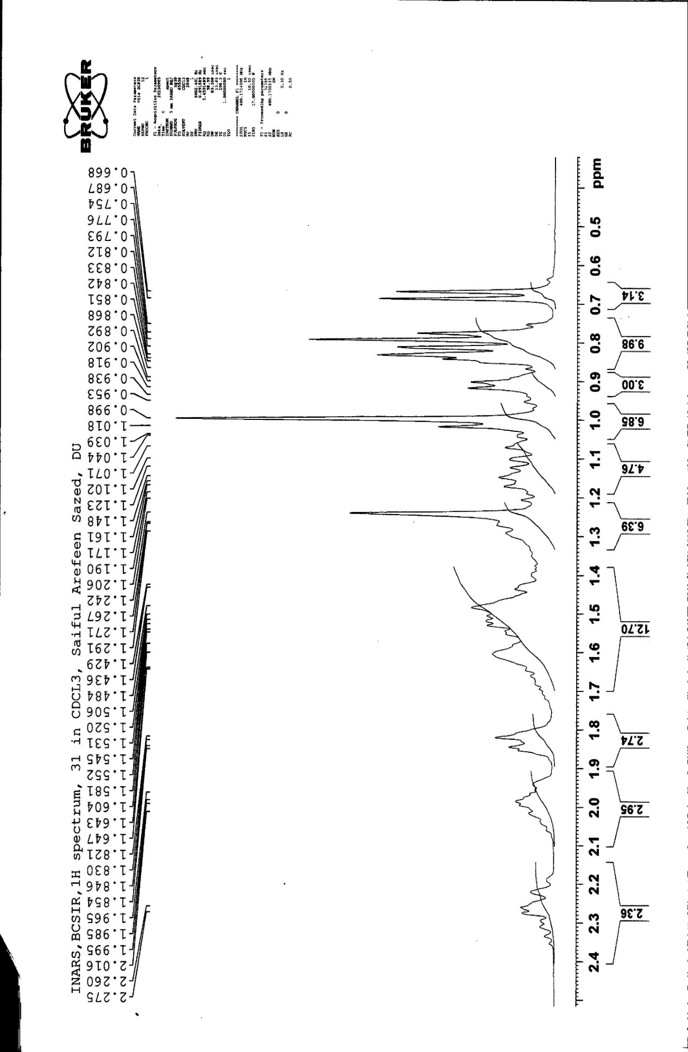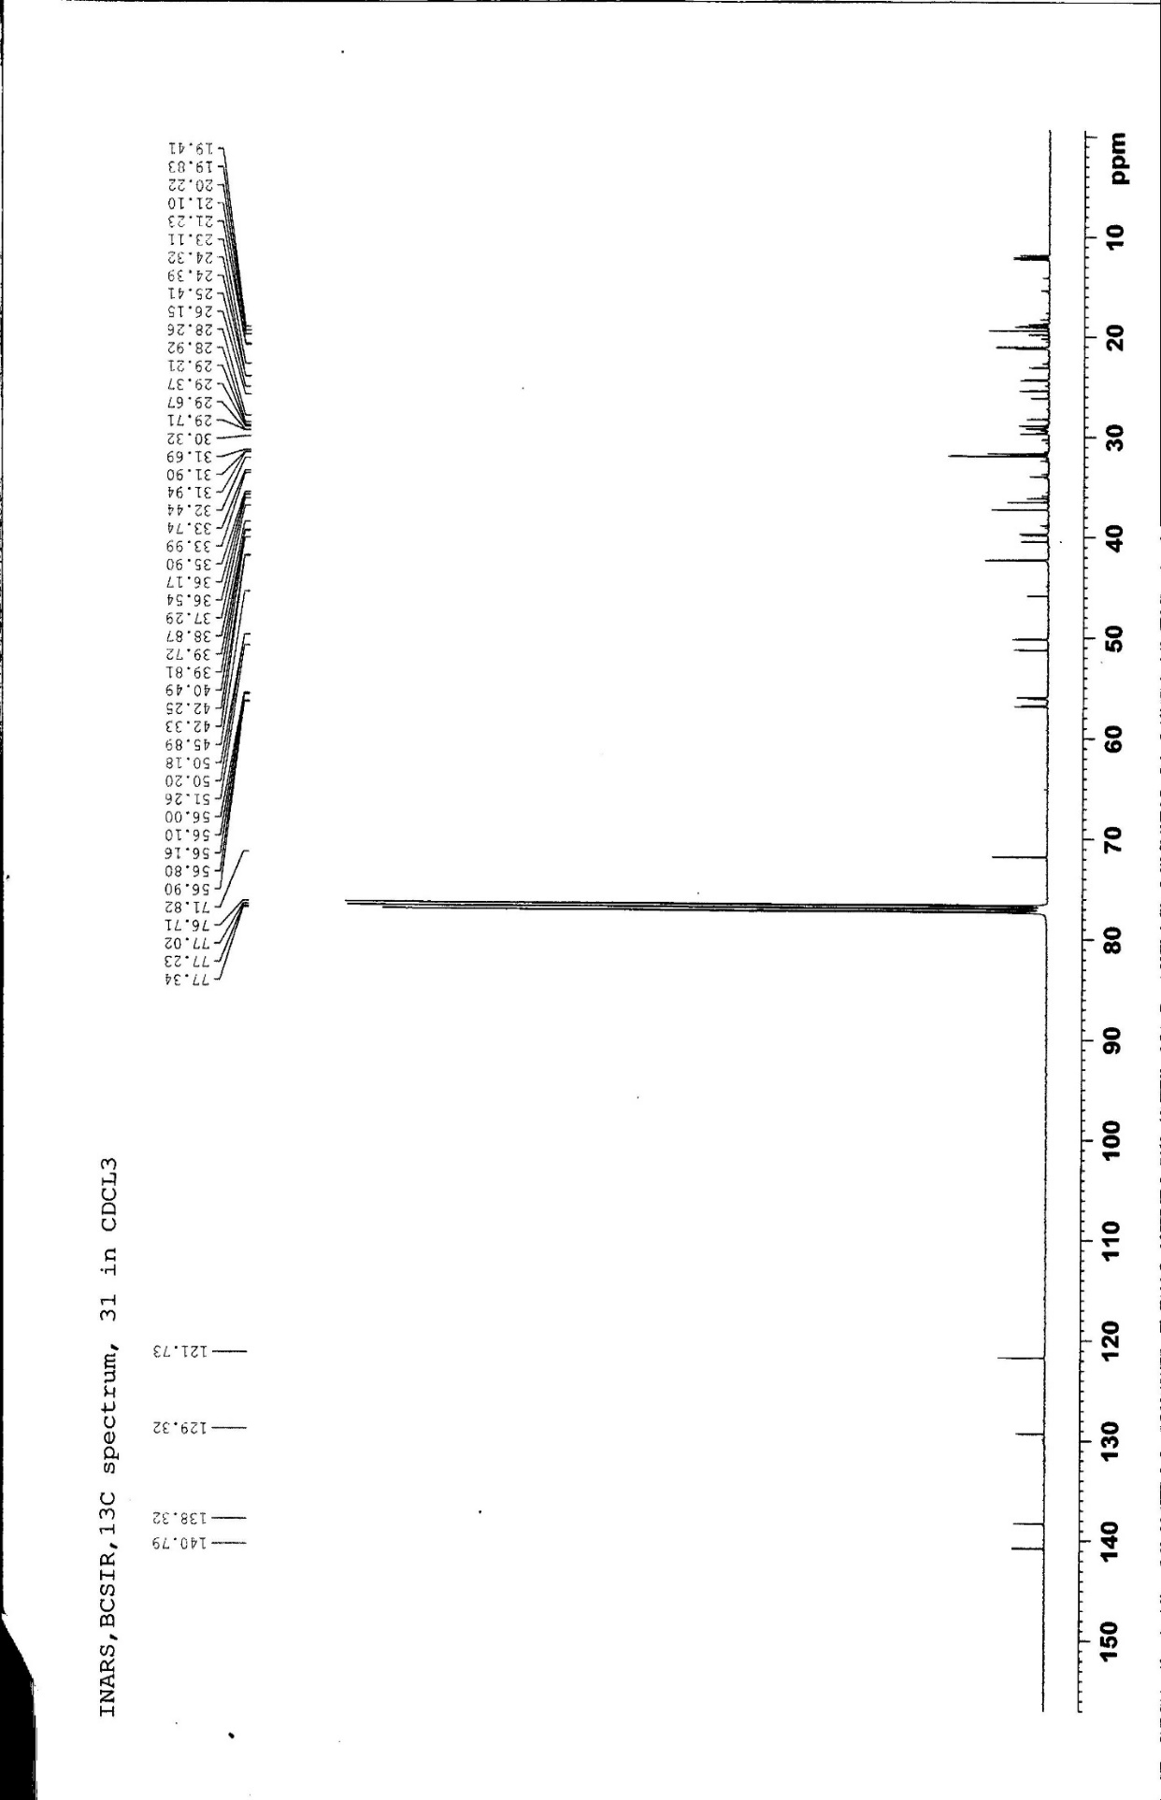

  - Figure 3.4.1: ¹H NMR spectrum (400 MHz) of compound 31 in CDCl₃

  - Figure 3.4.2: Partially Expanded ¹H NMR spectrum (400 MHz) of compound 31 in CDCl₃

  - Figure 3.4.3: Partially Expanded ¹H NMR spectrum (400 MHz) of compound 31 in CDCl₃

  - Figure 3.4.4: ¹³C NMR spectrum of compound 31 in CDCl₃

Characterization of compound compound 003 as Phytol (8)
Slightly impure compound 003 was obtained from column fraction of chloroform soluble partitionate of methanol extract of leaves of E. fusca which was purified by preparative TLC over silica gel F₂₅₄ using toluene and ethyl acetate (95:5) as a mobile phase. The compound showed purple spot on TLC plate when sprayed with 1% vanillin in sulfuric acid followed by heating for 5 minutes at 105-110ºC. It was found to be soluble in ethyl acetate, chloroform and chloroform.
The ¹H NMR spectrum (400 MHz, CDCl₃, Figures: 3.5.1-3.5.2 and Table-3.5) of compound 003 exhibited a doublet of two proton intensity at δ 4.17 (J = 6.8 Hz), which could be assigned to H-1. A broad triplet for one proton observed at δ 5.43, was attributed to the olefinic methine (=CH-). The triplet at δ 2.01 of two proton intensity was ascribed to H-4. A multiplet at δ 1.07 indicated the presence of two protons at H-7 and H-11. The proton attached to the terminal methyls at C-15 were observed as a multiplet at δ 1.66. A doublet at δ 0.89 for another six methyl protons was assigned to the positions at C-7 and C-11. In addition, doublet at δ 1.08 (J = 7.6 Hz) was ascribed to six methyl protons (H₃-16, H₃-17) attached to C-15. The above spectral features were comparable to those of phytol (Wailed et al., 2010) and therefore, compound 003 was characterized as a diterpene alcohol phytol.

Figure 3.5: Structure of phytol (8)
Table-3.5: ¹H NMR spectral data of compound 003 and phytol (Wailed et al., 2010) in CDCl₃
Position | δ_{H} in ppm in CDCl₃
 | 003 | phytol (Wailed et al., 2010)
 | δ in ppm, mult, J in Hz | δ in ppm, mult, J in Hz
H-1 | 4.17, d (J = 6.8 Hz) | 4.14, d (J = 6.8 Hz)
H-2 | 5.43, t (J = 6.8 Hz) | 5.40, t (J = 6.8 Hz)
H-4 | 2.01, t (J = 6.8 Hz) | 1.98, t (J = 7.0 Hz)
H-7 | 1.08, m | 1.07, m
H-11 | 1.08, m | 1.07, m
H-15 | 1.59, m | 1.66, m
Me-15 | 1.08, d (J = 7.6 Hz) | 0.87, d (J = 6.8 Hz)
Me-7, 11 | 0.89, d (J = 6.4 Hz) | 0.84, d (J = 6.8 Hz)
Me-3 | 1.59, s | 1.66, s
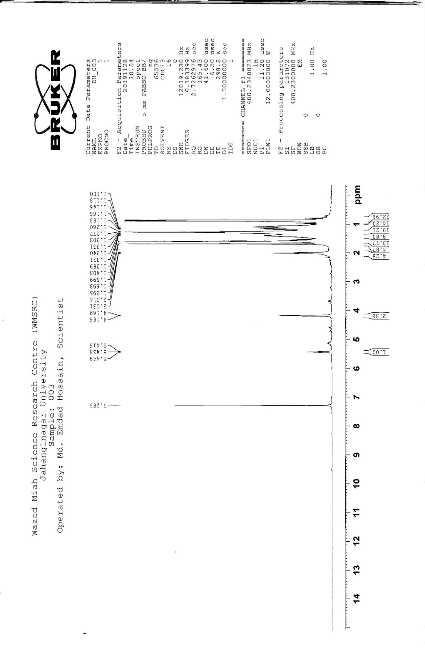

  - Figure 3.5.1: ¹H NMR spectrum (400 MHz) of compound 003 in CDCl₃

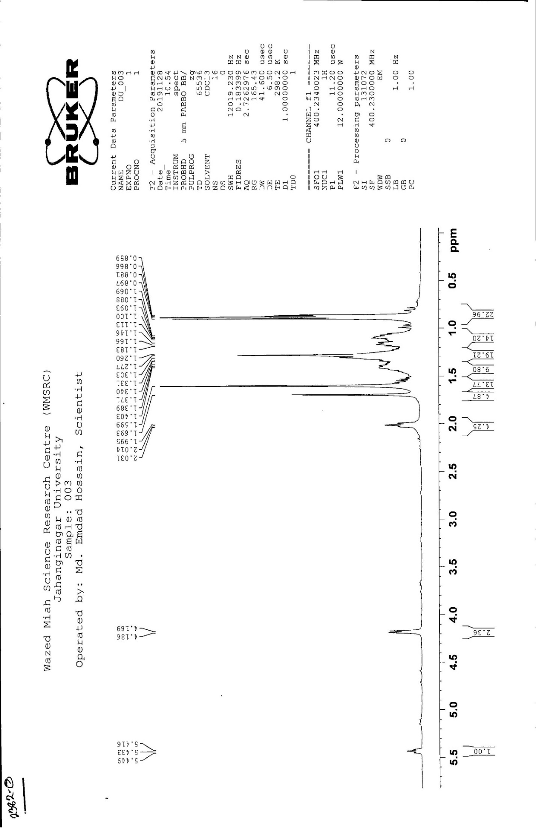

  - Figure 3.5.2: Partially Expanded ¹H NMR spectrum (400 MHz) of compound 003 in CDCl₃

