**Supplementary materials for “CliGAN: A structurally sensitive convolutional neural network model for statistical downscaling of precipitation from multi-model ensembles”**

Chiranjib Chaudhuri1* and Colin Robertson1

Wilfrid Laurier University, Department of Geography and Environmental Studies, Waterloo, Canada

Email: chiranjibchaudhuri@gmail.com

Keywords: Statistical downscaling, Generative Adversarial Network, Combination of Errors, Convolutional Neural Network, multi-scale structural similarity index, Wasserstein GAN

Figure S1: (a) Total Loss of training, (b) Content Loss, (c) Structural Loss, (d) Adversarial Loss, (e) Discriminator Loss, (f) Mean Absolute Error of the training.

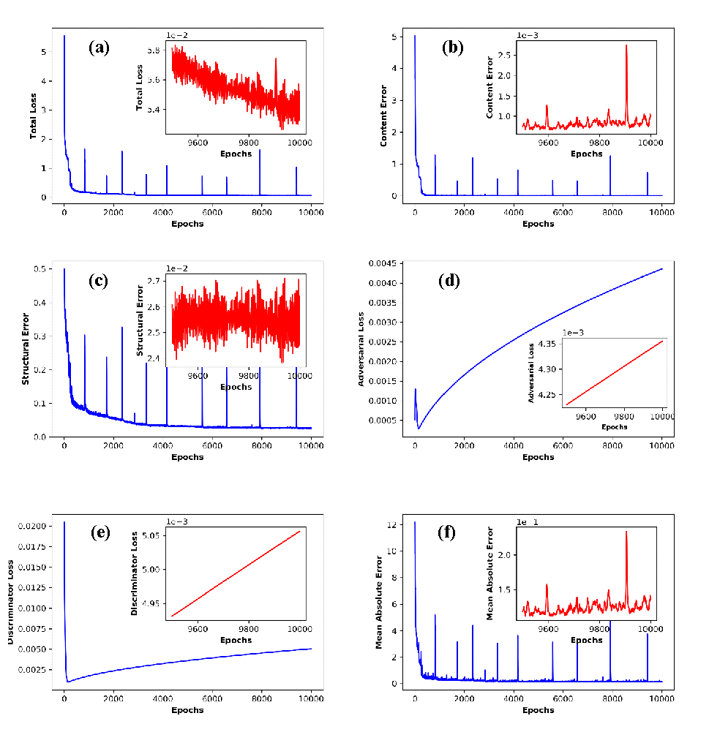

Figure S2: The eigen spectra of different GCMs (a) BCC ESM, (b) CAN ESM5, (c) CESM2, (d) CNRM CM6.1, (e) CNRM ESM2, (f) GFDL CM4, (g) HAD GEM3, (h) MRI, and (i) UK ESM1.



Figure S3: Eigen spectral of the observed rainfall

S3: Performance of PC-Neural Network for different number of hidden neurons

