Supplementary materials: Methods, Tables & Figures

Seasonal changes in size and mite-prevalence of a bee colony exposed to dinotefuran via pollen paste and damaged by Varroa mites

[Short title]
DF-exposed & mite-infested bee-colony

Toshiro Yamada
Graduate School of Natural Science & Technology, Kanazawa University, Kanazawa, Ishikawa, Japan
Email address: yamatoshikazu0501@yahoo.co.jp.

List of Supplementary Materials
Supplementary Method S1. Field experimental procedures.
Supplementary Method S2. Determination procedure of the numbers of adult bees and capped brood.
Supplementary Method S3. Criteria for determining mite-damaged bees and estimating the number of mite-damaged bees.
Supplementary Table S1. Summary of experimental conditions and results of four long-term field experiments in Shika, Japan.
Supplementary Table S2. Weather information & Experimental time.
Supplementary Table S3. Summary of observational results for control colonies (CR-1; CR-2; CR-3).
Supplementary Table S4. Summary of observational results for DF-exposed colonies (DF-1; DF-2; DF-3).
Supplementary Table S5. Summary of experimental note.
Supplementary Figure S1. The inside of the hive box is numbered clockwise from the face of the entrance.
Supplementary Figure S2. An example of numbered comb frame.
Supplementary Figure S3. Photo stand, two empty hive-boxes, experiment log and beekeeping tools.
Supplementary Figure S4. Overall view of experimental site.

Supplementary Method S1. Field experimental procedures.

STEP 1) To avoid being stung by a bee, dress firmly with protective measures, and conduct experiments. Further, the PP to be used, so as to be able to see what is administered to any bee colony, CR-1 (black) and DF-1 (red) or the like in magic ink it is described on a tray containing PP.
STEP 2) Experimental tools, recording paper, SS, trays with PP, camera, to prepare the empty hive-box or the like.
Step 3) Take a picture of the experiment site (entire hive-box) before the experiment (check whether abnormal conditions have occurred).
STEP 4) Count the number of dead bees in a large tray placed under the hive-box while picking up with tweezers. Throw away what you've finished counting out of the tray. It should be noted that the number of dead bees in the hive-box is counted during the internal inspection of the hive-box.
STEP 5) Take a picture of the front of the hive-box before the internal inspection (record and status record to make sure that the experiment target of the photography is not wrong) (Photo S1-1).
STEP 6) Open the hive-box and take the cloth that covered the top of the comb frame of the hive-box, and take a whole photograph of the top of the hive-box (Photo S1-2). In addition, gently return the bee attached to the cloth in the hive-box.
STEP 7) The tray with PP and the container with SS (tray, feeding frame) are taken out from the hive-box, measuring the remaining amounts of PP and SS by the upper dish balance. Incidentally, when taking out the container from the hive-box, gently return the bee attached to the container in the hive-box.
STEP 8) Gently remove the comb frame with the bee from the hive-box in the order of number (in order from left to right toward the front of the hive-box), take a picture of both sides of each comb frame (Photo S1-3). When you are taking a picture, if you find a queen bee, after taking a picture of the queen bee (Photo S1-4) put it in the queen cage and once isolate it. When the photograph of the comb frame is finished, put the comb frame in the empty hive-box prepared beforehand, and the lid of the hive-box is closed. The queen bee in the queen cage is placed at the top of comb frame placed in an empty hive-box.
STEP 9) After taking pictures of both sides of all the hive-frames with bees, take pictures of the four sides and the bottom in the hive-box in order to determine the number of adult bees left in the hive-box (Photo S1-5). If you can't find a queen bee when you're taking a picture of a comb frame, carefully check for the presence or absence of the queen bee, and if so, take a picture. If adult bees are outside the hive-box as well as inside the hive-box (sometimes near the entrance of the hive-box at tropical nights), take a picture to count the number (Photo S1-6).
STEP 10) If you cannot find the queen bee by all means, check the queen bee on all the comb frames carefully before taking a picture of capped brood of the next operation.
STEP 11) Take out the comb frame with bees that had been placed in the spare empty hive-box in the number order, return all the bees attached to the comb frame to the original hive-box. After taking pictures of both sides of the comb frame without bee in the order of the comb frame number Photo S1-7), the comb-frame is also returned to the original position of the original hive-box.
STEP 12) When taking a picture of the comb frame without bee, you may discover some abnormality, such as queen-cells, Varroa mites, wax-moth larvae and so on. In this case, keep taking pictures of them. These anomalies are not limited to this situation, and if found, record them in photographs as evidence (Photo S1-8).
STEP 13) If the queen bee is not found by all means, check in the next experiment. If it is not found next time, by the presence or absence of queen cages and by observing in detail the situation of spawning, etc., the presence or absence of a queen bee.is determined.
STEP 14) After covering the cloth on the top of comb frames, put new SS (800 g) and PP (300 g) in the corresponding hive-box, the measurement is ended with the lid of the hive-box.
STEP 15) After completion of the experiment, the test contents are confirmed and described in the research note.

Photo. S1-1. Front view of the hive-box (Example of CR-1).
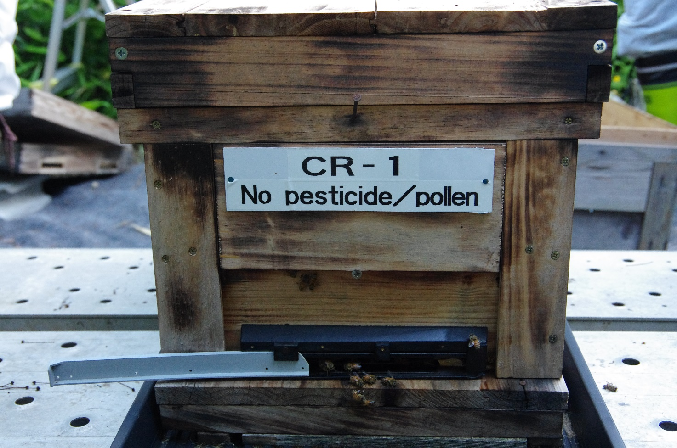

Photo. S1-2. Top photo of the hive-box (Example of DF-1).
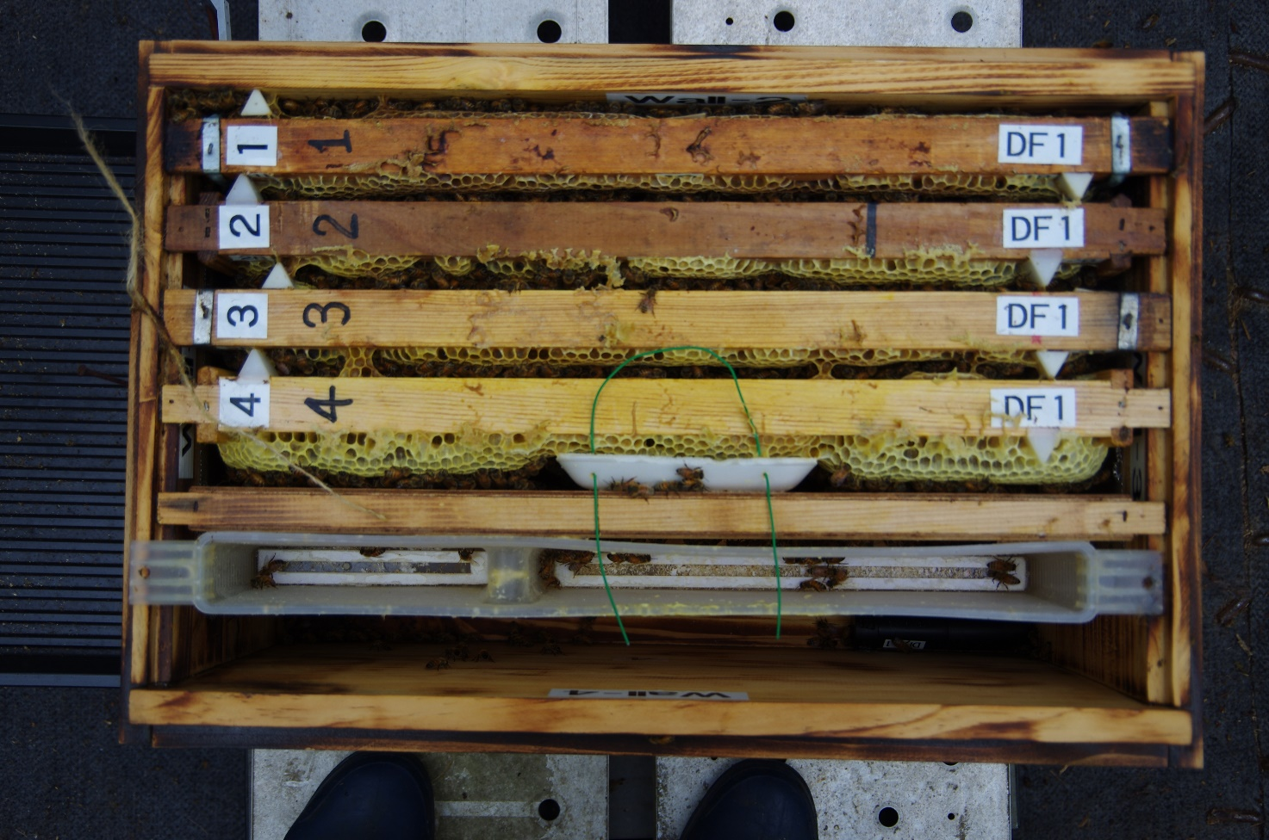
Comb frames
Front of hive-box
Sugar syrup
Pollen paste

Photo. S1-3. Comb-frame photo with bees (Example of 3F in CR-1).
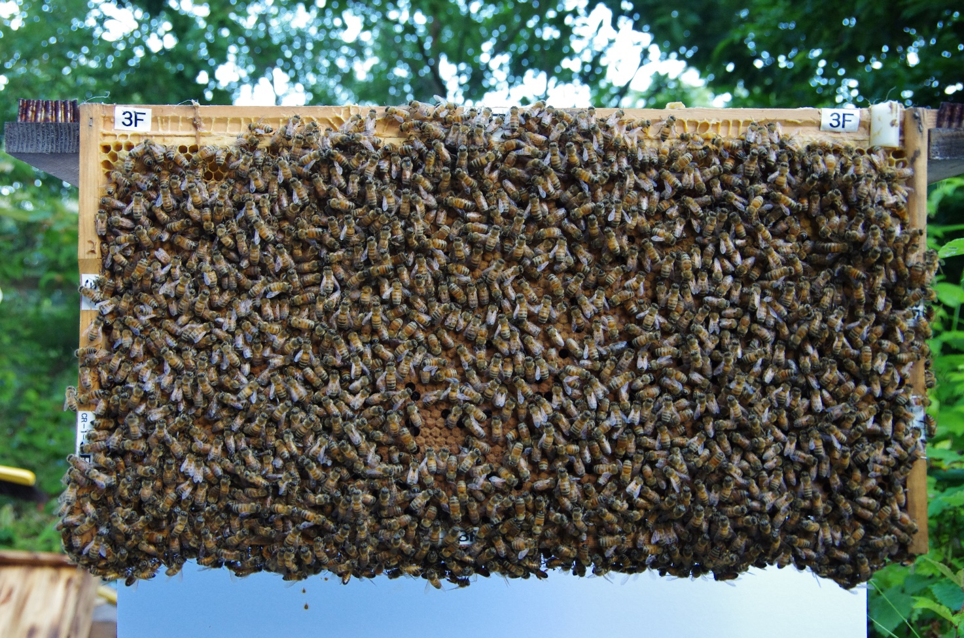

Photo. S1-4. Queen bee (Example in CR-1).
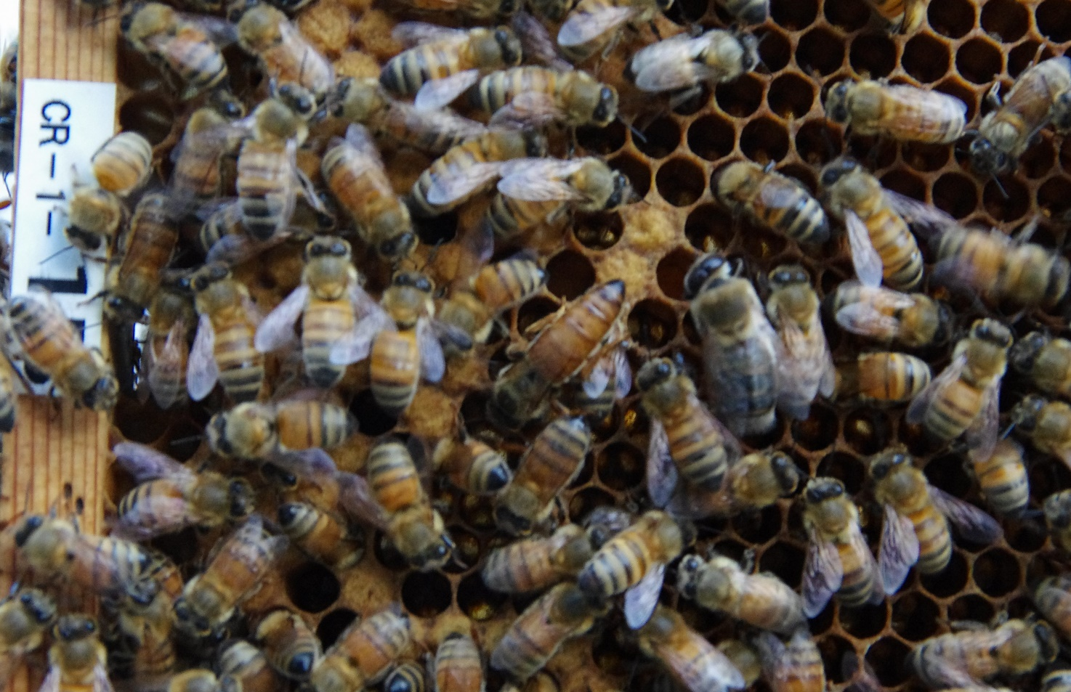

Photo. S1-5. The inside photos of the hive-box composing of four walls and bottom (Example of bottom).
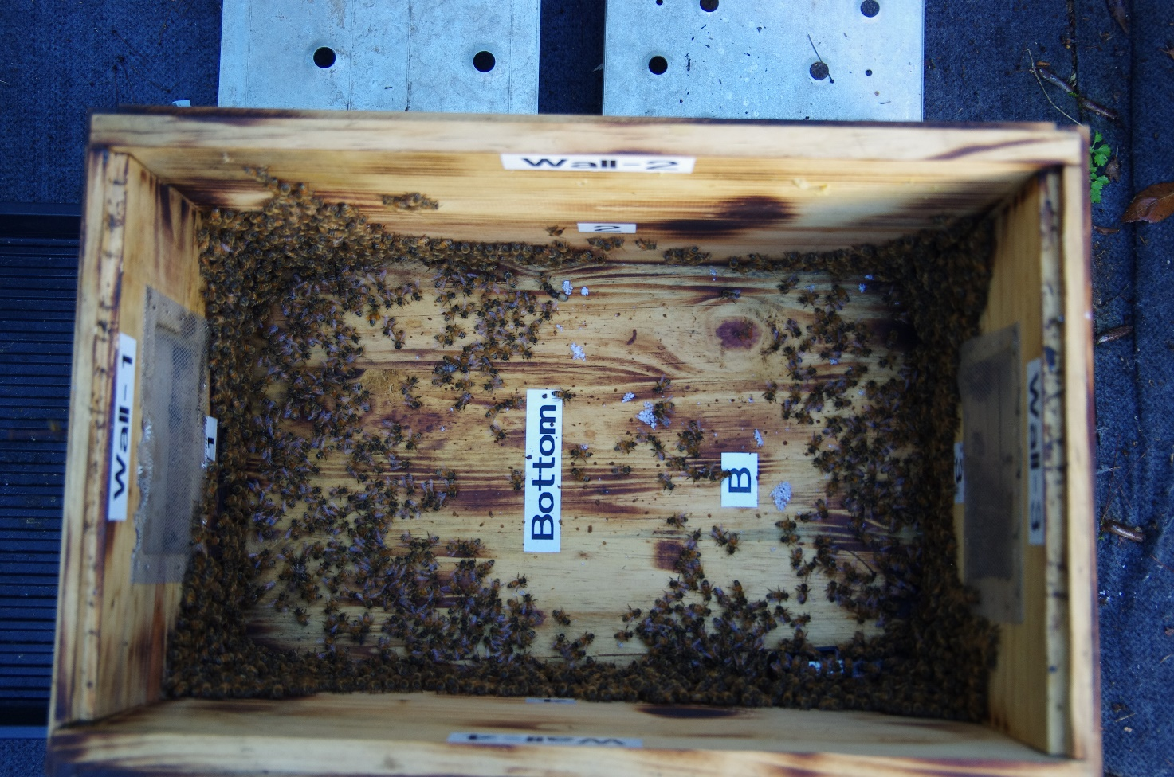
Wall-3
Wall-4
Wall-2
Wall-1
Front of hive-box
Photo. S1-6. Outside photo of the hive box with bees.
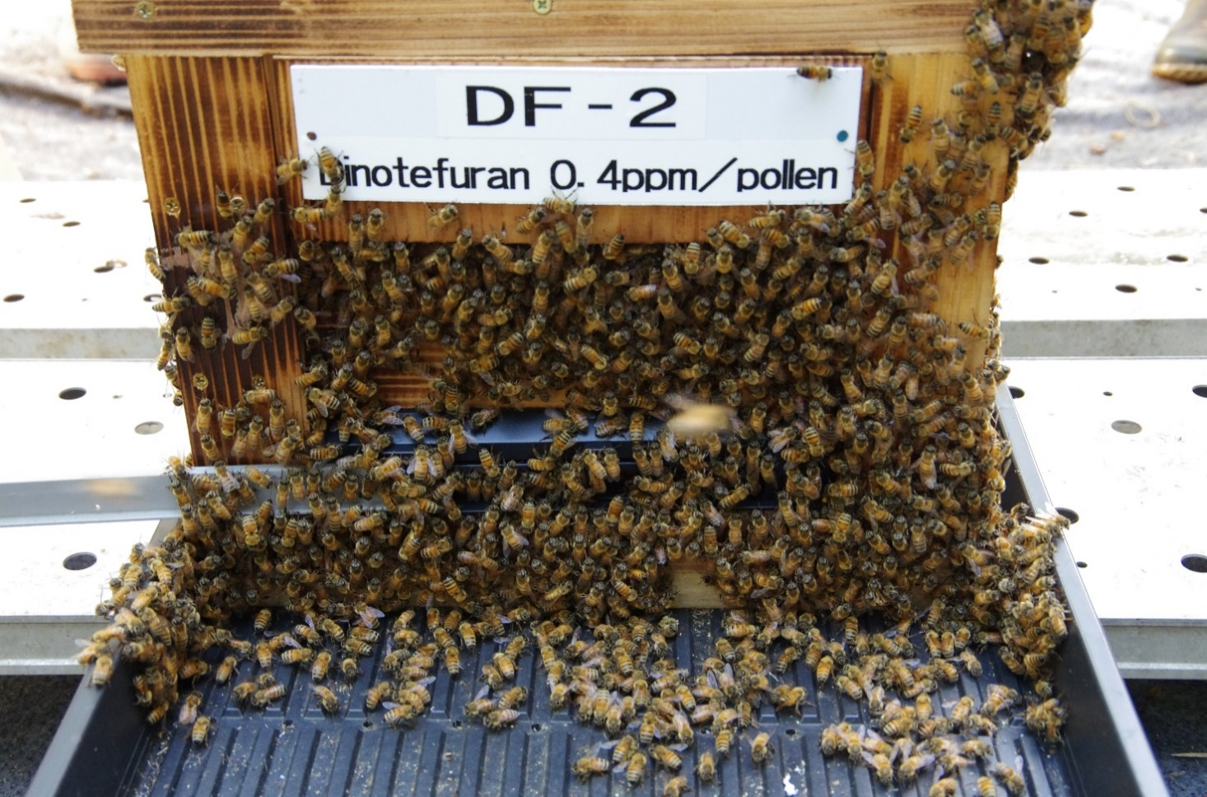

Photo.S1-7. Comb-frame photo without bees after removing bees from the comb (Example of 3F in CR-1).
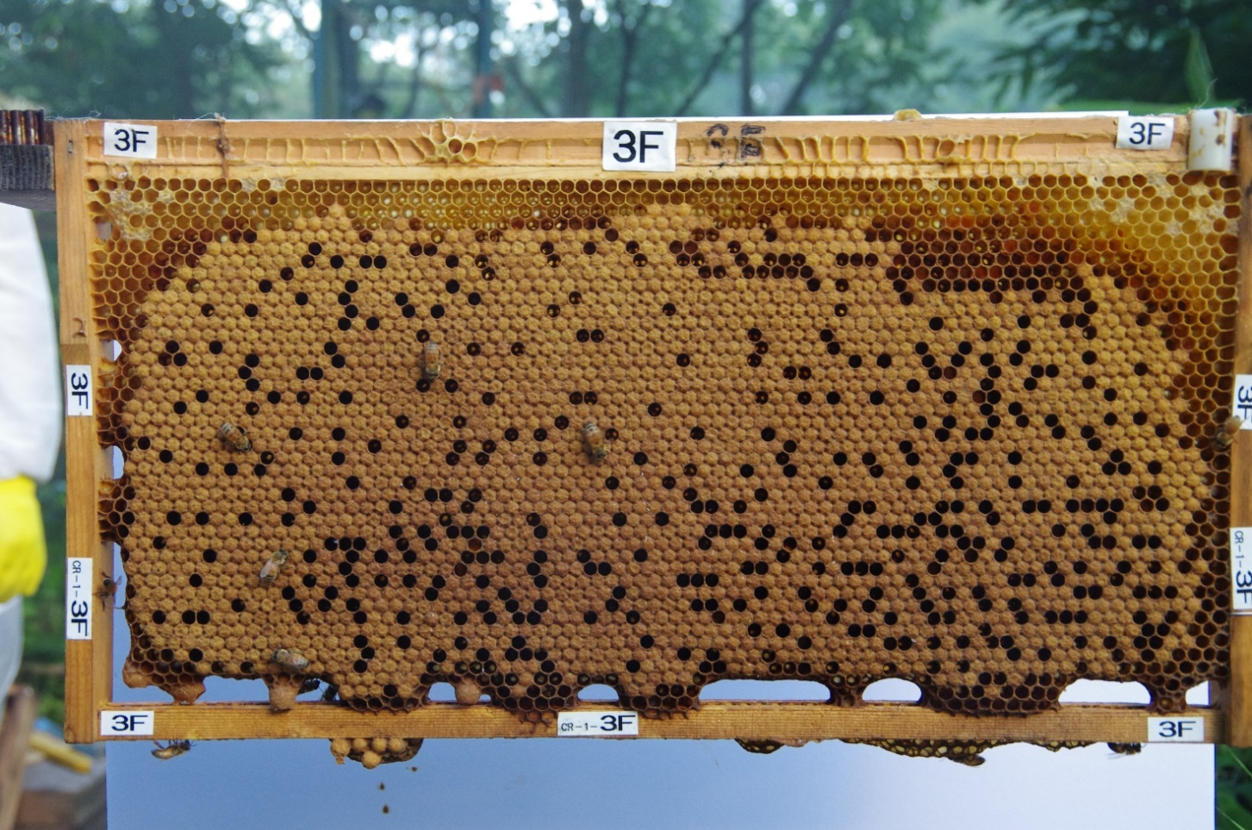
Photo. S1-8. Unusual situation discovery (Example of queen-cell & wax-worm in DF-1).
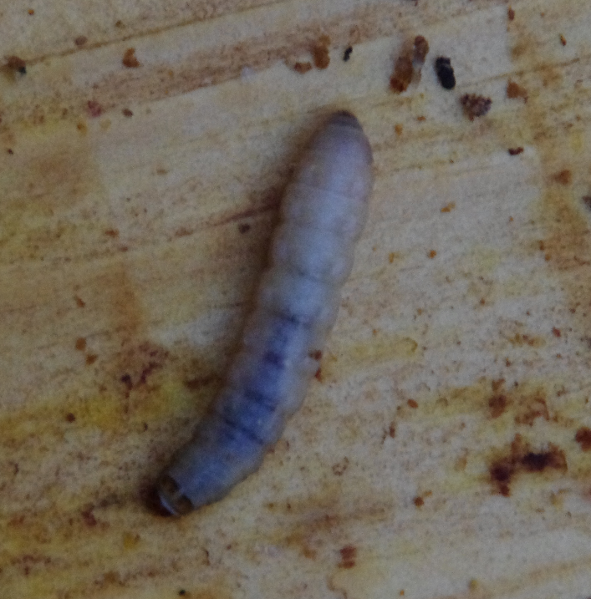
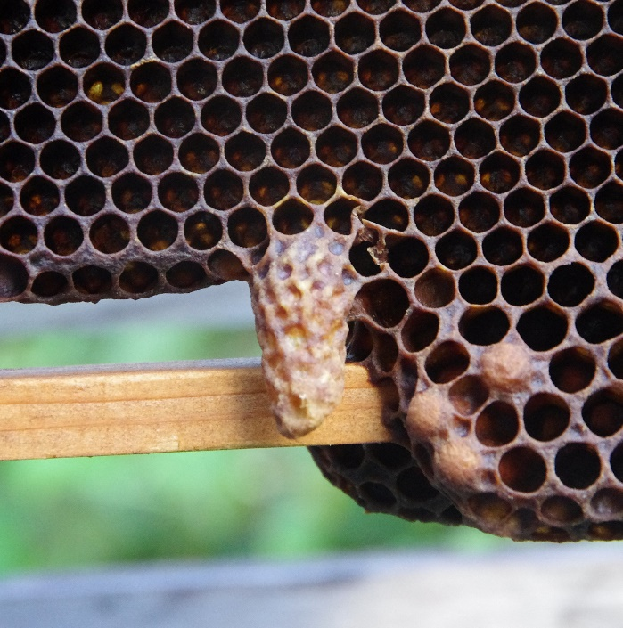

Supplementary Method S2. Determination procedure of the numbers of adult bees and capped brood.

STEP 1) The image of comb is binarized, and then the difference in brightness between the adult bee or the capped brood in the comb image and the place where there is no bee, and the features of the adult bee ad the capped brood are used to identify the bee and the capped brood. The identified adult bee or capped brood is counted.
STEP 2) In order to count as accurately as possible, before the binarization process of the image, divide the entire image into several areas that seem to have the same threshold value in each area (up to 4 areas) as below. Then, enter the optimal threshold for each divided area (the maximum number of divided areas 4, the split shape is optional). Examples of division: (1) Distinguish between the capped honey area and the capped brood area. (2) Distinguish between areas where there are few bees and areas where bees are dense. (3) Distinguish between different areas of contrast or lightness (e.g., the part where the light hits and the part of the shadow).
STEP 3) Enter the type of key to mark counted adult bees and capped brood one by one (+, *, numbers, etc.) and the color and size of key ((you can change them after the end of the count).
STEP 4) When the count is performed, while automatically marking those counted bee or capped brood in the image, continue counting, the number of counts at that time is displayed at the bottom of the image. After counting the adult bee or capped brood in the image in a short time, the total count in the image is displayed at the bottom of the image. The count status is visually determined, if dissatisfied, by changing the threshold value, recount. In a few tries, even if you change the threshold, if there is no improvement in the count situation, the count of approximate number by automatic measurement in the computer is assumed to have been completed.
STEP 5) After automatic counting by the computer, using the same software, switch to manual count operation, and then correct the count error at the time of automatic counting. Therefore, using a large screen monitor, while further enlarging the image, mark-mistakes of adult bees and capped brood during automatic counting (duplicate count, counting things that are not the object) and forgetting to mark (due to the overlap of bees, the blurred image, the extreme differences in light and dark, etc.) are corrected while visually checking, and all possible efforts are exerted to obtain the number of adult bees or the number of capped brood as accurate as possible (most important and serious work). It should be noted that, even when the software is manual counting, by the removal and grant of the mark, automatically change the number of bees or capped brood. You can resume this fix at any time. If it is determined that the correction is complete, it moves to the measurement of the next new image.
STEP 6) When posting the measured number of adult bees or capped brood in a separate table, call the measured image, check again in the enlarged image, after checking whether there is a count error (correct if you find a mistake), the number is posted to the separate table. The sum total of the numbers of adult bees on all combs and the numbers of adult bees on four walls and bottom in the hive-box, or the sum total of the numbers of capped brood of all combs, is the number of adult bees or the number of capped brood in a bee colony at a measurement day, respectively.

Supplementary Method S3. Criteria for determining mite-damaged bees and estimating the number of mite-damaged bees.

In this study, rather than a method of directly counting the number of Varroa mites in the bee colony, it is assumed that the number of bees damaged by mites is equivalent to the degree of the bee colony damage caused by mites. The number of mite-damaged bees on the enlarged photographic image of the comb with bees taken to measure the number of adult bees, using the software developed to count the numbers of adult bees and capped brood (see Table S2), is manually counted while referring to Figure 4 according to the following criteria.
In this method, it is not possible to directly evaluate the absolute number of mites in the bee colony, but it is possible to estimate indirectly the damage to the bee colony caused by mites. Additionally, since a photographic image for the measurement of the number of adult bees in a field experiment is used to evaluate the damage to the bee colony caused by Varroa mites, it is possible to re-measure the number of mite-damaged bees while checkig again and again whenever you need, and it is possible to improve the measurement accuracy. Further, using the photographic image for the past adult number measurement, it is also possible to measure the number of mite-damaged bees during past experiments.
Notes and criteria for determining whether the damaged bee by the Varroa mite using the captured image are shown below.
Female Varroa mites enter the comb-cell where the larva is just before capping the cell, lay the egg (all male mites) and the number of mites increases in the capped comb-cell. Not only the larvae, it is said to continue to cause damage to adult bees. However, it is impossible to count the number of mites in the capped comb-cell. Therefore, although indirect, there is a trace of mite-damage bees (the presence of mites can be confirmed, there are traces of swelling and inflammation that seem for the bee to have been bitten by mites, wings of the bee are deformed or fallen out, there is a missing mark of the mite on the bee), and the number of adult bees having the above traces can be regarded as an index to estimate the mite-damaged bee in the bee colony. The specific criteria for judgment are shown below.
It is suspected that the three-dimensional one attached to a bee, which is small and round (including the ellipse), is a mite in the color of the red-brown system (including the oval) and red-brown system (including the semi-transparent). A suspected mite are determined whether it is a mite based on the criteria below and Figure 4, while being examined from various angles, using an enlarged image. If a suspected mite cannot be determined by all means, it is considered a mite or a trace of the mite.
- What appears to be planar rather than three-dimensional in the vicinity of the neck is considered to be an innate pattern of a bee appearing when the bee bends its neck or a shadow of other bee wings, etc., and is not considered damage by mites.
- Small colors other than red-brown and black (especially whitish ones) are regarded as pollen.
- What the wings appear three-dimensional like wrinkles deformed is regarded as a shadow due to the shrinkage of the wings. However, the cause of the shrinkage of the wings is a large possibility of deformed wing virus mediated by Varroa mites. The state of the shrinkage of the wing is scrutinized on the image to determine whether the shrinkage is due to mites.
- If a bee with shrunk or missing wings has traces of a mite bite, it is considered a mite-damaged bee, even if it is not possible to confirm the presence of a mite.
- If you can't distinguish between mites and pollen or garbage, you should consider them mites. However, if it is clear that it is other than mites such as pollen and garbage, exclude it.
- Planar ones are usually determined to be not mites. However, after scrutiny, exceptionally, it may be considered a mite-damaged bee.
- Except for those that seem to be the rise of muscles, etc.
- The difference between a mite and garbage is judged by shape, color, surrounding situation, etc., and it counts unnatural things like mites (although it is subjective, counting the one like the mite)
- Traces bitten by mites (swelling by the bites) are also thought to be damage to bees.
- Regardless of what appears to be a mite or the number of traces bitten by mites, it is treated as a mite-damaged bee.
- Traces of a mite fallen out from a bee are treated as a mite-damaged bees.
Just before the larva’s cell is capped, the mites lay eggs in the food in the cell, since the eggs grow while sucking the body fluid of the larva hatched in the capped cell, it is almost impossible to find almost a mite even in the open cell. Therefore, it was decided not to evaluate the mites in the cells.
Mites are present in various places in the hive-box, shape is also easy to mistake for garbage and pollen, etc., also present in the invisible place (especially in the comb-cell), although the absolute number of mites is not known, this method to evaluate by the number of adult bees damaged by mites is believed to be a qualitative indicator of the number of presence of mites. Although the number of mites in the cell cannot be known, the infestation state of mites in the bee colony will be reflected in the number of mites adhering to the adult bee.
This method includes an uncertain element, under the above criteria, by measuring in the same person, and relative comparison of the number of mites between each bee colony, to some extent the time course of each bee group it is considered to represent. By the way, whenever a doubt occurs, again, using the image for the adult bee number measurement taken, recount.

Supplementary Table S1. Summary of experimental conditions and results of four long-term field experiments in Shika, Japan.

Supplementary Table S2. Weather information & Experimental time.

Date | Elapsed days | Weather | Temp. | Humidity | Experimental time |  | Remarks
Date | [day] | Weather | ℃ | % | from | until | Remarks
19-Jun-18 | 0 | fine | 24 | 65 | 6:00 | 8:30 | Start of experiment
1-Jul-18 | 12 | fine |  |  | 5:35 | 8:00 | Start of pesticide administration
16-Jul-18 | 27 | fine | 25 | 76 | 5:30 | 7:50
28-Jul-18 | 39 | cloudy | 23 | 71 | 5:30 | 7:40
12-Aug-18 | 54 | fine | 22 | 73 | 5:30 | 7:31
28-Aug-18 | 70 | cloudy→ rainy | 25 | 83 | 5:30 | 7:40
11-Sep-18 | 84 | fine | 19 | 93 | 5:30 | 7:30
23-Sep-18 | 96 | fine | 16 | 79 | 5:30 | 7:30
6-Oct-18 | 109 | fine | 20 | 84 | 6:00 | 7:50
23-Oct-18 | 126 | fine | 10 | 79 | 6:00 | 7:40 | DF-3 became extinct.
4-Nov-18 | 138 | fine | 9 | 87 | 6:15 | 7:50
18-Nov-18 | 152 | fine | 5 | 82 | 6:30 | 8:00
2-Dec-18 | 166 | fine | -0.2 | 75 | 6:45 | 7:50 | CR-2, CR-3, DF-1 and DF-2 became extinct.
16-Dec-18 | 180 | fine | -1 | 77 | 8:00 | 8:15 | DF-1 became extinct. Finish of experiment

Supplementary Table S3. Summary of observational results for control colonies (CR-1; CR-2; CR-3).

Supplementary Table S4. Summary of observational results for DF-exposed colonies (DF-1; DF-2; DF-3).

Supplementary Table S5. Summary of experimental note.
“Prep.” and “Obs.” are abbreviations for preparation and observation, respectively. Bold sentences are the notable points.
Supplementary Figure S1. The inside of the hive box is numbered clockwise from the face of the entrance.
In order to record the state of the inside of the hive-box in the photograph, the wall number clockwise from the entrance is attached to the wall of the inside of the hive-box, and the bottom of the nest box is also specified. The temperature and humidity data logger “EasyLog/El-USB-2” was placed inside CR-1, CR-3, DF-1, DF-3 and under the DF-2 hive-box (in the tray) to achieve the outside (ambient) temperature near the hive-box.

Data logger
FRONT : Wall-1e

Wall-4
Wall-2
Wall-3e

Supplementary Figure S2. An example of numbered comb frame.
Information identifying the comb frame in the hive-box is clearly stated on the comb frame. This photo image will be described as an example. "3F" identifies the position and surface of the nest monument frame in the hive-box, in this example, it shows the left side of the third comb frame from the left toward the front of the hive-box. "CR-1" of "CR-1-3F" shows the control group of CR-1, and "3F", as described above, represents the position of the comb frame in the hive-box.

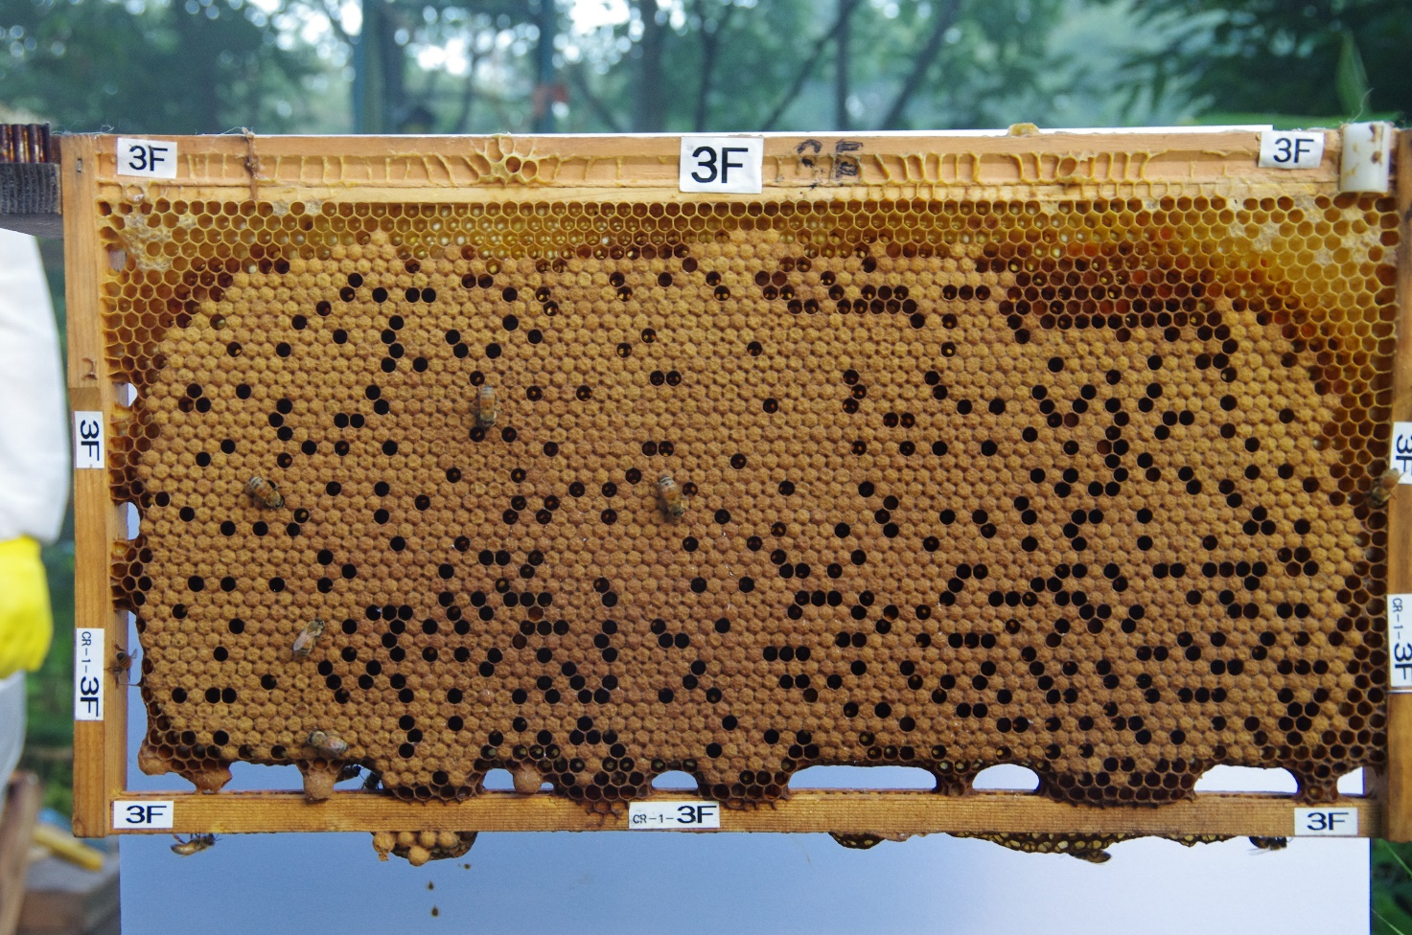

Supplementary Figure S3. Photo stand, two empty hive-boxes, experiment log and beekeeping tools.
In order to prevent vibration to the bee at the time of photography, and to keep the comb frame calm, I made my own photo stand. The comb frame with the bee is pulled out from the hive-box, and after taking the photograph of both sides of the comb frame, once, in order to store the comb frame with the bee, two empty hive-boxes are prepared in advance.

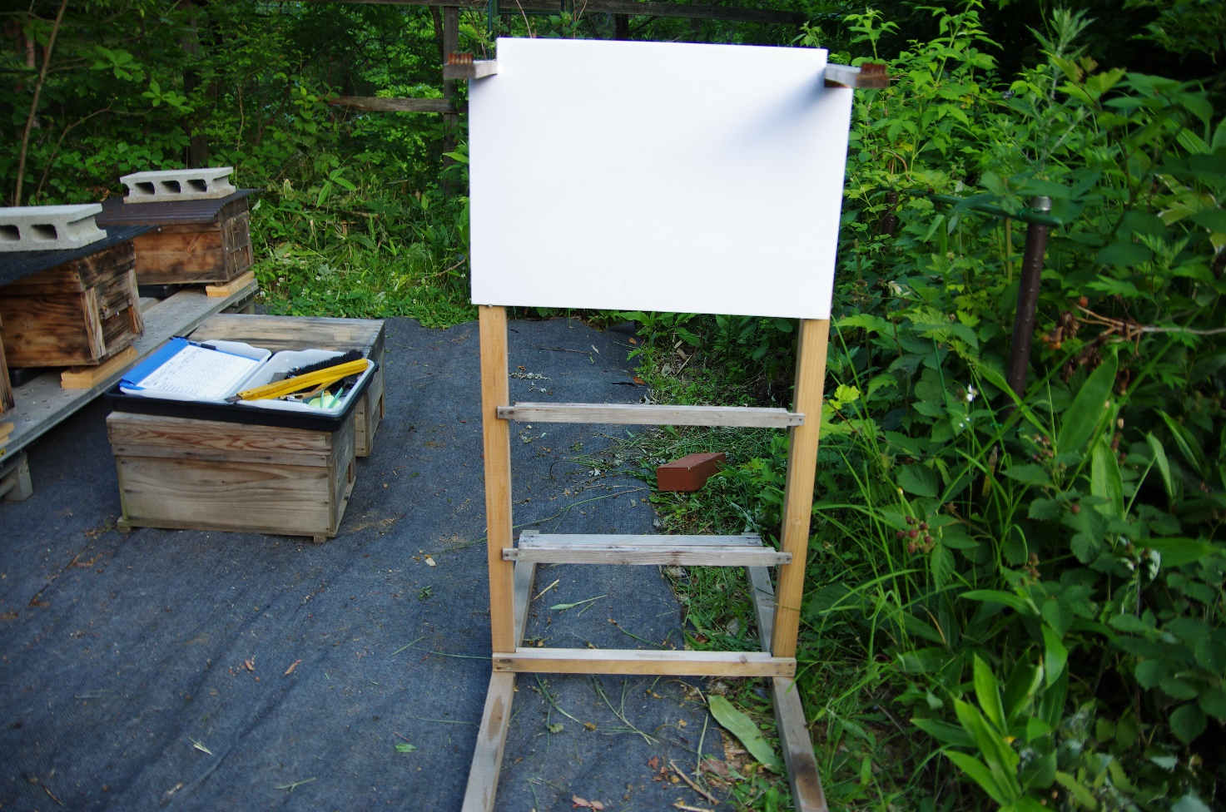
Experiment log Beekeeping tool

Empty hive-box
Photo stand

Supplementary Figure S4. Overall view of experimental site.
Each hive-box was arranged in the order of CR-1, DF-1, CR-2, DF-2, CR-3 and DF-3 from west to east every 80 cm, with the entrance facing south. Incidentally, CR-1, CR-2 and CR-3 are the control (pesticide-free) colonies and DF-1, DF-2 and DF-3 are the dinotefuran-exposed colonies where 0.4 ppm of dinotefuran are administered via pollen paste.

