SUPPLEMENT 1
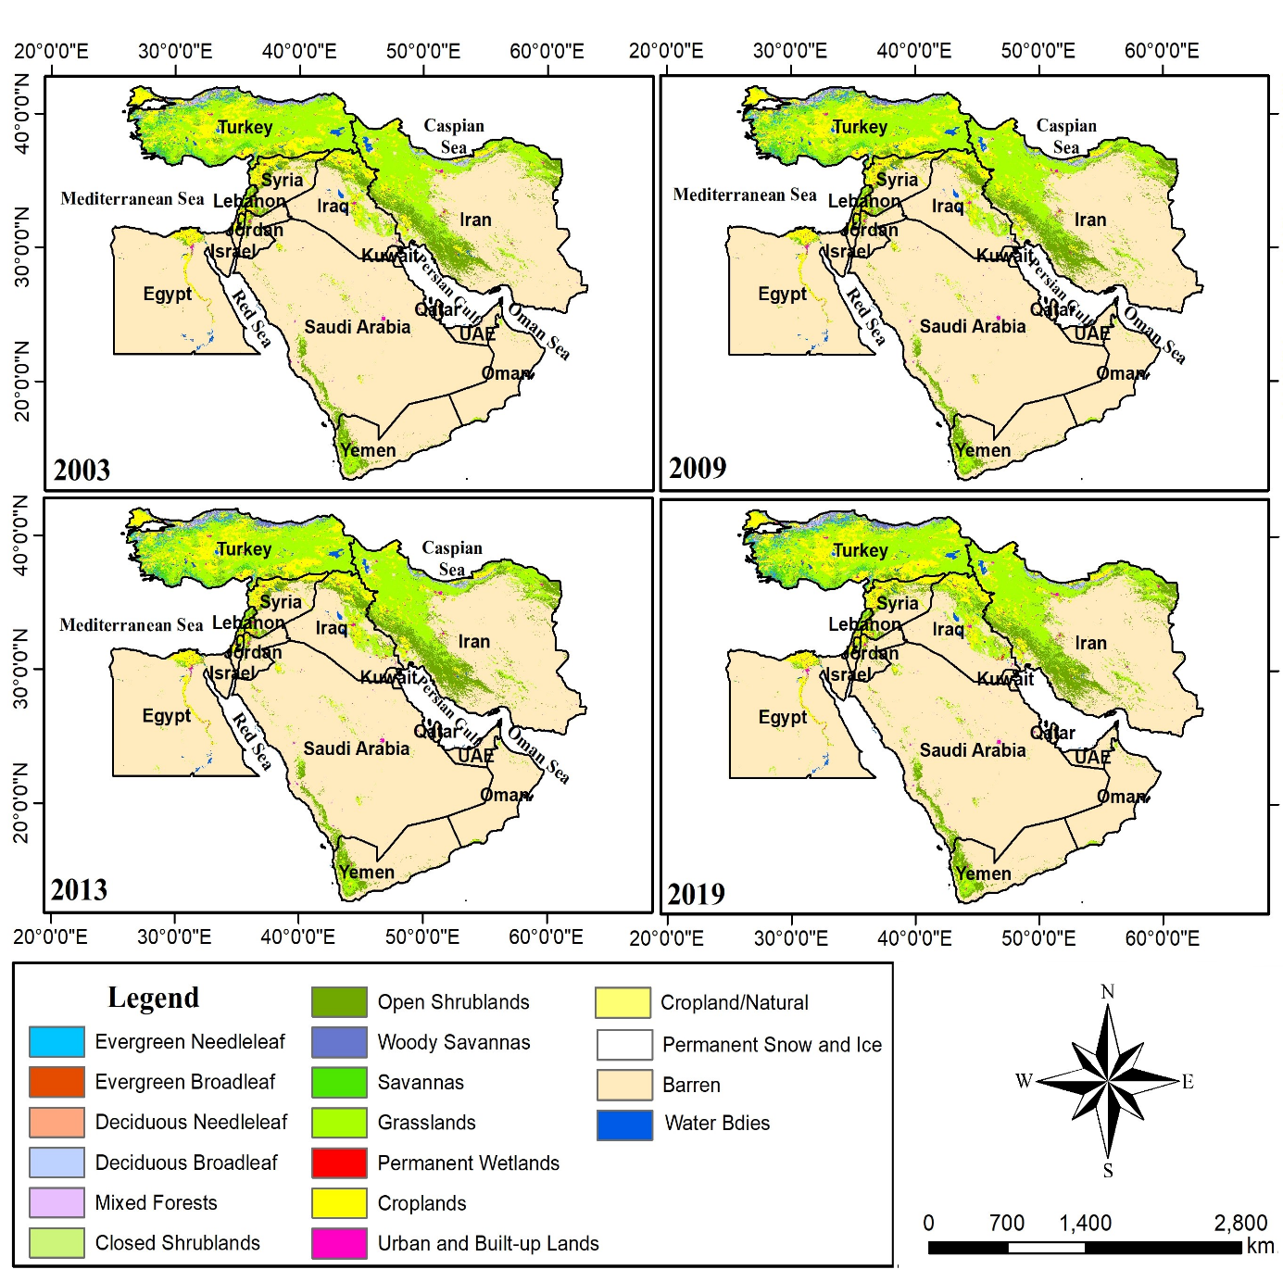
Figure S1. Maps presenting the land cover types from MODIS (MCD12Q1) images for 2003, 2009, 2013, and 2019.

