Supplementary Materials

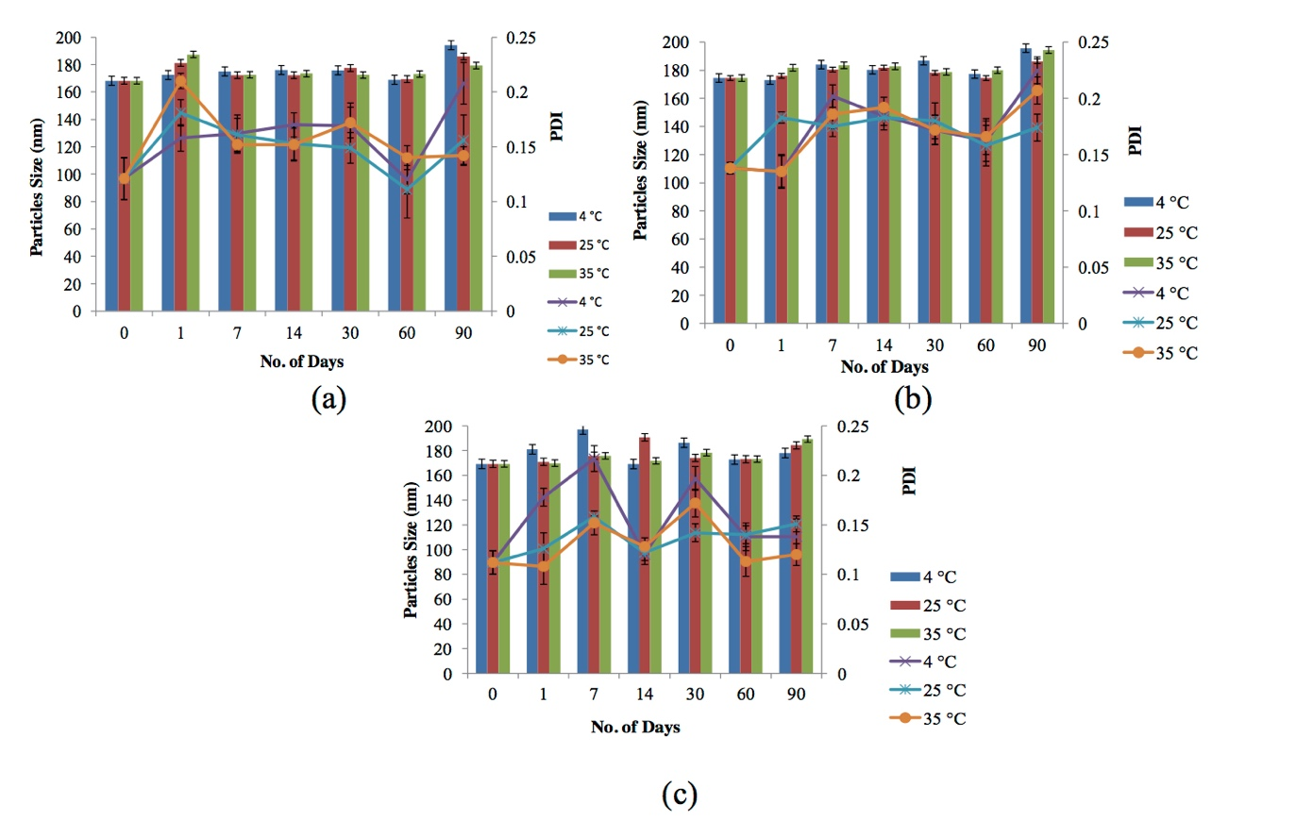
Figure S1: Particle size and PDI values of P(3HB-co-4HB) nanoparticles stored at different temperature for 90 days: (a) PHB16; (b) PHB30 and (c) PHB70.

