Supplementary Information
Activated Graphene Oxide-Calcium Alginate Beads for Adsorption of Methylene Blue and Pharmaceuticals

Authors: Burcu Gunesª, Yannick Jaquet^{b}, Laura Sánchez^{c}, Rebecca Pumarino ^{c}, Declan McGladeª, Brid Quiltyª, Anne Morrissey^{d}, Zahra Gholamvandª, Kieran Nolan^{e}, Jenny Lawlerª
ª School of Biotechnology and DCU Water Institute, Dublin City University, Glasnevin, Dublin 9, Ireland.
^{b} School of Biotechnology , Dublin City University and University of Applied Sciences and Arts Western Switzerland, Glasnevin, Dublin 9, Ireland.
^{c} School of Biotechnology, Dublin City University and University of Oviedo, Glasnevin, Dublin 9, Ireland.
^{d} School of Mechanical and Manufacturing Engineering and DCU Water Institute, Dublin City University, Glasnevin, Dublin 9, Ireland.
^{e} School of Chemical Sciences and DCU Water Institute, Dublin City University, Glasnevin, Dublin 9, Ireland.

**Corresponding Author: jenny.lawler@dcu.ie Tel: +3531 700 5787

Table of Contents
S.1 Structures of Analytes
S.2 Preparation of GO and Ca-Alg2/GO Beads
S.3 Dry and wet images of Ca-Alg2 and Ca-Alg2/GO Beads
S.4 FTIR GO and Ca-ALg2, Ca-Alg2/GO beads
S.5 XRD and Raman spectrum of GO
S.6 pKa values for pollutants and adsorbents, Henderson-Hasselbach equation.

S.1
Structure of Analytes

S.2
Preparation of GO
Graphite flakes were microwaved in small portions in a glass beaker in a 700 W microwave (modified, vented) on maximum power three times for 10 seconds each time to produce expanded graphite. 2 g of expanded graphite, 10 g of dried potassium permanganate and 250 mL of H₂SO₄ were added to a 2 L round bottomed flask, and stirred overnight at room temperature (RT). After that 500 mL of deionized (DI) water was added into the flask maintaining the temperature below 80 ºC using an ice bath.
100 mL of H₂O₂ was added slowly to the mixture (colour change to golden brown), after that the mixture was stirred for 30 minutes and the resulting particles were washed with 750 mL of 10% HCl solution and centrifuged three times. To remove any residual traces of preparatory chemicals, the obtained GO was resuspended in 750 mL of DI water and centrifuged three times, and the washed GO was resuspended in 50 mL of DI water to achieve a thick paste. To establish the concentration, 1 g of GO suspension was spread in a dried, weighed beaker, dried overnight at 60ºC and weighed again, and the concentration was then adjusted to 1% GO in DI water on a dry mass basis.

Preparation of Ca-Alg2/GO Beads
Na-Alg/GO solutions were prepared by weighing 5, 10 or 20 g of 1% w/w GO concentrate into a conical flask, then 50 mL of DI water were added to the flask. The suspension was ultrasonicated for 20 minutes to ensure good dispersion of GO, and was then added to 250 mL of a 2% w/w Na-Alg solution and stirred until a homogenous mixture was obtained.
Ca-Alg₂ beads were prepared using the Na-Alg solution without GO by using a syringe pump with a flow rate of 20 mL min⁻¹ and two 10 mL syringes with a 1 mm needle. The solution was dropped into an aqueous coagulation bath of CaCl₂ 6% w/v, the bath was continuously agitated with a magnetic stirrer in order to prevent beads agglomeration. The beads were left 24 hours without agitation to achieve a complete formation of Ca-Alg₂ gel beads, beads were collected and washed three times with 500 mL of DI water. The same procedure was used to prepare Ca-Alg₂/GO5, Ca-Alg₂/GO10, Ca-Alg₂/GO20 beads. Activated beads were then dried in at 60ºC over 2 days in order to reach a constant weight. The beads were stored in plastic vials at room temperature.
S.3
Images of Ca-Alg/GO dried beads (average diameter 0.46 ± 0.02 cm) and Ca-Alg dried beads.

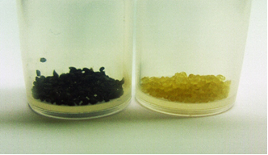

Images of (a) Ca-Alg wet gel beads and (b) Ca-Alg/GO wet gel beads. The scale bar = 0.5 cm.

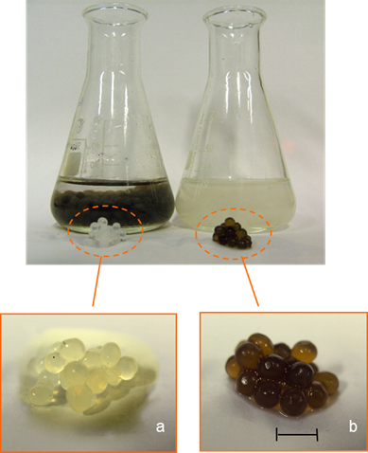

S.4
GO FTIR spectrum of GO sheets used in the preparation of alginate beads.
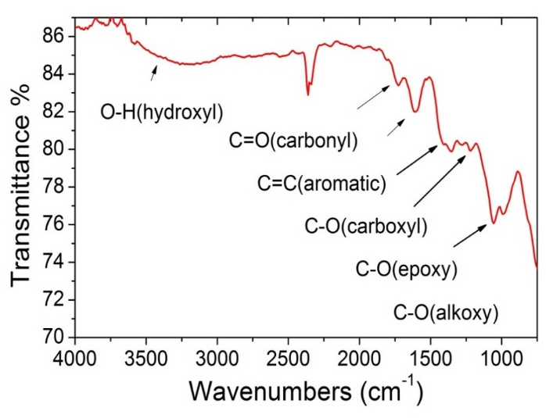

FTIR spectrum of Ca-Alg2 and Ca-Alg2/GO beads
S.5
XRD pattern of GO used in the preparation of the alginate beads.
It can be seen that as-prepared GO shows a distinct peak at 10° attributed to the (002) plane and corresponding to a layer-to-layer distance (d-spacing) of about 0.82 nm. The crystallite size of graphene oxide sheets is about 7.5nm based on the calculations from the half width at maximum (HWFM) of the X-raydiffraction peak using the Scherrer’s equation.

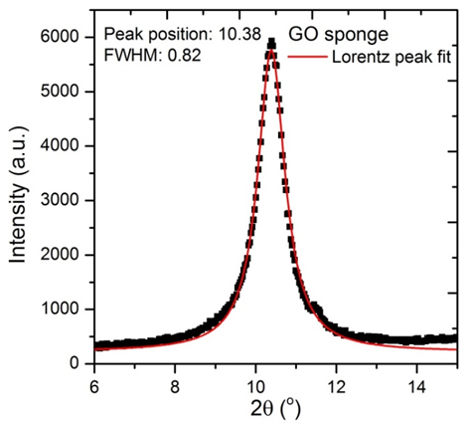

Raman Spectrum of GO used in the preparation of the alginate beads
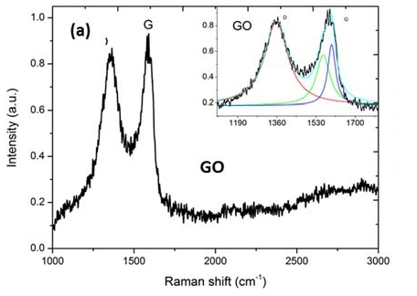
GO displayed a strong D band at 1357 cm⁻¹
Raman spectra can be deconvoluted (inset spectrum) to three Lorentzian peaks (with adj. R-Squared ≥ 92 %)
D/IG is 1.27 for GO

S.6
pKa values for pollutants and adsorbents, Henderson-Hasselbach equation.
Reported pKa values from the literature
Alginate¹ |  | Graphene Oxide² |  |  | Famotidine³ | Diclofenac⁴
pK_{a}=3.38 | pK_{a}=3.65 | pK_{a} = 4.3 | pK_{a} = 6.6 | pK_{a} = 9.8 | pK_{a}=6.98 | pK_{a} = 4.15

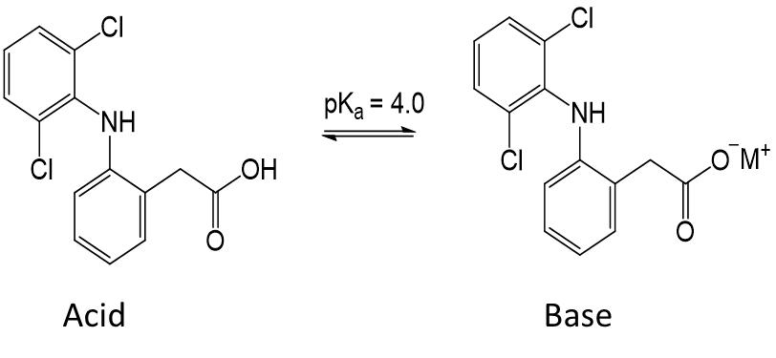
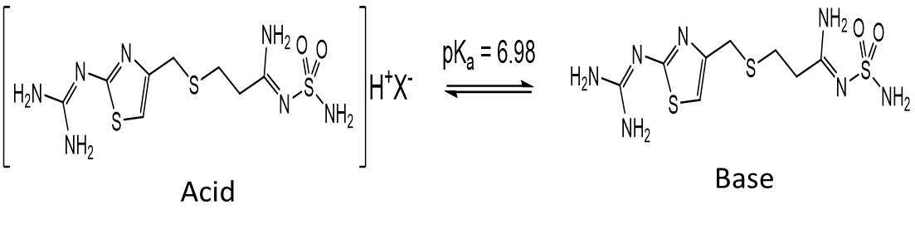
Henderson Hasselbach Equation:
pH = pKa + log [acid] / [base]
Example of [acid]/[base] ratio for Diclofenac at various pH values
pH of solution | pH = 2 | pH = 3.5 | pH = 5 | pH = 7
Acid/base | 100/1 | 3.16:1 | 0.1:1 | 0.001:1

References:
- Nicola L. Francis Philipp M. Hunger Amalie E. Donius Benjamin W. Riblett Antonios Zavaliangos Ulrike G. K. Wegst Margaret A. WheatleyN, “An Ice-templated, Linearly Aligned Chitosan-alginate Scaffold for Neural Tissue Engineering,” Journal of Biomedical Materials Research Part A, 2012, vol. 101, no. 12, pp. 3493–3503, 2013.
- M. S. Islam, and M. M. NARURKAR, Solubility, Stability and Ionization Behaviour of Famotidine, Journal of Pharmacy and Pharmacology: An International Journal of Pharmaceutical Science, Volume 45 (8) – Aug 1, 1993, 682-686.
- Bharathi Konkena and Sukumaran Vasudevan, Understanding Aqueous Dispersibility of Graphene Oxide and Reduced Graphene Oxide through pKa Measurements, Journal of Physical Chemistry Letters, 2012, 3, 867−872
- https://www.drugbank.ca/drugs/DB00586

