Appendix 1

To generate distribution maps and climate data for summer-breeding monarchs, we downloaded monarch occurrence records from the Global Biodiversity Information Facility (GBIF) (dataset ID: doi.org/10.15468/dl.jx7wck). We then filtered these data to include only records from the United States and Canada during July and August, which coincides with the peak of the monarch’s summer breeding period. Summertime records of monarchs in locations known to support year-round breeding populations (e.g. South Florida, coastal Georgia and the Carolinas, areas along the Gulf Coast, and southern California) were excluded from analyses. The map in Figure 1A was created using the ggmap package (Kahle and Wickham 2013)
We separated monarchs into eastern versus western North America based on their location relative to the continental divide. This left us with 19,286 eastern and 1,266 western records from July and August. We then used the coordinates listed in the GBIF database to pull data on 30 year July-August temperatures (1988-2018) from the PRISM database (PRISM Climate Group) using the prism package v0.0.6 (Hart and Bell 2015), as well as Bioclim data from the WorldClim v2.1 database (Fick and Hijmans 2017) using the raster package v3.1-5 (Hijmans 2020). PRISM data was generated at 4 km resolution, while WorldClim data was generated at 2.5 minute resolution. Because PRISM only includes data from the continental United States, we also downloaded 1981-2010 climate normals for all Canadian provinces with monarch occurrence records (Environment and Climate Change Canada). Canadian monarch occurrences were matched to climate records for the nearest recording station using the distm function in the geosphere package v1.5-10 (Hijmans 2019). For summertime temperature records, we averaged July and August daytime high temperatures and used this value as our index of the thermal environment experienced by adult monarchs (see Figure 2A). For summertime precipitation, we used BIO18 (precipitation during the warmest quarter) for each monarch occurrence record and used this value as our index of summertime precipitation (see Figure 2B).
These metrics are not meant to be fully representative of conditions experienced by monarchs and are instead rough approximations of temperature and precipitation conditions in locations where adult monarchs have been recorded during July-August. Among the caveats in our analysis are that (1) adult monarchs are highly mobile, and so the location where they are observed may not accurately describe the conditions that they experience over their lifetime; (2) occurrence records were not spatially thinned, and so areas with higher human population density (and hence higher observation probabilities) are weighed disproportionately; (3) our climate metrics reflect seasonal or quarterly averages, rather than conditions experienced on the day of collection. Still, in spite of these caveats, we feel that the metrics used and shown in Figure 2 are broadly representative of summertime conditions experienced by eastern and western monarchs.

References

- Environment and Climate Change Canada: Canadian Climate Normals 1981-2010. https://climate.weather.gc.ca/climate_normals/. Accessed July 2019.
- Fick, S.E. & Hijmans, R.J. (2017). WorldClim 2: new 1‐km spatial resolution climate surfaces for global land areas. Int. J. Climatol., 37, 4302–4315.
- Global Biodiversity Information Facility (GBIF). Dataset ID: doi.org/10.15468/dl.jx7wck. Created July 1, 2019.
- Hijmans, R.J. (2019). geosphere: Spherical Trigonometry. R package version 1.5-10.
https://CRAN.R-project.org/package=geosphere
- Hijmans, R.J. (2020). raster: Geographic Data Analysis and Modeling. R package version
3.1-5. https://CRAN.R-project.org/package=raster
- PRISM Climate Group: 30-Year Normals, Mean Temperature. Oregon State University, http://prism.oregonstate.edu, Accessed July 2019.

Appendix 2

To compare overwintering eastern and western populations, we used data from WWF Mexico (eastern) and Schultz et al. (2017) and the Xerces Society Thanksgiving monarch count (western). Eastern overwintering numbers are displayed as hectares occupied, with each hectare corresponding to approximately 21-28 million adults monarchs (Thogmartin et al. 2017a). We used simple linear regression to test for a correlation between eastern and western overwintering numbers within a given year and found only a weak positive correlation (R² = 0.02, p = 0.41), shown in Figure 1B.
Based on an earlier analysis suggesting that western overwintering numbers may be correlated with the previous year’s eastern population (Vandenbosch 2007), we conducted a similar analysis, shown below in Figure S1. We also found that western overwintering numbers are significantly positively correlated with eastern overwintering numbers in the preceding year (R² = 0.50, p < 0.001), consistent with Vandenbosch (2007). However, we note that this analysis is driven almost entirely by two years of high abundance in western North America (1996 and 1997) that also correspond to years with high uncertainty in overwintering estimates (Schultz et al. 2017). When these two years are omitted from analysis, the correlation is no longer significant (Figure S2). The positive correlation between eastern and western overwintering numbers (both within years and using a one-year time lag) may also reflect that both populations have declined over their monitoring periods, though likely for different underlying reasons (Pleasants and Oberhauser 2013, Thogmartin et al. 2017b, Agrawal and Inamine 2018, Crone et al. 2019).

References

- Agrawal, A.A. & Inamine, H. (2018). Mechanisms behind the monarch’s decline. Science, 360, 1294–1296.
- Crone, E.E., Pelton, E.M., Brown, L.M., Thomas, C.C. & Schultz, C.B. (2019). Why are monarch butterflies declining in the West? Understanding the importance of multiple correlated drivers. Ecol. Appl., 29, e01975.
- Pleasants, J.M. & Oberhauser, K.S. (2013). Milkweed loss in agricultural fields because of herbicide use: effect on the monarch butterfly population. Insect Conserv. Divers., 6, 135–144.
- Schultz, C.B., Brown, L.M., Pelton, E. & Crone, E.E. (2017). Citizen science monitoring demonstrates dramatic declines of monarch butterflies in western North America. Biol. Conserv., 214, 343–346.
- Thogmartin, W.E., Diffendorfer, J.E., López-Hoffman, L., Oberhauser, K., Pleasants, J., Semmens, B.X., et al. (2017a). Density estimates of monarch butterflies overwintering in central Mexico. PeerJ, 5, e3221.
- Thogmartin, W.E., Wiederholt, R., Oberhauser, K., Drum, R.G., Diffendorfer, J.E., Altizer, S., et al. (2017). Monarch butterfly population decline in North America: identifying the threatening processes. R Soc Open Sci, 4, 170760.
- Vandenbosch, R. (2007). What do monarch population time series tell us about eastern and western population mixing? J. Lep. Soc., 61, 28-31.

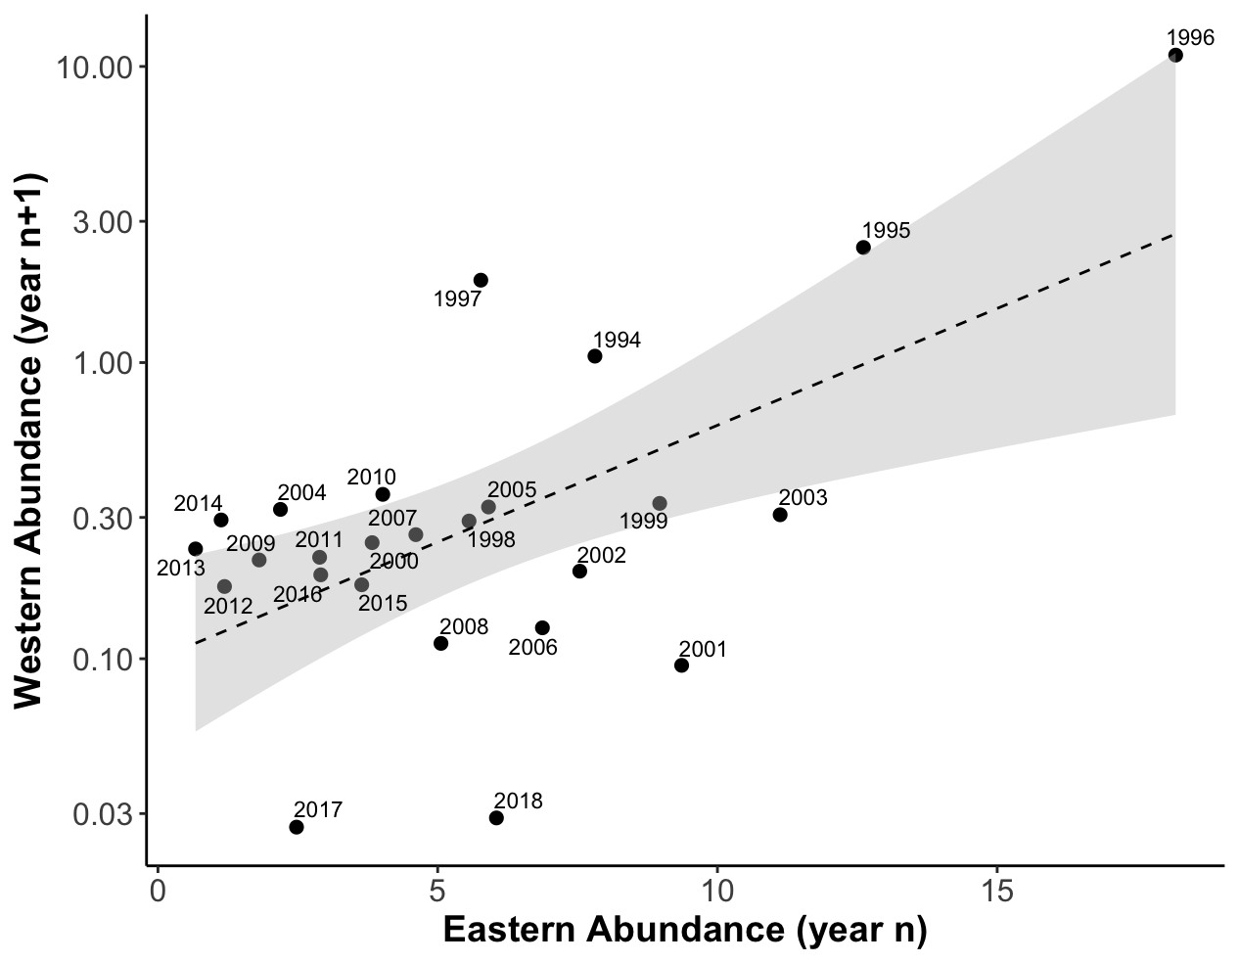
Figure S1 – When overwintering populations are plotted using a one-year time lag, eastern and western North American monarchs are strongly positively correlated (R² = 0.50, p < 0.001). In the plot above, a given point corresponds to eastern overwintering abundance in a particular year, and the western overwintering abundance in the following year (e.g. the point labeled 2003 corresponds to the year 2003 in the east, and 2004 in the west).

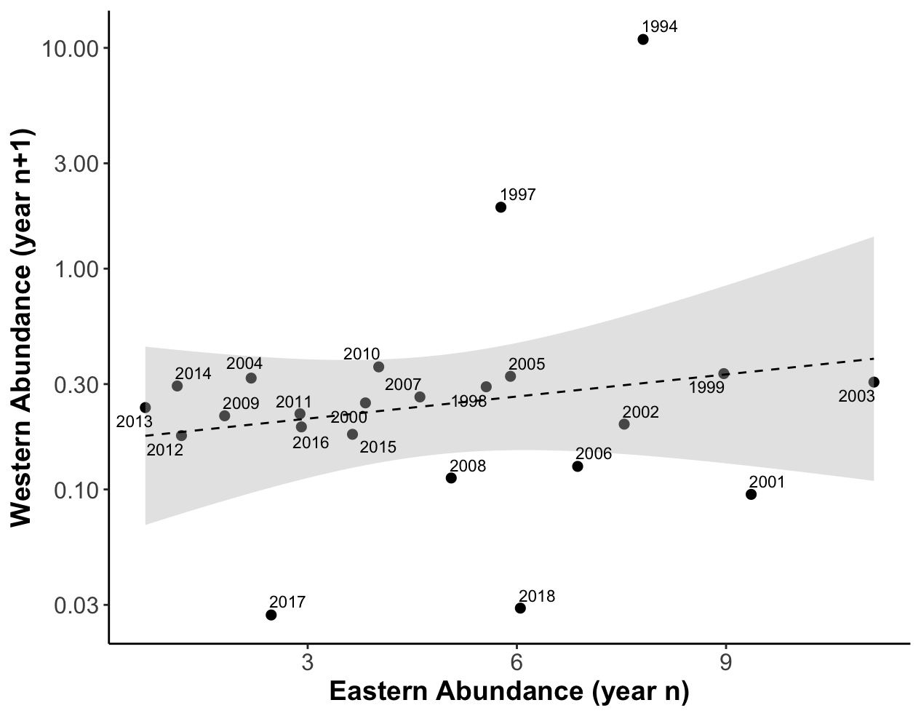
Figure S2– When two years (1995 and 1996 in the east, 1996 and 1997 in the west) are omitted from time series, the correlation between eastern and western overwintering numbers using a one year time lag is no longer significant (R² = 0.06, p = 0.275).

