Supplementary Appendix to:

SARS-CoV-2 infection in the central nervous system of a 1-year-old infant
Ismael Gomes, BSc ^{1,3}*, Karina Karmirian, BSc ^{2,3}*, Júlia T. Oliveira, PhD ²*, Carolina da S. G. Pedrosa, PhD ²*, Mayara Abud Mendes, PhD ², Fernando Colonna Rosman, MD ^{1,5}, Leila Chimelli, MD ^{4#}, Stevens Rehen, PhD ^{2,3#}
*These authors contributed equally to this work
# Co-senior authorship
Corresponding author:
Stevens Rehen (srehen@lance-ufrj.org)
+55 21 38836000

Affiliation details:
1 - Anatomic Pathology Service, Jesus Municipal Hospital, Rio de Janeiro, RJ, Brazil.
2 – D’Or Institute for Research and Education (IDOR), Rio de Janeiro, Brazil.
3 – Institute of Biomedical Sciences, Federal University of Rio de Janeiro (UFRJ), Rio de Janeiro, Brazil.
4 - Laboratory of Neuropathology, State Institute of Brain Paulo Niemeyer, Post-Graduate Programs of Pathology and Translational Neuroscience, UFRJ, Rio de Janeiro, RJ, Brazil.
5 - Department of Pathology, School of Medicine, UFRJ, Rio de Janeiro, Brazil.

Supplementary Methods
Autopsy procedures
Full autopsy was performed with a post-mortem interval of 37 hours following best practices autopsy guidelines according to biosafety practices in Anatomical Pathology Laboratories. All tissues were fixed at 10% buffered formalin (pH 7.4) for at least 48 hours and further processed using a standard protocol for paraffin embedding.
Immunofluorescence
Paraffin blocks from lungs and brain (choroid plexus [ChP], cerebral cortex, globus pallidus, lateral ventricle, medulla oblongata, midbrain, pons and putamen) were selected to produce a tissue microarray, as adapted from Pires et al. (2006) (18). Four micrometers sections were deparaffined, rehydrated, followed by 10 mM citrate buffer (pH 6.0) antigen retrieval for 30 minutes at 98 °C and blocked/permeabilized (3% bovine serum albumin / 0.3% Triton X-100) for 1 hour. Overnight incubation at 4°C was performed with anti-SARS-CoV-2 spike protein monoclonal antibody (SP), Genetex, Cat GTX632604, 1:500; convalescent serum (CS), 1:1000 or anti-dsRNA (J2), MerckMillipore Cat MABE1134, 1:200. Then, the slides were washed with PBS and incubated with secondary antibody (Goat anti-Mouse Alexa Fluor 488, 1:400; A-11001) for 45 minutes at 37 °C. Nuclei were stained with 0.5 µg/mL 4′-6-diamino-2-phenylindole for 5 minutes and the slides were mounted with Aqua-Poly-mount (Polysciences). Images were acquired with a confocal microscope Leica TCS SP8 using a 63x/oil objective lens.

Immunohistochemistry
From selected areas of the nervous tissue which presented histological lesions, immuno-histochemical reactions were performed, using the following monoclonal antibodies (Cell Marque, Sigma-Aldrich Co, Rocklin, CA, USA) and dilutions: anti-glial fibrillary acidic protein- GFAP- clone EP672y, (1:500), anti-NeuN (Zeta Corporation, Arcadia, CA, USA) Clone A100 (1:200), CD3 - Clone MRQ-39 (1:1000), CD20 - Clone SP-32 (1:1000), and CD68 - Clone Kp-1 (1:1000), according to standard protocols (19). Five micrometers thick tissue sections were incubated in a drying oven at 37 °C for six hours and then deparaffined in xylene. The tissue sections were rehydrated by placing in decreasing concentrations of alcohol and washed in distilled water. To enhance antigen retrieval, the tissue sections were pretreated in an Electric Pressure cooker for 15 minutes in the solution 1:20 Declere® (pH 6) / 1:100 Trilogy (pH9) in distilled water. To block endogenous peroxidase activity, the tissue sections were exposed to hydrogen peroxide, washed with distilled water and rinsed in phosphate buffered saline (PBS) to stop enzymatic digestion. They were then incubated with the primary antibody overnight at 4 °C, rinsed in PBS for 5 minutes and incubated with Polymer Hi Def (horseradish peroxidase system) for 10 minutes at room temperature preceded by several washes in PBS. The peroxidase reaction was visualized with DAB substrate, rinsed in running water; the sections were then counterstained with Meyer’s hematoxylin for 1 minute, washed in running tap water for 3 minutes, dehydrated in alcohol, cleared in xylene and mounted in resinous medium. Images were acquired with Axio Carl Zeiss Scop A1 microscope using 4x, 10x, 20x, and 40x objective lens.

Total RNA isolation and virus detection in human postmortem tissues
Specimens from heart, brain (frontal cortex, lateral ventricle, and choroid plexus (ChP), cerebellum, trachea, larynx, kidney, liver, stomach and lung were sliced into thick sections, transferred to a new tube and incubated in 400 μL of lysis buffer containing 10 mM Tris-HCl pH 7.8, 1 mM EDTA, 10% SDS and 20 mg/mL Proteinase K (ThermoFisher Scientific) each. This mixture was then incubated in a water bath at 60°C for 30 minutes. Subsequently, the content was transferred to 3.0 mm TriplePure Zirconium homogenizer beads (Benchmark Scientific) and shaken vigorously using the BeadBugTM Microtube Homogenizer apparatus (D1030-E, Benchmark Scientific). The total RNA was isolated in 1 mL of TRIzol™ Reagent (ThermoFisher Scientific), according to the manufacturer’s instructions. RT–qPCR was performed on each extracted sample using the 2019–nCoV CDC RUO Kit (IDT: 10006713) and 2019–nCoV CDC RUO Primers and Probes (PN: 10006713) for the detection of viral RNA (SARS-CoV-2 nucleocapsid N1 and N2 fragments) and the RNase P (RP) primer set for the detection of human RNase P RNA (Integrated DNA Technologies). For each specimen, three separated reactions were set up in a 96-well plate including N1, N2, and RP primers and probes. RT-qPCR was carried out in with a total reaction volume of 20 µL containing 15 µL of GoTaq® Probe 1-Step RT-qPCR System (Promega, A6120) comprised of the following components: 3.1 µL ultrapure water, 10 µL GoTaq® Probe qPCR Master Mix with dUTP (2X), 0.4 µL GoScriptTM RT Mix for 1-Step RT-qPCR, 1.5 µL primer/probe sets for either N1, N2, or RP (IDT) and 5 µL of extracted RNA. All reactions were carried out with appropriate negative (human specimen control – iPSC-derived astrocytes – and no template control - with water instead of template), and positive (2019-nCoV_N Positive Control, IDT: 10006625; Hs_RPP30 Positive Control, IDT, 10006626) controls, which were incorporated into each run to ensure proper testing control. Briefly, the reactions were performed on a StepOnePlusTM Real-Time PCR System thermocycler (ThermoFisher Scientific). Thermal cycling conditions comprised a holding stage at 45 °C for 15 min, 95 °C for 2 min, followed by 45 cycles of denaturation at 95 °C for 15 seconds, and annealing and extension at 60 °C for 1 minute.

Supplementary Figures

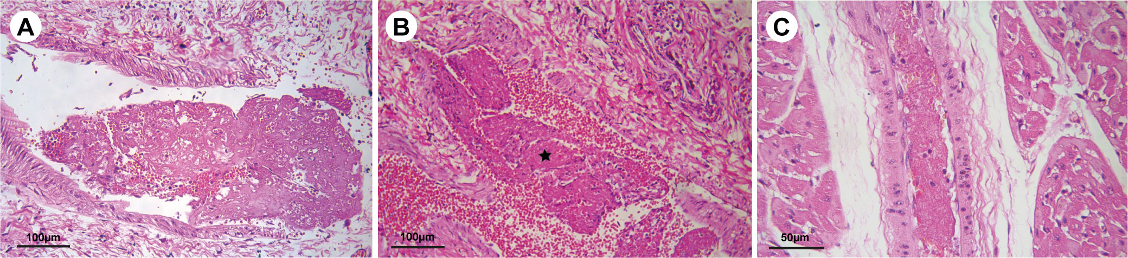Supplementary Figure 1: Light photomicrographs of microthrombosis in several organs. (A) Microthrombus in a small pulmonary artery of the left lung. Scale bar: 100 µm. (B) Thrombus in veins located adjacent to the thyroid (star). Scale bar: 100 µm. (C) Microthrombus in left ventricular myocardium. Scale bar: 50 µm. H&E.

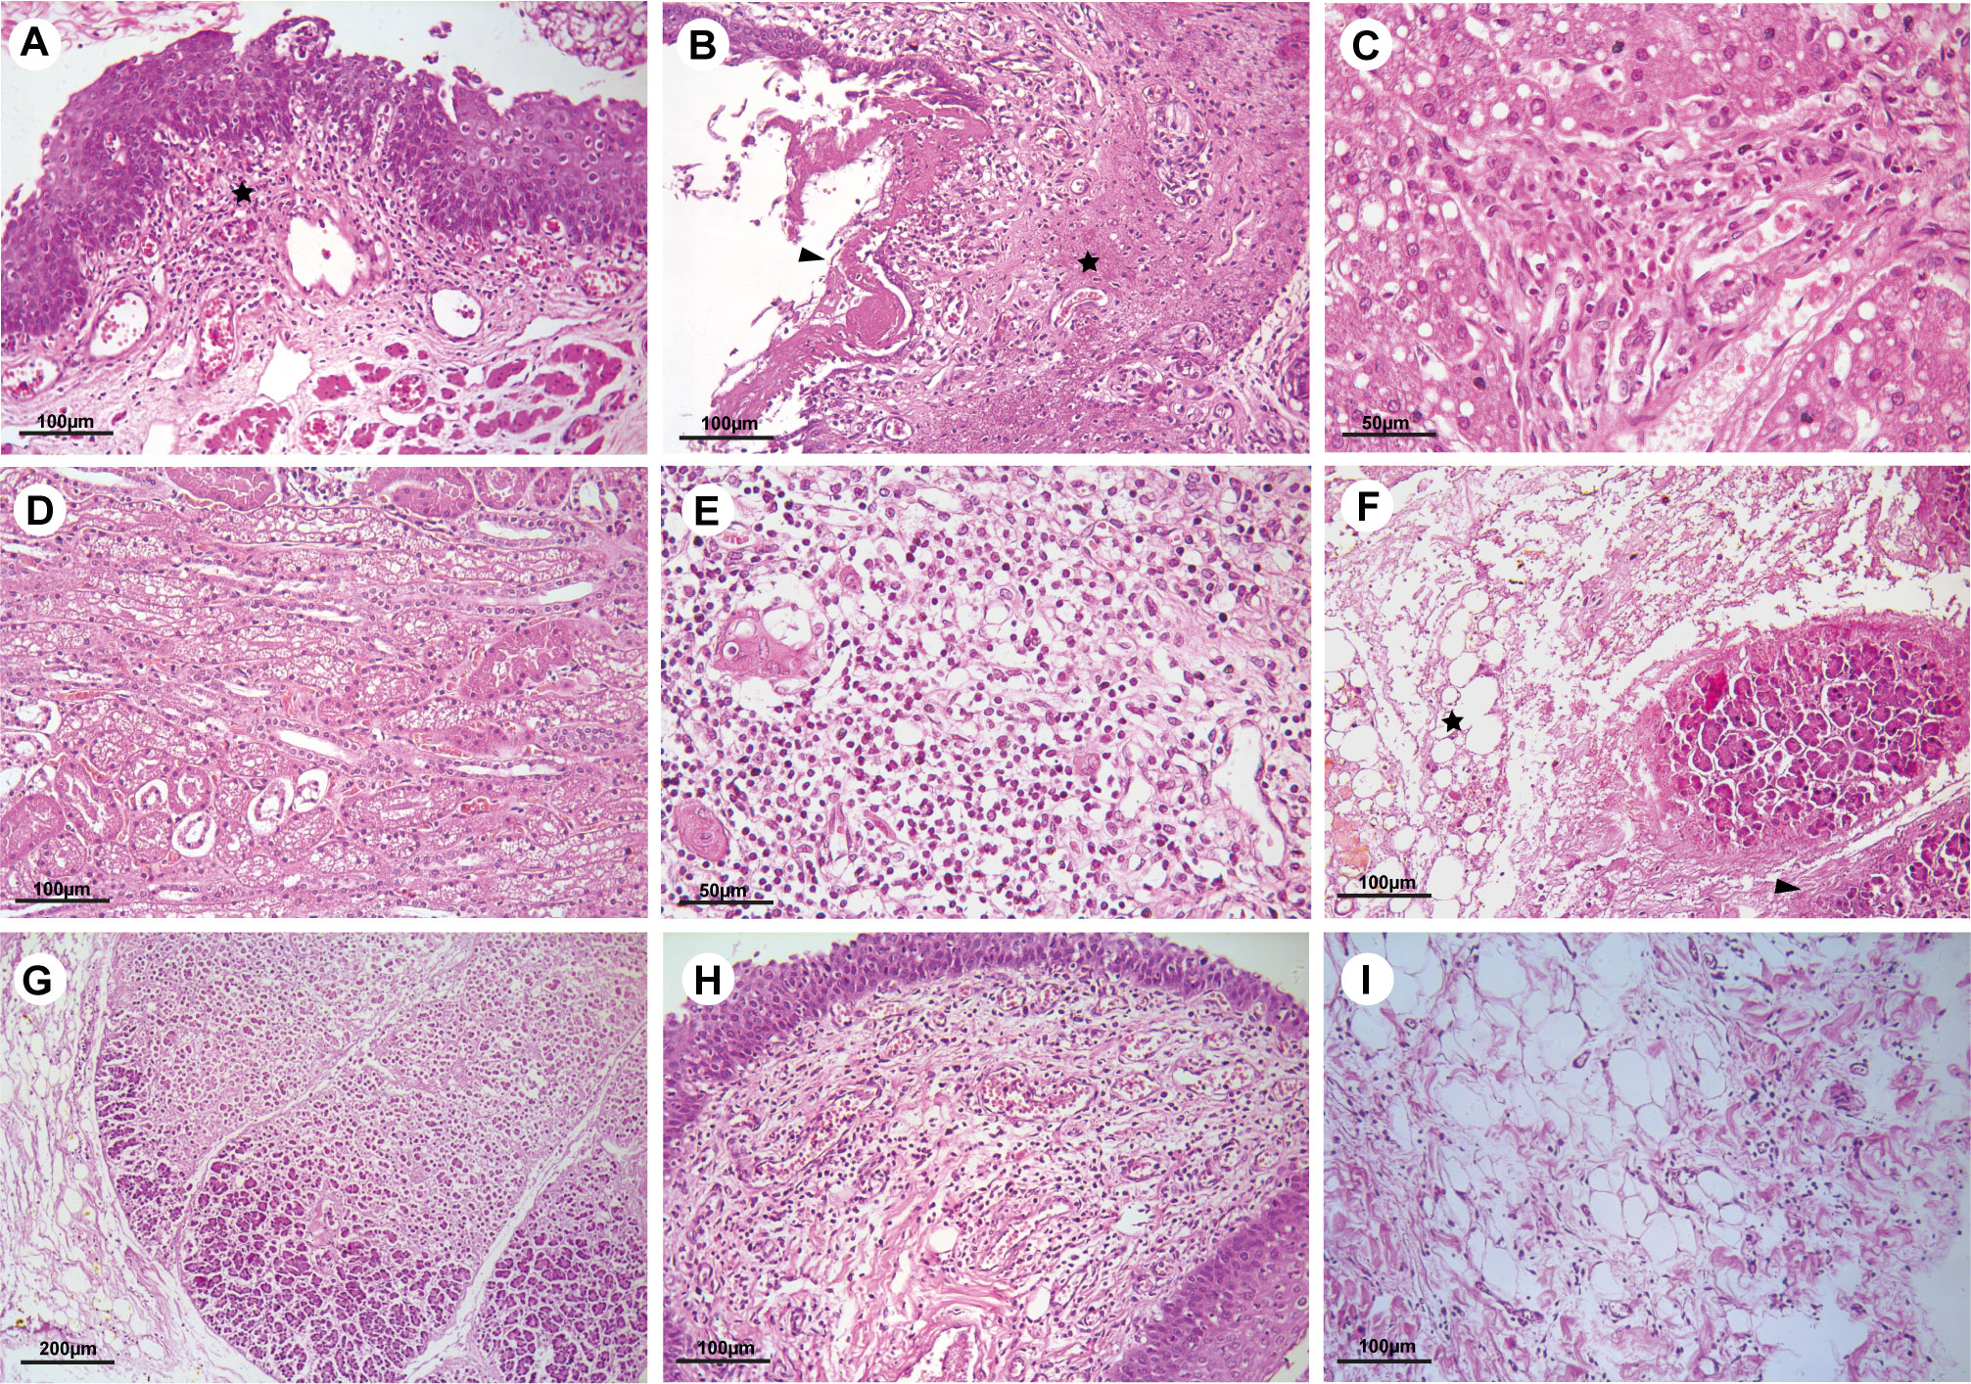Supplementary Figure 2: Histological characterization of multiple organs. (A) Esophagus presenting lymphocytic inflammatory infiltrate in the mucosa (star). (B) Laryngitis with necrosis (star) and mucosal erosion covered with eosinophilic and amorphous fibrinonecrotic tissue (arrowhead). (C) Liver steatosis. (D) Osmotic nephrosis secondary to hydroelectrolytic disturbances. (E) Thymus presenting marked lymphocyte hypoplasia. (F)-(G) Ischemic necrosis of the pancreas (arrowhead), along with steatonecrosis of the regional adipose tissue (star). (H) Posterior region of the tongue presenting marked hypoplasia of the lymphoid tissue. (I) Mild pericarditis in the right ventricle. H&E. Scale bars: (A, B, D, F, H, I) 100 µm; (C, E) 50 µm; (G) 200 µm.

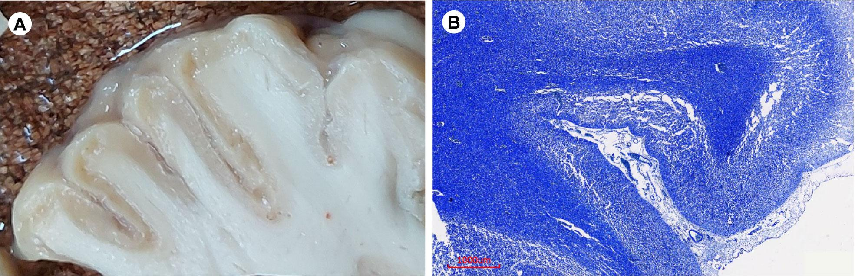
Supplementary Figure 3: Macroscopic appearance of brain tissue and myelin staining. (A) Cut surface of fixed brain showing thin granular and discolored cortex. (B) White matter myelination is preserved as seen with the Luxol Fast Blue staining Scale bar: 1000 µm.
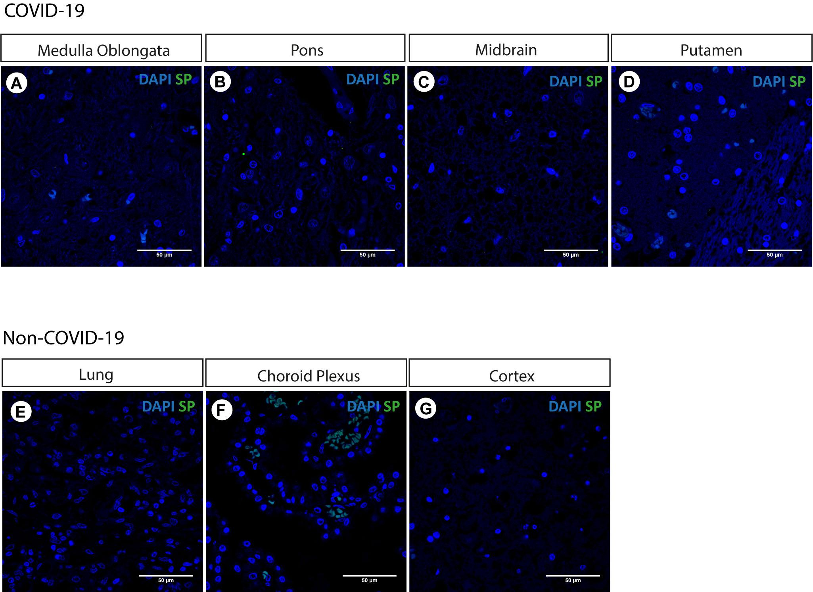
Supplementary Figure 4: Photomicrographs of immunostaining for SP in brain regions from COVID-19 patient and control samples from a non-COVID-19 patient. No SARS-CoV-2 infected cells were detected by SP in (A) medulla oblongata, (B) pons, (C) midbrain, and (D) putamen of the infant that deceased of COVID-19. Lung (E), choroid plexus (F) and cortex (G) from a non-COVID patient does not exhibit any fluorescence signal, confirming SP antibody specificity. Scale bars: 50 µm.
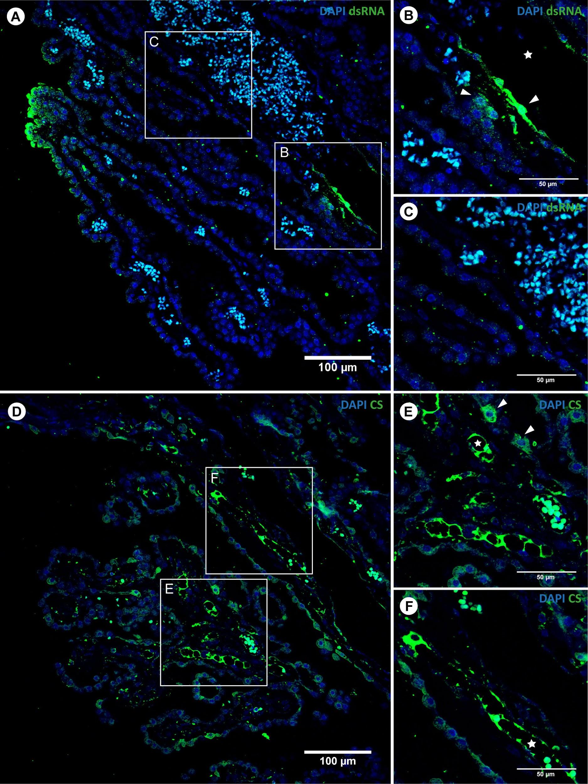
Supplementary Figure 5: Photomicrographs of immunostaining for dsRNA (A-C) and CS (D-F) in the choroid plexus endothelium. Lower magnification images (A and D) showing SARS-CoV-2 infection in vessels and capillaries. Scale bars: 100 µm. Details in B, C, E and F. Scale bars: 50 µm. Note the presence of viral staining at the lumina (star) and nearby infected cells (arrowheads).
Supplementary Table 1. Morphological Findings in Infant Postmortem Tissue Samples.
Organs | Macroscopic Examination | Histopathologic findings
Brain | Marked atrophy, edema, hydrocephalus ex vacuo. | Atrophic cerebral cortex, laminar necrosis, spongiosis, gliosis, microgliosis and macrophages. Diffuse white matter edema, focal perivascular and neuronal mineralization. Mild lymphocytic infiltrate in the leptomeninges.
Heart | Normal | Microthrombi in small arteries of the left ventricle. Focal mild lymphocytic infiltrate in right ventricle epicardium
Larynx | ∙∙ | Laryngitis: moderate lymphocytic inflammatory infiltrate in the mucosa and the submucosa, associated or not with mucosal erosion, necrosis and fibrinonecrotic membrane.
Trachea | ∙∙ | Mild lymphocytic infiltrate in some regions of the mucosa and submucosa. Focal squamous metaplasia.
Lungs | Enlarged, with congestion, edema and well demarcated lobules.  Pleural effusion. | Pneumonitis: diffuse respiratory bronchiolar damage with hyaline membranes and collapsed alveolar spaces, associated with interstitial lymphocytic inflammation, plugs of plasma proteins and cellular debris in bronchiolar lumina, occasionally with macrophages, and lymphoid aggregates in their walls. Pneumocyte type II proliferation in distal respiratory spaces. Congestion, edema, and some foci of hemorrhage and atelectasis. Microthrombi in some small pulmonary arteries. Pleura with mild lymphocytic infiltrate, congestion and edema.
Submandibular salivary glands | ∙∙ | Sialadenitis: focal moderate lymphocytic infiltration in both salivary glands.
Tongue | ∙∙ | Severe lymphoid hypoplasia in the posterior region and mild interstitial lymphocytic infiltrate around some small salivary glands.
Esophagus | ∙∙ | Esophagitis: focal lymphocytic infiltration of the mucosa, along with lymphocyte exocytosis. Regional venular thrombosis.
Stomach | ∙∙ | Mild gastritis, some lymphoid aggregates, congestion and foci of superficial hemorrhage of the mucosa.
Intestines | ∙∙ | Lymphoid aggregates in the mucosa and submucosa.
Liver | Pale red | Steatosis. Mild lymphocytic infiltration in some portal spaces; occasional recent venular microthrombi.
Pancreas | Dark gray with black areas | Ischemic necrosis of the head, body and tail of the pancreas with hemorrhage. Ischemic steatonecrosis of the regional adipose tissue. Ischemic necrosis of the regional lymph nodes. There was no pancreatitis.
Kidneys | ∙∙ | Diffuse osmotic nephrosis secondary to hydroelectrolytic disorders. Some microthrombi in small arteries.
Thymus | ∙∙ | Severe diffuse lymphoid hypoplasia.
Vermiform appendix | ∙∙ | Severe diffuse lymphoid hypoplasia.
Lymph nodes | ∙∙ | Moderate lymphoid hypoplasia.
Spleen | ∙∙ | White pulp lacking germinal centers.
Thyroid | ∙∙ | Small follicles. Microthrombi in regional small arteries and veins.
Retroperitoneal striated muscle | ∙∙ | Focal myositis with lymphocytic inflammatory infiltrate.
Pelvic vein | ∙∙ | Focal thrombophlebitis associated with apoptosis of leukocytes in the wall.

Supplementary Table 2: 2019-nCoV RTq-PCR Diagnostic Panel Results of Infant PostMortem Tissue Samples
Specimen Type | 2019-nCoV_N1 Assay | 2019-nCoV_N2 Assay | RP | Result Interpretation
 | Ct Mean (± SD) | Ct Mean (± SD) | Ct Mean (± SD) | (Detected/Total Tested)
Cortex | 28∙5 (± 1∙7) | 28∙3 (± 2∙8) | 27∙8 (± 1∙2) | 2019-nCoV detected (2/2)
Kidney | 31∙2 (± 1∙2) | 30∙7 (± 1∙1) | 25∙7 (± 1∙3) | 2019-nCoV detected (5/5)
Heart | 33∙4 (± 3∙1) | 35∙4 (± 3∙8) | 30∙3 (± 4∙8) | 2019-nCoV detected (4/5)
Choroid Plexus | 39∙2 | 34∙0 | 32∙4 | 2019-nCoV detected (1/1)
Lateral Ventricle | 35∙5 | 34∙2 (± 1∙0) | 34∙4 (± 1∙2) | 2019-nCoV detected (1/3)
Lung | 28∙4 (± 2∙0) | 28∙5 (± 0∙8) | 35∙7 (± 2∙7) | 2019-nCoV detected (3/3)
Stomach | 33∙7 | ND | 32∙3 (± 1∙0) | 2019-nCoV detected (1/2)
Brain | 34∙9 (± 1∙1) | 36 | 35∙7 (± 0∙6) | 2019-nCoV detected (1/3)
Cerebellum | 34∙8 (± 0∙1) | 35∙2 (± 0∙2) | 32∙9 (± 1∙5) | 2019-nCoV detected (1/3)
Trachea | 34∙8 (± 0∙4) | 36∙5 | 35∙9 (± 2∙1) | 2019-nCoV detected (1/3)
Liver | 30∙2 (± 2∙7) | 32∙4 (± 1∙7) | 31∙3 (± 1∙0) | 2019-nCoV detected (3/3)
Larynx | ND | 36∙6 | 36∙3 (± 2∙6) | 2019-nCoV detected (0/3)
2019-nCoV_N (Positive Control) | 27∙7 (± 0∙1) | 27∙9 (± 0∙2) | ND | 2019-nCoV Not Detected (4/4)
Hs_RPP30 (Positive Control) | ND | ND | 28∙2 (± 0∙3) | 2019-nCoV Not Detected (4/4)
No template Control (Negative Control) | ND | ND | ND | 2019-nCoV Not Detected (4/4)
Human Specimen Control (Negative Control) | ND | ND | 19∙1 (± 0∙5) | 2019-nCoV Not Detected (4/4)

RT-qPCR detection of SARS-CoV-2 regions of nucleocapsid genes (N1 and N2). The mean and standard deviations of cycle threshold (Ct) were calculated from data obtained in all analysed distinct fragments from the same postmortem tissue specimens. A Ct value less than 40 was interpreted as positive for SARS-CoV-2 RNA. Cortex (n=2), kidney (N=5), heart (n=5), choroid plexus (n=1), lateral ventricle (n=3), lung (n=3), stomach (n=2), brain (n=3), cerebellum (n=3), trachea (n= 3), liver (n=3), larynx (n=3). RP: human RNase P gene. ND: not determined (no Ct reported).

