Influence of different light regimes on the mycoparasitic activity and the production of the secondary metabolite 6-pentyl-α-pyrone in two strains of Trichoderma atroviride

Dubraska Moreno-Ruiz¹, Alessandro Fuchs¹, Kristina Missbach², Rainer Schumacher², Susanne Zeilinger¹
¹Department of Microbiology, University of Innsbruck. Innsbruck, Austria.
2 Department of Agrobiotechnology, University of Natural Resources and Life Sciences Vienna (BOKU). Vienna, Austria.

Supplementary data

Table S1. Primers used for generation of tmk3 gene deletion cassette and genotyping
Figure S1. Percentage of sequence identity of fungal light sensors
Figure S2. Sequence alignment of fungal phytochromes and White collar-like proteins.
Figure S3. Sequence alignment of fungal opsins.

Table S1. Primers used for generation of tmk3 gene deletion cassette and genotyping
Oligonucleotide | Sequence (5´- 3´)
for plasmid construction  BbpDM-tmk3-Fw  BbpDM-tmk3-Rv  5´ Ptmk3-Fw  5´ Ptmk3-Rv  3´ Ptmk3-Fw  3´ Ptmk3-Rv | TTAATTAATTAATTAAATGAAAAAGCCTGAACTCACCGC  TTAATTAATTAATTAAGGTTAAGAGGTTCTTCCGGCT  TGCAAGGCGATTAAGTTCTGGATGATTGGAGGGGGGAATG  CCGCTAGTCTCACCGTTATCATTCAGATTTCGATTTTTTGGGGG  GCACTCGTCCGAGGGCAAAGGAATAGCGCCCGCGCACGCA  TGACCATGATTACGCCAAGCTTGGTGGCCACCCATTGCG
for transformation  pLS-trafo-F  pLS-trafo-R | AACTGTTGGGAAGGGCGA  TGTGTGGAATTGTGAGCGG
Genotyping  Geno_hphR-Fw  Geno_3’ Ttmk3- Rv  Geno_5‘ Ptmk3-Fw(2)  Geno_Tmk3-Fw  Geno_Tmk3-R  Actin-T.a-Fw  Actin-T.a-Rv | GAGCTGATGCTTTGGGCC  TCTCTTGATTTCTACACAAACAGGG  CCCTGAAGCTGCTGGATGGA  ACTCAGACCTCCAGCCTGTG  ATAACATCGTCCGGGGGCG  CTACGGACCAGCAATACGGG  CATACAGGATCGCAAGATCTGC

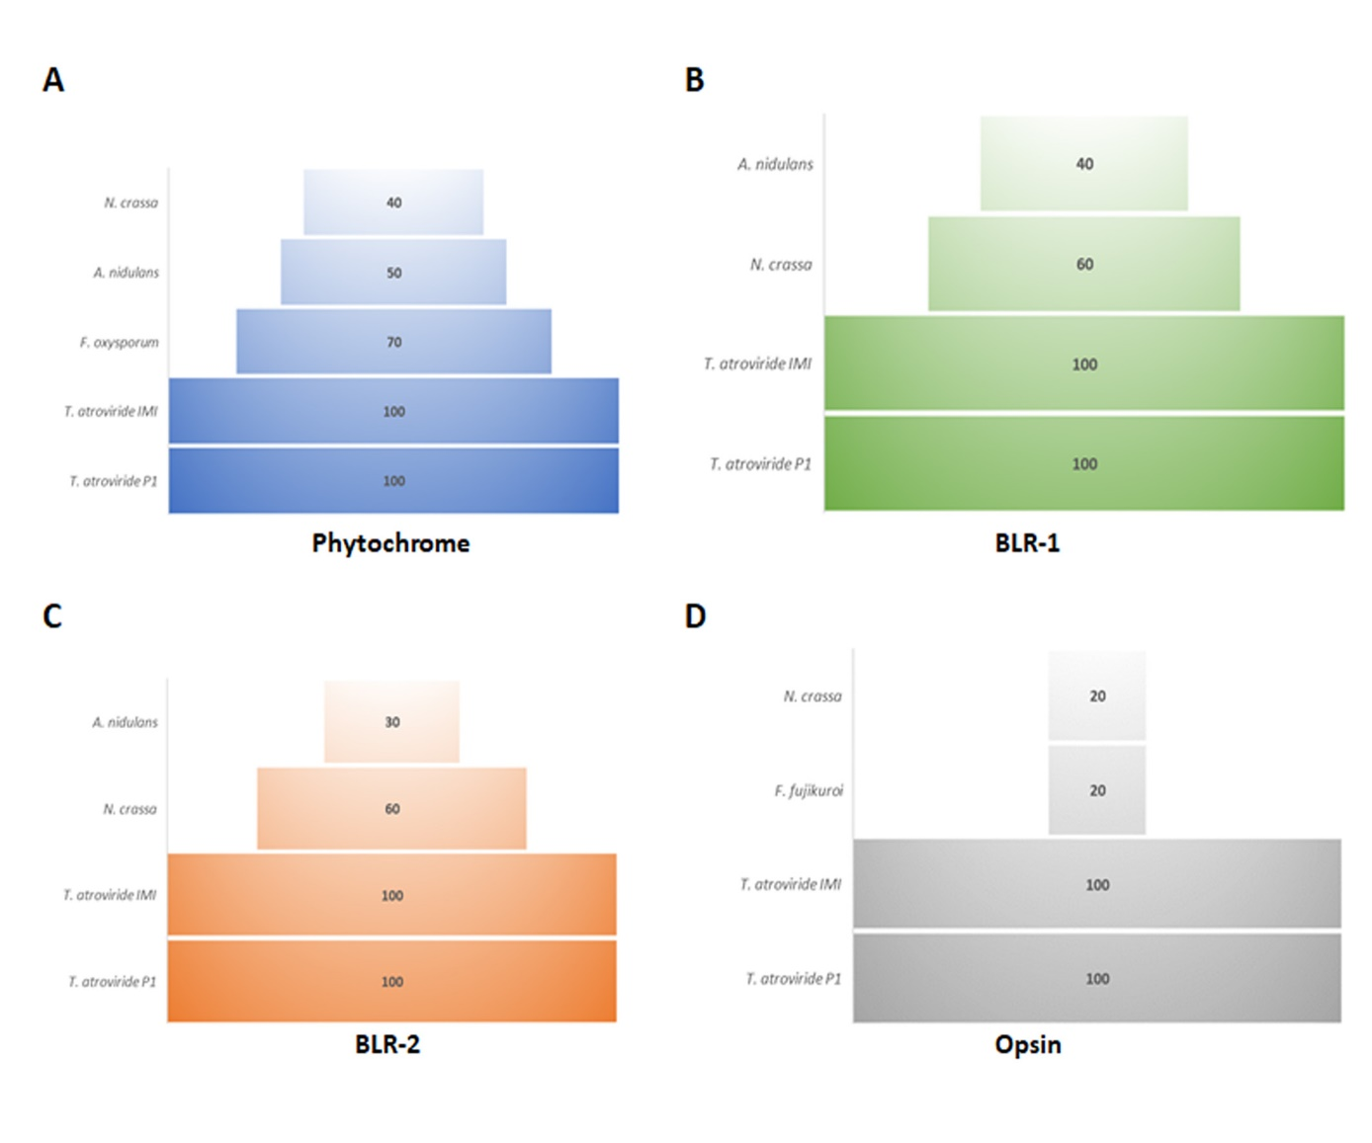
Figure S1. Percentage of sequence identity of fungal light sensors. A. Alignment of phytochrome protein from T. atroviride strains IMI 206040 and P1 with its orthologues from N. crassa, A. nidulans, and F. oxysporum. B. Alignment of the blue light sensor T BLR-1 from T. atroviride strains IMI206040 and P1 with its orthologues from N. crassa and A. nidulans. C. Alignment BLR-2 from T. atroviride strains IMI206040 and P1 with its orthologues from N. crassa and A. nidulans. D. Alignment of the opsin from T. atroviride strains IMI206040 and P1 with of its orthologue from N. crassa and F. fujikuroi. Protein sequences were retrieved from NCBI: XP_682277.1, AAP47230.1, XP_661211.1 (A. nidulans), XP_960050.2, XP_011395153.1, XP_963819.3, XP_959421.1 (N. crassa), XP_023437812.1 (F. fujikoroi), XP_018237567.1 (F. oxysporum f. sp. lycopersici 4287) , XP_013942313.1, XP_013938043.1, XP_013938453.1, XP_013947857.1 (T. atroviride IMI 206040) and JGI genome portal (Protein ID): 325757, 421757, 431266, 365324 (T. atroviride P1).
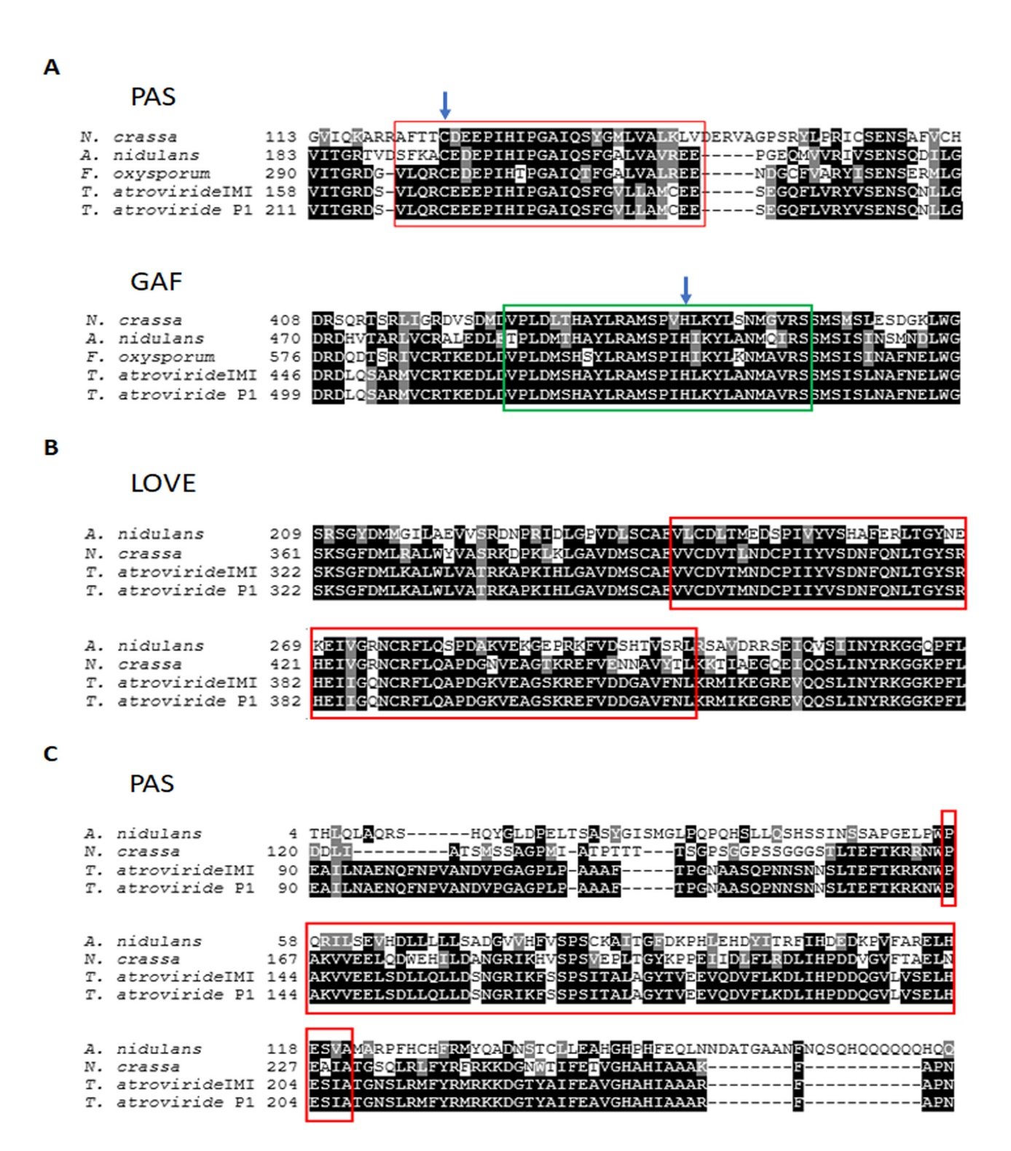
Figure S2. Sequence alignment of fungal phytochromes and WC proteins. A. Alignment of PAS and GAF domains of phytochrome protein sequences from T. atroviride strains IMI 206040 and P1, N. crassa, A. nidulans, and F. oxysporum. B. Alignment LOVE domain of BLR-1 from T. atroviride strains IMI and P1 with orthologues from N. crassa and A. nidulans. C. Alignment of PAS domain of BLR-2 from T. atroviride strains IMI and P1 with orthologues from N. crassa and A. nidulans. Protein sequences were retrieved from NCBI: XP_682277.1, AAP47230.1, XP_661211.1 (A. nidulans), XP_960050.2, XP_011395153.1, XP_963819.3 (N. crassa), XP_018237567.1 (F. oxysporum f. sp. lycopersici 4287) , XP_013942313.1, XP_013938043.1, XP_013938453.1 (T. atroviride IMI 206040) and JGI genome portal (Protein ID): 325757, 421757, 431266 (T. atroviride P1). Alignments were done with ClustalW (http://www.ebi.ac.uk/clustalW) and shading with Boxshade 3.21 (http://www.ch.embnet.org/software/BOX_form. html.
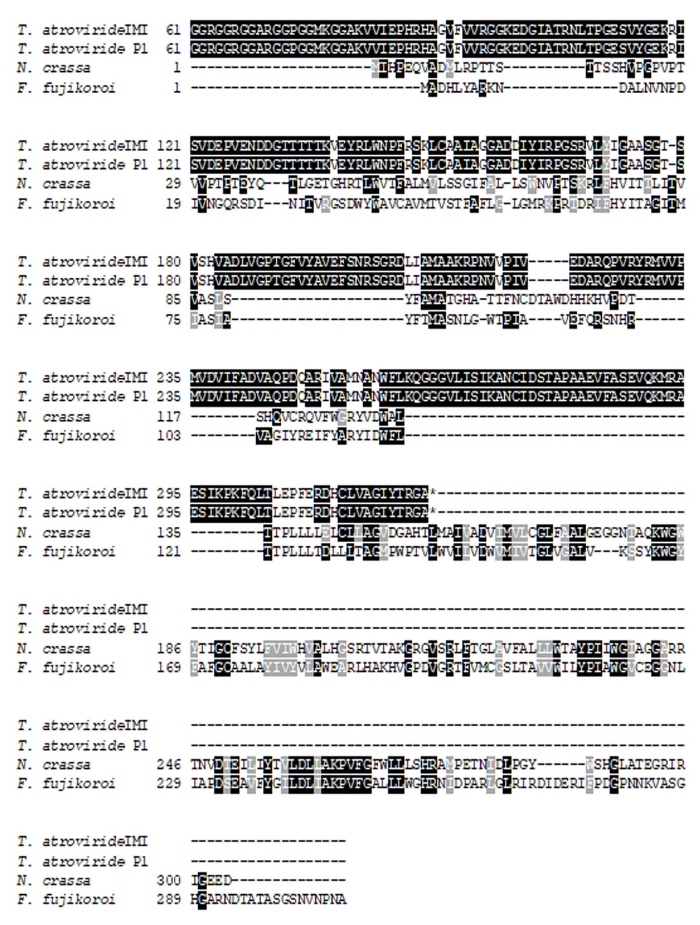
Figure S3. Sequence alignment of fungal opsins. Alignment of the opsin protein from T. atroviride strains IMI and P1 with orthologues from N. crassa and F. fujikuroi. Protein sequences were retrieved from NCBI GenBank: XP_959421.1 (N. crassa), XP_023437812.1 (F. fujikoroi), XP_013947857.1 (T. atroviride IMI 206040); and JGI genome portal (Protein ID): 365324 (T. atroviride P1). Alignments were done with ClustalW (http://www.ebi.ac.uk/clustalW) and shading with Boxshade 3.21 (http://www.ch.embnet.org/software/BOX_form. html.

