Supplementary Material

Supplementary Figure S1.
Results of the ISOLA modelling of the mainshock (top panel) and plots with synthetic vs observed waveforms (bottom panel) showing the quality of the fit.

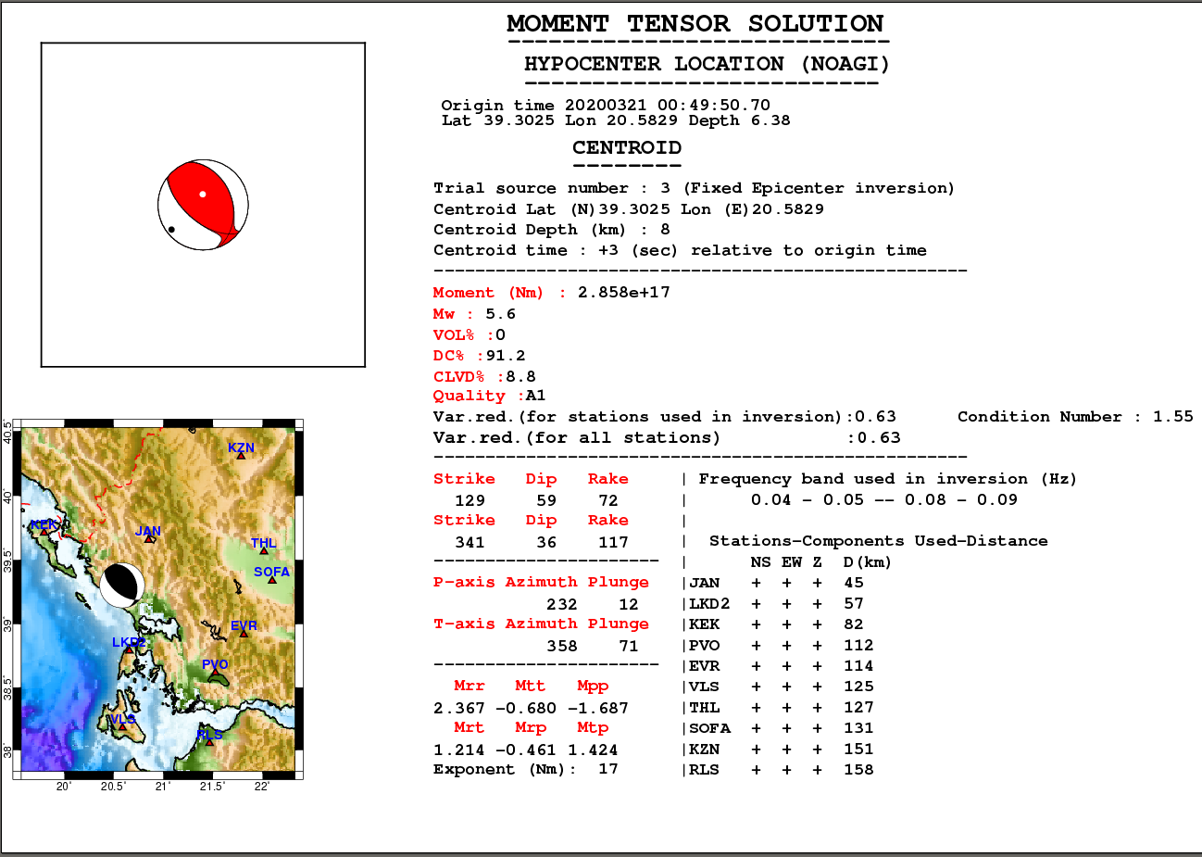
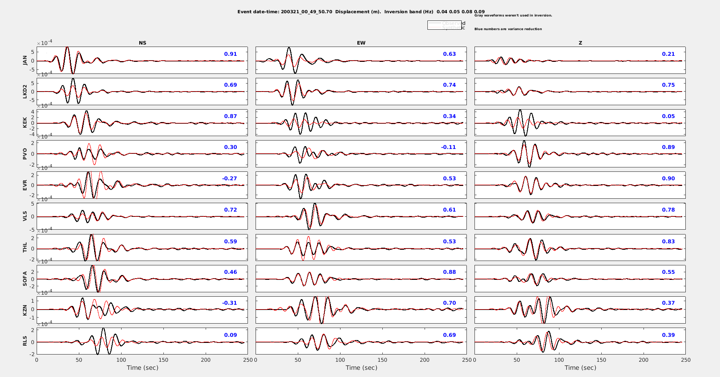

Supplementary Figure S2.
Top) Map of the relocated 2020 Kanallaki earthquake sequence. The relocated catalogue was divided in 6 spatial groups (see colours and numerical labels) using Ward’s linkage on the matrix of 2D inter-event epicentral distances, to provide visual aid for the cross-section description. (Bottom) Cross-sections along the profiles a1-a2 (in a SW-NE direction) and b1-b2 (in a NW-SE direction) shown on the map. Stars represent the larger events, with M_{L}≥3.5. The topography is also presented at the top of the cross-sections (without vertical exaggeration).

Supplementary Figure S3.
Map showing the Sentinel-1 frames with data used in this paper. Yellow star denotes the epicentre of the Kanallaki earthquake.

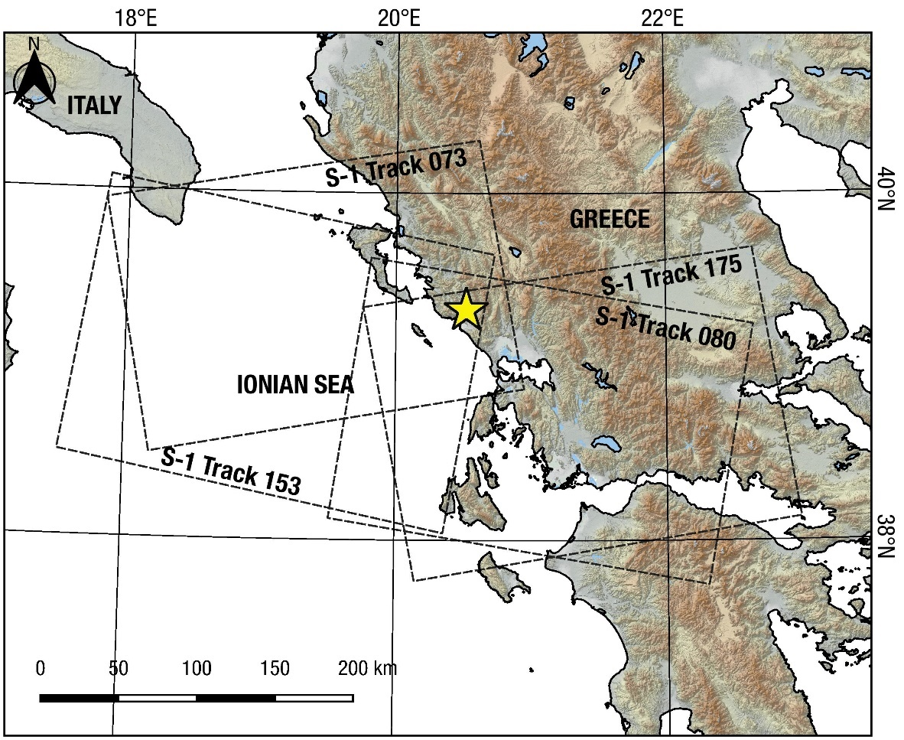

Supplementary Figure S4.
Coseismic interferograms for the Kanallaki earthquake that were not used in the inversion due to low quality and noise. Date of image pairs are reported on the lower left part of the images.

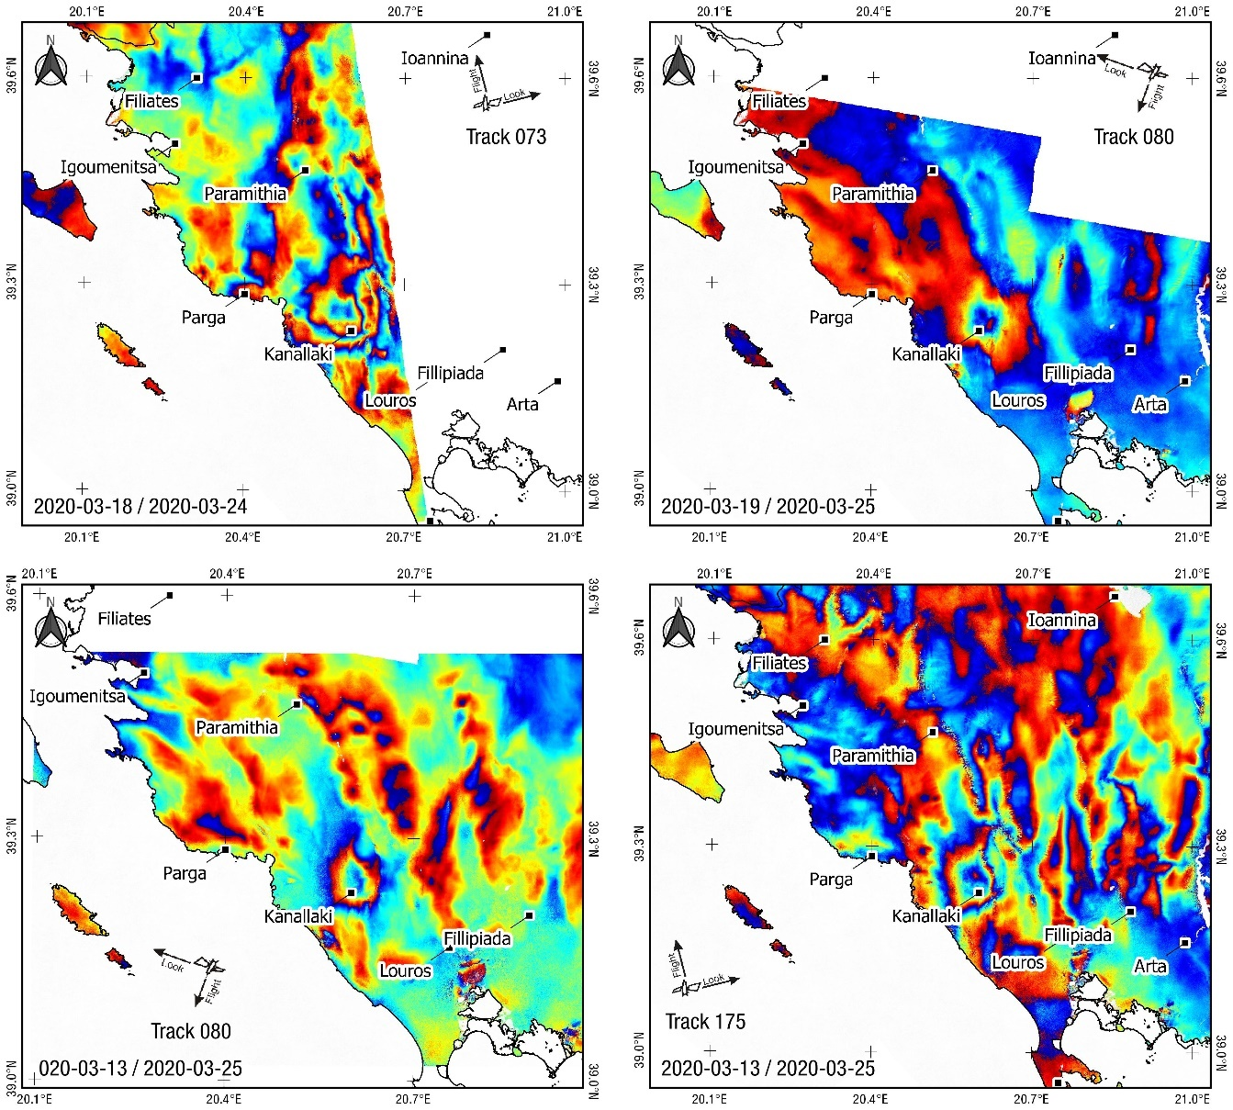

Supplementary Figure S5.
Aerial overview of the earthquake epicentre area. Picture made by A. Ganas on September 27, 2019 on the flight Athens to Brussels. View towards WSW. Kanallaki is on the southern side of the picture. Note the Lippa mountain with V-shaped orthogonal valleys facing the village of Gardiki. Lippa forms an anticline structure immediately west of Gardiki and the Kokitos river valley. The azimuth of this geological structure is N335°E. The Acherontas is river is located to the left of the Kokitos river (see Fig. 2).

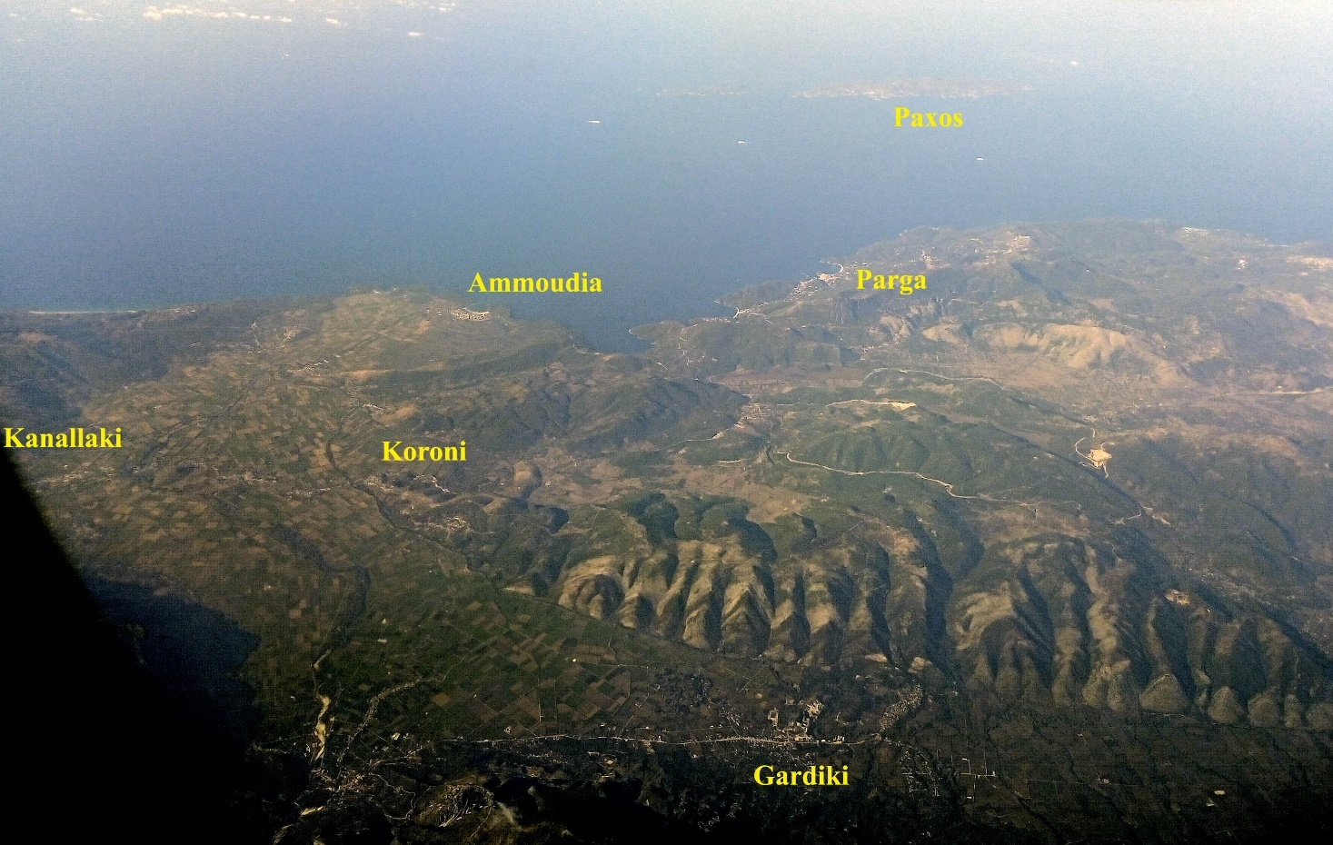

Supplementary Table S1.
Catalogue of strong events for the study area, 1915 - 2019 (M_{L}≥5.2; source Makropoulos et al. 2012).

YEAR | MONTH | DAY | HOUR | MIN | SEC | LAT | LON | DEP | Mw
1915 | 2 | 20 | 8 | 13 | 0 | 39.200 | 20.500 | 30 | 5.2
1920 | 10 | 21 | 18 | 57 | 51.7 | 39.430 | 20.360 | 10 | 5.6
1935 | 9 | 3 | 17 | 35 | 39.3 | 39.450 | 20.670 | 106 | 5.3
1938 | 3 | 11 | 14 | 51 | 6.1 | 39.230 | 20.520 | 55 | 5.2
1945 | 1 | 8 | 22 | 42 | 23.3 | 39.170 | 20.470 | 53 | 5.3
1968 | 3 | 28 | 16 | 37 | 47.3 | 39.490 | 20.380 | 18 | 5.2
1972 | 11 | 24 | 3 | 48 | 34.2 | 39.390 | 20.430 | 9 | 5.3
1979 | 11 | 6 | 5 | 26 | 16 | 39.560 | 20.320 | 26 | 5.6
1979 | 11 | 11 | 1 | 18 | 6.3 | 39.520 | 20.300 | 27 | 5.3
1981 | 7 | 3 | 21 | 42 | 57.7 | 39.540 | 20.670 | 25 | 5.2
1990* | 6 | 16 | 2 | 16 | 21.1 | 39.160 | 20.540 | 7 | 5.5
1993 | 6 | 13 | 23 | 26 | 40.3 | 39.340 | 20.530 | 20 | 5.6
2007 | 6 | 29 | 18 | 9 | 12.65 | 39.297 | 20.249 | 17.6 | 5.4
* from Louvari et al. (2001)

Supplementary Table S2.
Observed values (fringe picking) and modelled values (in mm). The first 86 values are for the ascending interferogram and the following 86 for the descending.

N° | UTM34-East (km) | UTM34-North (km) | Observed displacement along the line of sight | Model
1 | 464.88 | 4343.1 | 34 | 29.64
2 | 464.98 | 4342 | 34 | 25.97
3 | 464.98 | 4342.8 | 34 | 28.83
4 | 465.08 | 4342.4 | 34 | 27.52
5 | 465.08 | 4342.5 | 34 | 27.87
6 | 465.08 | 4342.6 | 34 | 28.21
7 | 462.98 | 4342.9 | 27 | 24.64
8 | 463.38 | 4341.4 | 27 | 20.54
9 | 463.38 | 4341.5 | 27 | 20.95
10 | 463.48 | 4345.4 | 27 | 28.83
11 | 463.58 | 4341.5 | 27 | 21.5
12 | 463.68 | 4343.7 | 27 | 29
13 | 463.78 | 4345.9 | 27 | 28.51
14 | 463.78 | 4346.7 | 27 | 26.06
15 | 463.98 | 4346.9 | 27 | 25.5
16 | 464.18 | 4344.1 | 27 | 30.71
17 | 464.18 | 4347.2 | 27 | 24.37
18 | 464.58 | 4340.7 | 27 | 19.95
19 | 465.08 | 4343.6 | 27 | 30.72
20 | 465.88 | 4347.1 | 27 | 22.63
21 | 465.98 | 4343.8 | 27 | 29.7
22 | 466.08 | 4343.9 | 27 | 29.51
23 | 466.08 | 4344 | 27 | 29.55
24 | 466.08 | 4346.4 | 27 | 24.93
25 | 466.68 | 4347.6 | 27 | 18.03
26 | 466.88 | 4342.9 | 27 | 25.67
27 | 461.08 | 4347.3 | 20 | 16.9
28 | 461.28 | 4346.1 | 20 | 19.61
29 | 461.38 | 4347.3 | 20 | 17.92
30 | 461.88 | 4342.1 | 20 | 17.71
31 | 462.28 | 4340.2 | 20 | 12.84
32 | 462.28 | 4347.6 | 20 | 19.84
33 | 462.28 | 4347.8 | 20 | 19.18
34 | 462.38 | 4340.8 | 20 | 15.18
35 | 462.68 | 4341.4 | 20 | 18.34
36 | 462.68 | 4341.5 | 20 | 18.71
37 | 462.88 | 4341.2 | 20 | 18.23
38 | 462.88 | 4341.3 | 20 | 18.62
39 | 462.88 | 4344 | 20 | 26.7
40 | 463.38 | 4348.3 | 20 | 19.13
41 | 463.58 | 4339.6 | 20 | 13.74
42 | 463.58 | 4339.7 | 20 | 14.12
43 | 464.28 | 4348.5 | 20 | 18.47
44 | 467.18 | 4341.8 | 20 | 21.91
45 | 467.28 | 4342.9 | 20 | 24.14
46 | 467.38 | 4341.9 | 20 | 21.53
47 | 464.18 | 4349.8 | 13 | 12.91
48 | 466.08 | 4349.7 | 13 | 10.99
49 | 464.68 | 4349.5 | 13 | 13.78
50 | 462.78 | 4349.3 | 13 | 14.56
51 | 466.08 | 4348.9 | 13 | 14.14
52 | 465.98 | 4348.6 | 13 | 15.65
53 | 460.58 | 4347.4 | 13 | 14.99
54 | 467.28 | 4347 | 13 | 18.21
55 | 459.98 | 4345.7 | 13 | 14.3
56 | 459.98 | 4345.6 | 13 | 14.31
57 | 460.48 | 4344.5 | 13 | 16.1
58 | 460.08 | 4343.9 | 13 | 13.72
59 | 468.18 | 4343.7 | 13 | 20.62
60 | 468.58 | 4342.8 | 13 | 18.2
61 | 468.08 | 4342 | 13 | 19.14
62 | 465.58 | 4340.1 | 13 | 17.82
63 | 462.68 | 4339 | 13 | 9.98
64 | 464.08 | 4338.8 | 13 | 11.62
65 | 464.08 | 4338.7 | 13 | 11.28
66 | 465.18 | 4338.6 | 13 | 11.84
67 | 456.38 | 4347.5 | 6 | 4.2
68 | 456.78 | 4347.6 | 6 | 4.84
69 | 457.18 | 4353 | 6 | 2.57
70 | 458.28 | 4353.1 | 6 | 3.07
71 | 458.68 | 4352.7 | 6 | 3.62
72 | 459.18 | 4341.8 | 6 | 7.35
73 | 459.78 | 4348.6 | 6 | 10.63
74 | 460.08 | 4352 | 6 | 5.33
75 | 460.78 | 4352.3 | 6 | 5.28
76 | 461.28 | 4339.1 | 6 | 7.36
77 | 461.88 | 4338.8 | 6 | 7.87
78 | 464.18 | 4336.1 | 6 | 4.85
79 | 465.68 | 4350.7 | 6 | 8.25
80 | 466.68 | 4349.5 | 6 | 10.51
81 | 467.68 | 4340.4 | 6 | 16.06
82 | 468.48 | 4339.6 | 6 | 11.85
83 | 469.08 | 4339.3 | 6 | 9.83
84 | 469.48 | 4340.6 | 6 | 11.35
85 | 469.68 | 4339.1 | 6 | 8.19
86 | 455.68 | 4346.6 | 6 | 3.13
87 | 467.78 | 4345.63 | 31.5 | 26.94
88 | 465.68 | 4345.53 | 31.5 | 28.82
89 | 465.78 | 4345.43 | 31.5 | 29.24
90 | 465.08 | 4345.23 | 31.5 | 28.07
91 | 465.28 | 4345.23 | 31.5 | 28.65
92 | 465.58 | 4345.23 | 31.5 | 29.36
93 | 465.58 | 4345.03 | 31.5 | 29.73
94 | 465.98 | 4344.93 | 31.5 | 30.57
95 | 465.98 | 4344.83 | 31.5 | 30.72
96 | 466.48 | 4344.73 | 31.5 | 31.21
97 | 466.98 | 4344.73 | 31.5 | 30.95
98 | 467.48 | 4344.73 | 31.5 | 30.12
99 | 466.88 | 4344.43 | 31.5 | 31.44
100 | 466.78 | 4344.33 | 31.5 | 31.59
101 | 465.88 | 4344.23 | 31.5 | 31.04
102 | 465.78 | 4343.13 | 31.5 | 29.65
103 | 465.78 | 4343.03 | 31.5 | 29.42
104 | 466.68 | 4342.13 | 31.5 | 28.13
105 | 466.28 | 4346.73 | 24.5 | 24.72
106 | 467.68 | 4346.73 | 24.5 | 22.69
107 | 466.28 | 4346.63 | 24.5 | 25.17
108 | 467.68 | 4346.63 | 24.5 | 23.15
109 | 466.08 | 4346.53 | 24.5 | 25.6
110 | 467.38 | 4346.43 | 24.5 | 24.76
111 | 466.28 | 4346.33 | 24.5 | 26.48
112 | 466.58 | 4346.23 | 24.5 | 26.78
113 | 464.88 | 4343.43 | 24.5 | 27.31
114 | 464.08 | 4343.33 | 24.5 | 23.44
115 | 464.98 | 4343.33 | 24.5 | 27.52
116 | 464.58 | 4342.93 | 24.5 | 24.94
117 | 467.88 | 4342.33 | 24.5 | 28.07
118 | 467.88 | 4342.23 | 24.5 | 27.81
119 | 464.38 | 4341.83 | 24.5 | 20.73
120 | 464.48 | 4341.83 | 24.5 | 21.15
121 | 464.68 | 4341.63 | 24.5 | 21.23
122 | 464.78 | 4341.63 | 24.5 | 21.61
123 | 466.48 | 4341.23 | 24.5 | 24.39
124 | 466.08 | 4349.43 | 17.5 | 11.89
125 | 466.58 | 4349.13 | 17.5 | 12.89
126 | 466.28 | 4348.93 | 17.5 | 14.01
127 | 466.38 | 4348.93 | 17.5 | 13.95
128 | 466.38 | 4348.83 | 17.5 | 14.41
129 | 466.18 | 4348.73 | 17.5 | 14.99
130 | 465.68 | 4348.23 | 17.5 | 17.4
131 | 465.78 | 4348.23 | 17.5 | 17.42
132 | 467.48 | 4348.03 | 17.5 | 16.84
133 | 467.78 | 4348.03 | 17.5 | 16.2
134 | 467.48 | 4347.93 | 17.5 | 17.33
135 | 467.88 | 4347.93 | 17.5 | 16.45
136 | 468.48 | 4347.33 | 17.5 | 17.58
137 | 463.88 | 4346.33 | 17.5 | 21.05
138 | 463.28 | 4343.23 | 17.5 | 19.1
139 | 463.58 | 4341.63 | 17.5 | 16.64
140 | 467.58 | 4341.63 | 17.5 | 26.27
141 | 463.98 | 4340.73 | 17.5 | 15.37
142 | 465.88 | 4340.73 | 17.5 | 21.18
143 | 466.18 | 4339.93 | 17.5 | 18.28
144 | 466.48 | 4339.93 | 17.5 | 18.72
145 | 462.38 | 4343.43 | 10.5 | 14.75
146 | 462.48 | 4343.63 | 10.5 | 15.49
147 | 462.58 | 4343.53 | 10.5 | 15.88
148 | 462.98 | 4346.43 | 10.5 | 16.91
149 | 462.98 | 4344.23 | 10.5 | 18.65
150 | 463.08 | 4346.03 | 10.5 | 18.12
151 | 463.68 | 4347.93 | 10.5 | 15.26
152 | 463.78 | 4347.13 | 10.5 | 18.29
153 | 463.78 | 4339.93 | 10.5 | 12.17
154 | 463.88 | 4347.03 | 10.5 | 18.96
155 | 463.88 | 4339.93 | 10.5 | 12.47
156 | 463.98 | 4339.93 | 10.5 | 12.77
157 | 464.08 | 4347.83 | 10.5 | 16.71
158 | 464.18 | 4339.83 | 10.5 | 13.05
159 | 464.38 | 4339.83 | 10.5 | 13.63
160 | 464.98 | 4349.33 | 10.5 | 12.11
161 | 464.98 | 4349.23 | 10.5 | 12.52
162 | 465.28 | 4349.43 | 10.5 | 11.88
163 | 465.58 | 4350.43 | 10.5 | 8.21
164 | 465.98 | 4338.83 | 10.5 | 13.6
165 | 466.18 | 4338.83 | 10.5 | 13.89
166 | 466.48 | 4350.53 | 10.5 | 7.52
167 | 466.58 | 4350.53 | 10.5 | 7.44
168 | 466.78 | 4350.43 | 10.5 | 7.61
169 | 467.08 | 4350.33 | 10.5 | 7.65
170 | 467.18 | 4350.53 | 10.5 | 6.89
171 | 467.58 | 4349.93 | 10.5 | 8.42
172 | 467.78 | 4349.63 | 10.5 | 9.23

Table S3.
Variability of the solution as a function of the focal mechanism parameters. We report the best fitting models obtained when using strictly the three angles reported in the Tab. 2 by various agencies. This shows that there is no major difference between the various models. The definition of the zero value of the interferogram has more impact on the model than the selection of a particular focal mechanism solution among those available.

Source | Centroid (UTM34)
 | Long. | Lat. | Depth | Fault length | Geodetic moment tensor
 | km | km | km | km | * 10¹⁷ N m
GCMT | 465.17 | 4345.32 | 7.57 | 4.58 | 2.40
GFZ | 465.84 | 4344.03 | 7.25 | 4.44 | 2.33
IPGP | 465.65 | 4344.60 | 7.19 | 4.42 | 2.32
USGS | 465.20 | 4343.23 | 7.26 | 4.14 | 2.17
NOA | 466.09 | 4344.74 | 7.39 | 4.78 | 2.51
AUTH | 465.39 | 4344.74 | 7.21 | 4.30 | 2.26
INGV | 465.15 | 4344.61 | 7.32 | 4.26 | 2.24
Average | 465.50 | 4344.47 | 7.31 | 4.42 | 2.32
Standard deviation | 0.37 | 0.66 | 0.13 | 0.21 | 0.11

Table S4.
Co-seismic landslides for the Mw 5.6 March 23 2020 earthquake. The table includes 17 locations where co-seismic landslides were identified using cloud-free pre- and post-seismic Copernicus Sentinel-2 optical imagery (10-m resolution). Locations are shown in Figure 8.

ID | East (UTM34N) | North (UTM34N) | Long | Lat
1 | 465120 | 4340835 | 20.5959 | 39.2160
2 | 465531 | 4340784 | 20.6007 | 39.2156
3 | 465465 | 4340661 | 20.5999 | 39.2145
4 | 466619 | 4340472 | 20.6133 | 39.2128
5 | 466202 | 4339220 | 20.6085 | 39.2015
6 | 466189 | 4338929 | 20.6084 | 39.1989
7 | 466206 | 4339018 | 20.6086 | 39.1997
8 | 465471 | 4349038 | 20.5996 | 39.2900
9 | 471122 | 4349479 | 20.6651 | 39.2942
10 | 471250 | 4349340 | 20.6666 | 39.2929
11 | 471133 | 4348849 | 20.6652 | 39.2885
12 | 467926 | 4343121 | 20.6283 | 39.2368
13 | 467908 | 4342958 | 20.6281 | 39.2353
14 | 469467 | 4343838 | 20.6461 | 39.2433
15 | 467841 | 4343526 | 20.6273 | 39.2404
16 | 467714 | 4342908 | 20.6259 | 39.2348
17 | 467530 | 4343329 | 20.6237 | 39.2386

