Supporting Information

Supplementary Information

Supplementary Information 1: Key sources of bias
The species range databases used in this analysis contain biases arising from unequal sampling effort across regions (the Wallacean shortfall) (Menegotto & Rangel, 2018), and a preferential focus on certain subsets of species (the Linnean shortfall) (Bosch et al., 2018; Troudet et al., 2017). The most prominent geographic gaps in global sampling effort are the tropics (across all depths) and deep offshore areas, particularly the deep pelagic region above the seabed (Menegotto & Rangel, 2018; Webb et al., 2010), A second important source of bias arises from uneven sampling across taxonomic groups, where certain types of species are better studied across all latitudes and depth strata. For instance, commercially valuable species, fish and large vertebrates more broadly, hard corals, and vascular plants are much better described than small invertebrates and alga (Menegotto & Rangel, 2018; Mora et al., 2008). The sampling effort biases imply our count-based metrics (e.g. the absolute numbers of transboundary species) may be underestimated more strongly in areas with lower sampling effort. Given that there are no areas in which ranges for all species have been described (the Linnean shortfall) we note that these counts represent the lower limit on the estimated counts for all countries.

Supplementary Figures and Tables
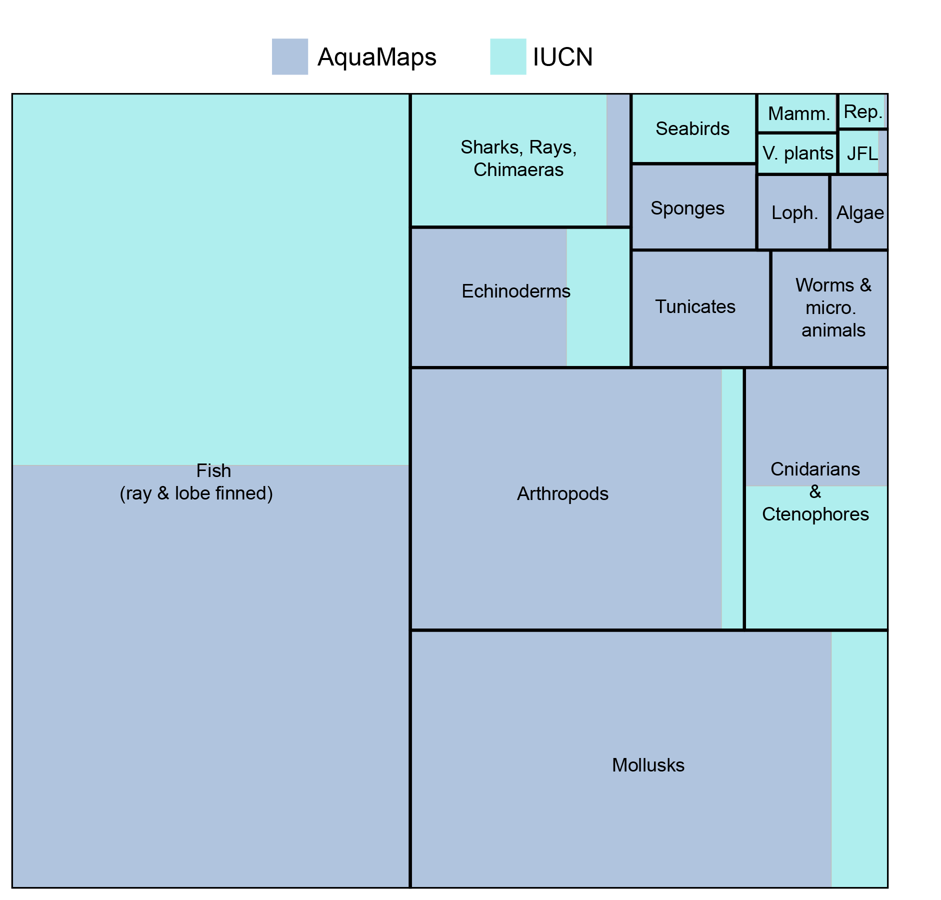
Supplementary Figure 1: Proportion of species maps from the AquaMaps and IUCN databases. Mamm=mammals, Rep=Reptiles, V. plants=Vascular plants, JFL=Jawless fish and lancelets, Loph=Lophophores.

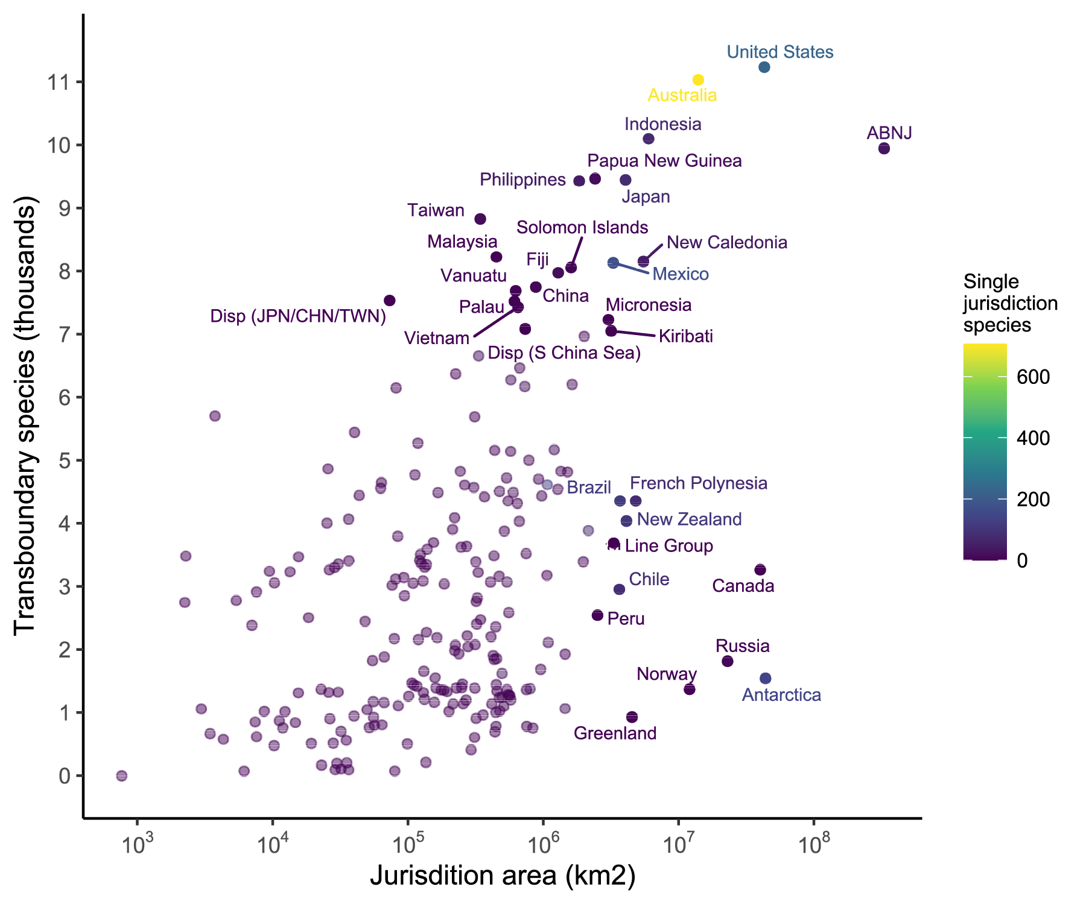
Supplementary Figure 2: Transboundary species per area. Number of transboundary species compared to area of jurisdiction (km²), shown on a log10 transformed scale. Labels show jurisdictions ranking in the top 20 for number of transboundary species or for area of jurisdiction. Disp = Disputed territory.

Supplementary Table 1: Taxonomic groupings for plant and animal species included in the analysis, and percent of species listed in the Ocean Biogeographic Information System (OBIS) database that have range maps in the IUCN or AquaMaps databases. Four kingdoms were excluded from the analysis. Groupings are not consistent across taxonomic levels (e.g., Mammals are a class of animals, whereas the group Lophophores contains multiple phyla)
Group | Subgroup 1 | Subgroup 2 | OBIS records | Records per Group | Maps per Group | Mapped (%)
Algae | Plants | Chlorophyta | 872 | 3970 | 180 | 4.5
 |  | Rhodophyta | 3098
Arthropods | Invertebrates | Arthropoda | 32419 | 32419 | 3553 | 11.0
Cnidarians & Ctenophores | Invertebrates | Cnidarians | 8324 | 8390 | 1532 | 18.3
 |  | Ctenophores | 66
Echinoderms | Invertebrates | Echinodermata | 5710 | 5710 | 1256 | 22.0
Fish (ray & lobe-finned) | Chordates | Actinopterygii | 14530 | 14530 | 12848 | 88.4
Jawless fish & lancelets | Chordates | Agnatha | 76 | 163 | 93 | 57.1
 |  | Cephalochordata | 22
 |  | Myxini | 65
Lophophores | Invertebrates | Brachiopoda | 229 | 3186 | 224 | 7.0
 |  | Bryzoa | 2907
 |  | Entoprocta | 39
 |  | Phoronida | 11
Mammals | Chordates | Mammalia | 135 | 135 | 131 | 97.0
Mollusks | Invertebrates | Mollusca | 26165 | 26165 | 5003 | 19.1
*Reptiles | Chordates | Reptilia | 89 | 89 | 74 | 83.1
*Seabirds | Chordates | Aves | 600 | 600 | 359 | 59.8
*Sharks, Rays, Chimaeras | Chordates | Chondrichthyans | 1053 | 1096 | 1199 | 109.4
 |  | Holocephali | 43
Sponges | Invertebrates | Porifera | 7688 | 7688 | 440 | 5.7
Tunicates | Chordates | Tunicata | 1843 | 1843 | 665 | 36.1
Vascular plants | Plants | Mangroves | *68 | 138 | 136 | 98.6
 |  | Seagrasses | *70
Worms & microscopic animals | Invertebrates | Acanthocephala | 110 | 17425 | 560 | 3.2
 |  | Annelida | 9100
 |  | Chaetognatha | 69
 |  | Echiura | 117
 |  | Gastrotricha | 191
 |  | Gnathostomulida | 39
 |  | Hemichordata | 57
 |  | Mesozoa | 52
 |  | Myxozoa | 48
 |  | Nematoda | 3292
 |  | Nemertea | 362
Table S1 continued
 |  | Placozoa | 2
 |  | Platyhelminthes | 3186
 |  | Rotifera | 183
 |  | Tardigrada | 202
 |  | Xenacoelomorpha | 415
Excluded |  | Bacteria | 624 | 624 | 5 | 0.8
Excluded |  | Chromista | 10784 | 10784 | 24 | 0.2
Excluded |  | Fungi | 231 | 231 | 0 | 0.0
Excluded |  | Protozoa | 267 | 267 | 18 | 6.7
*The low proportion of reptile and seabird maps compared to species listed in OBIS is due to different designations of species as marine (particularly for shorebirds and snakes). We use an expert-reviewed list of seabirds from BirdLife International, which uses a more conservative definition of a "seabird" compared to OBIS. The proportion of mapped Sharks, Rays, Chimaeras is greater than 100% due to recent changes in taxonomies

Supplementary Table 2: Species conservation status and taxonomic information. The top 100 species are shown, ranked by number of jurisdictions (Jur.) they occur in. Red List categories (Cat.) are CR = Critically Endangered, EN = Endangered, VU = Vulnerable, NT = Near Threatened, LC = Least Concern, DD = Data Deficient, None = Not assessed.
Rank | Species name | Jur. | Cat. | Species group | Class
1 | Orcinus orca | 220 | DD | Mammals | Mammalia
2 | Balaenoptera acutorostrata | 211 | LC | Mammals | Mammalia
3 | Tursiops truncatus | 211 | LC | Mammals | Mammalia
4 | Physeter macrocephalus | 210 | VU | Mammals | Mammalia
5 | Alopias vulpinus | 205 | VU | Sharks, Rays, Chimaeras | Chondrichthyes
6 | Ziphius cavirostris | 204 | LC | Mammals | Mammalia
7 | Eretmochelys imbricata | 203 | CR | Reptiles | Reptilia
8 | Grampus griseus | 202 | LC | Mammals | Mammalia
9 | Megaptera novaeangliae | 201 | LC | Mammals | Mammalia
10 | Xiphias gladius | 201 | LC | Fish (ray & lobe-finned) | Actinopterygii
11 | Pseudorca crassidens | 200 | NT | Mammals | Mammalia
12 | Microlophichthys microlophus | 200 | LC | Fish (ray & lobe-finned) | Actinopterygii
13 | Pyroteuthis margaritifera | 199 | None | Mollusks | Cephalopoda
14 | Argyropelecus hemigymnus | 198 | LC | Fish (ray & lobe-finned) | Actinopterygii
15 | Carcharodon carcharias | 197 | VU | Sharks, Rays, Chimaeras | Chondrichthyes
16 | Pteroplatytrygon violacea | 197 | LC | Sharks, Rays, Chimaeras | Chondrichthyes
17 | Remora remora | 197 | LC | Fish (ray & lobe-finned) | Actinopterygii
18 | Balaenoptera musculus | 196 | EN | Mammals | Mammalia
19 | Prionace glauca | 196 | NT | Sharks, Rays, Chimaeras | Chondrichthyes
20 | Isurus oxyrinchus | 195 | EN | Sharks, Rays, Chimaeras | Chondrichthyes
21 | Katsuwonus pelamis | 195 | LC | Fish (ray & lobe-finned) | Actinopterygii
22 | Istiophorus platypterus | 195 | LC | Fish (ray & lobe-finned) | Actinopterygii
23 | Stenella coeruleoalba | 194 | LC | Mammals | Mammalia
24 | Steno bredanensis | 192 | LC | Mammals | Mammalia
25 | Cyclothone braueri | 192 | LC | Fish (ray & lobe-finned) | Actinopterygii
26 | Chtenopteryx sicula | 190 | None | Mollusks | Cephalopoda
27 | Haliphron atlanticus | 189 | None | Mollusks | Cephalopoda
28 | Walvisteuthis virilis | 189 | None | Mollusks | Cephalopoda
29 | Lucifer typus | 187 | None | Arthropods | Malacostraca
30 | Ulva lactuca | 187 | None | Algae | Ulvophyceae
31 | Vitreledonella richardi | 187 | None | Mollusks | Cephalopoda
32 | Anoplogaster cornuta | 187 | LC | Fish (ray & lobe-finned) | Actinopterygii
33 | Cyclothone pseudopallida | 187 | LC | Fish (ray & lobe-finned) | Actinopterygii
34 | Onychoteuthis banksii | 186 | None | Mollusks | Cephalopoda
35 | Chauliodus sloani | 186 | LC | Fish (ray & lobe-finned) | Actinopterygii
36 | Cranchia scabra | 185 | None | Mollusks | Cephalopoda
37 | Lagocephalus lagocephalus | 185 | LC | Fish (ray & lobe-finned) | Actinopterygii
38 | Melanocetus johnsonii | 185 | LC | Fish (ray & lobe-finned) | Actinopterygii
39 | Sigmops elongatus | 184 | None | Fish (ray & lobe-finned) | Actinopterygii
40 | Cryptopsaras couesii | 184 | LC | Fish (ray & lobe-finned) | Actinopterygii
41 | Balaenoptera borealis | 183 | EN | Mammals | Mammalia
42 | Ulva clathrata | 182 | None | Algae | Ulvophyceae
43 | Octopoteuthis sicula | 182 | None | Mollusks | Cephalopoda
44 | Kogia breviceps | 182 | DD | Mammals | Mammalia
45 | Carcharhinus longimanus | 182 | VU | Sharks, Rays, Chimaeras | Chondrichthyes
46 | Cyclothone pallida | 182 | LC | Fish (ray & lobe-finned) | Actinopterygii
47 | Chaenophryne ramifera | 182 | LC | Fish (ray & lobe-finned) | Actinopterygii
48 | Vampyroteuthis infernalis | 181 | None | Mollusks | Cephalopoda
49 | Sternoptyx diaphana | 180 | None | Fish (ray & lobe-finned) | Actinopterygii
50 | Scopeloberyx opisthopterus | 179 | None | Fish (ray & lobe-finned) | Actinopterygii
51 | Melamphaes polylepis | 179 | None | Fish (ray & lobe-finned) | Actinopterygii
52 | Bolitaena pygmaea | 179 | None | Mollusks | Cephalopoda
53 | Kogia sima | 179 | DD | Mammals | Mammalia
54 | Chaenophryne longiceps | 179 | LC | Fish (ray & lobe-finned) | Actinopterygii
55 | Ceratias holboelli | 179 | LC | Fish (ray & lobe-finned) | Actinopterygii
56 | Liguriella podophthalma | 178 | None | Mollusks | Cephalopoda
57 | Cunina octonaria | 178 | None | Cnidarians & Ctenophores | Hydrozoa
58 | Coryphaena hippurus | 178 | LC | Fish (ray & lobe-finned) | Actinopterygii
59 | Alopias superciliosus | 178 | VU | Sharks, Rays, Chimaeras | Chondrichthyes
60 | Notolychnus valdiviae | 178 | LC | Fish (ray & lobe-finned) | Actinopterygii
61 | Melanostomias niger | 177 | None | Fish (ray & lobe-finned) | Actinopterygii
62 | Phyllodoce madeirensis | 177 | None | Worms & microscopic animals | Polychaeta
63 | Mesoplodon densirostris | 177 | DD | Mammals | Mammalia
64 | Cyclothone acclinidens | 177 | LC | Fish (ray & lobe-finned) | Actinopterygii
65 | Valenciennellus tripunctulatus | 176 | None | Fish (ray & lobe-finned) | Actinopterygii
66 | Gennadas scutatus | 176 | None | Arthropods | Malacostraca
67 | Thysanoteuthis rhombus | 176 | None | Mollusks | Cephalopoda
68 | Liocranchia reinhardti | 176 | None | Mollusks | Cephalopoda
69 | Polycheles typhlops | 176 | LC | Arthropods | Malacostraca
70 | Eurypharynx pelecanoides | 176 | LC | Fish (ray & lobe-finned) | Actinopterygii
71 | Eustomias dendriticus | 175 | None | Fish (ray & lobe-finned) | Actinopterygii
72 | Echeneis naucrates | 175 | LC | Fish (ray & lobe-finned) | Actinopterygii
73 | Bentheogennema intermedia | 174 | None | Arthropods | Malacostraca
74 | Gelidium pusillum | 174 | None | Algae | Florideophyceae
75 | Didemnum candidum | 174 | None | Tunicates | Ascidiacea
76 | Ommastrephes bartramii | 174 | None | Mollusks | Cephalopoda
77 | Glycera tesselata | 174 | None | Worms & microscopic animals | Polychaeta
78 | Cyclothone alba | 174 | LC | Fish (ray & lobe-finned) | Actinopterygii
79 | Lobianchia gemellarii | 174 | LC | Fish (ray & lobe-finned) | Actinopterygii
80 | Nemichthys scolopaceus | 173 | None | Fish (ray & lobe-finned) | Actinopterygii
81 | Systellaspis debilis | 173 | None | Arthropods | Malacostraca
82 | Japetella diaphana | 173 | None | Mollusks | Cephalopoda
83 | Remora osteochir | 173 | LC | Fish (ray & lobe-finned) | Actinopterygii
84 | Sergia japonica | 172 | None | Arthropods | Malacostraca
85 | Sandalops melancholicus | 172 | None | Mollusks | Cephalopoda
86 | Lysidice collaris | 172 | None | Worms & microscopic animals | Polychaeta
87 | Globicephala macrorhynchus | 172 | LC | Mammals | Mammalia
88 | Euprotomicrus bispinatus | 172 | LC | Sharks, Rays, Chimaeras | Chondrichthyes
89 | Taaningichthys bathyphilus | 172 | LC | Fish (ray & lobe-finned) | Actinopterygii
90 | Scopelarchus analis | 172 | LC | Fish (ray & lobe-finned) | Actinopterygii
91 | Ranzania laevis | 171 | None | Fish (ray & lobe-finned) | Actinopterygii
92 | Gnathophausia zoea | 171 | None | Arthropods | Malacostraca
93 | Stenella attenuata | 171 | LC | Mammals | Mammalia
94 | Mobula birostris | 171 | VU | Sharks, Rays, Chimaeras | Chondrichthyes
95 | Malacosteus niger | 170 | None | Fish (ray & lobe-finned) | Actinopterygii
96 | Bathothauma lyromma | 170 | None | Mollusks | Cephalopoda
97 | Pterygioteuthis giardi | 170 | None | Mollusks | Cephalopoda
98 | Manta birostris | 169 | None | Sharks, Rays, Chimaeras | Elasmobranchii
99 | Systellaspis pellucida | 169 | None | Arthropods | Malacostraca
100 | Balaenoptera brydei | 169 | None | Mammals | Mammalia

Supplementary Table 3: Species totals for 228 jurisdictions ranked by number of transboundary (TB) species. TB Thr = Threatened (Critically Endangered, Endangered, Vulnerable) species, One Jur. = one (single) jurisdiction species, TB/area = rank for number of transboundary species per km². Composite World Governance Indicator score is scaled 0-1 (1 = best governance score)
Jurisdiction | Number of species |  |  | Rank |  |  | WGI score
 | TB | TB Thr | One Jur | TB | TB/area | Area
United States | 11234 | 141 | 231 | 1 | 222 | 3 | 0.75
Australia | 11033 | 222 | 706 | 2 | 220 | 6 | 0.82
Indonesia | 10099 | 305 | 75 | 3 | 204 | 8 | 0.47
ABNJ | 9946 | 125 | 31 | 4 | 228 | 1 | NA
Papua New Guinea | 9469 | 237 | 17 | 5 | 166 | 21 | 0.38
Japan | 9450 | 207 | 82 | 6 | 188 | 13 | 0.77
Philippines | 9431 | 276 | 45 | 7 | 151 | 25 | 0.43
Taiwan | 8827 | 193 | 17 | 8 | 60 | 94 | 0.72
Malaysia | 8226 | 274 | 1 | 9 | 75 | 77 | 0.59
New Caledonia | 8154 | 142 | 45 | 10 | 207 | 9 | 0.72
Mexico | 8133 | 107 | 174 | 11 | 185 | 17 | 0.43
Solomon Isls | 8058 | 189 | 5 | 12 | 154 | 27 | 0.46
Fiji | 7974 | 135 | 18 | 13 | 140 | 32 | 0.54
China | 7750 | 106 | 11 | 14 | 115 | 41 | 0.44
Vanuatu | 7689 | 123 | 4 | 15 | 97 | 54 | 0.52
Disp (JPN/CHN/TWN) | 7538 | 151 | 0 | 16 | 24 | 167 | NA
Palau | 7524 | 116 | 1 | 17 | 96 | 55 | 0.56
Vietnam | 7429 | 173 | 1 | 18 | 101 | 52 | 0.43
Micronesia | 7229 | 153 | 3 | 19 | 186 | 19 | 0.57
Disp (S China Sea) | 7084 | 120 | 1 | 20 | 108 | 48 | NA
Kiribati | 7051 | 114 | 0 | 21 | 192 | 18 | 0.57
Marshall Isls | 6969 | 110 | 4 | 22 | 170 | 23 | 0.47
Panama | 6655 | 80 | 28 | 23 | 69 | 95 | 0.52
Tonga | 6465 | 78 | 10 | 24 | 107 | 50 | 0.55
Nicaragua | 6369 | 68 | 0 | 25 | 50 | 120 | 0.32
Costa Rica | 6274 | 82 | 17 | 26 | 102 | 57 | 0.62
India | 6204 | 144 | 12 | 27 | 167 | 26 | 0.48
SI Table 3 cont.
Colombia | 6172 | 89 | 20 | 28 | 119 | 49 | 0.46
Disp (AUS/IND/TLS) | 6148 | 123 | 0 | 29 | 31 | 162 | NA
Disp (AUS/PNG) | 5702 | 145 | 0 | 30 | 2 | 223 | NA
Nauru | 5689 | 31 | 0 | 31 | 74 | 103 | 0.49
East Timor | 5444 | 227 | 0 | 32 | 16 | 181 | 0.41
Guatemala | 5276 | 66 | 0 | 33 | 41 | 150 | 0.38
Madagascar | 5169 | 122 | 20 | 34 | 163 | 34 | 0.35
Howland Isl & Baker Isl | 5160 | 33 | 0 | 35 | 100 | 84 | 0.75
Mozambique | 5144 | 130 | 8 | 36 | 113 | 58 | 0.34
Somalia | 5003 | 102 | 1 | 37 | 139 | 44 | 0.08
Brunei | 4866 | 230 | 0 | 38 | 13 | 199 | 0.62
Seychelles | 4827 | 105 | 5 | 39 | 168 | 31 | 0.57
Tanzania | 4826 | 94 | 2 | 40 | 70 | 117 | 0.39
Tuvalu | 4815 | 115 | 0 | 41 | 175 | 28 | 0.56
Kenya | 4771 | 95 | 2 | 42 | 43 | 152 | 0.39
Sri Lanka | 4720 | 133 | 2 | 43 | 114 | 67 | 0.47
Maldives | 4701 | 84 | 5 | 44 | 152 | 40 | 0.40
Mayotte | 4648 | 93 | 0 | 45 | 32 | 171 | 0.72
South Africa | 4613 | 98 | 111 | 46 | 162 | 36 | 0.53
Wallis & Futuna | 4609 | 72 | 1 | 47 | 77 | 112 | 0.72
Thailand | 4571 | 226 | 4 | 48 | 83 | 106 | 0.44
Juan de Nova Isl | 4558 | 89 | 0 | 49 | 33 | 172 | 0.72
Mauritius | 4542 | 110 | 8 | 50 | 169 | 33 | 0.65
Venezuela | 4509 | 68 | 9 | 51 | 109 | 73 | 0.15
Bahamas | 4491 | 69 | 13 | 52 | 127 | 56 | 0.62
Comoro Isls | 4488 | 95 | 1 | 53 | 56 | 131 | NA
Glorioso Isls | 4443 | 87 | 0 | 54 | 25 | 180 | 0.72
Northern Mariana Isls & Guam | 4435 | 90 | 7 | 55 | 157 | 38 | 0.75
Cuba | 4421 | 62 | 2 | 56 | 99 | 91 | 0.41
Yemen | 4357 | 120 | 2 | 57 | 123 | 64 | 0.10
Brazil | 4356 | 83 | 123 | 58 | 211 | 14 | 0.45
SI Table 3 cont.
French Polynesia | 4355 | 77 | 81 | 59 | 217 | 10 | 0.72
British Indian Ocean Territory | 4319 | 102 | 3 | 60 | 136 | 53 | 0.77
Honduras | 4091 | 56 | 1 | 61 | 72 | 123 | 0.37
Belize | 4069 | 57 | 9 | 62 | 22 | 185 | 0.44
New Zealand | 4039 | 64 | 111 | 63 | 215 | 12 | 0.86
Andaman & Nicobar | 4035 | 102 | 4 | 64 | 142 | 51 | 0.48
Aruba | 4005 | 60 | 1 | 65 | 14 | 200 | 0.74
Puerto Rico & Virgin Isls (USA) | 3906 | 60 | 2 | 66 | 73 | 125 | 0.75
Ecuador | 3889 | 58 | 65 | 67 | 199 | 22 | 0.42
Myanmar | 3880 | 136 | 4 | 68 | 126 | 68 | 0.31
Disp (JPN/KOR) | 3798 | 49 | 0 | 69 | 40 | 161 | NA
Turks & Caicos Isls | 3699 | 57 | 0 | 70 | 64 | 136 | 0.77
Line Group | 3690 | 58 | 0 | 71 | 212 | 16 | 0.57
Dominican Republic | 3640 | 55 | 0 | 72 | 88 | 110 | 0.45
Jamaica | 3627 | 52 | 0 | 73 | 85 | 116 | 0.55
Guadeloupe & Martinique | 3593 | 56 | 3 | 74 | 59 | 137 | 0.72
Phoenix Group | 3522 | 71 | 1 | 75 | 155 | 47 | 0.57
Haiti | 3510 | 54 | 4 | 76 | 51 | 147 | 0.27
Norfolk Isl | 3488 | 52 | 4 | 77 | 122 | 86 | 0.82
Oecussi Ambeno | 3485 | 28 | 0 | 78 | 1 | 226 | 0.41
Saint Lucia | 3473 | 50 | 0 | 79 | 11 | 205 | 0.61
Bassas da India | 3414 | 26 | 0 | 80 | 54 | 148 | 0.72
Saint Vincent & the Grenadines | 3410 | 51 | 0 | 81 | 26 | 183 | 0.61
Cook Isls | 3395 | 65 | 3 | 82 | 203 | 24 | 0.52
Reunion | 3394 | 94 | 4 | 83 | 103 | 101 | 0.69
Ile Europa | 3369 | 28 | 0 | 84 | 57 | 146 | 0.72
Curacao | 3359 | 32 | 2 | 85 | 23 | 190 | 0.66
Guyana | 3351 | 40 | 0 | 86 | 62 | 138 | 0.46
Samoa | 3307 | 92 | 0 | 87 | 61 | 141 | 0.63
Dominica | 3303 | 53 | 0 | 88 | 20 | 194 | 0.60
Canada | 3266 | 60 | 0 | 89 | 225 | 4 | 0.82
SI Table 3 cont.
Grenada | 3265 | 54 | 0 | 90 | 18 | 197 | 0.56
Saba | 3243 | 52 | 0 | 91 | 7 | 214 | 0.66
Bonaire | 3235 | 31 | 0 | 92 | 10 | 208 | 0.66
Christmas Isl | 3225 | 28 | 1 | 93 | 106 | 96 | 0.82
Palmyra Atoll | 3179 | 41 | 0 | 94 | 176 | 37 | 0.75
Cocos Isls | 3166 | 49 | 1 | 95 | 135 | 75 | 0.82
Anguilla | 3145 | 56 | 0 | 96 | 47 | 159 | 0.67
British Virgin Isls | 3120 | 59 | 0 | 97 | 45 | 163 | 0.77
Suriname | 3089 | 42 | 0 | 98 | 63 | 145 | 0.46
Oman | 3072 | 73 | 21 | 99 | 145 | 65 | 0.53
American Samoa | 3071 | 93 | 0 | 100 | 125 | 90 | 0.68
Saint Kitts & Nevis | 3059 | 50 | 0 | 101 | 9 | 212 | 0.62
Antigua & Barbuda | 3052 | 54 | 0 | 102 | 53 | 154 | 0.58
Barbados | 3041 | 50 | 2 | 103 | 81 | 128 | 0.66
Trinidad & Tobago | 3021 | 60 | 3 | 104 | 44 | 166 | 0.52
Chile | 2955 | 58 | 86 | 105 | 219 | 15 | 0.70
Montserrat | 2917 | 50 | 0 | 106 | 5 | 217 | 0.77
El Salvador | 2855 | 33 | 0 | 107 | 49 | 158 | 0.43
South Korea | 2820 | 55 | 1 | 108 | 116 | 97 | 0.68
Northern Saint-Martin | 2780 | 51 | 0 | 109 | 4 | 221 | 0.72
Jarvis Isl | 2763 | 33 | 0 | 110 | 118 | 99 | 0.75
Sint Eustatius | 2749 | 27 | 0 | 111 | 3 | 227 | 0.66
Spain | 2587 | 63 | 3 | 112 | 156 | 62 | 0.66
Peru | 2546 | 51 | 6 | 113 | 214 | 20 | 0.47
Disp (COL/JAM) | 2508 | 22 | 0 | 114 | 15 | 204 | NA
France | 2475 | 59 | 1 | 115 | 133 | 93 | 0.72
Cambodia | 2450 | 120 | 0 | 116 | 37 | 179 | 0.35
Tokelau | 2406 | 30 | 0 | 117 | 128 | 98 | 0.86
Djibouti | 2386 | 74 | 0 | 118 | 8 | 219 | 0.34
Johnston Atoll | 2362 | 34 | 0 | 119 | 149 | 81 | NA
French Guiana | 2277 | 41 | 0 | 120 | 79 | 139 | 0.72
SI Table 3 cont.
Ile Tromelin | 2221 | 21 | 0 | 121 | 121 | 109 | 0.72
Wake Isl | 2206 | 33 | 0 | 122 | 147 | 89 | 0.75
Iran | 2192 | 59 | 0 | 123 | 89 | 132 | 0.30
Eritrea | 2176 | 100 | 1 | 124 | 55 | 165 | 0.18
Cayman Isls | 2161 | 50 | 3 | 125 | 76 | 149 | 0.67
Argentina | 2113 | 57 | 11 | 126 | 197 | 35 | 0.50
Portugal | 2078 | 56 | 0 | 127 | 137 | 102 | 0.71
Pakistan | 2072 | 69 | 2 | 128 | 110 | 121 | 0.31
Morocco | 2046 | 62 | 0 | 129 | 131 | 108 | 0.44
Saudi Arabia | 1983 | 115 | 3 | 130 | 112 | 122 | 0.45
Egypt | 1934 | 123 | 5 | 131 | 120 | 118 | 0.34
United Kingdom | 1929 | 44 | 0 | 132 | 209 | 29 | 0.77
Ireland | 1906 | 42 | 1 | 133 | 160 | 87 | 0.78
Sudan | 1884 | 94 | 0 | 134 | 52 | 168 | 0.18
Bermuda | 1856 | 30 | 8 | 135 | 165 | 78 | 0.72
Clipperton Isl | 1844 | 34 | 8 | 136 | 164 | 85 | NA
United Arab Emirates | 1824 | 53 | 0 | 137 | 48 | 176 | 0.63
Russia | 1815 | 52 | 7 | 138 | 226 | 5 | 0.37
Azores | 1689 | 39 | 1 | 139 | 200 | 39 | 0.71
Uruguay | 1658 | 61 | 0 | 140 | 92 | 143 | 0.67
Angola | 1622 | 57 | 24 | 141 | 173 | 71 | 0.32
Senegal | 1556 | 66 | 9 | 142 | 105 | 134 | 0.48
Antarctica | 1541 | 29 | 145 | 143 | 227 | 2 | NA
Guinea Bissau | 1470 | 56 | 0 | 144 | 87 | 155 | 0.27
Western Sahara | 1454 | 56 | 0 | 145 | 144 | 114 | NA
Canary Isls | 1447 | 56 | 1 | 146 | 174 | 79 | 0.66
Guinea | 1438 | 54 | 1 | 147 | 91 | 153 | 0.31
North Korea | 1419 | 39 | 0 | 148 | 98 | 151 | 0.18
Liberia | 1398 | 54 | 1 | 149 | 146 | 115 | 0.35
Sierra Leone | 1391 | 52 | 1 | 150 | 117 | 119 | 0.51
Ghana | 1391 | 59 | 0 | 150 | 141 | 133 | 0.38
SI Table 3 cont.
Equatorial Guinea | 1389 | 58 | 0 | 151 | 159 | 104 | 0.24
Cape Verde | 1381 | 43 | 45 | 152 | 202 | 43 | 0.60
Norway | 1372 | 32 | 2 | 153 | 224 | 7 | 0.85
Gambia | 1370 | 61 | 0 | 154 | 35 | 202 | 0.42
Italy | 1367 | 57 | 2 | 155 | 183 | 66 | 0.60
Iceland | 1365 | 23 | 2 | 156 | 198 | 46 | 0.81
Ivory Coast | 1359 | 56 | 0 | 157 | 124 | 130 | 0.40
Nigeria | 1358 | 55 | 2 | 158 | 130 | 129 | 0.29
Madeira | 1344 | 54 | 3 | 159 | 177 | 76 | 0.71
Gabon | 1335 | 53 | 1 | 160 | 134 | 127 | 0.35
Benin | 1327 | 52 | 0 | 161 | 42 | 191 | 0.44
Algeria | 1322 | 47 | 0 | 162 | 104 | 144 | 0.34
Disp (EGY/SDN) | 1322 | 94 | 0 | 162 | 38 | 198 | NA
Togo | 1315 | 52 | 0 | 163 | 27 | 206 | 0.34
Falkland Isls | 1287 | 26 | 2 | 164 | 187 | 63 | 0.77
Namibia | 1278 | 54 | 1 | 165 | 189 | 61 | 0.56
Kerguelen Isls | 1270 | 18 | 21 | 166 | 191 | 60 | 0.72
Tunisia | 1263 | 50 | 0 | 167 | 94 | 156 | 0.46
Greece | 1244 | 45 | 2 | 168 | 184 | 70 | 0.56
Prince Edward Isls | 1242 | 19 | 0 | 169 | 181 | 74 | 0.53
Sao Tome & Principe | 1213 | 40 | 3 | 170 | 111 | 142 | 0.46
Crozet Isls | 1206 | 20 | 2 | 171 | 195 | 59 | 0.72
Faeroe Isls | 1201 | 24 | 0 | 172 | 158 | 111 | 0.77
Croatia | 1176 | 44 | 1 | 173 | 67 | 175 | 0.59
Mauritania | 1165 | 56 | 0 | 174 | 129 | 135 | 0.35
Disp (JPN/KOR 2) | 1160 | 17 | 0 | 175 | 78 | 169 | NA
Turkey | 1143 | 43 | 0 | 176 | 161 | 113 | 0.40
Heard & McDonald Isls | 1139 | 16 | 0 | 177 | 179 | 88 | 0.82
Disp (JPN/RUS) | 1138 | 31 | 0 | 178 | 148 | 124 | NA
Bangladesh | 1111 | 56 | 0 | 179 | 90 | 160 | 0.34
Amsterdam Isl & Saint Paul Isl | 1104 | 25 | 6 | 180 | 193 | 69 | 0.72
SI Table 3 cont.
South Georgia & South Sandwich Isls | 1066 | 17 | 26 | 181 | 221 | 30 | 0.77
Jersey | 1061 | 28 | 0 | 182 | 6 | 225 | 0.75
Disp (ESH/MAR) | 1049 | 47 | 0 | 183 | 68 | 178 | NA
Macquarie Isl | 1029 | 21 | 3 | 184 | 194 | 72 | 0.82
Guernsey | 1023 | 29 | 0 | 185 | 19 | 215 | 0.75
Denmark | 1022 | 23 | 0 | 186 | 153 | 126 | 0.84
Saint Pierre & Miquelon | 1020 | 28 | 0 | 187 | 28 | 209 | 0.72
Ascension | 1008 | 27 | 9 | 188 | 190 | 82 | NA
Libya | 965 | 44 | 0 | 189 | 180 | 92 | 0.12
Republique du Congo | 948 | 52 | 1 | 190 | 65 | 182 | 0.17
Greenland | 931 | 16 | 0 | 191 | 223 | 11 | 0.78
Malta | 926 | 38 | 0 | 192 | 80 | 174 | 0.71
Niue | 910 | 32 | 2 | 193 | 178 | 100 | 0.42
Democratic Republic of the Congo | 904 | 49 | 0 | 194 | 46 | 196 | 0.17
Albania | 873 | 41 | 0 | 195 | 30 | 211 | 0.50
Montenegro | 855 | 41 | 0 | 196 | 21 | 218 | 0.53
Cameroon | 845 | 53 | 0 | 197 | 36 | 207 | 0.29
Netherlands | 808 | 22 | 0 | 198 | 93 | 170 | 0.84
Germany | 800 | 21 | 0 | 199 | 86 | 173 | 0.80
Tristan da Cunha | 786 | 28 | 1 | 200 | 213 | 45 | 0.77
Saint Helena | 785 | 25 | 7 | 201 | 201 | 80 | 0.77
Disp (KEN/SOM) | 766 | 28 | 0 | 202 | 84 | 177 | NA
Kuwait | 761 | 44 | 0 | 203 | 34 | 210 | 0.48
Pitcairn | 758 | 29 | 1 | 204 | 218 | 42 | 0.77
Qatar | 704 | 44 | 0 | 205 | 66 | 188 | 0.57
Bouvet Isl | 697 | 12 | 0 | 206 | 206 | 83 | 0.85
Belgium | 668 | 22 | 0 | 207 | 12 | 224 | 0.74
Bahrain | 621 | 44 | 0 | 208 | 29 | 216 | 0.45
Sweden | 610 | 23 | 0 | 209 | 196 | 105 | 0.84
Disp (TTO/VEN/GUY) | 580 | 20 | 0 | 210 | 17 | 222 | NA
Disp (NGA/STP) | 564 | 29 | 0 | 211 | 82 | 187 | NA
SI Table 3 cont.
Israel | 519 | 34 | 1 | 212 | 71 | 195 | 0.63
Lebanon | 515 | 29 | 0 | 213 | 58 | 203 | 0.33
Cyprus | 509 | 32 | 0 | 214 | 150 | 157 | 0.66
Syria | 480 | 28 | 0 | 215 | 39 | 213 | 0.11
Jan Mayen | 412 | 11 | 0 | 216 | 208 | 107 | 0.85
Ukraine | 214 | 13 | 1 | 217 | 205 | 140 | 0.36
Bulgaria | 205 | 13 | 0 | 218 | 143 | 186 | 0.55
Romania | 197 | 13 | 0 | 219 | 138 | 192 | 0.53
Georgia | 167 | 10 | 0 | 220 | 132 | 201 | 0.59
Poland | 109 | 7 | 0 | 221 | 171 | 189 | 0.63
Latvia | 97 | 7 | 0 | 222 | 172 | 193 | 0.66
Estonia | 95 | 7 | 0 | 223 | 182 | 184 | 0.74
Finland | 77 | 5 | 0 | 224 | 216 | 164 | 0.85
Lithuania | 76 | 6 | 0 | 225 | 95 | 220 | 0.68
Singapore | 1 | 0 | 0 | 226 | 210 | 228 | 0.83

