Spike protein of SARS-CoV-2: Impact of single amino acid mutation and effect of drug binding to the variant-insilico analysis.
Supplementary data
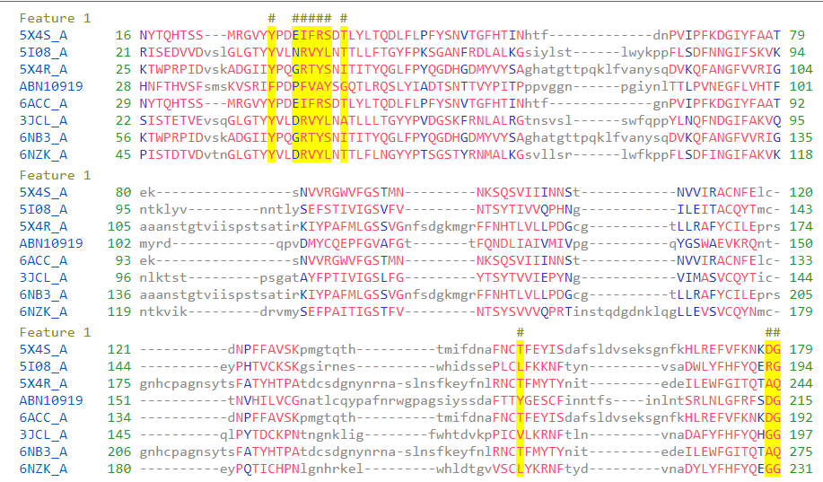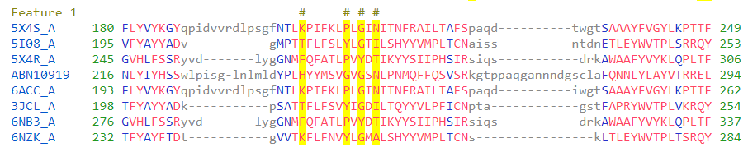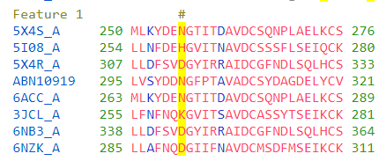
Figure 1.1: Sequence alignment of NTD- S1-domain of S-protein of diverse members. Conserved domain analysis was carried for the following species: SARS-CoV (PDB ID: 5X4S_A, 6ACC_A), HKU1 (PDB ID: 6ACC_A), MERES (PDB ID: 5X4R_A, 6NB3_A), Bat Coronavirus HKU9-2 (PDB ID: ABN10919), Murine hepatitis virus (PDB ID: 3JCL_A), Human coronavirus OC43 (PDB ID: 6NZK_A). Amino acids in red indicates highly conserved region and blue indicated moderately conserved region. The dashed line indicates variation in the sequence length after alignment and lower cases of amino acid indicates unaligned amino acids. The # symbol represents the amino acids involved in the catalytic or binding activity.

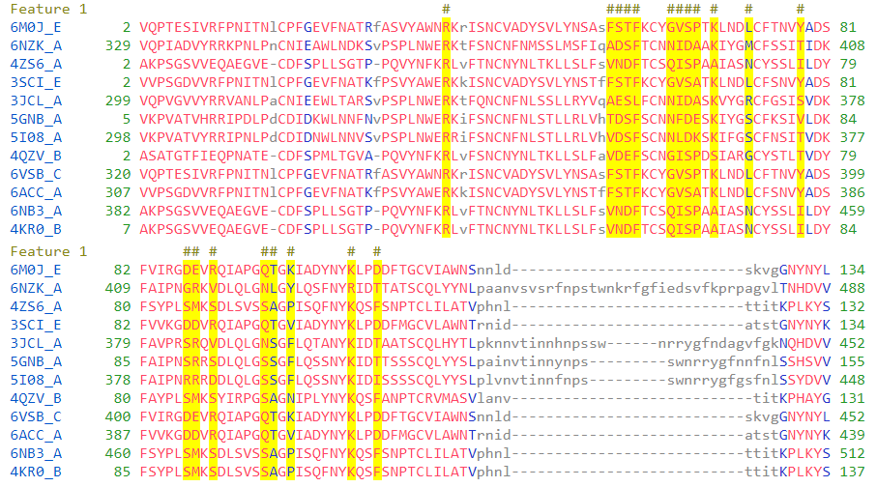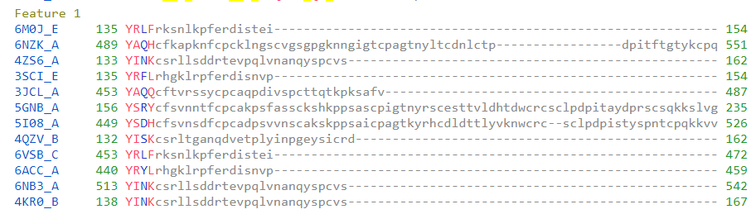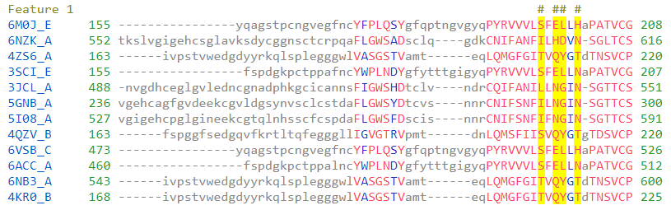
Figure 1.2: Sequence alignment of CTD of S1-domain of S-protein. Conserved domain analysis was carried out for the following species: SARS-CoV-2 (PDB ID: 6M0J_E), HCoV-OC43 (PDB ID: 6NZK_A), MERS (PDB ID: 4ZS6_A, 6NB3_A), SARS (PDB ID: 3SCI_E, 6VSB_C, 6ACC_A), Murine Hepatitis Virus (PDB ID: 3JCL_A), HKU1 (PDB ID: 5GNB_A, 5I08_A), HKU4 (PDB ID: 4QZV_B), 2cEMC (PDB ID: 4KR0_B).

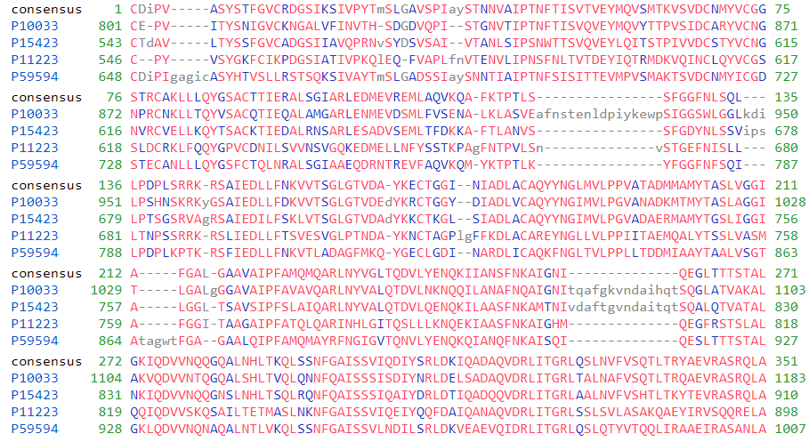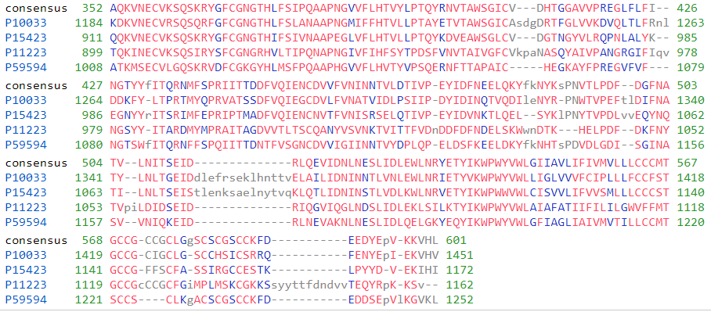
Figure 1.3: Sequence alignment of S2-domain of S-protein. Feline infectious peritonitis virus (PDB ID: P10033), Human coronavirus 229E (PDB ID: P15423), Avian infectious bronchitis virus (PDB ID: P11223), SARS coronavirus (PDB ID: P59594).

Table 1: List of S-protein sequence Accession number obtained from NCBI viruses with the Country name.
So. No. | Accession Number | Country | So.No. | Accession Number | Country
1. | NC_045512 | Wuhan | 41. | MT607244 | India
2. | MT627325 | China | 42. | MT576034 | India
3. | MT622319 | China | 43. | MT576042 | India
4. | MT568634 | China | 44. | MT509669 | USA
5. | MT568635 | China | 45. | MT246488 | USA
6. | MT568637 | China | 46. | MT252690 | USA
7. | MT568640 | China | 47. | MT345820 | USA
8. | LC553263 | Japan | 48. | MT259262 | USA
9. | LC553257 | Japan | 49. | MT641485 | USA
10. | LC553269 | Japan | 50. | MT269282 | USA
11. | MT590598 | Taiwan | 51. | MT246461 | USA
12. | MT499173.1 | USA | 52. | MT293177 | USA
13. | MT460139 | USA | 53. | MT293208 | USA
14. | MT506885 | USA | 54. | MT263403 | USA
15. | MT499201.1 | USA | 55. | MT263412 | USA
16. | MT444608 | USA | 56. | MT263418 | USA
17. | MT444612 | USA | 57. | MT259236 | USA
18. | MT439311 | USA | 58. | MT262915 | USA
19. | MT461603 | USA | 59. | MT263457 | USA
20. | MT499205 | USA | 60. | MT412200 | USA
21. | MT499200 | USA | 61. | MT385426 | USA
22. | MT506888 | USA | 62. | MT385440 | USA
23. | MT506701 | USA | 63. | MT385458 | USA
24. | MT500122 | Pakistan | 64. | MT509958 | Bangladesh
25. | MT270101 | Germany | 65. | MT622321 | Italy
26. | MT507271 | Jamaica | 66. | MT527178 | Italy
27. | MT499208 | Poland | 67. | MT528235 | Italy
28. | MT470102 | France | 68. | MT528237 | Italy
29. | MT450935 | Australia | 69. | MT077125 | Italy
30. | MT451139 | Australia | 70. | MT510690 | Africa
31. | MT439595 | India | 71. | MT510691 | Africa
32. | MT576044 | India | 72. | MT510692 | Africa
33. | MT635269 | India | 73. | MT510693 | Africa
34. | MT635270 | India | 74. | MT510696 | Africa
35. | MT635407 | India | 75. | MT510697 | Africa
36. | MT635410 | India | 76. | MT510700 | Africa
37. | MT635856 | India | 77. | MT510703 | Africa
38. | MT509651 | India | 78. | MT510694 | Africa
39. | MT509657 | India | 79. | MT510695 | Africa
40. | MT509504 | India | 80. | MT510698 | Africa

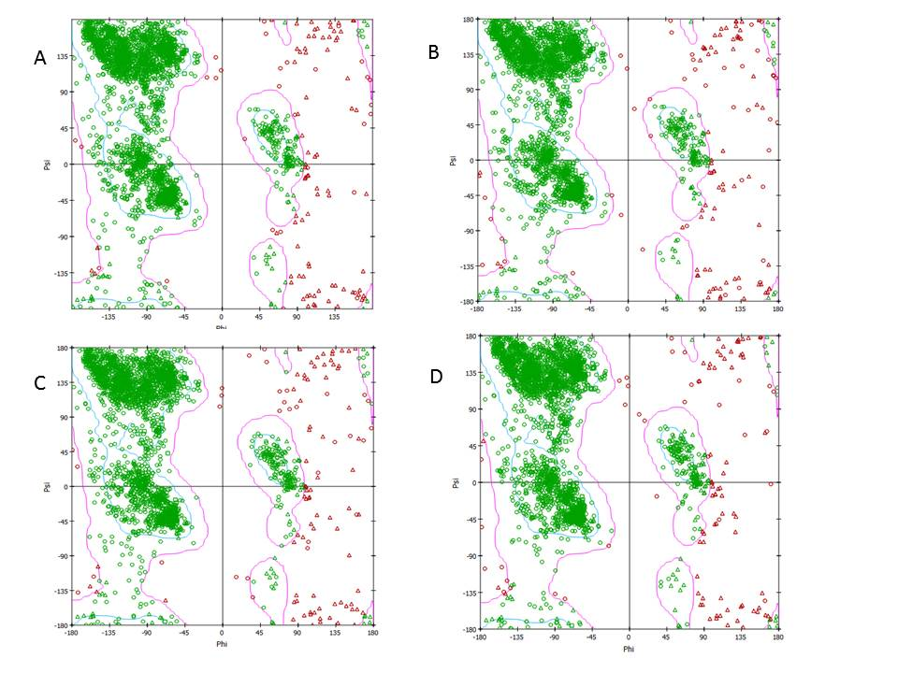
Figure 2: Ramachandran plot of the modelled protein. A) Wild type S-protein of SARS-CoV-2 B) D614G mutant of S-protein C) G476S mutant of S-protein D) V483A mutant of S-protein

Table 2:
The interacting amino acids of wild type S-protein and mutants are tabulated along with the human ACE2 receptor amino acids.
Wild type | G476S | V483A | D614G | ACE2
SER459 | ARG346  THR345 | ASP482  LEU517  HIS519  LEU518 | LYS458  SER459  ASN460 | TYR65
TRP353  PRO426  LEU425  LYS424  ARG355 | THR478  PRO479  SER477 | TYR351  ALA352 | TRP353  ASN422  TYR423  LYS424 | ASN46
LYS462  PHE464  CYS488  TYR489  SER459  ARG457  ASN487  PRO491  PRO463  PHE490 | TYR451  ALA348  ASN450  SER349  LEU452  ASN354  PHE347  ARG346 | LYS424 | PRO463  TYR489  ASN460  LYS462  LEU461  PHE464  SER459 | LYS13
VAL483  GLU484  GLN474  GLY482  ASN481  GLY485  ASN487 | LEU492  SER469  PRO491  TYR351  ARG454  PHE490 | ARG454 | GLY485  ASN481  PHE486  GLY482  ASN487  GLN474  VAL483  GLU484 | ASP20
THR478  PRO479 | ILE472  TYR473 | THR478  GLU484  GLY476  PRO479  SER477 | PRO479  THR478 | ASN312
ARG454  GLY485  GLU484 | LEU452  PHE490  LEU492 | PHE490  ARG454 | ARG457  ARG454  GLU484 | LEU21
GLU484  VAL483  GLY482  GLN474 | ALA475  PRO491  ILE468  ARG454  SER476  ILE472  PHE490  SER469 | LYS458  TYR489  PHE490  ARG454  PRO491  ASN481 | ALA474  GLY476  GLN474  GLU484 | GLN24
ASN481  GLY482  CYS480  PRO479  GLN474 | THR470  SER469  ILE468  ILE472 | CYS480  THR478 | GLN474  ASN481  GLY482  PRO479  CYS480 | TYR23
PRO479  THR478  ALA475  SER477  CYS480  GLY476  GLN474 | GLN474  TYR473  SER476  ALA475  ILE472 | CYS480  TYR489  ASN481  THR478  GLY482 | CYS480  ALA475  THR478  SER477  GLN474  GLY476 | LEU27
ARG454  TYR421  ARG457 | LEU452  ASN450  TYR451 | TRP353  LYS424 | TYR421  ARG454  ARG457 | PHE54
ASN487  ARG457  ARG454  TYR489  PRO491  PHE490 | SER349  TYR351  LEU452  ASN450  ALA352  LEU492  TYR351 | LYS424 | TYR489  ASN487  PHE490  PRO491  ARG454  ARG457 | GLU17
PHE490  PRO463  PRO491  ASN487  ARG457  SER459  TYR489  CYS488  PHE464  LYS462 | ARG346  PHE347  ASN354  LEU452  SER349  ASN450  ALA348  TYR451 | LYS424 | SER459  SER464  LEU461  LYS462  ASN460  TYR489  PRO463 | LYS13
ARG457  TYR421  LEU455  ARG454  PHE456 | ASN448  GLY446  ASN450  TYR449  GLY447 | TYR423  LEU425  LYS424  ARG355  TRP353  PRO426  SER514  ASP398 | PHE456  LEU455  TYR421  ARG454  ARG457 | GLU57
PRO479  THR478 | GLN474  TYR473  ILE472 | SER377  THR478 | THR478 | ARG339
SER477  THR478  ALA475  GLY476 | VAL483  CYS480  ALA475  SER476  GLN474 | TYR489  PHE486  GLU484  GLY485  THR478  ALA483  SER477 | GLY476  SER477  ALA475 | ASN31
ALA475  TRP353  ARG355 | CYS480  SER476  PRO479  THR478  VAL483  SER477 | TYR489  ASN487  PHE490  LEU492  CYS488 | TRP353  ALA475  ARG355 | ASN43
PRO479  ASN481 | ILE472 | CYS480  THR478 | ASN481 | ASP337
GLU516  ASN394  ARG357  TYR396 | CYS480  PRO479  ASN481 | TYR489  ASN487 | HIS519  TYR396  GLU516  ARG357 | GLU39
ASP420  LYS424  TYR351  TYR421  ASN422  GLU484 | LEU492  SER494 | ARG454  TRP353  TYR351  ALA352  TYR421  ASN422  VAL350 | GLY485  TRP353  TYR421  ARG454  ASP420  TYR351  GLU484  ASN422 | LYS50
SER459  ASN460 | ARG346  THR345 | PRO426 | SER459  ASN460 | PHE10
ARG457  PHE456 | ASN450  ARG346 | PHE429  PHE515  ASP428  PRO426 | SER459  ARG457  PHE456  LYS458 | LEU61
TYR421  ASP420  LYS424 | TYR449 | ARG355  TRP353 | TYR421  LYS424  ASP420 | ALA53
ARG457 | ASN450 | LYS424  ARG355  PRO426 | ARG457  LYS458  SER459 | GLN58

