Supplementary material

Recognition of potential Covid-19 drug treatments through the study of existing protein-drug and protein-protein structures: an analysis of kinetically active residues

Supplementary material
Ognjen Perišić¹
(1) Big Blue Genomics, Vojvode Brane 32, 11000 Belgrade, Serbia, ognjen.perisic@gmail.com
August 9, 2020

Supplementary material figures

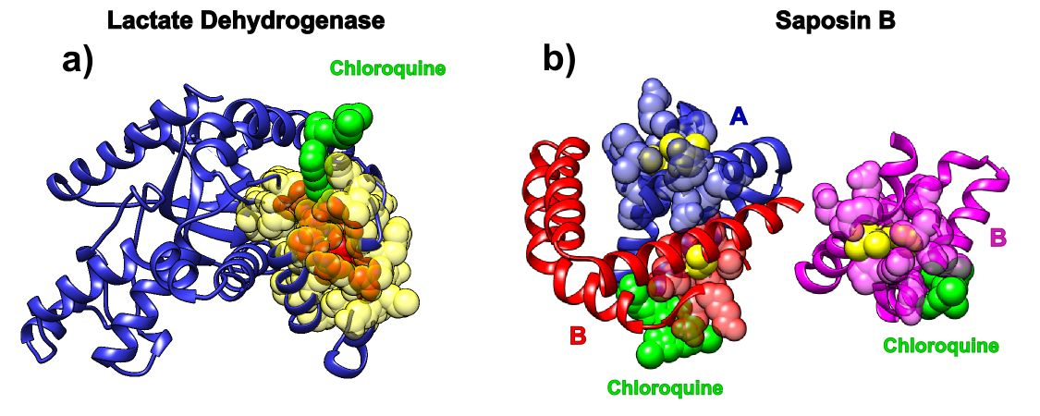
Figure S1. Hot residues and contact predictions for Lactate Dehydrogenase and Saposin B, determined by SAGNM. Images on the left depict chloroquine bound to cofactor binding site of Plasmodium Falciparum Lactate Dehydrogenase (pdb id 1cet). Images on the right depict chloroquine bound to Saposin B (pdb id 4v2o). a) Lactate Dehydrogenase is depicted as blue ribbon, SAGNM predictions are transparent yellow atoms and hot residues are red atoms. Chloroquine is depicted as green atoms. b) Saposin B chains are depicted as blue (chain A), pink (chain B) and red (chain C) ribbons. SAGNM predictions are depicted as transparent blue, pink and red atoms, and hot atoms are depicted as yellow atoms. Chloroquine molecules are depicted via green atoms.

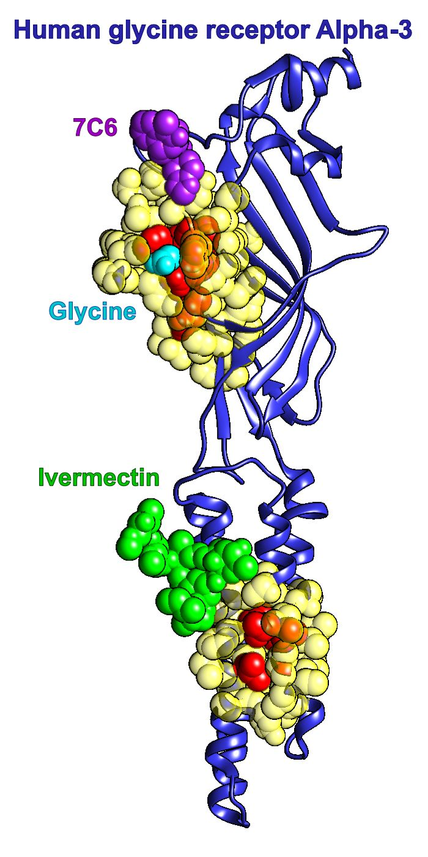
Figure S2. Ivermectin and its target protein, human glycine receptor Alpha-3 (pdb id 5vdh) with hot residues and contact predictions determined by SAGNM. Chain A from human glycine receptor Alpha-3 is represented as a blue ribbon. SAGNM predictions are depicted as transparent yellow atoms and hot residues are red atoms. Ivermectin is represented via green atoms. Glycine molecule is represented as cyan atoms. 7C6 molecule is represented as purple atoms.

The SAGNM algorithm recognized the residues Glu-157, Ser-158, Phe-168, Phe-207, Thr-208, Cys-209, Ile-210, Glu-211, Ser-238, Gly-256, Thr-259, Val-260, Val-294 and Leu-298 as from the chain A from 5vdh.pdb as kinetically hot. Their influence is spread to the residues Asn-38, Val-39, Thr-40, Cys-41, Pro-96, Asp-97, Leu-98, Phe-99, Phe-100, Ala-101, Ile-153, Met-154, Gln-155, Leu-156, Glu-157, Ser-158, Phe-159, Gly-160, Tyr-161, Thr-162, Met-163, Asn-164, Asp-165, Leu-166, Ile-167, Phe-168, Glu-169, Trp-170, Gln-171, Asp-172, Leu-195, Arg-196, Tyr-197, Cys-198, Thr-199, Lys-200, His-201, Asn-203, Thr-204, Gly-205, Lys-206, Phe-207, Thr-208, Cys-209, Ile-210, Glu-211, Val-212, Arg-213, Phe-214, His-215, Ile-234, Val-235, Ile-236, Leu-237, Ser-238, Trp-239, Val-240, Ser-241, Phe-242, Arg-252, Val-253, Ala-254, Leu-255, Gly-256, Ile-257, Thr-258, Thr-259, Val-260, Leu-261, Thr-262, Met-263, Thr-264, Cys-290, Leu-291, Leu-292, Phe-293, Val-294, Phe-295, Ser-296, Ala-297, Leu-298, Leu-299, Glu-300, Tyr-301 and Ala-302.
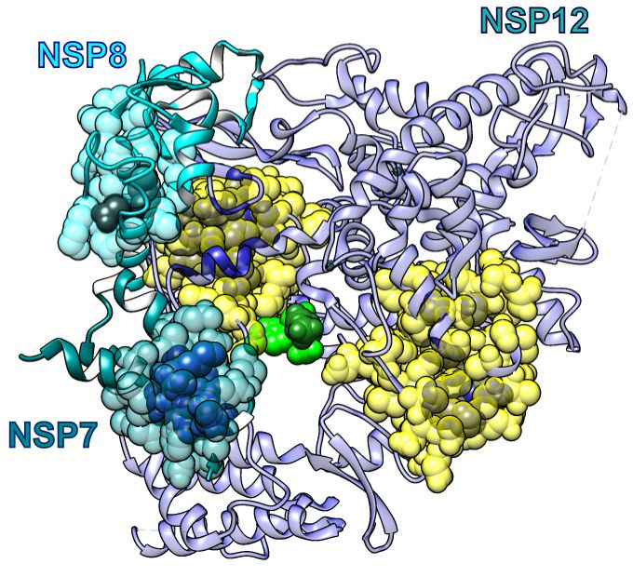
Figure S3. Remdesivir bound to the primer RNA inside the central channel of SARS-COV-2 RNA dependent RNA polymerase (RdRp), NSP12) (pdb id 7bv2 described in [12]). a) Three RNA polymerase chains, NSP 12, NSP7 and NSP8, represented as blue, cyan, and dark cyan ribbons. Remdesivir is represented via green atoms, and pyrophosphate as dark green atoms. SAGNM predictions for NSP12 are depicted as transparent yellow atoms and hot residues are blue atoms. SAGNM predictions for NSP7 are transparent green atoms and hot residues are blue atoms. SAGNM predictions for NSP9 are transparent cyan atoms and hot residues are gray atoms. Remdesivir is represented via green atoms, and pyrophosphate as dark green atoms.

The SAGNM algorithm recognized the residues Gly-503, Thr-538, Ile-539, Thr-540, Gln-541, Ala-558, Val-560, Ser-561, Val-609, His-613, Glu-665, Met-666, Val-667, Met-668, Ala-702, Ala-706, Phe-753, Cys-765 and Asn-767 in chain A as hot, the residues Asp-161 and Ile-185 in chain B as hot, and the residues Lys-7, Ser-10, His-36, Ile-39, Ala-48 and Lys-51 in chain C as hot. The influence of the hot residues in chain A is spread to the residues Ala-376, Asp-377, Pro-378, Asp-499, Lys-500, Ser-501, Ala-502, Gly-503, Phe-504, Pro-505, Phe-506, Asn-507, Asn-534, Val-535, Ile-536, Pro-537, Thr-538, Ile-539, Thr-540, Gln-541, Met-542, Asn-543, Leu-544, Lys-545, Ala-554, Arg-555, Thr-556, Val-557, Ala-558, Gly-559, Val-560, Ser-561, Ile-562, Cys-563, Ser-564, Thr-565, Val-605, Tyr-606, Ser-607, Asp-608, Val-609, Glu-610, Asn-611, Pro-612, His-613, Leu-614, Met-615, Gly-616, Trp-617, Cys-659, Ala-660, Gln-661, Val-662, Leu-663, Ser-664, Glu-665, Met-666, Val-667, Met-668, Cys-669, Gly-670, Gly-671, Ser-672, Leu-673, Tyr-674, Val-675, Lys-676, Ser-681, Ser-682, Gly-683, Asp-684, Gln-698, Ala-699, Val-700, Thr-701, Ala-702, Asn-703, Val-704, Asn-705, Ala-706, Leu-707, Leu-708, Ser-709, Thr-710, Tyr-748, Leu-749, Arg-750, Lys-751, His-752, Phe-753, Ser-754, Met-755, Met-756, Ile-757, Asp-761, Ala-762, Val-763, Val-764, Cys-765, Phe-766, Asn-767, Ser-768, Thr-769, Tyr-770, Ala-771, Gly-774, Leu-775, Val-776, Ala-777, Ser-778, Asn-781, Phe-782, Val-785, Thr-801, Glu-802, Thr-803, Asp-804 and Leu-805. The influence of the hot residues in chain B is spread to the residues Val-130, Val-131, Gln-157, Gln-158, Val-159, Val-160, Asp-161, Ala-162, Asp-163, Ser-164, Lys-165, Ala-181, Trp-182, Pro-183, Leu-184, Ile-185, Val-186, Thr-187, Ala-188 and Leu-189. And the influence of the hot residues in chain C is spread to the residues Ser-4, Asp-5, Val-6, Lys-7, Cys-8, Thr-9, Ser-10, Val-11, Val-12, Leu-13, Val-33, Gln-34, Leu-35, His-36, Asn-37, Asp-38, Ile-39, Leu-40, Leu-41, Ala-42, Thr-45, Thr-46, Glu-47, Ala-48, Phe-49, Glu-50, Lys-51, Met-52, Val-53 and Ser-54.

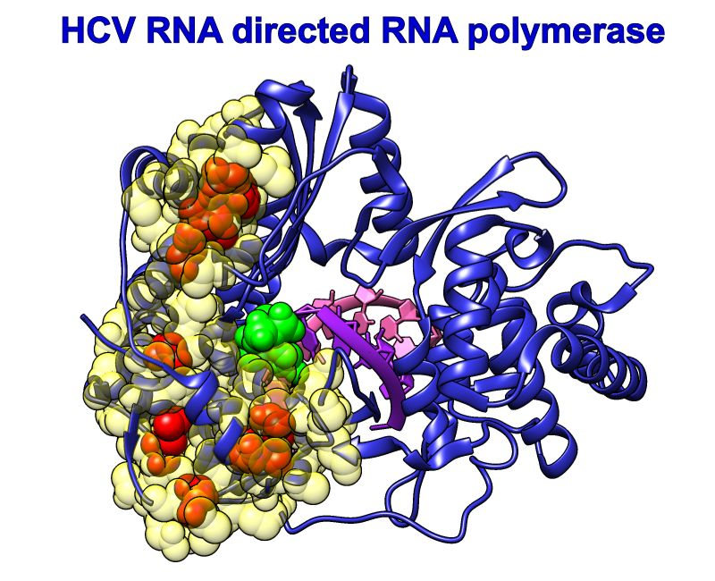
Figure S4. Sofosbuvir and its target protein Hepatitis C virus (HCV) RdRp (chain A in pdb id 4wtg) with hot residues and contact predictions determined by SAGNM. Chain A from HCV RdRp is represented as a blue ribbon. SAGNM predictions are depicted as transparent yellow atoms and kinetically hot residues are red atoms. Sofosbuvir is represented via green atoms. RNAs are pink and purple ribbons.

The SAGNM algorithm recognized the residues Ser-3, Tyr-4, Ala-9, Leu-10, Ile-11, Thr-12, Pro-13, Cys-14, Thr-40, Thr-41, Ser-42, Ser-44, Ala-45, Arg-48, Tyr-64, Pro-135, Thr-136, Thr-137, Ile-138, Met-139, Ala-140, Lys-141, Asn-142, Glu-143, Gly-153, Lys-154, Lys-155, Pro-156, Ala-157, Arg-158, Leu-159, Ile-160, Val-161, Asp-225, Ser-226, Thr-227, Val-228, Thr-229, Glu-230, Tyr-261, Val-262, Gly-263, Gly-264, Pro-265, Met-266, Phe-267, Asn-268, Ser-269, Lys-270, Gly-271, Gln-272, Thr-273, Cys-274, Gly-275, Tyr-276, Arg-277, Arg-278, Cys-279, Arg-280, Ala-281, Ser-282, Gly-283, Thr-294, Cys-295, Tyr-296, Val-297, Lys-298, Ala-299, Leu-300, Ala-301, Ala-302, Cys-303, Ala-305, Ala-306, Asn-335, Leu-336, Arg-337, Ala-338, Phe-339, Thr-340, Glu-341, Ala-342, Met-343, Thr-344, Arg-345, Tyr-346, Ser-347, Ala-348 and Pro-349 from 4wtg.pdb as predictions.

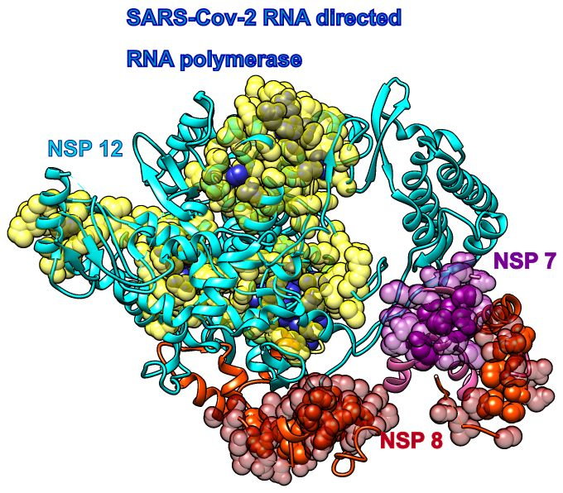
Figure S5. Covid-19 RNA directed RNA polymerase with cofactors NSP7 and NSP8 (pdb id 6m71). The NSP 12 chain is cyan, its SAGNM predictions are transparent yellow atoms, and hot residues are opaque blue atoms. The NSP 7 chain is pink, its SAGNM predictions are transparent purple atoms and hot residues are opaque purple atoms. The NSP 8 chain is orange, it SAGNM predictions are transparent red atoms and its hot atoms opaque orange atoms. The dashed lines represent segments missing from the coordinates file.

The SAGNM algorithm recognized the residues Gly-230, Cys-298, Cys-310, Asn-314, Gly-352, Ala-502, Gly-503, Thr-538, Ile-539, Thr-540, Gln-541, Gly-559, Val-560, Ser-561, Val-609, Glu-665, Val-667, Met-668, Ala-702, Ala-706, Val-763, Cys-765 and Asn-767 from the chain A from 6m71 as hot.
It also recognized the residues Met-196, Arg-197, Asn-198, Ala-199, Gly-200, Ile-201, Val-202, Thr-225, Thr-226, Pro-227, Gly-228, Ser-229, Gly-230, Val-231, Pro-232, Val-233, Val-234, Asp-274, Thr-276, Arg-279, Tyr-294, His-295, Pro-296, Asn-297, Cys-298, Val-299, Asn-300, Cys-301, Leu-302, Cys-306, Ile-307, Leu-308, His-309, Cys-310, Ala-311, Asn-312, Phe-313, Asn-314, Val-315, Leu-316, Phe-317, Ser-318, Gly-327, His-347, Phe-348, Arg-349, Glu-350, Leu-351, Gly-352, Val-353, Val-354, His-355, Asn-356, Ala-376, Asp-377, Pro-378, Leu-498, Asp-499, Lys-500, Ser-501, Ala-502, Gly-503, Phe-504, Pro-505, Phe-506, Asn-507, Gly-510, Lys-511, Ala-512, Asn-534, Val-535, Ile-536, Pro-537, Thr-538, Ile-539, Thr-540, Gln-541, Met-542, Asn-543, Leu-544, Lys-545, Arg-555, Thr-556, Val-557, Ala-558, Gly-559, Val-560, Ser-561, Ile-562, Cys-563, Ser-564, Thr-565, Val-605, Tyr-606, Ser-607, Asp-608, Val-609, Glu-610, Asn-611, Pro-612, His-613, Leu-614, Met-615, Gly-616, Trp-617, Cys-659, Ala-660, Gln-661, Val-662, Leu-663, Ser-664, Glu-665, Met-666, Val-667, Met-668, Cys-669, Gly-670, Gly-671, Ser-672, Leu-673, Tyr-674, Val-675, Lys-676, Ser-681, Gly-683, Asp-684, Gln-698, Ala-699, Val-700, Thr-701, Ala-702, Asn-703, Val-704, Asn-705, Ala-706, Leu-707, Leu-708, Ser-709, Thr-710, Lys-751, His-752, Phe-753, Ser-754, Met-755, Met-756, Ile-757, Ser-759, Asp-760, Asp-761, Ala-762, Val-763, Val-764, Cys-765, Phe-766, Asn-767, Ser-768, Thr-769, Tyr-770, Ala-771, Gly-774, Leu-775, Val-776, Ala-777, Ser-778, Asn-781, Phe-782, Val-785, Pro-809 and Phe-812 as predictions.

The SAGNM algorithm recognized the residues Ile-132, Trp-154, Ile-156, Val-159, Asp-161, Leu-184, Ile-185, Val-186, Thr-187 and Ala-188 from the chain B from 6m71 as hot.
It also recognized the residues Lys-127, Leu-128, Met-129, Val-130, Val-131, Ile-132, Pro-133, Asp-134, Tyr-135, Asn-136, Thr-137, Tyr-138, Thr-146, Phe-147, Thr-148, Ala-150, Ser-151, Ala-152, Leu-153, Trp-154, Glu-155, Ile-156, Gln-157, Gln-158, Val-159, Val-160, Asp-161, Ala-162, Asp-163, Ser-164, Lys-165, Val-167, Leu-180, Ala-181, Trp-182, Pro-183, Leu-184, Ile-185, Val-186, Thr-187, Ala-188, Leu-189, Arg-190 and Ala-191 as predictions.

The SAGNM algorithm recognized the residues Val-6, Ser-10, Leu-35, Ile-39, Ala-48 and Met-52 from the chain C from 6m71 as hot.
It also recognized the residues Met-3, Ser-4, Asp-5, Val-6, Lys-7, Cys-8, Thr-9, Ser-10, Val-11, Val-12, Leu-13, Cys-32, Val-33, Gln-34, Leu-35, His-36, Asn-37, Asp-38, Ile-39, Leu-40, Leu-41, Ala-42, Thr-45, Thr-46, Glu-47, Ala-48, Phe-49, Glu-50, Lys-51, Met-52, Val-53, Ser-54 and Leu-55 as predictions.

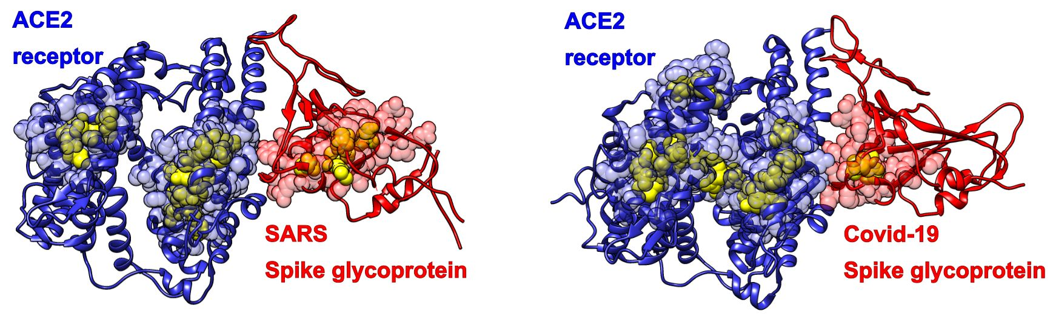
Figure S6. ACE2 receptor with SARS-COV Spike glycoprotein (pdb id 6cs2 left) and ACE2 receptor with Covid-19 Spike glycoprotein (6m0j.pdb, right). Predictions are blue transparent atoms (ACE2 receptor) and red transparent atoms (SARS and Covoid-19 Spike glycoprotein). Hot residues are yellow.

The SAGNM algorithm recognized the residues Asp-385, Phe-387, Pro-493, Arg-495 and Val-496 in the chain B of 6cs2, and predictions are residues Phe-334, Pro-335, Ser-336, Val-337, Trp-340, Glu-341, Arg-342, Asn-381, Val-382, Tyr-383, Ala-384, Asp-385, Ser-386, Phe-387, Val-388, Val-389, Lys-390, Gly-391, Leu-421, Ala-422, Trp-423, Thr-425, Arg-426, Asp-429, Ile-489, Gly-490, Tyr-491, Gln-492, Pro-493, Tyr-494, Arg-495, Val-496, Val-497, Val-498, Leu-499 and Ser-500.
The SAGNM algorithm recognized the residues Ser-43, Ala-46, Tyr-50, Met-62, Met-123, Val-172, Gly-173, Leu-176, Ala-348, His-373, His-374, Glu-375, His-378, Tyr-385, Ala-403, Gly-405, Ser-409 and Cys-498 as hot in the chain D of 6cs2.
The predictions are residues Leu-39, Phe-40, Tyr-41, Gln-42, Ser-43, Ser-44, Leu-45, Ala-46, Ser-47, Trp-48, Asn-49, Tyr-50, Asn-51, Thr-52, Asn-53, Ile-54, Thr-55, Asn-58, Val-59, Gln-60, Asn-61, Met-62, Asn-63, Asn-64, Ala-65, Gly-66, Trp-69, Ile-119, Leu-120, Asn-121, Thr-122, Met-123, Ser-124, Thr-125, Ile-126, Tyr-127, Gly-130, Lys-131, Trp-168, Arg-169, Ser-170, Glu-171, Val-172, Gly-173, Lys-174, Gln-175, Leu-176, Arg-177, Pro-178, Leu-179, Tyr-180, Phe-308, Ala-311, Ala-342, Cys-344, His-345, Pro-346, Thr-347, Ala-348, Trp-349, Asp-350, Leu-351, Gly-352, Phe-356, Arg-357, Ile-358, Leu-359, Phe-369, Leu-370, Thr-371, Ala-372, His-373, His-374, Glu-375, Met-376, Gly-377, His-378, Ile-379, Gln-380, Tyr-381, Asp-382, Met-383, Ala-384, Tyr-385, Ala-386, Ala-387, Gln-388, Pro-389, Leu-392, Arg-393, Asn-394, Gly-399, Phe-400, His-401, Glu-402, Ala-403, Val-404, Gly-405, Glu-406, Ile-407, Met-408, Ser-409, Leu-410, Ser-411, Ala-412, Ala-413, Met-474, Asp-494, Glu-495, Thr-496, Tyr-497, Cys-498, Asp-499, Pro-500, Ala-501, Ser-502, Ser-507, Asn-508, Arg-518, Thr-519, Tyr-521, Gln-522, Leu-558, Arg-559, Leu-560 and Gly-561.

The SAGNM algorithm recognized the residues Ser-43, Tyr-50, Met-62, Trp-69, Met-123, Val-172, Gly-173, Leu-176, Met-190, Ala-191, Asp-198, Ala-403, Gly-405, Ser-502, Arg-518, Leu-520 and Gln-522 of the chain A of 6m0j as hot.
The prediction are Leu-39, Phe-40, Tyr-41, Gln-42, Ser-43, Ser-44, Leu-45, Ala-46, Ser-47, Trp-48, Asn-49, Tyr-50, Asn-51, Thr-52, Asn-53, Ile-54, Thr-55, Asn-58, Val-59, Gln-60, Asn-61, Met-62, Asn-63, Asn-64, Ala-65, Gly-66, Asp-67, Lys-68, Trp-69, Ser-70, Ala-71, Phe-72, Leu-73, Gly-104, Ser-105, Val-107, Leu-108, Ile-119, Leu-120, Asn-121, Thr-122, Met-123, Ser-124, Thr-125, Ile-126, Tyr-127, Gly-130, Lys-131, Ser-167, Trp-168, Arg-169, Ser-170, Glu-171, Val-172, Gly-173, Lys-174, Gln-175, Leu-176, Arg-177, Pro-178, Leu-179, Tyr-180, Leu-186, Lys-187, Asn-188, Glu-189, Met-190, Ala-191, Arg-192, Ala-193, Asn-194, His-195, Tyr-196, Glu-197, Asp-198, Tyr-199, Gly-200, Asp-201, Tyr-202, Ala-342, His-373, His-374, Glu-375, Met-376, Gly-377, His-378, Glu-398, Gly-399, Phe-400, His-401, Glu-402, Ala-403, Val-404, Gly-405, Glu-406, Ile-407, Met-408, Ser-409, Phe-464, Lys-465, Tyr-497, Cys-498, Asp-499, Pro-500, Ala-501, Ser-502, Leu-503, Phe-504, His-505, Val-506, Ser-507, Asn-508, Arg-514, Tyr-515, Tyr-516, Thr-517, Arg-518, Thr-519, Leu-520, Tyr-521, Gln-522, Phe-523, Gln-524, Phe-525, Gln-526, Met-579, Asn-580, Val-581, Pro-583 and Leu-584.

The SAGNM algorithm recognized the residues Phe-497 and Pro-507 of the chain E of 6m0j as hot.
The predictions are the residues Ile-402, Arg-403, Gly-404, Ser-438, Asn-439, Ser-443, Gly-447, Asn-448, Gln-493, Ser-494, Tyr-495, Gly-496, Phe-497, Gln-498, Pro-499, Thr-500, Asn-501, Val-503, Gly-504, Tyr-505, Gln-506, Pro-507, Tyr-508, Arg-509, Val-510 and Val-511.

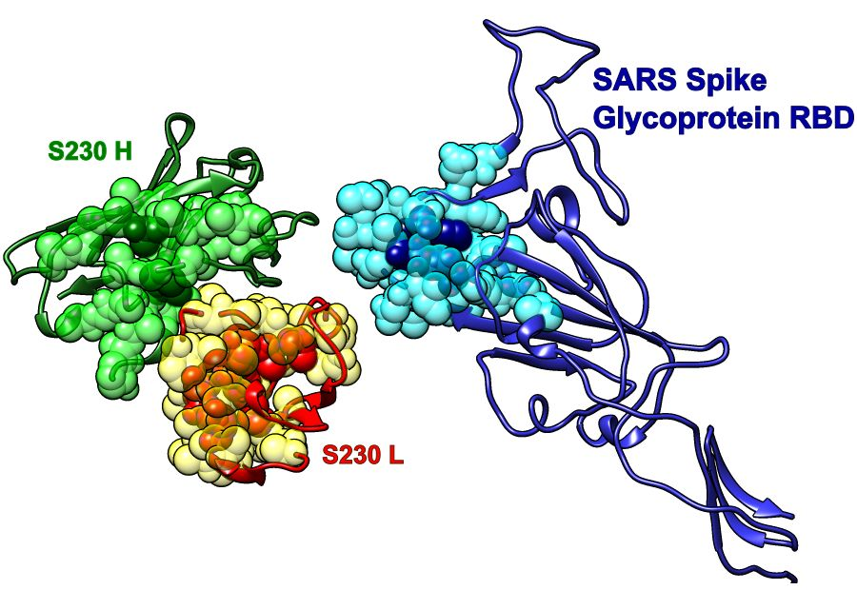
Figure S7. Receptor binding domain (RBD) of SARS-COV spike glycoprotein (Chain A, pdb id 6nb6) with human neutralizing S230 antibody FAB fragment. a) SARS-COV RBD (blue, chain A) with heavy (green, H and I) and light (red, L and M) chains. Predictions are cyan (SARS), yellow (S230 light) and light green (S230 heavy).

The SAGNM algorithm recognized the residues Ala-430, Phe-483 and Pro-493 from the RBD domain of SARS-COV spike glycoprotein (Chain A, pdb id 6nb6) as hot.
The predictions are Val-389, Lys-390, Gly-391, Thr-425, Arg-426, Asn-427, Ile-428, Asp-429, Ala-430, Thr-431, Ser-432, Thr-433, Gly-434, Asn-435, Asn-479, Asp-480, Tyr-481, Gly-482, Phe-483, Tyr-484, Thr-485, Thr-486, Thr-487, Ile-489, Gly-490, Tyr-491, Gln-492, Pro-493, Tyr-494, Arg-495, Val-496 and Val-497.
The SAGNM algorithm recognized the residues Glu-6, Val-37 and Tyr-95 from the chain H from 6nb6.pdb as hot. The corresponding predictions are Ala-2, Gln-3, Leu-4, Val-5, Glu-6, Ser-7, Gly-8, Gly-9, Ala-10, Ser-21, Cys-22, Ala-33, Met-34, His-35, Trp-36, Val-37, Arg-38, Gln-39, Ala-40, Pro-41, Gln-46, Trp-47, Leu-48, Thr-91, Ala-92, Val-93, Tyr-94, Tyr-95, Cys-96, Val-97, Thr-98, Gln-99, Gly-118, Gly-120 and Thr-121.
The SAGNM algorithm recognized the residues Glu-6, Val-37 and Tyr-95 from the chain I from 6nb6.pdb as hot. The corresponding predictions are Ala-2, Gln-3, Leu-4, Val-5, Glu-6, Ser-7, Gly-8, Gly-9, Ala-10, Ser-21, Cys-22, Ala-33, Met-34, His-35, Trp-36, Val-37, Arg-38, Gln-39, Ala-40, Pro-41, Gln-46, Trp-47, Leu-48, Thr-91, Ala-92, Val-93, Tyr-94, Tyr-95, Cys-96, Val-97, Thr-98, Gln-99, Gly-118, Gly-120 and Thr-121.
The SAGNM algorithm recognized the residues Gln-6, Cys-23, Trp-40, Phe-41, Ile-53, Tyr-92, Cys-93, Gly-104, Gly-106 and Thr-107 from the chain L from 6nb6.pdb as hot. The corresponding predictions are Val-3, Leu-4, Thr-5, Gln-6, Ser-7, Pro-8, Leu-9, Ser-10, Ala-19, Ser-20, Ile-21, Ser-22, Cys-23, Arg-24, Ser-25, Ser-26, Gln-27, Thr-36, Tyr-37, Leu-38, Asn-39, Trp-40, Phe-41, Gln-42, Gln-43, Arg-44, Pro-45, Pro-49, Arg-50, Arg-51, Leu-52, Ile-53, Tyr-54, Gln-55, Val-56, Ser-57, Asn-58, Arg-59, Phe-76, Val-88, Gly-89, Val-90, Tyr-91, Tyr-92, Cys-93, Met-94, Gln-95, Gly-96, Ser-97, Pro-100, Pro-101, Thr-102, Phe-103, Gly-104, Gln-105, Gly-106, Thr-107, Lys-108, Val-109, Glu-110 and Ile-111.
The SAGNM algorithm recognized the residues Gln-6, Cys-23, Trp-40, Tyr-91, Tyr-92, Thr-107 and Val-109 from the chain M from 6nb6.pdb as hot. The corresponding predictions are Val-3, Leu-4, Thr-5, Gln-6, Ser-7, Pro-8, Leu-9, Ser-10, Leu-11, Pro-12, Ala-19, Ser-20, Ile-21, Ser-22, Cys-23, Arg-24, Ser-25, Ser-26, Gln-27, Thr-36, Tyr-37, Leu-38, Asn-39, Trp-40, Phe-41, Gln-42, Gln-43, Arg-44, Arg-51, Leu-52, Ile-53, Phe-76, Asp-87, Val-88, Gly-89, Val-90, Tyr-91, Tyr-92, Cys-93, Met-94, Gln-95, Gly-96, Gly-104, Gly-106, Thr-107, Lys-108, Val-109 and Glu-110.

In all cases the expected number of targets is between 10 and 15%. That corresponds to the first, fastest mode in each case.

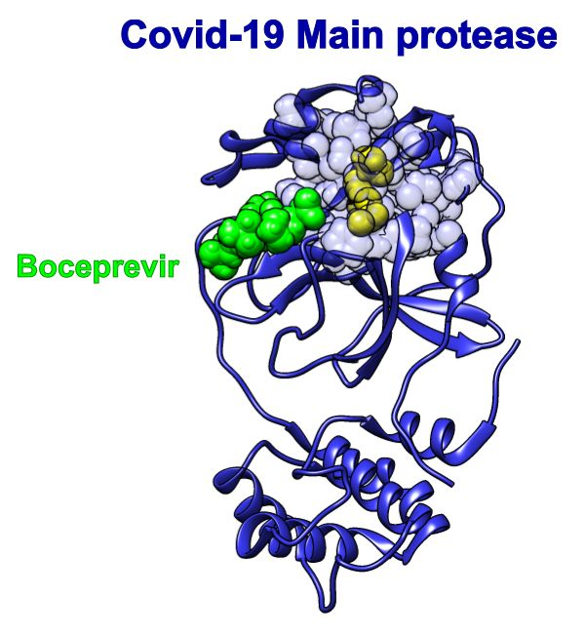
Figure S8. Hot residues and predictions for the SARS-Cov-2 main protease. The Covid-19 main protease (pdb id 6wnp) depicted as blue ribbon, with SAGNM predictions as transparent blue atoms, and hot residues as opaque yellow atoms. Boceprevir is depicted as a green molecule.

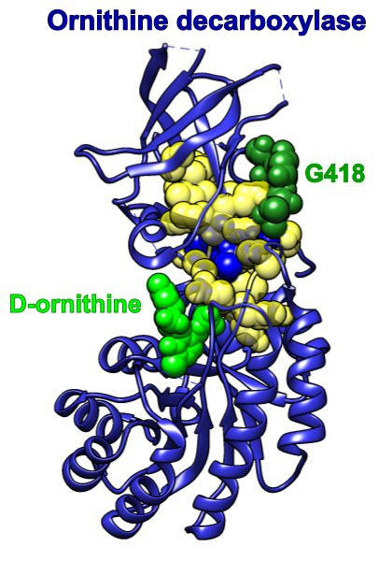
Figure S9. Ornithine decarboxylase (1njj.pdb) chain A depicted as blue ribbon, with SAGNM predictions as transparent yellow atoms, and hot residues as opaque blue atoms. D-ornithine and G-418 are depicted as green and dark green molecules, respectively.

