**Supplemental Tables**

**Supplemental Table 1.** Metabolic parameters in blood before and after treatment for each group.

|  |  |  |  |  |  |  |
| --- | --- | --- | --- | --- | --- | --- |
|  | Placebo  (n=16) | | *B. lactis* BL04  (n=20) | | *B. lactis* BL04 + PreforPro  (n=20) | |
|  | **Baseline** | **Final** | **Baseline** | **Final** | **Baseline** | **Final** |
| Glucose | 88 ± 19 | 93 ± 9 | 91 ± 5 | 93 ± 5 | 92 ± 5 | 94 ± 6 |
| BUN | 12 ± 4 | 13 ± 3 | 12 ± 4 | 12 ± 3 | 12 ± 2 | 12 ± 3 |
| CRE | 0.8 ± 0.2 | 0.8 ± 0.2 | 0.9 ± 0.2 | 0.8 ± 0.2 | 0.8 ± 0.2 | 0.9 ± 0.2 |
| CK | 148 ± 47 | 161 ± 66 | 160 ± 75 | 180 ± 200 | 171 ± 142 | 140 ± 99 |
| Na+ | 138 ± 3 | 137 ± 3 | 139 ± 6 | 138 ± 3 | 137 ± 3 | 137 ± 3 |
| K+ | 4.5 ± 1.1 | 4.3 ± 0.4 | 4.8 ± 0.5 | 4.5 ± 0.4 | 4.6 ± 0.5 | 4.6 ± 0.5 |
| Cl- | 107 ± 2 | 108 ± 2 | 107 ± 3 | 109 ± 3 | 107 ± 3 | 109 ± 3 |
| tCO2 | 26 ± 2 | 26 ± 1 | 25 ± 5 | 26 ± 2 | 25 ± 2 | 26 ± 2 |
| Data represent mean ± SD. No values were statistically significant with a p-value <0.05 Abbreviations: Blood Urea Nitrogen (BUN); Creatinine (CRE); Creatinine Kinase (CK); Sodium (NA); Potassium (K), Total Carbon Dioxide (tCO2) | | | | | | |

**Supplemental Table 2.** Alpha Diversity Metrics

|  |  |  |  |  |  |  |
| --- | --- | --- | --- | --- | --- | --- |
|  | Placebo  (n=16) | | *B. lactis* BL04  (n=20) | | *B. lactis* BL04 +PreforPro (n=20) | |
|  | Baseline | Final | Baseline | Final | Baseline | Final |
| Pileu’s Evenness | 0.698 ± 0.050 | 0.708 ± 0.042 | 0.686 ± 0.077 | 0.679 ± 0.056 | 0.710 ± 0.066 | 0.704 ± 0.059 |
| Faith’s Phylogenetic Diversity | 11.15 ± 2.364 | 11.41 ± 1.978 | 10.8 6 ± 3.053 | 10.58 ± 2.405 | 11.11 ± 3.970 | 10.99 ± 3.538 |
| Shannon Diversity | 5.098 ± 0.501 | 5.218 ± 0.445 | 4.951 ± 0.807 | 4.894 ± 0.582 | 5.142 ± 0.783 | 5.116 ± 0.704 |
| Data represents mean ± SD. No values were statistically significant with a p-value < 0.05. | | | | | | |

**Supplemental Figures**

**Supplemental Figure 1.** Individual scoresat baseline and 4 weeks post-treatment for each of the 4 sections of the gastrointestinal health questionnaire.

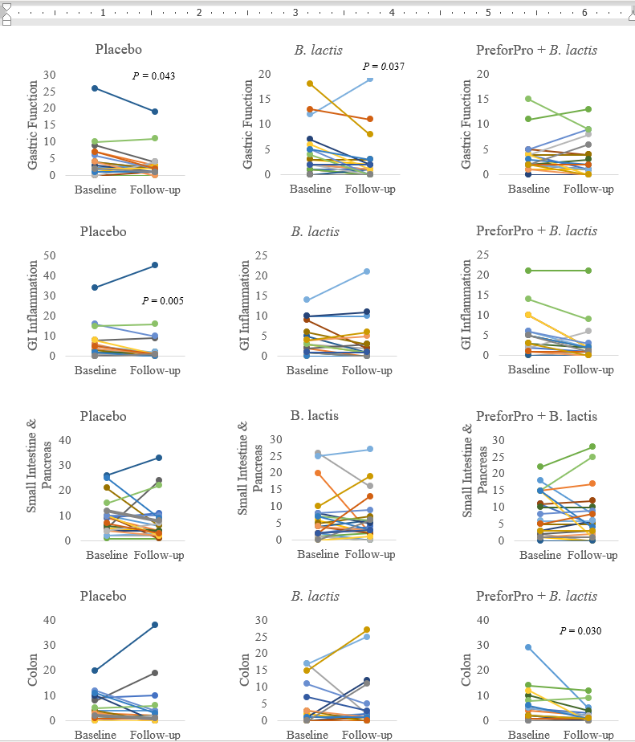

**Supplemental Figure 2.** Baseline adjusted scores for each section of the gastrointestinal health questionnaire across treatments. Data represent mean ± SEM.

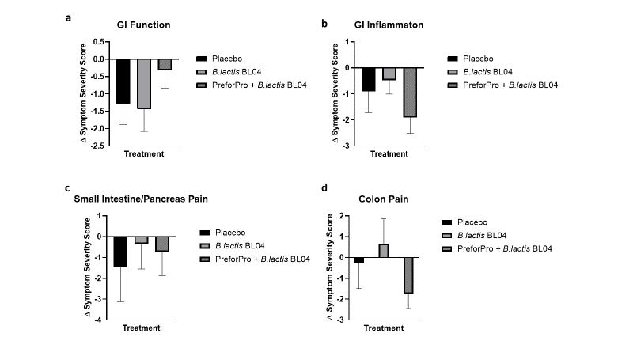

**Supplemental Figure 3.** Abundance of unclassified Enterobacteriaceae that putatively belong to *Escherichia coli.* Data represent mean ± SEM.

