Supplementary material for „The effect of a color tattoo on the local skin redox regulatory network: An N-of-1 study“ (Homolak, 2020)
As a limited amount of biological samples were available, analysis of nitrocellulose redox permanganometry (NRP), hydrogen peroxide dissociation rate, superoxide dismutase activity, lipid peroxidation, protein sulfhydryl, and low molecular weight thiol content was done without technical replication. The absence of technical replicates complicates the analysis of the observed effects, as the information suggestive of the inherent bioanalytical method variability cannot be inferred from data. To ensure the observed effects were truly due to differences between samples, and not due to chance, all methods used in the experiment were additionally validated, and coefficient of variation (CV=standard deviation (σ)/ mean (μ)) was calculated for the relevant variables.
Validation of methods and calculation of CV was conducted as follows:
Nitrocellulose redox permanganometry
Extensive validation of the NRP is available in the original proposal of the method [1]. Coefficients of variation for the NRP method measured from technical replication of the dilution curve of standard reducing agent Na₂S₂O₃ are between 0.9% and 3.7% in the quantification range of the curve [1]. Considering the observed difference between the control and the tattoo sample was 10.8%, the difference was regarded as a suggestion of biological effect.

Hydrogen peroxide dissociation rate
The hydrogen peroxide dissociation rate was measured by the carbonato-cobaltate quantification method previously proposed by Hadwan [2]. Validation was conducted as follows. First, a fresh solution of hydrogen peroxide (40 μl 10 mM H₂O₂ in 1xPBS) and reaction/stop solution 1 (10 ml of cobalt nitrate solution (0.2 g (Co(NO₃)₂x6H₂O dissolved in 10 ml dd H₂O) mixed well with 10 ml of sodium hexametaphosphate solution (0.1 g Na₆[(PO₃)₆] dissolved in ddH₂O) added to sodium bicarbonate solution (16.2 g NaHCO₃ dissolved in 180 ml of dH₂O) were prepared. Ten replicates of H₂O₂ solution (40 μl) were pipetted in a 96 well plate followed by 100 μl reaction/stop solution 1. The plate was shaken orbitally for 2 s and the absorbance was measured at 450 nm. The CV of raw absorbance values was 2.07%. CV of measured H₂O₂ values obtained by exponentiation of values approximated from the previously used model (lm(log(H₂O₂) ~ log (absorbance))) (Fig. S1) was 5.52%. As the H₂O₂ dissociation rate method depends on separate measurements of H₂O₂ concentration in two points in time (δt=t1-t0), an additional experiment was conducted for evaluation of bioanalytical method variability when the sample and human error due to repeated measurements are introduced. In this experiment a standard solution of Micrococcus lysodeikticus catalase diluted 1:1000 in 1xPBS was used. Ten replicates of catalase solution (1 μl) were pipetted in a 96 well plate in duplicate wells. In the first row of paired wells, 40 μl hydrogen peroxide solution was pipetted immediately (< 1 s) followed by 100 μl of reaction/stop solution 1. The same procedure was repeated in the second row of duplicated wells, however, the H₂O₂ solution was reacted with the sample for 60 s before the addition of the reaction/stop solution 1. The plate was shaken orbitally for 2 seconds and the absorbance was measured at 450 nm. CV of raw absorbance values was 1.75% and 3.72% for t0 and t1 respectively. CV of measured H₂O₂ values obtained by exponentiation of values approximated from the previously used model (lm(log(H2O2) ~ log (absorbance))) (Fig. S1) was 4.8% and 10.3% respectively. To calculate the CV of the average enzymatic activity, all possible unique combinations of H₂O₂ values measured in t0 and t1 were computed by permutation, and total σ was divided by total μ. Computed average CV was 6.5%. Considering the observed difference between control and tattoo sample was 11.8%, the difference was regarded as a suggestion of biological effect.
Table S1 Model used for calculation of H₂O₂ from the carbonato-cobaltate absorbance values at 450 nm.
Model: lm(log(h2o2)~log(absorbance)
log (hydrogen peroxide)
Predictors | Estimates | CI | p
(Intercept) | -8.02 | -8.60 – -7.45 | <0.001
absorbance [log] | 2.72 | 2.39 – 3.05 | <0.001
Observations | 8
R² / R² adjusted | 0.985 / 0.983

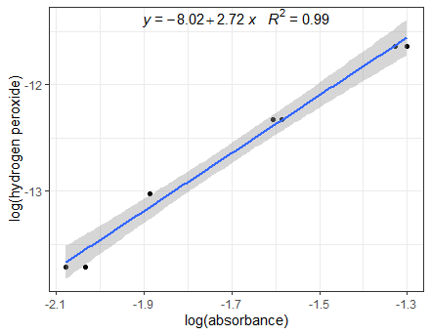
Fig. S1 Illustration of the linear model (lm(log(H₂O₂) ~ log (absorbance))) and values used for the calculation of the standard curve of H₂O₂ with the method proposed by Hadwan (2018).
Superoxide dismutase activity
Superoxide dismutase activity was assessed by 1,2,3-trihydroxybenzene autooxidation inhibition determined from quantification of absorbance increment at 325 nm for 300 s (t1 = 300 s; t0 = 0 s) as described in the manuscript [3]. Reading stability was tested by continuous measurement (300 s) of sample buffer (0.05 M Tris-HCl and 1 mM Na2EDTA (pH 8,2)) at 325 nm. The absorbance drift in the same time window was unmeasurable (< 0.000). Linearity determined with trihydroxybenzene standard (15 μl of 60 mM 1,2,3-trihydroxybenzene in 0.05 M Tris-HCl and 1 mM Na2EDTA (pH 8,2)) was 99.8%. Method variation was tested with 10 replicates of trihydroxybenzene standard, and the CV of the method was calculated as σ of difference in absorbance (t1 – t0) divided by μ of absorbance difference (t1 – t0). The calculated CV was 1.7%. Considering the observed difference between control and tattoo sample was 0.7%, it was concluded that the difference cannot be regarded as a suggestion of biological effect.
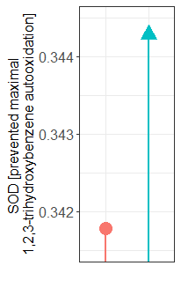
Fig S2. The observed difference in the SOD activity was removed from the manuscript as the difference was smaller than the CV of the method.

Lipid peroxidation
Lipid peroxidation was analyzed by the thiobarbituric reactive substances (TBARS) assay as described in the main text and previously reported by Prabhakar et al. [4]. Briefly, the determination of method variability was assessed by analysis of malondialdehyde content in a single sample of rat duodenum homogenate in 9 parallel replicates. A single homogenate was brought to room temperature, vortexed, pipetted in 9 individual 1.5 ml reaction tubes (36 μl in each). The tubes were then treated as individual samples, and all were processed with the same method as the tattoo and control skin samples from the manuscript. Calculated CV was 1.9 % indicating the observed difference of 15 % was suggestive of the biological effect.

Protein sulfhydryl content and low molecular weight thiol determination
Protein thiols and low molecular weight thiols (LMWT) were determined by reacting the samples with 5,5'-dithio-bis(2-nitrobenzoic acid) (DTNB) with subsequent quantification of 5-thio-2-nitrobenzoic acid (TNB) as described in the manuscript [4,5]. Method variability was assessed by analysis of a single rat duodenum homogenate in 7 parallel replicates. A single homogenate was brought to room temperature, vortexed, pipetted in 7 individual 1.5 ml reaction tubes (25 μl in each). The tubes were then treated as individual samples, and all were processed with the same method as the tattoo and control skin samples from the manuscript. Calculated CV was 3.8% indicating the observed difference of 2.8 % between control and tattoo sample low molecular weight thiol content was cannot be considered as an indicator of biological difference while the observed difference in protein sulfhydryl content of 8.5 % can be considered as a reflection of increased sulfhydryl content in tattoo sample when compared with the control.
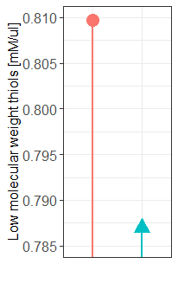
Fig S3. The observed difference in the concentration of low molecular weight thiols removed from the manuscript as the difference was smaller than the CV of the method.

I₂/KI-redox-stabilized oxidation-reduction potential (ORP)
In vitro sample reductive capacity was measured employing I₂/KI -redox-coupled microORP to ensure redox system stabilization as proposed by Cao et al. and described in the manuscript [6]. To ensure the maximal robustness of the method, the control and the tattoo same were measured in three time points and the results were reported as difference expressed in mV. As the prespecified system accuracy of the instrument was ±0.5 mV, and the average observed difference -4.33 mV, measurements were considered to reflect the biological difference of analyzed samples. Furthermore, an additional experiment was conducted to examine the method variability when technical and human errors are introduced. For this purpose, a blank redox pair electrode solution (0.1 M I₂ and 0.4 M KI) was prepared in 10 parallel replicates. The replicates were pipetted in individual reaction tubes and then treated as individual samples. The samples were left in the dark for 1 h at room temperature. The samples were then measured with the same instrument setup as the tattoo and control skin samples, and the mV difference (δ mV) was recorded in each run. Three runs were recorded in total with samples being measured in the randomized order. The observed δ mV was 1, 2, and 2 for the first (a), second (b), and third (c) run respectively (Fig S4). Considering that 1) the main source of variability of this method previously observed in our laboratory was the duration of the run, and each run of 10 control samples lasted much longer than the experimental run reported in the manuscript (⁓ 45 s vs. ⁓ 10 s) thereby introducing a significant safety margin, 2) measurement and preparation of 10 control samples enable sampling and indirect analysis of human error related to pipetting and measurement, and 3) in each control run, the maximal observed δ mV between 10 replicates was 2 mV (in comparison with 4.33 observed in the experimental run described in the manuscript), the observed difference between the tattoo and the control sample was considered as a suggestion of the biological effect rather than an artifact.
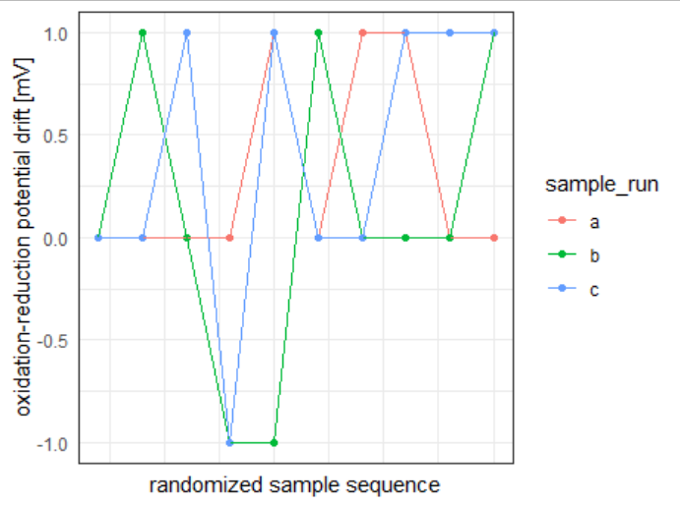
Fig S4. Datapoints from 3 runs of 10 individual replicates of a blank redox pair electrode solution examined in randomized order. A drift of the electrode from the initial measurement of the first sample is depicted on the Y-axis, and the number of subsequent sample replicate is shown on the X-axis with sequence illustrated as measured from left to right.

References
1 Homolak J, Kodvanj I, Babic Perhoc A, Virag D, Knezovic A, Osmanovic Barilar J, et al. Nitrocellulose redox permanganometry: a simple method for reductive capacity assessment. bioRxiv. 2020 Jun
2 Hadwan MH. Simple spectrophotometric assay for measuring catalase activity in biological tissues. BMC Biochem. 2018 Aug;19(1):7.
3 Li X. Improved pyrogallol autoxidation method: a reliable and cheap superoxide-scavenging assay suitable for all antioxidants. J Agric Food Chem. 2012 Jun;60(25):6418–24.
4 Prabhakar PV, Reddy UA, Singh SP, Balasubramanyam A, Rahman MF, Indu Kumari S, et al. Oxidative stress induced by aluminum oxide nanomaterials after acute oral treatment in Wistar rats. J Appl Toxicol. 2012 Jun;32(6):436–45.
5 Van der Plancken I, Van Loey A, Hendrickx MEG. Changes in sulfhydryl content of egg white proteins due to heat and pressure treatment. J Agric Food Chem. 2005 Jul;53(14):5726–33.
6 Cao T, He M, Bai T, Liu H. Establishment of a Method for Measuring Antioxidant Capacity in Urine, Based on Oxidation Reduction Potential and Redox Couple I/KI. Bioinorg Chem Appl. 2016 Dec;2016:7054049.

