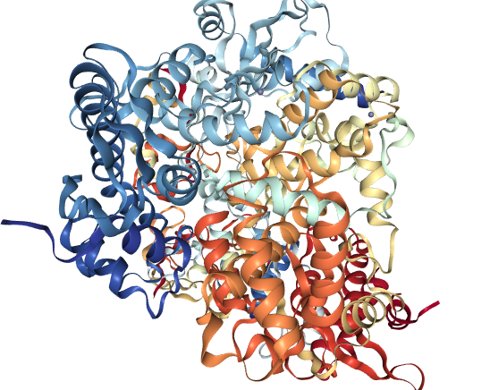

**Figure 1.** 3D structure of SARS-CoV-2 virus spike RNA dependent RNA polymerase

(PDB)-6NUR

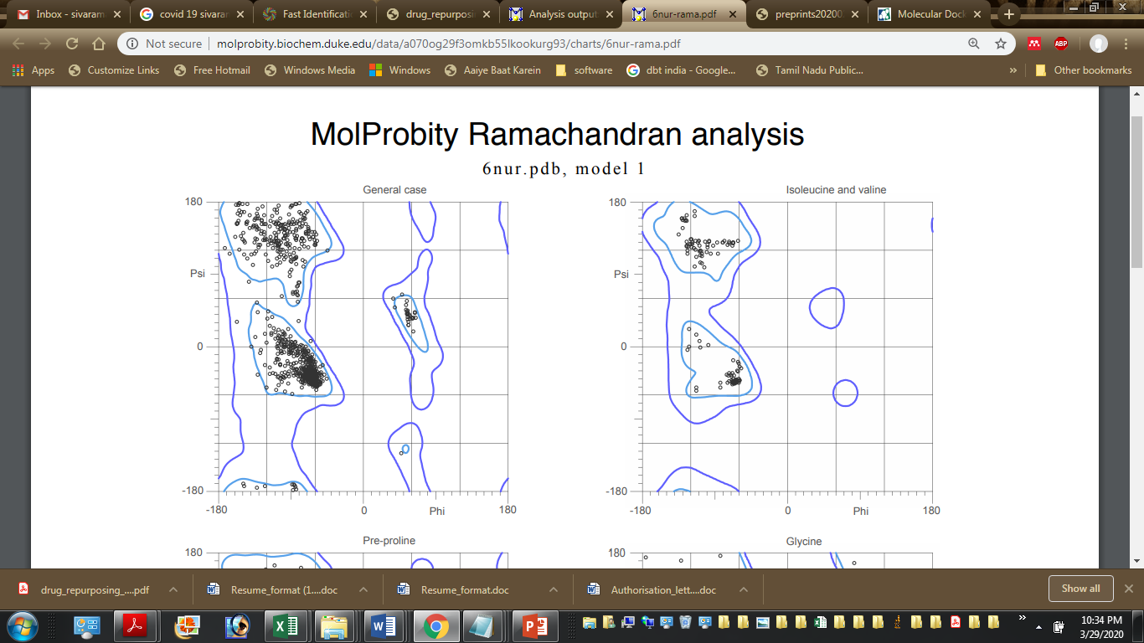

**Figure 2.** Ramachandran plot indicating amino acid resides in cluster of A- Chain

**Table 1: Summarizing the docking score and representing the interaction analysis plot with best binding docking pose of phytochemicals from the herbs of Kapa Sura Kudineer and Nilavembu Kudineer**

|  |  |  |  |  |  |
| --- | --- | --- | --- | --- | --- |
| **S.No** | **Name of the Ligand** | **Binding Free energy Kcal/**  **mol** | **2D Plot** | **Interaction**  **Surface** | **Docking Pose** |
|  | Eugenol | -4.08 |  |  |  |
|  | Rutin | -4.55 |  |  |  |
|  | Pellitorine | -5.16 |  |  |  |
|  | Gallic acid | -4.59 |  |  |  |
|  | Vasicine | -6.43 |  |  |  |
|  | Thymol | -4.59 |  |  |  |
|  | Carvacrol | -5.06 |  |  |  |
|  | Costunolide | -6.31 |  |  |  |
|  | Cynaropicrin | -6.51 |  |  |  |
|  | Bharangin | -6.72 |  |  |  |
|  | Andrographolide | -6.48 |  |  |  |
|  | Cissamine | -7.04 |  |  |  |
|  | β-pinene | -5.09 |  |  |  |
|  | Spathulenol | -6.47 |  |  |  |
|  | Vetiverol | -6.04 |  |  |  |
|  | Linoleic acid | -4.65 |  |  |  |
|  | Santalic acid | -5.85 |  |  |  |
|  | Cucurbitacin B | -7.25 |  |  |  |
|  | Vitexin | -7.41 |  |  |  |
|  | Alpha-Bisabolol | -6.20 |  |  |  |
|  | 6-Shogaol | -5.56 |  |  |  |
|  | 6-Gingerol | -5.32 |  |  |  |
|  | Beta Sitosterol | -7.95 |  |  |  |
|  | Piperidine | -6.05 |  |  |  |
|  | Apigenin | -6.16 |  |  |  |
|  | Piperine | -6.00 |  |  |  |
|  | Quercetin | -6.86 |  |  |  |
|  | Chlorogenic Acid | -5.68 |  |  |  |
|  | Favipiravir | -5.31 |  |  |  |

**Table 2: Summarizing 2D and 3D structure of Bio-active therapeutic ligand subjected to molecular docking Investigation against SARS-CoV-2 virus spike RNA dependent RNA polymerase (PDB)-6NUR**

|  |  |  |  |  |
| --- | --- | --- | --- | --- |
| **S.No** | **Name of the Ligand**  **Mol. Formula**  **Mol.Wt** | **2D structure** | **3D Structure** | **PubChem CID**  **Donor- D**  **Acceptor- A**  **Rotatable- R** |
|  | Eugenol  MW: 164.2 g/mol  MF:[C10H12O2](https://pubchem.ncbi.nlm.nih.gov/#query=C10H12O2) |  |  | 3314  D:1  A:2  R:3 |
|  | Rutin  MW: 610.5g/mol  MF:[C27H30O16](https://pubchem.ncbi.nlm.nih.gov/search/#query=C27H30O16) |  |  | [5280805](https://pubchem.ncbi.nlm.nih.gov/compound/5280805)  D:10  A:16  R:6 |
|  | Pellitorine  MW: 223.35g/mol  MF:[C14H25NO](https://pubchem.ncbi.nlm.nih.gov/search/#query=C14H25NO) |  |  | [5318516](https://pubchem.ncbi.nlm.nih.gov/compound/5318516)  D:1  A:1  R:8 |
|  | Gallic acid  MW: 170.12g/mol  MF:[C7H6O5](https://pubchem.ncbi.nlm.nih.gov/search/#query=C7H6O5) |  |  | 370  D:4  A:5  R:1 |
|  | Vasicine  MW: 188.23 g/mol  MF:[C11H12N2O](https://pubchem.ncbi.nlm.nih.gov/#query=C11H12N2O) |  |  | 72610  D:1  A:2  R:0 |
|  | Thymol  MW: 150.22g/mol  MF:[C10H14O](https://pubchem.ncbi.nlm.nih.gov/search/#query=C10H14O) |  |  | 6989  D:1  A:1  R:1 |
|  | Carvacrol  MW: 150.22g/mol  MF:[C10H14O](https://pubchem.ncbi.nlm.nih.gov/search/#query=C10H14O) |  |  | [10364](https://pubchem.ncbi.nlm.nih.gov/compound/10364)  D:1  A:1  R:1 |
|  | Costunolide  MW: 346.4g/mol  MF:[C19H22O6](https://pubchem.ncbi.nlm.nih.gov/search/#query=C19H22O6) |  |  | [119093](https://pubchem.ncbi.nlm.nih.gov/compound/119093)  D:2  A:6  R:4 |
|  | Cynaropicrin  MF:[C19H22O6](https://pubchem.ncbi.nlm.nih.gov/#query=C19H22O6)  MW: 346.4 g/mol |  |  | 119093  D:2  A:6  R:4 |
|  | Bharangin [MF:C](https://pubchem.ncbi.nlm.nih.gov/" \l "query=C20H24O4" \o "Find all compounds that have this formula)[20](https://pubchem.ncbi.nlm.nih.gov/" \l "query=C20H24O4" \o "Find all compounds that have this formula)[H](https://pubchem.ncbi.nlm.nih.gov/" \l "query=C20H24O4" \o "Find all compounds that have this formula)[24](https://pubchem.ncbi.nlm.nih.gov/" \l "query=C20H24O4" \o "Find all compounds that have this formula)[O](https://pubchem.ncbi.nlm.nih.gov/" \l "query=C20H24O4" \o "Find all compounds that have this formula)[4](https://pubchem.ncbi.nlm.nih.gov/" \l "query=C20H24O4" \o "Find all compounds that have this formula)  MW: 328.4 g/mol |  |  | 194464  D:1  A:4  R:1 |
|  | Andrographolide  MW: 350.4g/mol  MF:[C20H30O5](https://pubchem.ncbi.nlm.nih.gov/search/#query=C20H30O5) |  |  | 5318517  D:3  A:5  R:3 |
|  | Cissamine    MF: [C20H24NO4+](https://pubchem.ncbi.nlm.nih.gov/search/#query=C20H24NO4+)  MW: 342.4g/mol |  |  | [3082134](https://pubchem.ncbi.nlm.nih.gov/compound/3082134)  D:2  A:4  R:2 |
|  | β-pinene  MF:[C10H16](https://pubchem.ncbi.nlm.nih.gov/#query=C10H16)  MW: 136.23 g/mol |  |  | 14896  D:0  A:0  R:0 |
|  | Spathulenol  MW: 220.35g/mol  MF:[C15H24O](https://pubchem.ncbi.nlm.nih.gov/search/#query=C15H24O) |  |  | [92231](https://pubchem.ncbi.nlm.nih.gov/compound/92231)  D:1  A:1  R:0 |
|  | Vetiverol  MW: 262.4g/mol  MF:[C17H26O2](https://pubchem.ncbi.nlm.nih.gov/search/#query=C17H26O2) |  |  | [8347](https://pubchem.ncbi.nlm.nih.gov/compound/8347)  D:0  A:2  R:2 |
|  | Linolenic acid  MW: 278.4g/mol  MF:[C18H30O2](https://pubchem.ncbi.nlm.nih.gov/search/#query=C18H30O2) |  |  | [5280934](https://pubchem.ncbi.nlm.nih.gov/compound/5280934)  D:1  A:2  R:13 |
|  | Santalic acid  MW: 234.33g/mol  MF:[C15H22O2](https://pubchem.ncbi.nlm.nih.gov/search/#query=C15H22O2) |  |  | [101386282](https://pubchem.ncbi.nlm.nih.gov/compound/101386282)  D:1  A:2  R:4 |
|  | Cucurbitacin B  MF:[C32H46O8](https://pubchem.ncbi.nlm.nih.gov/search/#query=C32H46O8)  MW: 558.7g/mol |  |  | [5281316](https://pubchem.ncbi.nlm.nih.gov/compound/5281316)  D:3  A:8  R:6 |
|  | Vitexin  MF:[C21H20O10](https://pubchem.ncbi.nlm.nih.gov/search/#query=C21H20O10)  MW: 432.4g/mol |  |  | [5280441](https://pubchem.ncbi.nlm.nih.gov/compound/5280441)  D:7  A:10  R:3 |
|  | Alpha-Bisabolol  MF:[C15H26O](https://pubchem.ncbi.nlm.nih.gov/#query=C15H26O)  MW: 222.37 g/mol |  |  | 442343  D:1  A:1  R:4 |
|  | 6-Shogaol  C17H24O3  MF: [C17H24O3](https://pubchem.ncbi.nlm.nih.gov/search/#query=C17H24O3)  MW: 276.4g/mol |  |  | [5281794](https://pubchem.ncbi.nlm.nih.gov/compound/5281794)  D:1  A:3  R:9 |
|  | 6-Gingerol  MF: [C17H26O4](https://pubchem.ncbi.nlm.nih.gov/search/#query=C17H26O4)  MW: 294.4g/mol |  |  | [442793](https://pubchem.ncbi.nlm.nih.gov/compound/442793)  D:2  A:4  R:10 |
|  | Beta Sitosterol  C29H50O  MF: [C29H50O](https://pubchem.ncbi.nlm.nih.gov/search/#query=C29H50O)  MW: 414.7g/mol |  |  | [222284](https://pubchem.ncbi.nlm.nih.gov/compound/222284)  D:1  A:1  R:6 |
|  | Piperidine  MF: [C5H11N](https://pubchem.ncbi.nlm.nih.gov/search/#query=C5H11N)  MW: 85.15g/mol |  |  | [8082](https://pubchem.ncbi.nlm.nih.gov/compound/8082)  D:1  A:1  R:0 |
|  | Apigenin  MF: [C15H10O5](https://pubchem.ncbi.nlm.nih.gov/search/#query=C15H10O5)  MW: 270.24g/mol |  |  | [5280443](https://pubchem.ncbi.nlm.nih.gov/compound/5280443)  D:3  A:5  R:1 |
|  | Piperine  MF: [C17H19NO3](https://pubchem.ncbi.nlm.nih.gov/search/#query=C17H19NO3)  MW: 285.34g/mo |  |  | [638024](https://pubchem.ncbi.nlm.nih.gov/compound/638024)  D:0  A:3  R:3 |
|  | Quercetin  MW: 302.23 g/mol  [MF:C15H10O7](https://pubchem.ncbi.nlm.nih.gov/#query=C15H10O7) |  |  | 5280343  D:5  A:7  R:1 |
|  | Chlorogenic Acid  [MF:C16H18O9](https://pubchem.ncbi.nlm.nih.gov/#query=C16H18O9)  MW: 354.31 g/mol |  |  | 1794427  D:6  A:9  R:5 |
|  | Favipiravir  MW: 157.1 g/mol [MF:C5H4FN3O2](https://pubchem.ncbi.nlm.nih.gov/#query=C5H4FN3O2) |  |  | 492405  D:2  A:4  R:1 |