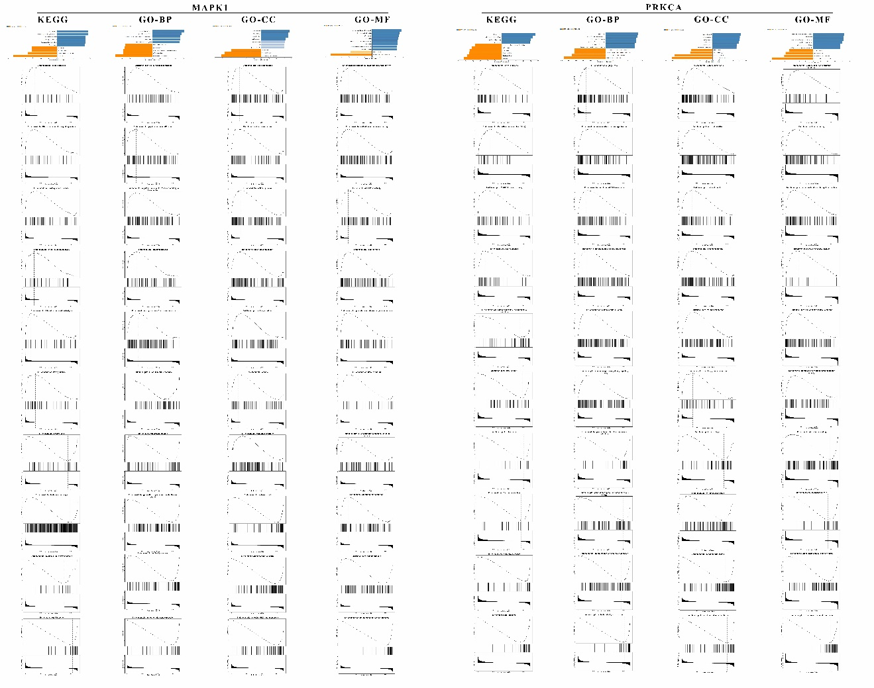
Figure S1. The enrichment analysis of correlated gene sets of MAPK1 and PRKCA. At the top of figure, the enriched pathway, BP, CC and MF were list based on normalized enrichment score (Redundancy reduction: weighted set cover). Below, the enrichment plot of each function item.
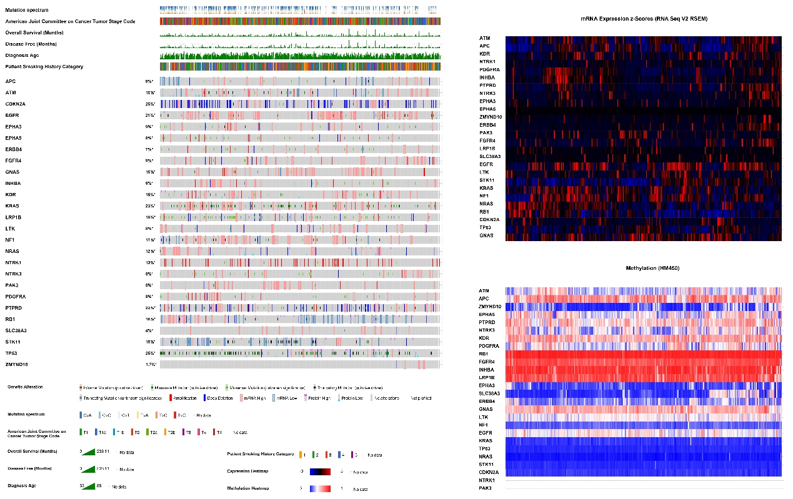
Figure S2. The integrated plot of clinical data and the 26 most significant mutated genes in 586 LUAD samples. From top to bottom panels indicate: mutation spectrum, American Joint Committee on Cancer tumor stage code, overall survival (months), disease free (months), diagnosis age, patient smoking history category and mutation symbol of DECGs, The key to the color-coding is at the bottom. The heatmap of mutated genes expression and methylation were clustered respectively and listed on the right.
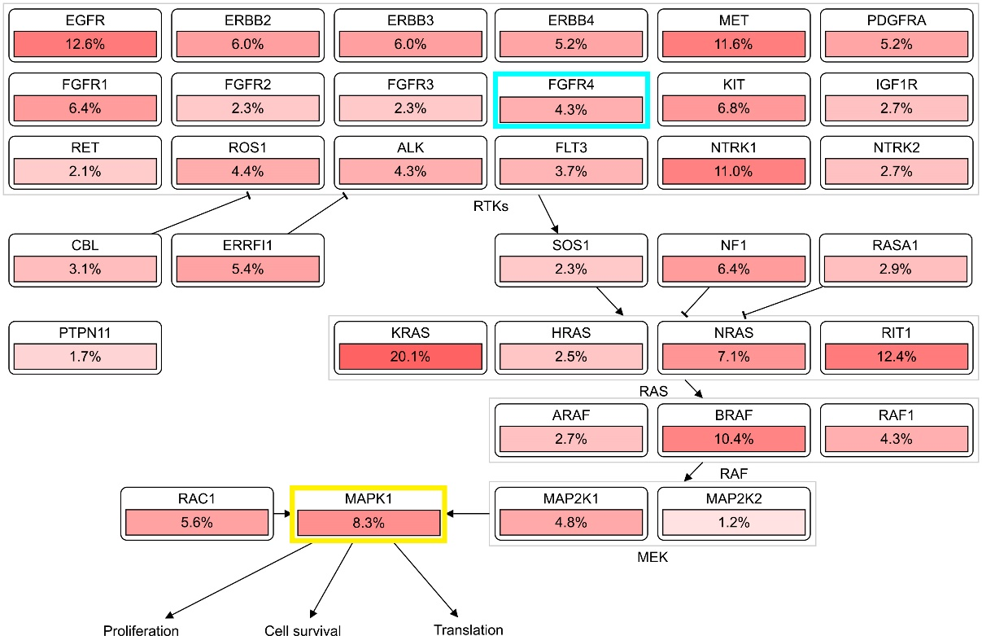
Figure S3. The RTK-RAS pathway (TCGA). The important genes of the RTK-RAS pathway were list in a network form with mutation frequency. FGFR4 was marked with a blue box while MAPK1 was marked with a yellow box.

