Less cytotoxic protoflavones as antiviral agents: protoapigenone 1′-*O*-isopropyl ether shows improved selectivity against the Epstein-Barr virus lytic cycle

**Supporting information**

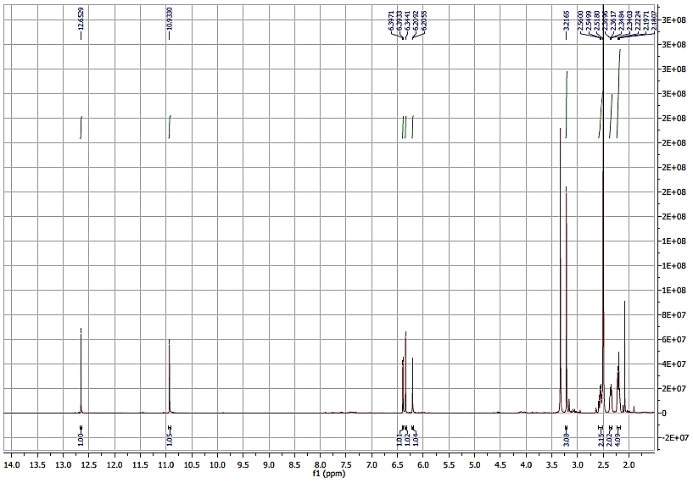

**Figure S1**. 1H NMR (500 MHz, DMSO-*d*6) spectrum of compound **10**.

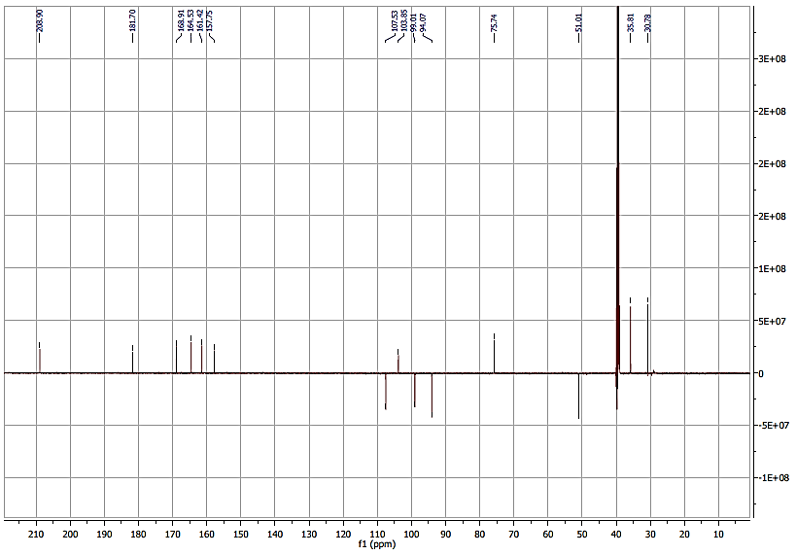

**Figure S2**. JMOD (125 MHz, DMSO-*d*6) spectrum of compound **10**.

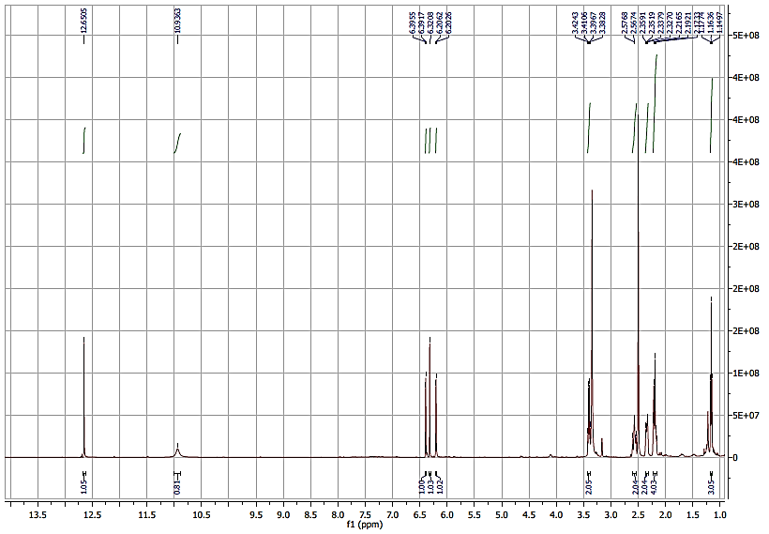

**Figure S3**. 1H NMR (500 MHz, DMSO-*d*6) spectrum of compound **11**.

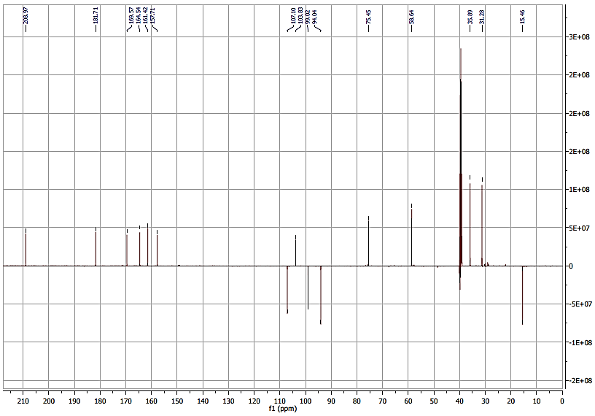

**Figure S4**. JMOD (125 MHz, DMSO-*d*6) spectrum of compound **11**.

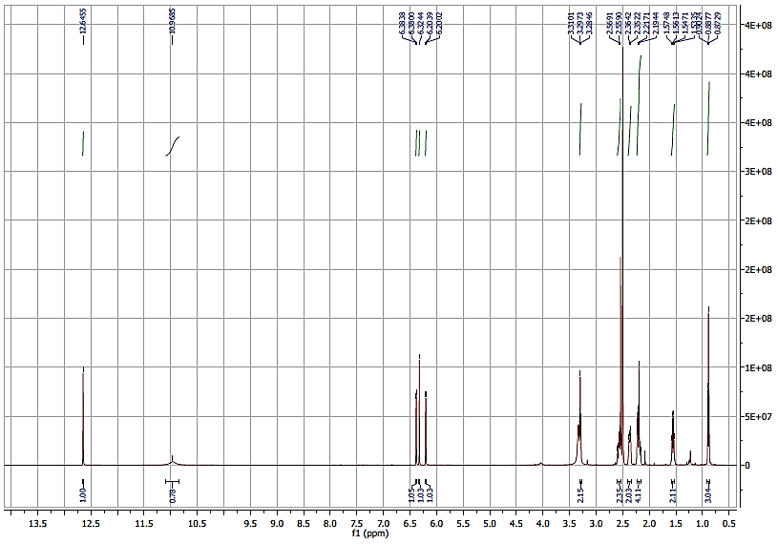

**Figure S5**. 1H NMR (500 MHz, DMSO-*d*6) spectrum of compound **12**.

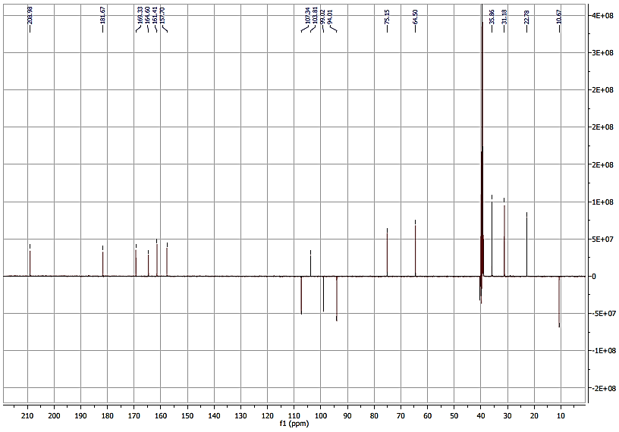

**Figure S6**. JMOD (125 MHz, DMSO-*d*6) spectrum of compound **12**.

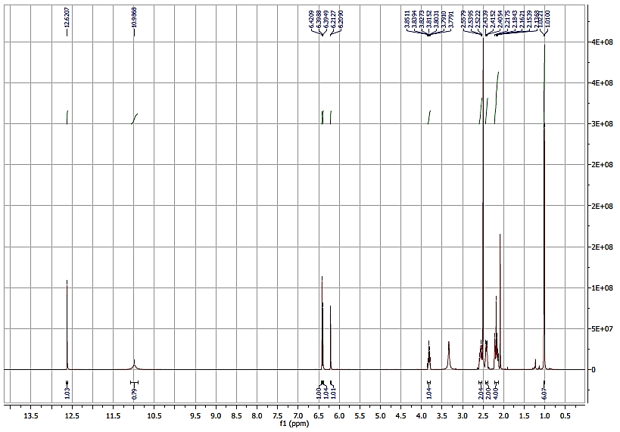

**Figure S7**. 1H NMR (500 MHz, DMSO-*d*6) spectrum of compound **13**.

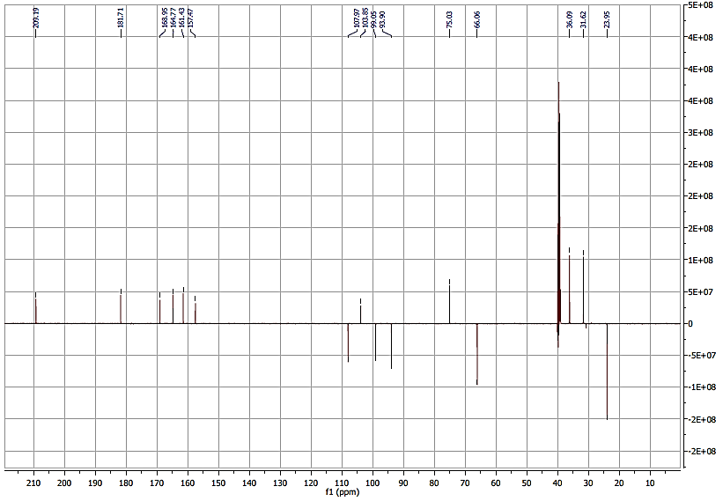

**Figure S8**. JMOD (125 MHz, DMSO-*d*6) spectrum of compound **13**.

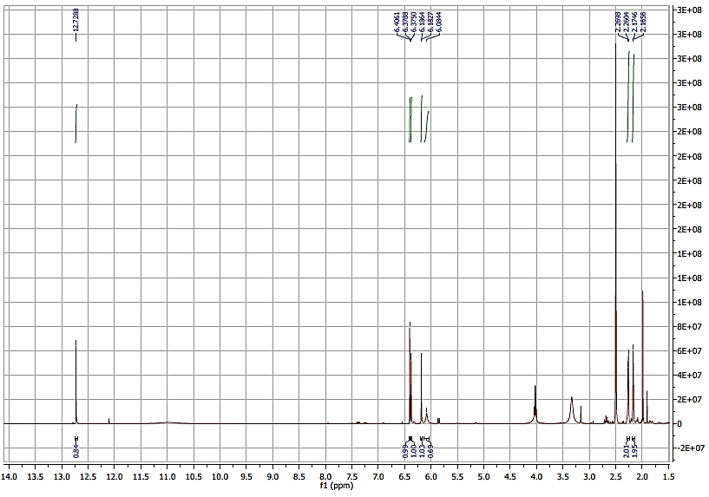

**Figure S9**. 1H NMR (500 MHz, DMSO-*d*6) spectrum of compound **15**.

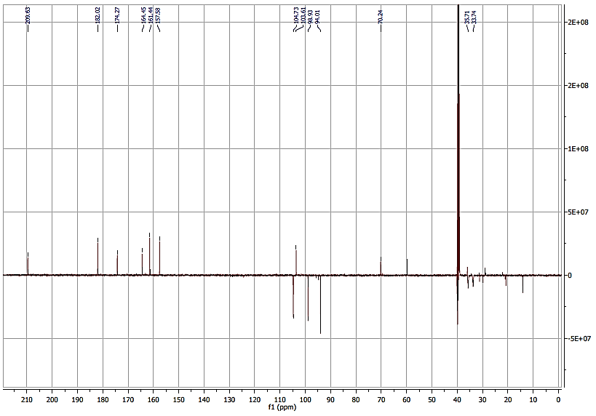

**Figure S10**. JMOD (125 MHz, DMSO-*d*6) spectrum of compound **15**.

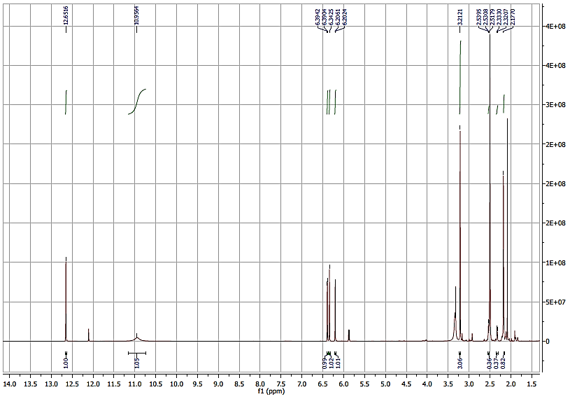

**Figure S11**. 1H NMR (500 MHz, DMSO-*d*6) spectrum of compound **16**.

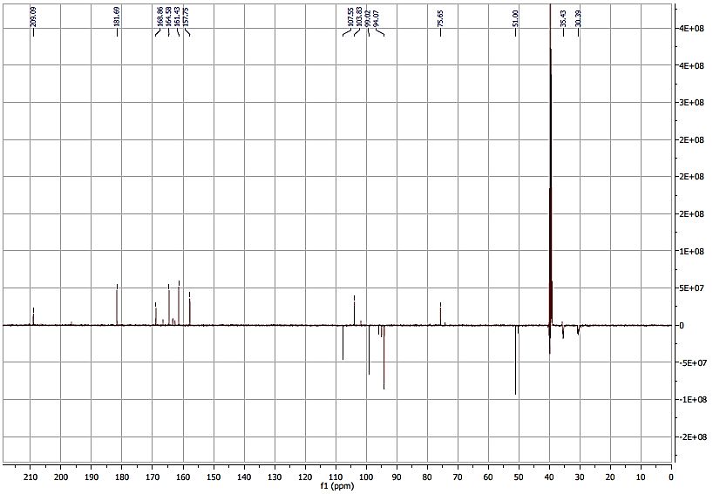

**Figure S12**. JMOD (125 MHz, DMSO-*d*6) spectrum of compound **16**.

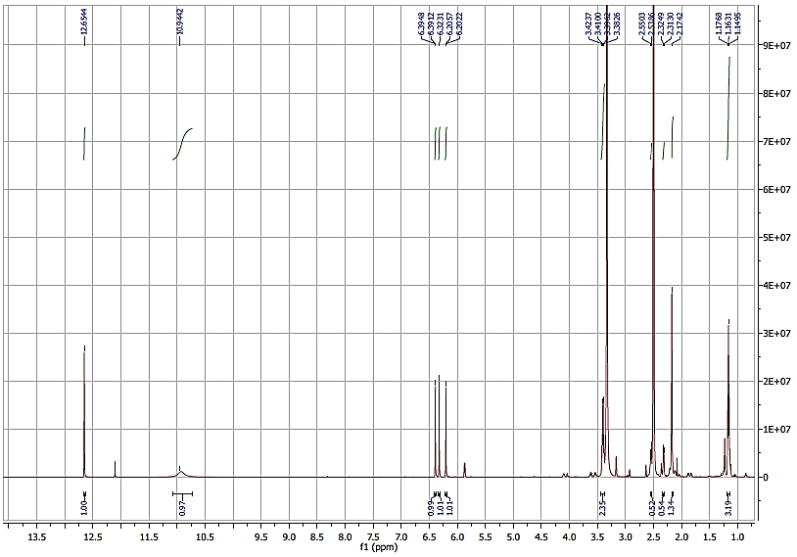

**Figure S13**. 1H NMR (500 MHz, DMSO-*d*6) spectrum of compound **17**.

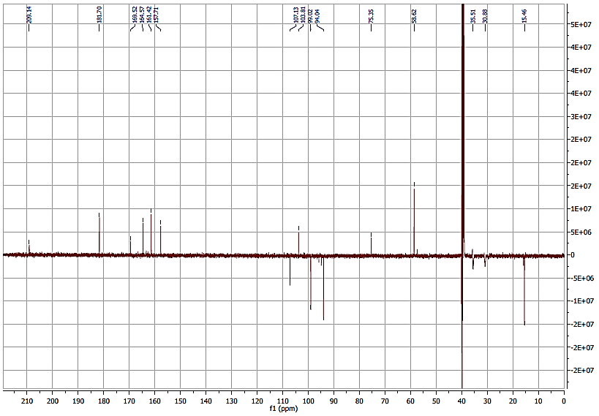

**Figure S14**. JMOD (125 MHz, DMSO-*d*6) spectrum of compound **17**.

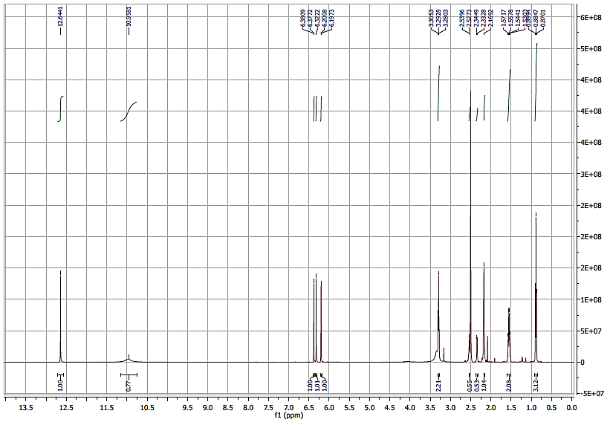

**Figure S15**. 1H NMR (500 MHz, DMSO-*d*6) spectrum of compound **18**.

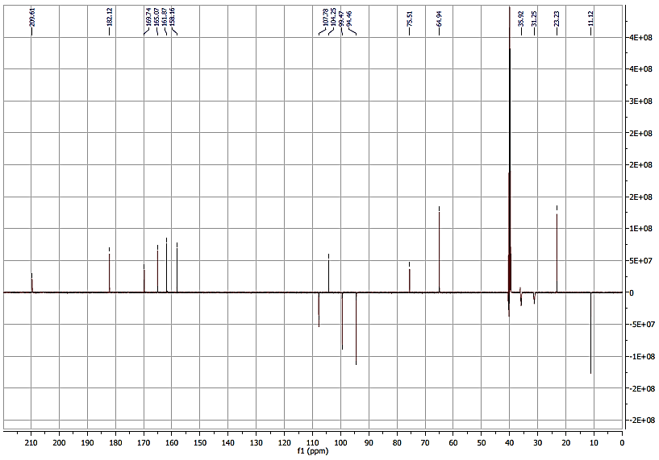

**Figure S16**. JMOD (125 MHz, DMSO-*d*6) spectrum of compound **18**.

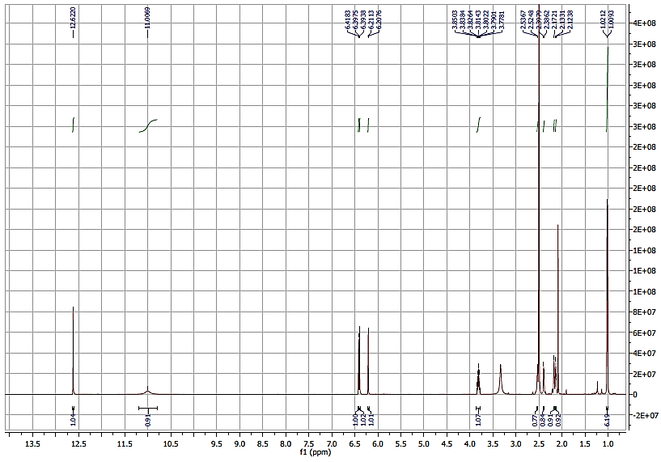

**Figure S17**. 1H NMR (500 MHz, DMSO-*d*6) spectrum of compound **19**.

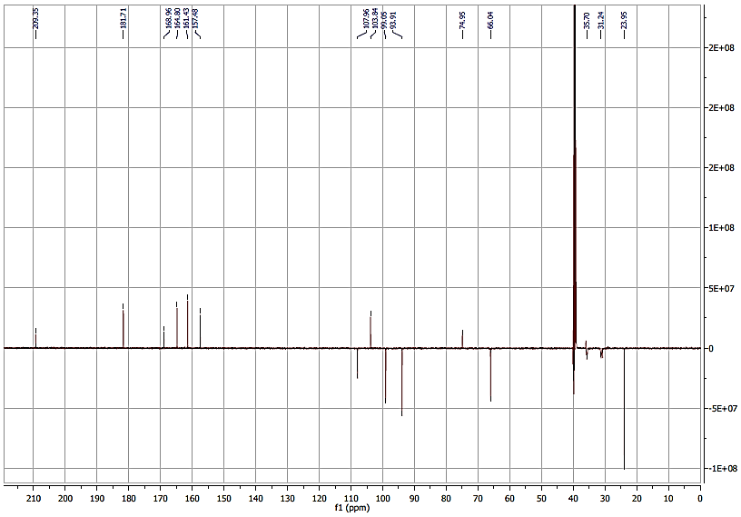

**Figure S18**. JMOD (125 MHz, DMSO-*d*6) spectrum of compound **19**.

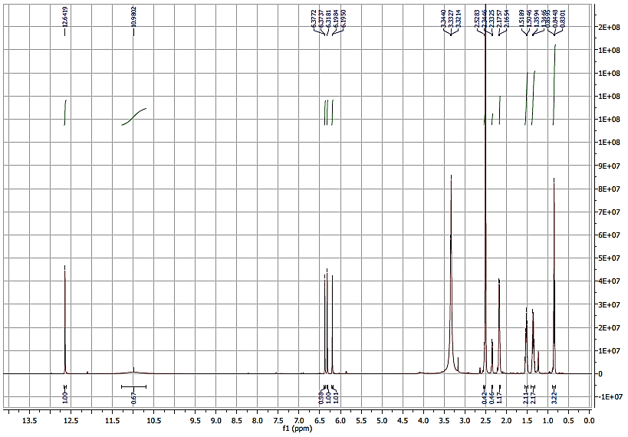

**Figure S19**. 1H NMR (500 MHz, DMSO-*d*6) spectrum of compound **20**.

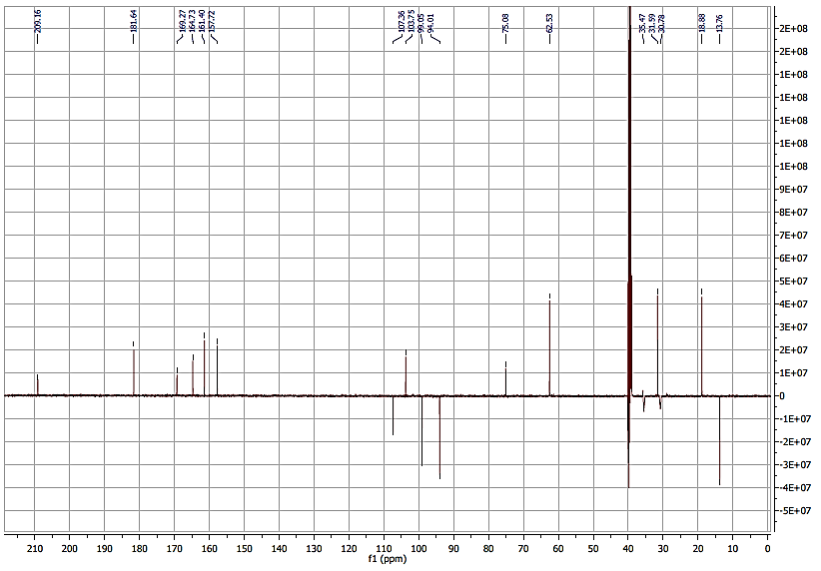

**Figure S20**. JMOD (125 MHz, DMSO-*d*6) spectrum of compound **20**.

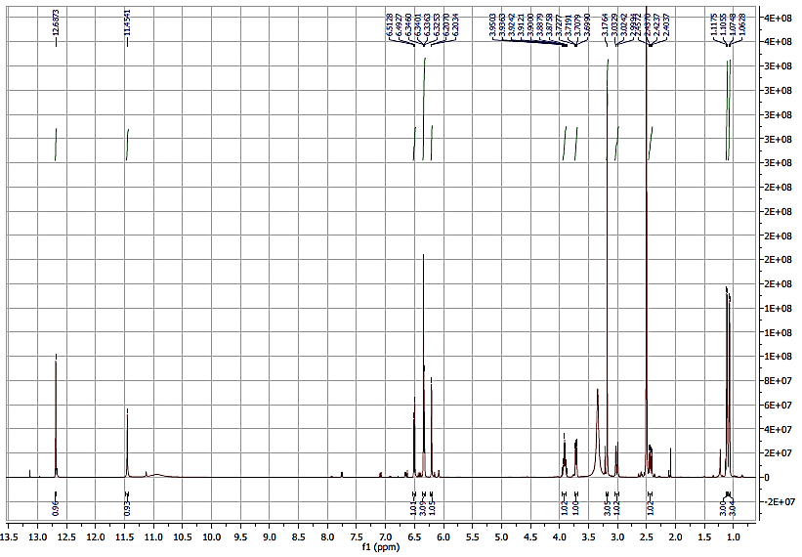

**Figure S21**. 1H NMR (500 MHz, DMSO-*d*6) spectrum of compound **21**.

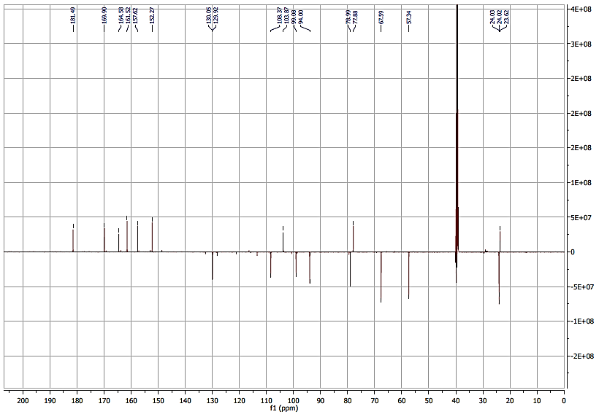

**Figure S22**. JMOD (125 MHz, DMSO-*d*6) spectrum of compound **21**.

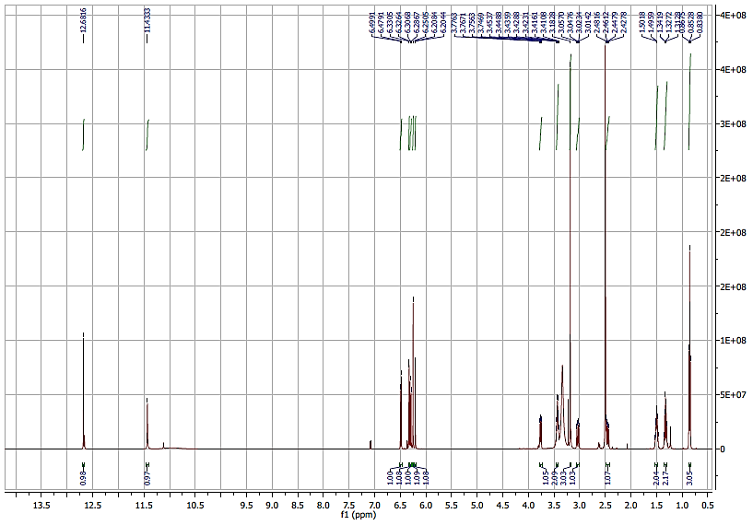

**Figure S23**. 1H NMR (500 MHz, DMSO-*d*6) spectrum of compound **22**.

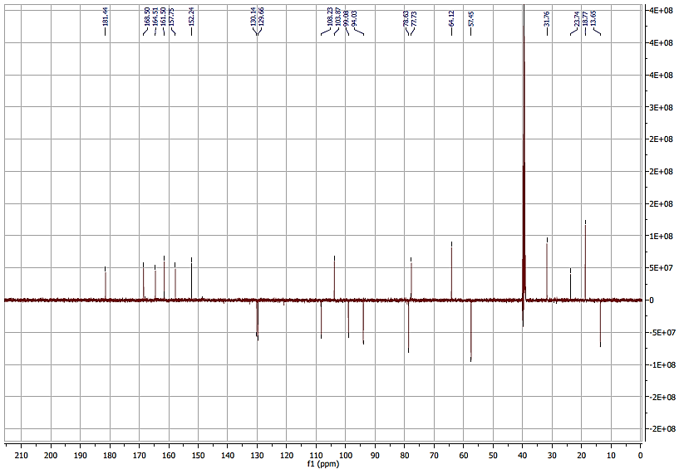

**Figure S24**. JMOD (125 MHz, DMSO-*d*6) spectrum of compound **22**.

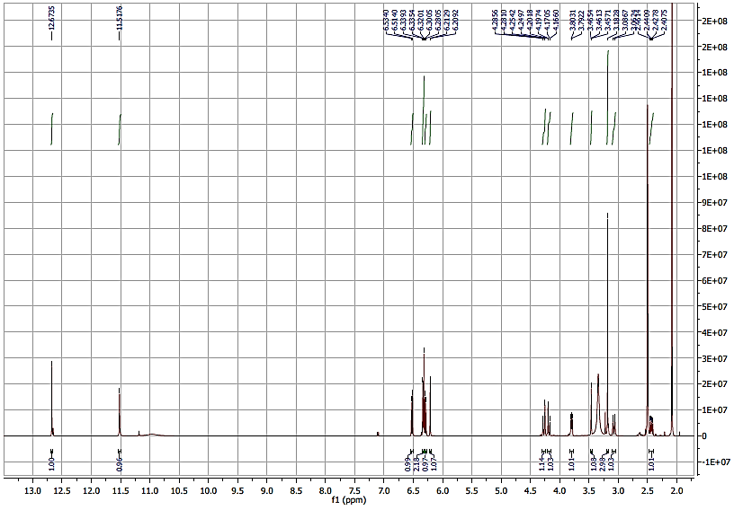

**Figure S25**. 1H NMR (500 MHz, DMSO-*d*6) spectrum of compound **23**.

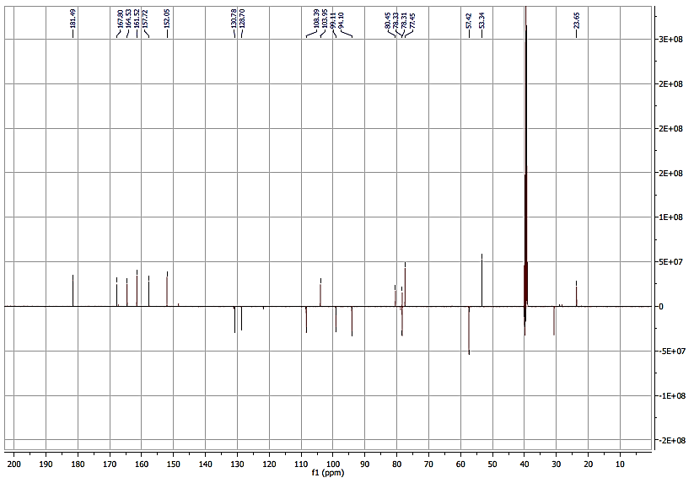

**Figure S26**. JMOD (125 MHz, DMSO-*d*6) spectrum of compound **23**.

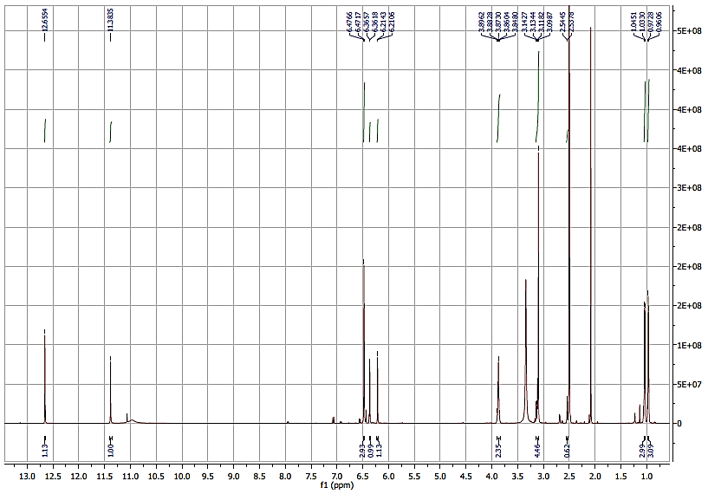

**Figure S27**. 1H NMR (500 MHz, DMSO-*d*6) spectrum of compound **24**.

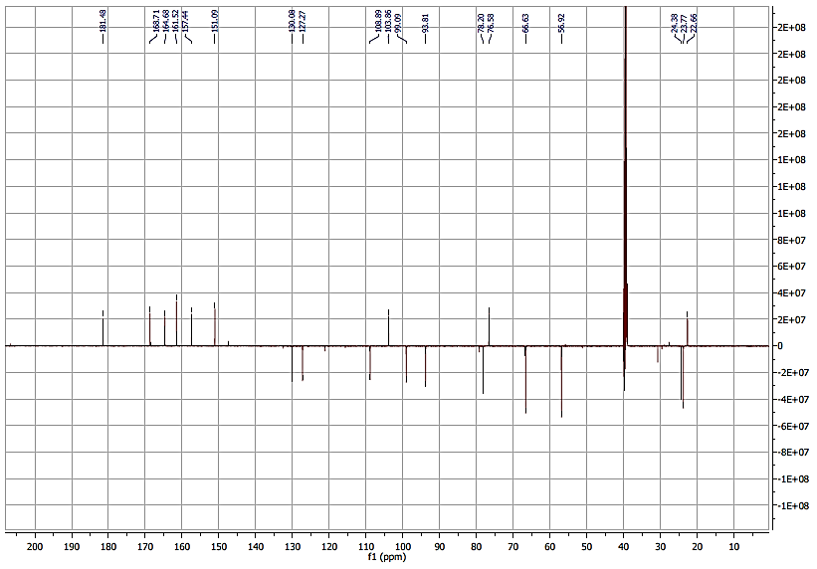

**Figure S28**. JMOD (125 MHz, DMSO-*d*6) spectrum of compound **24**.

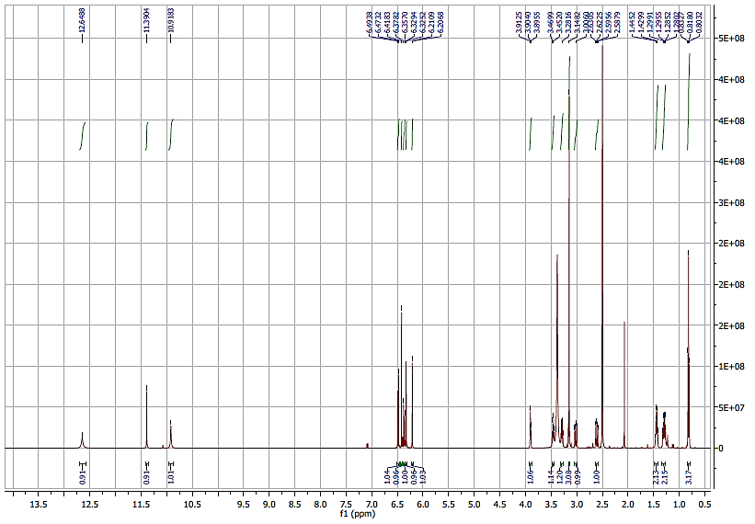

**Figure S29**. 1H NMR (500 MHz, DMSO-*d*6) spectrum of compound **25**.

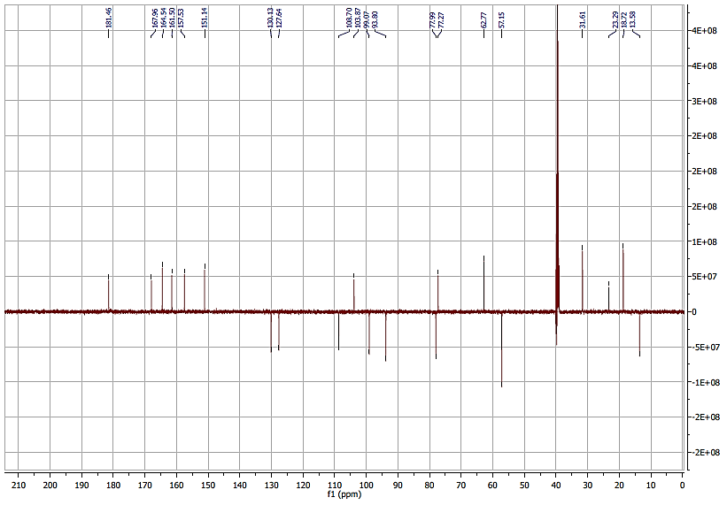

**Figure S30**. JMOD (125 MHz, DMSO-*d*6) spectrum of compound **25**.

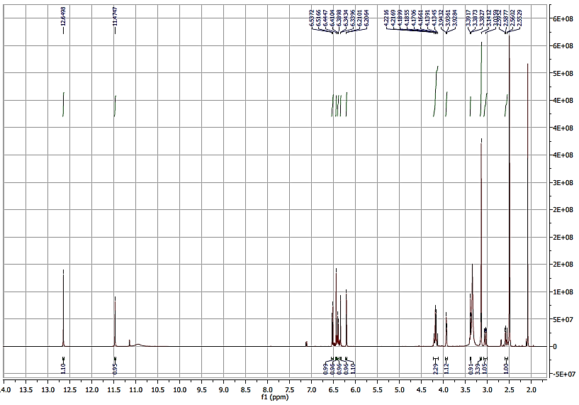

**Figure S31**. 1H NMR (500 MHz, DMSO-*d*6) spectrum of compound **26**.

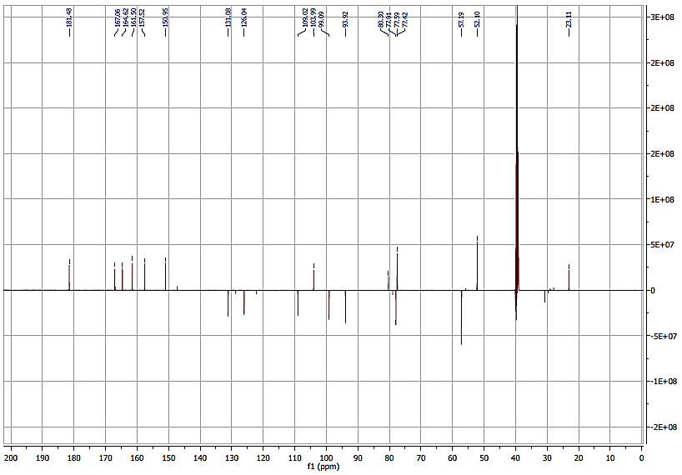

**Figure S32**. JMOD (125 MHz, DMSO-*d*6) spectrum of compound **26**.

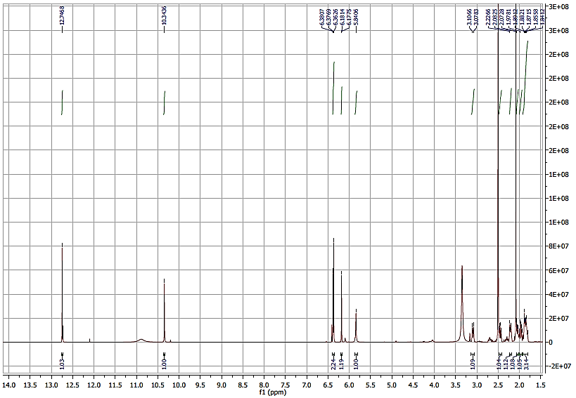

**Figure S33**. 1H NMR (500 MHz, DMSO-*d*6) spectrum of compound **27**.

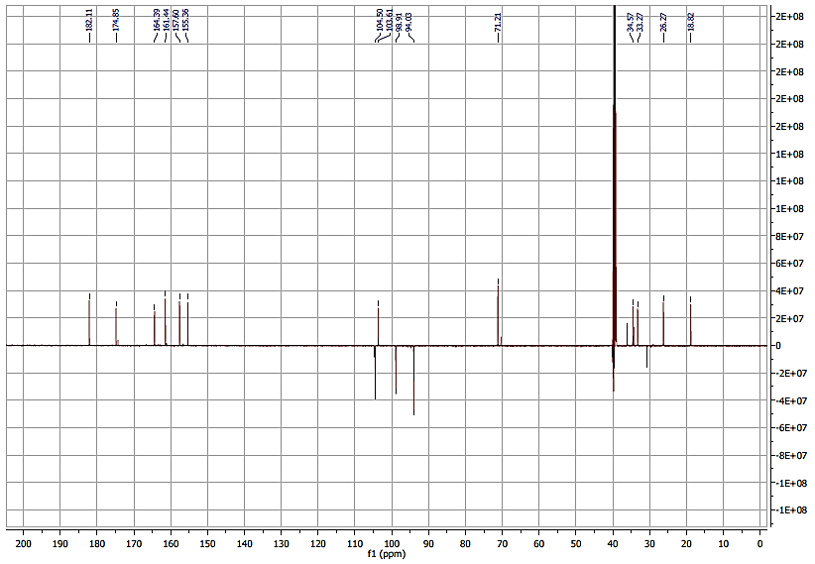

**Figure S34**. JMOD (125 MHz, DMSO-*d*6) spectrum of compound **27**.

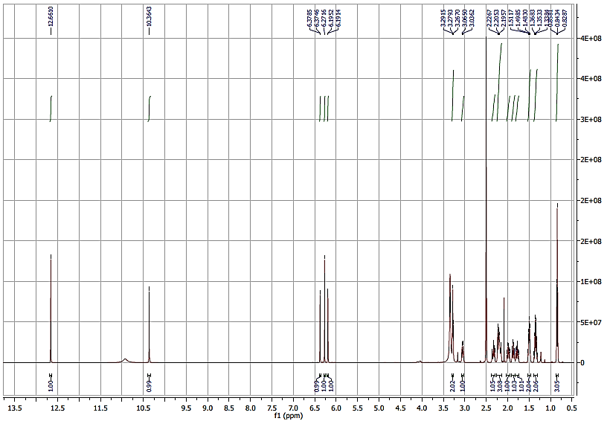

**Figure S35**. 1H NMR (500 MHz, DMSO-*d*6) spectrum of compound **28**.

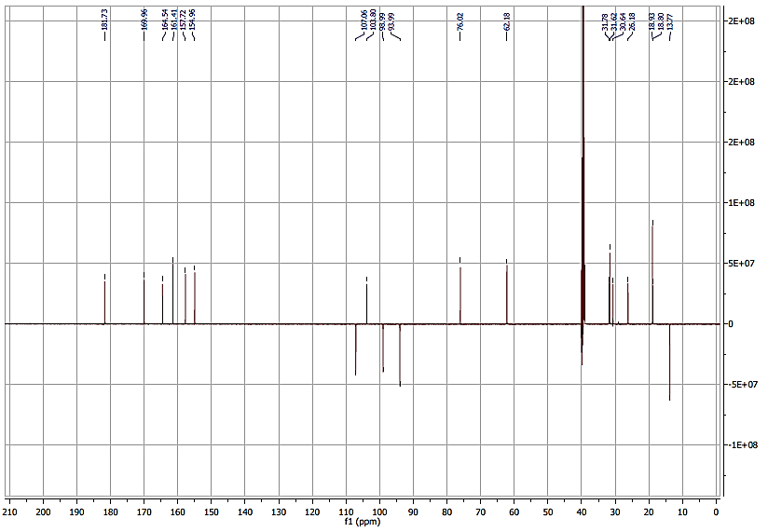

**Figure S36**. JMOD (125 MHz, DMSO-*d*6) spectrum of compound **28**.

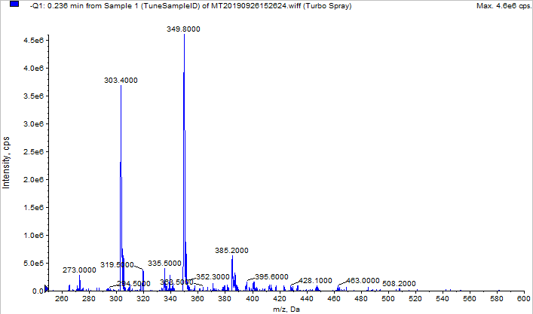

**Figure S37**. Mass spectrum of compound **10** recorded in negative ionization mode.

(solvent: CH3CN + 1% HCOOH)

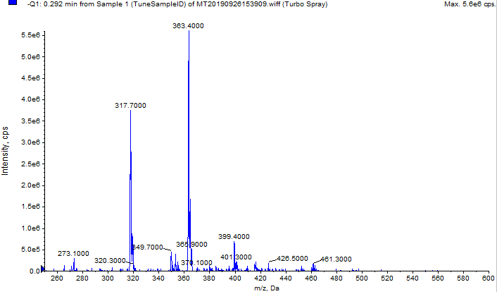

**Figure S38**. Mass spectrum of compound **11** recorded in negative ionization mode.

(solvent: CH3CN + 1% HCOOH)

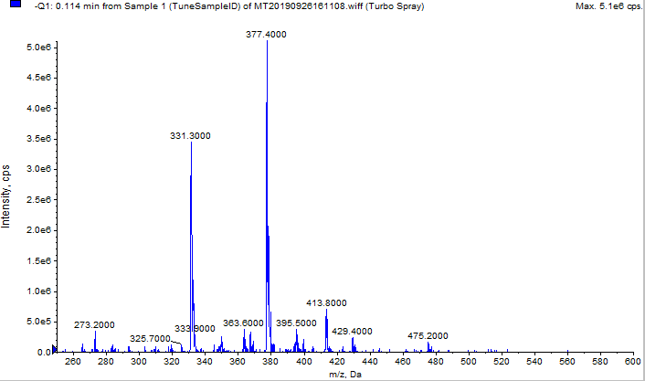

**Figure S39**. Mass spectrum of compound **12** recorded in negative ionization mode.

(solvent: CH3CN + 1% HCOOH)

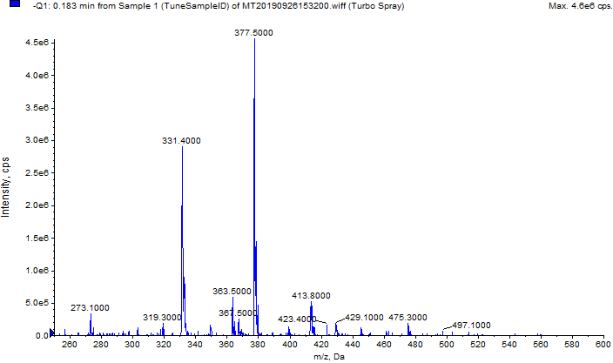

**Figure S40**. Mass spectrum of compound **13** recorded in negative ionization mode.

(solvent: CH3CN + 1% HCOOH)

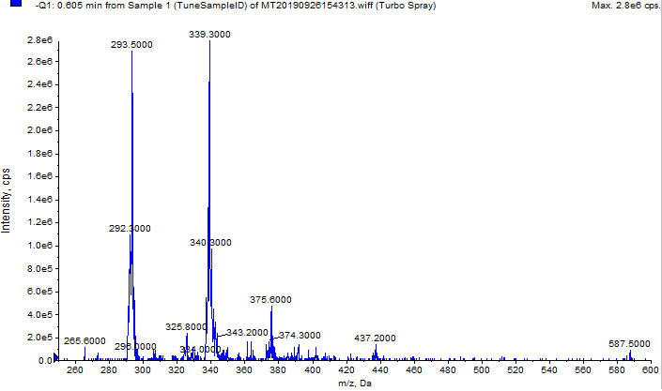

**Figure S41**. Mass spectrum of compound **15** recorded in negative ionization mode.

(solvent: CH3CN + 1% HCOOH)

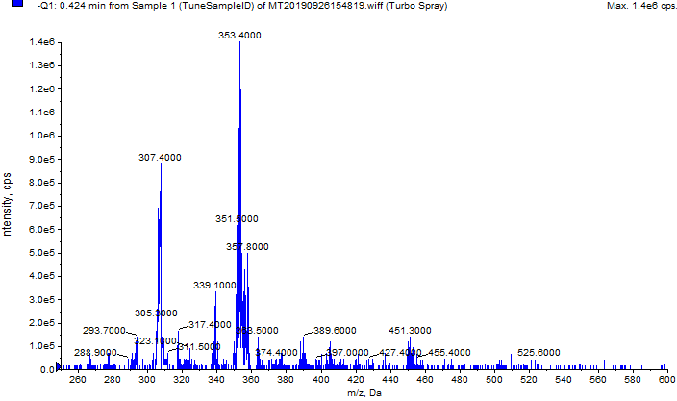

**Figure S42**. Mass spectrum of compound **16** recorded in negative ionization mode.

(solvent: CH3CN + 1% HCOOH)

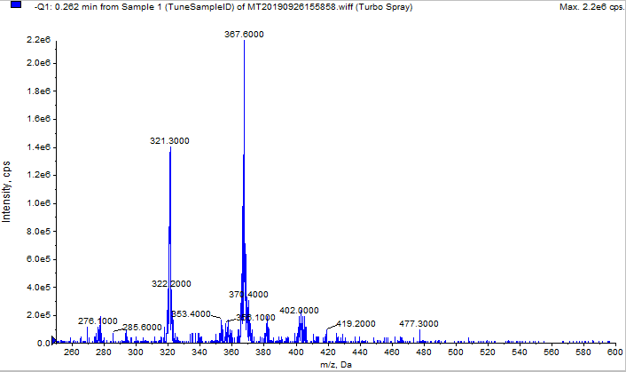

**Figure S43**. Mass spectrum of compound **17** recorded in negative ionization mode.

(solvent: CH3CN + 1% HCOOH)

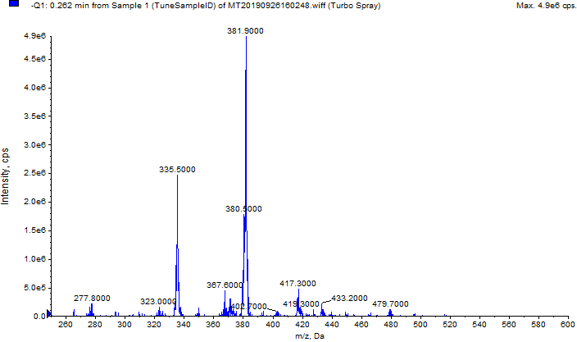

**Figure S44**. Mass spectrum of compound **18** recorded in negative ionization mode.

(solvent: CH3CN + 1% HCOOH)

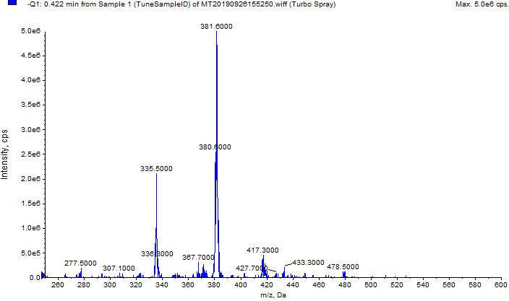

**Figure S45**. Mass spectrum of compound **19** recorded in negative ionization mode.

(solvent: CH3CN + 1% HCOOH)

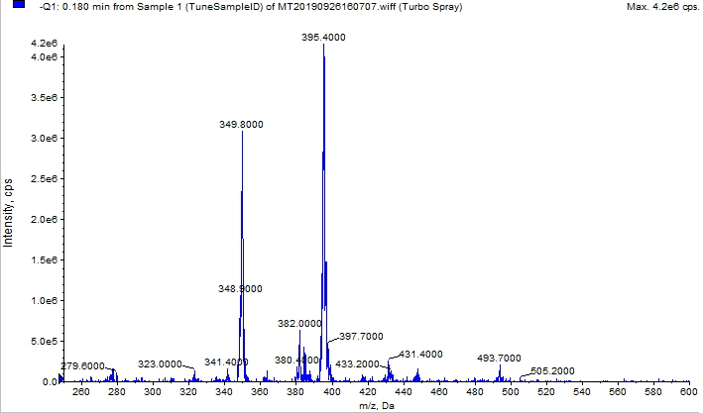

**Figure S46**. Mass spectrum of compound **20** recorded in negative ionization mode.

(solvent: CH3CN + 1% HCOOH)

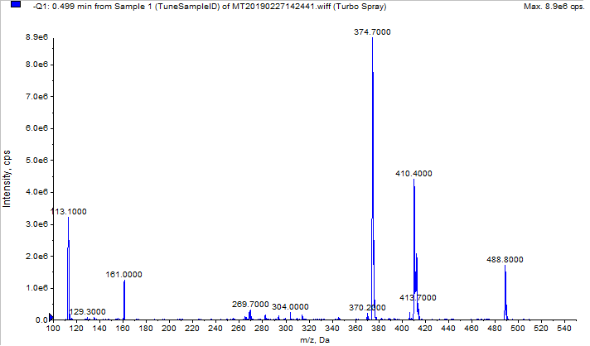

**Figure S47**. Mass spectrum of racemate **21** recorded in negative ionization mode.

(solvent: CH3CN)

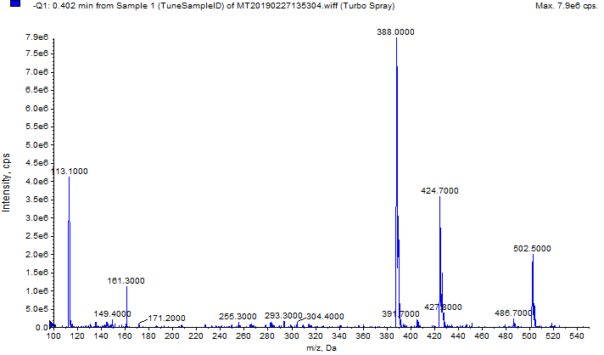

**Figure S48**. Mass spectrum of racemate **22** recorded in negative ionization mode.

(solvent: CH3CN)

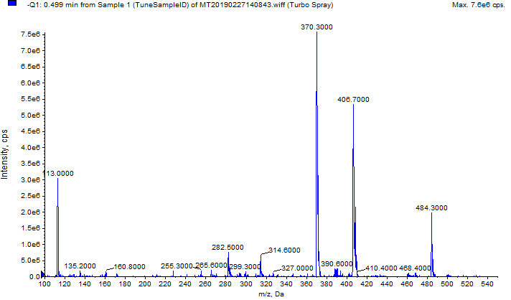

**Figure S49**. Mass spectrum of racemate **23** recorded in negative ionization mode.

(solvent: CH3CN)

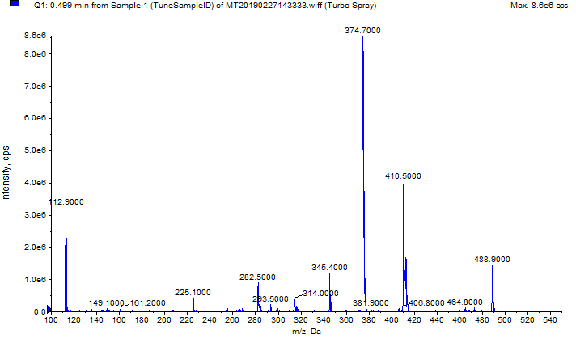

**Figure S50**. Mass spectrum of racemate **24** recorded in negative ionization mode.

(solvent: CH3CN)

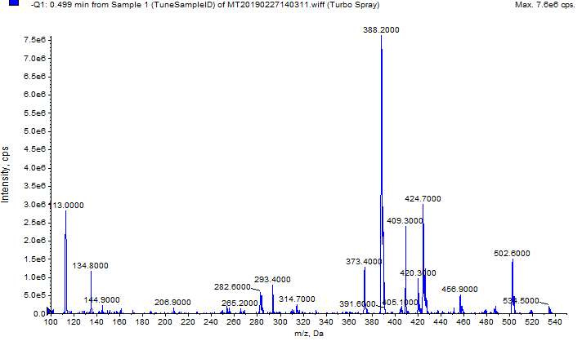

**Figure S51**. Mass spectrum of racemate **25** recorded in negative ionization mode.

(solvent: CH3CN)

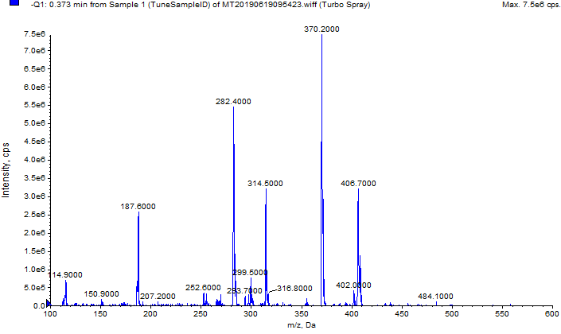

**Figure S52**. Mass spectrum of racemate **26** recorded in negative ionization mode.

(solvent: CH3CN)

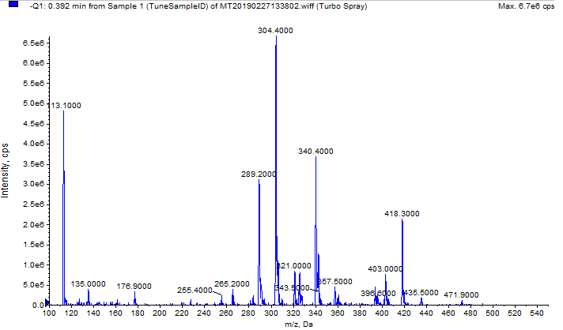

**Figure S53**. Mass spectrum of racemate **27** recorded in negative ionization mode.

(solvent: CH3CN)

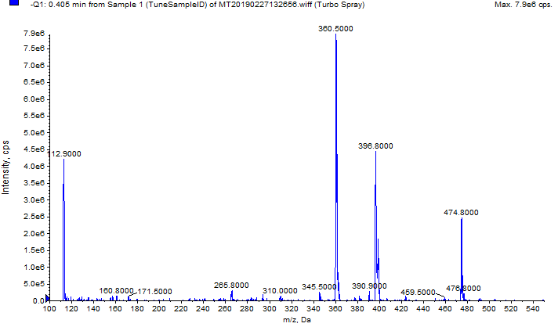

**Figure S54**. Mass spectrum of racemate **28** recorded in negative ionization mode.

(solvent: CH3CN)

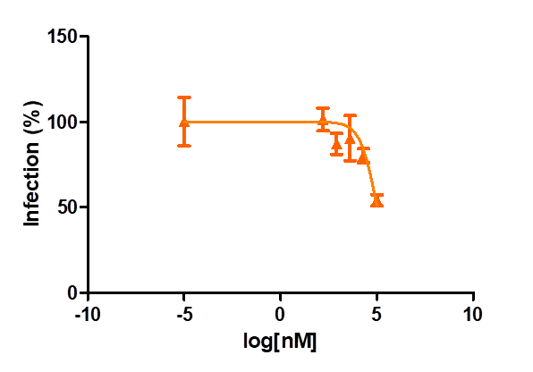

**Figure S55.** Compound **9** inhibits HIV-1 infection using the pseudotype virus assay at the non-cytotoxic concentration of 100 µM. Two independent experiments were performed in triplicates.

**Table S1.** Cytotoxicity of compounds **2**-**14** and **21**-**28** on U373-CD4-CCR5 cells, n=2. Compounds were tested up to 100 µM except for compound **9** whose cytotoxicity evaluation was repeated up to a maximum concentration of 500 µM. Both chemical strategies (B-ring saturation and 4′-oxime formation) allowed us to successfully decrease the cytotoxicity of protoflavones.

|  |  |  |
| --- | --- | --- |
| Compound | Compound type | Cytotoxic IC50 ± SEM [µM] |
| **2** | protoflavone | 0.22 ± 0.003 |
| **6** | protoflavone | 2.09 ± 0.13 |
| **7** | protoflavone | 0.25 ± 0.002 |
| **8** | protoflavone | 0.67 ± 0.03 |
| **9** | tetrahydroprotoflavone | > 500 |
| **10** | tetrahydroprotoflavone | > 100 |
| **11** | tetrahydroprotoflavone | > 100 |
| **12** | tetrahydroprotoflavone | > 100 |
| **13** | tetrahydroprotoflavone | > 100 |
| **14** | tetrahydroprotoflavone | ~ 6.37 |
| **21** | dihydroprotoflavone 4′-oxime | > 100 |
| **22** | dihydroprotoflavone 4′-oxime | > 100 |
| **23** | dihydroprotoflavone 4′-oxime | ~ 89.45 |
| **24** | dihydroprotoflavone 4′-oxime | > 100 |
| **25** | dihydroprotoflavone 4′-oxime | 53.88 ± 0.35 |
| **26** | dihydroprotoflavone 4′-oxime | > 100 |
| **27** | tetrahydroprotoflavone 4′-oxime | > 100 |
| **28** | tetrahydroprotoflavone 4′-oxime | 27.02 ± 8.4 |