Supplementary Information

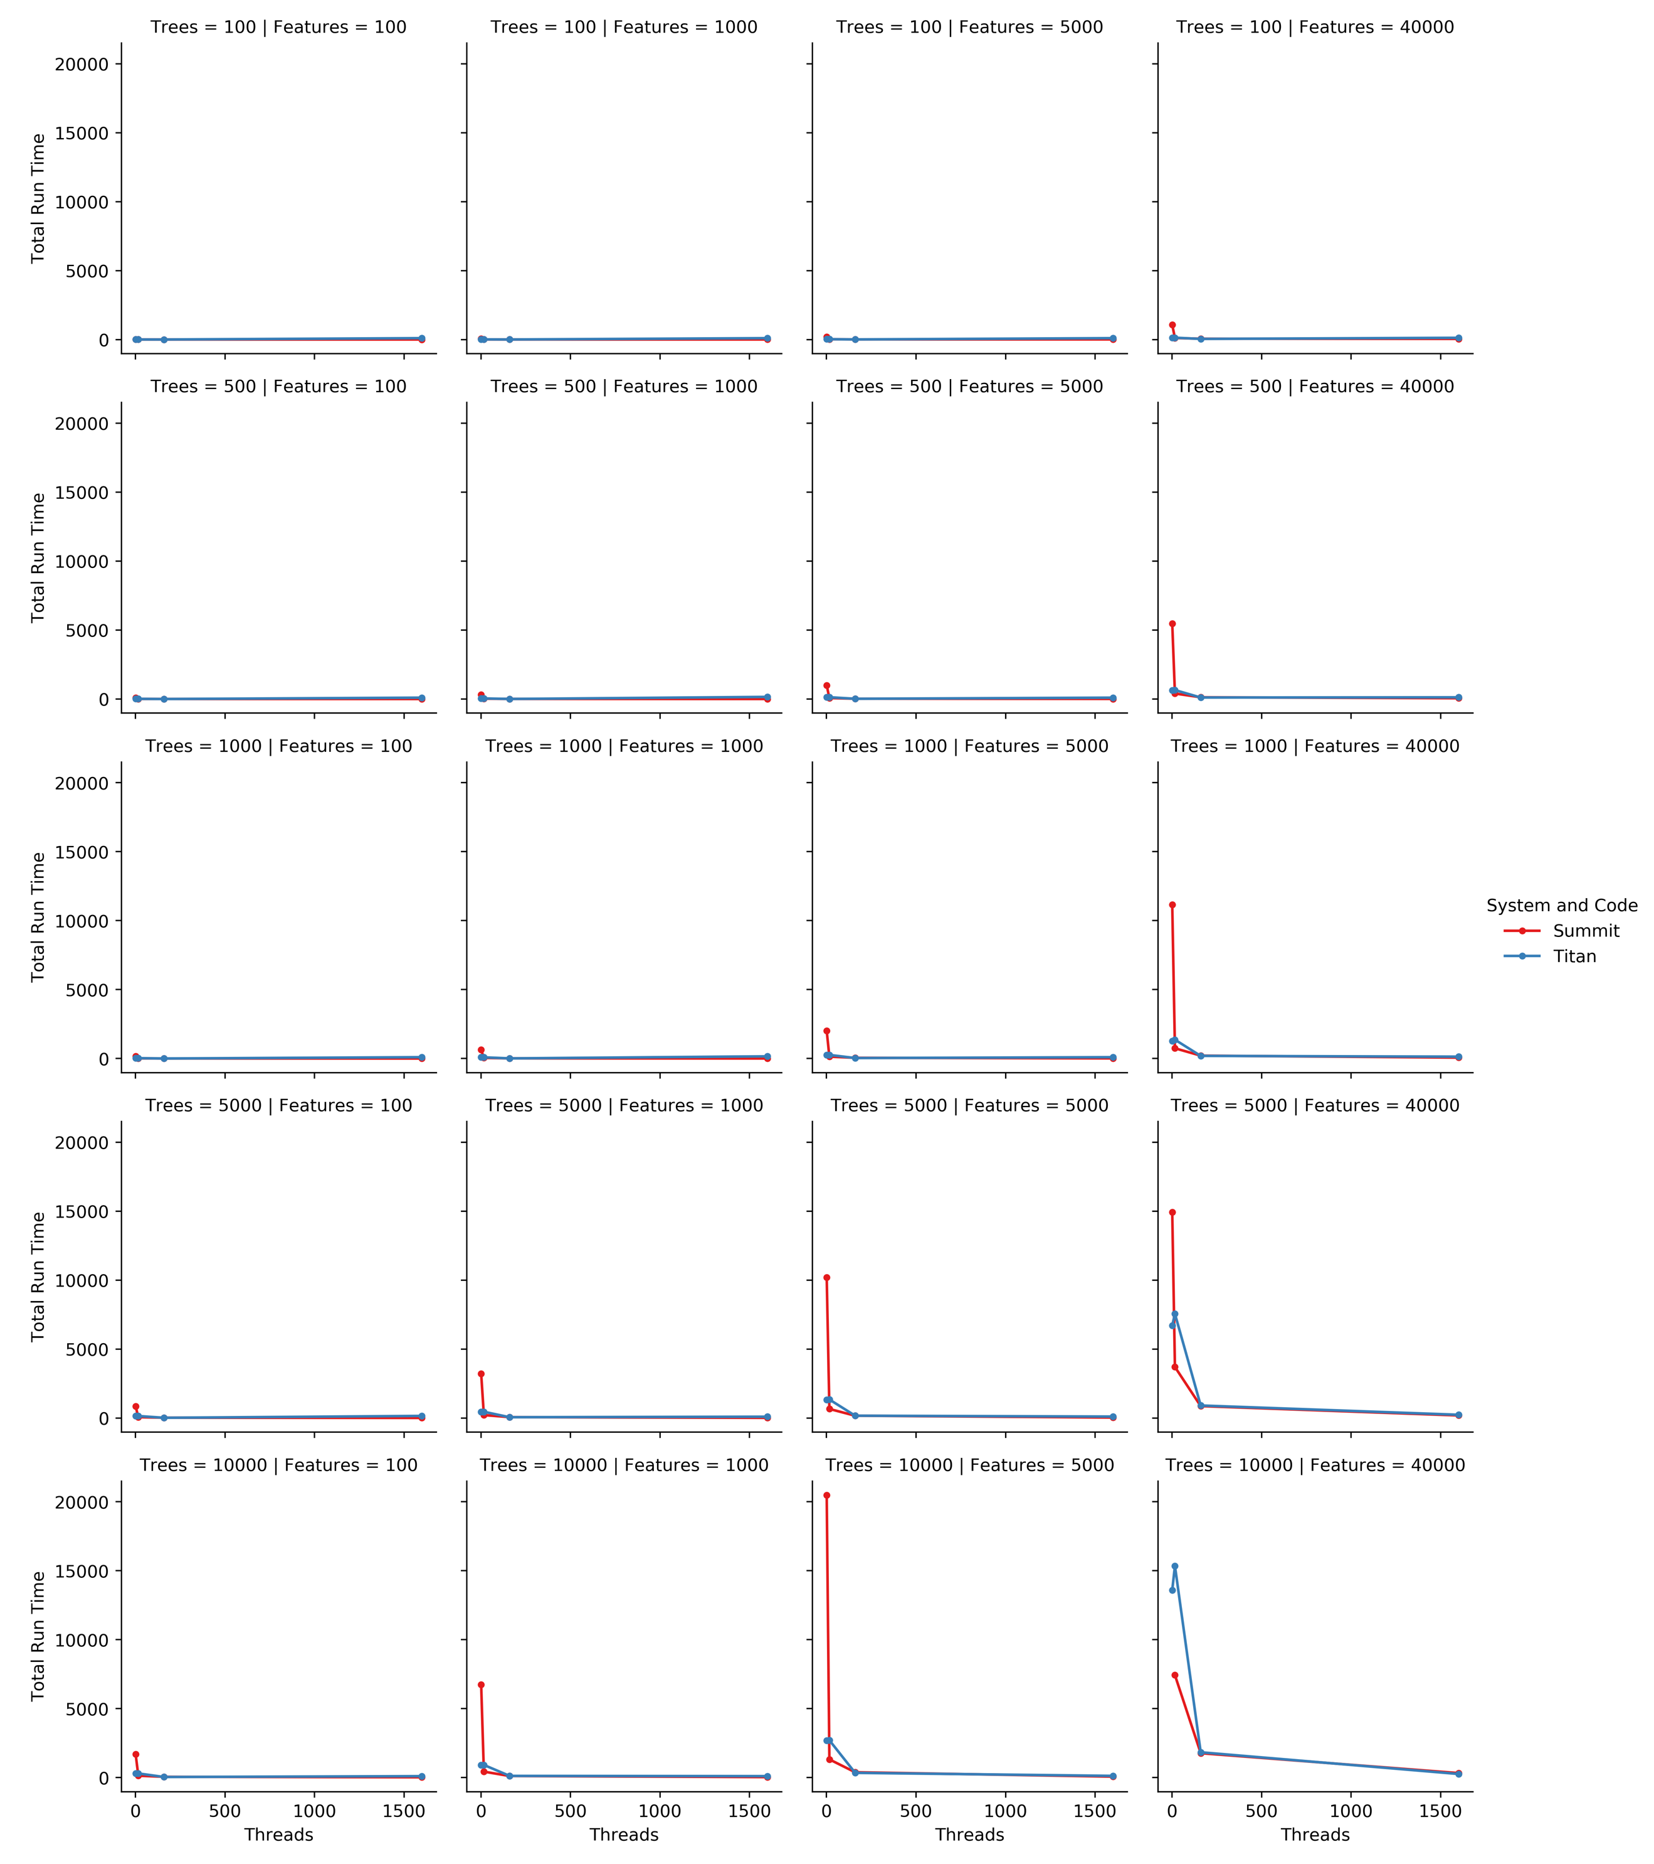
Figure S1: Runtime on HPC Systems. The full grid of graphs comparing Summit and Titan times to completion for the C++ code. The red line is for Summit and the blue line is for Titan.

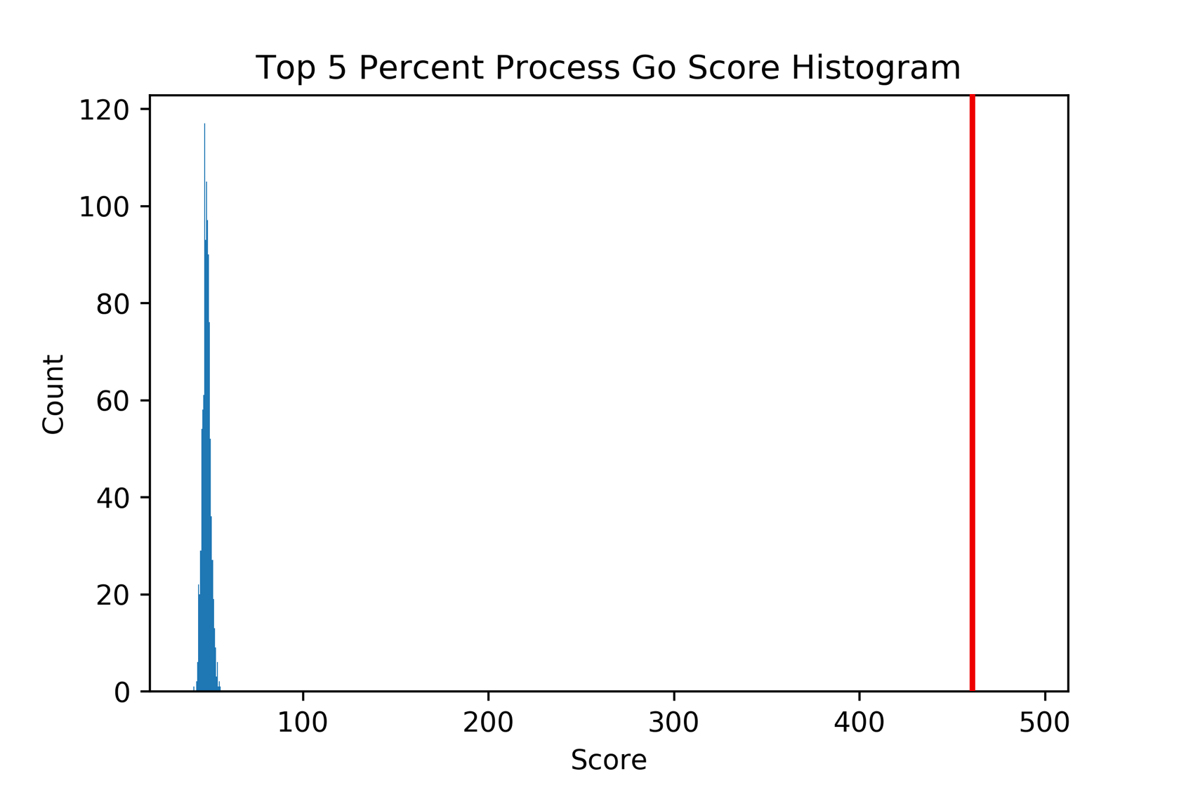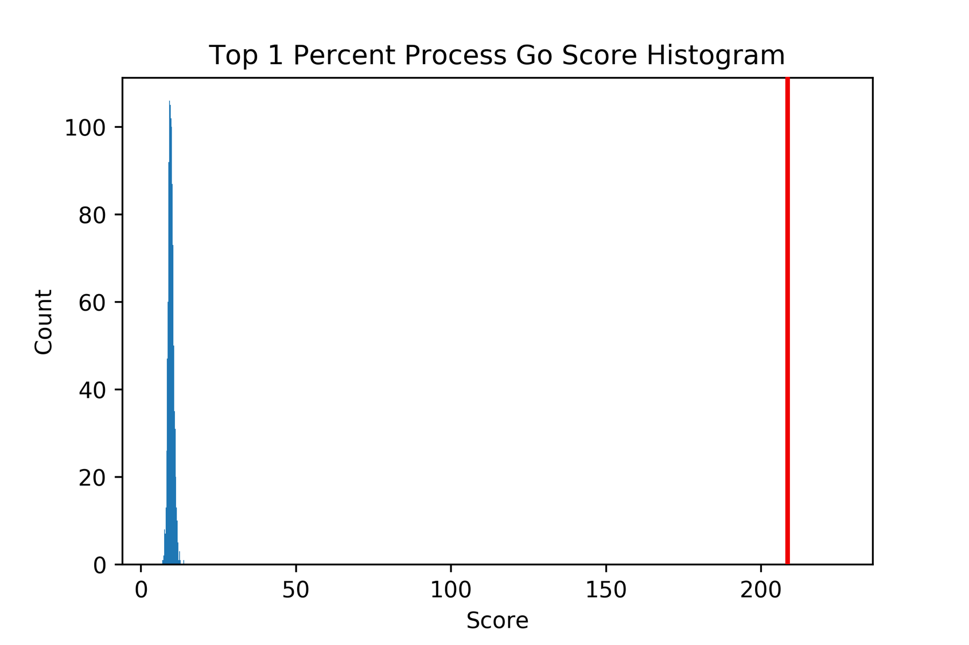

Figure S2: Null Distribution Plots. Null distrubtions with iRF intersect scores in red for the two thresholded Predictive Expression Networks not shown in the main text.

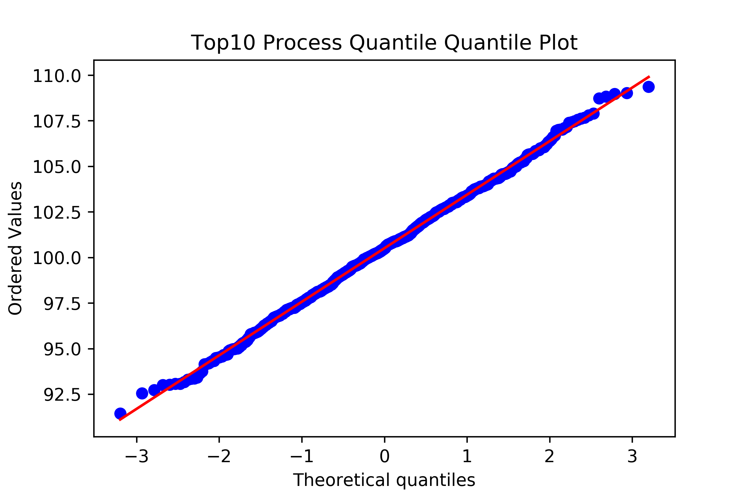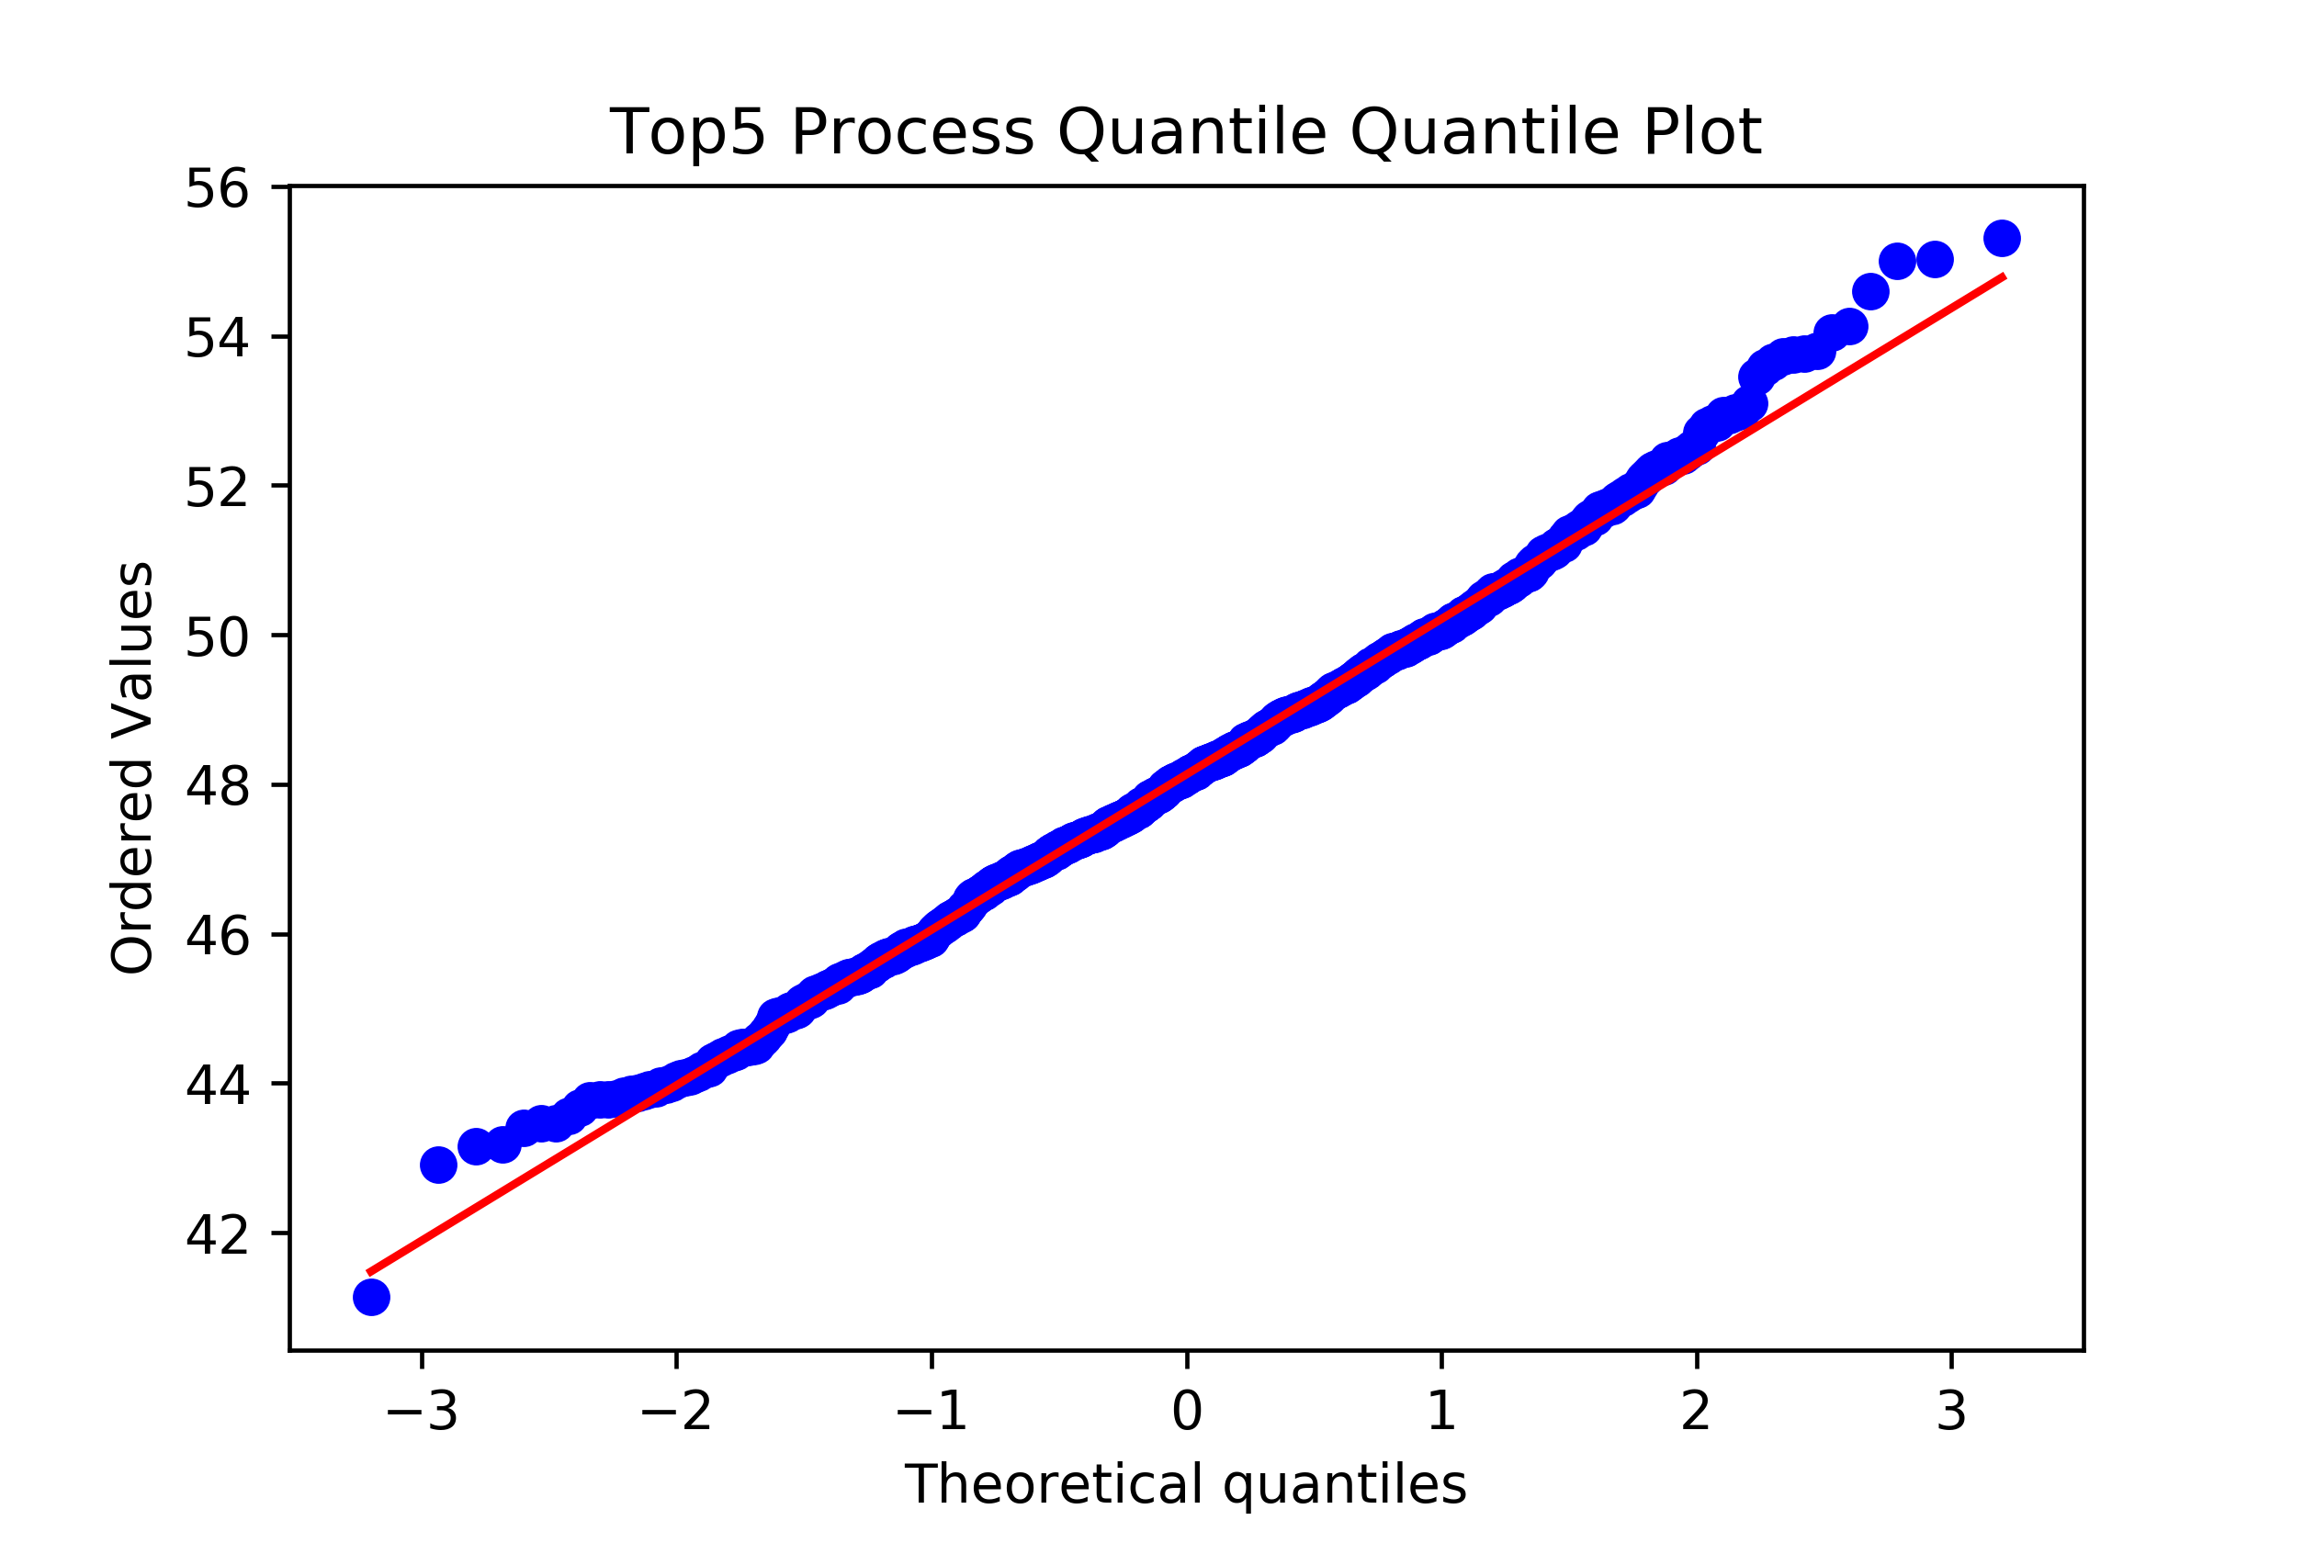
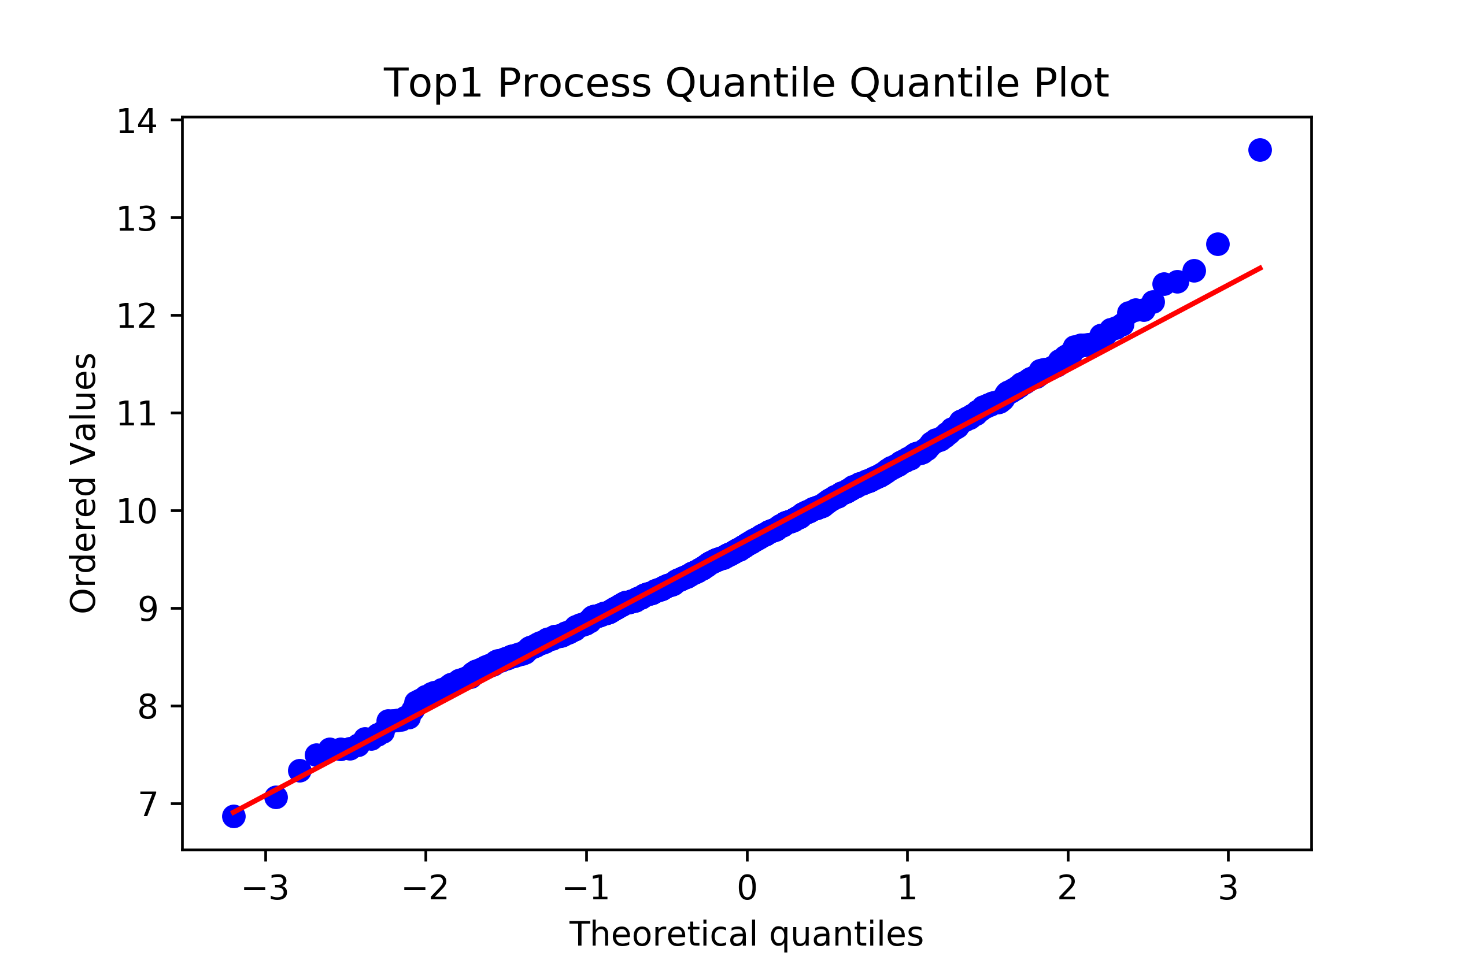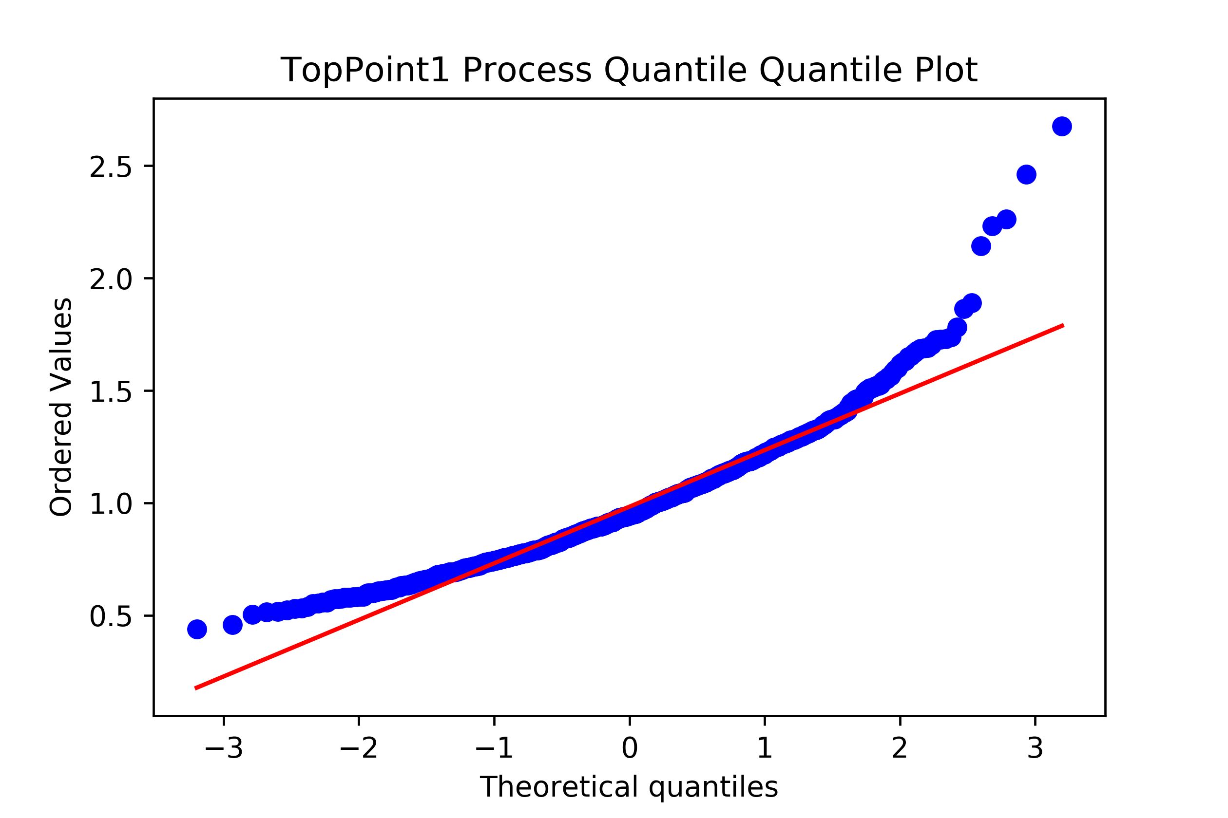
Figure S3: Quantile-Quantile Plots for the PENs. Quantile-quantile plots for each null distribution of the thresholded Predictive Expression Networks.

