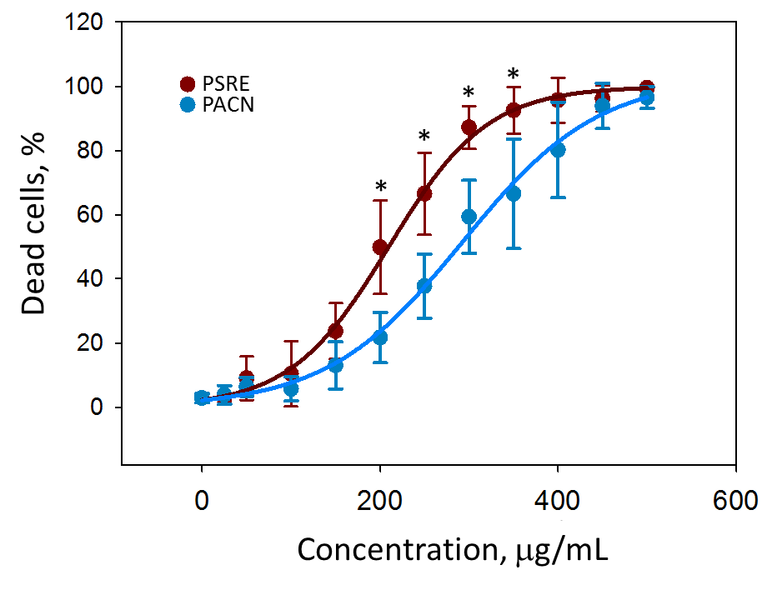

Supplementary Figure S1. The concentration-dependent toxicity of Pelargonium sidoides DC root extract (PSRE) and proanthocyanidins from PSRE (PACN) for rat gingival fibroblasts. The cells were incubated with the extracts at different concentrations for 24 h period and necrotic vs total cell assessment was performed by double nuclear staining (propidium iodide and Hoeachst3334) and fluorescent microscope. Data are presented as means plus standard deviation, and curve fitting analysis was done by SigmaPlot vs.13 software. * - significant difference compared to the samples treated with the same concentration of PACN (p<0.05).

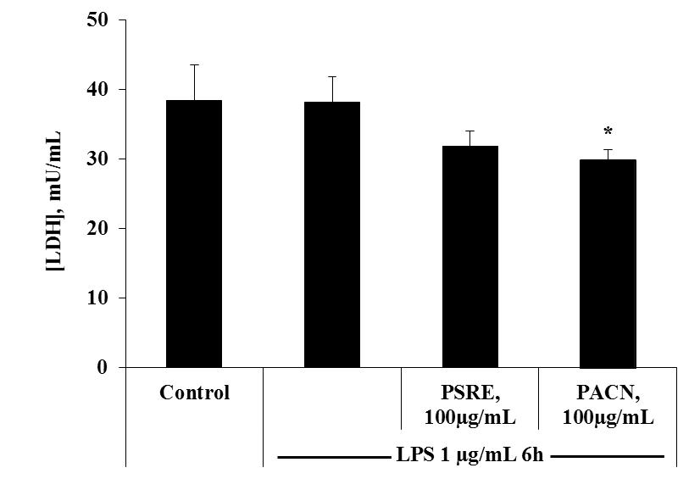

Supplementary Figure S2. Effects of Pelargonium sidoides DC root extract (PSRE) and proanthocyanidins from PSRE (PACN) on human peripheral blood mononuclear cell membrane damage measured by lactate dehydrogenase (LDH) assay. The LDH release was tested in the media after 6 h treatment with PSRE and PACN (100 µg/mL each) and LPS (1 µg/mL). Values are represented as the mean ± SD of 3 independent measurements in 3 parallels. Differences between the measurements were tested using one-way ANOVA followed by Tukey's Multiple Comparison Test. * - significant difference compared to the LPS control (p < 0.05).

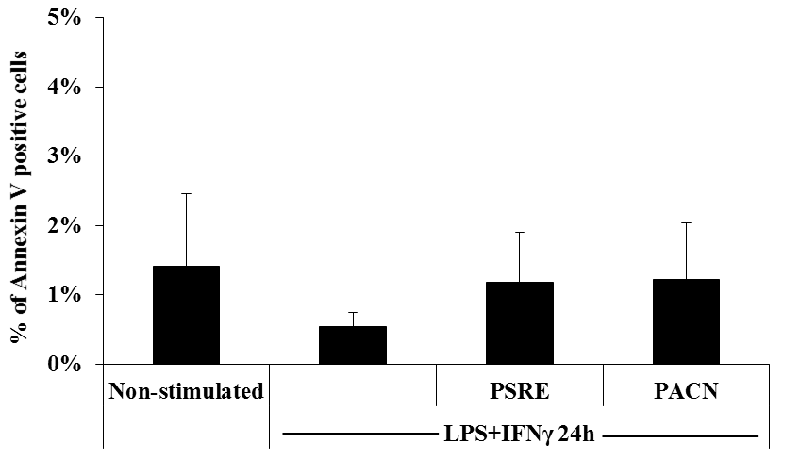

Supplementary Figure S3. Detection of apoptosis by staining bone-marrow derived macrophages (BMDM) for Annexin V. BMDM were stained for Annexin V after 24 h of incubation with Pelargonium sidoides DC root extract (PSRE) and proanthocyanidins from PSRE (PACN) at 100 μg/mL, and LPS/IFN-γ (10 ng/mL/100 U/mL). Apoptotic cells (Annexin V positive) were detected by flow cytometry. Values are presented as mean ± SD of 3 independent measurements in 3 parallels.

