Supplementary Materials

Core-Shell Nanofiber Containing Large Amount of Flame Retardants via Coaxial Dual-Nozzle Electrospinning as Battery Separators

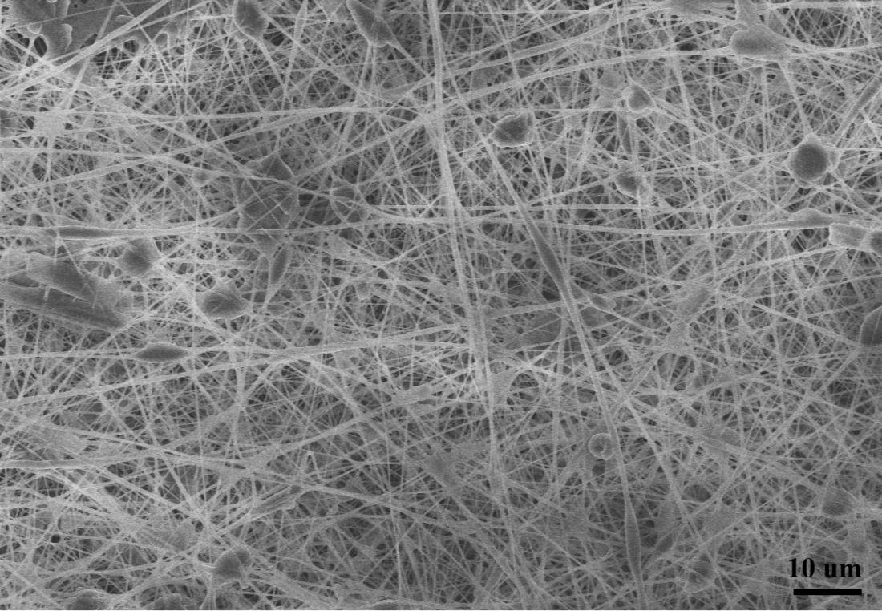
Figure S1. The morphology of the as-prepared TPP@PVDF-HFP when the Taylor cone was unstable.

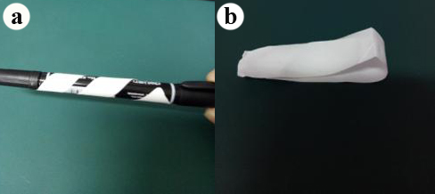
Figure S2. The test of the flexibility of TPP@PVDF-HFP fiber network by (a) rolling up on a pen or (b) after folding several times.

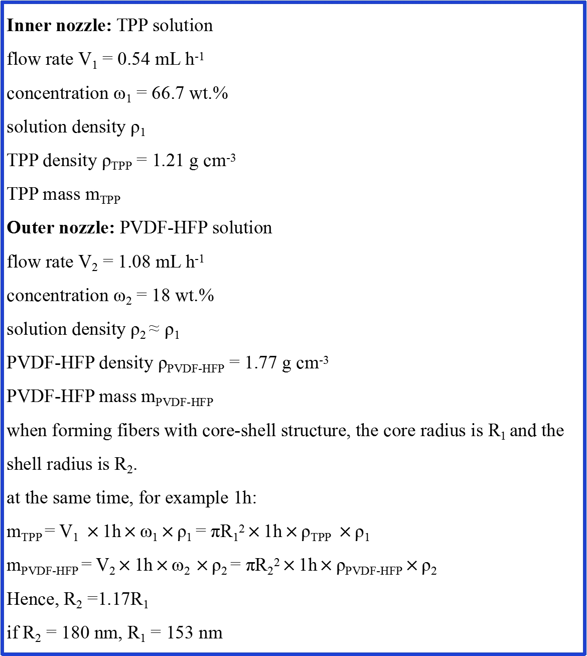
Figure S3. The calculation of dimensions for a single fiber of TPP@PVDF-HFP fiber network.

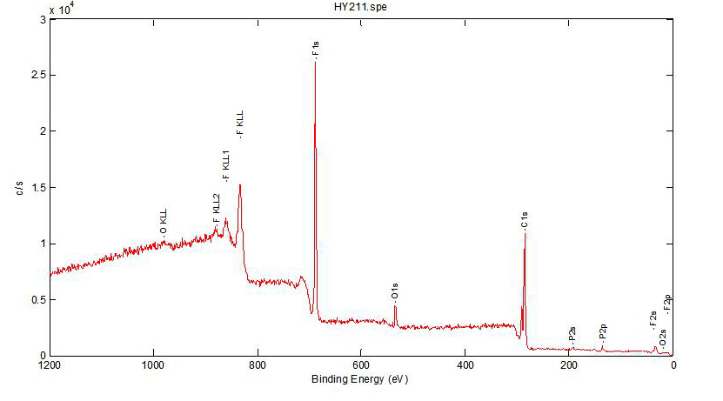
Figure S4. The XPS data of the TPP@PVDF-HFP fiber network after thermal stimuli.

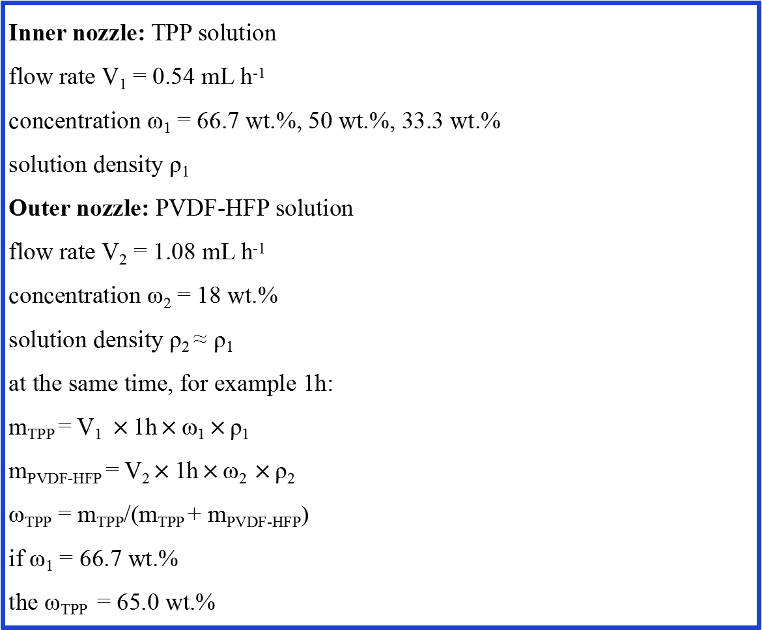
Figure S5. The theoretical calculation of overall TPP mass fraction in the TPP@PVDF-HFP fiber network.
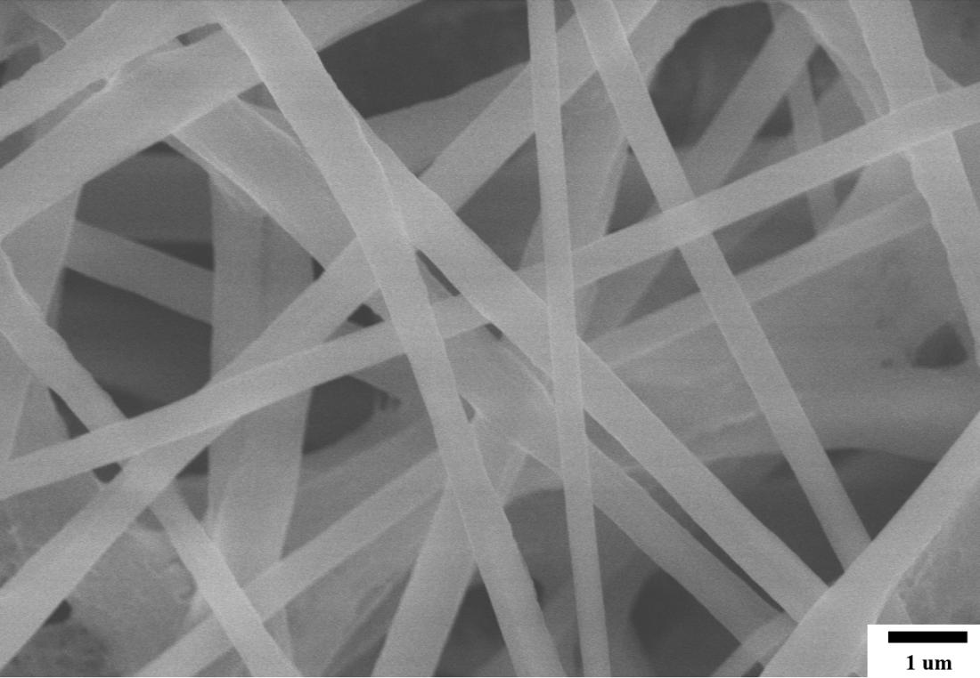
Figure S6. The SEM image of electrospun nanofibers on the commercial Celgard 2320 separator denoted as TPP@PVDF-HFP@commercial separator.

Movie. S1
Full process of ignition experiments on TPP@PVDF-HFP fibers.

Movie. S2
Full process of ignition experiments on TPP@PVDF-HFP@commercial separators fibers.

Movie. S3
Full process of ignition experiments on commercial separator type I (Celgard 2320).

Movie. S4
Full process of ignition experiments on commercial separator type II (Celgard 2500).

