Supplementary files

Computation of magnetization in body fragments from vases 1-6

Indicative detailed experimental results with the methodology reported in Sect. 7 are given (tables 1-4) using measurements of body fragments from vase 6.
For each of the remaining vases, 2 tables of measurements are presented. The first table contains measurements of the fragments’ thickness, L, of the distance, D, between the measurement position and the fragment edge in the common direction of the M_{xz}, Β_{xz} and the sensor readings of B_{i} (i=xz,y), with the x-sensor aligned along the direction of Β_{xz}.
The second table contains the sensor readings of B_{i} (i=x,y,z), with the x-sensor oriented in the grooves’ direction on the body fragments.
The above quantities and the relationships 4,5 are used for the calculation of magnetization components.

.
Vase 6 |  | A | Β | Γ | Δ | Ε | Ζ | Η | Θ | Ι | Κ
1 | D (±0.3) cm | 4.2 |  |  | 3.4 | 6.2 | 2.2 | 6.2 |  |  | 10.6
 | L (±0.1) cm | 0.9 |  |  | 0.8 | 0.7 | 0.7 | 0.7 |  |  | 0.9
 | B_{xz} (±1) nT | 32 |  |  | 6 | 6 | 29 | 38 |  |  | 37
 | B_{y} (±1) nT | 4 |  |  | 17 | 14 | 7 | 3 |  |  | -3
 | B (±1) nT | 32 |  |  | 18 | 15 | 30 | 38 |  |  | 37
 | θ_{Β}^{ο} | 83±2 |  |  | 20±3 | 24±4 | 76±2 | 85±2 |  |  | -85±2
2 | D (±0.3) cm | 2.4 | 14.8 | 10.7 | 1.2 | 6.3 | 4.8 | 3.2 | 2.1 | 3.4 | 2.5
 | L (±0.1) cm | 1.6 | 1.6 | 1.7 | 1.9 | 1.5 | 1.6 | 1.8 | 1.8 | 1.9 | 1.9
 | B_{xz} (±1) nT | 39 | 35 | 24 | 20 | 17 | 37 | 34-3 | 35 | 35 | 27
 | B_{y} (±1) nT | 2 | 6 | 14 | 16 | 15 | 2 | 34 | -7 | -7 | -13
 | B (±1) nT | 39 | 36 | 28 | 25 | 22 | 37 |  | 36 | 36 | 30
 | θ_{Β}^{ο} | 87±1 | 80±2 | 60±2 | 52±2 | 49±3 | 87±2 | -85±2 | -78±2 | -78±2 | -65±2
3 | D (±0.3) cm | 17.2 | 2.0 | 1.6 | 2.9 | 1.9 | 2.6 | 6.2 | 4.9 | 10.0 | 7.5
 | L (±0.1) cm | 1.5 | 1.7 | 1.7 | 1.5 | 1.4 | 1.5 | 1.7 | 1.9 | 1.8 | 1.8
 | B_{xz} (±1) nT | 35 | 37 | 37 | 34 | 31 | 34 | 32 | 25 | 18 | 18
 | B_{y} (±1) nT | -5 | 1 | 4 | 7 | 7 | -3 | -8 | -13 | -16 | -17
 | B (±1) nT | 35 | 37 | 37 | 35 | 32 | 34 | 33 | 28 | 24 | 25
 | θ_{Β}^{ο} | -81±2 | 88±2 | 84±2 | 78±2 | 77±2 | -85±2 | -75±2 | -63±2 | -49±2 | -47±2
4 | D (±0.3) cm | 7.5 | 5.5 | 5.9 | 8.7 | 6.8 | 1.8 | 5.1 | 2.5 | 6.4 | 5.1
 | L (±0.1) cm | 1.4 | 1.3 | 1.4 | 1.5 | 1.3 | 1.2 | 1.4 | 1.5 | 1.5 | 1.6
 | B_{xz} (±1) nT | 31 | 33 | 39 | 37 | 38 | 32 | 26 | 24 | 7 | 5
 | B_{y} (±1) nT | -8 | -5 | 2 | 3 | 2 | -7 | -12 | -15 | -19 | -18
 | B (±1) nT | 32 | 33 | 39 | 37 | 38 | 33 | 28 | 28 | 20 | 19
 | θ_{Β}^{ο} | -75±2 | -81±2 | 87±1 | 85±2 | 87±2 | -77±2 | -66±2 | -58±2 | -20±3 | -16±3
5 | D (±0.3) cm | 1.9 | 2.3 | 9.7 | 4.1 | 3.6 | 2.0 | 4.5 |  | 3.8
 | L (±0.1) cm | 1.0 | 1.2 | 1.1 | 1.2 | 1.2 | 1.1 | 1.0 |  | 1.1
 | B_{xz} (±1) nT | 25 | 34 | 33 | 34 | 34 | 27 | 23 |  | 4
 | B_{y} (±1) nT | -11 | -7 | -6 | -2 | -3 | -12 | -13 |  | -17
 | B (±1) nT | 27 | 35 | 34 | 34 | 34 | 29 | 26 |  | 17
 | θ_{Β}^{ο} | -67±2 | -78±2 | -79±2 | -86±2 | -85±2 | -67±2 | -61±2 |  | -13±3

Table 1. Measurements D, L, and sensor readings of B_{i} (i=xz,y), with the x-sensor aligned along the common direction of Bxz, Μxz, on the body fragments of vase 6.
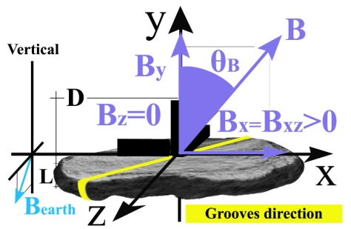

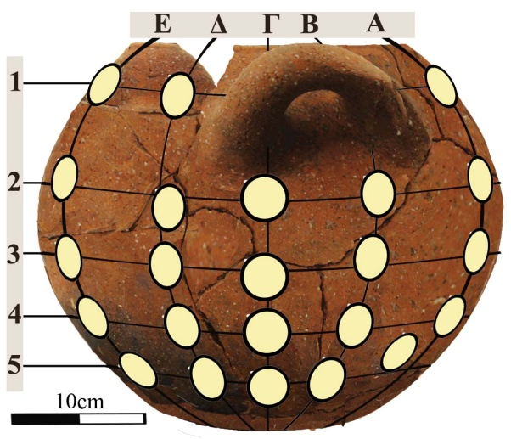
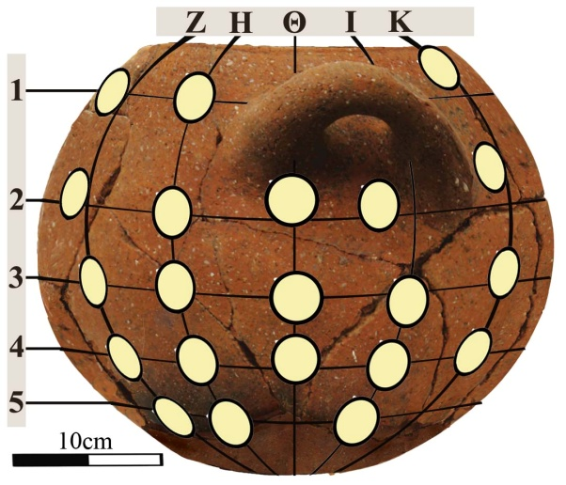

Vase 6
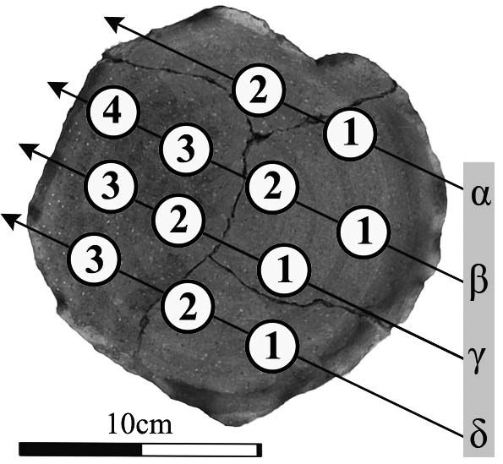
Vase 6  (Base) | λ | α˪(cm) | α//(cm)
 | 1.90  ±0.01 | 0.71  ±0.03 | 1.07  ±0.02

The computed magnitude of field, B, differs, while angles ,θ_{Β}, varies in a systematic way.

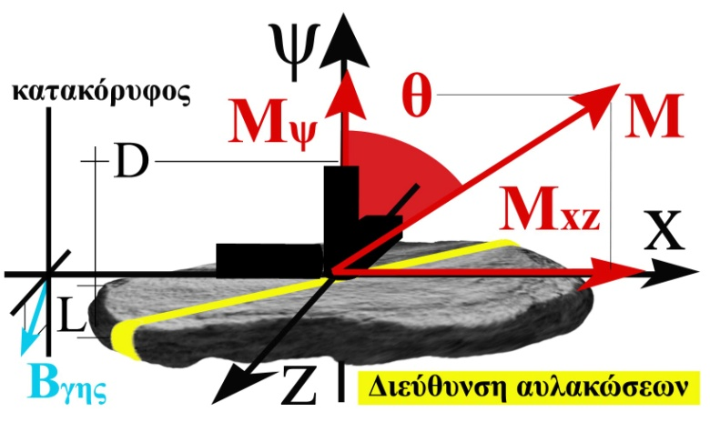  Vase 6 |  | A | Β | Γ | Δ | Ε | Ζ | Η | Θ | Ι | Κ
1 | D (±0.3) cm | 4.2 |  |  | 3.4 | 6.2 | 2.2 | 6.2 |  |  | 10.6
 | d(cm) | 3.6±1 |  |  | 0.2±0.0 | 0.2±0.0 | 1.5±0.2 | 4.4±1.4 |  |  | 5.6±1.8
 | θ^{ο} | 76±3 |  |  | 14±2 | 17±3 | 65±3 | 81±3 |  |  | -81±3
 | Μxz(mΑ/m) | 51±2 |  |  | 15±3 | 16±3 | 48±2 | 61±2 |  |  | 59±2
 | My (Α/m) | 13±3 |  |  | 64±4 | 54±4 | 23±3 | 10±3 |  |  | -10±3
 | Μ(mΑ/m) | 53±2 |  |  | 66±4 | 56±4 | 53±2 | 61±2 |  |  | 60±2
2 | D (±0.3) cm | 2.4 | 14.8 | 10,7 | 1,2 | 6,3 | 4,8 | 3,2 | 2,1 | 3,4 | 2,5
 | d(cm) | 16±7 | 4.7±0.8 | 1.6±0.1 | 1.3±0.1 | 1.0±0.1 | 15±7 | 10±3 | 4.5±0.6 | 4.8±0.7 | 2.2±0.2
 | θ^{ο} | 84±3 | 71±3 | 44±2 | 35±2 | 33±2 | 84±3 | -80±3 | -68±3 | -68±3 | -49±2
 | Μxz(mΑ/m) | 62±2 | 56±2 | 40±2 | 35±2 | 30±2 | 59±2 | 54±2 | 57±2 | 56±2 | 44±2
 | My (Α/m) | 6±3 | 19±3 | 42±3 | 49±3 | 47±3 | 6±3 | -10±3 | -22±3 | -22±3 | -39±3
 | Μ(mΑ/m) | 62±2 | 59±2 | 58±3 | 60±3 | 56±3 | 59±2 | 55±2 | 61±2 | 60±2 | 59±2
3 | D (±0.3) cm | 17.2 | 2,0 | 1,6 | 2,9 | 1,9 | 2,6 | 6,2 | 4,9 | 10,0 | 7,5
 | d(cm) | 5±1 | 32±30 | 8±2 | 3.7±0.5 | 3.1±0.5 | 8±3 | 3.4±0.4 | 2.0±0.2 | 1.1±0.1 | 1.1±0.1
 | θ^{ο} | -74±3 | 87±3 | 78±3 | 68±3 | 66±3 | -80±3 | -64±3 | -47±3 | -32±2 | -31±2
 | Μxz(mΑ/m) | 56±2 | 59±2 | 59±2 | 55±2 | 50±2 | 54±2 | 51±2 | 41±2 | 31±2 | 31±2
 | My (Α/m) | -16±3 | 3±3 | 13±3 | 22±3 | 22±3 | -10±3 | -26±3 | -39±3 | -49±3 | -53±3
 | Μ(mΑ/m) | 58±2 | 59±2 | 61±2 | 59±2 | 55±2 | 55±2 | 57±2 | 56±2 | 58±3 | 61±3
4 | D (±0.3) cm | 7.5 | 5,5 | 5,9 | 8,7 | 6,8 | 1,8 | 5,1 | 2,5 | 6,4 | 5,1
 | d(cm) | 2.7±0.4 | 4.3±0.8 | 14±6 | 9±3 | 12±6 | 2.8±0.4 | 1.7±0.2 | 1.3±0.1 | 0.3±0.1 | 0.3±0.1
 | θ^{ο} | -63±3 | -73±3 | 84±3 | 81±3 | 84±3 | -67±3 | -51±3 | -42±2 | -12±2 | -9±2
 | Μxz(mΑ/m) | 50±2 | 53±2 | 62±2 | 59±2 | 60±2 | 52±2 | 43±2 | 41±2 | 13±2 | 9±2
 | My (Α/m) | -26±3 | -16±3 | 6±3 | 10±3 | 6±3 | -22±3 | -36±3 | -46±3 | -62±3 | -58±3
 | Μ(mΑ/m) | 56±2 | 55±2 | 62±2 | 60±2 | 61±2 | 57±2 | 56±2 | 62±3 | 63±3 | 59±3
5 | D (±0.3) cm | 1.9 | 2.3 | 9,7 | 4,1 | 3,6 | 2,0 | 4,5 |  | 3,8
 | d(cm) | 1.3±0.2 | 2.9±0.4 | 3.0±0.5 | 10±5 | 7±2 | 1.4±0.1 | 1.0±0.5 |  | 0.2±0.0
 | θ^{ο} | -53±3 | -68±3 | -70±3 | -83±3 | -80±3 | -52±3 | -46±3 |  | -9±2
 | Μxz(mΑ/m) | 43±2 | 55±2 | 53±2 | 54±2 | 54±2 | 46±2 | 41±2 |  | 9±2
 | My (Α/m) | -33±3 | -22±3 | -19±3 | -6±3 | -10±3 | -36±3 | -40±3 |  | -59±4
 | Μ(mΑ/m) | 54±2 | 59±2 | 56±2 | 55±2 | 55±2 | 58±2 | 57±3 |  | 59±4

Table 2. Computation of the angles θ, of the distances d, and of the magnetization components M_{y}, M_{xz}, from the field components, B_{y}, B_{xz}, with the x-sensor axis aligned along the common direction of B_{xz}, M_{xz}. The values inside the colored frames (D<d=L.tanθ) are computed using the sufficient length relationships(4).
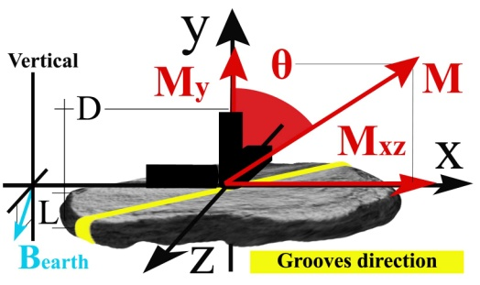

Vase 6

Vase 6  (Base) | M˪ | Μ// | Μ | γ^{ο}
 | (mA/m)
 | 42.5  ±0.2 | 39.8  ±0.2 | 58.3  ±0.2 | 43.3  ±0.3

The computed magnitude, M, displays similar values in the base and body fragments. For the body fragments, angles, θ, change in a systematic way.

Αγγείο 6 |  | A | Β | Γ | Δ | Ε | Ζ | Η | Θ | Ι | Κ
1 | Β_{y} (±1nΤ) | 5 |  |  | 17 | 13 | 8 | 3 |  |  | -4
 | B_{x}(±1nΤ) | -21 |  |  | -3 | 3 | 23 | 23 |  |  | 1
 | B_{z}(±1nΤ) | 22 |  |  | 7 | 6 | 21 | 28 |  |  | 34
 | B(±1nΤ) | 31 |  |  | 18 | 14 | 32 | 36 |  |  | 34
 | θ_{Β}^{ο} | 80±2 |  |  | 24±10 | 28±11 | 75±2 | 85±2 |  |  | -83±2
 | φ_{Β}^{ο} | 134±2 |  |  | 113±8 | 63±9 | 42±2 | 51±2 |  |  | 88±2
2 | Β_{y} (±1nΤ) | 1 | 7 | 14 | 17 | 15 | 2 | -2 | -7 | -7 | -13
 | B_{x}(±1nΤ) | -26 | -22 | -17 | -5 | 5 | 25 | 24 | 15 | 6 | -1
 | B_{z}(±1nΤ) | 29 | 21 | 23 | 20 | 23 | 27 | 32 | 29 | 28 | 31
 | B(±1nΤ) | 39 | 31 | 32 | 27 | 28 | 37 | 40 | 33 | 30 | 33
 | θ_{Β}^{ο} | 88±1 | 76±2 | 64±2 | 51±3 | 58±3 | 87±2 | -87±1 | -77±2 | -76±2 | -68±2
 | φ_{Β}^{ο} | 132±1 | 136±2 | 126±2 | 104±3 | 78±2 | 47±2 | 53±1 | 63±2 | 78±2 | 92±2
3 | Β_{y} (±1nΤ) | -5 | 2 | 4 | 8 | 7 | -4 | -7 | -12 | -17 | -17
 | B_{x}(±1nΤ) | -27 | -20 | -13 | -3 | 2 | 26 | 25 | 15 | 5 | -5
 | B_{z}(±1nΤ) | 27 | 25 | 26 | 33 | 34 | 27 | 25 | 18 | 20 | 17
 | B(±1nΤ) | 39 | 32 | 29 | 34 | 35 | 38 | 36 | 26 | 27 | 24
 | θ_{Β}^{ο} | -82±2 | 86±2 | 82±2 | 76±2 | 78±2 | -84±2 | -78±2 | -64±3 | -51±3 | -46±4
 | φ_{Β}^{ο} | 135±2 | 129±2 | 117±2 | 95±2 | 87±2 | 46±2 | 45±2 | 50±2 | 76±3 | 106±3
4 | Β_{y} (±1nΤ) | -7 | -5 | 2 | 4 | 1 | -7 | -12 | -14 | -19 | -18
 | B_{x}(±1nΤ) | -25 | -26 | -11 | -1 | 5 | 23 | 21 | 19 | 1 | -2
 | B_{z}(±1nΤ) | 24 | 28 | 31 | 38 | 38 | 22 | 14 | 14 | 3 | 5
 | B(±1nΤ) | 35 | 39 | 33 | 38 | 38 | 33 | 28 | 27 | 19 | 19
 | θ_{Β}^{ο} | -78±2 | -82±2 | 86±2 | 84±2 | 88±1 | -77±2 | -65±2 | -60±3 | -9±25 | -17±15
 | φ_{Β}^{ο} | 136±2 | 133±1 | 110±2 | 92±2 | 83±1 | 44±2 | 34±2 | 36±2 | 72±18 | 112±11
5 | Β_{y} (±1nΤ) | -12 | -7 | -5 | -2 | -3 | -11 | -13 |  | -16
 | B_{x}(±1nΤ) | -22 | -19 | -11 | -8 | 7 | 23 | 18 |  | 3
 | B_{z}(±1nΤ) | 14 | 20 | 28 | 39 | 33 | 16 | 10 |  | -1
 | B(±1nΤ) | 29 | 29 | 31 | 40 | 34 | 30 | 24 |  | 16
 | θ_{Β}^{ο} | -66±2 | -75±2 | -80±2 | -87±1 | -85±2 | -69±2 | -58±3 |  | -11±25
 | φ_{Β}^{ο} | 148±2 | 134±2 | 111±2 | 102±1 | 78±2 | 35±2 | 29±3 |  | 342±18

Table 3. Sensor readings with the x-sensor oriented in the grooves’ direction on the body fragments of vase 6.

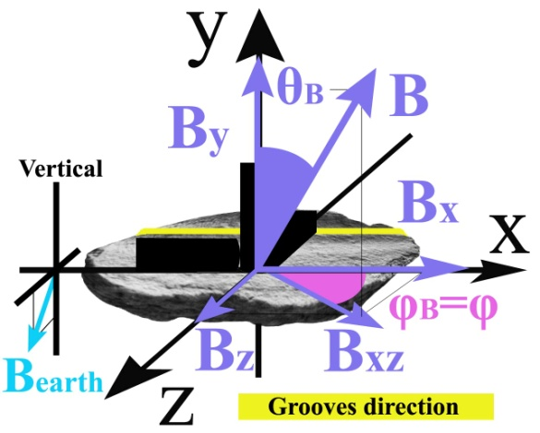

Vase 6

The magnitude of field ,B, varies, while the angles, θ_{Β}, φ_{Β} change in a systematic way.

Vase 6 |  | A | Β | Γ | Δ | Ε | Ζ | Η | Θ | Ι | Κ
1 | Μ_{y} (mΑ/m) | 16±3 |  |  | 64±4 | 50±4 | 26±3 | 10±3 |  |  | -13±3
 | Μ_{x} (mΑ/m) | -34±2 |  |  | -8±3 | 8±3 | 38±2 | 37±2 |  |  | 2±2
 | Μ_{z} (mΑ/m ) | 35±2 |  |  | 18±3 | 16±3 | 35±2 | 45±2 |  |  | 54±2
 | Μ (mΑ/m ) | 51±2 |  |  | 67±4 | 53±4 | 58±2 | 58±2 |  |  | 56±2
 | θ^{ο} | 72±4 |  |  | 17±17 | 20±18 | 63±4 | 81±3 |  |  | -77±3
 | φ^{ο} | 134±2 |  |  | 113±8 | 63±9 | 42±2 | 51±2 |  |  | 88±2
2 | Μ_{y} (mΑ/m) | 3±4 | 22±3 | 42±3 | 53±4 | 47±3 | 6±4 | -6±4 | -22±4 | -22±4 | -39±3
 | Μ_{x} (mΑ/m) | -41±2 | -35±2 | -28±2 | -9±2 | 9±2 | 40±2 | 38±2 | 24±2 | 10±2 | -2±2
 | Μ_{z} (mΑ/m ) | 46±2 | 34±2 | 39±2 | 35±2 | 41±2 | 43±2 | 51±2 | 47±2 | 45±2 | 51±2
 | Μ (mΑ/m ) | 62 | 53±2 | 64±2 | 63±4 | 63±3 | 59±2 | 64±2 | 57±2 | 51±2 | 64±2
 | θ^{ο} | 87±4 | 65±4 | 49±4 | 34±8 | 42±5 | 84±4 | -84±4 | -67±5 | -64±6 | -53±4
 | φ^{ο} | 132±1 | 136±2 | 126±2 | 104±3 | 78±2 | 47±2 | 53±1 | 63±2 | 78±2 | 92±2
3 | Μ_{y} (mΑ/m) | -16±3 | 6±4 | 13±4 | 26±4 | 22±4 | -13±4 | -22±3 | -35±3 | -53±3 | -53±3
 | Μ_{x} (mΑ/m) | -43±2 | -32±2 | -21±2 | -5±2 | 3±2 | 41±2 | 40±2 | 25±2 | 9±2 | -9±2
 | Μ_{z} (mΑ/m ) | 43±2 | 40±2 | 42±2 | 53±2 | 55±2 | 43±2 | 40±2 | 30±2 | 35±2 | 30±2
 | Μ (mΑ/m ) | 63±2 | 51±2 | 48±2 | 59±2 | 60±2 | 61±2 | 61±2 | 52±2 | 63±3 | 61±3
 | θ^{ο} | -75±3 | 83±5 | 75±5 | 64±5 | 68±4 | -78±4 | -68±3 | -47±5 | -34±6 | -30±7
 | φ^{ο} | 135±2 | 129±2 | 117±2 | 95±2 | 87±2 | 46±2 | 45±2 | 50±2 | 76±3 | 106±3
4 | Μ_{y} (mΑ/m) | -22±3 | -16±3 | 6±4 | 13±4 | 3±4 | -22±4 | -36±3 | -43±3 | -62±3 | -58±3
 | Μ_{x} (mΑ/m) | -40±2 | -41±2 | -18±2 | -2±2 | 8±2 | 37±2 | 35±2 | 33±3 | 2±2 | -4±2
 | Μ_{z} (mΑ/m ) | 39±2 | 45±2 | 49±2 | 60±2 | 60±2 | 36±2 | 23±2 | 24±2 | 6±2 | 9±2
 | Μ (mΑ/m ) | 60±2 | 63±2 | 53±2 | 62±2 | 61±2 | 56±2 | 55±2 | 59±3 | 62±3 | 59±3
 | θ^{ο} | -68±3 | -75±3 | 83±5 | 78±4 | 87±4 | -67±5 | -50±5 | -44±5 | -6±44 | -10±26
 | φ^{ο} | 136±2 | 133±2 | 110±2 | 92±2 | 83±1 | 44±2 | 34±2 | 36±2 | 72±18 | 112±11
5 | Μ_{y} (mΑ/m) | -36±3 | -22±4 | -16±3 | -6±4 | -10±4 | -33±3 | -40±3 |  | -55±4
 | Μ_{x} (mΑ/m) | -38±2 | -31±2 | -18±2 | -13±2 | 11±2 | 39±2 | 32±2 |  | 7±2
 | Μ_{z} (mΑ/m ) | 24±2 | 32±2 | 45±2 | 62±2 | 53±2 | 27±2 | 18±2 |  | -2±2
 | Μ (mΑ/m ) | 57±2 | 50±2 | 51±2 | 64±2 | 55±2 | 58±2 | 54±3 |  | 55±4
 | θ^{ο} | -51±4 | 27±6 | -72±4 | -84±4 | -80±5 | -56±4 | -43±6 |  | -7±42
 | φ^{ο} | 148±2 | 134±2 | 111±2 | 102±1 | 78±2 | 35±2 | 29±3 |  | 342±`18

Table 4. Computation of the magnetization components ,M_{i},(i=x,y,z), of the magnitude M and of the angles θ,φ, from sensor readings with the x-sensor oriented in the grooves direction in body fragments of vase 6.
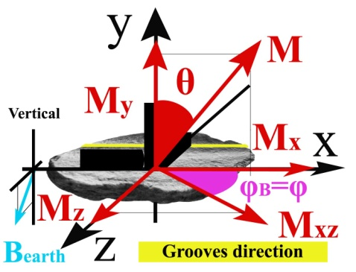

Vase 6

The computed magnitude, M, displays similar values in the base and body fragments, which is a criterion for finding ceramic fragments of the same vase from archaeological excavations. The angles, θ,φ, change in a systematic way.

Vase 6 | Μ˪ | Μ// | Μ | γ^{ο}
(Base)  (mA/m) | 42.5  ±0.2 | 39.8  ±0.2 | 58.3  ±0.2 | 43.3  ±0.3

Vase 1
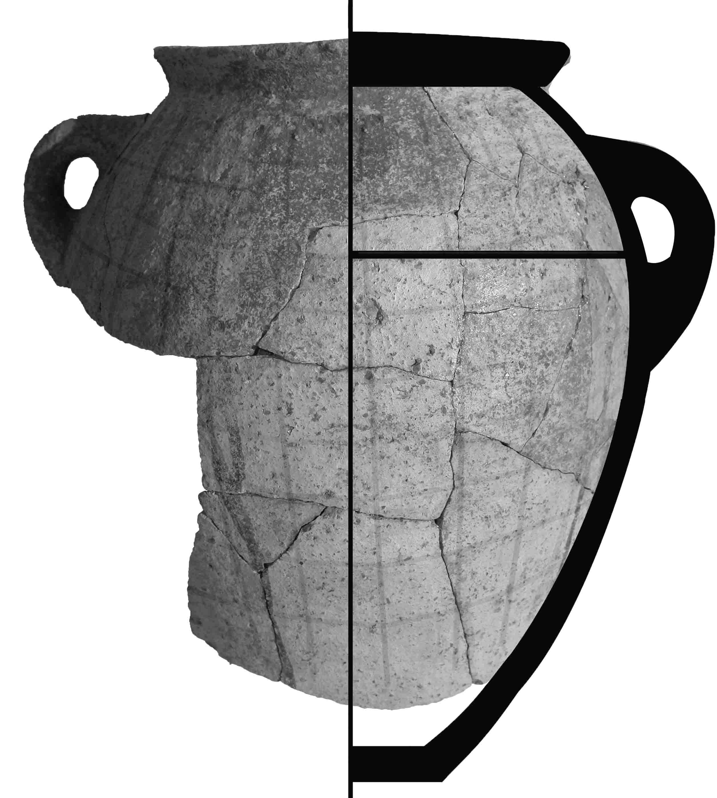 |  |  |  |  |  |  |  | α_{y}˪ (cm) | α_{x,z}// (cm) |  | λ
 |  |  |  |  |  |  |  | 0,82±0,04 | 1,42±0,02 |  | 2,0±0,1
 |  | A | Β | Γ | Δ | Ε | Ζ |  | Η | Θ |  | Ι
1 | D (±0.3) cm | 5.2 | 9.5 | 15.3 | 29.5 | 23.8 | 17.1 |  | 11.3 | 3.7
 | L (±0.1) cm | 1,0 | 1.1 | 1.1 | 1.2 | 1.1 | 1.1 |  | 1.0 | 1.1
 | B_{xz} (±1) nT | 50 | 33 | 18 | 2 | 15 | 40 |  | 55 | 80
 | B_{y} (±1) nT | 23 | 33 | 33 | 36 | 31 | 30 |  | 25 | 7
 | B (±1) nT | 55 | 47 | 38 | 36 | 34 | 50 |  | 60 | 80
 | θ_{Β}^{ο} | 65±1 | 45±1 | 29±2 | 3±2 | 26±2 | 53±1 |  | 66±1 | 85±1
2 | D (±0.3) cm | 5.3 | 10.7 | 16.7 | 18.9 | 24.3 | 18.3 |  | 13.1 | 3.5
 | L (±0.1) cm | 1.1 | 1.1 | 1.2 | 1.2 | 1.3 | 1.3 |  | 1.2 | 1.2
 | B_{xz} (±1) nT | 67 | 33 | 20 | 9 | 25 | 38 |  | 64 | 83
 | B_{y} (±1) nT | 22 | 31 | 35 | 35 | 33 | 31 |  | 23 | 5
 | B (±1) nT | 71 | 45 | 40 | 36 | 41 | 49 |  | 68 | 83
 | θ_{Β}^{ο} | 72±1 | 47±1 | 30±1 | 14±2 | 37±1 | 51±1 |  | 70±1 | 87±1
3 | D (±0.3) cm | 6.6 | 3.0 | 3.8 | 22.8 | 29.5 | 19.9 |  | 15.4 | 2.9
 | L (±0.1) cm | 1.2 | 1.2 | 1.3 | 1.2 | 1.3 | 1.4 |  | 1.3 | 1.3
 | B_{xz} (±1) nT | 71 | 37 | 22 | 16 | 31 | 48 |  | 73 | 81
 | B_{y} (±1) nT | 20 | 32 | 35 | 34 | 31 | 28 |  | 18 | 2
 | B (±1) nT | 74 | 49 | 41 | 38 | 44 | 56 |  | 75 | 81
 | θ_{Β}^{ο} | 74±1 | 49±1 | 32±1 | 25±2 | 45±1 | 60±1 |  | 76±1 | 89±1
4 | D (±0.3) cm | 7.2 | 4.4 | 8.8 | 6.7 | 5.9 | 22.7 |  | 15.9 | 3.3 |  | 10.3
 | L (±0.1) cm | 1.2 | 1.3 | 1.4 | 1.3 | 1.4 | 1.4 |  | 1.4 | 1.4 |  | 1.4
 | B_{xz} (±1) nT | 75 | 55 | 37 | 32 | 33 | 54 |  | 70 | 83 |  | 82
 | B_{y} (±1) nT | 17 | 25 | 31 | 31 | 33 | 26 |  | 19 | -5 |  | -9
 | B (±1) nT | 77 | 60 | 48 | 45 | 47 | 60 |  | 73 | 83 |  | 81
 | θ_{Β}^{ο} | 77±1 | 66±1 | 50±1 | 46±1 | 45±1 | 64±1 |  | 75±1 | -87±1 |  | -83±1
5 | D (±0.3) cm | 2.8 | 7.9 | 2.5 | 12.8 | 11.4 | 24.0 |  | 11.7 | 6.1 |  | 7.9
 | L (±0.1) cm | 1.3 | 1.3 | 1.3 | 1.3 | 1.5 | 1.4 |  | 1.4 | 1.5 |  | 1.5
 | B_{xz} (±1) nT | 78 | 63 | 44 | 37 | 44 | 66 |  | 75 | 81 |  | 79
 | B_{y} (±1) nT | 15 | 24 | 32 | 32 | 32 | 22 |  | 15 | -6 |  | -9
 | B (±1) nT | 79 | 67 | 54 | 49 | 54 | 70 |  | 76 | 81 |  | 80
 | θ_{Β}^{ο} | 79±1 | 69±1 | 54±1 | 49±1 | 54±1 | 72±1 |  | 79±1 | -86±1 |  | -84±1

Table 5a. Measurements D, L, and sensor readings of B_{i} (i=xz,y), with the x-sensor aligned along the common direction of Bxz, Μxz, on the body fragments of vase 1.

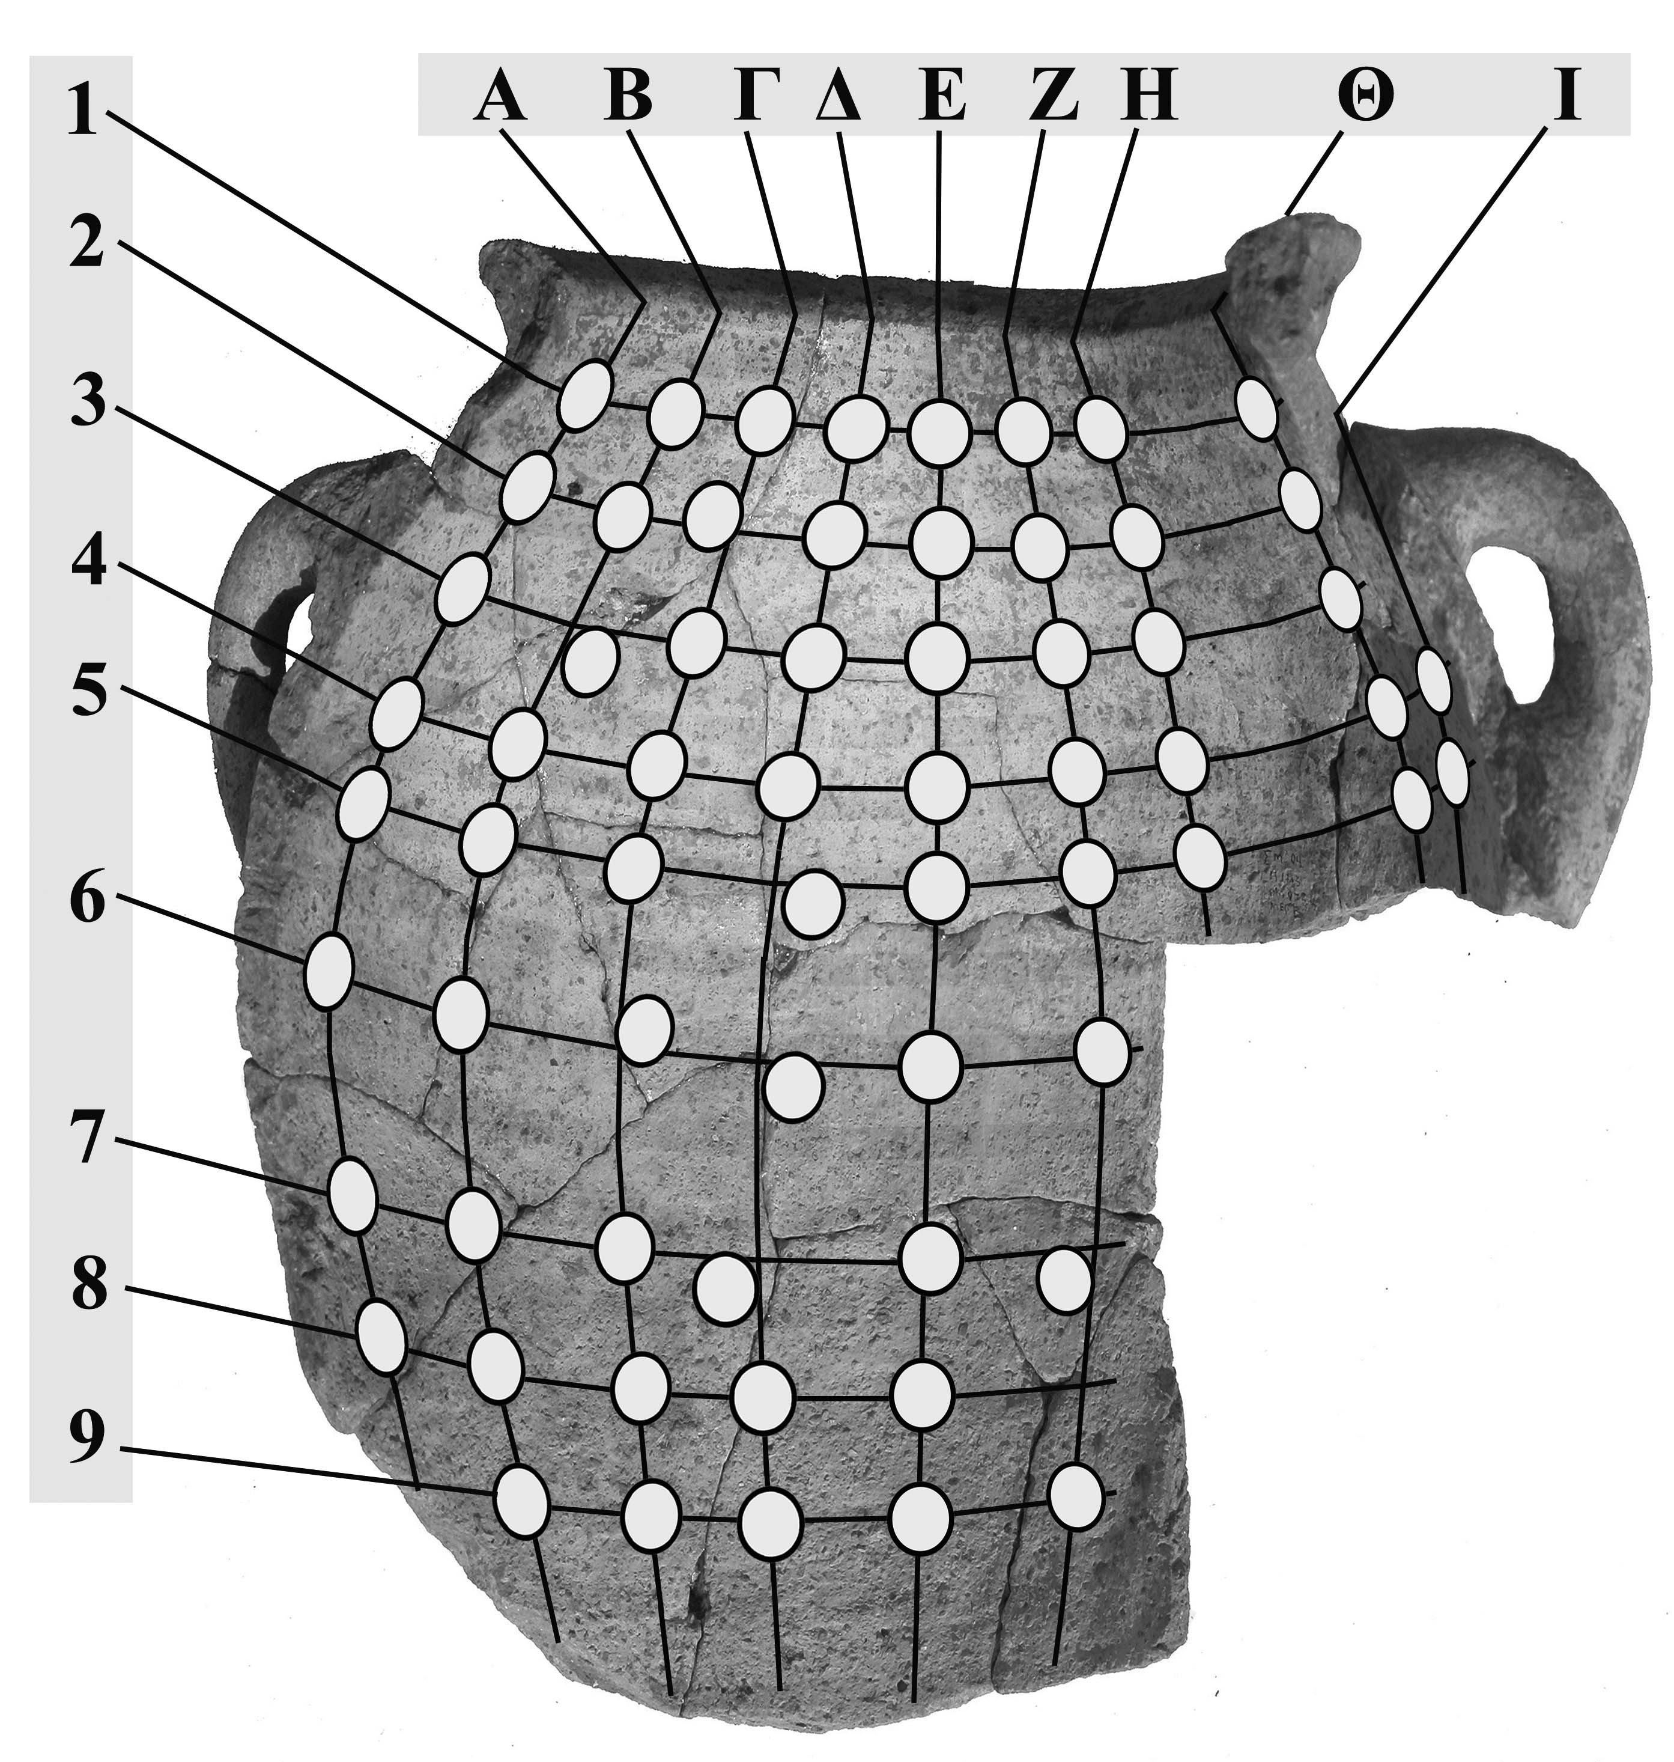

Vase 1
 |  | A | Β | Γ | Δ | Ε | Ζ | Η | Θ | Ι
6 | D (±0.3) cm | 6.9 | 3.2 | 12,7 | 6.7 | 8.2 | 8.0
 | L (±0.1) cm | 1.6 | 1.5 | 1,4 | 1.5 | 1.6 | 1.7
 | B_{xz} (±1) nT | 76 | 70 | 63 | 58 | 68 | 79
 | B_{y} (±1) nT | 12 | 17 | 27 | 27 | 21 | 13
 | B (±1) nT | 77 | 72 | 69 | 64 | 71 | 80
 | θ_{Β}^{ο} | 81±1 | 76±1 | 67±1 | 65±1 | 73±1 | 81±1
7 | D (±0.3) cm | 7.1 | 4.9 | 5.4 | 11.8 | 3.3 | 3.6
 | L (±0.1) cm | 1.7 | 1.7 | 1.8 | 1.7 | 1.8 | 1.7
 | B_{xz} (±1) nT | 85 | 78 | 73 | 66 | 71 | 81
 | B_{y} (±1) nT | 2 | 12 | 19 | 22 | 20 | 8
 | B (±1) nT | 85 | 79 | 75 | 70 | 74 | 81
 | θ_{Β}^{ο} | 89±1 | 81±1 | 75±1 | 72±1 | 74±1 | 84±1
8 | D (±0.3) cm | 7.4 | 4.5 | 10.9 | 8.8 | 9.6 | 5.5
 | L (±0.1) cm | 1.8 | 1.8 | 1.9 | 1.9 | 1.9 | 2.0
 | B_{xz} (±1) nT | 86 | 76 | 76 | 69 | 73 | 80
 | B_{y} (±1) nT | 1 | 13 | 17 | 18 | 19 | 8
 | B (±1) nT | 86 | 77 | 78 | 71 | 75 | 80
 | θ_{Β}^{ο} | 89±1 | 80±1 | 77±1 | 75±1 | 75±1 | 84±1
9 | D (±0.3) cm |  | 10.2 | 16.9 | 15.2 | 13.8 | 11.2
 | L (±0.1) cm |  | 1.9 | 2.0 | 2.1 | 2.0 | 2.0
 | B_{xz} (±1) nT |  | 79 | 79 | 76 | 78 | 82
 | B_{y} (±1) nT |  | 5 | 14 | 16 | 14 | 4
 | B (±1) nT |  | 79 | 80 | 78 | 79 | 82
 | θ_{Β}^{ο} |  | 86±1 | 80±1 | 78±1 | 80±1 | 87±1
Table 5b. Measurements D, L, and sensor readings of B_{i} (i=xz,y), with the x-sensor aligned along the common direction of Bxz, Μxz, on the body fragments of vase 1.

Vase 1
 |  | A | Β | Γ | Δ | Ε | Ζ | Η | Θ | Ι
1 | Β_{y} (±1nΤ) | 23 | 32 | 32 | 35 | 31 | 29 | 25 | 7
 | B_{x}(±1nΤ) | 47 | 33 | 18 | -3 | -19 | -41 | -57 | -60
 | B_{z}(±1nΤ) | 16 | 7 | 3 | -1 | 5 | 8 | 23 | 51
 | B(±1nΤ) | 55 | 46 | 37 | 35 | 37 | 51 | 66 | 79
 | θ_{Β}^{ο} | 65±1 | 47±1 | 30±2 | 5±2 | 32±2 | 55±1 | 68±1 | 85±1
 | φ_{Β}^{ο} | 19±1 | 12±2 | 9±3 | 198±18 | 165±3 | 169±1 | 158±1 | 140±1
2 | Β_{y} (±1nΤ) | 22 | 30 | 34 | 34 | 34 | 30 | 23 | 5
 | B_{x}(±1nΤ) | 60 | 29 | 18 | -3 | -22 | -39 | -57 | -62
 | B_{z}(±1nΤ) | 31 | 9 | 11 | 9 | 11 | 14 | 29 | 49
 | B(±1nΤ) | 71 | 43 | 40 | 35 | 42 | 51 | 68 | 72
 | θ_{Β}^{ο} | 72±1 | 45±1 | 32±1 | 16±2 | 36±1 | 54±1 | 70±1 | 86±1
 | φ_{Β}^{ο} | 27±1 | 17±2 | 31±3 | 108±6 | 153±2 | 160±1 | 153±1 | 142±1
3 | Β_{y} (±1nΤ) | 20 | 32 | 36 | 35 | 32 | 28 | 17 | 3
 | B_{x}(±1nΤ) | 62 | 31 | 13 | -3 | -20 | -47 | -60 | -62
 | B_{z}(±1nΤ) | 40 | 25 | 17 | 17 | 21 | 29 | 38 | 47
 | B(±1nΤ) | 76 | 51 | 42 | 39 | 43 | 62 | 73 | 78
 | θ_{Β}^{ο} | 75±1 | 51±1 | 31±1 | 26±1 | 42±1 | 63±1 | 77±1 | 88±1
 | φ_{Β}^{ο} | 33±1 | 39±1 | 53±3 | 100±3 | 134±2 | 148±1 | 148±1 | 143±1
4 | Β_{y} (±1nΤ) | 17 | 24 | 32 | 32 | 33 | 25 | 19 | -6 | -9
 | B_{x}(±1nΤ) | 59 | 41 | 19 | -2 | -21 | -40 | -58 | -63 | -56
 | B_{z}(±1nΤ) | 42 | 37 | 30 | 33 | 29 | 31 | 40 | 51 | 50
 | B(±1nΤ) | 74 | 60 | 48 | 46 | 49 | 56 | 73 | 81 | 76
 | θ_{Β}^{ο} | 77±1 | 67±1 | 48±1 | 46±1 | 47±1 | 64±1 | 75±1 | -86±1 | -83±1
 | φ_{Β}^{ο} | 35±1 | 42±1 | 58±2 | 93±2 | 126±2 | 142±1 | 145±1 | 141±1 | 139±1
5 | Β_{y} (±1nΤ) | 15 | 23 | 32 | 32 | 32 | 22 | 15 | -6 | -10
 | B_{x}(±1nΤ) | 54 | 48 | 21 | -7 | -21 | -48 | -58 | -68 | -61
 | B_{z}(±1nΤ) | 41 | 47 | 40 | 35 | 41 | 42 | 47 | 52 | 51
 | B(±1nΤ) | 69 | 71 | 55 | 48 | 56 | 67 | 76 | 86 | 80
 | θ_{Β}^{ο} | 78±1 | 71±1 | 55±1 | 48±1 | 55±1 | 71±1 | 79±1 | -86±1 | -83±1
 | φ_{Β}^{ο} | 37±1 | 44±1 | 62±1 | 101±1 | 117±1 | 139±1 | 141±1 | 143±1 | 140±1

Table 6a. Sensor readings of B_{i} (i=x,y,z), with the x-sensor oriented in the grooves’ direction on the body fragments of vase 1.

Vase 1
 |  | A | Β | Γ | Δ | Ε | Ζ | Η | Θ | Ι
6 | Β_{y} (±1nΤ) | 11 | 18 | 26 | 27 | 22 | 14
 | B_{x}(±1nΤ) | 55 | 42 | 21 | -1 | -28 | -48
 | B_{z}(±1nΤ) | 51 | 57 | 54 | 56 | 60 | 53
 | B(±1nΤ) | 76 | 76 | 64 | 62 | 70 | 73
 | θ_{Β}^{ο} | 82±1 | 76±1 | 66±1 | 64±1 | 72±1 | 79±1
 | φ_{Β}^{ο} | 43±1 | 54±1 | 69±1 | 91±1 | 115±1 | 132±1
7 | Β_{y} (±1nΤ) | 2 | 12 | 18 | 21 | 20 | 8
 | B_{x}(±1nΤ) | 65 | 48 | 20 | -5 | -25 | -52
 | B_{z}(±1nΤ) | 57 | 63 | 63 | 61 | 61 | 61
 | B(±1nΤ) | 86 | 81 | 69 | 65 | 69 | 84
 | θ_{Β}^{ο} | 89±1 | 81±1 | 75±1 | 71±1 | 73±1 | 84±1
 | φ_{Β}^{ο} | 41±1 | 53±1 | 72±1 | 95±1 | 112±1 | 130±1
8 | Β_{y} (±1nΤ) | 1 | 12 | 16 | 18 | 18 | 9
 | B_{x}(±1nΤ) | 62 | 47 | 20 | 1 | -27 | -50
 | B_{z}(±1nΤ) | 56 | 71 | 67 | 74 | 71 | 65
 | B(±1nΤ) | 84 | 82 | 72 | 76 | 78 | 82
 | θ_{Β}^{ο} | 89±1 | 82±1 | 77±1 | 76±1 | 77±1 | 84±1
 | φ_{Β}^{ο} | 42±1 | 56±1 | 73±1 | 89±1 | 111±1 | 128±1
9 | Β_{y} (±1nΤ) |  | 6 | 14 | 16 | 15 | 4
 | B_{x}(±1nΤ) |  | 44 | 27 | -4 | -29 | -51
 | B_{z}(±1nΤ) |  | 64 | 72 | 75 | 72 | 66
 | B(±1nΤ) |  | 86 | 78 | 77 | 79 | 84
 | θ_{Β}^{ο} |  | 86±1 | 80±1 | 78±1 | 79±1 | 87±1
 | φ_{Β}^{ο} |  | 55±1 | 71±1 | 93±1 | 112±1 | 128±1
Table 6b. Indicative sensor readings of B_{i} (i=x,y,z), with the x-sensor oriented in the grooves’ direction on the body fragments of vase 1.

Vase 2 |  |  |  |  |  |  |  | α_{y}˪ (cm) | α_{x,z}//  (cm) | λ
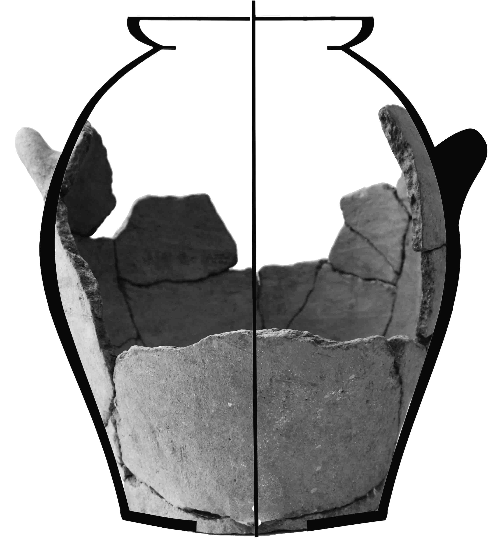
 |  |  |  |  |  |  |  | 1,15±  0,053 | 1,66±  0,05 | 2,0±0,1
 |  | A | Β | Γ | Δ | Ε | Ζ | Η | Θ | Ι
1 | D (±0.3) cm |  |  |  |  |  | 5.7 | 2.5 | 3.4
 | L (±0.1) cm |  |  |  |  |  | 0.9 | 0.8 | 0.8
 | B_{xz} (±1) nT |  |  |  |  |  | 21 | 16 | 28
 | B_{y} (±1) nT |  |  |  |  |  | 37 | 28 | 33
 | B (±1) nT |  |  |  |  |  | 43 | 32 | 43
 | θ_{Β}^{ο} |  |  |  |  |  | 30±1 | 30±2 | 40±1
2 | D (±0.3) cm |  |  |  |  |  | 9.3 |  |  | 2.0
 | L (±0.1) cm |  |  |  |  |  | 1.0 |  |  | 1.1
 | B_{xz} (±1) nT |  |  |  |  |  | 35 |  |  | 71
 | B_{y} (±1) nT |  |  |  |  |  | 38 |  |  | 32
 | B (±1) nT |  |  |  |  |  | 52 |  |  | 78
 | θ_{Β}^{ο} |  |  |  |  |  | 43±1 |  |  | 66±1
3 | D (±0.3) cm |  |  |  |  |  | 13.1 | 11.9 | 10.6 | 3.7
 | L (±0.1) cm |  |  |  |  |  | 1.2 | 1.3 | 1.1 | 1.2
 | B_{xz} (±1) nT |  |  |  |  |  | 46 | 38 | 49 | 89
 | B_{y} (±1) nT |  |  |  |  |  | 38 | 42 | 38 | 24
 | B (±1) nT |  |  |  |  |  | 60 | 57 | 62 | 92
 | θ_{Β}^{ο} |  |  |  |  |  | 50±1 | 42±1 | 52±1 | 75±1
4 | D (±0.3) cm |  |  |  |  |  | 2.8 | 2.6 | 6.4 | 1.7
 | L (±0.1) cm |  |  |  |  |  | 1.5 | 1.6 | 1.5 | 1.5
 | B_{xz} (±1) nT |  |  |  |  |  | 73 | 73 | 77 | 92
 | B_{y} (±1) nT |  |  |  |  |  | 37 | 33 | 28 | 20
 | B (±1) nT |  |  |  |  |  | 82 | 80 | 82 | 94
 | θ_{Β}^{ο} |  |  |  |  |  | 63±1 | 66±1 | 70±1 | 78±1
5 | D (±0.3) cm |  |  |  |  |  | 6.7 | 2.6 | 10.4 | 2.3
 | L (±0.1) cm |  |  |  |  |  | 1.6 | 1.6 | 1.4 | 1.3
 | B_{xz} (±1) nT |  |  |  |  |  | 88 | 73 | 90 | 99
 | B_{y} (±1) nT |  |  |  |  |  | 35 | 33 | 26 | 15
 | B (±1) nT |  |  |  |  |  | 95 | 80 | 94 | 100
 | θ_{Β}^{ο} |  |  |  |  |  | 68±1 | 66±1 | 74±1 | 81±1

Table 7a. Measurements D, L, and sensor readings of B_{i} (i=xz,y), with the x-sensor aligned along the common direction of Bxz, Μxz, on the body fragments of vase 2.

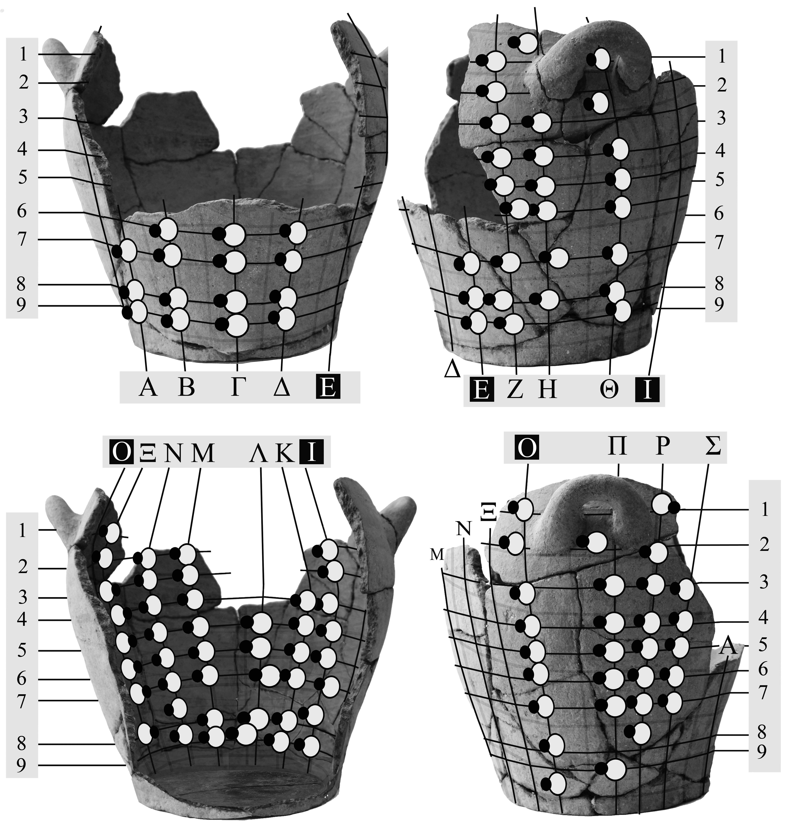

Vase 2 |  | .
 |  | A | Β | Γ | Δ | Ε | Ζ | Η | Θ | Ι
6 | D (±0.3) cm |  | 23.2 | 7.6 | 6.4 |  | 8.9 | 9.4 | 11.4 | 3.3
 | L (±0.1) cm |  | 1.3 | 1.3 | 1.3 |  | 1.4 | 1.3 | 1.3 | 1.3
 | B_{xz} (±1) nT |  | 88 | 105 | 102 |  | 93 | 86 | 93 | 104
 | B_{y} (±1) nT |  | -26 | -8 | 8 |  | 23 | 26 | 23 | 19
 | B (±1) nT |  | 92 | 105 | 102 |  | 96 | 90 | 96 | 106
 | θ_{Β}^{ο} |  | -74±1 | -86±1 | 86±1 |  | 76±1 | 73±1 | 76±1 | 80±1
7 | D (±0.3) cm | 27.8 | 21.2 | 14.6 | 11.0 | 8.1 | 3.9 | 2.7 | 14.6 | 3.0
 | L (±0.1) cm | 1.1 | 1.3 | 1.2 | 1.2 | 1.4 | 1.3 | 1.2 | 1.2 | 1.2
 | B_{xz} (±1) nT | 47 | 88 | 100 | 107 | 94 | 95 | 89 | 95 | 107
 | B_{y} (±1) nT | -33 | -26 | -14 | 5 | 20 | 22 | 24 | 22 | 9
 | B (±1) nT | 57 | 92 | 101 | 107 | 96 | 98 | 92 | 98 | 107
 | θ_{Β}^{ο} | -55±1 | -74±1 | -82±1 | 87±1 | 78±1 | 77±1 | 75±1 | 77±1 | 85±1
8 | D (±0.3) cm | 12.9 | 14.1 | 8.7 | 14.8 | 10.0 | 2.9 | 3.2 | 3.3 | 1.8
 | L (±0.1) cm | 1.0 | 1.1 | 1.0 | 1.1 | 1.2 | 1.1 | 1.1 | 1.1 | 1.1
 | B_{xz} (±1) nT | 55 | 87 | 102 | 104 | 92 | 86 | 77 | 85 | 97
 | B_{y} (±1) nT | -36 | -27 | -9 | 9 | 22 | 25 | 30 | 27 | 12
 | B (±1) nT | 66 | 91 | 102 | 104 | 95 | 90 | 83 | 89 | 98
 | θ_{Β}^{ο} | -57±1 | -73±1 | -85±1 | 85±1 | 77±1 | 74±1 | 69±1 | 72±1 | 83±1
9 | D (±0.3) cm | 4.9 | 7.6 | 8.7 | 16.6 | 13.0 | 4.1 |  | 4.4 | 2.4
 | L (±0.1) cm | 0.9 | 0.9 | 0.9 | 1.0 | 1.1 | 1.0 |  | 0.9 | 1.0
 | B_{xz} (±1) nT | 51 | 81 | 108 | 101 | 88 | 77 |  | 77 | 102
 | B_{y} (±1) nT | -31 | -24 | -2 | 12 | 25 | 29 |  | 28 | 16
 | B (±1) nT | 60 | 84 | 108 | 102 | 91 | 82 |  | 82 | 103
 | θ_{Β}^{ο} | -59±1 | -73±1 | -89±1 | 83±1 | 74±1 | 69±1 |  | 70±1 | 81±1

Table 7b. Measurements D, L, and sensor readings of B_{i} (i=xz,y), with the x-sensor aligned along the common direction of Bxz, Μxz, on the body fragments of vase 2.

Vase 2
 |  | Κ | Λ | Μ | Ν | Ξ | Ο | Π | Ρ | Σ
1 | D (±0.3) cm |  |  |  |  | 7.2 | 9.4 |  | 4.2
 | L (±0.1) cm |  |  |  |  | 1.1 | 1.1 |  | 1.0
 | B_{xz} (±1) nT |  |  |  |  | 101 | 101 |  | 86
 | B_{y} (±1) nT |  |  |  |  | -15 | -16 |  | -22
 | B (±1) nT |  |  |  |  | 102 | 102 |  | 89
 | θ_{Β}^{ο} |  |  |  |  | -82±1 | -81±1 |  | -76±1
2 | D (±0.3) cm |  |  | 10.9 | 2.7 | 3.6 | 5.0 | 3.0 | 12.6
 | L (±0.1) cm |  |  | 1.1 | 1.2 | 1.2 | 1.2 | 1.1 | 1.0
 | B_{xz} (±1) nT |  |  | 105 | 106 | 95 | 81 | 71 | 73
 | B_{y} (±1) nT |  |  | -2 | -10 | -21 | -30 | -29 | -32
 | B (±1) nT |  |  | 105 | 106 | 97 | 86 | 77 | 80
 | θ_{Β}^{ο} |  |  | -89±1 | -85±1 | -78±1 | -70±1 | -68±1 | -66±1
3 | D (±0.3) cm |  |  | 11.6 | 4.7 | 8.6 | 10.7 | 8.4 | 8.4 | 8.5
 | L (±0.1) cm |  |  | 1.2 | 1.3 | 1.3 | 1.3 | 1.2 | 1.1 | 1.1
 | B_{xz} (±1) nT |  |  | 103 | 104 | 92 | 87 | 67 | 67 | 73
 | B_{y} (±1) nT |  |  | -5 | -12 | -23 | -26 | -33 | -30 | -30
 | B (±1) nT |  |  | 103 | 105 | 95 | 91 | 75 | 73 | 79
 | θ_{Β}^{ο} |  |  | -87±1 | -83±1 | -76±1 | -73±1 | -64±1 | -66±1 | -68±1
4 | D (±0.3) cm | 3.6 |  | 6.7 | 3.3 | 8.6 | 8.4 | 2.0 | 2.6 | 3.2
 | L (±0.1) cm | 1.4 |  | 1.6 | 1.7 | 1.7 | 1.7 | 1.6 | 1.5 | 1.5
 | B_{xz} (±1) nT | 103 |  | 107 | 97 | 81 | 65 | 45 | 50 | 57
 | B_{y} (±1) nT | 17 |  | -11 | -19 | -30 | -33 | -42 | -38 | -40
 | B (±1) nT | 104 |  | 108 | 99 | 86 | 73 | 62 | 63 | 70
 | θ_{Β}^{ο} | 81±1 |  | -84±1 | -79±1 | -70±1 | -63±1 | -47±1 | -53±1 | -55±1
5 | D (±0.3) cm | 3.0 | 4.0 | 9.9 | 3.9 | 5.4 | 7.9 | 14.8 | 11.7 | 7.6
 | L (±0.1) cm | 1.2 | 1.3 | 1.4 | 1.5 | 1.4 | 1.5 | 1.4 | 1.4 | 1.3
 | B_{xz} (±1) nT | 107 | 109 | 99 | 90 | 79 | 52 | 35 | 31 | 48
 | B_{y} (±1) nT | 6 | -3 | -16 | -27 | -32 | -40 | -41 | -41 | -38
 | B (±1) nT | 107 | 109 | 100 | 94 | 85 | 66 | 54 | 51 | 61
 | θ_{Β}^{ο} | 87±1 | -88±1 | -81±1 | -73±1 | -68±1 | -52±1 | -40±1 | -37±1 | -52±1

Table 7c. Measurements D, L, and sensor readings of B_{i} (i=xz,y), with the x-sensor aligned along the common direction of Bxz, Μxz, on the body fragments of vase 2.

Vase 2
 |  | Κ | Λ | Μ | Ν | Ξ | Ο | Π | Ρ | Σ
6 | D (±0.3) cm | 7.5 | 3.9 | 8.8 | 3.7 | 6.7 | 5.7 | 9.8 | 7.8 | 4.8
 | L (±0.1) cm | 1.2 | 1.2 | 1.3 | 1.4 | 1.5 | 1.4 | 1.3 | 1.3 | 1.3
 | B_{xz} (±1) nT | 104 | 103 | 99 | 86 | 68 | 49 | 27 | 26 | 36
 | B_{y} (±1) nT | 6 | -7 | -16 | -25 | -36 | -37 | -40 | -40 | -41
 | B (±1) nT | 104 | 103 | 100 | 90 | 77 | 61 | 48 | 48 | 55
 | θ_{Β}^{ο} | 87±1 | -86±1 | -81±1 | -74±1 | -62±1 | -53±1 | -34±1 | -33±1 | -41±1
7 | D (±0.3) cm | 7.7 | 10.5 | 8.3 | 3.8 | 8.3 | 4.2 | 5.4 | 5.0 | 2.0
 | L (±0.1) cm | 1.2 | 1.2 | 1.2 | 1.2 | 1.3 | 1.3 | 1.3 | 1.2 | 1.2
 | B_{xz} (±1) nT | 108 | 108 | 96 | 83 | 57 | 41 | 17 | 31 | 31
 | B_{y} (±1) nT | 4 | 1 | -20 | -28 | -37 | -38 | -43 | -39 | -39
 | B (±1) nT | 108 | 108 | 98 | 88 | 68 | 56 | 46 | 50 | 50
 | θ_{Β}^{ο} | 88±1 | 89±1 | -78±1 | -71±1 | -57±1 | -47±1 | -22±1 | -38±1 | -38±1
8 | D (±0.3) cm | 2.3 | 1.8 | 6.6 | 2.7 | 3.8 | 2.0 |  | 2.0
 | L (±0.1) cm | 1.1 | 1.1 | 1.1 | 1.1 | 1.2 | 1.2 |  | 1.1
 | B_{xz} (±1) nT | 108 | 104 | 104 | 88 | 63 | 46 |  | 26
 | B_{y} (±1) nT | 4 | -5 | -13 | -24 | -34 | -37 |  | -37
 | B (±1) nT | 108 | 104 | 105 | 91 | 72 | 59 |  | 45
 | θ_{Β}^{ο} | 88±1 | -87±1 | -83±1 | -75±1 | -62±1 | -51± |  | -35±1
9 | D (±0.3) cm | 2.1 | 1.8 | 2.7 | 2.5 |  | 2.1 | 2.7
 | L (±0.1) cm | 0.9 | 1.1 | 0.9 | 1.0 |  | 1.1 | 1.0
 | B_{xz} (±1) nT | 103 | 108 | 105 | 91 |  | 48 | 32
 | B_{y} (±1) nT | 8 | -6 | -12 | -23 |  | -35 | -36
 | B (±1) nT | 103 | 108 | 106 | 94 |  | 59 | 48
 | θ_{Β}^{ο} | 86±1 | -87±1 | -83±1 | -76±1 |  | -54±1 | -42±1

Table 7d. Measurements D, L, and sensor readings of B_{i} (i=xz,y), with the x-sensor aligned along the common direction of Bxz, Μxz, on the body fragments of vase 2.

Vase 2
 |  | A | Β | Γ | Δ | Ε | Ζ | Η | Θ | Ι
1 | Β_{y} (±1nΤ) |  |  |  |  |  | 35 | 29 | 34
 | B_{x}(±1nΤ) |  |  |  |  |  | -13 | -2 | 19
 | B_{z}(±1nΤ) |  |  |  |  |  | 19 | 11 | 17
 | B(±1nΤ) |  |  |  |  |  | 42 | 31 | 42
 | θ_{Β}^{ο} |  |  |  |  |  | 33±1 | 21±2 | 37±1
 | φ_{Β}^{ο} |  |  |  |  |  | 124±2 | 100±5 | 42±2
2 | Β_{y} (±1nΤ) |  |  |  |  |  | 38 |  |  | 32
 | B_{x}(±1nΤ) |  |  |  |  |  | -15 |  |  | 51
 | B_{z}(±1nΤ) |  |  |  |  |  | 32 |  |  | 43
 | B(±1nΤ) |  |  |  |  |  | 52 |  |  | 74
 | θ_{Β}^{ο} |  |  |  |  |  | 43±1 |  |  | 64±1
 | φ_{Β}^{ο} |  |  |  |  |  | 115±2 |  |  | 40±1
3 | Β_{y} (±1nΤ) |  |  |  |  |  | 38 | 41 | 37 | 25
 | B_{x}(±1nΤ) |  |  |  |  |  | -24 | -5 | 25 | 65
 | B_{z}(±1nΤ) |  |  |  |  |  | 44 | 41 | 44 | 59
 | B(±1nΤ) |  |  |  |  |  | 63 | 58 | 63 | 91
 | θ_{Β}^{ο} |  |  |  |  |  | 53±1 | 45±1 | 54±1 | 74±1
 | φ_{Β}^{ο} |  |  |  |  |  | 119±1 | 97±1 | 60±1 | 42±1
4 | Β_{y} (±1nΤ) |  |  |  |  |  | 37 | 33 | 29 | 20
 | B_{x}(±1nΤ) |  |  |  |  |  | -27 | -17 | 36 | 61
 | B_{z}(±1nΤ) |  |  |  |  |  | 71 | 72 | 70 | 73
 | B(±1nΤ) |  |  |  |  |  | 84 | 81 | 84 | 97
 | θ_{Β}^{ο} |  |  |  |  |  | 64±  1 | 66±1 | 70±  1 | 78±1
 | φ_{Β}^{ο} |  |  |  |  |  | 111±1 | 103±1 | 63±1 | 50±1
5 | Β_{y} (±1nΤ) |  |  |  |  |  | 34 | 33 | 25 | 16
 | B_{x}(±1nΤ) |  |  |  |  |  | -32 | -12 | 35 | 59
 | B_{z}(±1nΤ) |  |  |  |  |  | 81 | 77 | 82 | 75
 | B(±1nΤ) |  |  |  |  |  | 93 | 85 | 93 | 97
 | θ_{Β}^{ο} |  |  |  |  |  | 69±1 | 67±1 | 74±1 | 80±1
 | φ_{Β}^{ο} |  |  |  |  |  | 112±1 | 99±1 | 67±1 | 52±1

Table 8a. Indicative sensor readings with the x-sensor oriented in the grooves’ direction on the body fragments of vase 2.

Vase 2
 |  | Α | Β | Γ | Δ | Ε | Ζ | Η | Θ | Ι
6 | Β_{y} (±1nΤ) |  | -29 | -8 | 8 |  | 23 | 27 | 23 | 18
 | B_{x}(±1nΤ) |  | -75 | -83 | -75 |  | -38 | -5 | 31 | 56
 | B_{z}(±1nΤ) |  | 53 | 66 | 78 |  | 87 | 78 | 84 | 81
 | B(±1nΤ) |  | 96 | 106 | 109 |  | 98 | 83 | 92 | 100
 | θ_{Β}^{ο} |  | -72±1 | -86±1 | 86±1 |  | 76±1 | 71±1 | 76±1 | 80±1
 | φ_{Β}^{ο} |  | 145±1 | 142±1 | 134±1 |  | 114±1 | 94±1 | 70±1 | 55±1
7 | Β_{y} (±1nΤ) | -33 | -25 | -15 | 5 | 20 | 22 | 25 | 22 | 10
 | B_{x}(±1nΤ) | -37 | -76 | -82 | -70 | -42 | -22 | -10 | 26 | 67
 | B_{z}(±1nΤ) | 24 | 53 | 61 | 73 | 87 | 91 | 83 | 89 | 80
 | B(±1nΤ) | 55 | 96 | 103 | 101 | 99 | 96 | 87 | 95 | 105
 | θ_{Β}^{ο} | -53±1 | -75±1 | -82±1 | 87±1 | 78±1 | 77±1 | 73±1 | 77±1 | 85±1
 | φ_{Β}^{ο} | 147±1 | 145±1 | 143±1 | 134±1 | 116±1 | 104±1 | 97±1 | 74±1 | 50±1
8 | Β_{y} (±1nΤ) | -35 | -27 | -9 | 7 | 22 | 25 | 29 | 26 | 11
 | B_{x}(±1nΤ) | -42 | -66 | -81 | -67 | -44 | -33 | -16 | 23 | 64
 | B_{z}(±1nΤ) | 31 | 45 | 64 | 77 | 83 | 86 | 84 | 89 | 72
 | B(±1nΤ) | 63 | 84 | 104 | 102 | 96 | 95 | 90 | 96 | 97
 | θ_{Β}^{ο} | -56±1 | -71±1 | -85±1 | 86±1 | 77±1 | 75±1 | 71±1 | 74±1 | 83±1
 | φ_{Β}^{ο} | 144±1 | 146±1 | 142±1 | 131±1 | 118±1 | 111±1 | 101±1 | 76±1 | 48±1
9 | Β_{y} (±1nΤ) | -30 | -24 | -1 | 13 | 26 | 28 |  | 28 | 16
 | B_{x}(±1nΤ) | -35 | -70 | -80 | -78 | -50 | -27 |  | 29 | 65
 | B_{z}(±1nΤ) | 32 | 54 | 67 | 78 | 76 | 68 |  | 77 | 75
 | B(±1nΤ) | 56 | 92 | 104 | 111 | 95 | 78 |  | 87 | 101
 | θ_{Β}^{ο} | -58±1 | -75±1 | -89±1 | 83±1 | 74±1 | 69±1 |  | 71±1 | 81±1
 | φ_{Β}^{ο} | 138±1 | 142±1 | 1401 | 135±1 | 123±1 | 112±1 |  | 69±1 | 49±1

Table 8b. Indicative sensor readings with the x-sensor oriented in the grooves’ direction on the body fragments of vase 2.

Vase 2
 |  | Κ | Λ | Μ | Ν | Ξ | Ο | Π | Ρ | Σ
1 | Β_{y} (±1nΤ) |  |  |  |  | -14 | -17 |  | -23
 | B_{x}(±1nΤ) |  |  |  |  | 59 | 45 |  | -13
 | B_{z}(±1nΤ) |  |  |  |  | 83 | 90 |  | 89
 | B(±1nΤ) |  |  |  |  | 103 | 102 |  | 93
 | θ_{Β}^{ο} |  |  |  |  | -82±1 | -80±1 |  | -76±1
 | φ_{Β}^{ο} |  |  |  |  | 55±1 | 63±1 |  | 98±1
2 | Β_{y} (±1nΤ) |  |  | -1 | -10 | -20 | -29 | -30 | -31
 | B_{x}(±1nΤ) |  |  | 82 | 70 | 63 | 42 | 8 | -19
 | B_{z}(±1nΤ) |  |  | 70 | 71 | 76 | 74 | 73 | 66
 | B(±1nΤ) |  |  | 108 | 100 | 101 | 90 | 79 | 75
 | θ_{Β}^{ο} |  |  | -89±1 | -84±1 | -79±1 | -71±1 | -68±1 | -66±1
 | φ_{Β}^{ο} |  |  | 40±1 | 45±1 | 50±1 | 60±1 | 84±1 | 106±1
3 | Β_{y} (±1nΤ) |  |  | -6 | -12 | -22 | -26 | -33 | -30 | -30
 | B_{x}(±1nΤ) |  |  | 78 | 77 | 60 | 46 | 4 | -23 | -33
 | B_{z}(±1nΤ) |  |  | 69 | 73 | 67 | 66 | 67 | 68 | 61
 | B(±1nΤ) |  |  | 104 | 107 | 93 | 85 | 75 | 78 | 76
 | θ_{Β}^{ο} |  |  | -87±1 | -84±1 | -76±1 | -72±1 | -64±1 | -67±1 | -67±1
 | φ_{Β}^{ο} |  |  | 41±1 | 43±1 | 48±1 | 55±1 | 87±1 | 109±1 | 118±1
4 | Β_{y} (±1nΤ) | 17 |  | -10 | -18 | -30 | -34 | -41 | -38 | -39
 | B_{x}(±1nΤ) | 68 |  | 81 | 76 | 65 | 44 | 1 | -23 | -28
 | B_{z}(±1nΤ) | 66 |  | 66 | 63 | 56 | 53 | 46 | 50 | 44
 | B(±1nΤ) | 96 |  | 105 | 100 | 91 | 77 | 62 | 67 | 65
 | θ_{Β}^{ο} | 80±1 |  | -85±1 | -80±1 | -71±1 | -64±1 | -48±1 | -55±1 | -53±1
 | φ_{Β}^{ο} | 44±1 |  | 39±1 | 40±1 | 41±1 | 50±1 | 89±1 | 115±1 | 122±1
5 | Β_{y} (±1nΤ) | 6 | -2 | -14 | -26 | -32 | -39 | -42 | -41 | -38
 | B_{x}(±1nΤ) | 74 | 77 | 80 | 70 | 59 | 38 | -2 | -14 | -30
 | B_{z}(±1nΤ) | 70 | 65 | 59 | 54 | 47 | 36 | 35 | 29 | 31
 | B(±1nΤ) | 102 | 101 | 100 | 92 | 82 | 65 | 55 | 52 | 57
 | θ_{Β}^{ο} | 87±1 | -89±1 | -82±1 | -74±1 | -67±1 | -53±1 | -40±1 | -38±1 | -49±1
 | φ_{Β}^{ο} | 43±1 | 40±1 | 36±1 | 38±1 | 39±1 | 43±1 | 93±2 | 116±2 | 134±1

Table 8c. Indicative sensor readings with the x-sensor oriented in the grooves’ direction on the body fragments of vase 2.

Vase 2
 |  | Κ | Λ | Μ | Ν | Ξ | Ο | Π | Ρ | Σ
6 | Β_{y} (±1nΤ) | 6 | -6 | -17 | -25 | -34 | -38 | -40 | -40 | -41
 | B_{x}(±1nΤ) | 73 | 80 | 81 | 71 | 55 | 41 | -5 | -13 | -25
 | B_{z}(±1nΤ) | 76 | 68 | 57 | 49 | 42 | 34 | 23 | 23 | 30
 | B(±1nΤ) | 106 | 105 | 100 | 90 | 77 | 65 | 465 | 48 | 57
 | θ_{Β}^{ο} | 87±1 | -87±1 | -80±1 | -74±1 | -64±1 | -54±1 | -30±1 | -33±1 | -44±1
 | φ_{Β}^{ο} | 46±1 | 40±1 | 35±1 | 35±1 | 37±1 | 40±1 | 102±2 | 119±2 | 130±1
7 | Β_{y} (±1nΤ) | 5 | 1 | -20 | -27 | -36 | -39 | -43 | -39 | -39
 | B_{x}(±1nΤ) | 75 | 80 | 78 | 74 | 48 | 35 | -1 | -12 | -26
 | B_{z}(±1nΤ) | 74 | 74 | 50 | 48 | 33 | 29 | 19 | 23 | 23
 | B(±1nΤ) | 105 | 109 | 95 | 92 | 68 | 60 | 47 | 47 | 52
 | θ_{Β}^{ο} | 87±1 | 89±1 | -78±1 | -73±1 | -58±1 | -49±1 | -24±1 | -34±1 | -42±1
 | φ_{Β}^{ο} | 45±1 | 43±1 | 33±1 | 33±1 | 35±1 | 40±1 | 93±3 | 118±2 | 139±2
8 | Β_{y} (±1nΤ) | 5 | -4 | -15 | -25 | -35 | -37 |  | -38
 | B_{x}(±1nΤ) | 79 | 77 | 80 | 68 | 51 | 29 |  | -11
 | B_{z}(±1nΤ) | 73 | 63 | 58 | 48 | 35 | 31 |  | 28
 | B(±1nΤ) | 103 | 100 | 100 | 87 | 71 | 56 |  | 48
 | θ_{Β}^{ο} | 87±1 | -88±1 | -81±1 | -73±1 | -60±1 | -49±1 |  | -38±1
 | φ_{Β}^{ο} | 45±1 | 39±1 | 361 | 35±1 | 34±1 | 47±1 |  | 111±2
9 | Β_{y} (±1nΤ) | 7 | -4 | -13 | -24 |  | -36 | -37
 | B_{x}(±1nΤ) | 72 | 81 | 82 | 68 |  | 33 | 3
 | B_{z}(±1nΤ) | 67 | 67 | 63 | 55 |  | 36 | 32
 | B(±1nΤ) | 99 | 105 | 104 | 91 |  | 61 | 49
 | θ_{Β}^{ο} | 86±1 | -88±1 | -83±1 | -75±1 |  | -54±1 | -41±1
 | φ_{Β}^{ο} | 43±1 | 40±1 | 38±1 | 39±1 |  | 47±1 | 85±2

Table 8d. Indicative sensor readings with the x-sensor oriented in the grooves’ direction on the body fragments of vase 2.

Vase 3 |  |  |  |  |  |  |  |  | α_{y}˪ (cm) | α_{x,z}// (cm) | λ
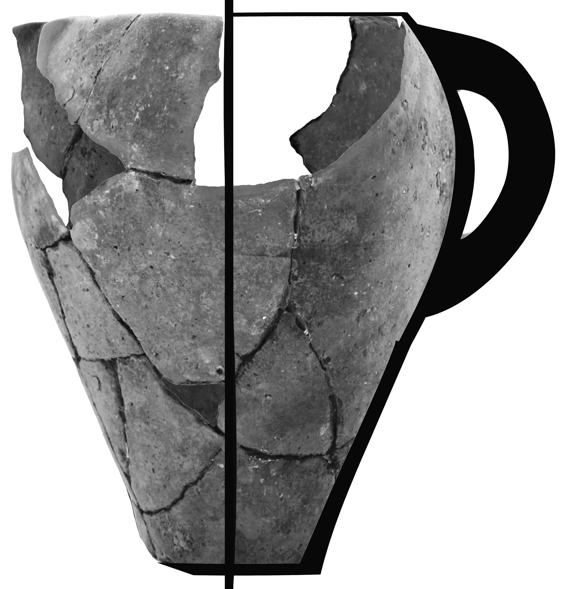

 |  |  |  |  |  |  |  |  | 1,07  ±0,05 | 1,61  ±0,03 | 2,0  ±0,1
 |  | A | Β | Γ | Δ | Ε | Ζ | Η | Θ | Ι | Κ
1 | D (±0.3) cm | 5.3 | 4.4 |  | 2.9 | 4.8 | 4.6 | 7.6 | 4.3 |  | 2.6
 | L (±0.1) cm | 1.1 | 0.9 |  | 0.8 | 1.0 | 1.1 | 0.9 | 9.0 |  | 1.2
 | B_{xz} (±1) nT | 29 | 53 |  | 105 | 96 | 90 | 92 | 105 |  | 59
 | B_{y} (±1) nT | 34 | 34 |  | -5 | -16 | -17 | -19 | 4 |  | 40
 | B (±1) nT | 45 | 63 |  | 105 | 97 | 92 | 94 | 105 |  | 71
 | θ_{Β}^{ο} | 40±1 | 57±1 |  | -87±1 | -81±1 | -79±1 | -78±1 | 88±1 |  | 56±1
2 | D (±0.3) cm | 7.8 | 9.7 |  | 5.4 |  |  | 4.5 |  | 1.9 | 3.7
 | L (±0.1) cm | 1.4 | 1.3 |  | 1.5 |  |  | 1.5 |  | 1.4 | 1.5
 | B_{xz} (±1) nT | 50 | 79 |  | 99 |  |  | 97 |  | 94 | 60
 | B_{y} (±1) nT | 36 | 28 |  | -14 |  |  | -22 |  | 14 | 38
 | B (±1) nT | 62 | 84 |  | 100 |  |  | 99 |  | 95 | 71
 | θ_{Β}^{ο} | 54±1 | 70±1 |  | -82±1 |  |  | -77±1 |  | 82±1 | 58±1
3 | D (±0.3) cm | 8.6 |  | 4.1 | 3.1 | 5.1 | 3.0 | 12.3 | 4.1 | 4.6 | 8.9
 | L (±0.1) cm | 1.4 |  | 1.2 | 1.4 | 1.3 | 1.3 | 1.4 | 1.5 | 1.4 | 1.3
 | B_{xz} (±1) nT | 94 |  | 102 | 76 | 44 | 38 | 73 | 95 | 106 | 96
 | B_{y} (±1) nT | 20 |  | -13 | -30 | -40 | -42 | -31 | -13 | 2 | 14
 | B (±1) nT | 96±1 |  | 103±1 | 82±1 | 59±1 | 57±1 | 79±1 | 95±1 | 106±1 | 97±1
 | θ_{Β}^{ο} | 78 |  | -83 | -68 | -48 | -42 | -67 | -82 | 89 | 82
4 | D (±0.3) cm | 4.1 | 5.6 | 5.0 | 2.4 | 2.0 | 3.8 | 8.7 | 2.7 | 8.3 | 15.7
 | L (±0.1) cm | 1.4 | 1.3 | 1.3 | 1.5 | 1.3 | 1.3 | 1.3 | 1.4 | 1.4 | 1.3
 | B_{xz} (±1) nT | 102 | 104 | 87 | 55 | 52 | 27 | 52 | 89 | 99 | 102
 | B_{y} (±1) nT | 16 | 7 | -20 | -34 | -35 | -44 | -33 | -23 | -1 | 12
 | B (±1) nT | 103 | 104 | 89 | 65 | 63 | 52 | 62 | 92 | 99 | 103
 | θ_{Β}^{ο} | 81±1 | 86±1 | -77±1 | -58±1 | -56±1 | -32±1 | -58±1 | -76±1 | -89±1 | 83±1
5 | D (±0.3) cm | 9.8 | 10.7 | 4.5 | 7.4 | 8.4 | 2.3 | 3.2 | 6.8 | 4.9 | 18.8
 | L (±0.1) cm | 1.3 | 1.2 | 1.1 | 1.2 | 1.2 | 1.1 | 1.1 | 1.2 | 1.2 | 1.3
 | B_{xz} (±1) nT | 88 | 95 | 96 | 71 | 59 | 39 | 64 | 101 | 104 | 95
 | B_{y} (±1) nT | 19 | 18 | -13 | -30 | -38 | -35 | -32 | -12 | 6 | 18
 | B (±1) nT | 90 | 97 | 97 | 77 | 70 | 52 | 72 | 102 | 104 | 97
 | θ_{Β}^{ο} | 78±1 | 79±1 | -82±1 | -67±1 | -57±1 | -48±1 | -63±1 | -83±1 | 87±1 | 79±1

Table 9. Measurements D, L, and sensor readings of B_{i} (i=xz,y), with the x-sensor aligned along the common direction of Bxz, Μxz, on the body fragments of vase 3.

Vase 3
 |  | A | Β | Γ | Δ | Ε | Ζ | Η | Θ | Ι | Κ
1 | Β_{y} (±1nΤ) | 36 | 34 |  | -6 | -16 | -17 | -19 | 4 |  | 40
 | B_{x}(±1nΤ) | -22 | -38 |  | -60 | -34 | 31 | 51 | 75 |  | 51
 | B_{z}(±1nΤ) | 26 | 40 |  | 82 | 87 | 91 | 86 | 78 |  | 39
 | B(±1nΤ) | 50 | 65 |  | 102 | 95 | 98 | 102 | 108 |  | 76
 | θ_{Β}^{ο} | 43±1 | 58±1 |  | -87±1 | -80±1 | -80±1 | -79±1 | 88±1 |  | 58±1
 | φ_{Β}^{ο} | 130±2 | 134±1 |  | 126±1 | 111±1 | 71±1 | 59±1 | 46±1 |  | 37±1
2 | Β_{y} (±1nΤ) | 36 | 28 |  | -15 |  |  | -22 |  | 15 | 37
 | B_{x}(±1nΤ) | -24 | -51 |  | -57 |  |  | 55 |  | 73 | 37
 | B_{z}(±1nΤ) | 49 | 51 |  | 71 |  |  | 84 |  | 67 | 46
 | B(±1nΤ) | 65 | 77 |  | 92 |  |  | 103 |  | 100 | 70
 | θ_{Β}^{ο} | 57±1 | 69±1 |  | -81±1 |  |  | -78±1 |  | 81±1 | 58±1
 | φ_{Β}^{ο} | 116±1 | 135±1 |  | 129±1 |  |  | 57±1 |  | 43±1 | 51±1
3 | Β_{y} (±1nΤ) | 19 |  | -14 | -31 | -39 | -41 | -32 | -14 | 2 | 14
 | B_{x}(±1nΤ) | -36 |  | -70 | -58 | -31 | 18 | 48 | 74 | 65 | 46
 | B_{z}(±1nΤ) | 84 |  | 64 | 43 | 30 | 33 | 49 | 65 | 74 | 94
 | B(±1nΤ) | 93 |  | 96 | 79 | 58 | 56 | 76 | 99 | 99 | 106
 | θ_{Β}^{ο} | 78±1 |  | -82±1 | -67±`1 | -48±1 | -43±1 | -65±1 | -82±1 | 89±1 | 82±1
 | φ_{Β}^{ο} | 113±1 |  | 138±1 | 143±1 | 136±1 | 61±2 | 46±1 | 41±1 | 49±1 | 64±1
4 | Β_{y} (±1nΤ) | 16 | 9 | -19 | -35 | -35 | -43 | -34 | -22 | -1 | 12
 | B_{x}(±1nΤ) | -25 | -55 | -72 | -46 | -41 | 16 | 48 | 73 | 63 | 34
 | B_{z}(±1nΤ) | 97 | 83 | 58 | 36 | 32 | 22 | 30 | 55 | 84 | 88
 | B(±1nΤ) | 101 | 100 | 94 | 68 | 63 | 51 | 66 | 94 | 105 | 95
 | θ_{Β}^{ο} | 81±1 | 85±1 | -78±1 | -59±1 | -56±1 | -32±1 | -59±1 | -76±1 | -89±1 | 83±1
 | φ_{Β}^{ο} | 104±1 | 124±1 | 141±1 | 142±1 | 142±1 | 54±2 | 32±1 | 37±1 | 53±1 | 69±1
5 | Β_{y} (±1nΤ) | 19 | 17 | -15 | -30 | -37 | -36 | -33 | -13 | -5 | 17
 | B_{x}(±1nΤ) | -21 | -52 | -72 | -49 | -36 | 21 | 44 | 70 | 71 | 49
 | B_{z}(±1nΤ) | 86 | 89 | 62 | 42 | 42 | 28 | 43 | 62 | 82 | 85
 | B(±1nΤ) | 91 | 104 | 96 | 71 | 67 | 50 | 70 | 94 | 109 | 100
 | θ_{Β}^{ο} | 78±1 | 81±1 | -81±1 | -65±1 | -56±1 | -44±1 | -621 | -82±1 | 87±1 | 80±1
 | φ_{Β}^{ο} | 104±1 | 120±1 | 139±1 | 139±1 | 131±1 | 53±2 | 44±1 | 42±1 | 49±1 | 60±1

Table 10. Indicative sensor readings with the x-sensor oriented in the grooves’ direction on the body fragments of vase 3.

Vase 4
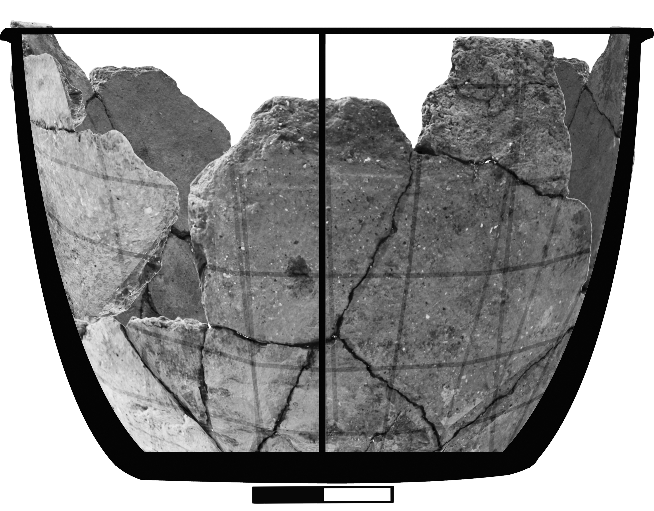
 |  |  |  |  | α_{y}˪ (cm) |  |  |  | α_{x,z}// (cm) |  |  | λ
 |  |  |  |  | 0.67±0,03 |  |  |  | 1.15±0,02 |  |  | 1.97±0,01
 |  | A | Β | Γ |  |  | Δ | Ε |  | Ζ | Η |  | Θ | Ι
1 | D (±0.3) cm |  |  | 1.7 |  |  | 1.6 |  |  | 4,2 |  |  | 5,7
 | L (±0.1) cm |  |  | 0.9 |  |  | 1.2 |  |  | 1,1 |  |  | 0,9
 | B_{xz} (±1) nT |  |  | 37 |  |  | 35 |  |  | 40 |  |  | 54
 | B_{y} (±1) nT |  |  | 16 |  |  | 15 |  |  | 17 |  |  | 5
 | B (±1) nT |  |  | 40 |  |  | 38 |  |  | 44 |  |  | 54
 | θ_{Β}^{ο} |  |  | 66±1 |  |  | 66±2 |  |  | 67±1 |  |  | 85±1
2 | D (±0.3) cm |  | 4.2 | 6.7 |  |  | 5.3 | 4.1 |  | 8.8 | 2.4 |  | 2.7 | 3.5
 | L (±0.1) cm |  | 1.3 | 1.3 |  |  | 1.3 | 1.2 |  | 1.3 | 1.3 |  | 1.3 | 1.5
 | B_{xz} (±1) nT |  | 47 | 43 |  |  | 43 | 43 |  | 46 | 43 |  | 48 | 55
 | B_{y} (±1) nT |  | 15 | 14 |  |  | 18 | 18 |  | 12 | 10 |  | 9 | 3
 | B (±1) nT |  | 49 | 45 |  |  | 47 | 47 |  | 48 | 44 |  | 49 | 55
 | θ_{Β}^{ο} |  | 72±1 | 72±1 |  |  | 67±1 | 67±1 |  | 75±1 | 77±1 |  | 79±1 | 87±1
3 | D (±0.3) cm | 1.9 | 10,6 | 2.0 |  |  | 9.1 | 9.9 |  | 13.9 | 4.4 |  | 9.6 | 2.8
 | L (±0.1) cm | 1.8 | 1.7 | 1.8 |  |  | 1.8 | 1.8 |  | 1.7 | 1.7 |  | 1.6 | 1.7
 | B_{xz} (±1) nT | 53 | 52 | 47 |  |  | 47 | 47 |  | 50 | 53 |  | 55 | 49
 | B_{y} (±1) nT | 5 | 12 | 13 |  |  | 12 | 14 |  | 10 | 7 |  | 2 | -3
 | B (±1) nT | 53 | 53 | 49 |  |  | 49 | 49 |  | 51 | 53 |  | 55 | 49
 | θ_{Β}^{ο} | 85±1 | 77±1 | 74±1 |  |  | 75±1 | 73±1 |  | 79±1 | 82±1 |  | 88±1 | -86±1
4 | D (±0.3) cm |  |  | 1.7 |  |  | 2.8 | 3.0 |  | 2.3 | 7.5 |  | 3>8 | 2.0
 | L (±0.1) cm |  |  | 2.1 |  |  | 2.1 | 2.0 |  | 2.1 | 2.1 |  | 2.0 | 2.0
 | B_{xz} (±1) nT |  |  | 50 |  |  | 45 | 49 |  | 53 | 55 |  | 55 | 53
 | B_{y} (±1) nT |  |  | 9 |  |  | 9 | 10 |  | 5 | 4 |  | -2 | -5
 | B (±1) nT |  |  | 51 |  |  | 46 | 50 |  | 53 | 55 |  | 55 | 53
 | θ_{Β}^{ο} |  |  | 80±1 |  |  | 79±1 | 78±1 |  | 85±1 | 86±1 |  | -88±1 | -85±1
5 | D (±0.3) cm |  |  | 4.8 |  |  | 2.6 | 6.6 |  | 5.5 | 2.5 |  | 2.3 | 4.4
 | L (±0.1) cm |  |  | 2.2 |  |  | 2.3 | 2.2 |  | 2.1 | 2.3 |  | 2.1 | 2.2
 | B_{xz} (±1) nT |  |  | 53 |  |  | 54 | 53 |  | 55 | 54 |  | 48 | 51
 | B_{y} (±1) nT |  |  | 6 |  |  | 7 | 6 |  | 3 | -1 |  | -6 | -9
 | B (±1) nT |  |  | 53 |  |  | 54 | 53 |  | 55 | 54 |  | 48 | 52
 | θ_{Β}^{ο} |  |  | 83±1 |  |  | 83±1 | 83±1 |  | 87±1 | -89±1 |  | -83±1 | -80±1

Table 11. Measurements D, L, and sensor readings of B_{i} (i=xz,y), with the x-sensor aligned along the common direction of Bxz, Μxz, on the body fragments of vase 4.

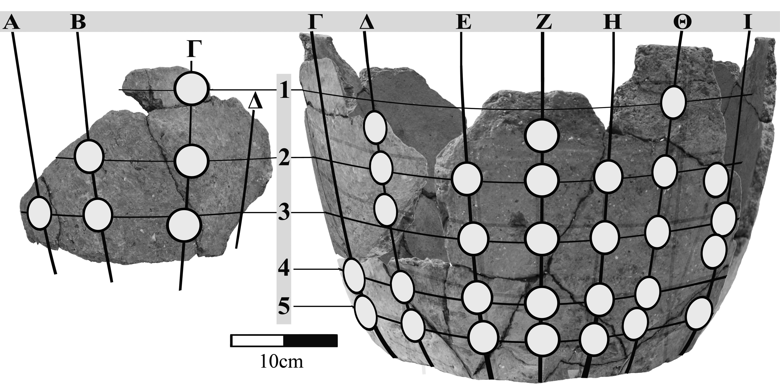

Vase 4
 |  | A | Β | Γ | Δ | Ε | Ζ | Η | Θ | Ι
1 | Β_{y} (±1nΤ) |  |  | 16 | 16 |  | 17 |  | 6
 | B_{x}(±1nΤ) |  |  | 10 | 3 |  | -23 |  | -39
 | B_{z}(±1nΤ) |  |  | 33 | 14 |  | 37 |  | 38
 | B(±1nΤ) |  |  | 38 | 38 |  | 47 |  | 55
 | θ_{Β}^{ο} |  |  | 65±1 | 65±2 |  | 68±1 |  | 84±1
 | φ_{Β}^{ο} |  |  | 73±1 | 85±2 |  | 122±1 |  | 136±1
2 | Β_{y} (±1nΤ) |  | 14 | 15 | 17 | 18 | 12 | 10 | 8 | 2
 | B_{x}(±1nΤ) |  | 27 | 13 | 2 | -11 | -16 | -27 | -30 | -35
 | B_{z}(±1nΤ) |  | 45 | 41 | 38 | 40 | 34 | 33 | 33 | 33
 | B(±1nΤ) |  | 54 | 46 | 42 | 45 | 40 | 44 | 45 | 48
 | θ_{Β}^{ο} |  | 75±1 | 71±1 | 66±2 | 66±1 | 72±2 | 77±1 | 80±1 | 88±1
 | φ_{Β}^{ο} |  | 59±1 | 72±1 | 87±2 | 105±1 | 115±2 | 129±1 | 132±1 | 137±1
 | Β_{y} (±1nΤ) | 6 | 11 | 13 | 12 | 14 | 10 | 7 | 1 | -2
3 | B_{x}(±1nΤ) | 33 | 21 | 4 | 6 | -8 | -24 | -32 | -40 | -35
 | B_{z}(±1nΤ) | 37 | 38 | 40 | 41 | 43 | 43 | 43 | 39 | 32
 | B(±1nΤ) | 50 | 45 | 42 | 43 | 46 | 50 | 54 | 56 | 47
 | θ_{Β}^{ο} | 83±1 | 76±1 | 72±1 | 74±1 | 72±1 | 78±1 | 82±1 | 89±1 | -88±1
 | φ_{Β}^{ο} | 48±1 | 61±1 | 84±1 | 82±1 | 101±1 | 119±1 | 127±1 | 136±1 | 138±1
4 | Β_{y} (±1nΤ) |  |  | 9 | 9 | 11 | 6 | 4 | -1 | -6
 | B_{x}(±1nΤ) |  |  | 12 | 1 | -9 | -26 | -27 | -35 | -38
 | B_{z}(±1nΤ) |  |  | 49 | 44 | 51 | 41 | 40 | 34 | 32
 | B(±1nΤ) |  |  | 51 | 45 | 53 | 49 | 48 | 49 | 50
 | θ_{Β}^{ο} |  |  | 80±1 | 78±1 | 78±1 | 83±1 | 85±1 | -89±1 | -83±1
 | φ_{Β}^{ο} |  |  | 76±1 | 89±1 | 100±1 | 122±1 | 124±1 | 136±1 | 140±1
5 | Β_{y} (±1nΤ) |  |  | 6 | 7 | 7 | 3 | -1 | -5 | -9
 | B_{x}(±1nΤ) |  |  | 8 | 3 | -11 | -19 | -32 | -39 | -41
 | B_{z}(±1nΤ) |  |  | 51 | 51 | 48 | 44 | 43 | 35 | 33
 | B(±1nΤ) |  |  | 52 | 52 | 50 | 48 | 54 | 53 | 53
 | θ_{Β}^{ο} |  |  | 83±1 | 82±1 | 82±1 | 86±1 | -89±1 | -84±1 | -80±1
 |  |  |  | 81±1 | 87±1 | 103±1 | 113±1 | 127±1 | 138±1 | 141±1

Table 12. Indicative sensor readings with the x-sensor oriented in the grooves’ direction on the body fragments of vase 4.

Vase 5 |  |  |  |  | α_{y}˪ (cm) |  |  | α_{x,z}// (cm) |  |  | λ
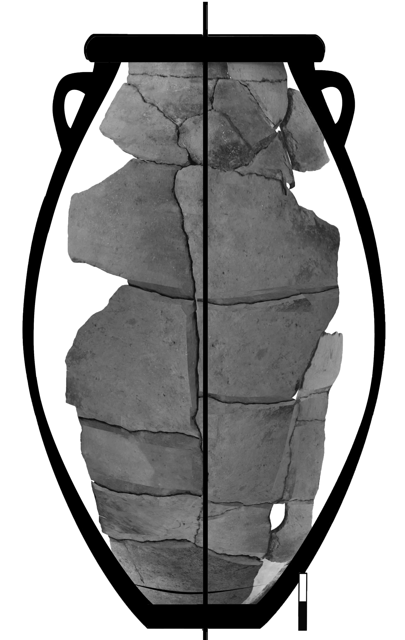 |  |  |  |  | 1,04±0,03 |  |  | 1,41±0,03 |  |  | 2,03±0,01
 |  | A | Β | Γ |  | Δ | Ε |  | Ζ | Η |  | Θ
1 | D (±0.3) cm | 10.4 | 2.2 | 4.7 |  | 1.8 | 10.4 |  | 7.6 | 3.3 |  | 1.2
 | L (±0.1) cm | 2.9 | 2.8 | 2.7 |  | 2.7 | 2.6 |  | 2.6 | 2.5 |  | 2.6
 | B_{xz} (±1) nT | 45 | 53 | 58 |  | 62 | 66 |  | 66 | 71 |  | 67
 | B_{y} (±1) nT | -24 | -22 | -19 |  | -17 | -14 |  | -9 | -7 |  | -6
 | B (±1) nT | 51 | 57 | 61 |  | 64 | 67 |  | 67 | 71 |  | 67
 | θ_{Β}^{ο} | -62±1 | -68±1 | -72±1 |  | -75±1 | -78±1 |  | -82±1 | -84±1 |  | -85±1
2 | D (±0.3) cm | 3.0 | 6.0 | 7.1 |  | 8.6 | 6.9 |  | 3.8 | 1.8 |  | 4.7
 | L (±0.1) cm | 2.4 | 2.4 | 2.3 |  | 2.3 | 2.3 |  | 2.2 | 2.2 |  | 2.2
 | B_{xz} (±1) nT | 55 | 57 | 61 |  | 64 | 64 |  | 70 | 70 |  | 72
 | B_{y} (±1) nT | -21 | -20 | -18 |  | -15 | -12 |  | -6 | -7 |  | -1
 | B (±1) nT | 59 | 60 | 64 |  | 66 | 65 |  | 70 | 70 |  | 72
 | θ_{Β}^{ο} | -69±1 | -71±1 | -74±1 |  | -77±1 | -80±1 |  | -85±1 | -84±1 |  | -89±1
3 | D (±0.3) cm | 15.4 | 25.0 | 26.4 |  | 32.1 | 23.1 |  | 6.7 | 4.8
 | L (±0.1) cm | 2.2 | 2.2 | 2.1 |  | 2.0 | 2.0 |  | 2.0 | 1.9
 | B_{xz} (±1) nT | 53 | 60 | 64 |  | 66 | 66 |  | 68 | 68
 | B_{y} (±1) nT | -21 | -19 | -15 |  | -14 | -10 |  | -11 | -3
 | B (±1) nT | 57 | 63 | 66 |  | 67 | 67 |  | 69 | 68
 | θ_{Β}^{ο} | -69±1 | -73±1 | -77±1 |  | -78±1 | -82±1 |  | -81±1 | -88±1
4 | D (±0.3) cm | 7.4 | 12.9 | 4,3 |  | 20.7 | 20.8 |  | 13.1 | 6.4
 | L (±0.1) cm | 2.0 | 2.0 | 1.9 |  | 1.9 | 1.8 |  | 1.8 | 1.7
 | B_{xz} (±1) nT | 41 | 49 | 57 |  | 61 | 61 |  | 65 | 66
 | B_{y} (±1) nT | -26 | -24 | -20 |  | -17 | -17 |  | -14 | -11
 | B (±1) nT | 48 | 54 | 60 |  | 63 | 63 |  | 66 | 67
 | θ_{Β}^{ο} | -58±1 | -64±1 | -71±1 |  | -75±1 | -75±1 |  | -78±1 | -81±1
5 | D (±0.3) cm |  | 28.4 | 6.0 |  | 20.0 | 14.2 |  | 9.2 | 3.6
 | L (±0.1) cm |  | 1.7 | 1.6 |  | 1.5 | 1.5 |  | 1.5 | 1.4
 | B_{xz} (±1) nT |  | 38 | 50 |  | 51 | 57 |  | 62 | 64
 | B_{y} (±1) nT |  | -27 | -23 |  | -22 | -19 |  | -16 | -14
 | B (±1) nT |  | 46 | 55 |  | 55 | 60 |  | 64 | 65
 | θ_{Β}^{ο} |  | -55±11 | -66±1 |  | -67±1 | -72±1 |  | -76±1 | -78±1

Table 13a. Measurements D, L, and sensor readings of B_{i} (i=xz,y), with the x-sensor aligned along the common direction of Bxz, Μxz, on the body fragments of vase 5.

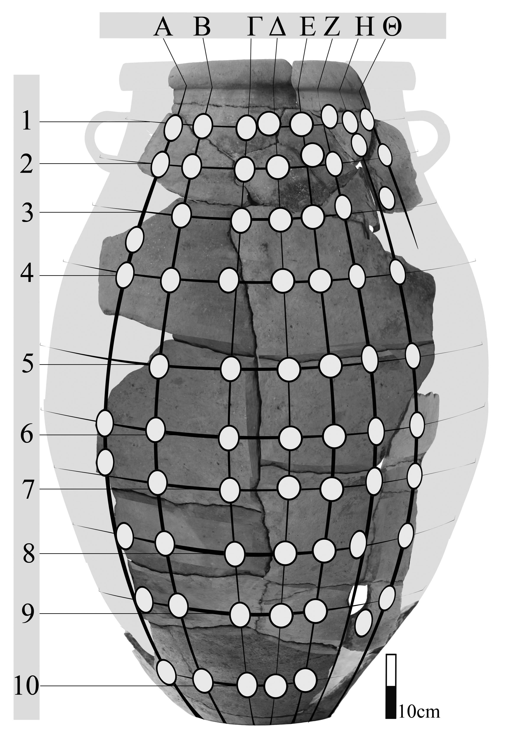

,

Vase 5
 |  |  |  | A | Β | Γ | Δ | Ε | Ζ | Η | Θ
6 |  | D (±0.3) cm |  | 12.9 | 17.1 | 6.1 | 15,5 | 9,.0 | 3.0 | 3.3
 |  | L (±0.1) cm |  | 1.4 | 1.4 | 1.4 | 1.4 | 1.4 | 1.3 | 1.3
 |  | B_{xz} (±1) nT |  | 21 | 22 | 34 | 41 | 51 | 56 | 59
 |  | B_{y} (±1) nT |  | -29 | -29 | -26 | -25 | -21 | -21 | -17
 |  | B (±1) nT |  | 35 | 36 | 43 | 48 | 55 | 60 | 61
 |  | θ_{Β}^{ο} |  | -36±2 | -38±2 | -53±1 | -59±1 | -68±1 | -70±1 | -74±1
7 |  | D (±0.3) cm |  | 4.5 | 6.3 | 5.3 | 14.9 | 8.0 | 1.8 | 1.4
 |  | L (±0.1) cm |  | 2.5 | 1.5 | 1.4 | 1.4 | 1.5 | 1.5 | 1.5
 |  | B_{xz} (±1) nT |  | 16 | 25 | 27 | 37 | 53 | 53 | 51
 |  | B_{y} (±1) nT |  | -30 | -28 | -27 | -26 | -22 | -19 | -18
 |  | B (±1) nT |  | 34 | 37 | 38 | 45 | 57 | 56 | 54
 |  | θ_{Β}^{ο} |  | -28±2 | -42±2 | -45±2 | -55±1 | -68±1 | -71±1 | -71±1
8 |  | D (±0.3) cm |  | 9.1 | 10.0 | 5.7 | 13.8 | 7.6 | 2.0 | 1.7
 |  | L (±0.1) cm |  | 1.6 | 1.7 | 1.6 | 1.6 | 1.6 | 1.7 | 1.7
 |  | B_{xz} (±1) nT |  | 8 | 19 | 28 | 40 | 47 | 52 | 54
 |  | B_{y} (±1) nT |  | -32 | -31 | -29 | -25 | -24 | -22 | -21
 |  | B (±1) nT |  | 33 | 36 | 40 | 47 | 53 | 56 | 58
 |  | θ_{Β}^{ο} |  | -14±2 | -32±2 | -44±1 | -58±1 | -63±1 | -67±1 | -69±1
9 |  | D (±0.3) cm |  | 5.3 | 13.5 | 3.7 | 11.1 | 5.6 | 5.5 | 2.4
 |  | L (±0.1) cm |  | 1.7 | 1.7 | 1.7 | 1.8 | 1.8 | 1.9 | 1.9
 |  | B_{xz} (±1) nT |  | 11 | 24 | 34 | 38 | 44 | 49 | 56
 |  | B_{y} (±1) nT |  | -31 | -29 | -27 | -27 | -26 | -23 | -20
 |  | B (±1) nT |  | 33 | 37 | 43 | 46 | 51 | 54 | 59
 |  | θ_{Β}^{ο} |  | -19±2 | -40±2 | -52±1 | -55±1 | -60±1 | -65±1 | -71±1
10 |  |  |  | 7,8 | 21.7 | 15.2 | 9.9 | 4.2
 |  |  |  | 2,1 | 2.1 | 2.2 | 2.3 | 2.3
 |  |  |  | 17 | 22 | 31 | 37 | 43
 |  |  |  | -32 | -31 | -30 | -28 | -27
 |  |  |  | 36 | 38 | 43 | 46 | 51
 |  |  |  | -28±2 | -36±2 | -46±1 | -53±1 | -58±1

Table 13b. Measurements D, L, and sensor readings of B_{i} (i=xz,y), with the x-sensor aligned along the common direction of Bxz, Μxz, on the body fragments of vase 5.

Vase 5
 |  | A | Β | Γ | Δ | Ε | Ζ | Η | Θ
1 | Β_{y} (±1nΤ) | -23 | -23 | -19 | -17 | -14 | -9 | -7 | -6
 | B_{x}(±1nΤ) | -11 | -24 | -32 | -40 | -49 | -53 | -58 | -59
 | B_{z}(±1nΤ) | 48 | 45 | 47 | 45 | 41 | 42 | 38 | 38
 | B(±1nΤ) | 54 | 56 | 60 | 62 | 65 | 68 | 70 | 70
 | θ_{Β}^{ο} | 115±1 | -66±1 | -72±1 | -74±1 | -78±1 | -83±1 | -84±1 | -85±1
 | φ_{Β}^{ο} | 1031 | 118±1 | 124±1 | 132±1 | 140±1 | 142±1 | 147±1 | 147±1
2 | Β_{y} (±1nΤ) | -20 | -21 | -18 | -15 | -12 | -6 | -7 | -1
 | B_{x}(±1nΤ) | -12 | -20 | -35 | -40 | -46 | -53 | -53 | -57
 | B_{z}(±1nΤ) | 56 | 53 | 47 | 50 | 47 | 43 | 43 | 39
 | B(±1nΤ) | 61 | 60 | 61 | 66 | 67 | 70 | 69 | 69
 | θ_{Β}^{ο} | -71±1 | -70±1 | -73±1 | -77±1 | -80±1 | -85±1 | -84±1 | -89±1
 | φ_{Β}^{ο} | 102±1 | 111±1 | 127±1 | 129±1 | 134±1 | 141±1 | 141±1 | 146±1
3 | Β_{y} (±1nΤ) | -22 | -19 | -15 | -14 | -10 | -11 | -3
 | B_{x}(±1nΤ) | -17 | -24 | -31 | -45 | -47 | -48 | -55
 | B_{z}(±1nΤ) | 47 | 52 | 55 | 46 | 49 | 46 | 42
 | B(±1nΤ) | 54 | 60 | 65 | 66 | 69 | 67 | 69
 | θ_{Β}^{ο} | -67±1 | -72±1 | -77±1 | -78±1 | -82±1 | -81±1 | -88±1
 | φ_{Β}^{ο} | 110±1 | 115±1 | 119±1 | 134±1 | 134±1 | 136±1 | 143±1
4 | Β_{y} (±1nΤ) | -26 | -23 | -20 | -17 | -16 | -13 | -11
 | B_{x}(±1nΤ) | -13 | -23 | -32 | -43 | -46 | -54 | -57
 | B_{z}(±1nΤ) | 40 | 44 | 45 | 44 | 40 | 40 | 42
 | B(±1nΤ) | 49 | 55 | 59 | 64 | 63 | 68 | 72
 | θ_{Β}^{ο} | -59±2 | -65±1 | -70±1 | -75±1 | -76±1 | -79±1 | -81±1
 | φ_{Β}^{ο} | 108±1 | 118±1 | 125±1 | 134±1 | 139±1 | 143±1 | 144±1
5 | Β_{y} (±1nΤ) |  | -27 | -23 | -22 | -18 | -15 | -14
 | B_{x}(±1nΤ) |  | -21 | -36 | -37 | -48 | -50 | -55
 | B_{z}(±1nΤ) |  | 33 | 36 | 34 | 34 | 35 | 33
 | B(±1nΤ) |  | 47 | 56 | 55 | 61 | 63 | 66
 | θ_{Β}^{ο} |  | -56±2 | -66±1 | -67±1 | -73±1 | -76±1 | -78±1
 | φ_{Β}^{ο} |  | 122±1 | 135±1 | 137±1 | 145±1 | 145±1 | 149±1

Table 14a. Indicative sensor readings with the x-sensor oriented in the grooves’ direction on the body fragments of vase 5.

Vase 5
 |  | A | Β | Γ | Δ | Ε | Ζ | Η | Θ
6 | Β_{y} (±1nΤ) | -28 | -28 | -26 | -24 | -20 | -20 | -17
 | B_{x}(±1nΤ) | -10 | -16 | -25 | -40 | -45 | -48 | -53
 | B_{z}(±1nΤ) | 16 | 14 | 24 | 19 | 25 | 27 | 25
 | B(±1nΤ) | 33 | 35 | 43 | 50 | 55 | 58 | 61
 | θ_{Β}^{ο} | -34±4 | -38±3 | -54±2 | -62±1 | -69±1 | -70±1 | -74±1
 | φ_{Β}^{ο} | 122±3 | 139±3 | 136±2 | 155±1 | 151±1 | 151±1 | 155±1
7 | Β_{y} (±1nΤ) | -30 | -29 | -27 | -26 | -22 | -19 | -19
 | B_{x}(±1nΤ) | -9 | -20 | -24 | -35 | -47 | -48 | -47
 | B_{z}(±1nΤ) | 11 | 13 | 12 | 16 | 22 | 20 | 22
 | B(±1nΤ) | 33 | 37 | 38 | 46 | 56 | 55 | 55
 | θ_{Β}^{ο} | -26±5 | -40±3 | -45±3 | -56±2 | -67±1 | -70±1 | -70±1
 | φ_{Β}^{ο} | 129±4 | 147±2 | 153±2 | 155±1 | 155±1 | 157±1 | 155±1
8 | Β_{y} (±1nΤ) | -31 | -31 | -29 | -25 | -23 | -21 | -20
 | B_{x}(±1nΤ) | -8 | -21 | -30 | -39 | -45 | -51 | -53
 | B_{z}(±1nΤ) | 5 | 4 | 4 | 13 | 12 | 14 | 18
 | B(±1nΤ) | 32 | 37 | 42 | 48 | 52 | 57 | 59
 | θ_{Β}^{ο} | -17±8 | -35±3 | -47±2 | -59±2 | -64±1 | -69±1 | -71±1
 | φ_{Β}^{ο} | 148±6 | 169±3 | 172±2 | 162±1 | 165±1 | 165±1 | 161±1
9 | Β_{y} (±1nΤ) | -32 | -29 | -27 | -27 | -25 | -23 | -21
 | B_{x}(±1nΤ) | -11 | -23 | -33 | -38 | -44 | -52 | -56
 | B_{z}(±1nΤ) | -10 | -5 | -4 | 0 | 2 | 5 | 9
 | B(±1nΤ) | 35 | 37 | 43 | 46 | 50 | 57 | 60
 | θ_{Β}^{ο} | -25±5 | -39±3 | -51±2 | -55±2 | -61±1 | -67±1 | -70±1
 | φ_{Β}^{ο} | 222±4 | 192±2 | 187±2 | 180±2 | 177±1 | 175±1 | 171±1
10 | Β_{y} (±1nΤ) | -32 | -31 | -30 | -28 | -26
 | B_{x}(±1nΤ) | -7 | -21 | -34 | -38 | -45
 | B_{z}(±1nΤ) | -14 | -12 | -8 | -11 | -6
 | B(±1nΤ) | 35 | 39 | 46 | 48 | 52
 | θ_{Β}^{ο} | -26±5 | -38±3 | -50±2 | -55±2 | -61±1
 | φ_{Β}^{ο} | 243±4 | 210±2 | 193±2 | 196±1 | 188±1

Table 14b. Indicative sensor readings with the x-sensor oriented in the grooves’ direction on the body fragments of vase 5.

