Supplementary Materials
High consistency of structure-based design and X-ray crystallography: Design, synthesis, kinetic evaluation and crystallographic binding mode determination of biphenyl-N-acyl-β-D-glucopyranosylamines as glycogen phosphorylase inhibitors
Thomas Fischer, Symeon M. Koulas, Anastasia S. Tsagkarakou, Efthimios Kyriakis, George A. Stravodimos, Vassiliki T. Skamnaki, Panagiota G.V. Liggri, Spyros E. Zographos, Rainer Riedl* and Demetres D. Leonidas*

2-(acetoxymethyl)-6-aminotetrahydro-2H-pyran-3,4,5-triyl triacetate (6; ZHAWOC6075)
NMR
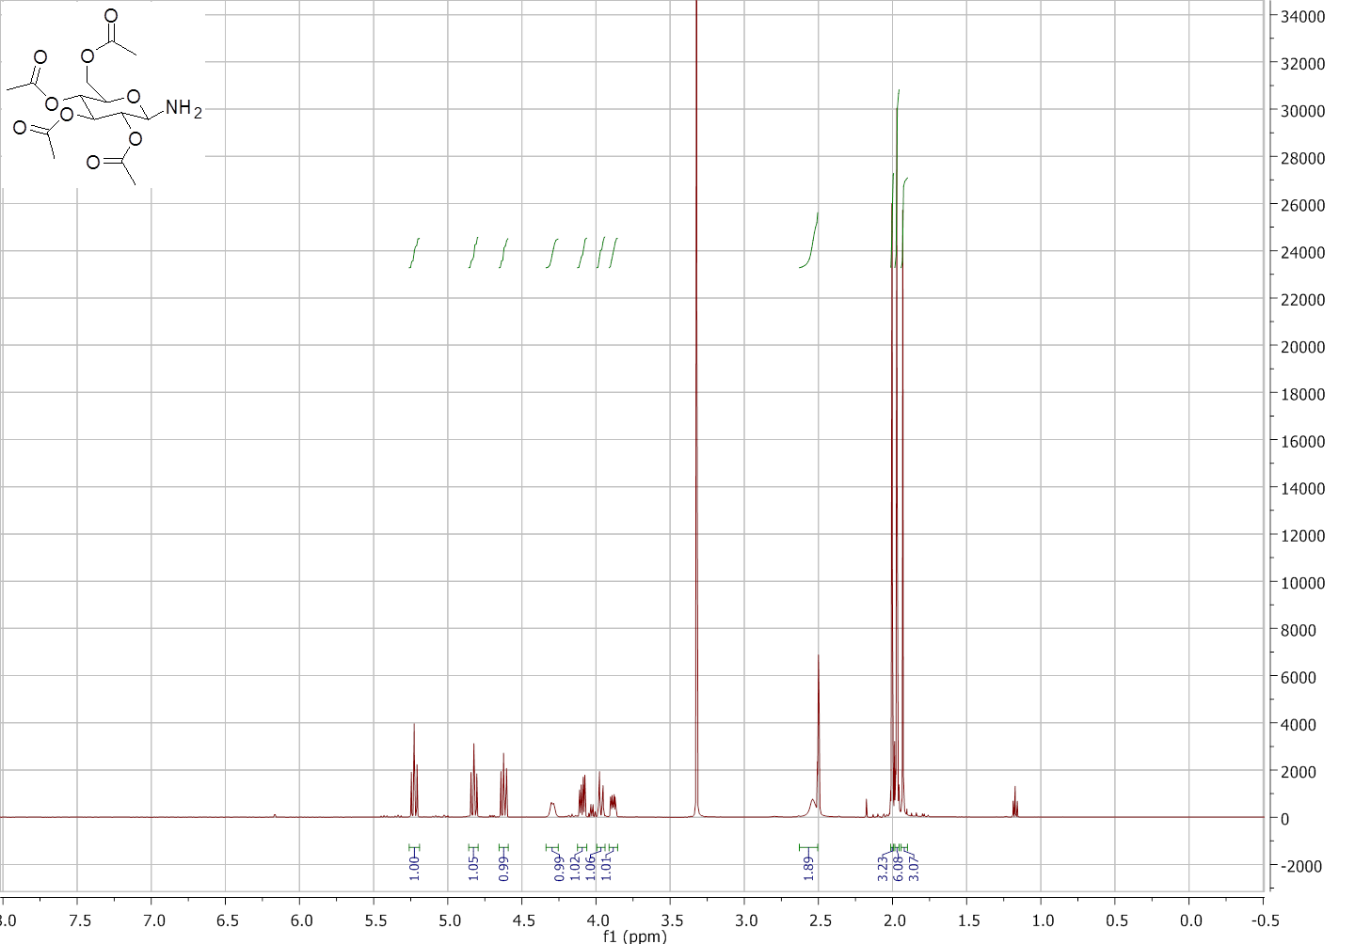

2-(acetoxymethyl)-6-aminotetrahydro-2H-pyran-3,4,5-triyl triacetate (6; ZHAWOC6075)
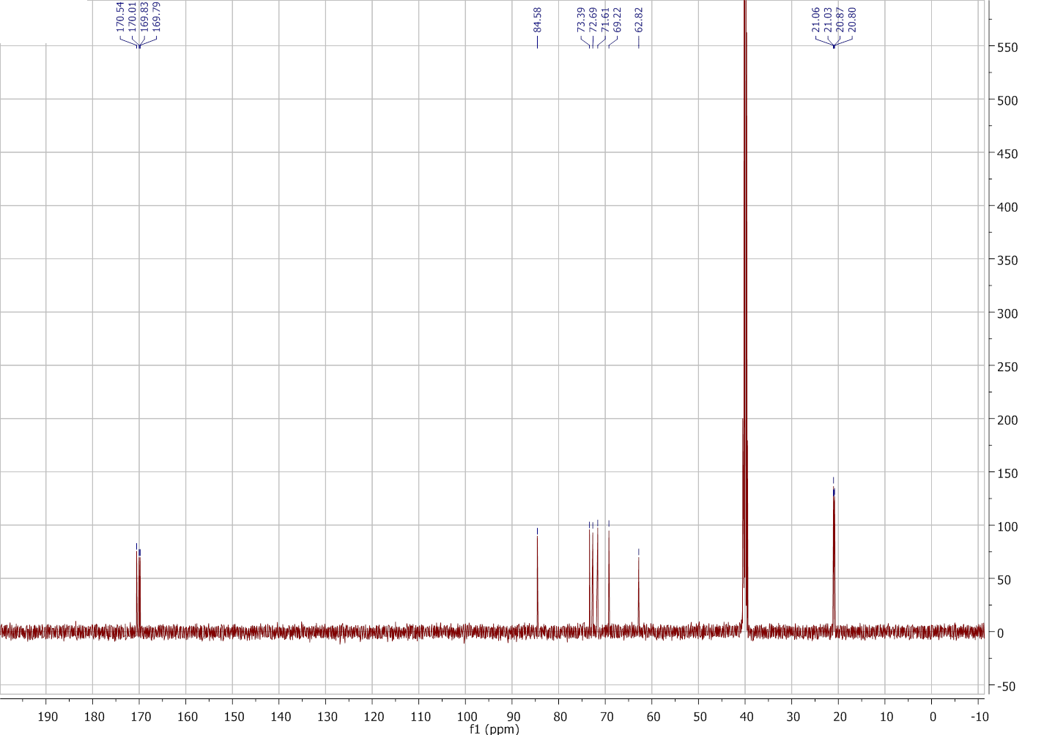
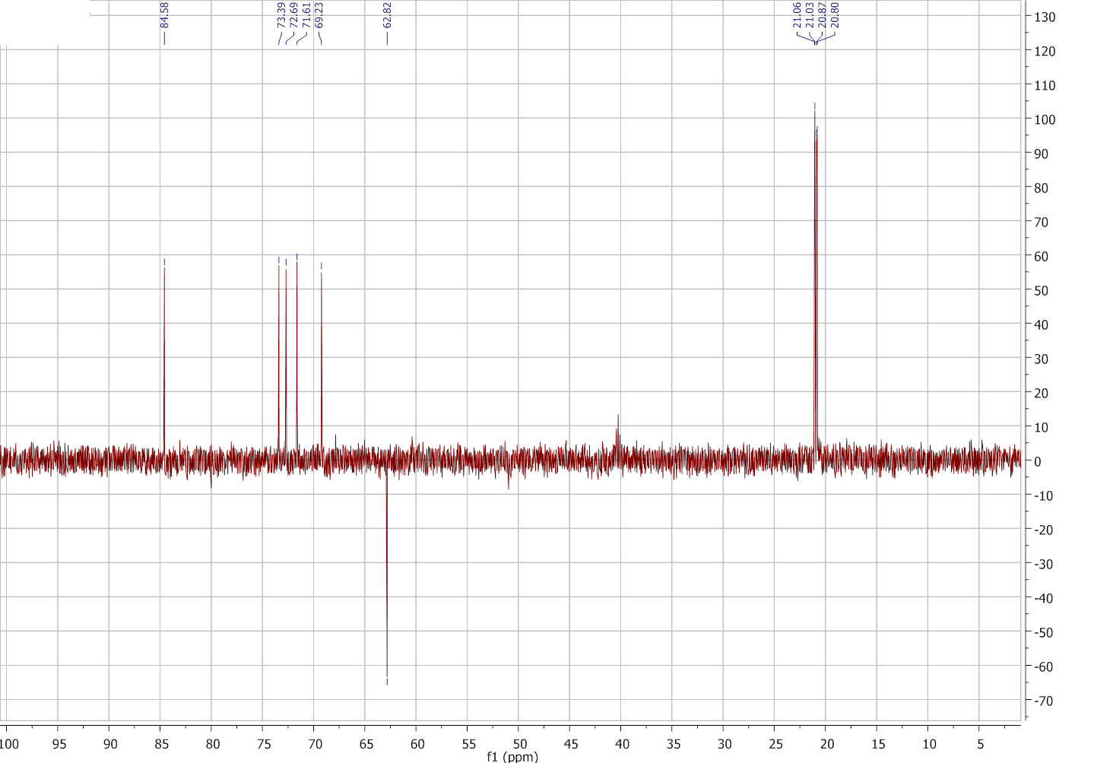

2-(acetoxymethyl)-6-(4'-fluorobiphenyl-3-ylcarboxamido)tetrahydro-2H-pyran-3,4,5-triyl triacetate (7; ZHAWOC6074)
NMR
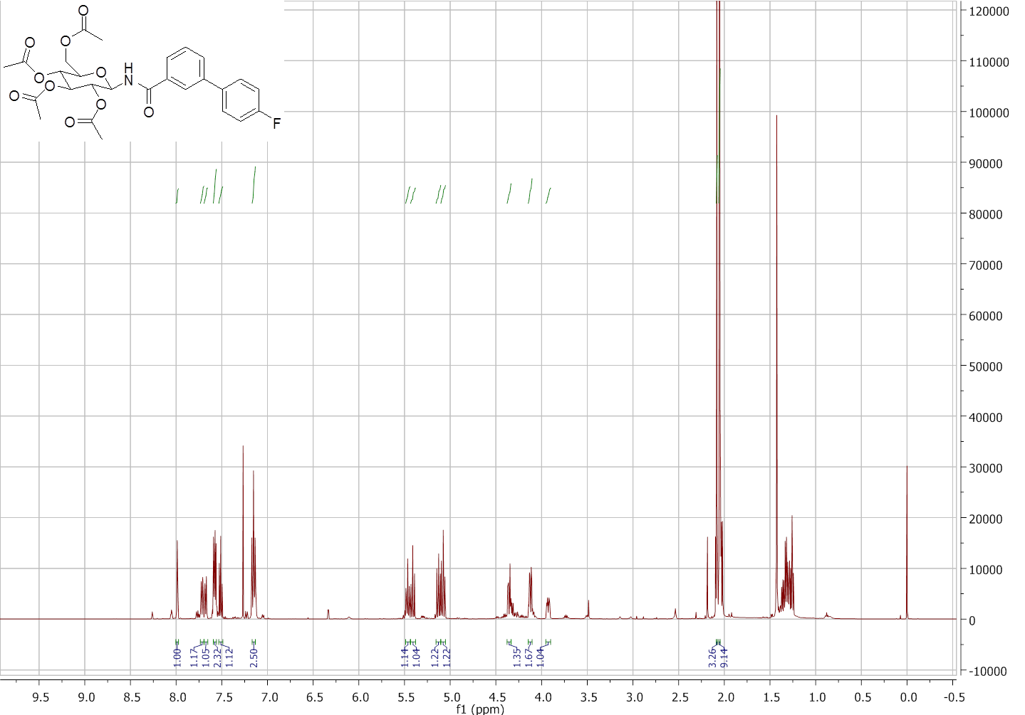

2-(acetoxymethyl)-6-(4'-fluorobiphenyl-3-ylcarboxamido)tetrahydro-2H-pyran-3,4,5-triyl triacetate (7; ZHAWOC6074)
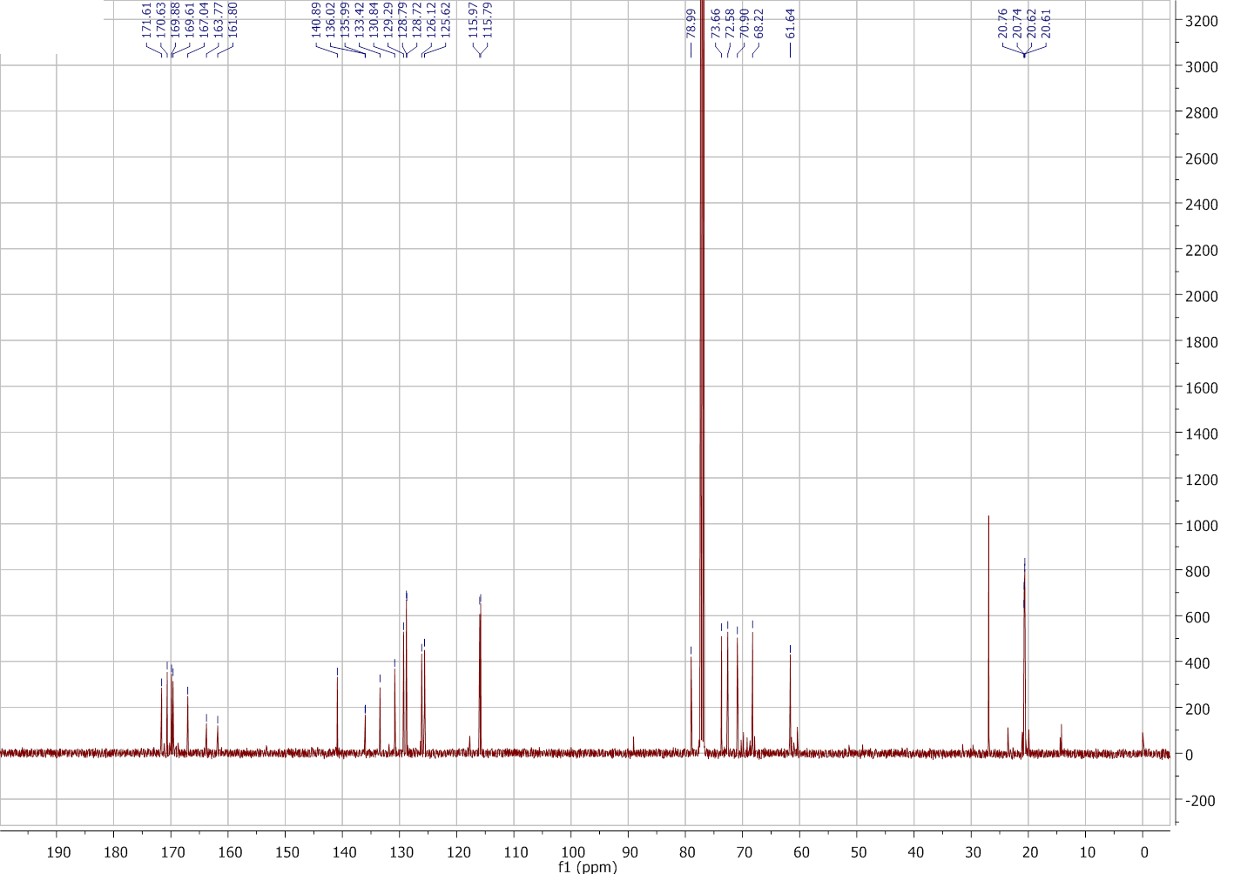
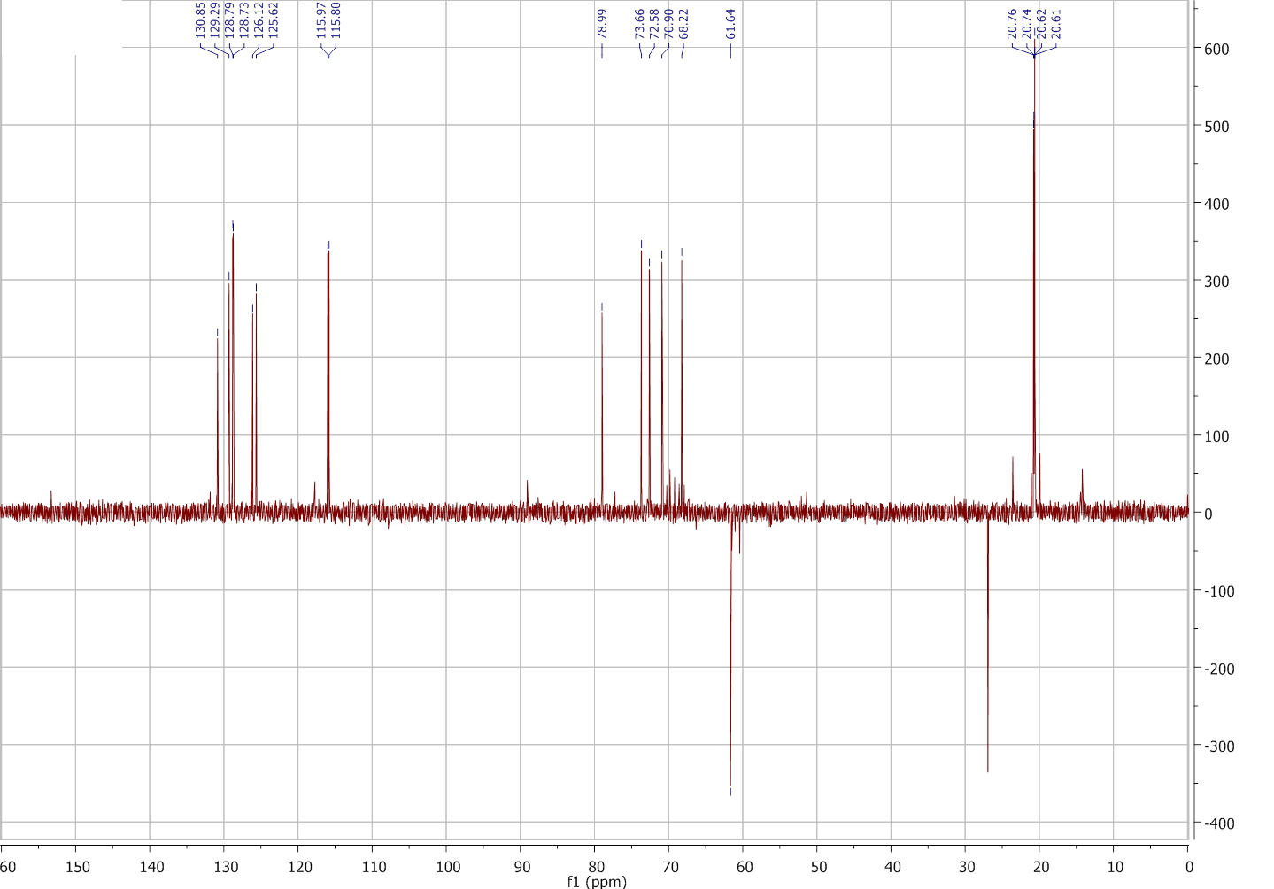

2-(acetoxymethyl)-6-biphenyl-4-ylcarboxamidotetrahydro-2H-pyran-3,4,5-triyl triacetate (8; ZHAWOC6076)
NMR
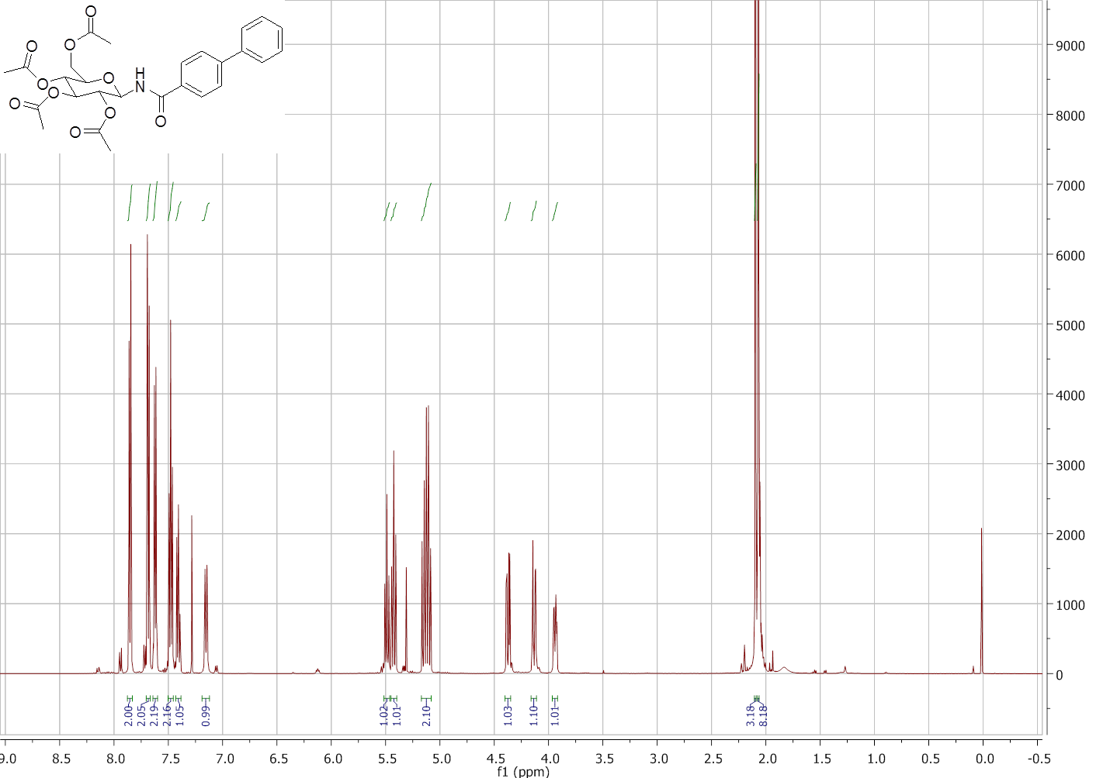

2-(acetoxymethyl)-6-biphenyl-4-ylcarboxamidotetrahydro-2H-pyran-3,4,5-triyl triacetate (8; ZHAWOC6076)
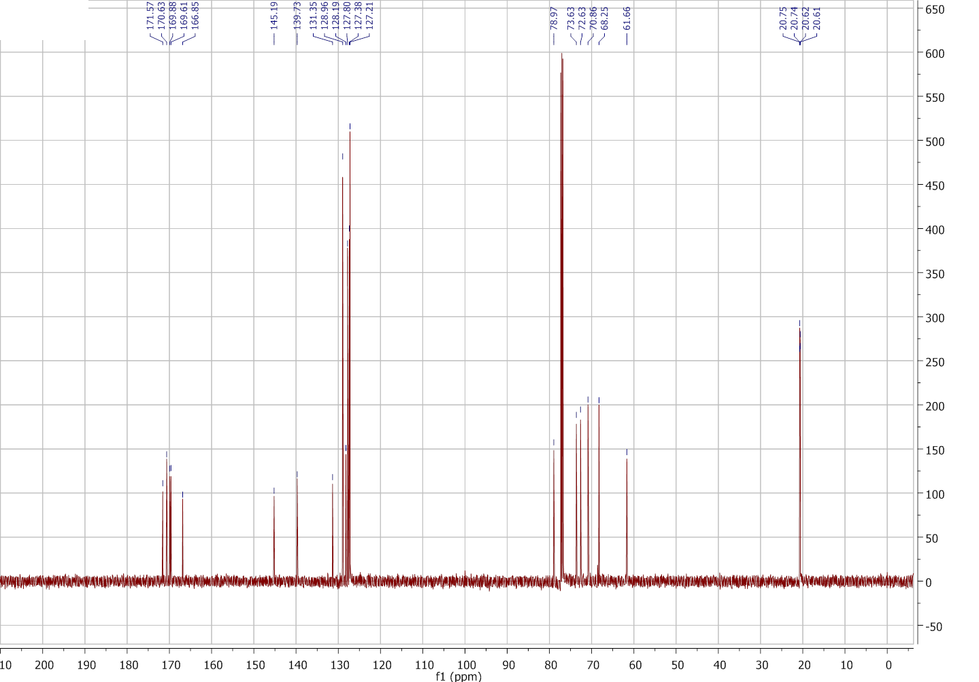
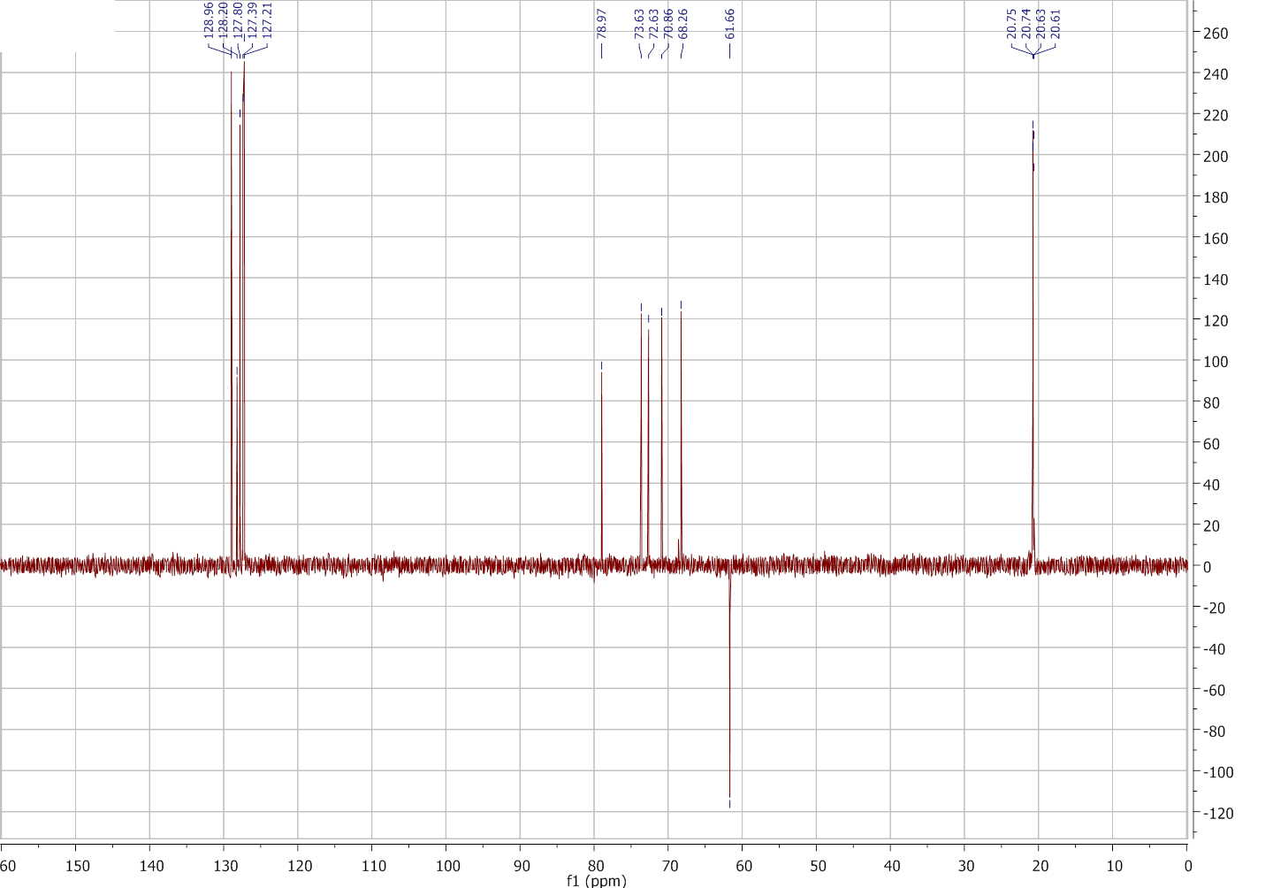

4'-fluoro-N-(3,4,5-trihydroxy-6-(hydroxymethyl)tetrahydro-2H-pyran-2-yl)biphenyl-3-carboxamide (3; ZHAWOC6072)
NMR
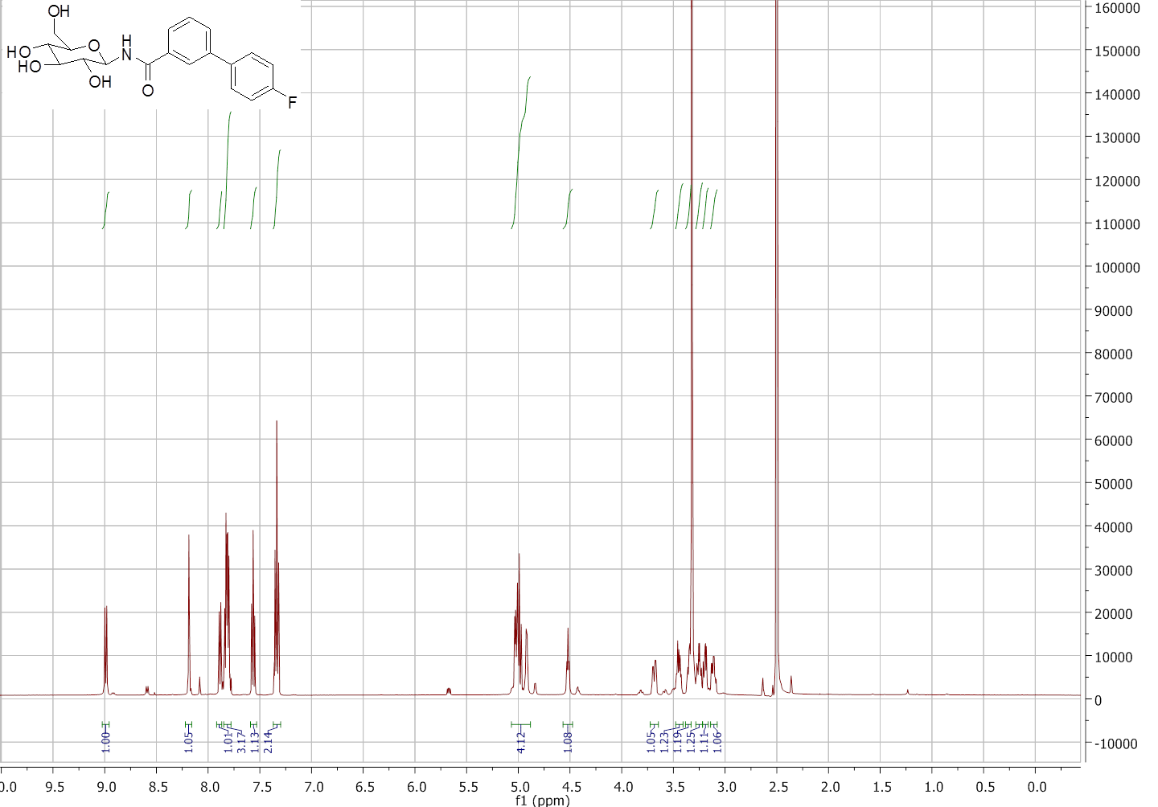

4'-fluoro-N-(3,4,5-trihydroxy-6-(hydroxymethyl)tetrahydro-2H-pyran-2-yl)biphenyl-3-carboxamide (3; ZHAWOC6072)
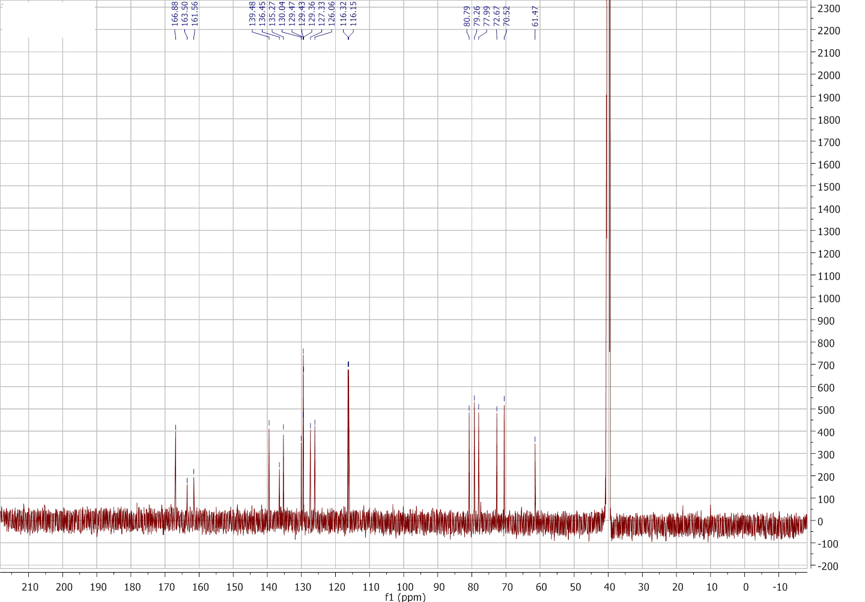
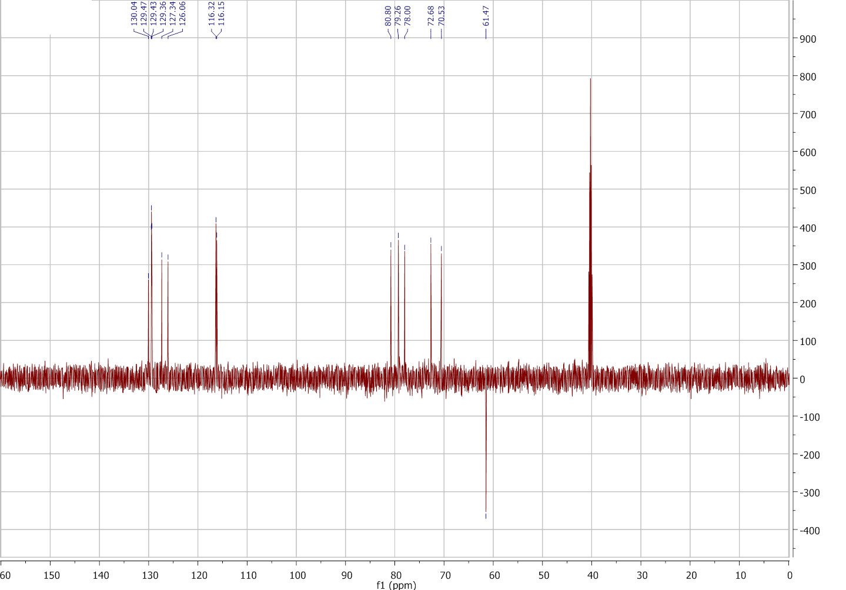
4'-fluoro-N-(3,4,5-trihydroxy-6-(hydroxymethyl)tetrahydro-2H-pyran-2-yl)biphenyl-3-carboxamide (3; ZHAWOC6072)
LC-MS
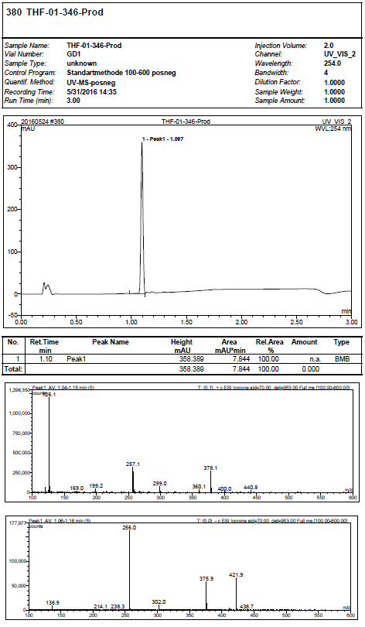

4'-fluoro-N-(3,4,5-trihydroxy-6-(hydroxymethyl)tetrahydro-2H-pyran-2-yl)biphenyl-3-carboxamide (3; ZHAWOC6072)
HPLC
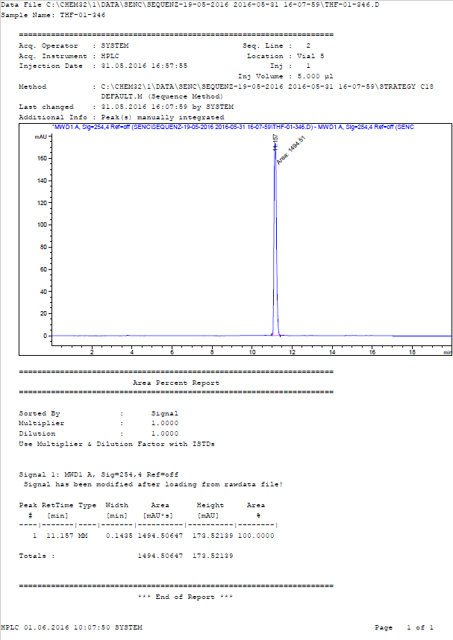
N-(3,4,5-trihydroxy-6-(hydroxymethyl)tetrahydro-2H-pyran-2-yl)biphenyl-4-carboxamide (4; ZHAWOC6077)
NMR
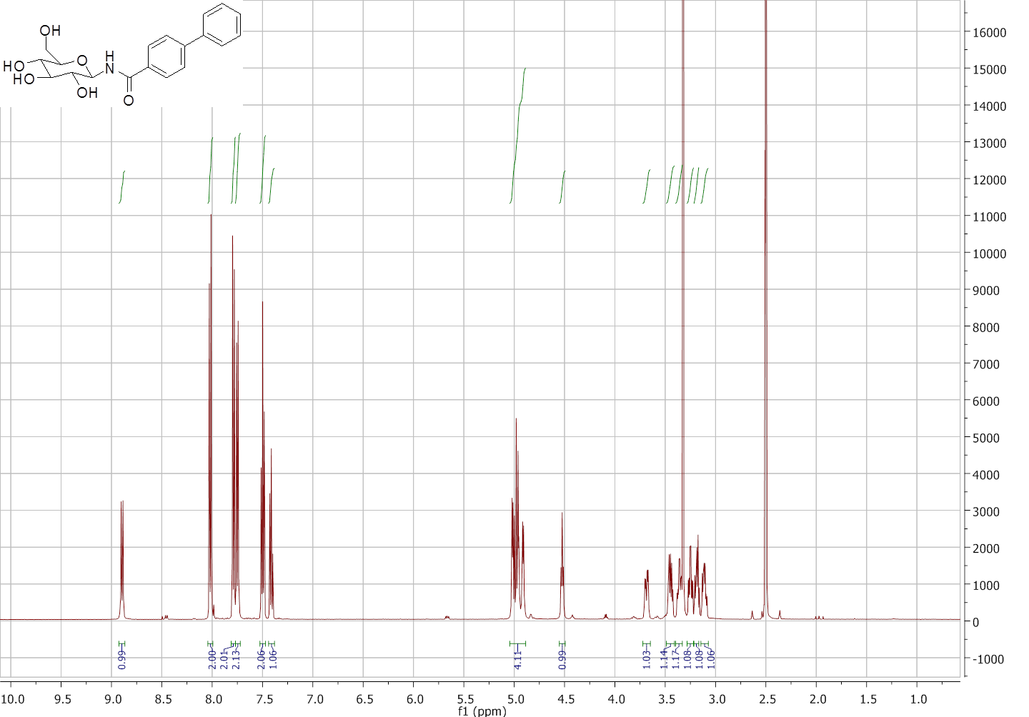

N-(3,4,5-trihydroxy-6-(hydroxymethyl)tetrahydro-2H-pyran-2-yl)biphenyl-4-carboxamide (4; ZHAWOC6077)
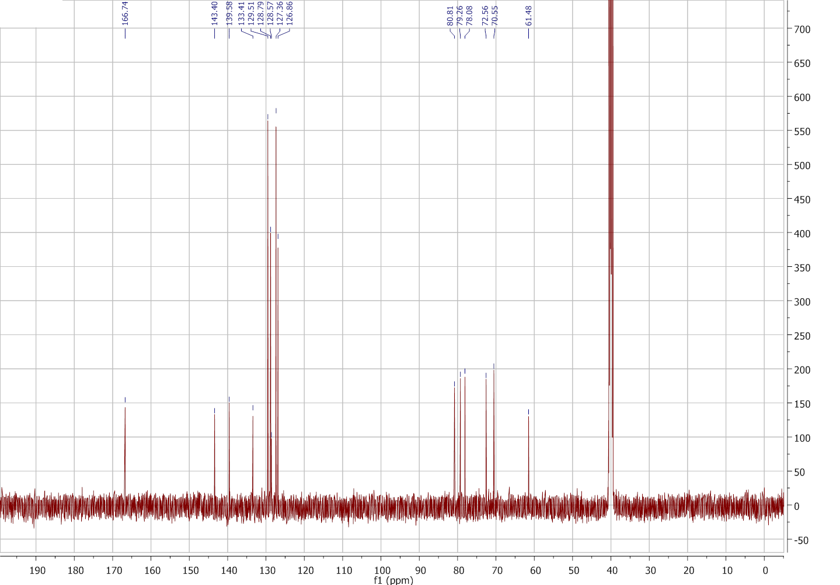
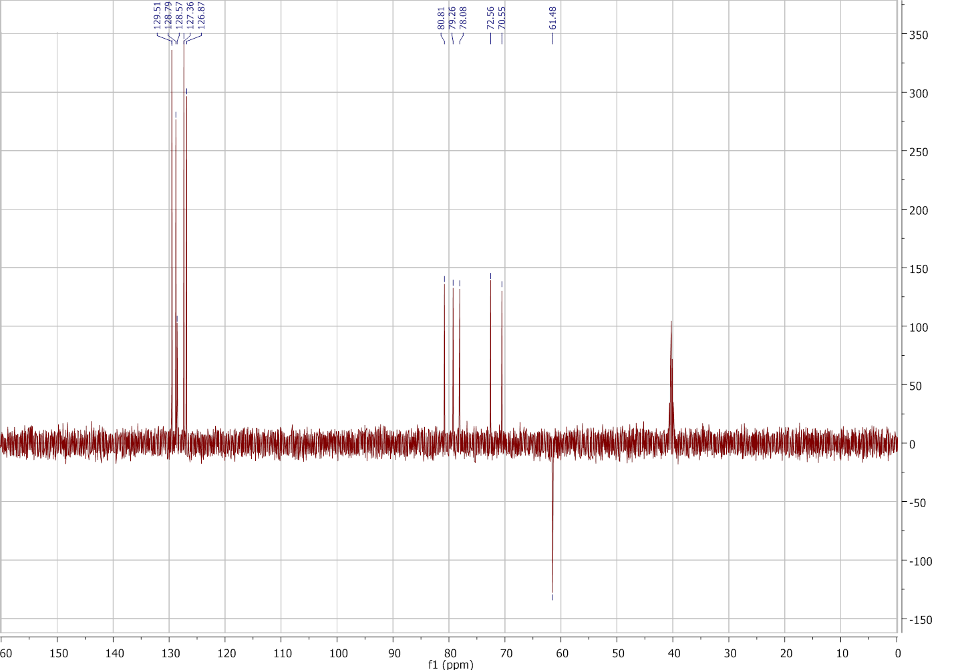

N-(3,4,5-trihydroxy-6-(hydroxymethyl)tetrahydro-2H-pyran-2-yl)biphenyl-4-carboxamide (4; ZHAWOC6077)
LC-MS
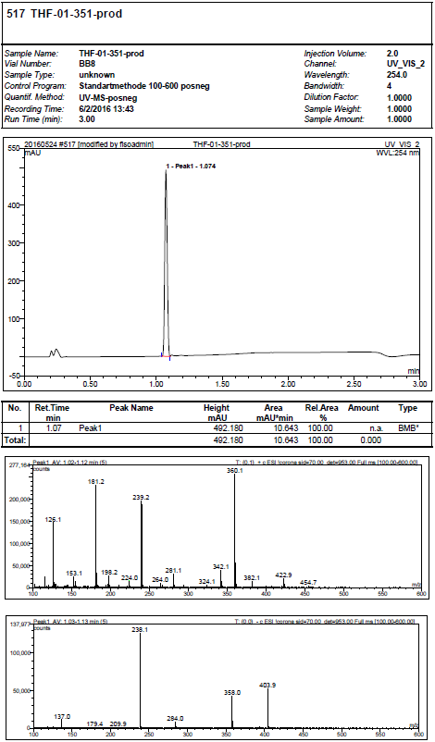

N-(3,4,5-trihydroxy-6-(hydroxymethyl)tetrahydro-2H-pyran-2-yl)biphenyl-4-carboxamide (4; ZHAWOC6077)
HPLC
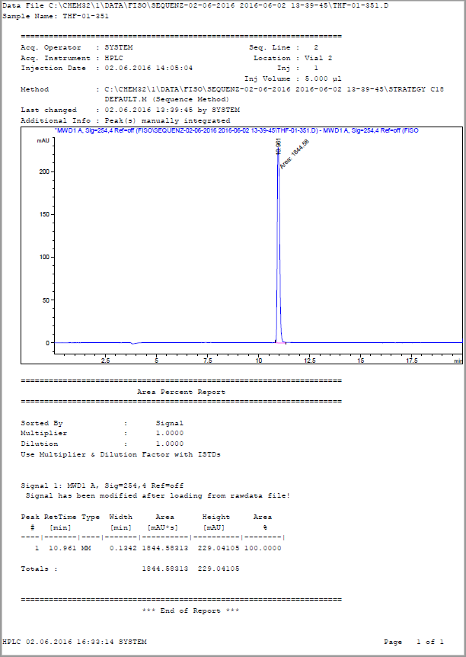
Kinetics
Figure S1. Competitive inhibition of hlGPa at 0.2% w/v glycogen, different Glc-1-P concentrations (2, 3, 4, 6 and 10 mM) and different inhibitor concentrations. The insert plot of the KM(app.) versus inhibitor concentration yields the Ki values. For 3 (left), concentrations used were 0.0 (), 10 (), 20 (), 30 (), and 50 () μM, for 4 (right), concentrations used were 0.0 (), 30 (), 40 (), 50 (), and 60 () μM.

X-ray crystallography
Table S1. Summary of the diffraction data processing and refinement statistics for the rmGPb complexes. Values in parentheses are for the outermost shell.
rmGPb complex | 3 | 4
Data collection and processing statistics
Resolution (Å) | 13.71 - 2.50 | 13.82 - 2.40
Outermost shell (Å) | 2.61 - 2.50 | 2.50 - 2.40
Reflections μeasured | 120373 | 130910
Unique reflections | 32589 (3644) | 36628 (3704)
Multiplicity | 3.7 (2.6) | 3.6 (2.6)
R_{symm} | 0.110 (0.754) | 0.068 (0.451)
Completeness (%) | 96.1 (89.7) | 90.2 (87.0)
<I/σI> | 10.3 (1.6) | 12.2 (2.0)
CC^{1/2} | 0.977 (0.563) | 0.988 (0.772)
Refinement statistics
R_{cryst} | 0.163 (0.262) | 0.147 (0.224)
R_{free} | 0.212 (0.311) | 0.196 (0.268)
No of solvent molecules | 214 | 241
r.m.s. deviation from ideality in
bonds (Å) | 0.010 | 0.008
angles (°) | 1.4 | 1.3
Average B factor (Å²)
Protein atoms | 19.2 | 19.5
Solvent molecules | 25.2 | 26.1
Inhibitor atoms | 30.0 | 22.9
PDB entry | 6R0H | 6R0I

Table S2: Potential hydrogen bond interactions of inhibitors with rmGPb residues at the catalytic site in the crystal.
Inhibitor  atom |  | Distances (Å)
 | Protein Residues (atoms) | 3 | 4
O2' | Asn284 (ND2) | 3.3 | 3.3
 | Tyr573 (OH) | 3.0 | 3.1
 | Glu672 (OE2) | 3.0 | 3.2
 | Water170 (O) | 2.9 | 2.8
O3' | Glu672 (OE2) | 2.8 | 2.8
 | Ala673 (N) | 3.2 | 3.3
 | Ser674 (N) | 2.9 | 3.1
 | Gly675 (N) | 3.0 | 3.1
O4' | Gly675 (N) | 2.8 | 2.8
 | Water96 (O) | 2.6 | 2.7
O6' | His377 (ND1) | 2.7 | 2.6
 | Asn484 (ND2) | 2.7 | 2.7
O2 | Leu136 (N) | - | 3.0
 | Water193 (O) | 2.8 | 3.2
N1 | Asn284 (ND2) | 3.2 | -
 | His377 (O) | 3.2 | -
F1 | Asn282 (ND2) | 3.2 | -
Total |  | 16 | 14

Table S3. van der Waals interactions of the inhibitors at the rmGPb active site
Inhibitor atoms | 3 | 4
 | Protein residues (atoms)
C2' | His377 (O)
C3' | Glu672 (OE2) | Glu672 (OE1)
O3' | Glu672 (CG, CD)
C4' |  | Gly675 (N)
O4' | Ser674 (CB), Gly675 (CA, C) | Ser674 (CB), Gly675 (CA, C)
C5' | Gly135 (CA, C) | Gly135 (CA, C), Leu136 (N)
C6' | Gly135 (C), His377 (ND1, CE1,) His484 (ND2) | Gly135 (C), Leu136 (CA), Leu139 CD2), His377 (ND1, CE1), His484 (ND2)
O6' | His377 (CE1) | His377 (CE1)
C2 | Leu136 (CB), Asn284 (ND2) | Leu136 (CB)
O2 | Leu136 (CB) | Leu136 (CB)
C3 | Leu136 (CD1), Asn284 (CG, ND2) | Leu136 (CB, CD1)
C4 | His377 (CB), Thr378 (CG2) | Leu136 (CD1)
C5 | Asp339 (CG), Thr378 (CG2) | His341 (CE1)
C6 | His341 (CE1, NE2) | His341 CE1)
C7 | His341 (CE1) | Asn282 (O), Asp283 (CA), Asn284 (N)
C9 | His341 (CE1) | His341 (CE1, NE2)
C10 | His341 (CE1) | Ala383 (O)
C11 | Asn282 (ND2, O), Phe285 (O) | Phe285 (C, O), Phe286 (CA) Ala383 (O)
C12 | Asn282 (C, O, ND2), Arg292 (NH2) | Phe285 (C, O) Phe286 (CA)
C13 | Glu88 (OE2), Asn133 (ND2) | Arh292 (NH2), His341 (CE1, NE2)
C14 | Glu88 (OE2), His341 (CE1) | His341 (CE1, NE2)
Total | 40 | 40

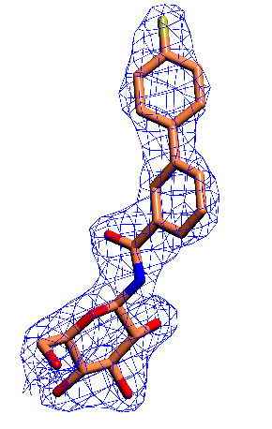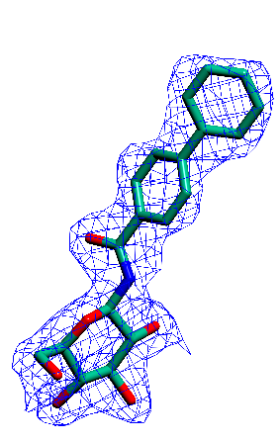
Figure S2. The REFMAC weighted 2Fo-Fc electron density maps of the bound ligands (3 and 4) at the catalytic site. Maps are contoured at 1.0 σ before the incorporation of the ligand molecules in the refinement process and the final models of the inhibitors are shown.

