Supplementary Materials
Spatially resolved soil solution chemistry in a central European atmospherically polluted high-elevation catchment
Daniel A. Petrash¹, Frantisek Buzek¹, Martin Novak¹, Bohuslava Cejkova¹, Pavel Kram¹, Tomas Chuman¹, Jan Curik¹, Frantisek Veselovsky², Marketa Stepanova¹, Oldrich Myska¹, Pavla Holeckova¹, Leona Bohdalkova¹

Supplementary Materials:
Figure S1 Descriptive statistics (2012- 2013) for soil water concentration values of dissolved organic carbon, sulfate, nitrate, base cations, Al and chloride (in mg L⁻¹) and pH values at the 50-cm depth at UDL.
Figure S2: Non-parametric multidimensional scaling ordination of time-series hydrochemical data for runoff, atmospheric in lysimeters.
Figure S3: Comparison of monthly precipitation volumes at UDL during the monitoring period (2012-2013) vs. the hydrologic years 2016-2017.
Table S1: Coefficient of variation (Cv = 100σ/μ ) of inorganic species across our lysimeter network.

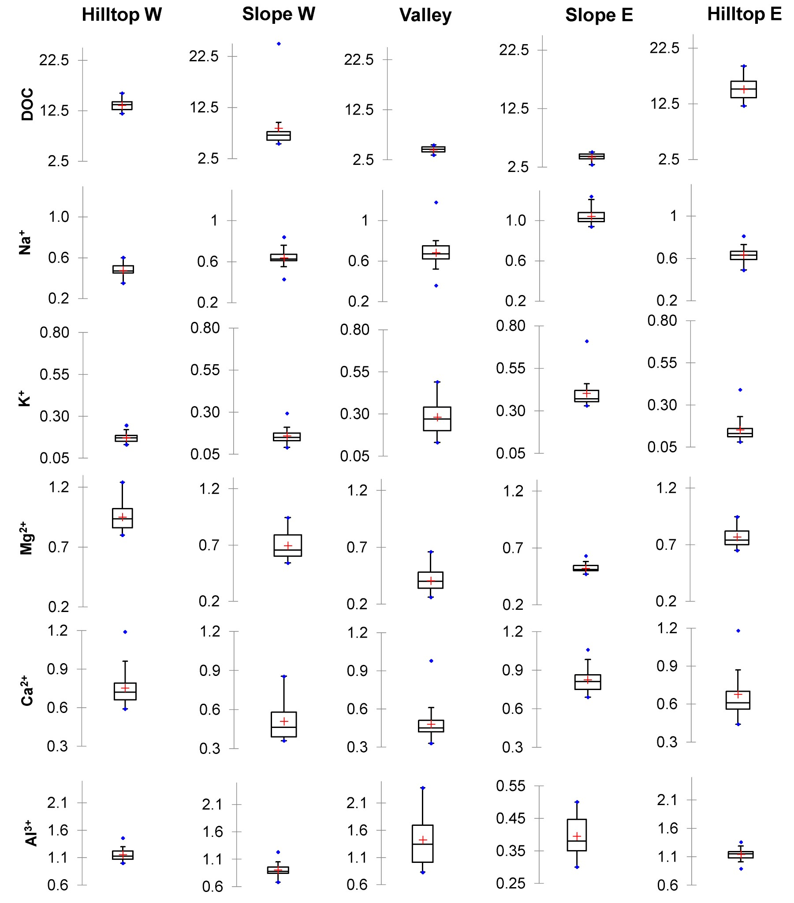
Supplementary Material. Figure S1. Descriptive statistics (2012- 2013) for soil water concentration values of dissolved organic carbon, sulfate, nitrate, base cations, Al and chloride (in mg L-1) and pH values at the 50-cm depth at UDL. The statistical distribution shows minimum, first quartile, median, third quartile and maximum for individual samples

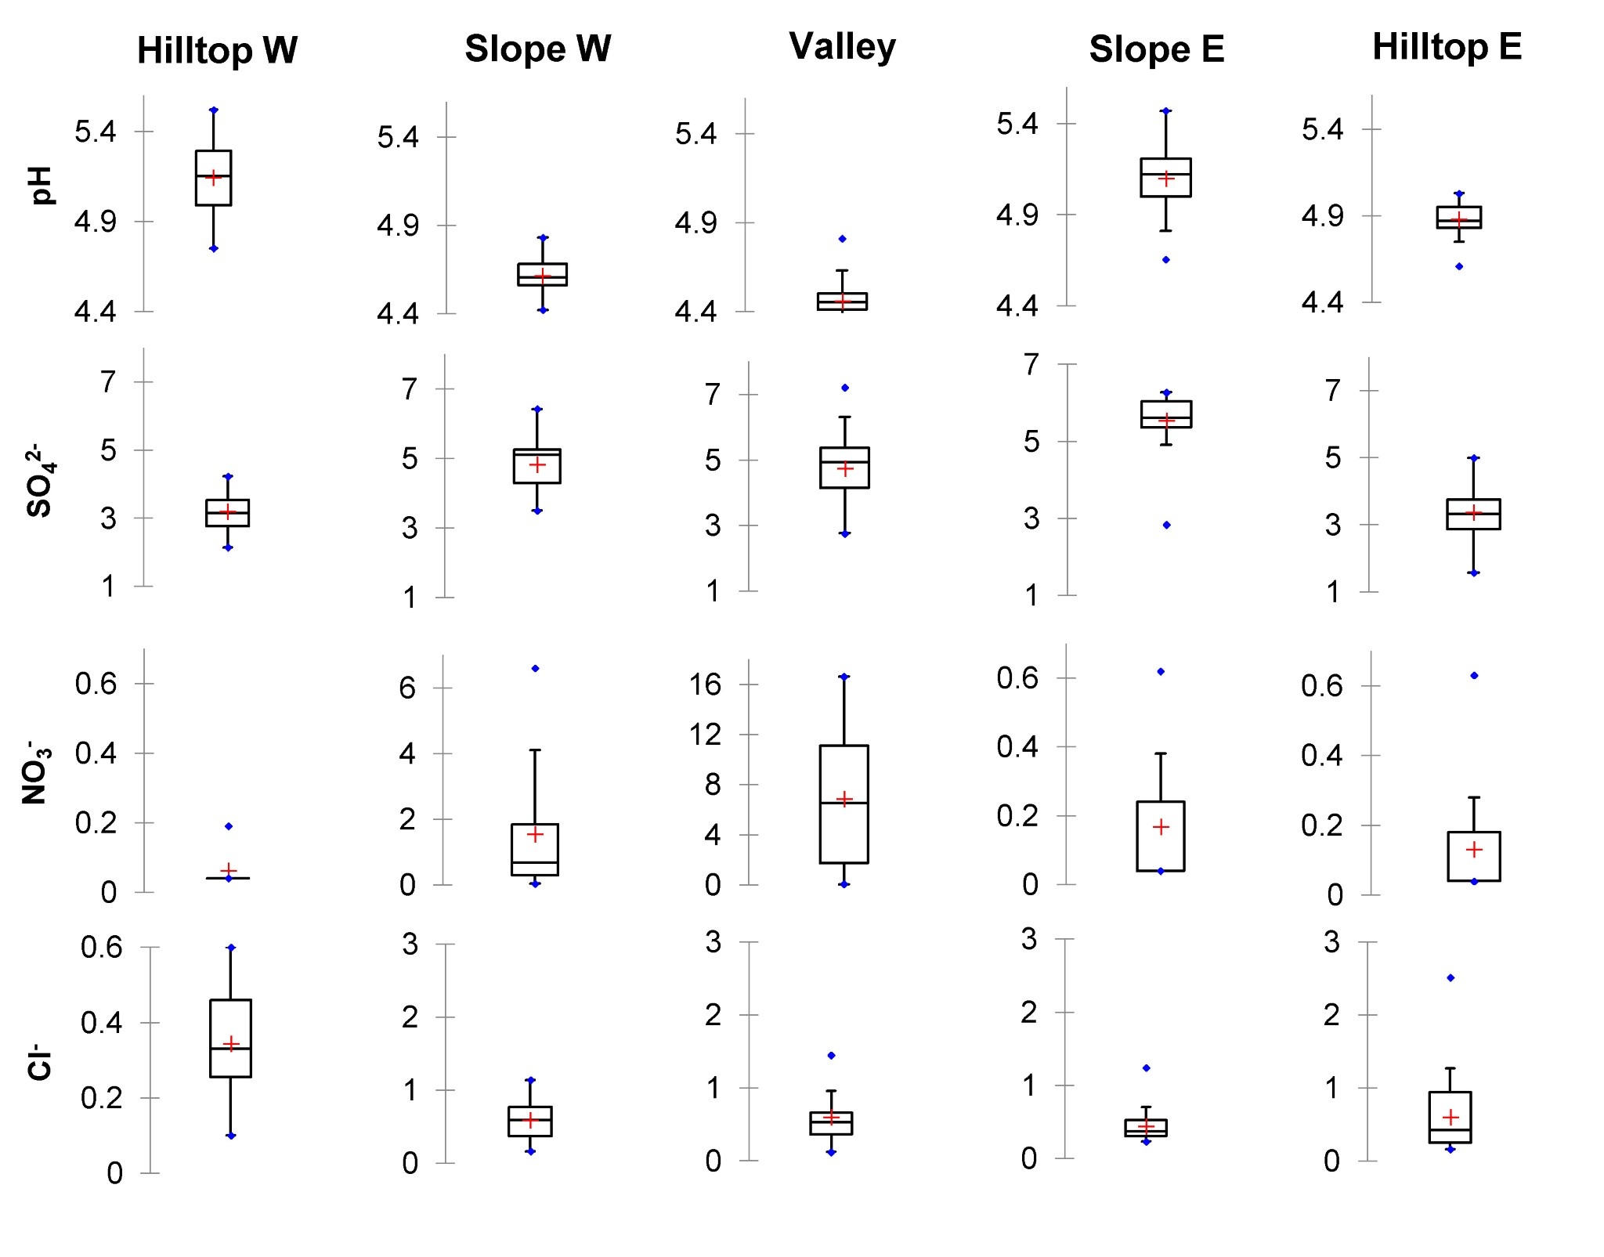
Supplementary Material. Figure S1. cont.

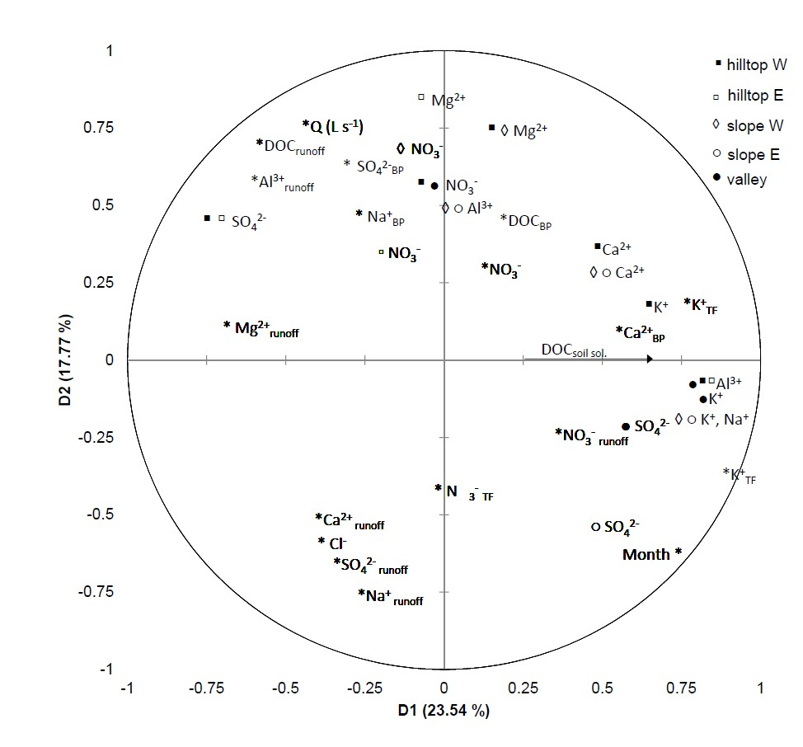
Supplementary Material. Figure S2. Non-parametric multidimensional scaling ordination of time-series hydrochemical data for runoff, atmospheric in lysimeters. Note that only varimax rotated parameters exhibiting statistical significance > 0.25 are shown. The variables describe 41.3 % of the co-variation

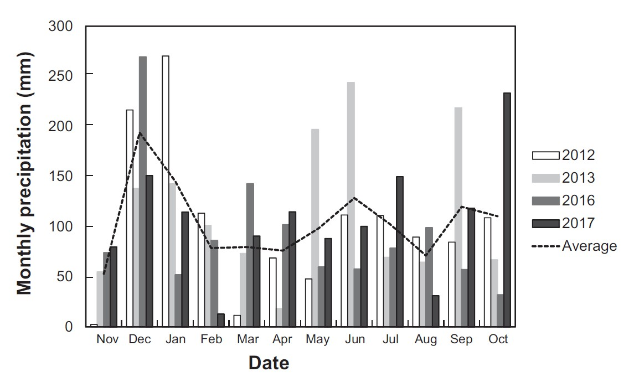
Supplementary Material. Figure S3. Comparison of monthly precipitation volumes at UDL during the monitoring period (2012-2013) vs. the hydrologic years 2016-2017.

Supplementary Material. Table S1. Coefficient of variation (%) of inorganic species across our lyzimeter network.
Analyte | Hilltops | Slopes | Valley
SO4^{2‐} | 17 | 17 | 15
NO3‐ | 2 | 15 | 17
Al³⁺ | 8 | 10 | 12
Na⁺ | 9 | 10 | 11
K⁺ | 55 | 40 | 33
Mg²⁺ | 12 | 21 | 15
Ca²⁺ | 7 | 17 | 6
Calculation is based on six triplicates for hilltop and slopes and three triplicates for the valley location. The triplicates were obtained each fourth month.

