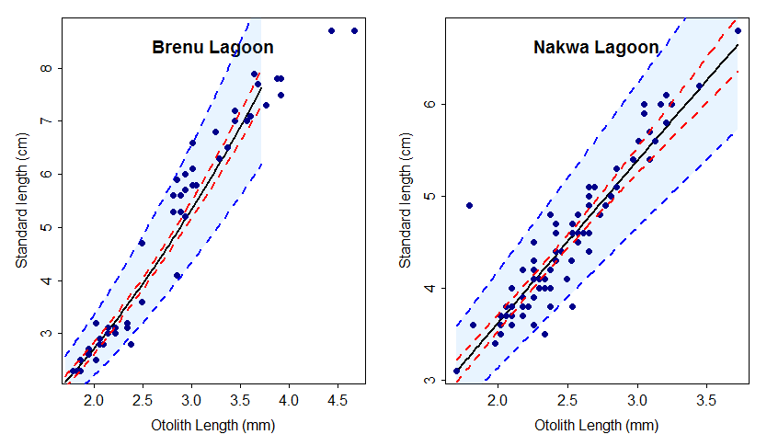

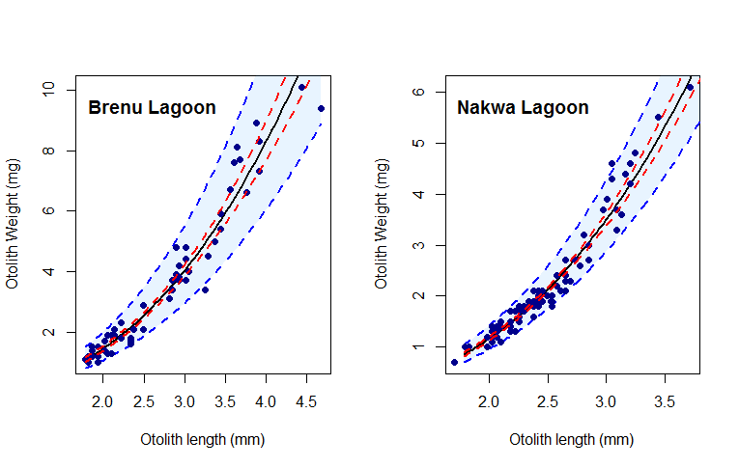

Appendix 1. Relation of (a) otolith length and standard length (b) otolith length and otolith weight of Sarotherodon melanotheron from both Nakwa and Brenu lagoons.

