The Assessment of Different Component Analyses in Determining the Post-glacial Land Uplift Rate by GRACE data: A Case Study in Fennoscandia and

Laurentia

Mehdi S. Shafiei Joud1

Lars E. Sjöberg12

Mohammad Bagherbandi12

1Division of Geodesy and Satellite Positioning, Royal Institute of Technology (KTH), SE-10044

Stockholm, Sweden.

2Department of Industrial Development, IT and Land Management University of Gävle, Gävle, Sweden

Supplementary martial for:

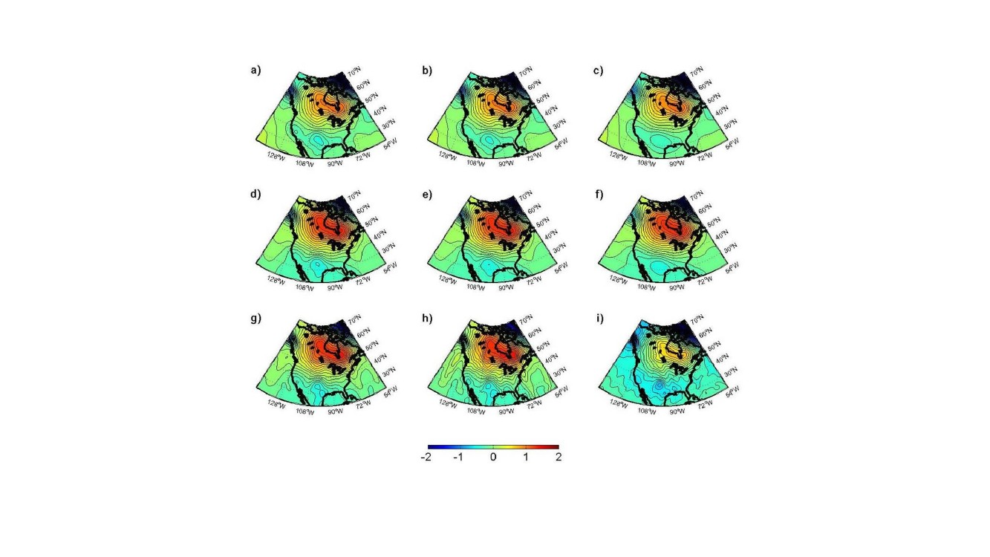Post-glacial Land uplift rate determined by GRACE data; M.S.S.

Joud, L.E. Sjöberg, M. Bagherbandi

2



Fig. S1: The gravimetric geoid rate models using CSR (top), GFZ (middle), and CNES (bottom) data and three extracting methods, ICA (a,d,g), PCA (b,e,h), and RA (c,f,i), for North America. Units: mm/a

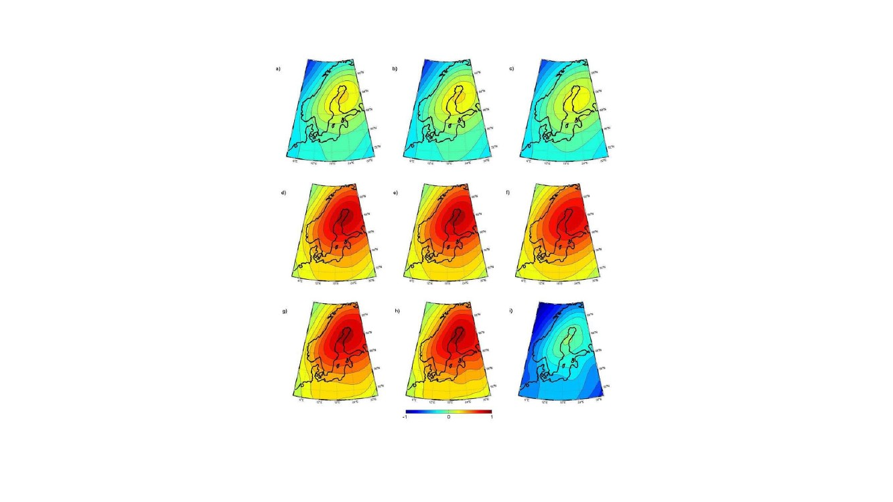Post-glacial Land uplift rate determined by GRACE data; M.S.S.

Joud, L.E. Sjöberg, M. Bagherbandi

3



Fig. S2: The gravimetric geoid rate models using CSR (top), GFZ (middle), and CNES (bottom) data and three extracting methods, ICA (a,d,g), PCA (b,e,h), and RA (c,f,i), for Fennoscandia. Units: mm/a

.

Post-glacial Land uplift rate determined by GRACE data; M.S.S.

Joud, L.E. Sjöberg, M. Bagherbandi

4

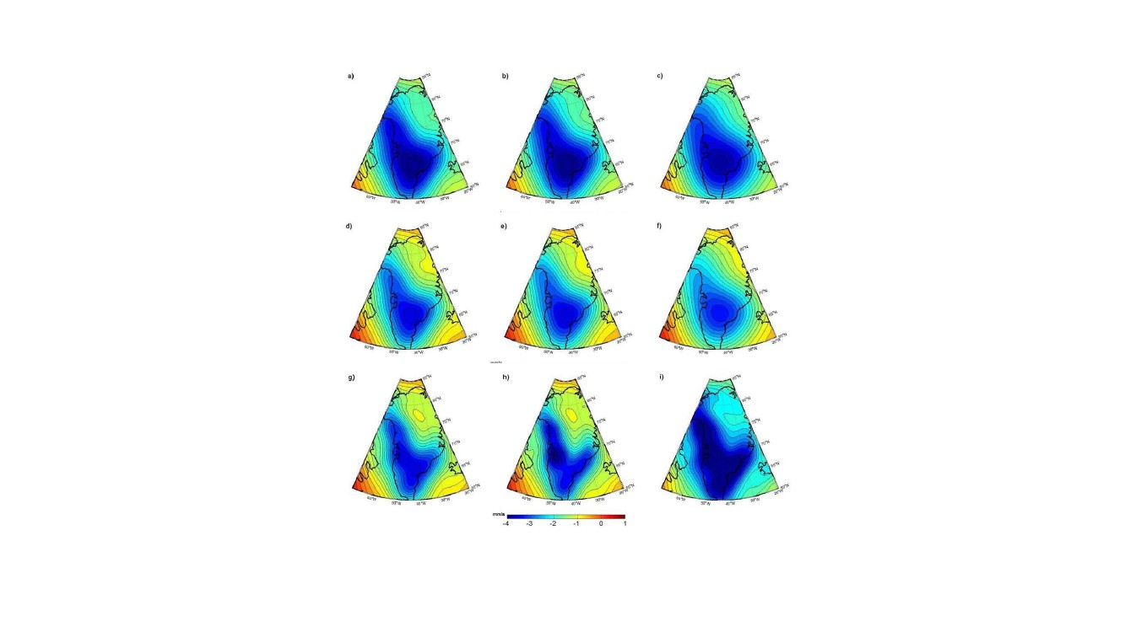

Fig. S3: The gravimetric geoid rate models using CSR (top), GFZ (middle), and CNES (bottom) data and three extracting methods, ICA (a,d,g), PCA (b,e,h), and RA (c,f,i), for Greenland. Units: mm/a

5

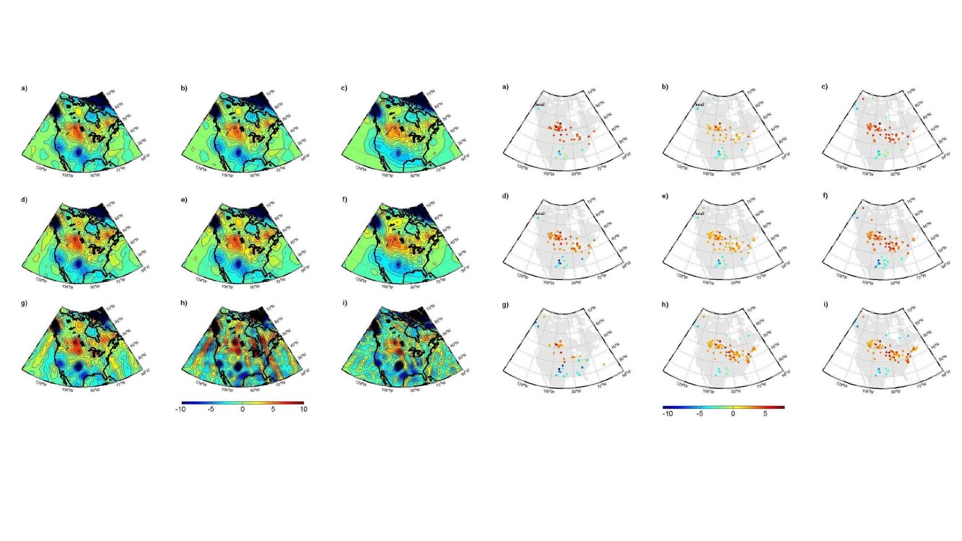

Fig. S4: The difference between the land uplift rate from CSR (top), GFZ (middle), and CNES (bottom) data , using three extracting methods, ICA (a,d,g), PCA (b,e,h), and RA (c,f,i), with that from the gridded GPS data, for North America. Units: $mm/a$ mm/a

Fig. S5: The T-values, i.e. the differences (vs. GPS data) over their SDs of the rejected differences difference between the land uplift rate from CSR (top), GFZ (middle), and CNES (bottom) data , using three extracting methods, ICA (a,d,g), PCA (b,e,h), and RA (c,f,i), with that from the gridded GPS data, for North America. Units: $mm/a$ mm/a

6

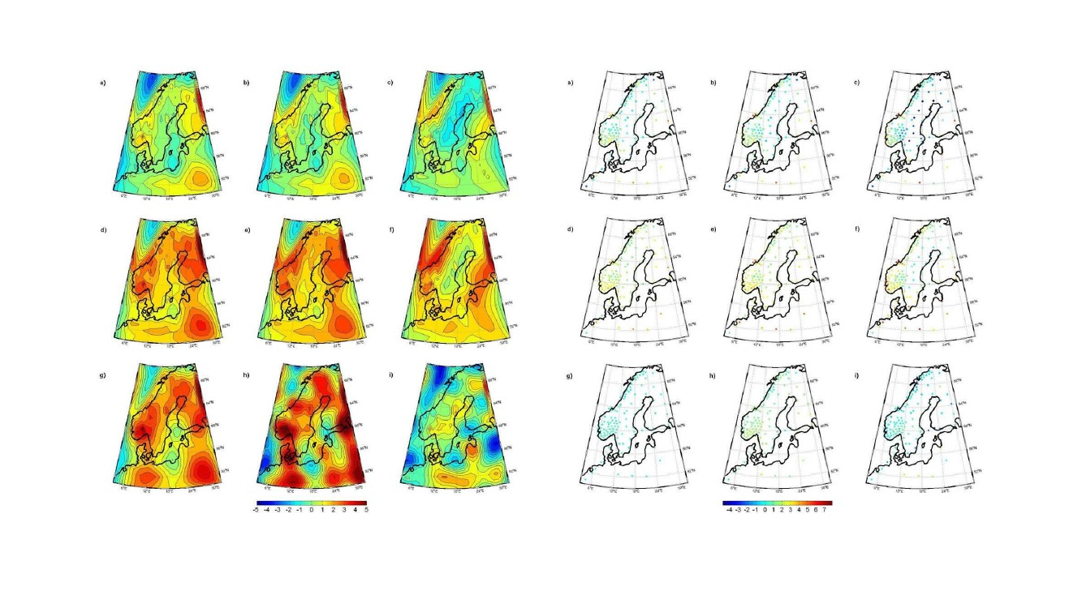

Fig. S7: The T-values, i.e. the differences (vs. GPS data) over their SDs of the difference between the land uplift rate from CSR (top), GFZ (middle), and CNES (bottom) data , using three extracting methods, ICA (a,d,g), PCA (b,e,h), and RA (c,f,i), with that from the gridded GPS data, for North America. Units: $mm/a$ mm/a

Fig. S6: The difference between the land uplift rate from CSR (top), GFZ (middle), and CNES (bottom) data , using three extracting methods, ICA (a,d,g), PCA (b,e,h), and RA (c,f,i), with that from the gridded GPS data, for Fennoscandia. Units: $mm/a$ mm/a

.

Post-glacial Land uplift rate determined by GRACE data; M.S.S.

Joud, L.E. Sjöberg, M. Bagherbandi

7

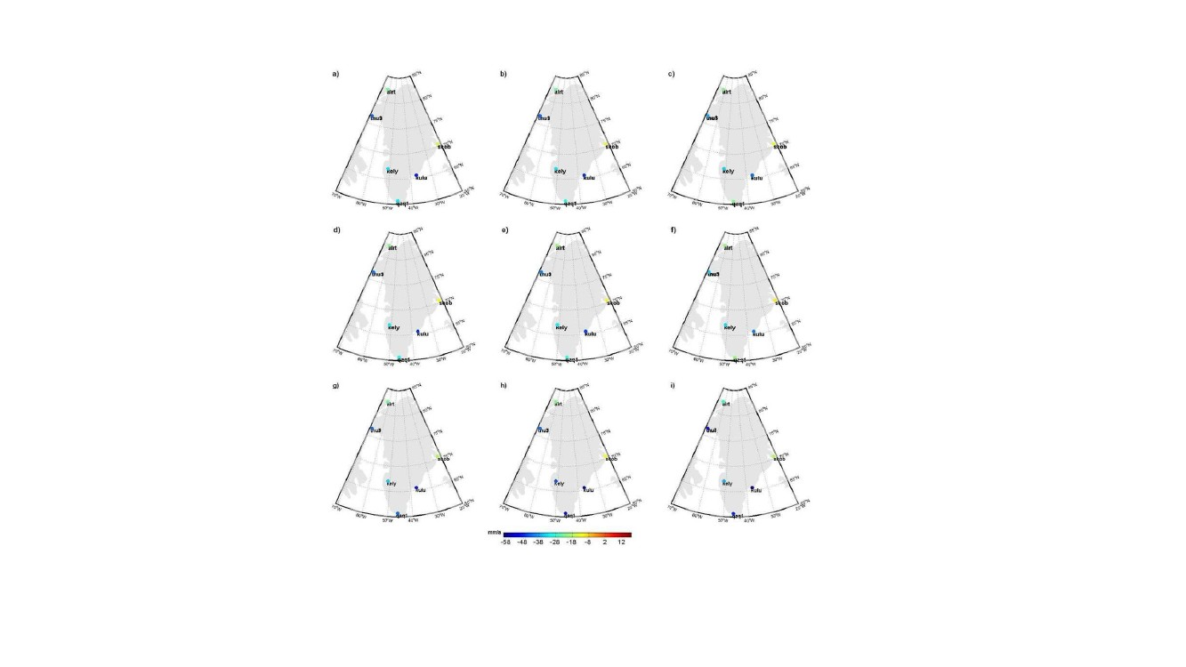

Fig. S8: The land uplift rate of the gravimetric models using CSR (top), GFZ (middle), and CNES (bottom) data and three extracting methods,

ICA (a,d,g), PCA (b,e,h), and RA (c,f,i), minus the GPS data, for Greenland. Units: : $mm/a$ mm/a

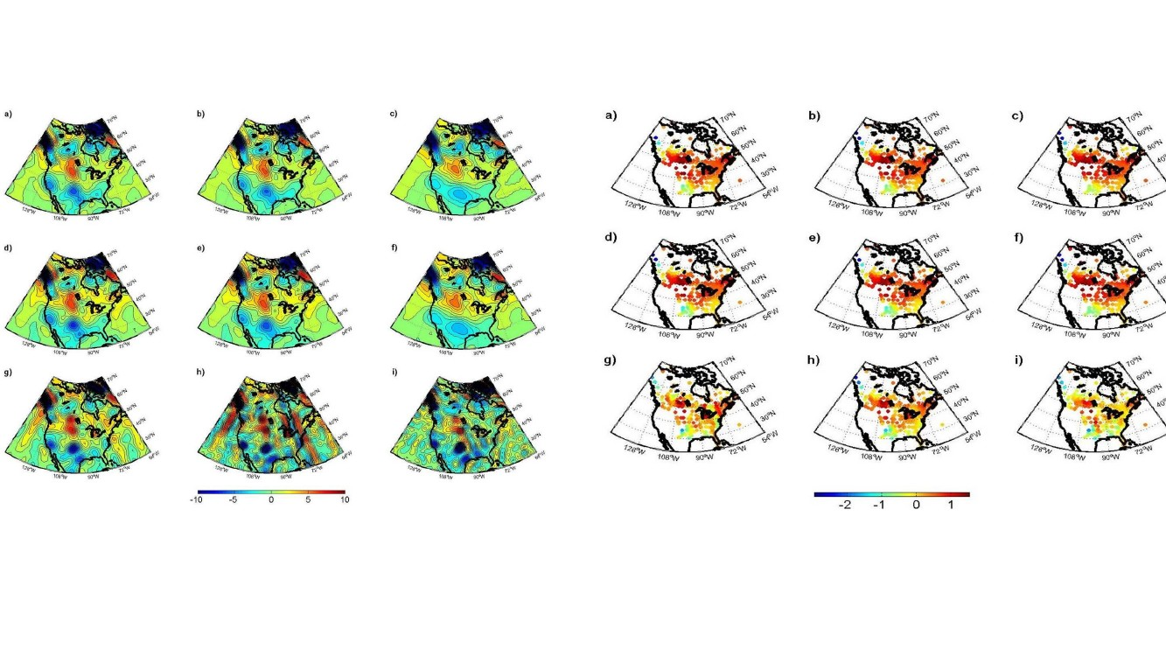8



Fig. S10: The T-values, i.e. the differences (vs. GPS data) over their SDs of the difference between the land uplift rate from CSR (top), GFZ (middle), and CNES (bottom) data , using three extracting methods, ICA (a,d,g), PCA (b,e,h), and RA (c,f,i), with that from the GIA forward model, for North America. Units: $mm/a$ mm/a

Fig. S9: The difference between the land uplift rate from CSR (top), GFZ (middle), and CNES (bottom) data , using three extracting methods, ICA (a,d,g), PCA (b,e,h), and RA (c,f,i), with that from the GIA forward model, for North America. Units: $mm/a$ mm/a

Post-glacial Land uplift rate determined by GRACE data; M.S.S.

Joud, L.E. Sjöberg, M. Bagherbandi

9

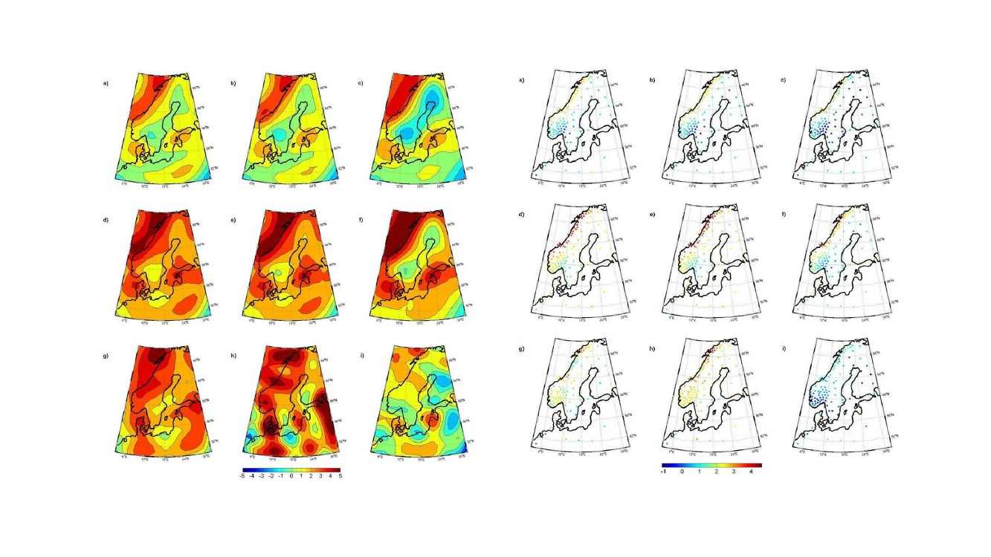

Fig. S12: The T-values, i.e. the differences (vs. GPS data) over their SDs of the difference between the land uplift rate from CSR (top), GFZ (middle), and CNES (bottom) data , using three extracting methods, ICA (a,d,g), PCA (b,e,h), and RA (c,f,i), with that from the GIA forward model, for Fennoscandia. Units: $mm/a$ mm/a

Fig. S11: The difference between the land uplift rate from CSR (top), GFZ (middle), and CNES (bottom) data, using three extracting methods, ICA (a,d,g), PCA (b,e,h), and RA (c,f,i), with that from the GIA forward model, for Fennoscandia. Units: $mm/a$ mm/a

.

10

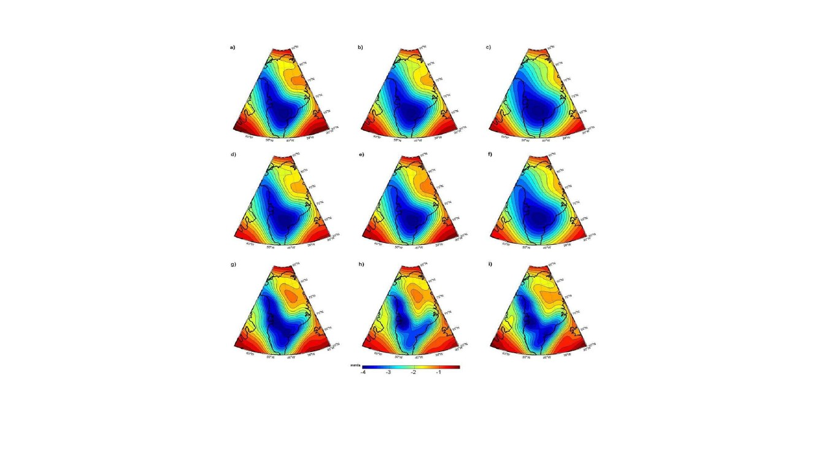

Fig. S13: The difference between the geoid rate from the CSR (top), GFZ (middle), and CNES (bottom) data, using three extracting methods, ICA (a,d,g), PCA (b,e,h), and RA (c,f,i) ), with that from the GIA forward model, for Greenland. Units: $mm/a$

.

a)

b)

Post-glacial Land uplift rate determined by GRACE data; M.S.S.

Joud, L.E. Sjöberg, M. Bagherbandi

11

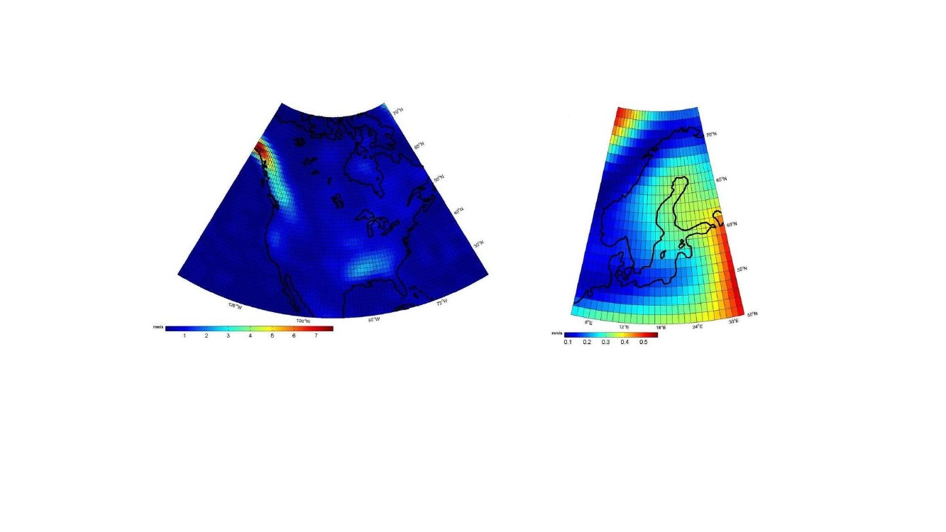

Fig. S14: The standard errors of the determination of the gravimetric land uplift rates for a) North America and b) Fennoscandia, at each $1^{o}×1^{o}$ pixel



and Fennoscandia.

Table S1: Statistics of the gravimetric models, Laurentia, Units: mm/a

Corrections

GFZ

Data Analysis Centres

CSR

CNES

Mean Geopotential and

secular change

EIGEN-6C, NMAX=200

IERS-2010, NMAX=360

EIGEN-GRGS v2,

IERS-2010

Frequency

independent

terms

Solid

Earth

Tides

Frequency

dependent

terms

Permanent

tide in

Tidal

arguments

Diurnal and

semidiurnal

Ocean

Tides

Long period

IERS-2010 Eqs. 6.3, 6.5,

6.7

Degree 2 corrections, 21,

8,

and 2 tide parameters of

long,

diurnal and semi-diurnal

4.1736E-09

Doodson (1921),

Schwiderski (1983)

Degree 2 and 3 Eq. 6.6,

Ellipticity Degree 2 to 4

tides

Eqs. 6.7, IERS-2010 of

Elastic Earth,

Degree 2 corrections,

Table 6.5, IERS 2010

IERS-2010 6.3, 6.5, 6.7

Degree 2 corrections, 21, 8,

and 2 tide parameters of long,

diurnal and semi-diurnal

4.1736E-09

4.173E-09

Doodson (1921),

Catwright & Taylor (1971)

(Ray 2012), GOT4.8

EOT 11a (Svacenko &

Bosch 2011)

FES2012 (LEGOS)

FES 2004 (Lefevre et al.

2005)

3rd body

5 planets point masses and

Moon and its J2 indirect

effect

Eq. 6.24IERS 2010

routine from IERS website

based on Eans (2000),

ORTHO EOP.F

AOD1B (Flechtner et al.

2015)

5 planets point masses and

Moon and its J2 indirect

effect

Eq. 6.24, IERS 2010

routine from IERS website

based on Eans (2000),

ORTHO EOP.F

AOD1B (Flechtner et al.

2015)

5 planets point masses and

Moon and its J2 indirect effect

Pole tides

Polar motion

Eq. 6.24IERS 2010

routine from IERS website

based on Eans (2000), ORTHO

EOP.F

ECMWF ERA-interim (every

3 hr)

oceanic de-aliasing fields

TUGO (every 3 hr)

Atmospheric and Oceanic

non-tidal

Post-glacial Land uplift rate determined by GRACE data; M.S.S.

Joud, L.E. Sjöberg, M. Bagherbandi

13

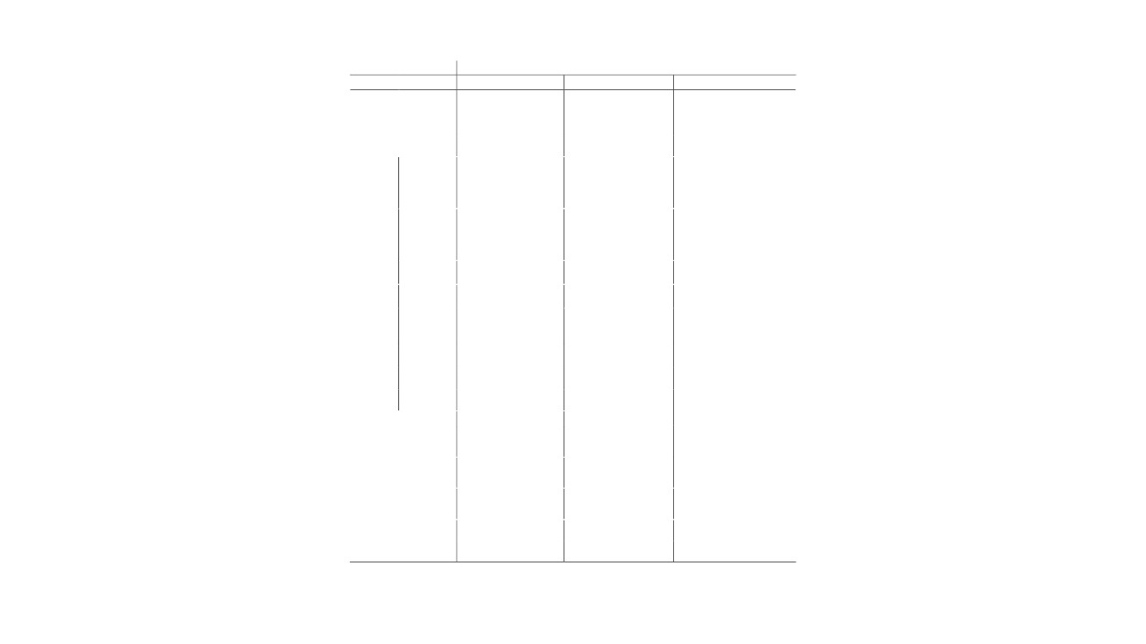

Table S2: The corrections used in GRACE level-2 data product of the German Research Centre for Geosciences (GFZ, Dahle et al. 2012), University of Texas at Austin, Center for Space Research (CSR, Bettadpur 2012), and Centre National d’Etudes Spatiales (CNES, http://grgs.obs-mip.fr/grace), Toulouse. IERS 2010: International Earth Rotation and Reference System Service conventions (Petit and Luzum 2010).