Article
Entropy Generation Optimization for Rarified Nanofluid Flows in a Square Cavity with Two Fins at the Hot Wall
Wael Al-Kouz ^{1,}*, Ahmad Al-Muhtady ², Wahib Owhaib ², Sameer Al-Dahidi ², Montasir Hader ³ and Rama Abu-Alghanam ⁴
¹ Mechatronics Engineering Department, German Jordanian University, Amman, 11180, Jordan; wael.alkouz@gju.edu.jo (W. A.); rama.abualghanam@gju.edu.jo (R. A.)
² Mechanical and Maintenance Engineering Department, German Jordanian University, Amman, 11180, Jordan; ahmad.almuhtady@gju.edu.jo (A. A.); Wahib.Owhaib@gju.edu.jo (W. O.); Sameer.Aldahidi@gju.edu.jo (S. A.)
³ Aeronautical Engineering Department, Jordan University of Science and Technology, Irbid, 22110, Jordan; hader@just.edu.jo (M.H.)
⁴ Energy Engineering Department, German Jordanian University, Amman, 11180, Jordan; rama.abualghanam@gmail.com (R. A.)

* Correspondence: wael.alkouz@gju.edu.jo; Tel.: +962-6429-4444 (ext. 4519)
Received: date; Accepted: date; Published: date
Abstract: Computational Fluid Dynamics (CFD) is utilized to study entropy generation for the rarefied steady state laminar 2-D flow of air-Al₂O₃ nanofluid in square cavity equipped with two solid fins at the hot wall. Such flows are of great importance in industrial applications, such cooling of the electronic equipment’s and nuclear reactors. In the current study, effects of Knudsen number (Kn), Rayleigh number (Ra) and the nano solid particles volume fraction ($ϕ$) on the entropy generation are investigated. The values of parameters considered in this work are as follows:$0≤Kn≤0.1$,${10}^{3}≤Ra≤{10}^{6}, 0≤ϕ≤0.2$. Length of the fins (L_{F}) is considered to be fixed and equals to 0.5 m, whereas the location of the fins with respect to the lower wall (H_{F}) is set to 0.25 and 0.75 m. Simulations demonstrate that there is an inverse direct effect of Kn on the entropy generation. Moreover, it is found that when Ra is less than 10⁴, the entropy generation, due to the flow, increases as $ϕ$ increases. In addition, the entropy generation due to the flow will decrease at Ra greater than 10⁴ as $ϕ$ increases. Moreover, the entropy generation due to heat will increase as both the $ϕ$ and Ra increase. In addition, a correlation model of the total entropy generation as a function of all of the investigated parameters in this study is proposed. Finally, an optimization technique is adapted to find out the conditions at which the total entropy generation is minimized.
Keywords: natural convection; entropy generation; square cavity; low pressure; nanofluid.

1. Introduction
Cai et al. [1] reported that in recent years, unconventional reservoirs have drawn tremendous attention worldwide; they have discussed a series of recent works on various fractal-based approaches in such reservoirs. They covered many topics including fractal characterization of pore structure and its influence on the physical properties and fluid flow in fracture network under shearing, porous flow phenomena and gas adsorption mechanism. One of the basic problems that is investigated deeply in the last few decades is the natural convection mode of heat transfer that serves in a number of engineering applications, for example solar collectors [2-3], fuel cell industry [4], petroleum engineering [5-6], and cooling of electronic components [7-8], etc. However, the unsatisfying heat-transfer rate due to the natural convection
is a significant issue for the application. As a result, dispersion of nano solid particles into a base fluid has been developed as a widely-used method to address such an issue. By dispersing nano solid particles into the base fluid, the resulting nanofluid will have superior thermal properties compared to the base fluid. For instance, Choi et al. [9] introduced “nanofluids” used in many industrial applications. In the work conducted by Khanafer et al. [10], numerical solution of natural convection heat transfer in two-dimensional enclosure where nanofluid is used as the working fluid is analyzed. They concluded that there is a direct proportional relationship between the heat transfer rate and the $ϕ$ at a given Grashof number. Moreover, Khanafer et.al [11] studied the validity of nanofluids effective viscosity and thermal conductivity models along with experimental results available in the literature and their features in enhancement of heat transfer. Buongiorno [12] discussed and provided explanation to the convective heat transfer enhancement associated with using nanofluid. He proposed a new model for transport phenomena in nanofluids based on two-component nonhomogeneous equilibrium model. In Oztop et al. [13], CFD analysis is used to solve a mathematical model for fluid flow and heat transfer due to buoyancy effect in a partially heated cavity filled with nanofluid. They noticed that at a given Ra, there is an enhancement in heat transfer as ϕ increases. In addition, Ghasemi et al. [14] numerically studied the natural convection of water/Al₂O₃ nanofluid in square cavity under a magnetic field. They found that for any ϕ, heat transfer rate is strongly dependent on Ra; it may enhance or deteriorate. Also, Kefayati et al. [15] simulated the heat transfer and flow of free convection in cavities filled with water/SiO₂ using lattice Boltzmann method. They concluded that there is a direct relationship between the heat transfer rate and ϕ for the studied aspect ratios and Ra. Additionally, Kefayati [16] analyzed entropy generation and heat transfer of laminar free convection flow in porous square cavity filled with non-Newtonian nanofluid Cu/water using finite difference lattice Boltzmann method. He found that the heat transfer rate is enhanced and entropy generation is dropped when both ϕ and Ra are increased. Al-Kouz et al. [17] numerically investigated free convection heat transfer characteristics of rarefied flows in an inclined square enclosure equipped with two solid or porous fins at the hot wall. They found that with equipped fins to the hot wall, the heat transfer rate is enhanced. Moreover, they found that using porous fins has advanced impact on heat transfer. Al-Kouz et al. [18] numerically studied low-pressure gaseous flows free convection heat transfer characteristics of nanofluid (Air-Al₂O₃) inside a square enclosure equipped with two solid fins at the hot wall. They revealed that for a given Ra, adding nanoparticles results in enhancement in heat transfer rate.
Studying the rate of entropy generation is important in engineering because it suitably calculates thermodynamics irreversibilties. For example, Kefayati et al. [19] analyzed the natural convection flow in inclined cavity of non-Newtonian nanofluid using Buongiorno’s mathematical model by finite difference lattice Boltzmann method. They observed that the lowest entropy generation and highest Bejan number occur at inclined angle of zero at given Ra. Parvin et al. [20] numerically investigated entropy generation and laminar free convective heat transfer in an odd-shaped enclosure filled with Cu-water nanofluid. Their results revealed that with increasing Ra, entropy generation caused by heat is increased while the entropy generation caused by the fluid flow is decreased. They also extracted the optimum value of Ra at which the heat transfer is maximized and the total entropy generation is minimized. In the work of Merji et al. [21] and Mahmoudi et al. [22], numerical study using Lattice Boltzmann method for the laminar free convection and entropy generation in a square enclosure filled with water/Al₂O₃ nanofluid under a magnetic field is conducted. They found that ϕ has a direct effect on the heat transfer rate and an inverse effect on the total entropy generation. In the article by Armaghani et al. [23], a numerical study of the entropy generation and natural convection heat transfer in baffled L-shaped cavity filled with water-Alumina nanofluid has been presented. The authors revealed that as the aspect ratio increases, the heat transfer rate enhances particularly when nanofluid is utilized as a working fluid. Al-Zamily [24] numerically studied the influence of porous central layer thickness inside a cavity on heat transfer, fluid flow and entropy generation. The cavity is filled with nanofluid (water/ TiO₂) at constant wall heat flux located at two different wall positions. Results show that the nanofluid flow is stronger and heat transfer rate increases as the central porous layer thickness decreases. He also concluded that the heat transfer rate is enhanced with ϕ. Bouchouch et al. [25] investigated the free convection heat transfer and entropy generation of nanofluid (water/ Al₂O₃) in a square enclosure with thick bottom wall heated with non-isothermal heater with sinusoidal function. The authors have shown that using the nanofluid enhances the heat transfer. Moreover, they concluded that the entropy generation increases with Ra. Ashorynejad et al. [26] numerically investigated entropy generation of free convection heat transfer in a square porous enclosure with various porosities filled with different water base nanofluids (Al₂O₃, TiO₂ and CuO) using Lattice Boltzmann method. They concluded that dispersion of nano solid particles decreases the total entropy generation and enhances heat transfer. They also concluded that the entropy generation is increased with cavity porosity. In their work, Sheremet et al. [27] studied numerically free convection heat transfer and entropy generation of water based nanofluid inside square cavity with variable temperature distribution sidewalls. They concluded that the total entropy generation increases with Ra and rise of the temperature distribution sidewalls amplitude. Alsabery et al. [‎28] numerically investigated free convection and entropy generation of nanofluid (water/ Al₂O₃) in square enclosure with a concentric solid inserts and different temperature distributions. They observed a strong heat transfer rate enhancement with increasing Ra for a given Rayleigh number range. In addition, they concluded that the total entropy generation rises with increasing Ra and reduction in the size of the concentric solid insert beyond a given Ra. A numerical investigation using the two-phase mixture and Darcy-Birnkman-Forchheimer model for the free convection, and entropy generation of nanofluid (water / Cu) inside a cavity furnished with porous fins is presented by Siavashi et al. [29]. They revealed that low $ϕ$ enhances the heat transfer rate at a given Ra. They also found that the thermal irreversibility is dominant pertaining to friction entropy generation. Finally, they concluded that the entropy generation is reduced by using porous fins. Kashyap et al. [‎30] numerically investigated using two-phase lattice Boltzmann the natural convection of nanofluid (water/Cu) in porous square cavity at different boundary conditions. They observed that for all the boundary conditions they studied, the use of nanofluid enhances the heat transfer and reduces the entropy generation depending on $ϕ$. Gibanov et al. [31] analyzed numerically the free convection heat transfer and entropy generation of nanofluid (water-Alumina) in a lid-driven cavity with a bottom solid wall. They concluded that $ϕ$ has a direct effect on the heat transfer. Mansour et al. [32] numerically investigated the entropy generation and magneto-hydrodynamics (MHD) natural convection heat transfer in a square porous enclosure filled with hybrid nanofluid (water-Cu-Al₂O₃). They revealed that for a given Ra, the heat transfer rate is decreased and entropy generation is increased with increasing ϕ. Rahimi et al. [33] investigated natural convection heat transfer and entropy generation of nanofluid (water-CuO) inside a square cavity equipped with fins. They concluded that heat transfer rate increases with increasing Ra and ϕ, whereas entropy generation increases with Ra and decreases with ϕ for the investigated parameters ranges. In their paper, Rashidi et al. [34] investigated the effects of different modeling approaches on the entropy generation in circular tube heat exchanger using nanofluids, the considered geometry is a horizontal tube with constant wall heat flux. The flow regime is turbulent. They found out that the values for entropy generation are very close for the single phase and mixture models. Additionally, they concluded that for higher volume fractions (i.e. greater than 4%), differences between the models appear. In their work, Yarmand et al. [35], studied numerically entropy generation during turbulent flow of Zirconia-water and other nanofluids in square cross section tube with a constant heat flux, the flow is assumed to be turbulent. Their results show that the optimal volume concentration of nanoparticles to minimize the entropy generation increases when Reynolds number decreases, it was also found that the thermal entropy generation increases with the increase of nanoparticle size whereas the frictional entropy generation decreases. Entropy generation in thermal radiative loading of structures with distinct heaters have been studied numerically by Jamalabadi et al. [36], they used finite volume analysis and the semi implicit method for pressure linked equations to solve for the continuity, momentum and energy equations, their results show that the entropy value was most influenced by temperature than the density. They also showed that the heating ratio of onset of natural and radiative entropy generation increases by an increase of number of discrete heater sources. In their research, Aghaei et al. [37] analyzed experimentally and numerically the effect of horizontal and vertical elliptic baffles inside an enclosure on the mixed convection of a MWCNTs-water nanofluid and its entropy generation, they concluded that horizontal placement of thermal baffle led to a higher heat transfer rate. Moreover, they found that the entropy generation values in the horizontal position were higher than the vertical position. Mahmoudinezhad et al. [38] investigated numerically and experimentally the adiabatic partition effect on natural convection heat transfer inside a square cavity, the flow is considered to be steady state, 2-D. They used finite volume analysis along with Mach-Zehender interferometer to carry out the study. Their results show that that average Nusselt number increases by increasing Rayleigh number. However, for a given Ra, the maximum and minimum heat transfer occurs at partition angles of 45º and 90º, respectively. Finally, Nasiri et al. [39] used a smoothed particle hydrodynamics approach to investigate forced convection nanofluid heat transfer over a horizontal cylinder. Their results show that the smoothed particle hydrodynamics approach is appropriate method for such numerical modeling. In addition, they concluded that nanofluid heat transfer characteristics marked improvements compared to base fluids.
Despite many studies in the field of entropy generation deal with water-based nanofluid inside square cavities, there is lack in studies that tackle the entropy generation of natural convection low-pressure cavities filled with air based nanofluid. Therefore, the purpose of the present numerical investigation is to give more insight into the entropy generation in square cavities equipped with two solid fins at the hot wall filled with low-pressure air/Al₂O₃ nanofluid. Analyzed parameters include Rayleigh number (10³≤Ra≤10⁶) to cover both conduction dominant and convection dominant modes of heat transfer, Knudsen number (0 ≤Kn≤0.1) to cover both slip and continuum flow regimes, and nanosolid particles volume fraction (0 ≤ϕ≤0.2).

2. Mathematical Modeling

2.1 Mathematical Formulation
In this study, two dimensional steady state laminar natural convection of air-Al₂O₃ nanofluid flow is investigated. Due to a small temperature difference between the hot and cold walls, all of the thermophysical properties of the nanofluid are assumed constant except for the density variation that is modeled using the Boussinesq approximation. Figure 1 represents the geometry characterized as a square cavity of length L with two fins at the hot wall in the study. In this study, both slip and continuum flow regimes are analyzed.

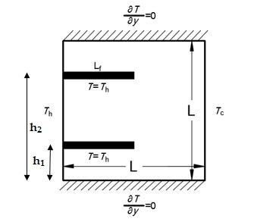
Figure 1. The configuration used for the computational domain h₁
Dispersing nanoparticles to the base fluid will enhance the thermophysical properties of the resulting nanofluid. Reported in Al-Kouz et al. [10], these properties can be calculated based on the following equations:
Viscosity:
$$μ_{nf}= \frac{μ_{f}}{({1- ∅)}^{2.5}}$$ | (1)

Density:
$$ρ_{nf}=\left(1-∅\right)ρ_{f}+{∅ρ}_{s}$$ | (2)

Heat Capacitance:
$$C_{P_{nf}}=\left(1-∅\right){\left(C_{P}\right)}_{f}+∅{\left(C_{P}\right)}_{s}$$ | (3)

Thermal Expansion Coefficient:
$$β_{nf}= β_{f}\left[\frac{1}{1+ \frac{(1- ∅)ρ_{f}}{∅ρ_{s}}}\frac{β_{s}}{β_{f}}+ \frac{1}{1+ \frac{∅}{1- ∅}\frac{ρ_{s}}{ρ_{f}}}\right]$$ | (4)

Thermal Conductivity:
$$k_{nf}= k_{f}\frac{k_{s}+ 2k_{f}- 2∅(k_{f}- k_{s})}{k_{s}+ 2k_{f}+ ∅(k_{f}- k_{s})}$$ | (5)

Table 1 shows the thermophysical properties utilized to obtain the resulting properties of the Al₂O₃-air nanofluid.

Table 1. Thermophysical properties of air and Al₂O₃.
Physical Properties | Air | Al₂O₃
Cp (J/kg K) | 1006.43 | 765
ρ [kg/m³] | 1 | 3970
k [W/m²K] | 0.025 | 40
β [1/K] | 0.00333 | 0.0000085
α [m²/s] | 0.000019 | 0.00001317

The governing equations of the current study are reported in Al-Kouz et al. [18] and are summarized below:
Continuity:
$$\frac{∂u}{∂x}+\frac{∂v}{∂y}=0$$ | (6)

x- momentum:
$$ρ_{nf}\left(u\frac{∂u}{∂x}+v\frac{∂u}{∂y}\right)=-\frac{∂P}{∂x}+μ[\frac{∂^{2}u}{∂x^{2}}+\frac{∂^{2}u}{∂y^{2}}]$$ | (7)

y-momentum:
$$ρ_{nf}\left(u\frac{∂v}{∂x}+v\frac{∂v}{∂y}\right)=-\frac{∂P}{∂y}-ρ_{nf}g+μ[\frac{∂^{2}v}{∂x^{2}}+\frac{∂^{2}v}{∂y^{2}}]$$ | (8)

Energy:
$$ρ_{nf}C_{p_{nf}}\left(u\frac{∂T}{∂x}+v\frac{∂T}{∂y}\right)=k_{nf}[\frac{∂^{2}T}{∂x^{2}}+\frac{∂^{2}T}{∂y^{2}}]$$ | (9)

With the following boundary conditions in the slip flow regime as reported in Karniadakis et al. [40], Lockerby et al. [41] and Colin [42]:
$$u_{w}-u_{g}=\left(\frac{{2-σ}_{v}}{σ_{v}}\right)λ\frac{∂u}{∂n}≈\left(\frac{{2-σ}_{v}}{σ_{v}}\right)K_{n}(u_{g}-u_{c})$$ | (10)
$$v_{g}=0$$ | (11)
$$T_{w}-T_{g}=\left(\frac{{2-σ}_{T}}{σ_{T}}\right)\frac{2γ}{γ+1}\frac{k}{μc_{v}}λ\frac{∂T}{∂n}≈\left(\frac{{2-σ}_{T}}{σ_{T}}\right)\frac{2γ}{γ+1}\frac{k}{μc_{v}}(T_{g}-T_{c})$$ | (12)

In equations 10 and 12, $σ_{v}$and$σ_{T}$ refer to the momentum and thermal accommodation coefficients, respectively, and Kn is defined as:
$$K_{n}=\frac{λ}{L}$$ | (13)
where L is the square cavity characteristic length and $λ$ is the mean free path.
The imposed thermal boundary conditions at x= 0 and L:
$$At\left(x=0,y\right), T=T_{h}$$ | (14)
$$At\left(x=L,y\right), T=T_{c}$$ | (15)

where T_{h} is the temperature at the hot surface and T_{c} is the temperature at the cold surface, the fins temperature is set to T_{h}
In order to calculate the local heat fluxes, and referring to Al-Kouz et al. [18],equations 16 and 17 are utilized:
$$q_{F}^{''}=-k\frac{∂T}{∂n}|_{F}$$ | (16)
$$q_{h}^{''}=-k\frac{∂T}{∂n}|_{h},q_{c}^{''}=-k\frac{∂T}{∂n}|_{c}$$ | (17)

To calculate the total heat transfer from the hot to the cold wall , one should integrate the local heat flux along the wall of the hot wall combined with the fins as follows:
$$Q=\sum{\left(\int_{A_{h}}{q_{h}^{''}}dA_{h}+\int_{A_{F}}{q_{F}^{''}}dA_{F}\right)=\int_{A_{c}}{q_{c}^{''}}dA_{c}}$$ | (18)

Then, the average heat transfer coefficient along combined hot wall and the fins or along the cold surface is derived as follows:
$$\overline{h}=\frac{Q}{\left(T_{i}-T_{o}\right)A_{T}}=\frac{Q}{\left(T_{i}-T_{o}\right)A_{c}}$$ | (19)
From the previous equation, one can derive the average Nusselt number for L= 1m, where:
$$Nu=\frac{\overline{h}L}{k_{n_{f}}}=\frac{\overline{h}}{k_{nf}}$$ | (20)
Following Parvin et al. [20], the total entropy generation is defined as:
$${Sgen}_{tot}={Sgen}_{f}+{Sgen}_{h}$$ | (21)
In equation 21, Sgen_{f} is the entropy generation caused by the flow and Sgen_{h} is the entropy generation due to heat

where,
$${Sgen}_{f}=\frac{k_{nf}}{{T_{o}}^{2}}\left[{\left(\frac{∂T}{∂x}\right)}^{2}+{\left(\frac{∂T}{∂y}\right)}^{2}\right]$$ | (22)
${Sgen}_{h}=\frac{μ_{nf}}{T_{o}}\left[2{\left(\frac{∂u}{∂x}\right)}^{2}+{2\left(\frac{∂v}{∂y}\right)}^{2}+\left(\frac{∂u}{∂x}+\frac{∂v}{∂y}\right)\right]$ and $T_{o}=\frac{T_{h}+T_{c}}{2}$ | (23)

2.2 Numerical Solution
In this study, a finite volume technique is utilized using ANSYS Fluent software to investigate flow, heat transfer characteristics and the total entropy generation for steady, 2D, laminar natural convection rarefied nanofluid in square cavity. The SIMPLE algorithm presented by Versteeg and Malalasekera [43] and Patankar and Spalding [44] is utilized. In order to calculate the pressure field, PRESTO algorithm is used. Moreover, a hybrid second order accuracy scheme of upwind and central difference is used to differentiate the convective terms. As a starting point, a 40×40 mesh elements are tested. In addition, $σ_{v}$and$σ_{T}$ for all simulations are considered to be unity. The solution is converged when the maximum of the normalized absolute residual across all nodes is $<$ 10⁻⁶.

2.3 Grid Independency
The grid that is used in all simulations is a two dimensional mesh and it is shown in Figure 2. Initially, the step sizes of the grid are increasing in the x and y directions with expansion factors of 1.06 and 1.15 respectively, these values were selected to capture the gradients near solid-fluid interface. Then the mesh was adapted in which velocity gradients near the solid surfaces are calculated. After this, the number of cells is increased to lower the gradients below a certain value. It was noticed that any further change in these parameters would not affect the results. A grid independency test is performed by monitoring Nu at the cold surface, and solutions for different numbers of grid nodes were obtained. It was obvious that adding more cells beyond a certain value will not affect Nu. In addition, the average magnitude of the velocity inside the cavity was monitored and tabulated. Table 2. summarizes the values of Nu as well the velocity magnitude inside the cavity along with their relative error to the values obtained for mesh size of 100x100 elements
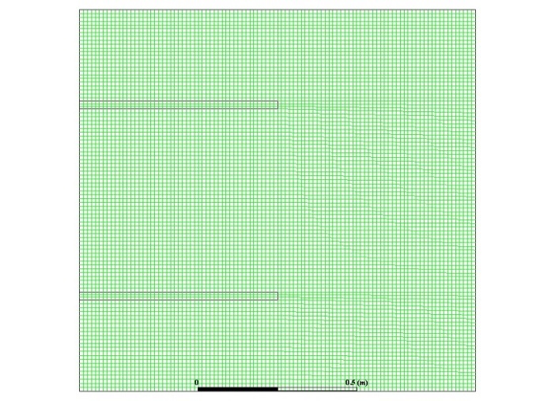
Figure 2. 2D mesh utilized in all simulations.
Figure 3 and table.2 demonstrate that the solution is converged for a 100×100 nodes grid size. This grid size is considered for all simulations conducted in this study.
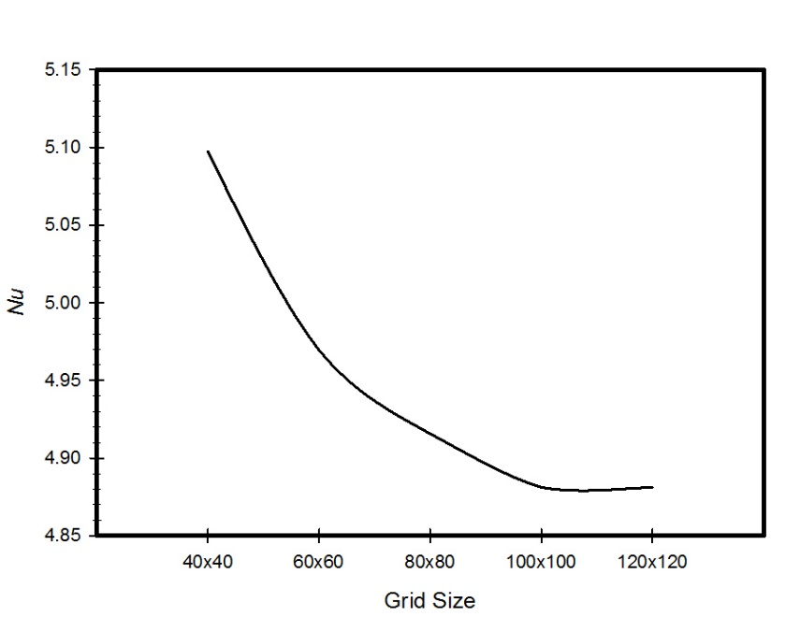
Figure 3. Grid independency test for Nusselt number.
Table 1. Mesh independency test.
Mesh size | Average velocity  [m/s] |  | Relative error in the average velocity % |  |  | Nu | Relative error  in Nu % | Simulation time [s]
40x40 | 0.00055464421 |  |  | 0.050516 | 5.0973 |  | 0.044250507 415
60x60 | 0.00057143194 |  |  | 0.021778 | 4.9694 |  | 0.01804847 622
80x80 | 0.00057617336 |  |  | 0.013661 | 4.9157 |  | 0.00704730 739
100x100 | 0.00058415352 | 0.0 |  |  | 4.8813 |  | 0.0 |  | 823
120x120 | 0.00058415352 | 0.0 |  |  | 4.881297 |  | 6.15e-7 |  | 876

2.4 Code Verification
For verification purposes, results of the current code are compared with the results extracted by Parvin et al. [12] for the case of an odd shape enclosure filled with Cu-water nanofluid. Figure 4 shows a comparison between the entropy generation caused by the flow and entropy generation due to heat obtained by the current code and those obtained by Parvin et al. [12] at ϕ= 5%, comparisons show satisfactory agreement with an error of less than 1%.

Figure 4. Validation of the current code.

3. Results and discussion
Figures 5, 6 and 7 show the total entropy generation contours inside the square cavities with a fin position of H_{F}= 0.25, 0.75 m and fin lengths of 0.5 m for the cases where Kn= zero, 0.05 and 0.1 to cover both of the slip and continuum flow regimes. Moreover, ϕ = 0, 0.01, 0.1 and 0.2 are considered. The contours are plotted for cases where Ra=10³, 10⁴ and 10⁵. It is clear from the contours that there is a formation of a large clockwise rotating cell. By increasing Kn for the same ϕ and Ra, less circulation is observed inside the cavity. This decrease will affect the heat transfer characteristics. For the cases of ϕ= 0.2 and different Kn, more distortion to the flow is observed compared to the other values of$ϕ$. The more recirculation and distorted contours will lead to better heat transfer enhancement. Moreover, figures show that as Ra increases for the same Kn and ϕ, more distortion of the contours will occur inside the cavity, so entropy generation will increase due to the increase in the velocity gradients. But still the entropy generation caused by heat is dominant.

Figure 5. Total entropy generation contours, Kn=0 at at different nanoparticles volume fractions (ϕ = 0, 0.01, 0.1 and 0.2) and Ra=10³, 10⁴ and 10⁵.

Figure 6. Total entropy generation contours, Kn=0.05 at different nanoparticles volume fractions (ϕ = 0, 0.01, 0.1 and 0.2) and Ra=10³, 10⁴ and 10⁵.

Figure 7. Total entropy generation contours, Kn=0.1 at different nanoparticles volume fractions (ϕ= 0, 0.01, 0.1 and 0.2) and Ra=10³, 10⁴ and 10⁵.

Figure 8 illustrates variations of the entropy generation caused by heat with the nano solid particles volume fraction at different Kn for the cases of Ra=1000 and 10000. The graphs show that for the two values of Ra, as the $ϕ$ increases then the entropy generation due to heat increases as well. This can be attributed to the fact that at low Ra, the dominant mode of heat transfer is conduction; by adding nano solid particles, k_{eff} will increase and a better heat transfer is achieved. Better heat transfer implies increase in the entropy generation due to heat. Moreover, the graphs show that as Kn increases for the same $ϕ$ then the entropy generation due to heat will decrease. Higher Kn will result in more rarefaction effects and consequently less interaction between the nanofluid particles; this will lead to less entropy generation. Finally, the graphs also show that for the higher Ra, the entropy generation due to heat will increase for the same value of Kn and nano solid particles volume fraction. In figures 5-8, as Ra increases, convection becomes the dominant mode of heat transfer, so more circulation of the flow happens and consequently an increase in the total entropy generation is observed.

Figure 8. Variation of Sgen_{h} with at different Kn, Ra= 1000, 10000.

Figure 9. Variation of Sgen_{h} with ϕ at different Kn, Ra= 100000, 1000000.

Figure 9 shows variations of the entropy generation due to heat with the nano solid particles volume fraction at different Kn for the cases of Ra=10⁵ and 10⁶. The graphs show that for the two values of Ra, as the $ϕ$ increases then the entropy generation due to heat decreases. This is mainly due to the fact that at high Ra, the dominant mode of heat transfer is convection; by adding nano solid particles, lowering effect of nano solid particles on convection heat transfer becomes dominant. Moreover, graphs show that higher Kn will result in less entropy generation. Finally, the graphs also show that for the higher Ra, the entropy generation due to heat will increase for the same value of Kn and ϕ.
Variations of the entropy generation due to the flow with Ra at different values of nano solid particles volume fractions are plotted in figure 10. The graph shows that as Ra increases, then the entropy generation due to the flow will increase. As Ra increases, more circulation occurs inside the cavity, so velocity gradient and entropy generation increases. Moreover, as Kn increases, the entropy generation due to flow will decrease; this is mainly due to the rarefaction effects. Finally, as the nano solid particles volume fraction increases, then the entropy generation will increase due to the flow (friction) effects.

Figure 10. Variation of Sgen_{f} with Ra at different, Kn= 0, 0.05 and 0.1.

Based on the simulation results, a correlation of the entropy generation among all parameters considered in this study with R²=0.92 is presented as follows:
Sgen,tot=C1C2KnRaC3C4ϕ. (24)
Where, C₁= 2.2e-4 kJ/kg.K, C₂= 0.134, C₃= 0.226, C₄= 0.0077

It is obvious that Bejan number is close to unity for all simulations conducted in the study. Bejan number (Be) is defined as follows:
Be=SgenhSgentot (25)
Figure 11 shows a comparison between the total entropy generation results obtained from the simulations with those obtained from the correlations, the figure shows that there is a great match between the simulation and the correlation results. Deviations between the two are noticed for the conditions at which Kn= 0 and ϕ= 0.
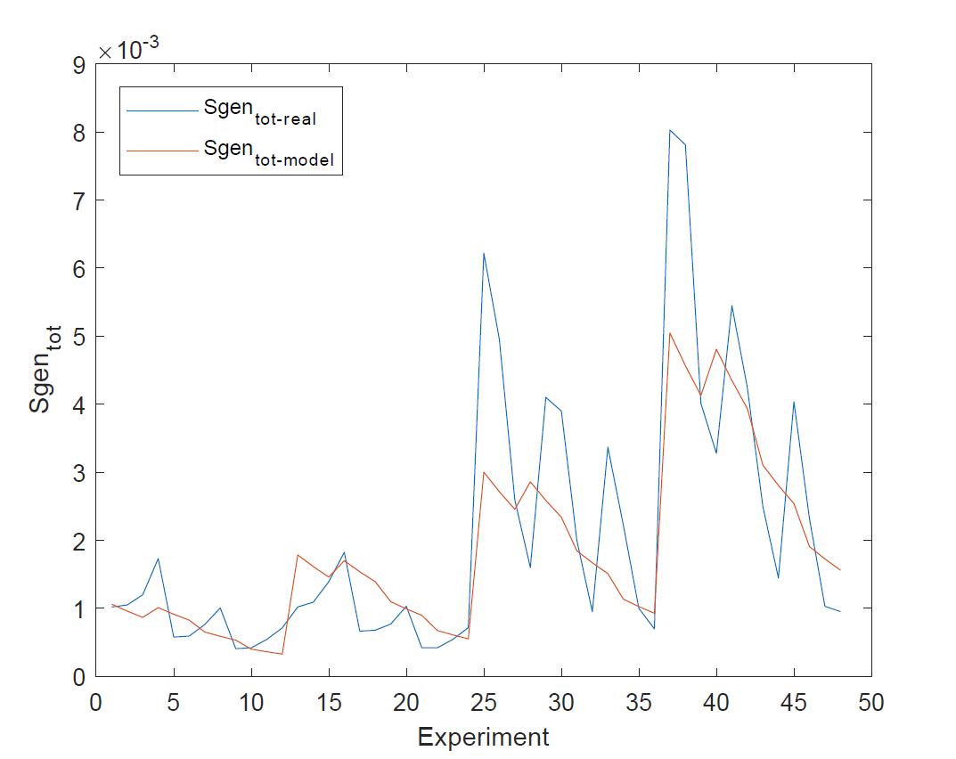
Figure 11. Comparison between the Sgen_{tot} obtained by simulations and those obtained by correlations.

Using Minitab software, design of experiments for the simulations conducted in this work is shown in Figures (12, 13, 14 and 15). Figure 12 shows the main effects of (Kn, Ra and ϕ) on the entropy generation due to heat, it is clear from the figure that there is a strong direct proportional relationship between Sgen_{h} and Ra higher than 10⁴, and weak proportional relationship for Ra less than 10⁴. The graph also shows that there is a weak inverse proportional relationship between Sgen_{h} and Kn. Moreover, the graph shows a strong inverse proportional relationship between Sgen_{h} and ϕ.
Figure 13 shows the interaction plots between parameters investigated in this work on Sgen_{h}, the graph shows that there is an interaction between Ra and ϕ, as they intersect. The changes that we are getting at the level of one independent variables are not changing systematically across the levels of the other independent variable. Therefore, a special effect has been achieved when combining them which comes in harmony with the opposite trends seen in Figures 8 and 9.

Figure 12. Main effects plot for Sgen_{h} vs. Kn, Ra and ϕ.

Figure 13. Interaction plot for Sgen_{h}.

Figure 14 shows the main effects of (Kn, Ra and ϕ) on the entropy generation due to flow, it is clear from the figure that there is a strong direct proportional relationship between Sgen_{f} and Ra. The graph also shows that there is a strong inverse proportional relationship between Sgen_{f} and Kn less than 0.05. For Kn greater than 0.05, there is no effect on Sgen_{f}. Moreover, the graph shows a strong direct proportional relationship between Sgen_{f} and the volume fraction of the nano solid particles for volume fractions greater than 0.01 and there is almost negligible effect for volume fractions less than 0.01.

Figure 14. Main effects plot for Sgen_{f} vs. Kn, Ra and ϕ.

Figure 15 illustrates the interaction plots between parameters investigated in this work on Sgen_{f}, the graph shows that there is an interaction between any two parameters, as they do intersect.

Figure 15. Interaction plot for Sgen_{f}.

Finally, in order to find the conditions at which the minimum entropy generation is obtained, optimization of the multi variable function of the total entropy generation for the parameters ranges considered in the study is conducted. The optimization that yields the minimum total entropy generation reveals that this will happen at Ra= 1001.1, ϕ= 0.19995 and Kn= 0.099 with minimum total entropy generation of 3.29e-4 kJ/kg.K
It is worth mentioning here that another simulation with the resulting conditions for the minimal entropy generation obtained from the optimization is carried out and the total entropy generation is calculated and is equal to 3.2645e-4 kJ/kg.K, which makes the optimal value extracted from the optimization of the model’s correlation in a great agreement with the experimental simulation value.

4. Conclusions
Entropy generation analysis using CFD for a steady state, two-dimensional low-pressure gaseous laminar nanofluid flow inside a square cavity equipped with two solid fins attached to the hot wall is carried out. Such flows are of great importance due to their engineering applications. Rarefaction, Ra and ϕ effects on entropy generation are investigated. Results show that:
- As Kn increases, entropy generation will decrease.
- For low Ra numbers, the entropy generation due to flow increases as ϕ increases.
- For higher Ra, the entropy generation due to flow decreases as ϕ increases.
- The entropy generation due to heat increases as both Ra and ϕ increase.
- A correlation model of the total entropy generation as a function of all the parameters investigated in this study is proposed.
- The conditions at which the optimum (minimum) entropy generation in the investigated ranges of the parameters in this study is calculated mathematically and were validated numerically using CFD.

Author Contributions: conceptualization, Wael Al-Kouz and Ahmad Al-Muhtady; methodology, Wael Al-Kouz; software, Rama Abu-Alghanam; validation, Wahib Owhaib and Sameer Al-Dahidi; formal analysis, Wael Al-Kouz and Ahmad Al-Muhtadi; design of experiments, Ahmad Al-Muhtady; correlations, Montasir Hader; writing—original draft preparation, Wael Al-Kouz; writing—review and editing, Wael Al-Kouz and Wahib Owhaib; supervision, Wael Al-Kouz; project administration, Wael Al-Kouz.
Funding: This work is a result from partial support by German Jordanian University seed grant under Grant No. SATS 30/2016.
Conflicts of Interest: The authors declare no conflict of interest.
Nomenclature
The following notations are used in this manuscript:

Notations
A_{c} | Cold wall area [m²]
A_{h} | Hot wall area [m²]
A_{F} | Fin area [m²]
Be | Bejan number
C_{p} | Specific heat [J kg⁻¹ K⁻¹]
G | Gravity acceleration in the x direction [m/s²]
h₁ | Fin 1 Position [m]
h₂ | Fin 2 Position [m]
h | Convection heat transfer coefficient
K | Thermal conductivity [W m⁻¹ K⁻¹]
Kn | Knudsen number
kf | Fluid thermal conductivity [W m⁻¹ K⁻¹]
knf | Nanofluid thermal conductivity [W m⁻¹ K⁻¹]
ks | Nano particles thermal conductivity [W m⁻¹ K⁻¹]
L | Length of the square cavity [m]
L_{F} | Fin length [m]
Nu | Nusselt Number
P | Pressure [Pa]
Q | Heat transfer [W]
qc'' | Local heat flux at the wall of the cold surface [W/m²]
qh'' | Local heat flux at the wall of the hot surface [W/m²]
qF'' | Local heat flux at the fin [W/m²]
R | Universal gas constant [J/mol.K]
Ra | Rayleigh number (gβ(T₁-T₂)L3/αν)
T | Temperature [°C]
T_{c} | Temperature of the first cell from the wall [°C]
T_{i} | Hot surface temperature [°C]
T_{o} | Cold surface temperature [°C]
T_{g} | Temperature of the nanofluid [°C]
T_{w} | Temperature of the wall [°C]
u | Velocity in x-direction [m/s]
u_{c} | Tangential velocity of the first cell from the wall [m/s]
u_{g} | Tangential velocity of the nanofluid [m/s]
u_{w} | Tangential velocity of the wall [m/s]
V | Velocity in y-direction [m/s]
x, y | Cartesian coordinates [m]

Greek Symbols
α | Thermal diffusivity [m²/s]
β | Thermal expansion coefficient [1/K]
γ | Specific weight (N/m³)
λ | Molecular mean free path (m)
μ | Dynamic viscosity [kg m⁻¹ s₋₁]
ν | Kinematic viscosity [m²s⁻¹]
ϕ | Nano particles volume fraction %
ρ | Density of air, given by ideal gas equation (P/RT), [Kg/m³]
σ_{T} | Thermal accommodation coefficient
σ_{v} | Momentum accommodation coefficient

Subscripts
Eff | Effective
f | Fluid
F | Fin
g | Gas flow
i | Hot wall
n | Normal
nf | Nanofluid
o | Cold wall
r | Ratio
w | Wall

References
- Cai, J., Zhang, L., Ju, Y., Pia, G., & Zhang, Z. (2018). An Introduction to Fractal-Based Approaches In Unconventional Reservoirs — Part I. Fractals, 26(02), 1802001. doi:10.1142/s0218348x18020012
- Shafieian, A., Khiadani, M., & Nosrati, A. (2018). A review of latest developments, progress, and applications of heat pipe solar collectors. Renewable and Sustainable Energy Reviews, 95, 273-304. doi:10.1016/j.rser.2018.07.014
- Phiraphat, S., Prommas, R., & Puangsombut, W. (2017). Experimental study of natural convection in PV roof solar collector. International Communications in Heat and Mass Transfer, 89, 31-38. doi:10.1016/j.icheatmasstransfer.2017.09.022
- Liang, M., Liu, Y., Xiao, B., Yang, S., Wang, Z., & Han, H. (2018). An analytical model for the transverse permeability of gas diffusion layer with electrical double layer effects in proton exchange membrane fuel cells. International Journal of Hydrogen Energy, 43(37), 17880-17888. doi:10.1016/j.ijhydene.2018.07.186
- Long, G., Liu, S., Xu, G., Wong, S., Chen, H., & Xiao, B. (2018). A Perforation-Erosion Model for Hydraulic-Fracturing Applications. SPE Production & Operations, 33(04), 770-783. doi:10.2118/174959-pa
- Long, G., & Xu, G. (2017). The Effects of Perforation Erosion on Practical Hydraulic-Fracturing Applications. SPE Journal, 22(02), 645-659. doi:10.2118/185173-pa
- Mey, G. D., Torzewicz, T., Kawka, P., Czerwoniec, A., Janicki, M., & Napieralski, A. (2016). Analysis of nonlinear heat exchange phenomena in natural convection cooled electronic systems. Microelectronics Reliability, 67, 15-20. doi:10.1016/j.microrel.2016.11.003
- Purusothaman, A. (2018). Investigation of natural convection heat transfer performance of the QFN-PCB electronic module by using nanofluid for power electronics cooling applications. Advanced Powder Technology, 29(4), 996-1004. doi:10.1016/j.apt.2018.01.018
- Choi, S.U. S; Eastman, J.A. Enhancing thermal conductivity of fluids with nanoparticles. ASME International Mechanical Engineering Congress & Exposition November 12-17, 1995, San Francisco.
- Khanafer, K.; Vafai, K.; Lightstone, M. Bouyancy driven heat transfer enhancement in a two dimensional enclosure utilizing nanofluids. International Journal of Heat and Mass Transfer 2003, 46, 3639-3653.
- Khanafer, K.; Vafai, K. A critical synthesis of thermosphysical characteristics of nanofluids. International Journal of Heat and Mass Transfer 2011, 54, 4410-4428.
- Boungioron, J. Convective transport in nanofluids. ASME Journal of Heat Transfer 2006, 128, 240-250.
- Oztop, H.F.; Abu-Nada, E. Numerical study of natural convection in partially heated rectangular enclosures filled with nanofluids. International Journal of Heat Fluid Flow 2008, 29, 1326-1336.
- Ghasemi, B.; Aminossadati, S.M.; Raisi, A. Magnetic field effect on natural convection in a nanofluid-filled square enclosure. International Journal of Thermal Science 2011, 50, 1748-1756.
- Kefayati, G.H.R.; Hosseinizadeh, S.F.; Gorji, M.; Sajjadi, H. Lattice Boltzmann simulation of natural convection in tall enclosures using water/SiO₂ nanofluid. International communication in Heat and Mass transfer 2011, 38, 798-805.
- Kefayati, G.H.R. Heat transfer and entropy generation of natural convection on non-Newtonian nanofluids in porous cavity. Powder Technology 2016, 299, 127-149.
- Al-Kouz, W.; Alshare, A.; Kiwan, S.; Al-Muhtady, A.; Alkhalidi, A. Two-dimensional analysis of low-pressure flows in an inclined square cavity with two fins attached to the hot wall. International Journal of Thermal Sciences 2018, 126, 181-193.
- Al-Kouz, W.; Kiwan, S.; Alkhalidi, A.; Sari, M.; Alshare, A. Numerical study of heat transfer enhancement for low-pressure flows in a square cavity with two fins attached to the hot wall using AL₂O₃-air nanofluid. Journal of Mechanical Engineering 2018, 64, 26-36.
- Kefayati, G.H.R.; Che Sidik, N.A. Simulation of natural convection and entropy generation of non-Newtonian nanofluid in an inclined cavity using Buongiorno’s mathematical model (Part II, entropy generation). Powder Technology 2017, 305, 679-703.
- Parvin, S.; Chamkha, A.J. An analysis on free convection flow, heat transfer and entropy generation in an odd-shapped cavity filled with nanofluid. International communications in Heat and Mass Transfer 2014, 54, 8-17.
- Mejri, I.; Mahmoudi, A.; Abbasi, M.A.; Omri, A. Magnetic field effect on entropy generation in a nanofluid-filled enclosure with sinusoidal heating on both side walls 2014, Powder Technology, 266, 340-353.
- Mahmoudi, A.; Mejri, I.; Abbasi, M.A.; Omri, A. Analysis of the entropy generation in nanofluid-filled cavity in the presence of magnetic field and uniform heat generation/absorption. Journal of Molecular Liquids 2014, 198, 63-77.
- Armaghani, T.; Kasaeipoor, A.; Alavi, N.; Rashidi, M.M. Numerical investigation of water-alumina nanofluid natural convection heat transfer and entropy generation in a baffled L-shaped cavity. Journal of Molecular Liquids 2016, 223, 243-251.
- Al-Zamily, A.M.J. Analysis of natural convection and entropy generation in a cavity filled with multi-layers of porous medium and nanofluid with a heat generation. International Journal of Heat and Mass Transfer 2017, 106, 1218-1231.
- Bouchoucha, A.E.M.; Bessaïh, R.; Oztop, H.F.; Al-Salem, K.; Bayrak, F. Natural convection and entropy generation in a nanofluid filled cavity with thick bottom wall: effect of non-isothermal heating. International Journal of Mechanical Science 2017, 126, 95-105.
- Ashorynejad, H.R.; Hoseinpour, B. Investigation of different nanofluids effect on entropy generation on natural convection in porous cavity. European Journal of Mechanics B/Fluids 2017, 62, 86-93.
- Sheremet, M.A.; Grosan, T.; Pop, I. Natural convection and entropy generation in a square cavity with variable temperature side walls filled with a nanofluid: Buongiorno’s mathematical model. Entropy 2017, 19, 337, 1-16.
- Alsabery, A.I.; Ishak, M.S.; Chamkha, A.J.; Hashim, Ishak. Entropy Generation analysis and natural convection in a nanofluid-filled square cavity with a concentric solid insert and different temperature distributions. Entropy 2018, 20, 336, 1-24.
- Siavashi, M.; Yousofvand, R.; Rezanejad, S. Nanofluid and porous fins effect on natural convection and entropy generation of flow inside a cavity. Advanced Powder Technology 2018, 29, 142-156.
- Kashyap, D.; Dass, A.K. Two-phase lattice Boltzmann simulation of natural convection in a Cu-water nanofluid filled porous cavity: effects of thermal boundary conditions on heat transfer and entropy generation. Advanced Powder Technology 2018, 29, 2707-2724.
- Gibanov, N.S.; Sheremet, M.A.; Oztop, H.F.; Abu-Hamdeh, N. Mixed convection with entropy generation of nanofluid in a lid-driven cavity under the effects of a heat-conducting solid wall and vertical temperature gradient. European Journal of Mechanics / B Fluids 2018, 70, 148-159.
- Mansour, M.A.; Siddiqa, S.; Gorla, R.S.R.; Rashad, A.M. Effect of heat source and sink on entropy generation and MHD natural convection of Al₂O₃-Cu/water hybrid nanofluid filled with square porous cavity. Thermal Science and Engineering Progress 2018, 6, 57-71.
- Rahimi, A.; Sepehr, M.; Lariche, M.J.; Kasaeipoor A.; Malekshah, E.H. Entropy generation analysis and heatline visualization of free convection in nanofluid (KKL model-based) –filled cavity including internal active fins using lattice Boltzmann method. Computers and Mathematics with Applications 2018, 75, 1814-1830.
- Rashidi, M. M., Nasiri, M., Shadloo, M. S., & Yang, Z. (2016). Entropy Generation in a Circular Tube Heat Exchanger Using Nanofluids: Effects of Different Modeling Approaches. Heat Transfer Engineering, 38(9), 853-866. doi:10.1080/01457632.2016.1211916
- Yarmand, H., Ahmadi, G., Gharehkhani, S., Kazi, S., Safaei, M., Alehashem, M., & Mahat, A. (2014). Entropy Generation during Turbulent Flow of Zirconia-water and Other Nanofluids in a Square Cross Section Tube with a Constant Heat Flux. Entropy, 16(11), 6116-6132. doi:10.3390/e16116116
- Jamalabadi, M. A., Safaei, M., Alrashed, A., Nguyen, T., & Filho, E. B. (2017). Entropy Generation in Thermal Radiative Loading of Structures with Distinct Heaters. Entropy, 19(10), 506. doi:10.3390/e19100506
- Aghaei, A., Sheikhzadeh, G. A., Goodarzi, M., Hasani, H., Damirchi, H., & Afrand, M. (2018). Effect of horizontal and vertical elliptic baffles inside an enclosure on the mixed convection of a MWCNTs-water nanofluid and its entropy generation. The European Physical Journal Plus, 133(11). doi:10.1140/epjp/i2018-12278-4
- Mahmoudinezhad, S., Rezania, A., Yousefi, T., Shadloo, M. S., & Rosendahl, L. A. (2017). Adiabatic partition effect on natural convection heat transfer inside a square cavity: Experimental and numerical studies. Heat and Mass Transfer, 54(2), 291-304. doi:10.1007/s00231-017-2103-7
- Nasiri, H., Jamalabadi, M. Y., Sadeghi, R., Safaei, M. R., Nguyen, T. K., & Shadloo, M. S. (2018). A smoothed particle hydrodynamics approach for numerical simulation of nano-fluid flows. Journal of Thermal Analysis and Calorimetry. doi:10.1007/s10973-018-7022-4

- Karniadakis, G., Beskok A., Aluru, N. (2005). Microflows and Nanoflows.Springer;.
- Lockerby, D., Reese, J., Barber, R. (2004) Velocity boundary condition at solid wall in rarefied gas calculations, Physical Review E, Vol. 70,No. 1, 017303.
- Stéphane Colin, (2006). Heat Transfer and Fluid Flow in Minichannels and microchannels: Single-phase gas flow in microchannels, Elsevier Ltd
- Versteeg, H., Malalasekera, W. (1995). An Introduction to Computational Fluid Dynamics: The Finite Volume Method, Prentice-Hall, Essex.
- Patankar, S.V., Spalding, D. B., (1972). A calculation procedure for heat, mass and momentum transfer in three-dimensional parabolic flows, Int. J. of Heat and Mass Transfer 15 No. 10, 1787-1806.
© 2018 by the authors. Submitted for possible open access publication under the terms and conditions of the Creative Commons Attribution (CC BY) license (http://creativecommons.org/licenses/by/4.0/).

