Supplementary Materials: Table S1: Female Aedes aegypti transcriptomic RNA-seq data show Leucine-Rich Repeat Proteins 7-days post infection or post injection between Key west and Orlando strains.
Table S1A. Female Aedes aegypti transcriptomic RNA-seq data show Leucine-Rich Repeat Proteins related genes expression in the Zika infection in Key West strain compared with Orlando strain Aedes aegypti 7-days post infection.
Transcript ID | Log2FC |  | p-adj | Gene description
AAEL000108-RA | 0.8163 | 8.6 x 10⁻¹ |  | leucine aminopeptidase
AAEL000243-RA | -2.1351 | 1.3 x 10⁻² |  | leucine-rich transmembrane protein
AAEL000424-RA | -0.1229 | 1.0 x 10⁻¹ |  | leucine aminopeptidase
AAEL000925-RA | -0.0806 | 5.5 x 10⁻¹ |  | leucine-zipper-like transcriptional regulator
AAEL001401-RA | 3.2722 | 2.3 x 10⁻²⁷ |  | leucine-rich immune protein (Short)
AAEL001402-RA | 3.2947 | 3.3 x 10⁻³³ |  | leucine-rich immune protein (Short)
AAEL001414-RA | 3.3722 | 2.1 x 10⁻³⁶ |  | leucine-rich immune protein (Short)
AAEL001417-RA | 3.9485 | 2.0 x 10⁻⁵ |  | leucine-rich immune protein (Short)
AAEL001420-RA | 3.4335 | 1.6 x 10⁻⁷³ |  | leucine-rich immune protein (Short)
AAEL001649-RA | -0.2792 | 4.7 x 10⁻³ |  | leucine aminopeptidase
AAEL001766-RA | 1.7007 | 2.4 x 10⁻² |  | leucine-rich transmembrane protein
AAEL002166-RA | -0.0764 | 4.8 x 10⁻¹ |  | leucine rich repeat (in flii) interacting protein
AAEL002295-RA | 2.4545 | 1.9 x 10⁻⁴⁴ |  | leucine-rich transmembrane protein
AAEL002307-RA | 1.0570 | 6.1 x 10⁻² |  | leucine-rich transmembrane protein
AAEL002615-RA | 2.2527 | 5.0 x 10⁻¹² |  | leucine-rich transmembrane protein
AAEL003262-RA | 1.8141 | 3.9 x 10⁻⁵ |  | leucine-rich transmembrane protein
AAEL003408-RA | 1.3747 | 5.3 x 10⁻⁶ |  | leucine-rich transmembrane protein
AAEL003554-RA | 0.0380 | 8.3 x 10⁻¹ |  | leucine rich repeat protein
AAEL003597-RA | 1.8100 | 2.7 x 10⁻¹ |  | leucine-rich transmembrane protein
AAEL003597-RB | 1.4073 | 4.9 x 10⁻¹ |  | leucine-rich transmembrane protein
AAEL003713-RA | 1.3970 | 7.3 x 10⁻⁴ |  | leucine-rich transmembrane protein
AAEL003720-RA | 1.1688 | 5.6 x 10⁻⁵ |  | leucine-rich transmembrane protein
AAEL003859-RA | 0.2431 | 2.1 x 10⁻¹ |  | leucine-rich transmembrane protein
AAEL004466-RA | 2.5519 | 4.4 x 10⁻¹ |  | leucine-rich immune protein (Coil-less)
AAEL004773-RA | -0.0661 | 6.3 x 10⁻¹ |  | leucine carboxyl methyltransferase
AAEL005351-RA | -0.0974 | 2.1 x 10⁻¹ |  | leucine-rich transmembrane protein
AAEL005734-RA | 0.0613 | 6.7 x 10⁻¹ |  | leucine-rich transmembrane protein
AAEL005762-RA | 2.2277 | 2.7 x 10⁻⁵ |  | leucine-rich transmembrane protein
AAEL006026-RA | -0.0266 | 9.2 x 10⁻¹ |  | leucine rich protein, putative
AAEL006377-RA | 1.5263 | 1.2 x 10⁻¹ |  | leucine-rich immune protein (Coil-less)
AAEL006975-RA | 1.7989 | 8.7 x 10⁻⁵ |  | leucine aminopeptidase
AAEL007103-RA | 3.2536 | 7.5 x 10⁻¹¹ |  | leucine-rich immune protein TM
AAEL007224-RA | 1.1275 | 1.4 x 10⁻¹ |  | leucine-rich immune protein (Coil-less)
AAEL007231-RA | 0.1956 | 1.0 x 10⁻⁰ |  | leucine-rich immune protein (Coil-less)
AAEL007363-RA | 0.8814 | 5.2 x 10⁻⁶ |  | leucine-rich transmembrane protein
AAEL007565-RA | -0.0052 | 1.0 x 10⁻⁰ |  | leucine rich protein, putative
AAEL007778-RA | 1.5531 | 8.6 x 10⁻¹⁵ |  | leucine-rich transmembrane protein
AAEL007785-RA | 1.0229 | 1.2 x 10⁻¹ |  | leucine-rich transmembrane protein
AAEL008658-RA | 2.4764 | 1.6 x 10⁻¹¹ |  | leucine-rich immune protein TM
AAEL009520-RA¹ | 3.0383 | 4.5 x 10⁻²⁵ |  | leucine-rich immune protein (Long)
AAEL009792-RA | 0.6257 | 8.4 x 10⁻¹ |  | leucine-rich immune protein (Coil-less)

Transcript ID | Log2FC | p-adj | Gene description
AAEL009894-RA | -0.1055 | 4.2 x 10⁻¹ | leucine-rich immune protein (Coil-less)
AAEL010111-RA | 0.7172 | 2.1 x 10⁻¹ | leucine-rich transmembrane protein
AAEL010125-RA | 3.2598 | 7.0 x 10⁻⁸ | leucine-rich immune protein (Coil-less)
AAEL010128-RA | 4.8149 | 2.4 x 10⁻⁷ | leucine-rich immune protein (Long)
AAEL010132-RA | 0.1733 | 1.0 x 10⁻⁰ | leucine-rich immune protein (Long)
AAEL010286-RA | 1.5368 | 1.1 x 10⁻¹ | leucine-rich transmembrane protein
AAEL010656-RA | 2.7658 | 3.9 x 10⁻⁷ | leucine-rich immune protein (Short)
AAEL010772-RA | 0.3692 | 8.7 x 10⁻¹ | Leucine-rich repeat-containing protein 50 homolog
AAEL011387-RA | 0.2131 | 5.3 x 10⁻¹ | leucine-rich repeat protein
AAEL011760-RA | -0.2186 | 8.7 x 10⁻¹ | leucine-rich transmembrane protein
AAEL012086-RA | 2.4679 | 1.7 x 10⁻¹² | leucine-rich immune protein (Long)
AAEL012092-RA | 2.1252 | 2.6 x 10⁻²⁸ | leucine rich repeat protein
AAEL012093-RA | 2.2739 | 1.9 x 10⁻¹⁰ | leucine-rich transmembrane protein
AAEL012255-RA | 4.2146 | 2.0 x 10⁻⁴ | leucine-rich immune protein (Short)
AAEL012763-RA | 0.2781 | 7.3 x 10⁻¹ | leucine-rich immune protein (Coil-less)
AAEL012767-RA | 0.2458 | 9.9 x 10⁻¹ | leucine-rich immune protein (Short)
AAEL012771-RA | -2.1327 | 9.0 x 10⁻² | leucine-rich immune protein (Coil-less)
AAEL012911-RA | 0.4919 | 1.8 x 10⁻¹ | leucine-rich immune protein (Coil-less)
¹ AAEL009520-RA is the same gene as AAEL024406.

Table S1B. Female Aedes aegypti transcriptomic RNA-seq data show Leucine-Rich Repeat Proteins related genes expression in Control (blood-feeding only) in the Key West strain compared with Orlando strain Aedes aegypti 7-days post injection.

Transcript ID | Log2FC | p-adj | Gene description
AAEL000108-RA | 0.2407 | 1.0 x 10⁻⁰ | leucine aminopeptidase
AAEL000243-RA | 5.2443 | 1.8 x 10⁻²⁶ | leucine-rich transmembrane protein
AAEL000424-RA | 0.2572 | 5.3 x 10⁻¹ | leucine aminopeptidase
AAEL000762-RA | 1.7648 | 4.0 x 10⁻¹ | leucine-rich immune protein (Coil-less)
AAEL000925-RA | -0.0274 | 1.0 x 10⁻⁰ | leucine-zipper-like transcriptional regulator
AAEL001401-RA | 1.2776 | 7.7 x 10⁻¹ | leucine-rich immune protein (Short)
AAEL001402-RA | 0.7638 | 8.5 x 10⁻¹ | leucine-rich immune protein (Short)
AAEL001414-RA | 1.1630 | 7.5 x 10⁻¹ | leucine-rich immune protein (Short)
AAEL001417-RA | 1.1400 | 5.8 x 10⁻¹ | leucine-rich immune protein (Short)
AAEL001420-RA | 0.9209 | 8.7 x 10⁻¹ | leucine-rich immune protein (Short)
AAEL001649-RA | 0.1852 | 7.8 x 10⁻¹ | leucine aminopeptidase
AAEL001766-RA | -0.2723 | 9.8 x 10⁻¹ | leucine-rich transmembrane protein
AAEL002166-RA | 0.0549 | 9.8 x 10⁻¹ | leucine rich repeat (in flii) interacting protein
AAEL002295-RA | -0.0871 | 1.0 x 10⁻⁰ | leucine-rich transmembrane protein
AAEL002307-RA | -1.9783 | 5.3 x 10⁻² | leucine-rich transmembrane protein
AAEL002615-RA | 0.1515 | 1.0 x 10⁻⁰ | leucine-rich transmembrane protein
AAEL003262-RA | 1.5448 | 1.4 x 10⁻¹ | leucine-rich transmembrane protein
AAEL003408-RA | -1.3019 | 2.4 x 10⁻¹ | leucine-rich transmembrane protein
AAEL003554-RA | -0.0706 | 9.7 x 10⁻¹ | leucine rich repeat protein
Transcript ID | Log2FC | p-adj | Gene description
AAEL003597-RA | 0.1151 | 1.0 x 10⁻⁰ | leucine-rich transmembrane protein
AAEL003713-RA | 0.1831 | 1.0 x 10⁻⁰ | leucine-rich transmembrane protein
AAEL003720-RA | -0.8548 | 5.4 x 10⁻¹ | leucine-rich transmembrane protein
AAEL003859-RA | 0.3130 | 7.8 x 10⁻¹ | leucine-rich transmembrane protein
AAEL004466-RA | 2.0123 | 8.8 x 10⁻¹ | leucine-rich immune protein (Coil-less)
AAEL004773-RA | 0.0049 | 1.0 x 10⁻⁰ | leucine carboxyl methyltransferase
AAEL005351-RA | -0.1827 | 5.8 x 10⁻¹ | leucine-rich transmembrane protein
AAEL005734-RA | -0.2283 | 6.6 x 10⁻¹ | leucine-rich transmembrane protein
AAEL005762-RA | -0.4492 | 9.2 x 10⁻¹ | leucine-rich transmembrane protein
AAEL006026-RA | 0.0909 | 9.6 x 10⁻¹ | leucine rich protein, putative
AAEL006377-RA | 0.2883 | 1.0 x 10⁻⁰ | leucine-rich immune protein (Coil-less)
AAEL006975-RA | -1.4523 | 2.8 x 10⁻¹ | leucine aminopeptidase
AAEL007103-RA | 1.5062 | 6.7 x 10⁻¹ | leucine-rich immune protein TM
AAEL007224-RA | 1.6625 | 6.4 x 10⁻¹ | leucine-rich immune protein (Coil-less)
AAEL007231-RA | -0.2972 | 1.0 x 10⁻⁰ | leucine-rich immune protein (Coil-less)
AAEL007363-RA | -0.3259 | 8.7 x 10⁻¹ | leucine-rich transmembrane protein
AAEL007565-RA | -0.0600 | 9.8 x 10⁻¹ | leucine rich protein, putative
AAEL007778-RA | 1.1993 | 5.6 x 10⁻¹ | leucine-rich transmembrane protein
AAEL007785-RA | -0.4638 | 9.3 x 10⁻¹ | leucine-rich transmembrane protein
AAEL008658-RA | 0.3448 | 9.8 x 10⁻¹ | leucine-rich immune protein TM
AAEL009520-RA¹ | 1.7824 | 6.0 x 10⁻¹ | leucine-rich immune protein (Long)
AAEL009792-RA | -0.0468 | 1.0 x 10⁻⁰ | leucine-rich immune protein (Coil-less)
AAEL009894-RA | -0.9167 | 2.9 x 10⁻⁴ | leucine-rich immune protein (Coil-less)
AAEL010111-RA | 0.5586 | 8.8 x 10⁻¹ | leucine-rich transmembrane protein
AAEL010125-RA | 1.6477 | 5.3 x 10⁻¹ | leucine-rich immune protein (Coil-less)
AAEL010128-RA | -0.4969 | 9.1 x 10⁻¹ | leucine-rich immune protein (Long)
AAEL010132-RA | 1.1041 | 6.9 x 10⁻¹ | leucine-rich immune protein (Long)
AAEL010286-RA | 3.0287 | 1.5 x 10⁻⁵ | leucine-rich transmembrane protein
AAEL010656-RA | -0.0488 | 1.0 x 10⁻⁰ | leucine-rich immune protein (Short)
AAEL010772-RA | -0.0798 | 1.0 x 10⁻⁰ | Leucine-rich repeat-containing protein 50 homolog
AAEL011387-RA | 0.1003 | 1.0 x 10⁻⁰ | leucine-rich repeat protein
AAEL011760-RA | 2.0781 | 8.8 x 10⁻² | leucine-rich transmembrane protein
AAEL012086-RA | 2.1793 | 4.9 x 10⁻¹ | leucine-rich immune protein (Long)
AAEL012092-RA | -0.2727 | 9.7 x 10⁻¹ | leucine rich repeat protein
AAEL012093-RA | -0.5269 | 7.5 x 10⁻¹ | leucine-rich transmembrane protein
AAEL012255-RA | 0.5067 | 9.4 x 10⁻¹ | leucine-rich immune protein (Short)
AAEL012538-RA | 1.3374 | 7.5 x 10⁻¹ | leucine-rich immune protein (Short)
AAEL012763-RA | 0.2824 | 9.6 x 10⁻¹ | leucine-rich immune protein (Coil-less)
AAEL012767-RA | 2.3014 | 1.8 x 10⁻¹ | leucine-rich immune protein (Short)
AAEL012771-RA | 2.5966 | 3.0 x 10⁻¹ | leucine-rich immune protein (Coil-less)
AAEL012911-RA | -0.6582 | 7.1 x 10⁻¹ | leucine-rich immune protein (Coil-less)
AAEL015627-RA | -0.1674 | 1.0 x 10⁻¹ | leucine-rich immune protein (Coil-less)
¹ AAEL009520-RA is the same gene as AAEL024406.

Table S1C. Female Aedes aegypti transcriptomic RNA-seq data show Leucine-Rich Repeat Proteins related genes dysregulated in the Key West strain Aedes aegypti 7-days post infection with ZIKV compared with Control in Key West strain.
Transcript ID | Log2FC | p-adj | Gene description
AAEL000108-RA | -1.7731 | 4.8 x 10⁻¹ | leucine aminopeptidase
AAEL000243-RA | -6.6469 | 7.6 x 10⁻⁴⁴ | leucine-rich transmembrane protein
AAEL000424-RA | -0.3141 | 3.1 x 10⁻¹ | leucine aminopeptidase
AAEL000762-RA | -1.1738 | 5.4 x 10⁻¹ | leucine-rich immune protein (Coil-less)
AAEL000925-RA | -0.0007 | 1.0 x 10⁻⁰ | leucine-zipper-like transcriptional regulator
AAEL001401-RA | -1.3103 | 6.4 x 10⁻¹ | leucine-rich immune protein (Short)
AAEL001402-RA | -0.8166 | 7.5 x 10⁻¹ | leucine-rich immune protein (Short)
AAEL001414-RA | -1.4239 | 5.2 x 10⁻¹ | leucine-rich immune protein (Short)
AAEL001417-RA | -1.5243 | 1.7 x 10⁻¹ | leucine-rich immune protein (Short)
AAEL001420-RA | -1.3793 | 5.7 x 10⁻¹ | leucine-rich immune protein (Short)
AAEL001649-RA | -0.2873 | 4.6 x 10⁻¹ | leucine aminopeptidase
AAEL001766-RA | 0.1960 | 9.8 x 10⁻¹ | leucine-rich transmembrane protein
AAEL002166-RA | -0.0592 | 9.5 x 10⁻¹ | leucine rich repeat (in flii) interacting protein
AAEL002295-RA | 0.3188 | 7.8 x 10⁻¹ | leucine-rich transmembrane protein
AAEL002307-RA | 1.3559 | 2.1 x 10⁻¹ | leucine-rich transmembrane protein
AAEL002615-RA | 0.1694 | 9.9 x 10⁻¹ | leucine-rich transmembrane protein
AAEL003262-RA | -0.1092 | 1.0 x 10⁻⁰ | leucine-rich transmembrane protein
AAEL003408-RA | 2.1477 | 1.8 x 10⁻⁴ | leucine-rich transmembrane protein
AAEL003554-RA | 0.1223 | 7.6 x 10⁻¹ | leucine rich repeat protein
AAEL003597-RB | -0.1468 | 1.0 x 10⁻⁰ | leucine-rich transmembrane protein
AAEL003713-RA | -0.0746 | 1.0 x 10⁻⁰ | leucine-rich transmembrane protein
AAEL003720-RA | 0.8861 | 9.8 x 10⁻² | leucine-rich transmembrane protein
AAEL003859-RA | -0.0278 | 1.0 x 10⁻⁰ | leucine-rich transmembrane protein
AAEL004466-RA | 0.4468 | 1.0 x 10⁻⁰ | leucine-rich immune protein (Coil-less)
AAEL004773-RA | -0.0228 | 1.0 x 10⁻⁰ | leucine carboxyl methyltransferase
AAEL005351-RA | 0.1178 | 6.8 x 10⁻¹ | leucine-rich transmembrane protein
AAEL005734-RA | 0.2204 | 5.8 x 10⁻¹ | leucine-rich transmembrane protein
AAEL005762-RA | 0.5146 | 7.0 x 10⁻¹ | leucine-rich transmembrane protein
AAEL006026-RA | -0.0849 | 9.3 x 10⁻¹ | leucine rich protein, putative
AAEL006377-RA | -0.8786 | 8.4 x 10⁻¹ | leucine-rich immune protein (Coil-less)
AAEL006975-RA | 2.0656 | 1.0 x 10⁻² | leucine aminopeptidase
AAEL007103-RA | -0.5660 | 9.0 x 10⁻¹ | leucine-rich immune protein TM
AAEL007224-RA | 0.0491 | 1.0 x 10⁻⁰ | leucine-rich immune protein (Coil-less)
AAEL007231-RA | -2.5365 | 4.8 x 10⁻¹ | leucine-rich immune protein (Coil-less)
AAEL007363-RA | 0.3441 | 6.6 x 10⁻¹ | leucine-rich transmembrane protein
AAEL007565-RA | 0.0044 | 1.0 x 10⁻⁰ | leucine rich protein, putative
AAEL007778-RA | -1.4858 | 3.1 x 10⁻¹ | leucine-rich transmembrane protein
AAEL007785-RA | 0.5315 | 8.3 x 10⁻¹ | leucine-rich transmembrane protein
AAEL008658-RA | 0.3609 | 8.9 x 10⁻¹ | leucine-rich immune protein TM
AAEL009520-RA¹ | -0.9495 | 7.8 x 10⁻¹ | leucine-rich immune protein (Long)
AAEL009792-RA | -1.2373 | 6.2 x 10⁻¹ | leucine-rich immune protein (Coil-less)

Transcript ID | Log2FC | p-adj | Gene description
AAEL009894-RA | 0.8665 | 9.7 x 10⁻⁵ | leucine-rich immune protein (Coil-less)
AAEL010111-RA | -0.2184 | 9.6 x 10⁻¹ | leucine-rich transmembrane protein
AAEL010125-RA | -1.5972 | 4.5 x 10⁻¹ | leucine-rich immune protein (Coil-less)
AAEL010128-RA | -0.0478 | 1.0 x 10⁻⁰ | leucine-rich immune protein (Long)
AAEL010132-RA | -1.7077 | 3.7 x 10⁻¹ | leucine-rich immune protein (Long)
AAEL010286-RA | -3.3918 | 5.0 x 10⁻⁹ | leucine-rich transmembrane protein
AAEL010656-RA | 0.2515 | 9.6 x 10⁻¹ | leucine-rich immune protein (Short)
AAEL010772-RA | -0.3624 | 9.7 x 10⁻¹ | Leucine-rich repeat-containing protein 50 homolog
AAEL011387-RA | -0.1587 | 9.4 x 10⁻¹ | leucine-rich repeat protein
AAEL011760-RA | -0.9940 | 4.4 x 10⁻¹ | leucine-rich transmembrane protein
AAEL012086-RA | -1.4555 | 6.0 x 10⁻¹ | leucine-rich immune protein (Long)
AAEL012092-RA | 0.5027 | 4.8 x 10⁻¹ | leucine rich repeat protein
AAEL012093-RA | 0.9895 | 7.1 x 10⁻² | leucine-rich transmembrane protein
AAEL012255-RA | -0.4482 | 9.4 x 10⁻¹ | leucine-rich immune protein (Short)
AAEL012538-RA | -0.1787 | 1.0 x 10⁻¹ | leucine-rich immune protein (Short)
AAEL012763-RA | -1.1587 | 1.5 x 10⁻¹ | leucine-rich immune protein (Coil-less)
AAEL012767-RA | -2.6500 | 8.8 x 10⁻² | leucine-rich immune protein (Short)
AAEL012771-RA | -1.2948 | 6.3 x 10⁻¹ | leucine-rich immune protein (Coil-less)
AAEL012911-RA | 0.8990 | 2.6 x 10⁻¹ | leucine-rich immune protein (Coil-less)
AAEL015627-RA | -0.1380 | 1.0 x 10⁻⁰ | leucine-rich immune protein (Coil-less)
¹ AAEL009520-RA is the same gene as AAEL024406.

Table S1D. Female Aedes aegypti transcriptomic RNA-seq data show Leucine-Rich Repeat Proteins related genes dysregulated in the Orlando strain Aedes aegypti 7-days post infection with ZIKV compared with Control in Orlando strain.
Transcript ID | Log2FC | p-adj | Gene description
AAEL000108-RA | -2.3592 | 3.5 x 10⁻¹ | leucine aminopeptidase
AAEL000243-RA | 0.7358 | 7.8 x 10⁻¹ | leucine-rich transmembrane protein
AAEL000424-RA | 0.0654 | 8.7 x 10⁻¹ | leucine aminopeptidase
AAEL000925-RA | 0.0531 | 9.7 x 10⁻¹ | leucine-zipper-like transcriptional regulator
AAEL001401-RA | -3.3173 | 6.3 x 10⁻² | leucine-rich immune protein (Short)
AAEL001402-RA | -3.3550 | 6.1 x 10⁻⁵ | leucine-rich immune protein (Short)
AAEL001414-RA | -3.6456 | 5.0 x 10⁻² | leucine-rich immune protein (Short)
AAEL001417-RA | -4.3471 | 7.7 x 10⁻² | leucine-rich immune protein (Short)
AAEL001420-RA | -3.9058 | 4.5 x 10⁻² | leucine-rich immune protein (Short)
AAEL001649-RA | 0.1785 | 5.5 x 10⁻¹ | leucine aminopeptidase
AAEL001766-RA | -1.7846 | 1.9 x 10⁻¹ | leucine-rich transmembrane protein
AAEL002166-RA | 0.0738 | 9.0 x 10⁻¹ | leucine rich repeat (in flii) interacting protein
AAEL002295-RA | -2.2315 | 3.4 x 10⁻² | leucine-rich transmembrane protein
AAEL002307-RA | -1.6840 | 4.1 x 10⁻² | leucine-rich transmembrane protein
AAEL002615-RA | -1.9453 | 3.0 x 10⁻¹ | leucine-rich transmembrane protein
AAEL003262-RA | -0.3746 | 9.6 x 10⁻¹ | leucine-rich transmembrane protein
AAEL003408-RA | -0.5226 | 7.4 x 10⁻¹ | leucine-rich transmembrane protein
AAEL003554-RA | 0.0152 | 1.0 x 10⁻⁰ | leucine rich repeat protein
Transcript ID | Log2FC | p-adj | Gene description
AAEL003597-RA | -1.1217 | 9.3 x 10⁻¹ | leucine-rich transmembrane protein
AAEL003597-RB | -1.4416 | 6.3 x 10⁻¹ | leucine-rich transmembrane protein
AAEL003713-RA | -1.4416 | 6.3 x 10⁻¹ | leucine-rich transmembrane protein
AAEL003720-RA | -1.2985 | 4.1 x 10⁻¹ | leucine-rich transmembrane protein
AAEL003859-RA | -1.1459 | 2.6 x 10⁻¹ | leucine-rich transmembrane protein
AAEL004466-RA | 0.0440 | 1.0 x 10⁻⁰ | leucine-rich immune protein (Coil-less)
AAEL004773-RA | -0.1240 | 1.0 x 10⁻⁰ | leucine carboxyl methyltransferase
AAEL005351-RA | 0.0501 | 9.8 x 10⁻¹ | leucine-rich transmembrane protein
AAEL005734-RA | 0.0344 | 9.8 x 10⁻¹ | leucine-rich transmembrane protein
AAEL005762-RA | -0.0691 | 9.5 x 10⁻¹ | leucine-rich transmembrane protein
AAEL006026-RA | -2.1727 | 1.2 x 10⁻¹ | leucine rich protein, putative
AAEL006377-RA | 0.0329 | 1.0 x 10⁻⁰ | leucine-rich immune protein (Coil-less)
AAEL006975-RA | -2.1250 | 1.9 x 10⁻² | leucine aminopeptidase
AAEL007103-RA | -1.1907 | 2.6 x 10⁻¹ | leucine-rich immune protein TM
AAEL007224-RA | -2.3203 | 1.9 x 10⁻² | leucine-rich immune protein (Coil-less)
AAEL007231-RA | 0.5661 | 9.6 x 10⁻¹ | leucine-rich immune protein (Coil-less)
AAEL007363-RA | -3.0437 | 1.6 x 10⁻¹ | leucine-rich transmembrane protein
AAEL007565-RA | -0.8595 | 3.8 x 10⁻² | leucine rich protein, putative
AAEL007778-RA | -0.0497 | 9.6 x 10⁻¹ | leucine-rich transmembrane protein
AAEL007785-RA | -1.8464 | 1.3 x 10⁻² | leucine-rich transmembrane protein
AAEL008658-RA | -0.9593 | 5.4 x 10⁻¹ | leucine-rich immune protein TM
AAEL009520-RA¹ | -1.7802 | 8.1 x 10⁻² | leucine-rich immune protein (Long)
AAEL009792-RA | -2.2074 | 2.8 x 10⁻⁴ | leucine-rich immune protein (Coil-less)
AAEL009894-RA | 0.0551 | 9.9 x 10⁻¹ | leucine-rich immune protein (Coil-less)
AAEL010111-RA | -0.3721 | 9.2 x 10⁻¹ | leucine-rich transmembrane protein
AAEL010125-RA | -3.2166 | 2.2 x 10⁻² | leucine-rich immune protein (Coil-less)
AAEL010128-RA | -5.3692 | 2.8 x 10⁻⁶ | leucine-rich immune protein (Long)
AAEL010132-RA | -0.7796 | 8.7 x 10⁻¹ | leucine-rich immune protein (Long)
AAEL010286-RA | -1.9108 | 5.4 x 10⁻¹ | leucine-rich transmembrane protein
AAEL010656-RA | -2.5623 | 4.4 x 10⁻³ | leucine-rich immune protein (Short)
AAEL010772-RA | -0.8164 | 9.2 x 10⁻¹ | Leucine-rich repeat-containing protein 50 homolog
AAEL011387-RA | -0.2728 | 8.2 x 10⁻¹ | leucine-rich repeat protein
AAEL011760-RA | 1.2954 | 3.9 x 10⁻¹ | leucine-rich transmembrane protein
AAEL012086-RA | -1.7527 | 2.6 x 10⁻² | leucine-rich immune protein (Long)
AAEL012092-RA | -1.9051 | 1.2 x 10⁻¹ | leucine rich repeat protein
AAEL012093-RA | -1.8185 | 2.4 x 10⁻² | leucine-rich transmembrane protein
AAEL012255-RA | -4.1624 | 3.1 x 10⁻⁵ | leucine-rich immune protein (Short)
AAEL012763-RA | -1.1534 | 1.8 x 10⁻¹ | leucine-rich immune protein (Coil-less)
AAEL012767-RA | -0.6035 | 9.8 x 10⁻¹ | leucine-rich immune protein (Short)
AAEL012771-RA | 3.4269 | 5.6 x 10⁻² | leucine-rich immune protein (Coil-less)
AAEL012911-RA | -0.2531 | 9.4 x 10⁻¹ | leucine-rich immune protein (Coil-less)
¹ AAEL009520-RA is the same gene as AAEL024406.

Figure S1A-E. AaeLRIM3, AaeLRIM4, AaeLRIM15, AaeLRIM16, and AaeLRIM17 relative expression in the all developmental stages.
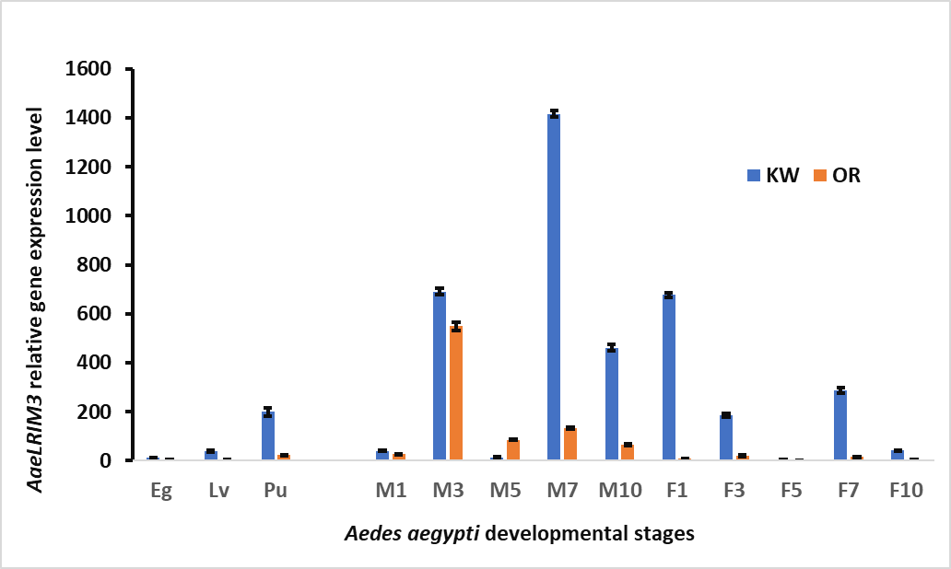
Figure S1A. AaeLRIM3
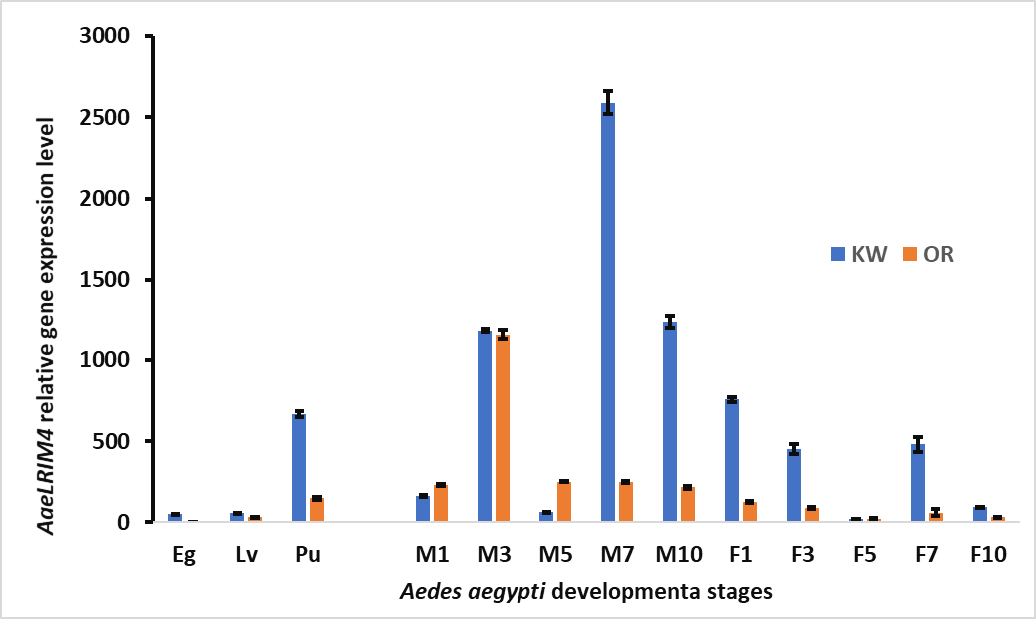
Figure S1B. AaeLRIM4
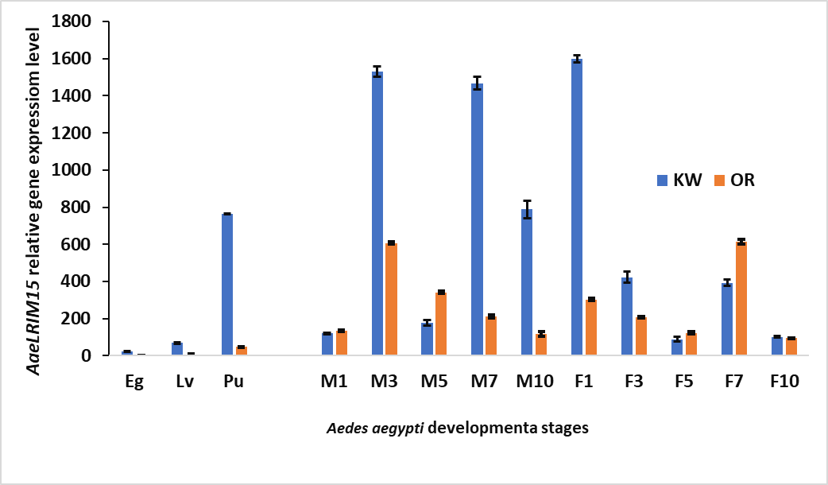
Figure S1C. AaeLRIM15

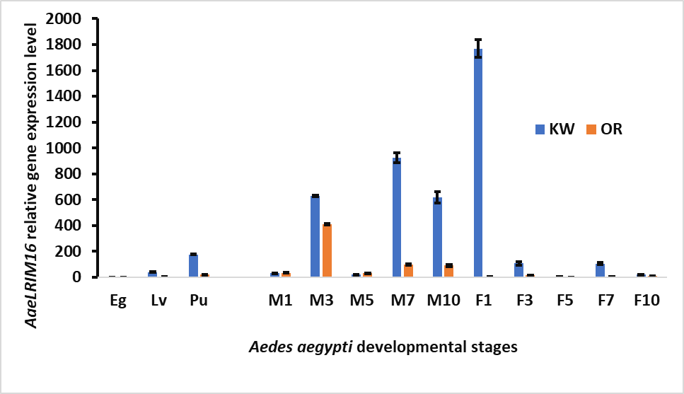
Figure S1D. AaeLRIM16
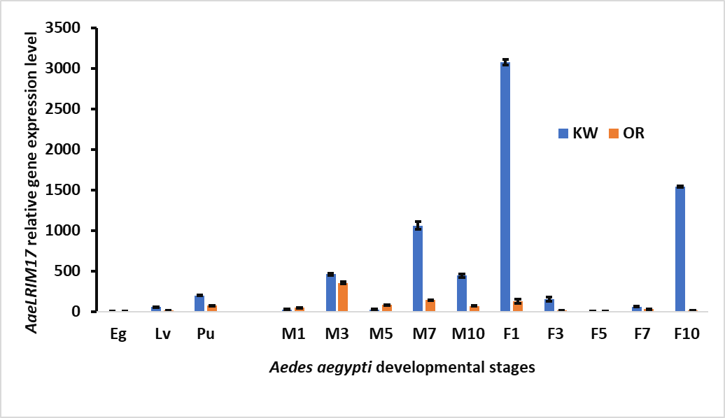
Figure S1E. AaeLRIM17

Figure S1A-E. AaeLRIM3, AaeLRIM4, AaeLRIM15, AaeLRIM16, and AaeLRIM17 relative expression in the all developmental stages, from eggs (Eg), larvae (Lv), pupae (Pu), and adults Ae. aegypti, including male (M1, male 1-d-old; M3, male 3-d-old; M5, male 5-d-old; M7, male 7-d-old; and M10, male 10-d-old) and female (F1, female 1-d-old; F3, female 3-d-old; F5, female 5-d-old; F7, female 7-d-old; and 10F, female 10-dold) in the Key West strain (KW) and Orlando (OR) strain Aedes aegypti. (A) AaeLRIM3; (B) AaeLRIM4; (C) AaeLRIM15; (D) AaeLRIM16; and (E) AaeLRIM17.

Figure S2A-B. . AaeLRIM3, AaeLRIM4, AaeLRIM15, AaeLRIM16,and AaeLRIM17 relative expression level fold changes in Aedes aegypti female infected with ZIKV (Key West strain and Orlando strain).
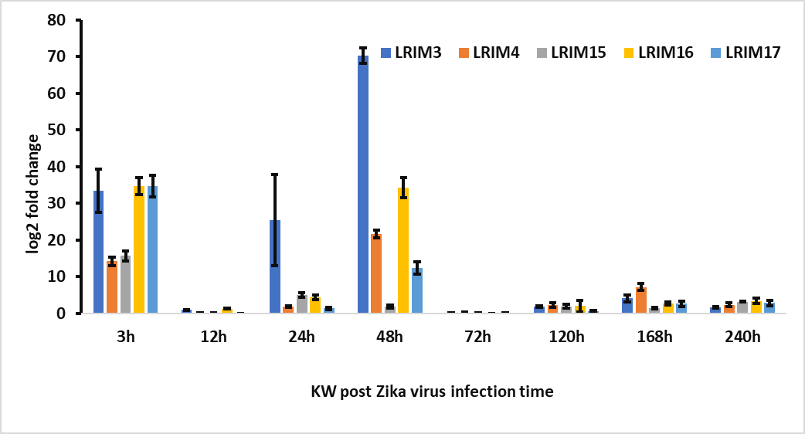
Figure S2A. KW strain female Ae. aegypti

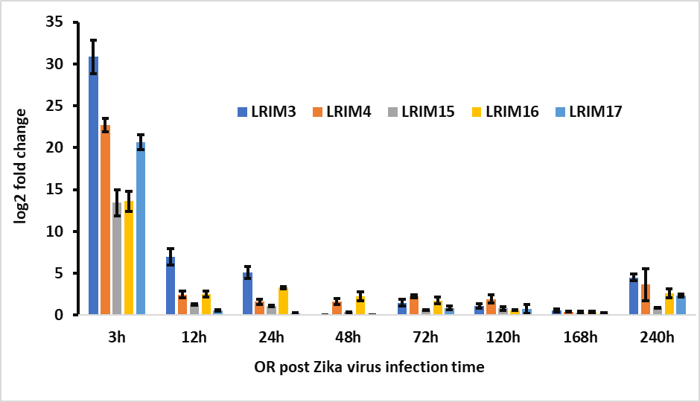
Figure S2B. Orlando strain female Ae. aegypti

Figure S2A-B. . AaeLRIM3, AaeLRIM4, AaeLRIM15, AaeLRIM16,and AaeLRIM17 relative expression level fold changes in Aedes aegypti female infected with ZIKV. The fold change was calculated using the 2 ^{[-average ΔΔCT ]} method. ΔCt (Control) = Ct (AaeLRIM1/AaeAPL1) –Ct (AeaActin); ΔCt (infected-ZIKV) = Ct (AaeLRIM1/AaeAPL1) – Ct (AeaActin); ΔΔCt =ΔCt (infected-ZIKV)−ΔCt (Control). The 3, 12, 24, 48, 72, 120, 168, and 240 h represented gene expression post infected with ZIKV. (A) KW strain female Ae. aegypti; (B) Orlando strain female Ae. aegypti.

Figure S3A-B. AaeLRIM3, AaeLRIM4, AaeLRIM15, AaeLRIM16,and AaeLRIM17 relative expression level fold changes in Aedes aegypti female infected with CHIKV(Key West strain and Orlando strain).

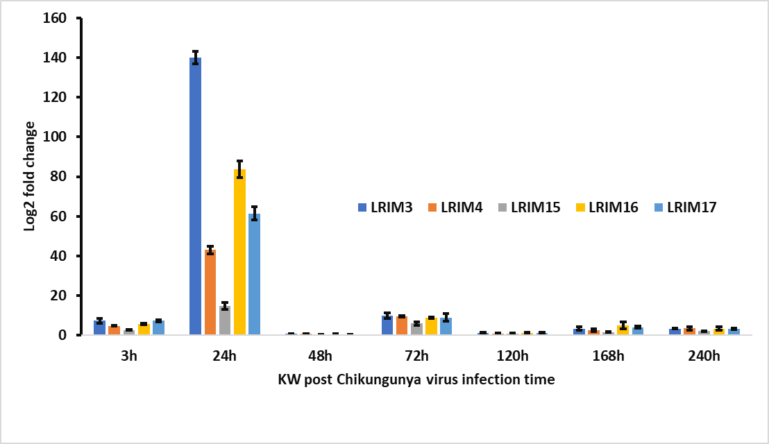
Figure S3A. KW strain female Ae. aegypti
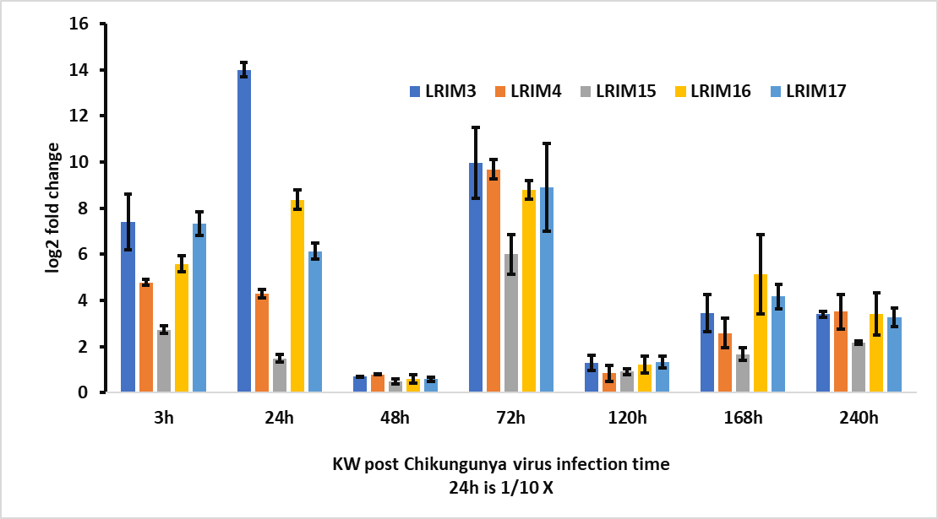
Figure S3B. Orlando strain female Ae. aegypti.

Figure S3A-B. AaeLRIM3, AaeLRIM4, AaeLRIM15, AaeLRIM16,and AaeLRIM17 relative expression level fold changes in Aedes aegypti female infected with CHIKV. The fold change was calculated using the 2 ^{[-average ΔΔCT ]} method. ΔCt (Control) = Ct (AaeLRIM1/AaeAPL1) –Ct (AeaActin); ΔCt (infected-CHIKV) = Ct (AaeLRIM1/AaeAPL1) – Ct (AeaActin); ΔΔCt =ΔCt (infected-CHIKV)−ΔCt (Control). The 3, 24, 48, 72, 120, 168, and 240 h represented gene expression post infected with CHIKV. (A) KW strain female Ae. aegypti; (B) Orlando strain female Ae. aegypti.

